Electronic Supplementary Materials

Table S1 Expression of genes between samples related to different signal transduction pathways.

KEGG Pathways | Number of genes annotated | BVT_3dpi vs CK |  | BVT_6dpi vs CK |  | BVT_6dpi vs BVT_3dpi
 |  | Up | Down | Up | Down | Up | Down
Neuroactive ligand-receptor interaction | 85 | 6 | 5 | 4 | 8 | 3 | 8
MAPK signaling pathway | 134 | 1 | 2 | 0 | 1 | 0 | 1
Two-component system | 13 | 1 | 0 | 0 | 0 | 0 | 0
Calcium signaling pathway | 80 | 0 | 1 | 0 | 1 | 0 | 0
mTOR signaling pathway | 50 | 0 | 1 | 0 | 0 | 0 | 0
Wnt signaling pathway | 81 | 0 | 2 | 0 | 0 | 1 | 0
Notch signaling pathway | 48 | 0 | 1 | 0 | 1 | 0 | 1
TGF-beta signaling pathway | 37 | 0 | 2 | 0 | 0 | 1 | 0
VEGF signaling pathway | 43 | 1 | 0 | 0 | 0 | 0 | 0
ECM-receptor interaction | 51 | 1 | 0 | 1 | 0 | 1 | 2
Jak-STAT signaling pathway | 26 | 0 | 1 | 0 | 0 | 0 | 0

Table S2 List of Forward and Reverse primers used in quantitative RT-PCR analysis.

Unigene ID | Annotation | Forward primer | Reverse primer
comp15682_c0 | Trypsin | GGCTGGTAAAATGGCAACGG | CACGACCGCCCTCCTTATAG
comp19542_c0 | Lipoprotein lipase | ATGTTGTTGGAGTCGCTGGT | CGTTGGGGTAAAAGTCAGCG
comp9968_c0 | Stearoyl-CoA desaturase | GGCAGCAGAACACTTCGACT | TACTGGTGTACCGTCGCCTA
comp17951_c0 | Attacin | GCCCTCGGTAGTGTTGGTAT | CCGGCACCAGTCAACTTAGA
comp16005_c0 | Gloverin precursor | TGGCATACACAAACGCCCAA | AGTTGTCCGCCACCAAAGTT
comp13751_c0 | Phosphatidyllinositol 4 phosphate 5 kinase | ACGGAGCAGGCGAGATTTTA | ATGACGAGCAGTTCCGTGAC
comp15533_c0 | Glucoronosyl transferase | ACGTGCTATATGGTGGACCG | AATCTGTATGCGGGTAGCGT
comp7919_c0 | UDP- glycosyltransferase | CGACACCTGTGCCTAGTCTG | GAGGCAGAGCATCGACACTT
comp14600_c0 | Chymotrypsin | CAACACAAACGCACCTCCAG | CACAAGGGAAGCCCCATGAT
 | Actin (Reference gene) | GGGAAATCGTGCGTGAC | GAAGGAAGGCTGGAAGAG
 | GAPDH (Reference gene) | CTGTCGCTAATGTATCC GTTGTC | AACCTGCTCCTCAGTGTAGTCAAG

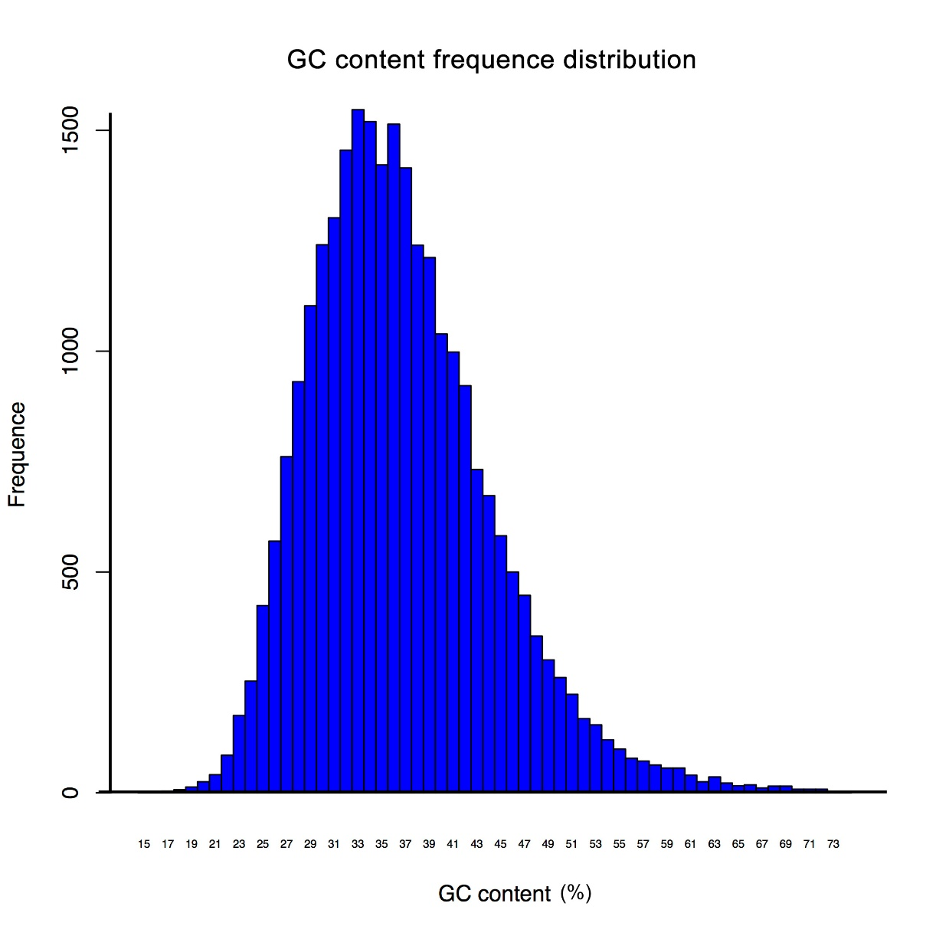
Figure S1 GC content distribution in the unigenes.

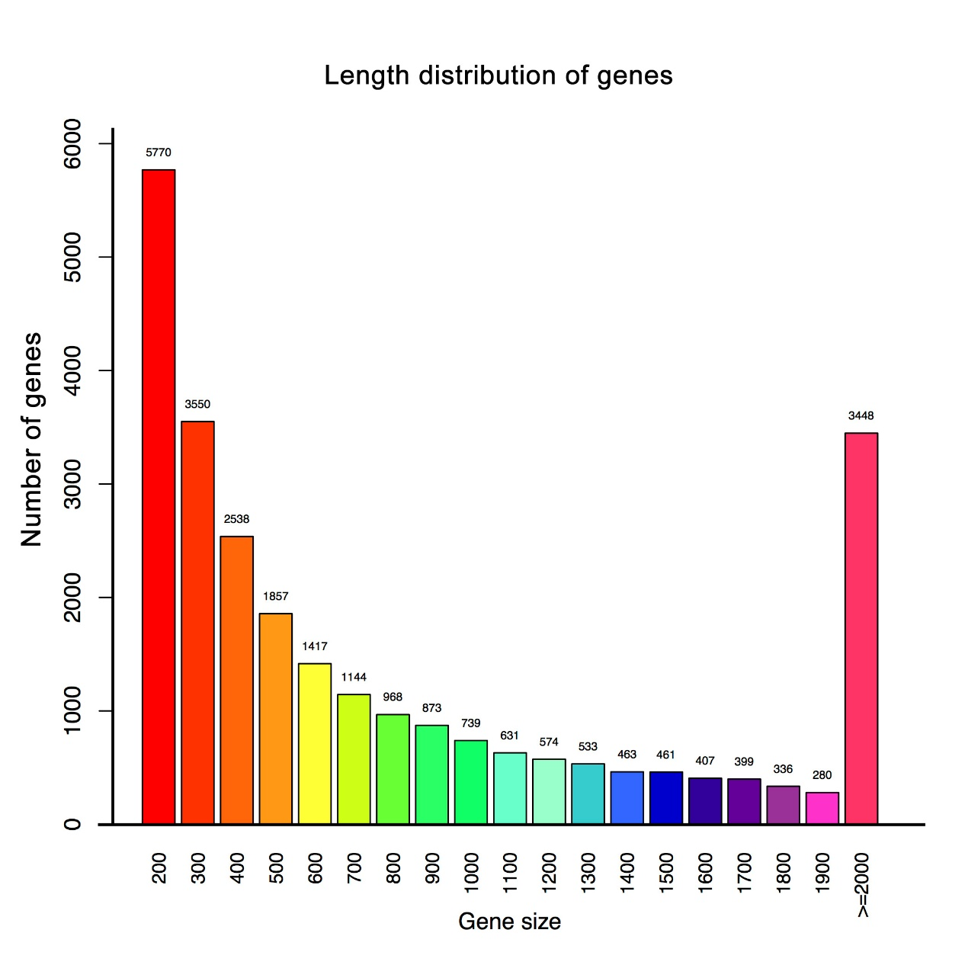

Figure S2 Length distribution of the unigenes.

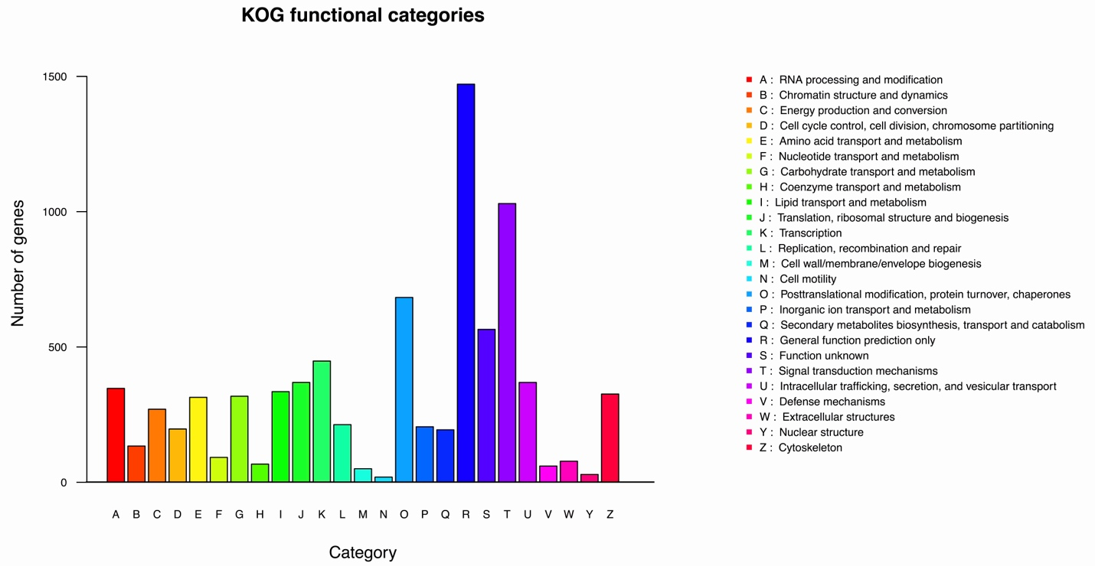

Figure S3 KOG functional classification of L. dispar transcriptome. Y-axis represents a number of unigenes involved and X-axis denotes different categories of KOG functional groups.

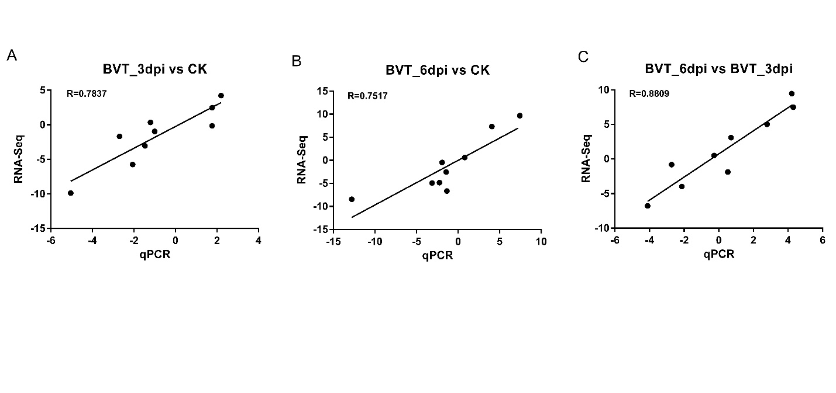
Figure S4 Validation of RNA-Seq data analysis by RT-qPCR. The nine genes differentially expressed at all time points were validated for their expression by RT-qPCR for CK, BVT_3dpi and BVT_6dpi. Overall, all time points showed consistency between the two methods in their expression trends.

