Virologica Sinica

Supplementary Data

Drug repurposing screen identifies vidofludimus calcium and pyrazofurin as novel chemical entities for the development of hepatitis E interventions

Hongbo Guo^{a, 1, *}, Dan Liu^{a1}, Kuan Liu^{b, c, 1}, Yao Houª, Chunyang Liª, Qiudi Liª, Xiaohui Dingª, Monique M A Verstegen^{c}, Jikai Zhangª, Lingli Wangª, Yibo Dingª, Renxian Tangª, Xiucheng Pan^{d}, Kuiyang Zhengª, Luc J W van der Laan^{c}, Qiuwei Pan^{b, *}, Wenshi Wang^{a, *}
ª Department of Pathogen Biology and Immunology, Jiangsu Key Laboratory of Immunity and Metabolism, Jiangsu International Laboratory of Immunity and Metabolism, Xuzhou Medical University, Xuzhou, 221004, China.
^{b} Department of Gastroenterology and Hepatology, Erasmus MC-University Medical Center, Rotterdam, NL-3015 CN, the Netherlands.
^{c} Department of Surgery, Erasmus MC Transplant Institute, University Medical Center, Rotterdam 3015CE, NL-3015 CN, the Netherlands.
^{d} Department of Infectious Diseases, The Affiliated Hospital of Xuzhou Medical University, Xuzhou, 221002, China.

*Corresponding authors.
Emails: Hongbo.guo@xzhmu.edu.cn (H. Guo), wenshi.wang@xzhmu.edu.cn (W. Wang), q.pan@erasmusmc.nl (Q. Pan).
ORCID of corresponding authors: 0009-0006-9241-1414 (H. Guo), 0000-0002-7330-262X (W. Wang), 0000-0001-9982-6184 (Q.Pan)
1 These authors contributed equally to this work.
160
Fig. S1. Characterization of HEV replication in HEK293T cell line. (A) Schematic illustration of HEV p6 Gaussia luciferase (Gluc) replicon system (HEV-p6-Gluc) and replication-defective mutant (HEV-p6-GAD-Gluc). The in-vitro transcribed RNAs were electroporated into HuH7 or HEK293T cells. After passaging, cells were seeded in the cell culture plates. Gluc secreted in supernatant were measured at different time points, which correlates to HEV replication. (B) The luciferase values were measured in HuH7 cell based HEV-p6-Gluc, HEV-p6-GAD-Gluc (replication defect control) and mock-electroporated models. (C) The luciferase values were measured in HEK293T cell based HEV-p6-Gluc, HEV-p6-GAD-Gluc (replication defect control) and mock-electroporated models. (D) Schematic illustration of full-length HEV p6 genome (HEV-p6-wt) and replication-defective mutant (HEV-p6-GAD). The in-vitro transcribed RNAs were electroporated into HEK293T cells. After passaging, the cells were seeded in the cell culture plates. The RNAs were extracted from cell lysates and supernatant 3 days after seeding to determine virus release and virus replication in HEK293T cells. (E) The levels of intracellular HEV RNA in HEK293T were measured by RT-qPCR. (F) The levels of extracellular HEV RNA in HEK293T were measured by RT-qPCR. (G) Immunofluorescence staining of HEV ORF2 protein in HEK293T cell based HEV-p6-wt or HEV-p6-GAD models.
Fig. S2. Supplement of exogenous uridine reversed the anti-HEV effect of vidofludimus calcium (5 μmol/L) and pyrazofurin (1 μmol/L). Immunofluorescence staining in HuH7 cell based HEV-p6 model after 72 hours of drug treatment with or without the supplement of exogenous uridine. HEV ORF2 was stained in red. Hoechst (blue) was applied to visualize nuclei. (Scale bar, 50μm).

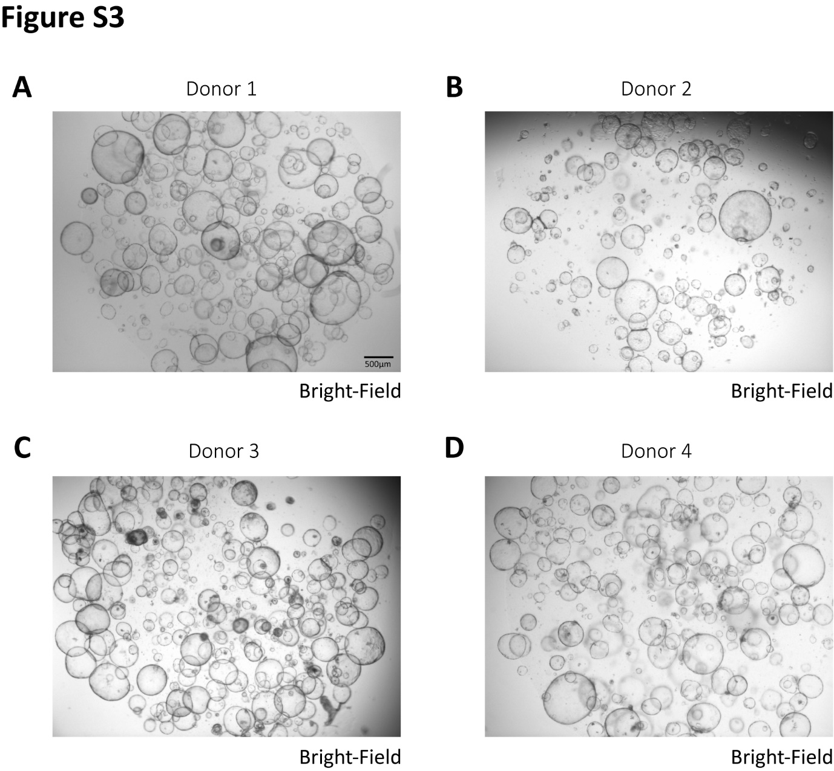

Fig. S3. Morphology of primary human liver organoids derived from four donors (A-D) in bright field. Scale bar, 500 μm.
Fig. S4. The anti-HEV activity of vidofludimus calcium and pyrazofurin was measured in human liver organoids harboring HEV-p6-Gluc. The relative luciferase values were detected with the treatment of vidofludimus calcium (A-D) and pyrazofurin (E-H) based on live organoids models derived from 4 different donors (n=6-8). CTR, untreated control. Data are presented as means ± SEM. (*, P<0.05; **, P<0.01; ***, P<0.001.)
Fig. S5. Cell viability was measured in liver organoids model after 1-3 days treatment with vidofludimus calcium (A) or pyrazofurin (B) at different concentrations. CTR, untreated control. Data are presented as means ± SEM.

Fig. S6. Construction and characterization of HEV p6 mutants M1 (Y1320H), M2 (G1634R) and M1+2 (Y1320H and G1634R). (A) Schematic illustration of full-length HEV p6 genome mutants. (B) Immunofluorescence analysis of viral ORF2 protein (red) in full-length HuH7-p6 WT and mutant M1, M2 and M1+2 infectious models. Hoechst (blue) was applied to visualize nuclei. (Scale bar, 50μm). (C) Quantification of ORF2-positive cells based on immunofluorescence analysis. (D) Immunofluorescence staining of viral ORF2 protein (red) in WT and HEV mutants after 72 h treatment with ribavirin (RBV). (E) The IC₅₀ values of ribavirin against WT and mutant HEV strains were calculated using GraphPad Prism software based on the quantification of immunofluorescence staining. Data are presented as means ± SEM.

Fig. S7. The 50% cytotoxic concentration (CC₅₀) values of vidofludimus calcium (A) or pyrazofurin (B) were calculated using GraphPad Prism software (n=3). Data were normalized to the untreated control (CTR) (set as 100%). Data are presented as means ± SEM.

Fig. S8. Determination of synergistic effect of vidofludimus calcium and pyrazofurin in combination with IFN-α or ribavirin. (A-B) The anti-HEV effect of vidofludimus calcium or pyrazofurin in combination with IFN-α, respectively. (C-D) The anti-HEV effect of vidofludimus calcium or pyrazofurin in combination with ribavirin, respectively. Data were normalized to the untreated control (CTR) (set as 100%). Data are presented as means ± SEM (Standard error of the mean).

Supplementary Table S1 262 compounds used in the study (separate excel file).

