Virologica Sinica

Supplementary Data

Structural analysis of conformational changes in the mpox virus A7 protein
Xincheng Ni ª, Kai Wang ª, Yinze Han ª, Jian Lei ^{a, *}

ª National Clinical Research Center for Geriatrics, and State Key Laboratory of Biotherapy and Cancer Center, West China Hospital, Sichuan University, Chengdu, 610041, China.

*Corresponding author.
E-mail address: leijian@scu.edu.cn (J. Lei).
ORCID: 0000-0001-9326-0554

Materials and Methods
Plasmid construction
The constructs of MPXV A7 (Genbank: NC_063383.1), A7N₁₂₁ (residues 1–121), A7N₁₃₇ (residues 1–137) and A7C (residues 122–372) were amplified by PCR using the plasmid pET28a-A7 (GENERAL BIOL. Anhui, China) as the template. These PCR products were then ligated into the modified pET28a plasmids, containing an N-terminal hexa-histidine tag and a subsequent Tobacco Etch Virus (TEV) protease cleavage site. The corresponding primers used for these constructs are listed in Supplementary Table S1. All recombinant plasmids were verified by sequencing (Tsingke Biotechnology Co., Ltd., Chengdu, China).

Protein expression and purification
All plasmids for in vitro assays were expressed in the same approach. The sequenced plasmid was transformed into E. coli BL21(DE3) (Novagen). Then the cells were incubated overnight at 37°C in 50 mL Luria-Broth (LB) medium supplemented with kanamycin at a final concentration of 50 μg/mL. The cell culture was inoculated into 2 × 1 L LB medium on the next day. When the OD₆₀₀ value of the culture reached 0.6, overexpression of the target gene was induced for 16 h with 0.5 mmol/L isopropyl-D-thiogalactoside (IPTG) supplementation at 18 °C. The 2 L culture was subsequently harvested by centrifugation for 15 min, 1,914 ×g at 4°C. The harvested E. coli BL21(DE3) cells were resuspended in 50 mL buffer A (20 mmol/L Tris-HCl, pH 7.5, 10 mmol/L imidazole, 500 mmol/L NaCl) and lysed by ultrasonication on ice. After centrifugation for 30 min at 38,759 ×g at 4°C, the supernatant of the lysed mixture was applied to Ni Sepharose™ Fast Flow beads (GE Healthcare). Next, the His-tagged protein was eluted by buffer B (20 mmol/L Tris-HCl, pH 7.5, 500 mmol/L imidazole, 500 mmol/L NaCl) with a step-gradient method. The His-tag of the target protein was further cleaved by TEV protease (prepared by ourselves). The corresponding protein was subsequently dialyzed against buffer C (20 mmol/L Tris-HCl, pH 7.5, 150 mmol/L NaCl, 5 mmol/L dithiothreitol (DTT) and 5% Glycerol) overnight at 4 °C. Finally, all target proteins were purified again by size-exclusion chromatography (Superdex 75 Increase 10/300 GL, GE Healthcare) using the buffer C, and the quality of these proteins was assessed by SDS-PAGE.

Lipid-binding assay
MPXV A7, A7N₁₂₁, and A7C (20 μL, approximately 2 mg/mL) were prepared in buffer D (20 mmol/L Tris-HCl, pH 8.0, 150 mmol/L NaCl and 5 mmol/L DTT) and mixed with 1 μL NBD-PE (N-(7-Nitrobenz-2-oxa-1,3-diazol-4-yl)-1,2-dihexadecanoyl-snglycero-3-phosphoethanolamine, triethylammonium salt) (Macklin, Shanghai, China) at 2 mg/mL in methanol. All the reaction systems were incubated on ice for 2 h, and subsequently analyzed by native PAGE. A Tanon-5200 Imager (Tanon Co., Ltd., Shanghai, China) was used for the visualization of the fluorescence and coomassie-stained protein bands from the gel.

Crystallization and data collection
Both purified A7N₁₂₁ and A7N₁₃₇ were concentrated to approximately 20 mg/mL in buffer C. Crystallization trials for these two samples were performed at 291 K by employing the sitting-drop vapor-diffusion method with 1 µL of protein plus 1 µL of reservoir. Crystals of A7N₁₂₁ were observed under the condition of No.24 of the kit PACT premierTM (Molecular Dimensions): 0.01 mol/L Zinc chloride, 0.1 mol/L MES pH 6.0, 20% w/v PEG 6000. While crystals of A7N₁₃₇ were obtained under condition of No.95 of the kit IndexTM (Hampton Research): 0.1 mol/L Potassium thiocyanate, 30% w/v Polyethylene glycol monomethyl ether 2000. All above crystals were shock-cooled in liquid nitrogen. The diffraction dataset of A7N₁₂₁ (~ 1.7 Å) was collected with X-ray wavelength of 0.97915 Å at Shanghai synchrotron radiation facility (SSRF) beamline BL18U1, Shanghai, China. The diffraction dataset of A7N₁₃₇ (~ 2.5 Å) was collected at a wavelength of 0.97851 Å at SSRF beamline BL19U1, Shanghai, China. Two data sets were processed by XDS (Kabsch, 2010) and scaled with Aimless in CCP4 (Evans & Murshudov, 2013). The space group of A7N₁₂₁ crystal is C2 with unit-cell parameters: a = 76.0 Å, b = 31.3 Å, c = 49.8 Å, α = 90°, β = 112.34°, γ = 90°. While the space group of A7N₁₃₇ is C222₁ with unit-cell parameters: a = 37.9 Å, b = 140.3 Å, c = 153.5 Å, α = β = γ = 90°. The detailed crystallographic statistics are presented in Table 1.

Phase determination and model refinement
The structures of MPXV A7N₁₂₁ and A7N₁₃₇ were determined by molecular replacement (MR) method. The initial phase of MPXV A7N₁₂₁ was determined by MR with program MOLREP (Vagin & Teplyakov, 2009), using VACV A6N (PDB code: 6CB6) as the search model. Next, the initial model of the MPXV A7N₁₂₁ was rebuild and refined using programs Coot (Emsley et al., 2010) and REFMAC5 (Kovalevskiy et al., 2018). The final R_{factor} is 0.180, with R_{free} = 0.205. Subsequently, the structure of A7N₁₃₇ was determined with program MOLREP (Vagin & Teplyakov, 2009), using our A7N₁₂₁ (PDB code: 8IZT) as the search model. The primary A7N₁₃₇ model was continually rebuilt and refined using programs Coot (Emsley et al., 2010) and PHENIX. refine (Adams et al., 2010). The R_{factor} and R_{free} of A7N₁₃₇ are 0.210 and 0.239, respectively. Please see Table 1 for the final refinement statistics.

Differential scanning fluorimetry (DSF)
The structural integrity of the protein at increasing temperature was performed using SYPRO Orange (Sigma, USA) as an external fluorophore in a CFX96 Touch Real-Time PCR Detection System (Bio-Rad, USA). Each reaction sample contained 1 μL SYPRO Orange fluorophore (diluted 1000-fold) and 9 μL target protein (final concentration at 10 μmol/L) in DSF buffer (20 mmol/L Tris-HCl, pH 7.5, 150 mmol/L NaCl). Samples were then loaded in 96-well PCR plates and heated from 25 to 95 °C with a heating rate of 2 °C/min. Fluorescence intensity was analyzed using Bio-Rad CFX Maestro 1.1 software.

Molecular dynamics (MD) simulation
We performed 50 nanosecond (ns) MD simulation using the chain A of A7N₁₃₇. The system was conveniently constructed by CHARMM-GUI (Jo et al., 2008), and the model of target protein was constructed and optimized by CHARMM force field (Best et al., 2012; Klauda et al., 2010). The system was solvated with the TIP3 water model and neutralized with potassium and chloride ions. Prior to the production simulation, a steepest descent algorithm was employed to minimize the system for 100 picosecond (ps) to eliminate any unnatural collisions. Subsequently, a 250 ps equilibration process was conducted, gradually releasing the scaling restraint until the force was fully removed. The MD simulation was performed under the isothermal-isobaric (NPT) conditions at a temperature of 303.15 K and a pressure of 1 atmosphere, using a time step of 2 femtosecond (fs) and constraining bonds involving hydrogen atoms with the linear constraint solver (LINCS) algorithm. The particle mesh Ewald (PME) method was used for calculating electrostatic interactions. Finally, the root mean square fluctuation (RMSF) was calculated for each residue of interest. All simulations were performed with the Gromacs software package, version 2018.8 (Abraham et al., 2015) and animated demonstration of molecular dynamics simulations were produced using VMD version 1.93 (Humphrey et al., 1996).

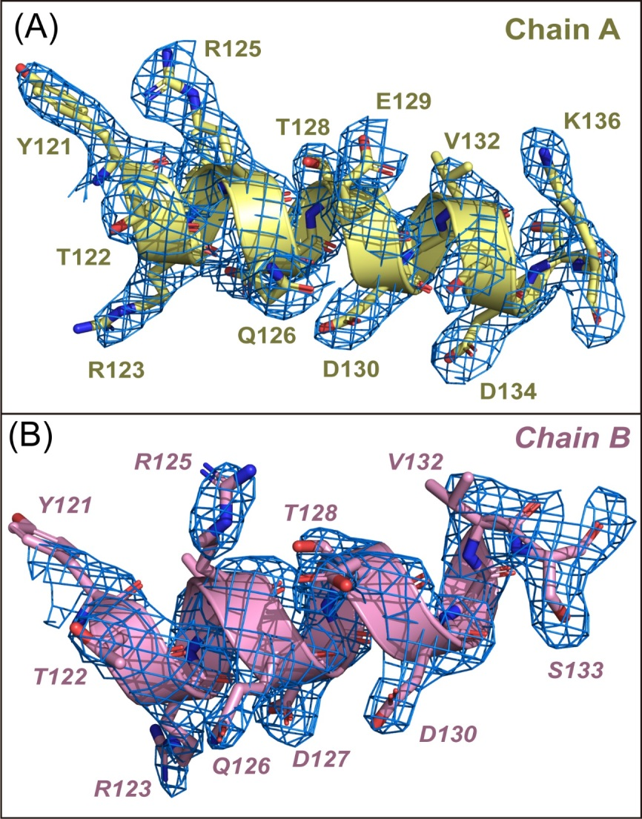
Fig. S1 The 2Fo−Fc electron density maps of the linking helices in two A7N₁₃₇ chains. (A, B) The linking helices of the A7N₁₃₇ chains A and B are shown in yellow and pink, respectively. Each residue of the linking helix is shown as sticks. The 2Fo−Fc electron density map (σ = 1) of each helix is displayed in blue mesh. Figures were prepared using PyMOL (https://pymol.org).

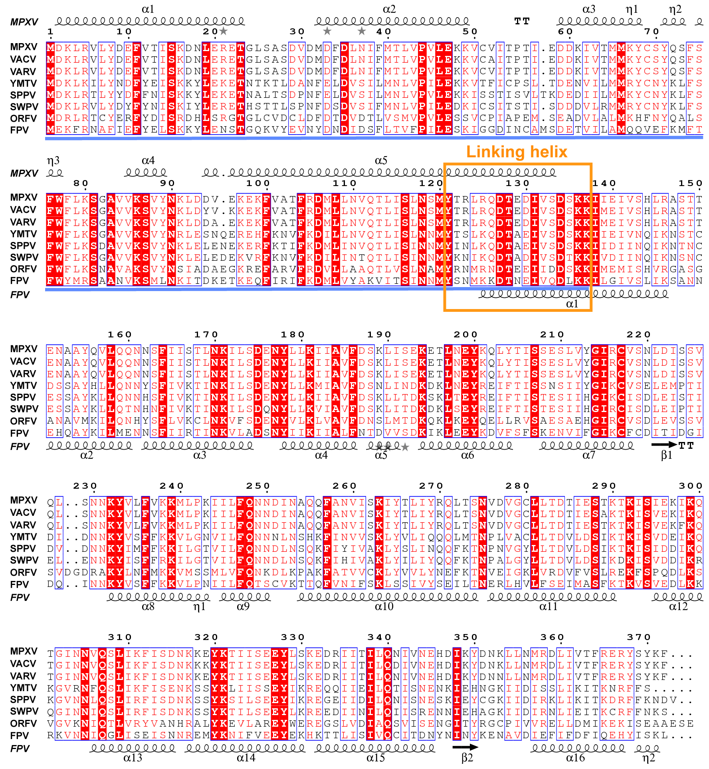
Fig. S2 Structure-based multiple sequence alignment of MPXV A7 and its orthologs from different poxviruses. The corresponding sequence accession numbers are: MPXV, NC_063383.1; VACV, NC_006998.1; VARV, NC_001611.1; YMTV, NC_005179.1; SPPV, NC_004002.1; SWPV, NC_003389.1; ORFV, NC_005336.1; FPV, NC_002188.1. The truncation A7N₁₃₇ is underlined in blue and the linking helix is marked by an orange box. The secondary structures of MPXV A7N₁₃₇ (top, PDB code: 8IZU, chain A) and FPV170-C (bottom, PDB code: 6BR8, chain A) are indicated. This figure was prepared using the program ESPript (Gouet et al., 1999).

Movie S1. Molecular dynamics (MD) simulation to predict the movements of A7N₁₃₇. A7N₁₃₇ (chain A) was used as the initial conformation. The linking helix of A7N₁₃₇ presents a significant up-and-down swing during the first 10 ns of MD simulation (Please see separate video file).

Table S1. Primers used for MPXV A7 and its truncations.

Gene | Forward primer (5′ to 3′) | Reverse primer (5′ to 3′)
A7  (1–372) | CTAGCTAGCATGGACAAACTTAGAGTTCTATACGATG | CCGCTCGAGTTAGAATTTATACGAATATCGTTCTCT
A7N₁₂₁  (1–121) | CTAGCTAGCATGGACAAACTTAGAGTTCTATACGATG | CCGCTCGAGTTAATACATAGAGTTAAGAGAAATTAGAGT
A7N₁₃₇  (1–137) | CTAGCTAGCATGGACAAACTTAGAGTTCTATACGATG | CCGCTCGAGTTATTTTTTGGAATCGGATACTATATCTTCGG
A7C  (122–372) | CTAGCTAGCACTAGACTGCGTCAAGATACCGAAG | CCGCTCGAGTTAGAATTTATACGAATATCGTTCTCT

References
Abraham, M.J., Murtola, T., Schulz, R., Páll, S., Smith, J.C., Hess, B., Lindahl, E., 2015. GROMACS: High performance molecular simulations through multi-level parallelism from laptops to supercomputers. SoftwareX 1-2, 19-25.
Adams, P.D., Afonine, P.V., Bunkóczi, G., Chen, V.B., Davis, I.W., Echols, N., Headd, J.J., Hung, L.W., Kapral, G.J., Grosse-Kunstleve, R.W., McCoy, A.J., Moriarty, N.W., Oeffner, R., Read, R.J., Richardson, D.C., Richardson, J.S., Terwilliger, T.C., Zwart, P.H., 2010. PHENIX: a comprehensive Python-based system for macromolecular structure solution. Acta Crystallogr. D Biol. Crystallogr. 66, 213-221.
Best, R.B., Zhu, X., Shim, J., Lopes, P.E., Mittal, J., Feig, M., Mackerell, A.D. Jr., 2012. Optimization of the additive CHARMM all-atom protein force field targeting improved sampling of the backbone φ, ψ and side-chain χ(1) and χ(2) dihedral angles. J. Chem. Theory. Comput. 8, 3257-3273.
Emsley, P., Lohkamp, B., Scott, W.G., Cowtan, K., 2010. Features and development of Coot. Acta Crystallogr. D Biol. Crystallogr. 66, 486-501.
Evans, P.R., & Murshudov, G.N., 2013. How good are my data and what is the resolution? Acta Crystallogr. D Biol. Crystallogr. 69, 1204-1214.
Gouet, P., Courcelle, E., Stuart, D.I., Métoz, F., 1999. ESPript: analysis of multiple sequence alignments in PostScript. Bioinformatics 15, 305-308.
Humphrey, W., Dalke, A., Schulten, K., 1996. VMD: visual molecular dynamics. J. Mol. Graph. 14, 33-38.
Jo, S., Kim, T., Iyer, V.G., Im, W., 2008. CHARMM-GUI: a web-based graphical user interface for CHARMM. J. Comput. Chem. 29, 1859-1865.
Kabsch, W., 2010. XDS. Acta Crystallogr. D Biol. Crystallogr. 66, 125-132.
Klauda, J.B., Venable, R.M., Freites, J.A., O'Connor, J.W., Tobias, D.J., Mondragon-Ramirez, C., Vorobyov, I., Mackerell, A.D. Jr., Pastor, R.W., 2010. Update of the CHARMM all-atom additive force field for lipids: validation on six lipid types. J. Phys. Chem. B 114, 7830-7843.
Kovalevskiy, O., Nicholls, R.A., Long, F., Carlon, A., Murshudov, G.N., 2018. Overview of refinement procedures within REFMAC5: utilizing data from different sources. Acta Crystallogr. D Biol. Crystallogr. 74, 215-227.
Vagin, A., & Teplyakov, A., 2009. Molecular replacement with MOLREP. Acta Crystallogr. D Biol. Crystallogr. 66, 22-25.

