Virologica Sinica

Supplementary Data

Phosphorylation of PB2 at serine 181 restricts viral replication and virulence of the highly pathogenic H5N1 avian influenza virus in mice

Jiao Hu ^{a,c,d, 1}, Zixiong Zeng ^{a,c,d,1}, Xia Chen^{a,c,d}, Manyu Zhang ^{a,c,d}, Zenglei Hu ^{a,b}, Min Gu ^{a,c,d}, Xiaoquan Wang ^{a,c,d}, Ruyi Gao ^{a,c,d}, Shunlin Hu ^{a,c,d}, Yu Chen ^{a,c,d}, Xiaowen Liu ^{a,c,d}, Daxin Peng ^{a,c,d}, Xiufan Liu ^{a,c,d,} *

ª Animal Infectious Disease Laboratory, School of Veterinary Medicine, Yangzhou University, Yangzhou, 225009, China
^{b} Joint International Research Laboratory of Agriculture and Agri-Product Safety, The Ministry of Education of China, Yangzhou University, 225009, China
^{c} Jiangsu Co-Innovation Center for Prevention and Control of Important Animal Infectious Diseases and Zoonosis, Yangzhou University, Yangzhou, 225009, China
^{d} Key Laboratory of Prevention and Control of Biological Hazard Factors (Animal Origin) for Agri-food Safety and Quality, Ministry of Agriculture of China (26116120), Yangzhou University, Yangzhou, 225009, China
*Corresponding author.
E-mail: xfliu@yzu.edu.cn (X. Liu)

¹ Jiao Hu and Zixiong Zeng contributed equally to this work.
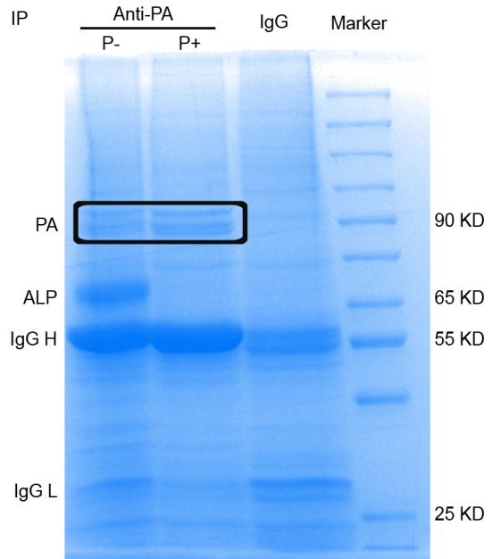
Fig. S1. Preparation of IP samples for MS analysis. For preparation of the IP samples, a total of 3 × 10⁶ HEK 293T cells were transfected with 12 µg of pcDNA-PA plasmid. After 24 h, cells were infected with 2 MOI of the CK10 virus. After 8 h, cells were lysed in 700 μL RIPA lysis Buffer. More specifically, RIPA in the control (IgG group) and phosphorylation group (P+) contained cOmplete™ Mini protease inhibitor and phosphatase inhibitor PhosSTOP™, while RIPA in the dephosphorylation group (P-) only included the cOmplete™ Mini protease inhibitor. Bands circled with box were cut for further MS analysis.

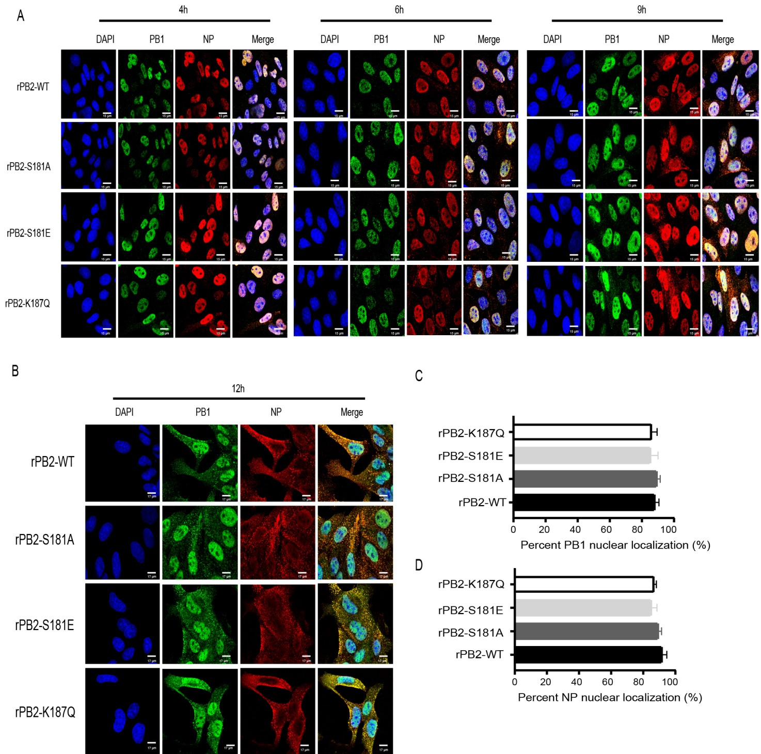
Fig. S2. Influence of PB2-S181E/A and PB2-S187Q mimic mutation on PB1 and NP nuclear accumulation in MDCK cells. MDCK cells were infected with the indicated virus at an MOI of 2, cell cultures were then fixed and processed for immunofluorescence observation at indicated time points. Cell nuclei were stained with DAPI. A At 4 h, 6 h and 9 h p.i., cells were fixed and processed for immunofluorescence observation. B At 12 h p.i., cells were fixed and processed for immunofluorescence observation. C At 4 h p.i., the PB1 nuclear accumulation in MDCK-infected cells was determined as the ratio of cells showing green fluorescence in the nucleus to the total number of cells counted (n = 200). D At 4 h p.i., the NP nuclear accumulation in MDCK-infected cells was determined as the ratio of cells showing red fluorescence in the nucleus to the total number of cells counted (n = 200). Values shown are the means of the results of three independent experiments SDs. *, P < 0.05 compared with the result for rPB2-WT virus-infected cells.

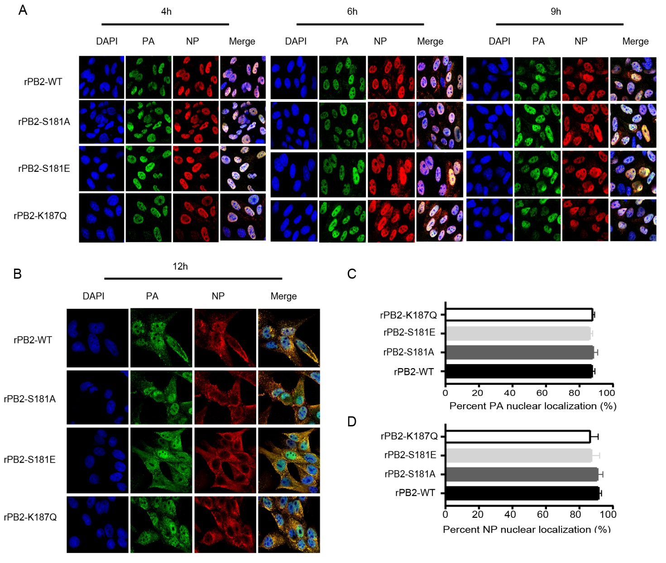
Fig. S3. Influence of PB2-S181E/A and PB2-S187Q mimic mutation on PA and NP nuclear accumulation in MDCK cells. MDCK cells were infected with the indicated virus at an MOI of 2, cell cultures were then fixed and processed for immunofluorescence observation at indicated time points. Cell nuclei were stained with DAPI. A At 4 h, 6 h and 9 h p.i., cells were fixed and processed for immunofluorescence observation. B At 12 h p.i., cells were fixed and processed for immunofluorescence observation. C At 4 h p.i., the PA nuclear accumulation in MDCK-infected cells was determined as the ratio of cells showing green fluorescence in the nucleus to the total number of cells counted (n = 200). D At 4 h p.i., the NP nuclear accumulation in MDCK-infected cells was determined as the ratio of cells showing red fluorescence in the nucleus to the total number of cells counted (n = 200). Values shown are the means of the results of three independent experiments SDs. *, P < 0.05 compared with the result for rPB2-WT virus-infected cells.

Supplementary Table S1 Primers for point mutation for pHW2000-PB2 and pCDNA3.1-PB2 plasmids.
Mutation | Primers | Sequence（5’→3’）
PB2-S181A | PB2-S181A-F | GAATACTGACTTCAGAGGCGCAGTTGAC
 | PB2-S181A-R | CCTCTGAAGTCAGTATTCTAGCTCCCAC
PB2-S181E | PB2-S181E-F | GAATACTGACTTCAGAGGAGCAGTTGACA
 | PB2-S181E-R | TCCTCTGAAGTCAGTATTCTAGCTCCCAC
PB2-K187R | PB2-K187R-F | CGCAGTTGACAATAACGAGAGAGAAGAAAG
 | PB2-K187R-R | CTCGTTATTGTCAACTGCGACTCTGAAG
PB2-K187Q | PB2-K187Q-F | CGCAGTTGACAATAACGCAAGAGAAGAAAG
 | PB2-K187Q-R | GCGTTATTGTCAACTGCGACTCTGAAG

Supplementary Table S2 qRT-PCR primers for determination of cytokines expression in mouse lung.
Gene | Primers | Sequence（5’-3’）
β-actin | β-actin-F | CATCCGTAAAGACCTCTATGCCAAC
 | β-actin-R | ATGGAGCCACCGATCCACA
IP-10 | IP-10-F | CCAAGTGCTGCCGTCATTTTC
 | IP-10-R | GGCTCGCAGGGATGATTTCAA
IL-6 | IL-6-F | TGAGATCTACTCGGCAAACCTAGTG
 | IL-6-R | CTTCGTAGAGAACAACATAAGTCAGATACC
TNF-α | TNF-α-F | GACTAGCCAGGAGGGAGAACAGA
 | TNF-α-R | CCTGGTTGGCTGCTTGCTT
IFN-γ | IFN-γ-F | AAGCGTCATTGAATCACACC
 | IFN-γ-R | CGAATCAGCAGCGACTCCTT
IL-2 | IL-2-F | TTCAATTGGAAGATGCTGAGA
 | IL-2-R | ATCATCGAATTGGCACTCAA
IL-1β | IL-1β-F | GCCTTGGGCCTCAAAGGAAAGAATC
 | IL-1β-R | GGAAGACACAGATTCCATGGTGAAG

