Virologica Sinica

Supplementary Data

Naturally occurring PA^{E206K} point mutation in 2009 H1N1 pandemic influenza viruses impairs viral replication at high temperatures

Mengmeng Cao ª, Qiannan Jia ª, Jinghua Li ª, Lili Zhao ª, Li zhu ^{b}, Yufan Zhang ^{b}, Shan Li ^{b}, Tao Deng ^{a, b,}*

- NHC Key Laboratory of Systems Biology of Pathogens, Institute of Pathogen Biology, Chinese Academy of Medical Sciences & Peking Union Medical College, Beijing, 100730, China
^{b.} CAS Key Laboratory of Pathogen Microbiology and Immunology, Institute of Microbiology, Chinese Academy of Sciences, Beijing, 100101, China.

*Corresponding author.
dengt@im.ac.cn (T. Deng);
ORCID: 0000-0002-8303-0891
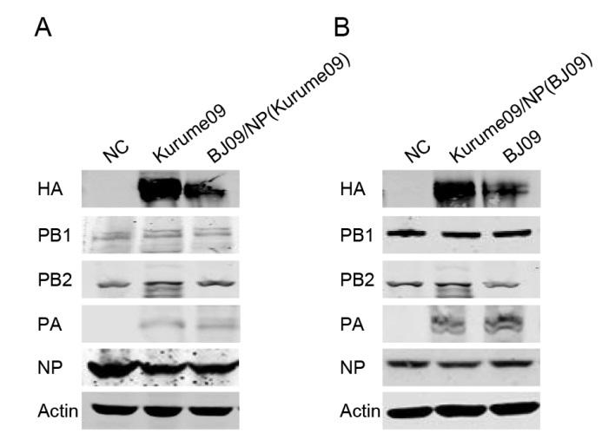
Supplementary Figure S1 Identification of polymerase activity determinants of 2009 H1N1 virus in the RNP system. (A) 293T cells were transfected with PB1, PB2 and PA protein expressing plasmids of A/Beijing/2009 and NP of A/Kurume/2009, together with pPOLI-HA-RT (A/WSN/1933). HA levels were analysed by Western blotting. (B) 293T cells were transfected with PB1, PB2 and PA protein expressing plasmids of A/Kurume/2009 and NP of A/Beijing/2009, together with pPOLI-HA-RT (A/WSN/1933). HA levels were analysed by Western blotting.
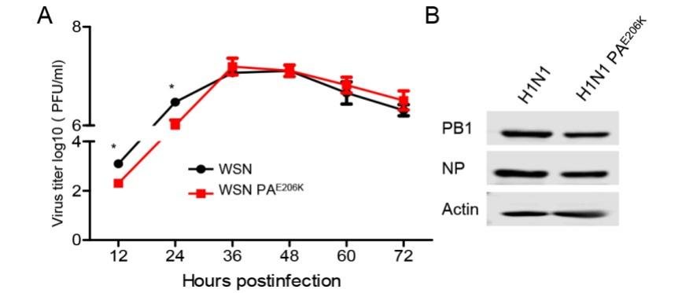
Supplementary Figure S2 PA E206K affected replication of influenza A virus in vitro. (A) MDCK cells were infected with wild-type or PA^{E206K} WSN viruses at a multiplicity of infection (MOI) of 0.001 and culture at 37 °C. Viral titres were measured by plaque assays at the indicated time points. Error bars represent the standard deviations of the results of three independent experiments. (B) A549 cells were infected with H1N1(A/California/04/2009) or H1N1(A/California/04/2009) PA^{E206K} virus (MOI=1). At the 6h after infection, PB1 and NP levels were analysed by Western blotting.
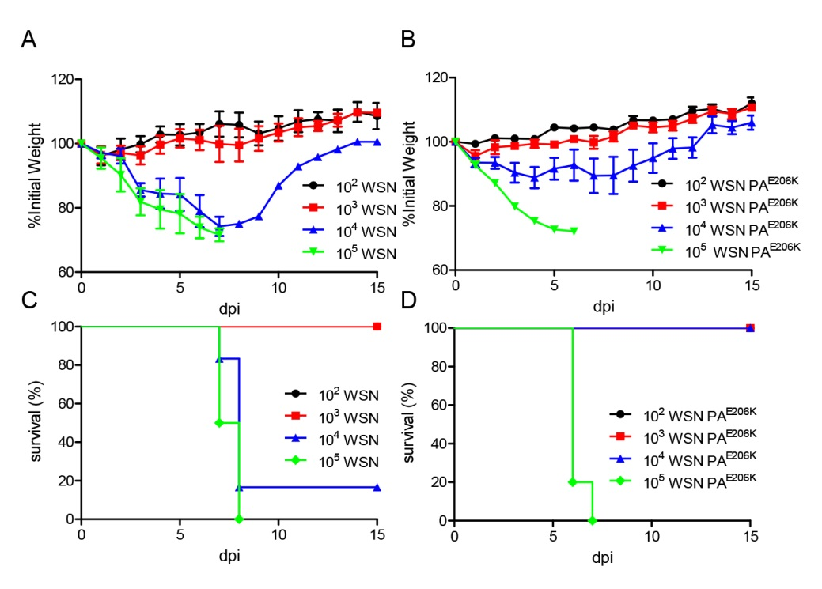
Supplementary Figure S3 MLD50 of WSN or WSN PA^{E206K} in mice. Six mice per group were intranasally inoculated with 102, 103, 104, 105 PFU/mouse (each in 30 μL) of the WSN (A) or WSN PA^{E206K} (B). Mouse body weights were monitored daily for 15 days, and the percent survival values were calculated.
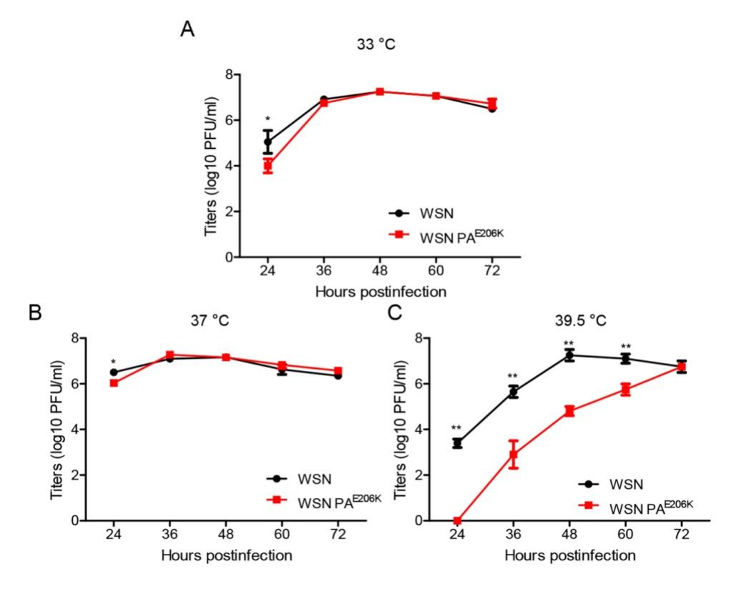
Supplementary Figure S4 Kinetics of replication of WSN and WSN PA^{E206K} at different temperatures. MDCK cells were infected with WSN and WSN PA^{E206K} at a multiplicity of infection of 0.001 at different temperature (33 °C (A), 37 °C (B) and 39.5 °C (C) in A549 cells. The titers were determined via plaque assays at the indicated time points on MDCK cells. Data represent the mean ±standard error of the mean of three independent experiments.
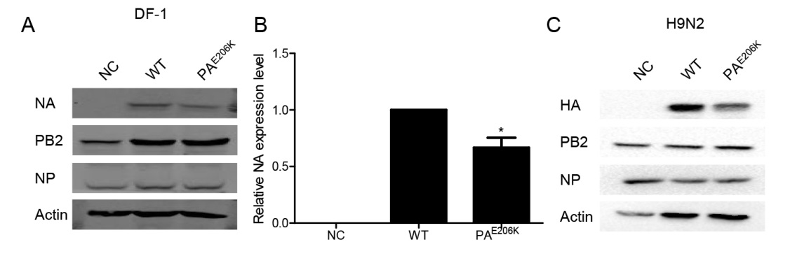
Supplementary Figure S5 PA E206K reduced polymerase activity of influenza A virus in the RNP reconstitution system in DF1 cells. (A) DF1 cells were transfected with A/WSN/1933 virus RNP reconstitution system plasmids (pcDNA-PB1, pcDNA-PB2, pcDNA-NP and pPRC.425-NA), along with pcDNA-PA or pcDNA-PA^{E206K}. NA levels were analysed by Western blotting. (B) Statistical analysed of NA levels in panel A. values of NA were standardized to the actin levels and normalized to levels of NA in cells transfected with control vector. Data represent the mean ± standard error of the mean of three independent experiments. (C) 293T cells were transfected with A/Quail/HongKong/G1/1997 (H9N2) virus RNP reconstitution system plasmids (pcDNA-PB1, pcDNA-PB2, pcDNA-NP and pPOLI-HA-RT), along with pcDNA-PA or pcDNA-PA^{E206K}. HA levels were analysed by Western blotting.

