Virologica Sinica

Supplementary Data

Mice with type I interferon signaling deficiency are prone to epilepsy upon HSV-1 infection

Wei Yang ^{a, b}, Chong-Yang Tang ^{c}, Dong-Ying Fan ^{d}, Yi-Song Wang ^{d}, Pei-Gang Wang ^{d}, Jing An ^{b, d},
Guo-Ming Luan ^{a, b, c, e, *}

ª Beijing Key Laboratory of Epilepsy, Sanbo Brain Hospital, Capital Medical University, Beijing, 100093, China.
^{b} Beijing Institute for Brain Disorders, Capital Medical University, Beijing, 100093, China.
^{c} Department of Neurosurgery, Epilepsy Center, Sanbo Brain Hospital, Capital Medical University, Beijing, 100093, China.
^{d} Department of Microbiology, School of Basic Medical Sciences, Capital Medical University, Beijing, 100069, China.
^{e} Chinese Institute for Brain Research, Beijing, 102206, China.

*Corresponding author:
Email address: luangm@ccmu.edu.cn (G-M. Luan)
ORCID: 0000-0001-5084-2458

Supplementary Materials
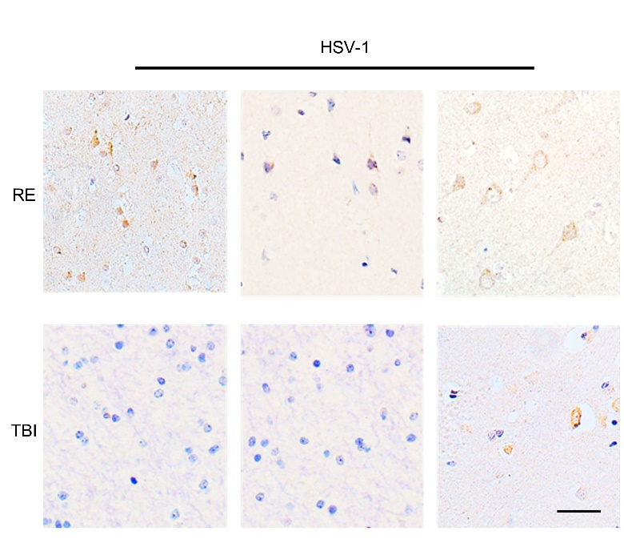

Fig. S1 Distribution of HSV-1 antigens in RE patients. Immunohistochemistry staining of brains from RE patients. Brain tissues from traumatic brain injury (TBI) patients served as control. Scale bar, 25 μm.

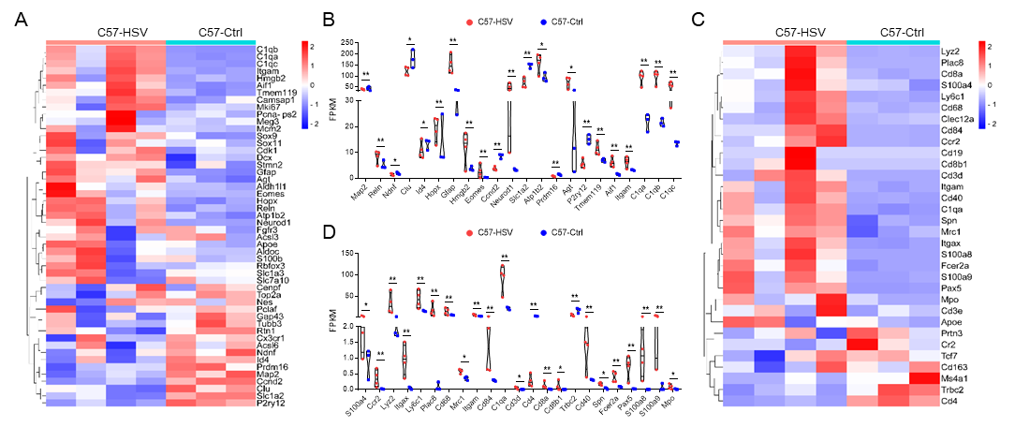
Fig. S2 Expression of cell marker genes in HSV infected brains from WT mice. Brain tissues from HSV-1 infected infant mice at 5 dpi were subjected to RNA sequencing, PBS-injected mice served as control (n = 3–4 mice for each group). A and B The expression levels of markers of brain cells in brains from HSV-1 infected WT mice were shown in heatmap (A) and genes with significantly altered levels were shown in violin chart (B). C and D The expression levels of markers of immune cells in brains from HSV-1 infected WT mice were shown in heatmap (C) and genes with significantly altered levels were shown in violin chart (D). Data in this figure were expressed as FPKM value and analyzed using the two-sided Student’s t test. * P < 0.05, ** P < 0.01.

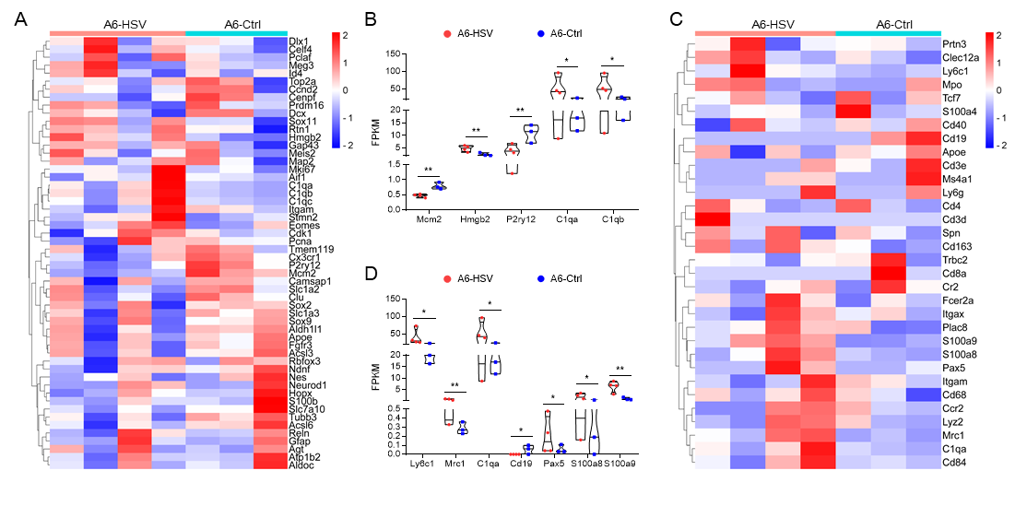
Fig. S3 Expression of cell marker genes in HSV infected brains from A6 mice. Brain tissues from HSV-1 infected infant mice at 5 dpi were subjected to RNA sequencing, PBS-injected mice served as control (n = 3–4 mice for each group). A and B The expression levels of markers of brain cells in brains from HSV-1 infected A6 mice were shown in heatmap (A) and genes with significantly altered levels were shown in violin chart (B). C and D The expression levels of markers of immune cells in brains from HSV-1 infected A6 mice were shown in heatmap (C) and genes with significantly altered levels were shown in violin chart (D). Data in this figure were expressed as FPKM value and analyzed using the two-sided Student’s t test. * P < 0.05, ** P < 0.01.

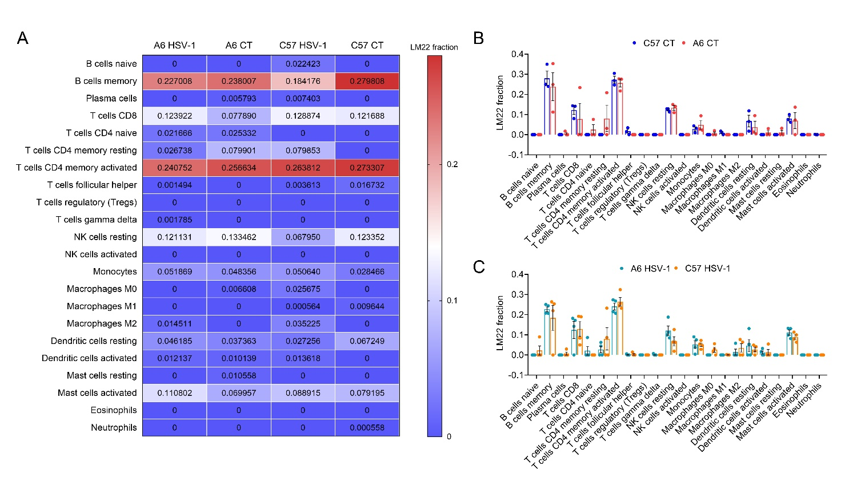
Fig. S4 Immune landscape analysis of HSV-infected brain tissues. The proportion of infiltrated immune cells in brain tissues from WT and A6 infant mice were calculated by CIBERSORT algorithm. A The differences in immune cells of HSV-infected brain tissues from WT and A6 infant mice were shown by heatmap. B and C The differences in immune cells of brain tissues from control (B) and HSV-1 infected mice (C) (n = 3–4 mice for each group).

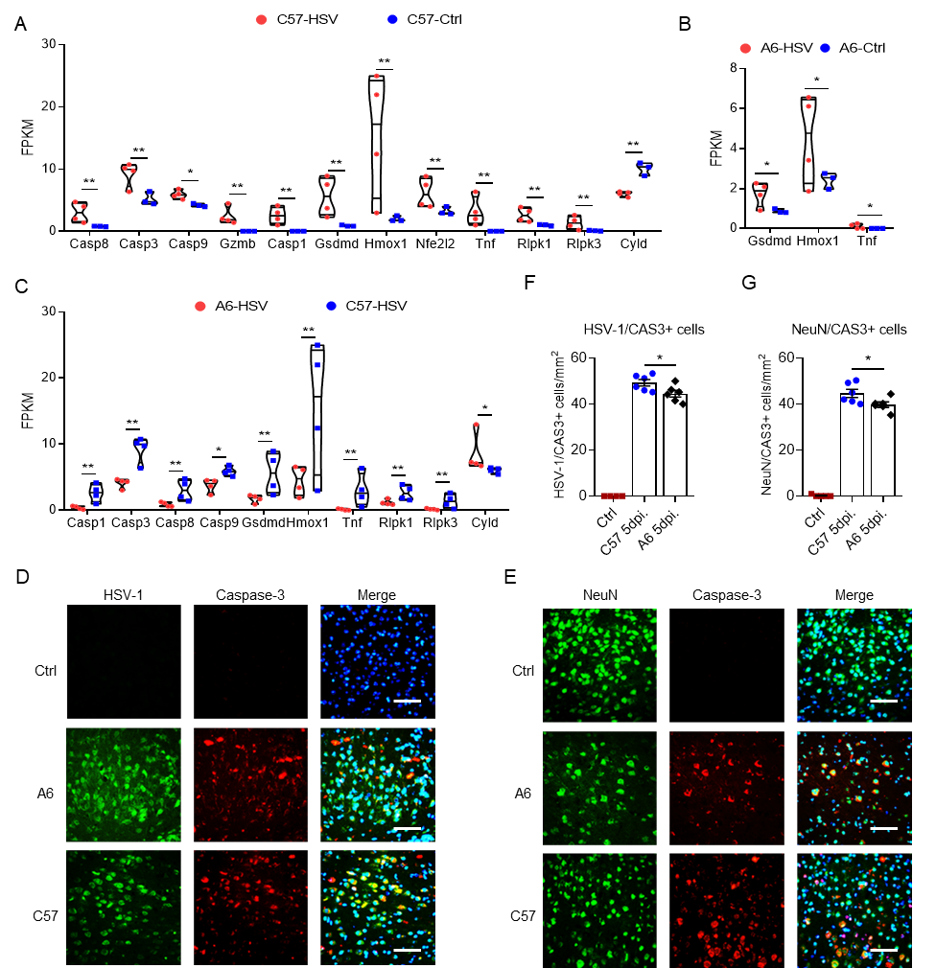
Fig. S5 Expression of cell death-related genes in HSV infected brains. Brain tissues from HSV-1 infected infant mice at 5 dpi were subjected to RNA sequencing, PBS-injected mice served as control (n= 3-4 mice for each group). A The expression levels of cell death-related genes in brains from HSV-1 infected and control WT mice with significantly altered levels were shown in violin chart. B The expression levels of cell death-related genes in brains from HSV-1 infected and control A6 mice with significantly altered levels were shown in violin chart. (C) The expression levels of cell death-related genes in brains from HSV-1 infected A6 compared with that of WT mice with significantly altered levels were shown in violin chart. D–G Brain tissues from HSV-1 infected WT and A6 mice at 5 dpi (n = 4–6 mice for each group) were subjected to co-immunofluorescence staining with anti-Caspase-3 antibody and anti-HSV-1 antibody (D), or anti-NeuN antibody (E). Nuclei were shown with DAPI. Scale bar, 50 μm. The number of HSV-1+ Caspase-3+ cells (F) and NeuN+ Caspase-3+ cells (G) were calculated by Image J. Scale bar, 25 μm. Results were shown as means ± SEM and analyzed using the two-sided Student’s t test. * P < 0.05, ** P < 0.01. Data in this figure expressed as FPKM value were analyzed using the two-sided Student’s t test. * P < 0.05, ** P < 0.01.

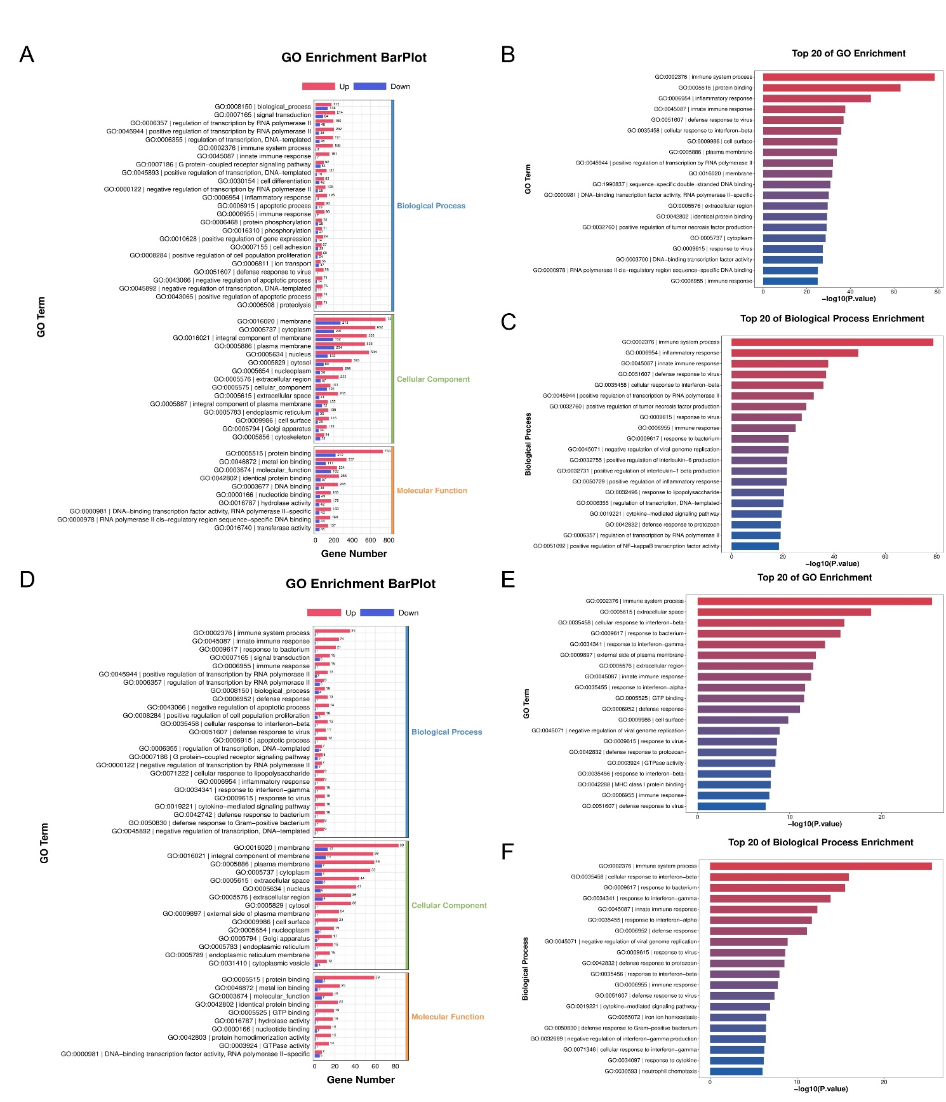
Fig. S6 GO analysis of DEGs of HSV-infected brains. Brain tissues from HSV-1 infected infant mice at 5 dpi (n= 3–4 mice for each group) were subjected to RNA sequencing, PBS-injected mice served as control. A–C The DEGs between brains from HSV-1 infected and control WT mice were subjected to GO analysis. The top 10 most significantly enriched GO terms in BP, MF and CC (A), and the top 20 most significantly enriched GO terms (B) and the top 20 most significantly enriched GO terms in biological process (C) were shown. D–F The DEGs between brains from HSV-1 infected and control A6 mice were subjected to GO analysis. The top 10 most significantly enriched GO terms in BP, MF and CC (D), and the top 20 most significantly enriched GO terms (E) and the top 20 most significantly enriched GO terms in biological process (F) were shown.

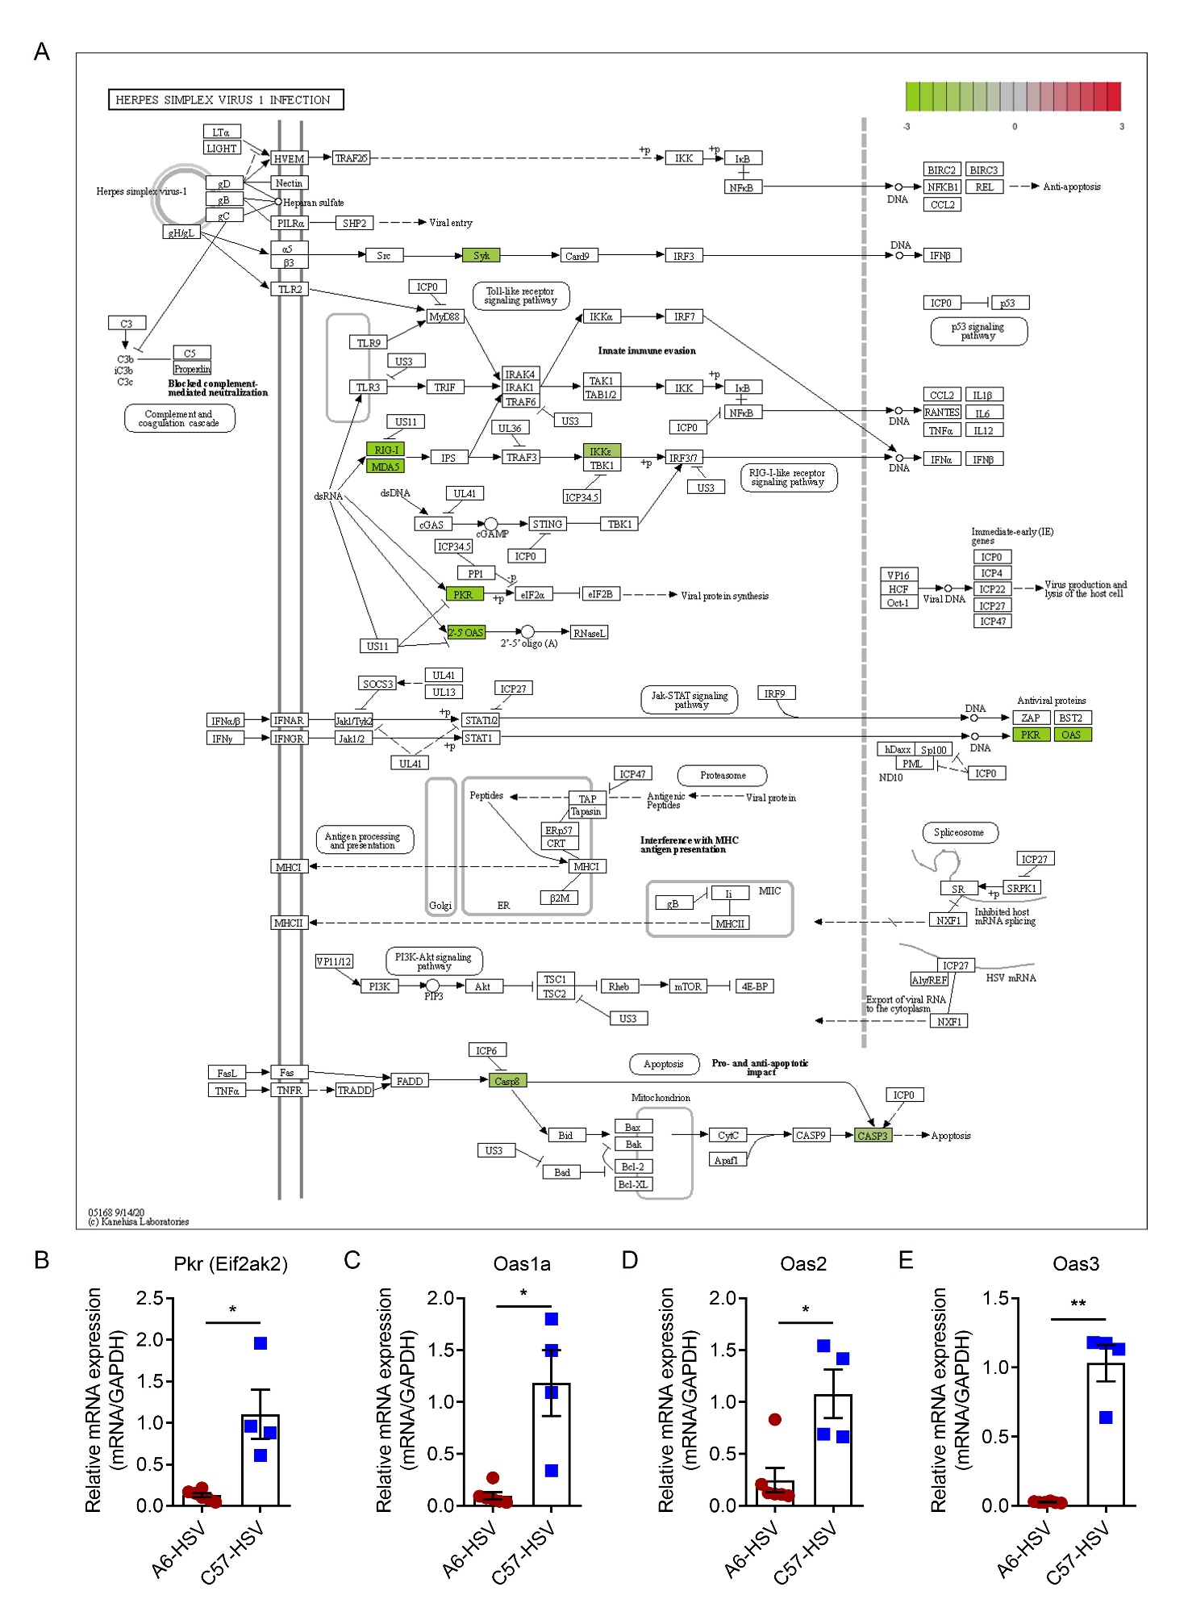
Fig. S7 Herpes simplex virus 1 infection pathway visualization with mapped data of DEGs between HSV-infected brains from A6 and WT infant mice. (A) DEGs between HSV-infected brains from A6 and WT infant mice were subjected to “Herpes simplex virus 1 infection pathway” for visualization by Pathview. (B–E) The expression levels of antiviral gene Pkr (Eif2ak2) (B), Oas1a (C), Oas2 (D) and Oas3 (E) in brains from HSV-1 infected A6 compared with that of WT mice were analyzed by RT-qPCR (n = 4–6 mice for each group). Results were shown as means ± SEM and analyzed using the two-sided Student’s t test. * P < 0.05, ** P < 0.01.

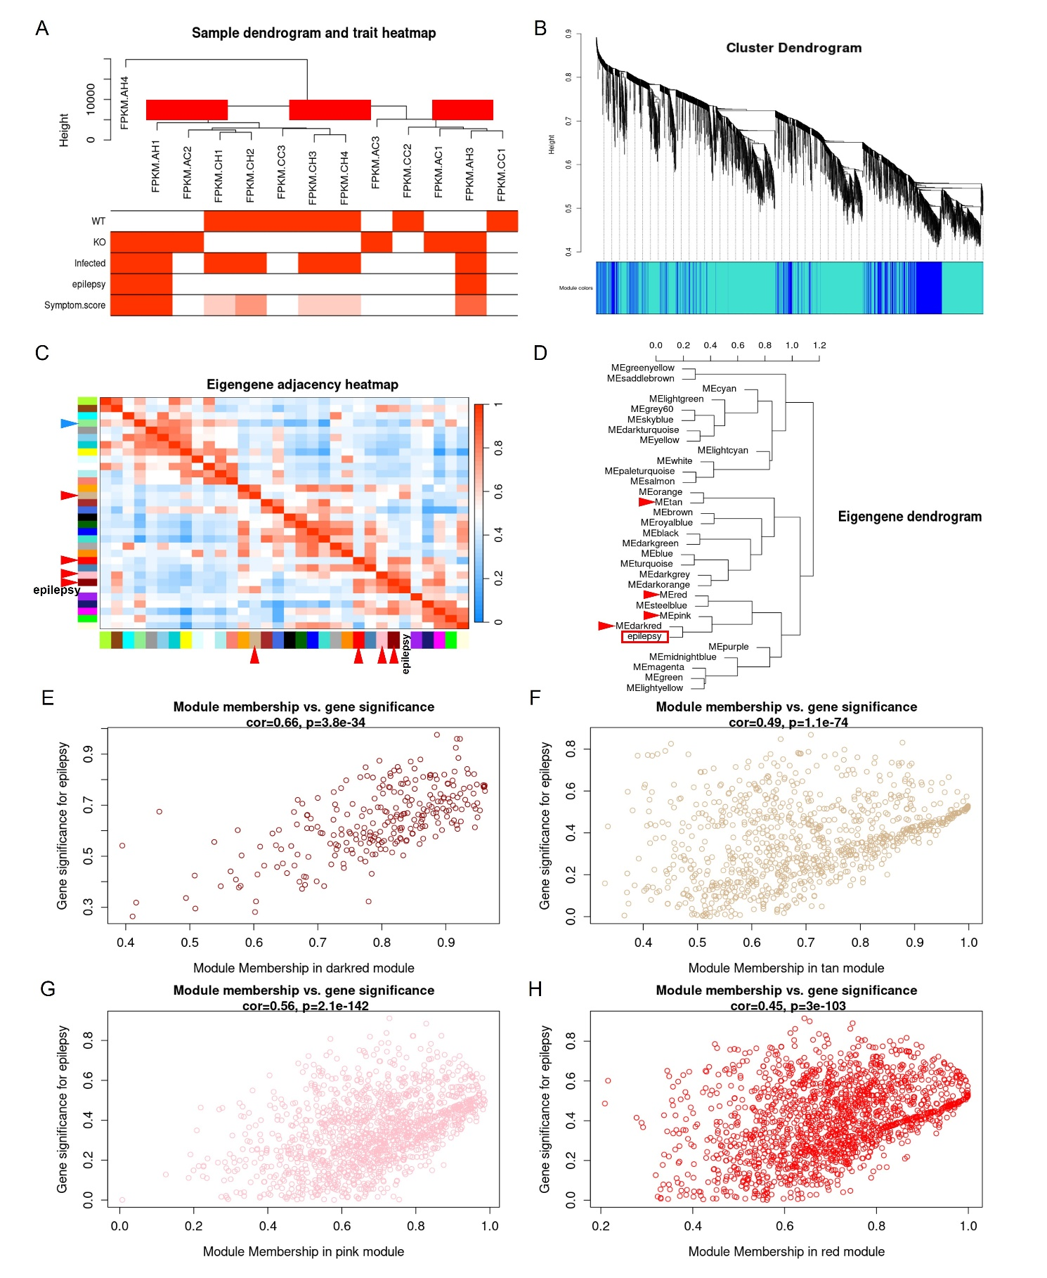
Fig. S8 WGCNA analysis to select epilepsy-correlated gene modules. A Clustering of module genes. B Cluster dendrogram for selecting gene modules. C and D Association between the gene modules and HSV-induced epilepsy. E–H Module membership vs. gene significance for epilepsy in darkred module (E), tan module (F), pink module (G) and red module (H).

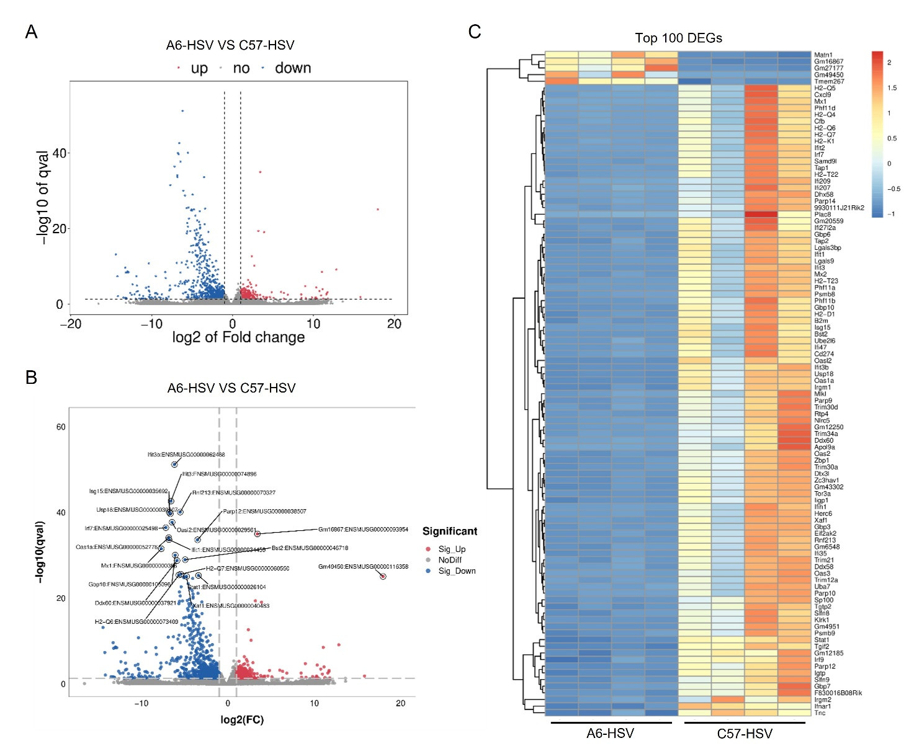
Fig. S9 DEGs between HSV-infected brains from A6 and WT infant mice. A Volcano plot of all detected transcripts between HSV-1 infected brains from A6 and WT infant mice. The threshold of screening DEGs is set at |logFC| ≥ 1.0 and p (p.adjust) < 0.05. Points are colored according to expression status: non-significant genes, grey, significant up-regulated genes, red; and down-regulated genes, blue. B Volcano plot of top 20 DEGs between HSV-infected brains from A6 and WT infant mice. C Heatmap of top 100 DEGs between HSV-infected brains from A6 and WT infant mice.

Supplementary Table S1. DEGs between uninfected brains from A6 and WT infant mice.

Supplementary Table S2. Marker genes of brain cells.

Supplementary Table S3. Marker genes of immune cells.

Supplementary Table S4. Table of cell death-related genes.

Supplementary Table S5. Marker genes of epilepsy.

Supplementary Table S6. Top 10 hub genes of overlapping genes calculated by cytoHubba using Degree scoring method.

Supplementary Table S7. Expression of hub genes in HSV-infected brain tissues from A6 and WT infant mice at transcriptome level.

