Virologica Sinica

Supplementary Data

Ferroptosis contributes to JEV-induced neuronal damage and neuroinflammation

Wenjing Zhu^{a, b, c, d}, Qi Li^{a, b, c, d}, Yong Yin^{a, b, c, d}, Huanchun Chen^{a, b, c, d},Youhui Si^{a, b, c, d}, Bibo Zhu^{a, b, c, d}, Shengbo Cao^{a, b, c, d}, Zikai Zhao^{a, b, c, d*}, Jing Ye^{a, b, c, d*}

a National Key Laboratory of Agricultural Microbiology, Huazhong Agricultural University, Wuhan, 430070, China
b Frontiers Science Center for Animal Breeding and Sustainable Production, China Huazhong Agricultural University, Wuhan, 430070, China
c The Cooperative Innovation Center for Sustainable Pig Production, Huazhong Agricultural University, Wuhan, 430070, China
d Hubei Hongshan Laboratory, Wuhan, 430070, China

*Corresponding authors.
Email addresses: yej@mail.hzau.edu.cn (J. Ye), zikaizhao@hotmail.com (Z. Zhao)
ORCIDs: 0000-0002-3258-6224 (J. Ye), 0000-0002-4758-1282 (Z. Zhao)

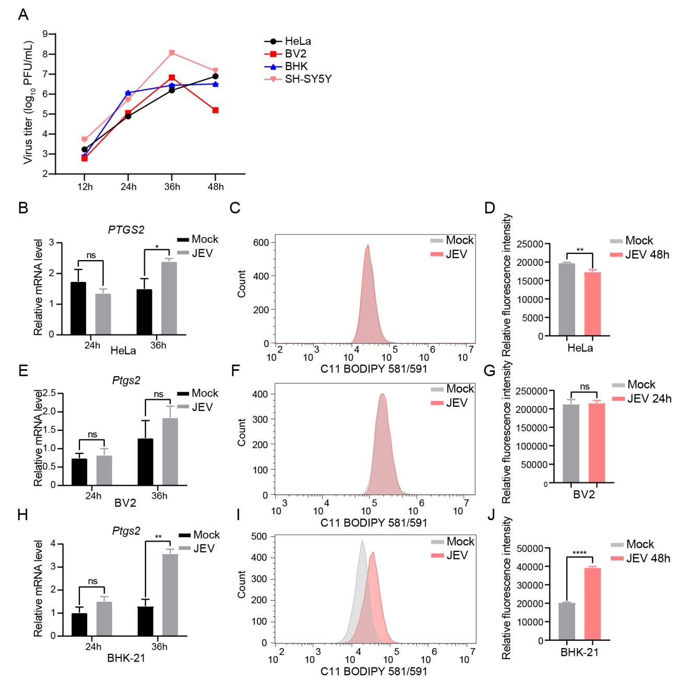
Figure S1. Erastin treatment upregulated the expression of PTGS2 at mRNA levels in SH-SY5Y cells and mouse primary neurons. A and B SH-SY5Y cells or mouse primary neurons were infected or mock-infected with JEV at an MOI of 1. At indicated time post-infection, cells were subjected to RT-qPCR to detect the mRNA level of JEV C. C to F SH-SY5Y cells were treated with Erastin (10 µmol/L) or the vehicle (DMSO) for 12 h, cells were subjected to RT-qPCR to detect the mRNA level of PTGS2 (C) and the level of lipid peroxidation through flow cytometry (E). Mouse primary neurons were treated with Erastin (20 µmol/L) or vehicle (DMSO) for 48 h, cells were subjected to RT-qPCR to detect the mRNA level of Ptgs2 (D) and the level of lipid peroxidation through flow cytometry (F). Data are representative of three independent experiments with three biological replicates. Significance was analyzed using a Student’s two-tailed unpaired t-test (n = 3 in each group), *P<0.05, **P<0.01, ****P<0.0001.
Figure S2. JEV is able to induce ferroptosis in BHK-21 cells but not in HeLa cells or BV2 cells. HeLa, BV2, BHK-21 and SH-SY5Y cells were infected with JEV at an MOI of 1, the supernatants of JEV-infected cells were harvested at 12-48 h post-infection for plaque assay, and the titration was performed on BHK-21 cells (A). HeLa, BV2 and BHK-21 cells were infected or mock-infected with JEV at an MOI of 1. At indicated time post-infection, cells were subjected to RT-qPCR to detect the mRNA level of PTGS2 (B, E and H) and the level of lipid peroxidation by flow cytometry (C, D, F, G, I and J). Data are representative of three independent experiments with three biological replicates. Significance was analyzed using a Student’s two-tailed unpaired t-test (n = 3 in each group), *P< 0.05, **P< 0.01, ****P< 0.0001. ns, not significant.
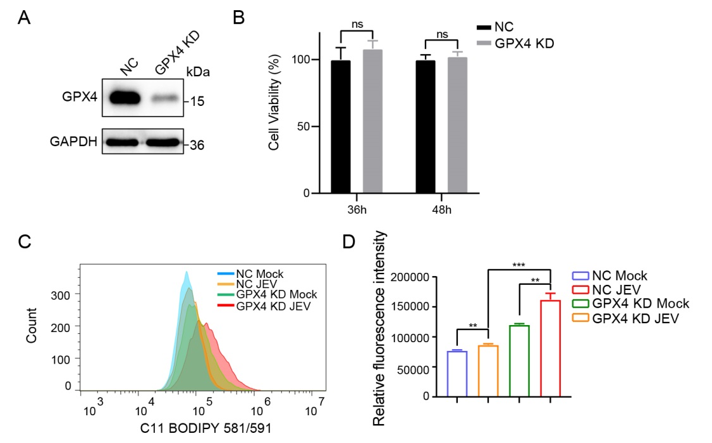
Figure S3. Knockdown of GPX4 promotes ferroptosis induced by JEV infection. A and B GPX4 KD cells were subjected to Western blotting analysis of the expression of GPX4 (A) and detect the cell viability at different time (B). C and D NC and GPX4 KD cells were infected or mock-infected with JEV at an MOI of 1. At 24 h post-infection, the cells were subjected to detect the level of lipid peroxidation. Data are representative of three independent experiments with three biological replicates. **P< 0.01, ***P< 0.001. ns, not significant.
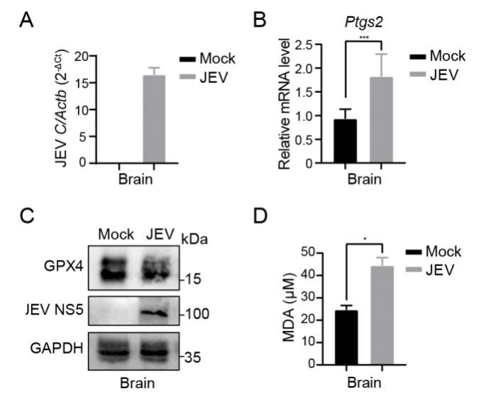
Figure S4. JEV infection induces ferroptosis in mouse brains. C57BL/6 mice were infected with JEV as described in Fig 5A. The mice were sacrificed at 7 dpi, and brains were collected and homogenized. A and B The mRNA levels of JEV C and Ptgs2 in brain lysates were measured by RT-qPCR. C and D Detection of expression level of GPX4 and MDA in brain lysates. Data are representative of three independent experiments with three biological replicates. *P < 0.05, ***P < 0.001. ns, not significant.

Supplementary Table S1. Primers used for qRT-PCR
Name | Sequence
ACTB(H) F | 5′- AGCGGGAAATCGTGCGTGAC -3′
ACTB(H) R | 5′- GGAAGGAAGGCTGGAAGAGTG -3′
PTGS2(H) F | 5′- CGGTGAAACTCTGGCTAGACAG -3′
PTGS2(H) R | 5′- GCAAACCGTAGATGCTCAGGGA -3
ACSL4(H) F | 5′- TCTGCTTCTGCTGCCCAATT -3′
ACSL4(H) R | 5′- CGCCTTCTTGCCAGTCTTTT -3′
YAP1(H) F | 5′- TCTTACACCGTGCTGCCATT -3′
YAP1(H) R | 5′- AGCACCTGTCCAGGTATCAC -3′
JEV-C F | 5′- GGCTCTTATCACGTTCTTCAAGTTT -3′
JEV-C R | 5′- TGCTTTCCATCGGCCTAAAA -3′
Actb(M) F | 5′- CACTGCCGCATCCTCTTCCTCCC -3′
Actb(M) R | 5′- CAATAGTGATGACCTGGCCGT -3′
Ptgs2(M) F | 5′- CGGACTGGATTCTATGGTGAAA -3′
Ptgs2(M) R | 5′- CTTGAAGTGGGTCAGGATGTAG -3′
Tnf-α(M) F | 5′- TGTCTCAGCCTCTTCTCATTCC -3′
Tnf-α(M) R | 5′- TTAGCCCACTTCTTTCCCTCAC -3′
Il-6(M) F | 5′- CATGTTCTCTGGGAAATCGTG -3′
Il-6(M) R | 5′- TCCAGTTTGGTAGCATCCATC -3′
Ccl-2(M) F | 5′- CGGCGAGATCAGAACCTACAAC -3′
Ccl-2(M) R | 5′- GGCACTGTCACACTGGTCACTC -3′
Ccl-5(M) F | 5′- TGCCCACGTCAAGGAGTATTTC -3′
Ccl-5(M) R | 5′- AACCCACTTCTTCTCTGGGTTG -3′
(M: mouse; H: human)

