Virologica Sinica

Supplementary Data

Hsp90 β is Critical for the Infection of Severe Fever with Thrombocytopenia Syndrome Virus

Bo Wang ^{a, b}, Leike Zhang ª, Fei Deng ª, Zhihong Hu ª, Manli Wang ª, Jia Liu ^{a,} *

ª State Key Laboratory of Virology, Wuhan Institute of Virology, Center for Biosafety Mega-Science, Chinese Academy of Sciences, Wuhan, 430071, China;
^{b} The Third Affiliated Hospital of Guangzhou Medical University, Guangzhou Medical University, Guangzhou, 511436, China;

* Corresponding author:
E-mail address: liujia@wh.iov.cn (J. Liu)
ORCID: https://orcid.org/0000-0003-0591-9895

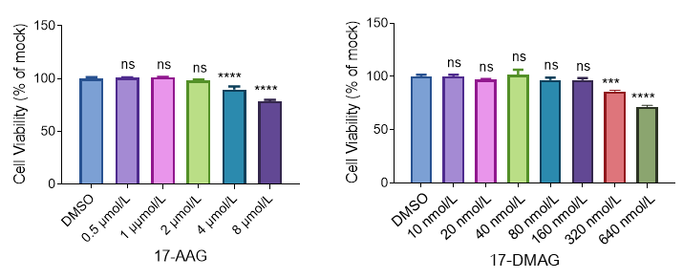
Figure S1. Cytotoxicity analysis of 17-AAG and 17-DMAG in HEK-293 cells. HEK-293 cells were treated with different concentrations of drugs or DMSO. After 24 h treatment, cell viability was determined with cell counting kit-8 as manufacturer’s protocol. Two independent experiments were performed. Data are shown as the mean ± SD. Statistical significance was determined using one-way ANOVA followed by Dunnett's multiple comparisons test. ns, not significant;; ****, P < 0.0001.

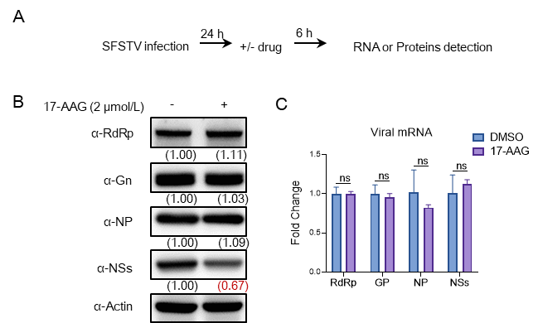
Figure S2. NSs protein is the main target of Hsp90s inhibitor. A Workflow of the experiment. HEK-293 cells were infected with SFTSV at an MOI of 1. At 24 h post-infection, 17-AAG was added for another 6 h. Fresh medium containing DMSO was used as a control. The cells were harvested at 6 h post-treatment for Western blotting analysis and quantification of viral mRNA. B Results of Western blotting analyses. C Quantification of intracellular viral mRNA. The relative levels of viral and host proteins from Western blotting results were assessed using ImageJ software. Two independent experiments were performed. Data are shown as the mean ± SD. Statistical significance was determined using two-way ANOVA followed by Sidak's multiple comparisons test. ns, not significant.

