VS6387

Letter

Received: 23 May 2023; accepted: 24 October 2023

Isolation and characterization of spike S2-specific monoclonal antibodies with reactivity to pan-coronaviruses
Yabin Hu^{a,b,1}, Jun Chen^{a,b,1}, Jing Yang^{a,1}, Zhanpeng Liu^{c}, Xiaoyue Zhang^{c}, Qian Wu^{a,d}, Lulu Liu^{c}, Shishan Tengª, Rongzhang Heª, Bo Liuª, Xingyu Zhengª, Rui Luª, Dong Panª, You Wang^{e}, Liting Pengª, Hongying chen^{c, *}, Yi-Ping Li^{d, *}, Wenpei Liu^{a, *}, Xiaowang Qu^{a, e,*}
ªCollege of Basic Medical Sciences, Hengyang Medical School, University of South China & MOE Key Lab of Rare Pediatric Diseases, Hengyang, 421001, China
^{b}Translational Medicine Institute, The First People’s Hospital of Chenzhou, Hengyang Medical School, University of South China, Chenzhou, 423000, China
^{c}College of Life Sciences, Northwest A&F University, Yangling, 712100, China
^{d}Institute of Human Virology, Department of Pathogen Biology and Biosecurity, and Key Laboratory of Tropical Disease Control of Ministry of Education, Zhongshan School of Medicine, Sun Yat-sen University, Guangzhou, 510080, China
^{e}School of Public Health, University of South China, Hengyang, 421001, China

*Corresponding authors.
E-mail address: quxiaowang@163.com (X. Qu), wenpeiliu_2008@foxmail.com (W. Liu), lyiping@mail.sysu.edu.cn (Y. Li), chenhy@nwsuaf.edu.cn (H. Chen)
ORCID: 0000-0002-8135-7292 (X. Qu), 0000-0002-4624-2879 (W. Liu), 0000-0001-6011-3101 (Y. Li), 0000-0001-8258-0683 (H. Chen)

¹Yabin Hu, Jun Chen and Jing Yang contributed equally to this study.

Highlights
- Five broad-spectrum mAbs identified from COVID-19 convalescents and vaccinees possessed the ability to recognize spike S2 of pan-coronaviruses.
- Five mAbs targeted distinct but conserved epitopes on spike S2 of pan-coronaviruses.
- Three of these five mAbs were competitively bound to the fusion peptide epitopes of coronavirus spike protein.
Dear Editor,
Severe acute respiratory syndrome coronavirus 2 (SARS-CoV-2), the seventh coronavirus known to jump from intermediate hosts to humans, has resulted in a worldwide pandemic and caused immense economic damage (Tan et al., 2020; Zhu et al., 2020). It is believed that coronavirus spillover may occur again in the future. Human exposure to a bat coronavirus has been serologically confirmed in a rural area of China, indicating that the coronavirus spillover occurred, although the origin and frequency of spillovers are unclear (Wang et al., 2018). Domestic animals and pets could be infected with coronaviruses and may serve as a reservoir and an intermediate host for further virus adaptation before spilling over to humans. Cats and ferrets are susceptible to SARS-CoV-2, and cat-to-cat transmission through respiratory droplets has been reported (Meekins et al., 2020; Shi et al., 2020). Coronaviruses enter the host cell by interacting with surface spike (S) proteins and host receptor proteins. Broad-spectrum monoclonal antibodies (mAbs) for multiple human and animal coronaviruses have been shown to recognize the spike proteins of coronaviruses (Klompus et al., 2021). We previously constructed 274 mAbs against the SARS-CoV-2 S from COVID-19 convalescents and inactivated vaccine recipients, and identified five broad neutralizing antibodies against SARS-CoV-2 Omicron subvariants (Chen et al., 2023). In this study, we conducted screening to evaluate the recognizing ability of these mAbs on S proteins derived from both human and animal coronaviruses, with the aim to identify mAbs that can recognize pan-coronaviruses.
First, we tested the binding activity of the 274 mAbs to S proteins of seven human coronaviruses and found that five mAbs (VSM7-28, VSM7-75, VSM6-5, VSM6-39, and SCM14-3) bound weakly to the SARS-CoV-2 spike S1 subunit, but had strong binding potency with the spike S2 subunits of SARS-CoV-2, other β-coronaviruses (SARS-CoV, MERS-CoV, OC43, and HKU1), and α-coronaviruses (229E and NL63) (Fig. 1A, Supplemental Fig. S1, Supplemental Fig. S2A–G). Of the five mAbs, VSM7-28 had the most potent binding potency to all seven human coronavirus spike extracellular domain (S-ECD) proteins (EC₅₀ ranging between 0.0082–0.029 μg/mL), followed by SCM14-3 (EC₅₀, 0.0066–0.2005 μg/mL), VSM7-75 (EC₅₀, 0.037–3.849 μg/mL), VSM6-5 (EC₅₀, 0.019–5.725 μg/mL), and VSM6-39 (EC₅₀, 0.0543–8.969 μg/mL). VSM6-5 and VSM6-39 had weak binding potency with HKU1 and NL63 (EC₅₀ > 10 μg/mL), respectively (Fig. 1A). Next, we tested the neutralization activity of the mAbs and found that none of them could neutralize a SARS-CoV-2 pseudotyped virus (Supplemental Fig. S3).
Since these mAbs had no neutralizing activity, we examined whether they had a broad binding activity with other SARS-CoV-2 variants. The binding potency of these mAbs with S-ECDs from SARS-CoV-2 variants of concern (VOCs), harboring mutations to escape from antibody binding and neutralization, were tested by ELISA. The results showed that VSM7-28 and VSM7-75 had strong reactivity to the S-ECD of eight VOCs [Alpha, Beta, Gamma, Delta, and Omicron variants (BA.1, BA.2, BA.3, and BA.2.75)]. VSM6-5 bound to Alpha, Beta, Gamma, Delta, and Omicron variants (BA.2, BA.3, BA.4/5, and BA.2.75). VSM6-39 only bound to Alpha, Beta, Gamma, Delta, and Omicron variants (BA.1, BA.2, and BA.3), with no binding to Omicron variants BA.4/5 and BA.2.75 (Fig. 1A, Supplemental Fig. S2H–P). Omicron variants BA.2, BA.3, BA.4/5, and BA.2.75 shared the same S2 sequence; however, the mAbs exhibited significant differences in binding activity to these proteins, indicating that these distinctions may be attributed to the different spatial configurations.
Given the zoonotic nature of coronaviruses, we examined the reactivity of these mAbs against the S2 of nine animal coronaviruses, including six SARS-like coronaviruses from bats (RaTG13 and WIV1), civets (SZ3 and Civet007) and pangolins (PCoV-GX and PCoV-GD) (Xiao et al., 2020), which could infect human epithelial cells using the ACE2 receptor (Ge et al., 2013; Xu et al., 2022), and three coronaviruses from bovine (BCoV), wigeon (HKU20), and chicken (IBV). VSM7-28, VSM7-75, VSM6-39 and SCM14-3 efficiently bound to the spike S2 of the nine coronaviruses. VSM6-5 showed binding ability with seven viruses but did not bind to S2 of WIV1 and IBV (Fig. 1A, Supplemental Fig. S2Q–Y). The data revealed that the five spike S2-binding mAbs also exhibited broad-spectrum reactivity with coronaviruses from animals.
To determine whether these mAbs share overlapping epitopes, we performed competition ELISA experiments. The mAbs VSM7-28, VSM7-75, and VSM6-39 had competitive binding with SARS-CoV-2 S-ECD (Fig. 1B), indicating that they may share overlapped epitopes. However, the Fc domain of antibodies occupies a significant space, leading to steric hindrance and potential antibody competition. To address this, we utilized papain to remove the Fc region, thus generating Fab fragments of three mAbs (VSM7-28, VSM7-75, and VSM6-39). Subsequently, we repeated competitive experiments using these Fab fragments. The obtained results exhibited high consistency with those of the full-length antibodies, suggesting that the observed competition remained unaffected by the steric hindrance imposed by the Fc domain of the antibody (Supplemental Fig. S4). In contrast, VSM6-5 and SCM14-3 had no competitive binding with other mAbs, suggesting that they may target distinct epitopes (Fig. 1B). In general, broad-spectrum mAbs target conserved coronavirus epitopes, such as the fusion peptide 1 and heptad repeat 1 (Klompus et al., 2021; Sun et al., 2022), which are essential for membrane fusion. Therefore, we synthesized the peptides that are conserved across Alpha, Beta, Gamma, and Delta coronaviruses (Supplemental Table S1), including the fusion peptide 1 and heptad repeat 1 peptide, and characterized the binding activity of the five mAbs to these peptides. VSM7-28, VSM7-75 and VSM6-39 bound with the fusion peptide 1 (⁸¹⁵RSFIEDLLFNKVTLAD⁸³⁰) but not with the other peptides. Among them, VSM7-28 had the most potent binding to the fusion peptide 1 (EC₅₀, 0.4126 μg/mL), followed by VSM7-75 (EC₅₀, 0.7782 μg/mL) and VSM6-39 (EC₅₀, 35.7 μg/mL) (Fig. 1C, Supplemental Table S2). SCM14-3 had weak binding with the heptad repeat 1 peptide (⁹⁷¹GAISSVLNDILSRLDKVEAEVQI⁹⁹³). VSM6-5 did not bind to the fusion peptide 1, fusion peptide 2, and heptad repeat 1 peptide, indicating that it recognized an unknown conserved epitope (Fig. 1B and 1C, Supplemental Fig. S5).
We further characterized the antibody germline by using IMGT/V-QUEST. The heavy chains of the five mAbs were from IGHV3, three of which (VSM7-28, VSM6-5, and VSM6-39) shared the same germline of VH3-30 (Supplemental Table S3), one of the most prevalent genes in SARS-CoV-2 mAbs (Kreer et al., 2020; Andreano et al., 2021). These mAbs had different light chains: four of them (IGKV1-12, IGKV3-15, IGKV3D-15, and IGKV4-1) had κ chains, and one (IGLV1-47) had a λ chain. The heavy-chain complementarity-determining region 3 (H-CDR3) was 8–19 amino acids in length (median, 17 aa), and L-CDR3 was 9–11 amino acids in length (median, 10 aa). The nucleotide sequences encoding the antibody VH were 84.1%–95.3% identical to the germline (median, 91.5%), and the VL genes were 92.3%–96.1% identical to their germline sequences (median, 93.0%) (Supplemental Table S3), indicating that these mAbs underwent a high level of somatic mutations. In a previous report, low level of somatic mutations were observed in the antibodies elicited in the early response to SARS-CoV-2 infections (Zost et al., 2020). Therefore, the mAbs tested in this study were probably produced after the priming by endemic coronavirus infection, before further boosted by SARS-CoV-2 infection or vaccination.
To further assess the role of the somatic mutations in the maturation of these mAbs, we generated germline reverted antibodies (gHgL) and compared their binding activity with the mature ones (mHmL). In addition, heavy or light chain switched antibodies (gHmL or mHgL) were also constructed for comparison with each other. All the gHgL antibodies had no binding with the prototype SARS-CoV-2 spike S2 protein, but chain-switched antibodies VSM7-28/gHmL (EC₅₀, 2.704 μg/mL), VSM7-75/mHgL (EC₅₀, 0.6925 μg/mL), and VSM6-39/mHgL (EC₅₀, 0.5656 μg/mL) had modest binding potency (Fig. 1D, Supplemental Table S4). These findings suggest that the somatic mutations of both heavy and light chains are required for the potent binding activity of these antibodies.
In summary, we isolated and characterized five spike S2-binding mAbs with broad reactivity with multiple coronaviruses from humans and animals. As these mAbs bind to at least three distinct epitopes, it is worthwhile to determine their accurate binding sites in future studies. It has been reported that an S2 booster after two doses of a full-length S DNA vaccine can induce a broader mAb response in mice, compared to a booster of the same S DNA vaccine (Ng et al., 2022). This study implies that the S2 region could be an immunogen for eliciting broad-spectrum antibodies against multiple coronaviruses. Mapping and identifying the epitopes on S2 subunit will facilitate the development of mAbs-based intervention strategies and antigen designs toward a broad immune response. Since these mAbs broadly react with the S2 of some or all of the 25 coronaviruses from humans and animals tested in this study, it is worth testing more viruses and the combination of mAbs recognizing different epitopes, which may further broaden the binding profiles of these mAbs. Coronavirus spillover may occur again in the future. The mAbs targeting the S protein, especially receptor binding domain (RBD), have been proven essential in controlling and treating COVID-19. However, from the perspective of developing methods for diagnoses and surveillance purposes, the variable nature of RBD makes it unsuitable as a target. The nucleocapsid protein is the most common target of the commercial antigen test kits. This is because the nucleocapsid proteins rarely share the same motifs in different coronaviruses, which minimizes the likelihood of cross-reactivity and enhances the specificity of detection. However, this specificity also limits their detection spectrum. In contrast, the S2 region is highly conserved across most coronaviruses and contains several common motifs, including the fusion region 1 and heptad repeat 1 (Supplemental Fig. S6). Consequently, these S2-targeting mAbs, possess an advantage over current reagents in the diagnosis of pan-coronavirus infections. Collectively, we have identified five mAbs that broadly recognize human and animal coronavirus, laying a foundation for the development of reagents and broad-spectrum vaccines for the surveillance of unknown coronavirus infections.
Footnotes
This work was supported by the National Natural Science Foundation of China (82102365, 92269115, 32270996, 82061138020), the Science and Technology Innovation Program of the Hunan Province of China (2022RC3079), the SC1-PHE-CORONAVIRUS-2020: Advancing Knowledge for the Clinical and Public Health Response to the 2019-nCoV Epidemic’ from the European Commission (CORONADX, no. 101003562, to Y-PL), Natural Science Foundation of the Hunan Province of China (2021JJ40006, 2022JJ30095), Educational Commission of the Hunan Province of China (21A0529), the Clinical Medical Innovation Technology Guide Project of the Hunan Province (2021SK50304, 2021SK50306 and 2021SK50312), the Scientific Research Innovation Project of Graduate of Hunan Province (CX20221024), and the Scientific Research Innovation Project of Graduate of University of South China (213YXC019). This study was approved by the Institutional Ethical Review Board of The Central Hospital of Shaoyang, Hunan Province, China (V.1.0, 20200301) and The First People’s Hospital of Chenzhou, Hunan Province, China (V.3.0, 2021001). Each participant signed a written consent form. The authors declare no competing interests.

References
Andreano E, Nicastri E, Paciello I, Pileri P, Manganaro N, Piccini G, Manenti A, Pantano E, Kabanova A, Troisi M, Vacca F, Cardamone D, De Santi C, Torres JL, Ozorowski G, Benincasa L, Jang H, Di Genova C, Depau L, Brunetti J, Agrati C, Capobianchi MR, Castilletti C, Emiliozzi A, Fabbiani M, Montagnani F, Bracci L, Sautto G, Ross TM, Montomoli E, Temperton N, Ward AB, Sala C, Ippolito G, Rappuoli R. 2021. Extremely potent human monoclonal antibodies from covid-19 convalescent patients. Cell, 184: 1821-1835 e1816.
Chen J, Yang J, Chang F, Hu Y, Wu Q, Teng S, Liu Y, Zhang J, He R, Liu B, Zheng X, Liu Z, Peng Y, Xie Z, Zhang Y, Lu R, Pan D, Wang Y, Peng L, Liu W, Li YP, Qu X. 2023. Identification of broad neutralizing antibodies against omicron subvariants from covid-19 convalescents and vaccine recipients. Virol Sin, 38: 313-316.
Ge XY, Li JL, Yang XL, Chmura AA, Zhu G, Epstein JH, Mazet JK, Hu B, Zhang W, Peng C, Zhang YJ, Luo CM, Tan B, Wang N, Zhu Y, Crameri G, Zhang SY, Wang LF, Daszak P, Shi ZL. 2013. Isolation and characterization of a bat sars-like coronavirus that uses the ace2 receptor. Nature, 503: 535-538.
Klompus S, Leviatan S, Vogl T, Mazor RD, Kalka IN, Stoler-Barak L, Nathan N, Peres A, Moss L, Godneva A, Kagan Ben Tikva S, Shinar E, Dvashi HC, Gabizon R, London N, Diskin R, Yaari G, Weinberger A, Shulman Z, Segal E. 2021. Cross-reactive antibodies against human coronaviruses and the animal coronavirome suggest diagnostics for future zoonotic spillovers. Sci Immunol, 6.
Kreer C, Zehner M, Weber T, Ercanoglu MS, Gieselmann L, Rohde C, Halwe S, Korenkov M, Schommers P, Vanshylla K, Di Cristanziano V, Janicki H, Brinker R, Ashurov A, Krahling V, Kupke A, Cohen-Dvashi H, Koch M, Eckert JM, Lederer S, Pfeifer N, Wolf T, Vehreschild M, Wendtner C, Diskin R, Gruell H, Becker S, Klein F. 2020. Longitudinal isolation of potent near-germline sars-cov-2-neutralizing antibodies from covid-19 patients. Cell, 182: 843-854 e812.
Meekins DA, Morozov I, Trujillo JD, Gaudreault NN, Bold D, Carossino M, Artiaga BL, Indran SV, Kwon T, Balaraman V, Madden DW, Feldmann H, Henningson J, Ma W, Balasuriya UBR, Richt JA. 2020. Susceptibility of swine cells and domestic pigs to sars-cov-2. Emerg Microbes Infect, 9: 2278-2288.
Ng KW, Faulkner N, Finsterbusch K, Wu M, Harvey R, Hussain S, Greco M, Liu Y, Kjaer S, Swanton C, Gandhi S, Beale R, Gamblin SJ, Cherepanov P, McCauley J, Daniels R, Howell M, Arase H, Wack A, Bauer DLV, Kassiotis G. 2022. Sars-cov-2 s2-targeted vaccination elicits broadly neutralizing antibodies. Sci Transl Med, 14: eabn3715.
Shi J, Wen Z, Zhong G, Yang H, Wang C, Huang B, Liu R, He X, Shuai L, Sun Z, Zhao Y, Liu P, Liang L, Cui P, Wang J, Zhang X, Guan Y, Tan W, Wu G, Chen H, Bu Z. 2020. Susceptibility of ferrets, cats, dogs, and other domesticated animals to sars-coronavirus 2. Science, 368: 1016-1020.
Sun X, Yi C, Zhu Y, Ding L, Xia S, Chen X, Liu M, Gu C, Lu X, Fu Y, Chen S, Zhang T, Zhang Y, Yang Z, Ma L, Gu W, Hu G, Du S, Yan R, Fu W, Yuan S, Qiu C, Zhao C, Zhang X, He Y, Qu A, Zhou X, Li X, Wong G, Deng Q, Zhou Q, Lu H, Ling Z, Ding J, Lu L, Xu J, Xie Y, Sun B. 2022. Neutralization mechanism of a human antibody with pan-coronavirus reactivity including sars-cov-2. Nat Microbiol, 7: 1063-1074.
Tan W, Zhao X, Ma X, Wang W, Niu P, Xu W, Gao GF, Wu G. 2020. A novel coronavirus genome identified in a cluster of pneumonia cases - wuhan, china 2019-2020. China CDC Wkly, 2: 61-62.
Wang N, Li SY, Yang XL, Huang HM, Zhang YJ, Guo H, Luo CM, Miller M, Zhu G, Chmura AA, Hagan E, Zhou JH, Zhang YZ, Wang LF, Daszak P, Shi ZL. 2018. Serological evidence of bat sars-related coronavirus infection in humans, china. Virol Sin, 33: 104-107.
Xiao K, Zhai J, Feng Y, Zhou N, Zhang X, Zou JJ, Li N, Guo Y, Li X, Shen X, Zhang Z, Shu F, Huang W, Li Y, Zhang Z, Chen RA, Wu YJ, Peng SM, Huang M, Xie WJ, Cai QH, Hou FH, Chen W, Xiao L, Shen Y. 2020. Isolation of sars-cov-2-related coronavirus from malayan pangolins. Nature, 583: 286-289.
Xu Z, Kang X, Han P, Du P, Li L, Zheng A, Deng C, Qi J, Zhao X, Wang Q, Liu K, Gao GF. 2022. Binding and structural basis of equine ace2 to rbds from sars-cov, sars-cov-2 and related coronaviruses. Nat Commun, 13: 3547.
Zhu N, Zhang D, Wang W, Li X, Yang B, Song J, Zhao X, Huang B, Shi W, Lu R, Niu P, Zhan F, Ma X, Wang D, Xu W, Wu G, Gao GF, Tan W, China Novel Coronavirus I, Research T. 2020. A novel coronavirus from patients with pneumonia in china, 2019. N Engl J Med, 382: 727-733.
Zost SJ, Gilchuk P, Chen RE, Case JB, Reidy JX, Trivette A, Nargi RS, Sutton RE, Suryadevara N, Chen EC, Binshtein E, Shrihari S, Ostrowski M, Chu HY, Didier JE, MacRenaris KW, Jones T, Day S, Myers L, Eun-Hyung Lee F, Nguyen DC, Sanz I, Martinez DR, Rothlauf PW, Bloyet LM, Whelan SPJ, Baric RS, Thackray LB, Diamond MS, Carnahan RH, Crowe JE, Jr. 2020. Rapid isolation and profiling of a diverse panel of human monoclonal antibodies targeting the sars-cov-2 spike protein. Nat Med, 26: 1422-1427.

Figure legends
Fig. 1. Cross-binding reactivity of the five mAbs with human and animal coronaviruses. A Heatmap of the EC₅₀ values of the five mAbs against spike protein of seven human coronaviruses, nine SARS-CoV-2 VOCs and nine animal coronaviruses. Binding ability of mAbs to spike protein of human and animal coronaviruses was measured by enzyme linked immunosorbent assay (ELISA), and EC₅₀ values were calculated from concentration-response curves by sigmoidal fitting using GraphPad Prism 8.0 software. “>” means EC₅₀ values > 10 μg/mL. B Cross-competition patterns between five mAbs. Competition ELISA was used to determine whether the binding of one antibody affected the binding of another. The prototype SARS-CoV-2 spike S-ECD protein was coated on an ELISA plate at a concentration of 2 μg/mL; unlabeled competitor antibodies were added at 10 μg/mL, and then biotin-labeled detected antibodies were added at 0.1 μg/mL. The percentage of binding reduction compared to the binding potency without a competitor mAb is shown. C The binding curves of mAbs reactive to SARS-CoV-2 S2 fusion peptide 1 and heptad repeat 1 peptide. ELISA was employed to measure the binding activity between mAbs and peptides. The mAbs were coated on an ELISA plate at a concentration of 2 μg/mL; biotinylated peptides were serially diluted three-fold starting at 100 μg/mL and added to the plate, and then peroxidase-AffiniPure streptavidin was added to detect the binding. D The binding curves of mature mAbs (mHmL) and corresponding germline-reverted and heavy or light chain switched mAbs (gHgL, gHmL, mHgL) reactive to SARS-CoV-2 S2 subunit. Binding ability of mature mAbs and switched mAbs to prototype SARS-CoV-2 spike S2 protein was measured by ELISA. The prototype SARS-CoV-2 spike S2 protein was coated on an ELISA plate at a concentration of 2 μg/mL; mAbs were serially diluted three-fold starting at 10 μg/mL and added to the plate, and then peroxidase-AffiniPure goat anti-human IgG (H + L) antibody was added to detect the binding. An anti-HCV mAb (HNC5) was used as a negative control. Data are shown as the mean with standard deviation, representing technical replicates of three independent experiments. Data were analyzed and plotted by GraphPad Prism (version 8.0).

Virologica Sinica

Supplementary Data

Isolation and characterization of spike S2-specific monoclonal antibodies with reactivity to pan-coronaviruses

Yabin Hu^{a,b,1}, Jun Chen^{a,b,1}, Jing Yang^{a,1}, Zhanpeng Liu^{c}, Xiaoyue Zhang^{c}, Qian Wu^{a,d}, Lulu Liu^{c}, Shishan Tengª, Rongzhang Heª, Bo Liuª, Xingyu Zhengª, Rui Luª, Dong Panª, You Wang^{e}, Liting Pengª, Hongying chen^{c, *}, Yi-Ping Li^{d, *}, Wenpei Liu^{a, *}, Xiaowang Qu^{a, e,*}

ªCollege of Basic Medical Sciences, Hengyang Medical School, University of South China & MOE Key Lab of Rare Pediatric Diseases, Hengyang, 421001, China
^{b}Translational Medicine Institute, The First People’s Hospital of Chenzhou, Hengyang Medical School, University of South China, Chenzhou, 423000, China
^{c}College of Life Sciences, Northwest A&F University, Yangling, 712100, China
^{d}Institute of Human Virology, Department of Pathogen Biology and Biosecurity, and Key Laboratory of Tropical Disease Control of Ministry of Education, Zhongshan School of Medicine, Sun Yat-sen University, Guangzhou, 510080, China
^{e}School of Public Health, University of South China, Hengyang, 421001, China

*Corresponding authors.
E-mail address: quxiaowang@163.com (X. Qu), wenpeiliu_2008@foxmail.com (W. Liu), lyiping@mail.sysu.edu.cn (Y. Li), chenhy@nwsuaf.edu.cn (H. Chen)

¹Yabin Hu, Jun Chen and Jing Yang contributed equally to this study.

Materials and methods
Expression and purification of coronavirus spike S2 subunit proteins
Spike S-ECD proteins from SARS-CoV-2, SARS-CoV, MERS-COV, HKU1, OC43, NL63, 229E, and SARS-CoV-2 variants (Alpha, Beta, Gamma, Delta, and Omicron BA.1, BA.2, BA.4/5, and BA.2.75) were purchased from Sino Biological, Beijing, China. The coding sequences of the commercially synthesized spike S2 subunits are as follows: SARS-CoV-2 Omicron BA.3 (GenBank accession number, OW901148.1), RaTG13 (MN996532.2), WIV1 (KC881007.1), PCoV-GX (MT040335.1), PCoV-GD (Xiao et al., 2020) (MT799524.1), SZ3 (AY304486.1), Civet007 (AY572034.1), BCoV (MN982198.1), and HKU20 (NC_016995.1) (Genscript, Nanjing, China). The synthesized S2 sequences were cloned into a baculovrius/insect cell expression vector containing a twin-strep-tag® (SA-WSHPQFEK-(GGGS)2-GGSAWSHPQFEK) and a 6× His epitope tag, which was modified from pQBD (Cao et al., 2019). Baculovriuses were generated by co-transfection of Sf9 cells with the spike S2 constructs and BacIIIG bacmid vector using FuGENE® HD, according to the manufacturer’s instructions (Promega, Wisconsin, USA). Recombinant S2 proteins were produced in baculovirus-infected Sf9 cells and purified using a Strep-Tactin® Superflow® high-capacity cartridge (IBA Lifesciences, Göttingen, Germany) in an ÄKTA pure protein purification system (Cytiva, Marlborough, USA).
Expression, purification, and sequence analysis of monoclonal antibodies
The spike S-ECD protein was labeled with Alexa Fluor® 488 and Alexa Fluor® 647 (Invitrogen™, California, USA) and used as a protein probe to sort IgG⁺ memory B cells from peripheral blood mononuclear cells (PBMCs). These PBMCs were obtained from a 62-year-old male convalescent of the prototype strain of SARS-CoV-2 infection, in addition to two male volunteers aged 27 and 33 who had been administered two doses of the SARS-CoV-2 inactivated vaccine. Antibody variable regions of the heavy and light chain (VH and VL) genes were amplified from single B cells by RT-PCR and nested-PCRs using IgG-specific primers as described previously (Wardemann and Busse, 2019). The VH and VL sequences were synthesized and inserted separately into Ig heavy-chain (AbVec2.0-IGHG1) and light-chain (AbVec1.1-IGKC and AbVec1.1-IGLC2-XhoI) expression vectors, respectively. FreeStyle™ 293F cells were transiently transfected with plasmids expressing heavy and light chains (ratio, 1:2). Antibodies were purified using an ÄKTA pure protein purification system with HiTrap Protein A columns (Cytiva). The VH and VL genes, somatic mutations, and CDR3 length were analyzed using the International Immunogenetics Information System (IMGT) Database (http://www.imgt.org). Germline-reverted VH and VL were constructed using IMGT/V-QUEST.
Enzyme-linked immunosorbent assay (ELISA)
Ninety-six-well ELISA plates (JETBIOFIL, Guangdong, China) were coated with S-ECD or S2 proteins at 2 µg/mL in phosphate-buffered saline (PBS) at 4 ℃ overnight. The coated plates were blocked with a blocking buffer [PBS, containing 2% bovine serum albumin (BSA; Sigma, Taufkirchen, Germany), 2% fetal bovine serum (FBS; OPCEL, Hohhot, China)], before adding three-fold serial dilutions of mAbs (starting at 10 µg/mL) and incubating at 37 ℃ for 1 h. After washing five times with PBS containing 0.5% tween-20 (PBST), the mAbs bound to S-ECD or S2 were examined by adding a Peroxidase-AffiniPure Goat anti-human IgG (H+L) antibody (Jackson ImmunoResearch Labs, Pennsylvania, USA) and incubating at 37 ℃ for 1 h. The plates were developed by adding 100 µL of a 3,3′,5,5′-tetramethylbenzidine (TMB) substrate (ThermoFisher Scientific, Massachusetts, USA) and incubating for 5–10 min at room temperature, followed by the addition of 50 μL of 1 mol/L H₂SO₄. Subsequently, the optical densities of the samples were measured at 450 nm (OD₄₅₀) on a Varioskan Flash Multimode Reader (ThermoFisher Scientific, Massachusetts, USA). The data were plotted using GraphPad Prism software (version 8.0). For the peptide-binding ELISA, 96-well ELISA plates (JETBIOFIL) were coated with mAbs at 2 μg/mL, before adding three-fold serial dilutions of biotinylated peptides and incubating at 37 ℃ for 1 h. Then, Peroxidase-AffiniPure Streptavidin (1:2000 dilution; Solarbio Life Science, Beijing, China) was added and incubated at 37 ℃ for 1 h. Next, substrate TMB was added, and the OD₄₅₀ value was measured. Each experiment was independently repeated three times in technical triplicates.
SARS-CoV-2 pseudotyped virus production and neutralization assay
A plasmid encoding the spike protein of SARS-CoV-2 (Accession YP_009724390.1) was synthesized and cloned into a mammalian expression vector pcDNA3.1. SARS-CoV-2 pseudotyped viruses were produced in HEK293T cells transfected with the SARS-CoV-2 spike-encoding plasmid and PNL4-3 vector containing a luciferase reporter using PEI reagent (Polysciences, Pennsylvania, USA). The pseudotyped viruses were harvested by centrifugation at 4,000 ×g for 15 min, filtered through a 0.22-mm filter, aliquoted, and stored at –80 °C until use. Neutralization assays were performed by incubating pseudotyped viruses with mAbs and scored by the reduction in luciferase intensity level after the infection of the target cells. Briefly, HEK293T-ACE2 cells were seeded at a density of 1 × 10⁴ cells/well in a 96-well plate and incubated overnight. mAbs were five-fold serially diluted in DMEM, starting at 200 μg/mL, and the pseudotyped viruses (final dilution: 1:10) were added to each mAb dilution and incubated at 37 ℃ for 1 h. After incubation, the mAb-virus mix was added to the 293T-ACE2 cells. Following incubation for 48 h, the cells were lysed using 1× luciferase cell culture lysis buffer (Promega, Wisconsin, USA). The luciferase intensity was measured using a Varioskan Flash Multimode Reader (ThermoFisher Scientific, Massachusetts, USA) with a Luciferase Assay System (Promega, Wisconsin, USA). The percentage of virus neutralization was calculated for each mAb concentration relative to the control cells. Each experiment was independently repeated three times in technical triplicates. The neutralization data were analyzed using GraphPad Prism (version 8.0).
Competition ELISA
The EZ-LinkTM Sulfo-NHS-LC-Biotinylation Kit (ThermoFisher Scientific, Massachusetts, USA) was used to biotinylate mAbs and assess the degree of biotin incorporation in them. mAbs with more than one biotin molecule per IgG molecule were used for the next tests. The competition ELISA was then performed as described previously, with some modifications (Shiakolas et al., 2021). Briefly, plates were coated with S-ECD at 4 °C overnight and then blocked with a blocking buffer at 25 °C for 2 h. Competitor mAbs or mAbs Fab (30 μL) were added to each well at 10 μg/mL and incubated at 37 °C for 30 min. The biotinylated antibodies (90 μL) were added to a final concentration of 0.1 μg/mL in a final volume of 120 μL/well. The plate was incubated at 37 °C for 1 h. After washing five times with PBST, Peroxidase-AffiniPure Streptavidin (Solarbio Life Science, Beijing, China) was added at a 1:2000 dilution and incubated at 37 °C for 60 min. The substrate was added, and the OD₄₅₀ was measured. The percentage of reduction in binding was calculated using the equation:
1 – (OD_{with competitor antibody} – OD_{blank}) / (OD_{without competitor antibody} – OD_{blank}) × 100%.
Multiple sequences alignment
The spike S2 protein sequences from human and animal coronaviruses were downloaded from the NCBI database (https://www.ncbi.nlm.nih.gov/protein/) for multiple sequence alignment. Sequences were aligned against the SARS-CoV-2 reference sequence using ClustalW (http://www.ebi.ac.uk/clustalw/). Identical amino acids and homologous amino acids were marked in the same color. Alignment figures were created using Jalview.

References
Cao Z, Liu S, Nan H, Zhao K, Xu X, Wang G, Ji H, Chen H. 2019. Immersion immunization with recombinant baculoviruses displaying cyprinid herpesvirus 2 membrane proteins induced protective immunity in gibel carp. Fish Shellfish Immunol, 93: 879-887.
Shiakolas AR, Kramer KJ, Wrapp D, Richardson SI, Schafer A, Wall S, Wang N, Janowska K, Pilewski KA, Venkat R, Parks R, Manamela NP, Raju N, Fechter EF, Holt CM, Suryadevara N, Chen RE, Martinez DR, Nargi RS, Sutton RE, Ledgerwood JE, Graham BS, Diamond MS, Haynes BF, Acharya P, Carnahan RH, Crowe JE, Jr., Baric RS, Morris L, McLellan JS, Georgiev IS. 2021. Cross-reactive coronavirus antibodies with diverse epitope specificities and fc effector functions. Cell Rep Med, 2: 100313.
Wardemann H, Busse CE. 2019. Expression cloning of antibodies from single human b cells. Methods Mol Biol, 1956: 105-125.
Xiao K, Zhai J, Feng Y, Zhou N, Zhang X, Zou JJ, Li N, Guo Y, Li X, Shen X, Zhang Z, Shu F, Huang W, Li Y, Zhang Z, Chen RA, Wu YJ, Peng SM, Huang M, Xie WJ, Cai QH, Hou FH, Chen W, Xiao L, Shen Y. 2020. Isolation of sars-cov-2-related coronavirus from malayan pangolins. Nature, 583: 286-289.

Supplemental Table 1 Sequence of conserved peptides in coronavirus.
Name | Sequence
Fusion peptide 1 (815–830) | RSFIEDLLFNKVTLAD
Fusion peptide 2 (835–855) | KQYGDCLGDIAARDLICAQKF
Heptad repeat 1 (940–970) | STASALGKLQDVVNQNAQALNTLVKQLSSNF
Heptad repeat 1 (971–993) | GAISSVLNDILSRLDKVEAEVQI

Supplementary Table 2 Recognition of peptides from prototype SARS-CoV-2 spike S2 by the five mAbs.
Peptides | VSM7-28 | VSM7-75 | VSM6-5 | VSM6-39 | SCM14-3
Fusion peptide 1 (815–830) | 0.4126 | 0.7782 | > 10 | 35.7 | > 10
Fusion peptide 2 (835–855) | > 10 | > 10 | > 10 | > 10 | > 10
Heptad repeat 1 (940–970) | > 10 | > 10 | > 10 | > 10 | > 10
Heptad repeat 1 (971–993) | > 10 | > 10 | > 10 | > 10 | > 10
The EC₅₀ (μg/mL) is shown for each antibody.

Supplemental Table 3 Characteristics of gene usage, somatic mutations, and CDR3 length of five mAbs that bound to the prototype SARS-CoV-2 spike S2 subunit.
mAbs | VSM7-28 | VSM7-75 | VSM6-5 | VSM6-39 | SCM14-3
H-V gene | IGHV3-30 | IGHV3-64D | IGHV3-30 | IGHV3-30 | IGHV3-7
H-D gene | IGHD3-9 | IGHD6-25 | IGHD2-15 | IGHD5-12 | IGHD3-16
H-J gene | IGHJ4*02 | IGHJ6*03 | IGHJ3*02 | IGHJ3*02 | IGHJ4*02
H-Identity to germline (%) | 95.3 | 84.1 | 91.5 | 90.2 | 92.4
H-CDR3 length | 17 | 19 | 17 | 16 | 8
L-V gene | IGKV1-12 | IGKV3-15 | IGKV4-1 | IGKV3D-15 | IGLV1-47
L-J gene | IGKJ2*01 | IGKJ4*01 | IGKJ2*01 | IGKJ5*01 | IGLJ1*01
L-Identity to germline (%) | 92.3 | 93 | 96.1 | 93 | 94.2
L-CDR3 length | 9 | 11 | 9 | 10 | 11

Supplemental Table 4 Recognition of prototype SARS-CoV-2 spike S2 by the mature (mHmL), germline (gHgL), and chain-switched (gHmL and mHgL) antibodies.
mAbs | VSM7-28 | VSM7-75 | VSM6-5 | VSM6-39 | SCM14-3
mHmL | 0.005593 | 0.01504 | 0.08202 | 0.02871 | 0.1590
gHmL | > 10 | > 10 | 0.05222 | > 10 | > 10
mHgL | 2.704 | 0.6925 | 0.5656 | 6.402 | > 10
gHgL | > 10 | > 10 | > 10 | > 10 | > 10
The EC₅₀ (μg/mL) is shown for each antibody.

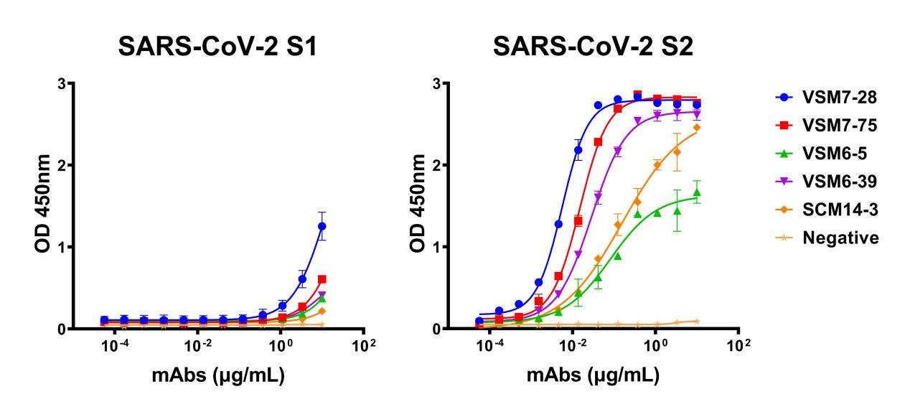
Supplementary Fig. S1. Five mAbs specifically bind to the prototype SARS-CoV-2 spike S2 subunit. The binding curves of five mAbs reactive to the SARS-CoV-2 S1 (left) and S2 (right) subunits. The prototype SARS-CoV-2 spike S1 or S2 proteins were coated on an ELISA plate at a concentration of 2 μg/mL; mAbs were serially diluted three-fold starting at 10 μg/mL and added to the plate, and then peroxidase-AffiniPure goat anti-human IgG (H + L) antibody was added to detect the binding. An anti-HCV mAb (HNC5) used as a negative control.
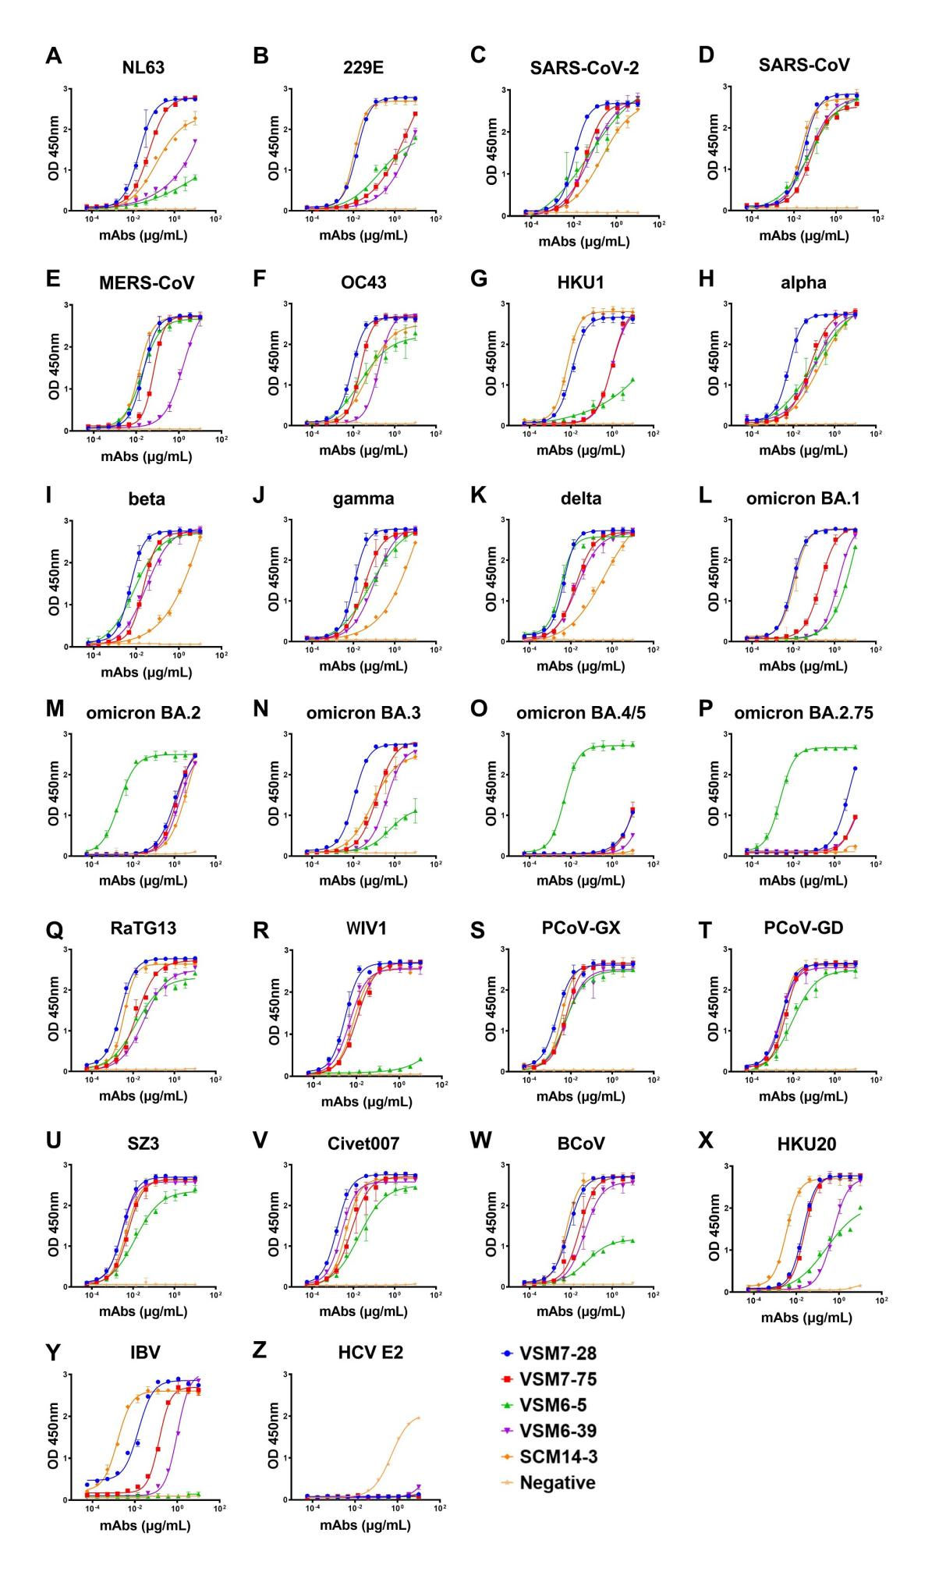
Supplementary Fig. S2. Binding of five mAbs against the spike proteins of 25 human and animal coronaviruses. The binding curves of five mAbs against spike proteins of seven human coronaviruses (A–G), nine SARS-CoV-2 variants (H–P), and nine animal coronaviruses (Q–Y). HCV E2 protein was used as the negative virus surface protein (Z). Spike proteins of human or animal coronaviruses were coated on an ELISA plate at a concentration of 2 μg/mL; mAbs were serially diluted three-fold starting at 10 μg/mL and added to the plate, and then peroxidase-AffiniPure goat anti-human IgG (H + L) antibody was added to detect the binding. An anti-HCV mAb (HNC5) used as a negative control.

Supplementary Fig. S3. Neutralization activities of five mAbs against prototype SARS-CoV-2 pseudotyped virus. Pseudotype-based virus assays were used to test for neutralization. mAbs were serially diluted five-fold starting at 200 μg/mL and incubated with pseudotyped viruses, and then neutralization activities were scored by the reduction in luciferase intensity level after the infection of the HEK293T-ACE2 cells. An anti-HCV mAb (HNC5) used as a negative control.

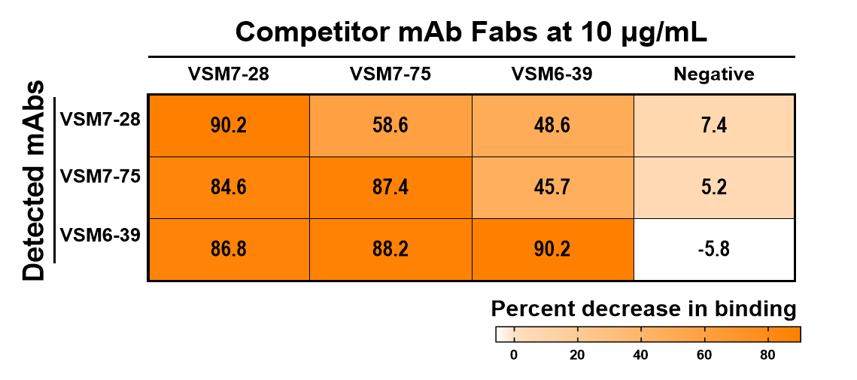
Supplementary Fig. S4. Cross-competition patterns between three mAbs. Competition ELISA was used to determine whether the binding of one antibody affected the binding of another via the Fc region. The prototype SARS-CoV-2 spike S-ECD proteins were coated on an ELISA plate at a concentration of 2 μg/mL; competitor antibodies Fab were added at 10 μg/mL, and then biotin-labeled detected antibodies were added at 0.1 μg/mL.The percentage of binding reduction compared to the binding without a competitor mAb Fab fragments is shown.

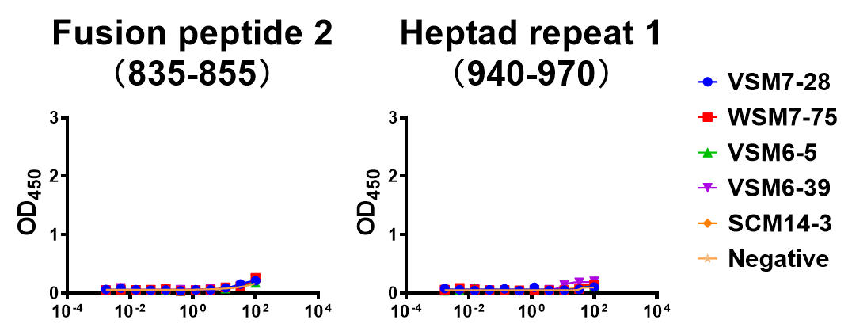
Supplementary Fig. S5. Binding of five mAbs against the fusion peptide 2 (835–855) and heptad repeat 1 (940–970). ELISA was employed to measure the binding activity between mAbs and peptides. The mAbs were coated on an ELISA plate at a concentration of 2 μg/mL; biotinylated peptides were serially diluted three-fold starting at 100 μg/mL and added to the plate, and then peroxidase-AffiniPure streptavidin was added to detect the binding. The binding curves of five mAbs reactive to fusion peptide 2 (left) and heptad repeat 1 (right) were shown.

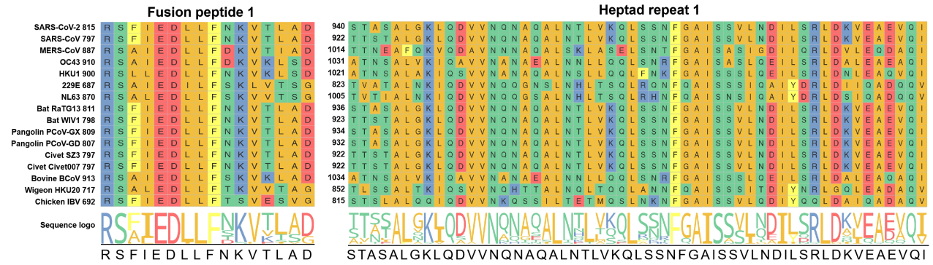
Supplementary Fig. S6. Sequence homology analysis of the fusion peptide 1 and heptad repeat 1 domains of the spike S2 of human and animal coronaviruses. Multiple sequence alignment for the fusion peptide 1 (left) and heptad repeat 1 domain (right) of the spike S2 of human and animal coronaviruses. Sequence logo indicates the extents of homologous amino acids.

中文信息登记表
（请添加中文信息，将用于论文的中文推广，请重视。）
题 目
泛冠状病毒棘突蛋白S2特异性单克隆抗体的分离与鉴定
作者姓名:
胡雅彬 陈俊 杨晶 刘占鹏 张潇月 伍谦 刘璐璐 滕石山 贺荣章 刘波 郑星雨 卢瑞 潘东 王优 彭莉婷 陈红英 李义平 刘文培 瞿小旺
单位:
a 南华大学衡阳医学院基础医学院
b 南华大学转化医学研究所
c 西北农林科技大学生命科学院
d 中山大学中山医学院
e 南华大学衡阳医学院公共卫生学院
摘要:
在不到20年的时间里，动物冠状病毒向人类的溢出引起了三次严重公共卫生事件：严重急性呼吸综合征（SARS）、中东呼吸综合征（MERS）和新型冠状病毒肺炎（COVID-19）。冠状病毒主要通过表面棘突蛋白与宿主受体蛋白相互作用而感染宿主细胞。此前，我们从COVID-19康复者和接种灭活疫苗的人群中获取了274个针对新型冠状病毒棘突蛋白的单克隆抗体。在此，我们对这些抗体进行深入的分析，旨在筛选识别泛冠状病毒的单克隆抗体。结果发现了5个对25种来自人和动物的冠状病毒具有广谱反应性的单克隆抗体，包括7种人冠状病毒、新型冠状病毒的突变株，来自果子狸、蝙蝠和穿山甲的异常冠状病毒，以及牛、山羊和鸡的冠状病毒。进一步对这些抗体的抗病毒特征进行分析，发现抗体VSM7-28、VSM7-75和VSM6-39靶向冠状病毒棘突蛋白融合肽1表位，另外两个单克隆抗体靶向不同但保守的表位。5个抗体的重链和轻链都经历了高水平的体细胞突变，这对它们的广谱结合活性至关重要。这些单克隆抗体的发现为未来开发未知冠状病毒感染监测试剂和广谱疫苗奠定了基础。
关键字:
新型冠状病毒 单克隆抗体 棘突蛋白S2 泛冠状病毒
邮寄地址：
（编辑部将为通讯作者寄送一份样刊，请留下您的详细地址和电话，便于投递）
地址：湖南省衡阳市南华大学红湘校区医学院办公楼
姓名：瞿小旺
电话：15526272595

