Virologica Sinica
Supplementary Materials

Artemisia annua L. leaf extracts suppress influenza virus infection by targeting the viral nucleoprotein and blocking mitochondria-mediated apoptosis

Xiwen Zhao ^{a, b}, Xuan Dai ^{b}, Fuyi Wang ^{b, c}, Chenyang Li ^{c}, Xun Song ^{d}, Yingying Han ^{c}, Chaowei Zhang ^{c},
Lu Wang ^{e,} *, Zhendan He ^{d ,}*, Rongping Zhang ^{a,} *, Liang Ye ^{b,} *

ª College of Chinese Medicine, School of Chinese Materia Medica and Yunnan Key Laboratory of Southern Medicine Utilization, Yunnan University of Chinese Medicine, Kunming 650500, China.
^{b} Department of Immunology, International Cancer Center, Shenzhen University Medical School, Shenzhen 518055, China.
^{c} College of Pharmacy, Shenzhen University Medical School, Shenzhen 518055, China.
^{d} College of Pharmacy, Shenzhen Technology University, Shenzhen 518118, China.
^{e} Hyperbaric oxygen department, Shenzhen University General Hospital, Shenzhen 518055, China.

*Corresponding authors:
Email addresses: liangyeszu@163.com (L. Ye), zhrpkm@163.com (R. Zhang), hezhendan@126.com (Z. He), luwangszu@163.com (L. Wang)
ORCID: 0000-0002-6735-0836 (L. Ye)

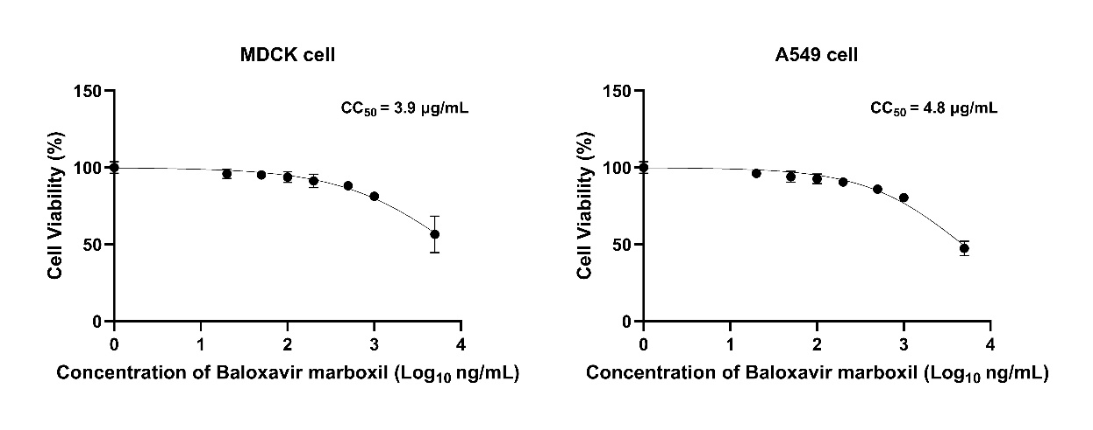
Fig. S1. Effect of baloxavir marboxil on cell viability of IAV host cells. Influenza virus-sensitive MDCK and A549 cells were treated for 48 hours with various concentrations of baloxavir marboxil (0, 20, 50, 100, 200, 500, 1000, and 5000 ng/mL), and the 50% cytotoxic concentration (CC₅₀) value of baloxavir marboxil cell viability was determined by the CCK-8 assay. Data are presented as mean ± SD (n = 6).
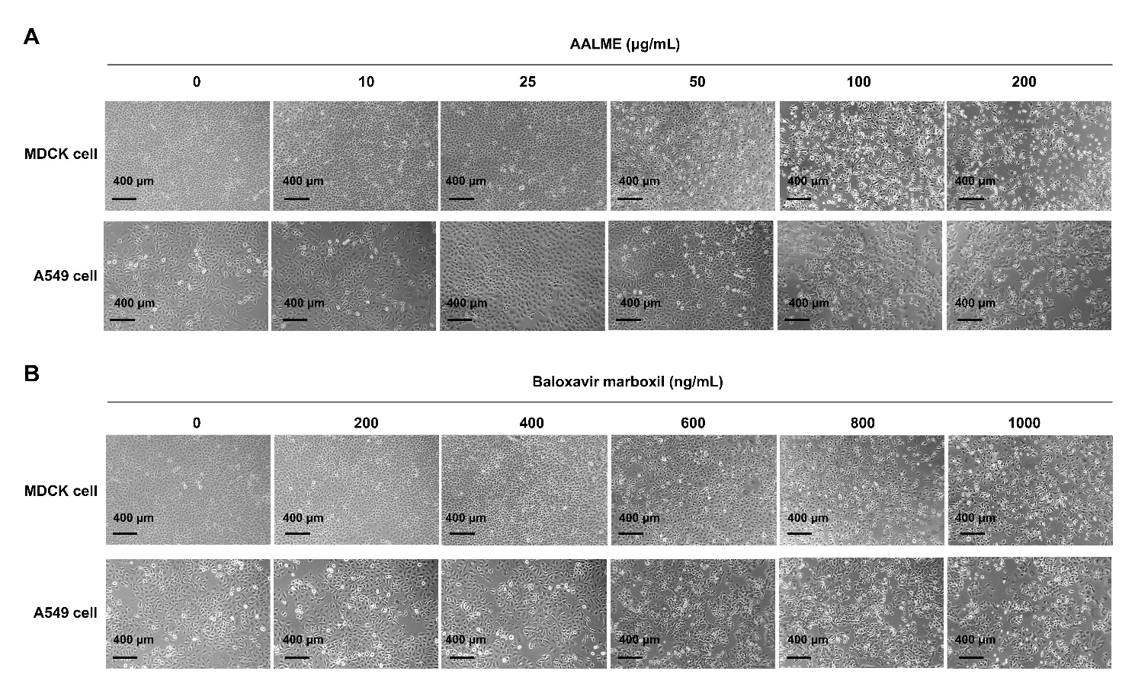
Fig. S2. Cytopathic effect of AALME and baloxavir marboxil on MDCK and A549 cells. Influenza virus-sensitive MDCK and A549 cells were treated for 48 hours with various concentrations of AALME (0, 10, 25, 50, 100, and 200 ng/mL) and baloxavir marboxil (0, 200, 400, 600, 800, and 1000 ng/mL). Cytopathic effect (CPE) was observed by a microscope. Scale bars, 400 μm.

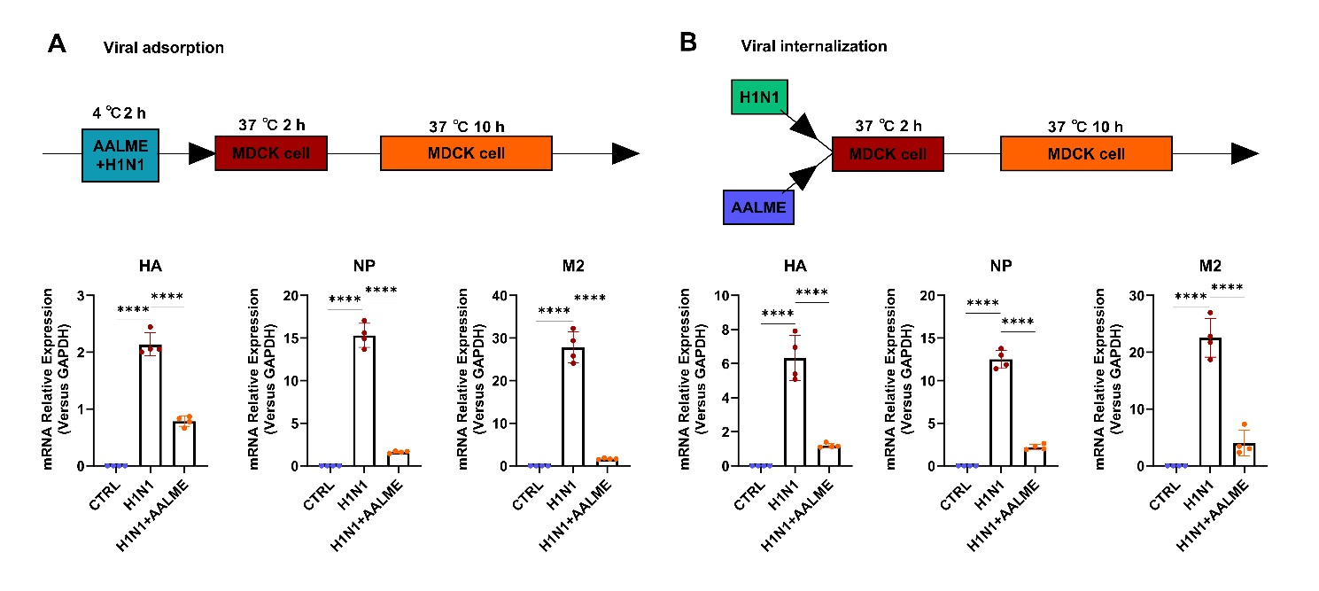
Fig. S3. AALME affects the viral adsorption and internalization processes of IAV. A H1N1 virus PR8 (MOI = 0.05) and AALME (25 μg/mL) were mixed and incubated for 2 hours at 4 ℃ before administering to MDCK cells. After incubating at 37 ℃ for 2 hours, the mixture was removed and replaced with fresh medium without TPCK-treated trypsin. Cells were then incubated at 37 ℃ for 10 hours. B MDCK cells were treated with H1N1 virus PR8 (MOI = 0.05) and AALME (25 μg/mL) for 2 hours at 37℃. The supernatant was then removed and replaced with fresh medium lacking TPCK-treated trypsin and then incubated at 37℃ for 10 hours. The mRNA expression levels of viral genes (HA, NP, and M2) were determined by RT-qPCR. Data are shown as the mean ± SEM (n = 4). ****P < 0.0001, versus the H1N1 control group, one-way ANOVA with Dunnett’s multiple comparisons test.
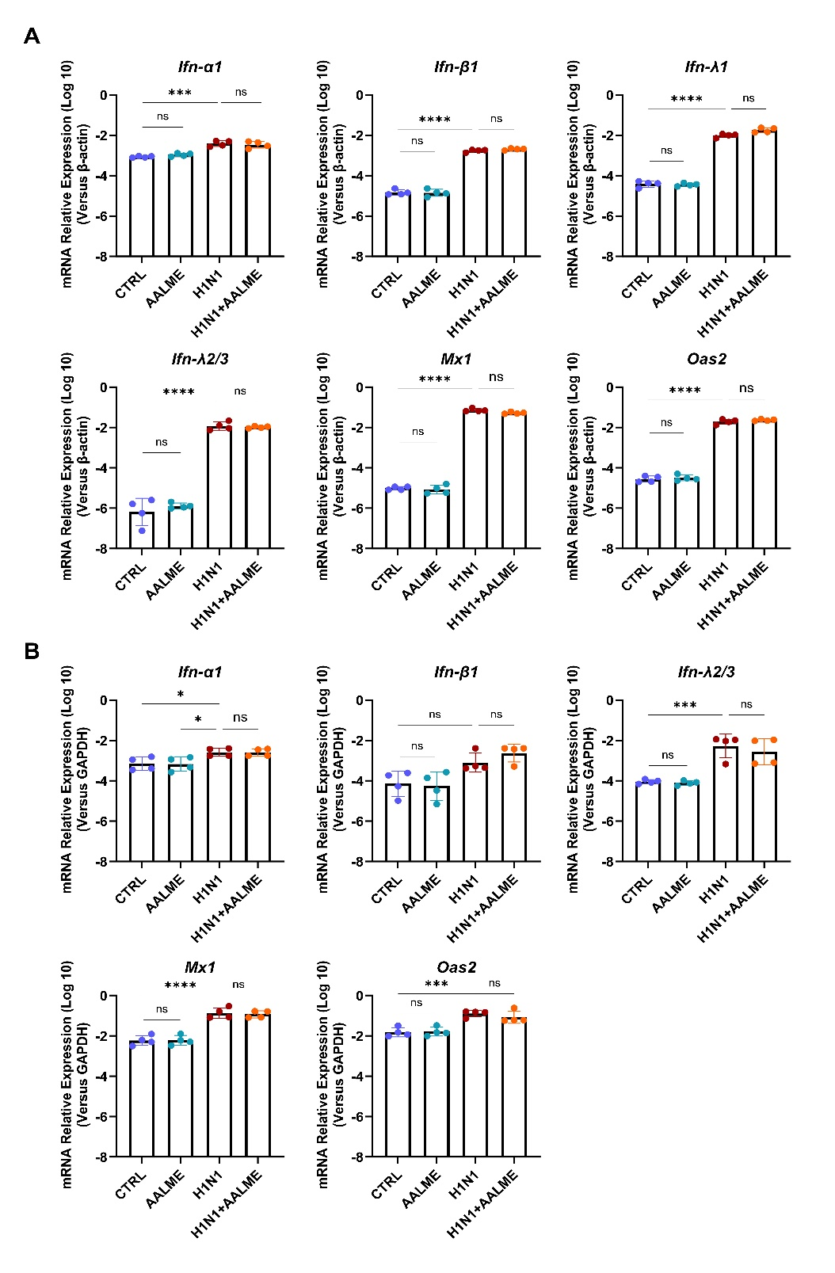
Fig. S4. AALME does not improve the mRNA expression of major innate antiviral host factors. A MDCK cells were incubated for 2 hours at 37 ℃ with AALME (25 μg/mL) or fresh medium before being infected or uninfected with H1N1 virus PR8 (MOI = 0.05) for 2 hours. The inoculum was then replaced with fresh medium and cultured for 24 hours at 37 ℃. B Mice were intranasally infected with or without of H1N1 virus PR8, mixed or unmixed with AALME (10 mg/kg), and mice received AALME (10 mg/kg) by intranasal administration for three consecutive days. Lung tissues were obtained on day 3 post-infection. RT-qPCR was used to determine the mRNA expression levels of the genes IFN-α1, IFN-β1, IFN-λ1, IFN-λ2/3, Mx1, and Oas2 in MDCK cells or lung tissues. Data were presented as the mean ± SEM (n = 4). *P < 0.05, ***P < 0.001, ****P < 0.0001 by unpaired two-tailed Student’s t-test. ns, no significant difference.
Table S1. The qPCR primers sequences used in this study.
Primer | Sequence (5′–3′)
18S-F | CCCCTCGATGCTCTTAGCTG
18S-R | CTTTCGCTCTGGTCCGTCTT
HA-F | GATCGGTGTGCCTGCCTTC
HA-R | CGTTGCTGCGACCCTTGT
NP-F | CTGGCAAAGAGCCCTAAGGA
NP-R | CTCAGAGGGTCAATGGAATTCC
M2-F | TTAGAAAACAGGGTCTTGGAGGAG
M2-R | CGTAAGGTAATACAGCCAGGCATA
β-actin human-F | ACATGGCCTCCAAGGAGTAAGA
β-actin human-R | GATCGAGTTGGGGCTGTGACT
IFNα-1 human-F  IFNα-1 human-R | TACTCCTATGCCACGCTCAT  GCGGAAGTAGCAGAAGTTGTC
IFNβ-1 human-F  IFNβ-1 human-R | GTGGACTACGCCACCAATCC  TAGATGGCCGACAGGGTGAT
IFNλ-1 human-F  IFNλ-1 human-R | AACTGGGAAGGGCTGCCACATT  GGAAGACAGGAGAGCTGCAACT
IFNλ-2/3 human-F  IFNλ-2/3 human-R | CCTGCACCACCAACTGCTTA  CATGAGTCCTTCCACGATACCA
Mx1 human-F  Mx1 human-R | TGGACAAATGCGACGAACC  CCCGCTCACTTGCTGCTT
Oas2 human-F  Oas2 human-R | ACCGAACAATGCCTACCTG  TGAGCCACAGCGTGTCCTA
GAPDH mouse-F  GAPDH mouse-R | TGTATTACCACATGGGCAGAC  ATCCAGGCGATAGGCAGAG
IL-6 mouse-F  IL-6 mouse-R | GACATCCCTGAGGAGATTAAG  ATGTTCTGGAGCATCTCATAG
IL-1β mouse-F | TGCGATGATGATTACCTT
IL-1β mouse-R | ATTCTCTTGCTCTGGATAC
Cxcl10 mouse-F | CTCCGATGAGGGCTCTTGCT
Cxcl10 mouse-R | AGACGGAATCCTCAGCATCTTC
TNF-α mouse-F  TNF-α mouse-R | CUCAAAGGCAACUUCGACUTT  AGUCGAAGUUGCCUUUGAGTT
IFNα-1 mouse-F  IFNα-1 mouse-R | GGATGTGACCTTCCTCAGACTC  ACCTTCTCCTGCGGGAATCCAA
IFNβ-1 mouse-F  IFNβ-1 mouse-R | GCCTTTGCCATCCAAGAGATGC  ACACTGTCTGCTGGTGGAGTTC
IFNλ-2/3 mouse-F  IFNλ-2/3 mouse-R | CCAGTGGAAGCAAAGGATTGCC  TCAGGTCCTTCTCAAGCAGCCT
Mx1 mouse-F  Mx1 mouse-R | TGGACATTGCTACCACAGAGGC  TTGCCTTCAGCACCTCTGTCCA
Oas2 mouse-F  Oas2 mouse-R | CACCAAAGTCCTGAAGACCGTC  AGAGTCGTAACTCTCCAGCGAG
Table S2. Identification of compound abundance in AALME.
Excel file (Supplementary Table S2)

