Virologica Sinica

Supplementary Data

Development and immunoprotection assessment of novel vaccines for avian infectious bronchitis virus
Benli Huang^{a, b, c, d, e, 1}, Sheng Chen^{a, b, c, d, e, 1}, Zhanxin Wang^{f}, Keyu Feng^{a, b, c, d, e}, Yutao Teng^{a, b, c, d, e}, Ruoying Li^{a, b, c, d, e}, Guanming Shao^{a, b, c, d, e}, Jiaqian Rao^{a, b, c, d, e}, Xinheng Zhang^{a, b, c, d, e,*}, Qingmei Xie^{a, b, c, d, e,*}

ª State Key Laboratory of Swine and Poultry Breeding Industry & Heyuan Branch, Guangdong Provincial Laboratory of Lingnan Modern Agricultural Science and Technology, College of Animal Science, South China Agricultural University, Guangzhou, 510642, China
^{b} Guangdong Provincial Key Lab of AgroAnimal Genomics and Molecular Breeding, College of Animal Science, South China Agricultural University, Guangzhou, 510642, China
^{c} Guangdong Engineering Research Center for Vector Vaccine of Animal Virus, Guangzhou, 510642, China
^{d} Zhongshan Innovation Center of South China Agricultural University, Zhongshan 528400, China
^{e} Guangdong Provincial Key Lab of AgroAnimal Genomics and Molecular Breeding, College of Animal Science, South China Agricultural University, Guangzhou, 510642, China
^{f} Wens Foodstuff Group. CO., LTD, Guangdong, Yunfu, 527400, China

¹Benli Huang and Sheng Chen contributed equally to this work and shared the first authorship.

Corresponding authors:
Email address: qmx@scau.edu.cn (Q. Xie); xhzhang@scau.edu.cn (X. Zhang).
ORCID: 0000-0001-6537-7798 (Q. Xie); 0000-0002-3232-4929 (X. Zhang)。

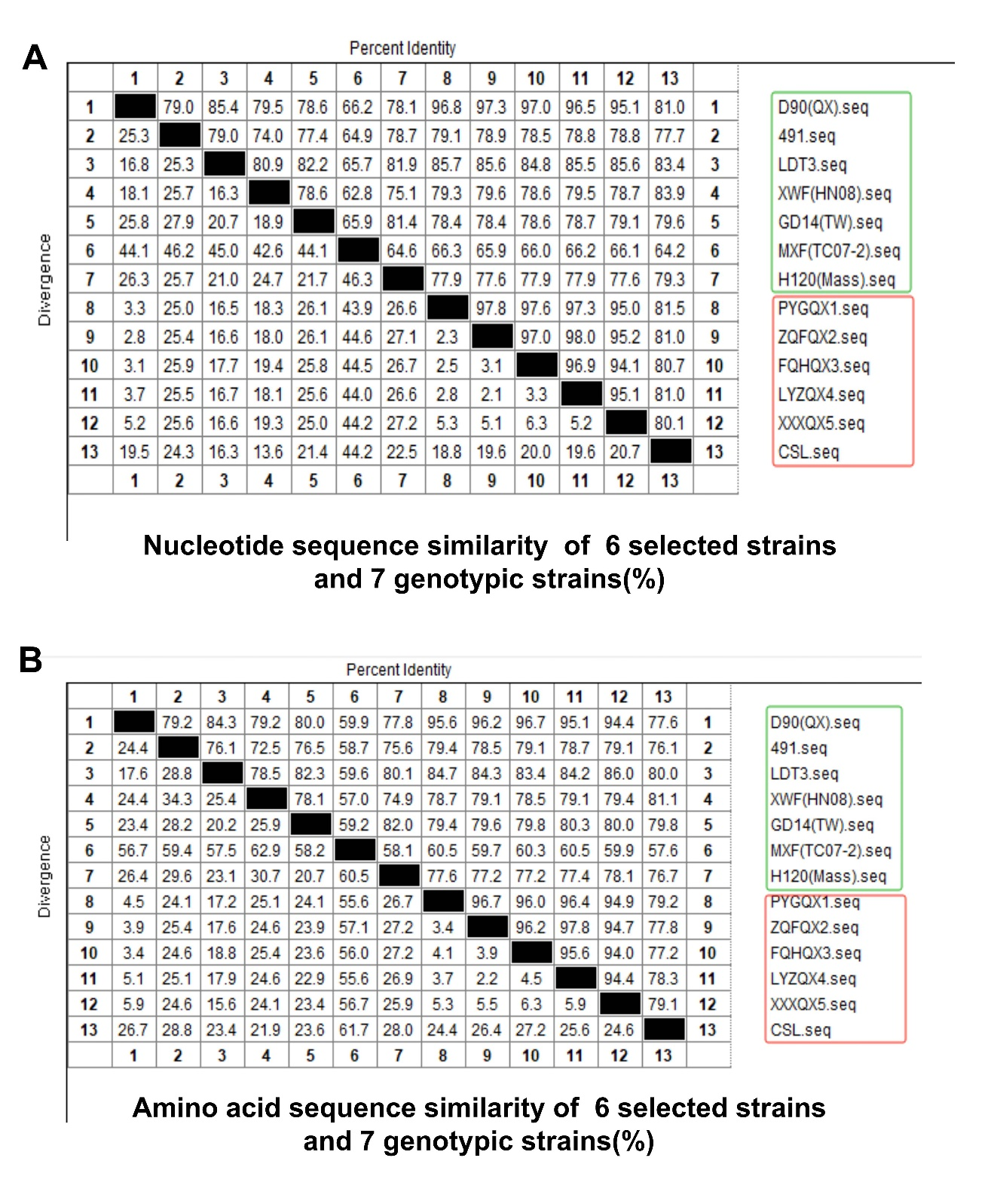
Supplementary Figure S1. The nucleotide and amino acid sequence similarities of S1 gene among six candidate strains and seven genotypic strains. In the green box there are seven different genotypic strains sequences; six candidate strains are in the red box. A Nucleotide sequence similarity of six candidate strains and seven genotypic strains (%). B Amino acid sequence similarity of 6 candidate strains and seven genotypic strains (%).

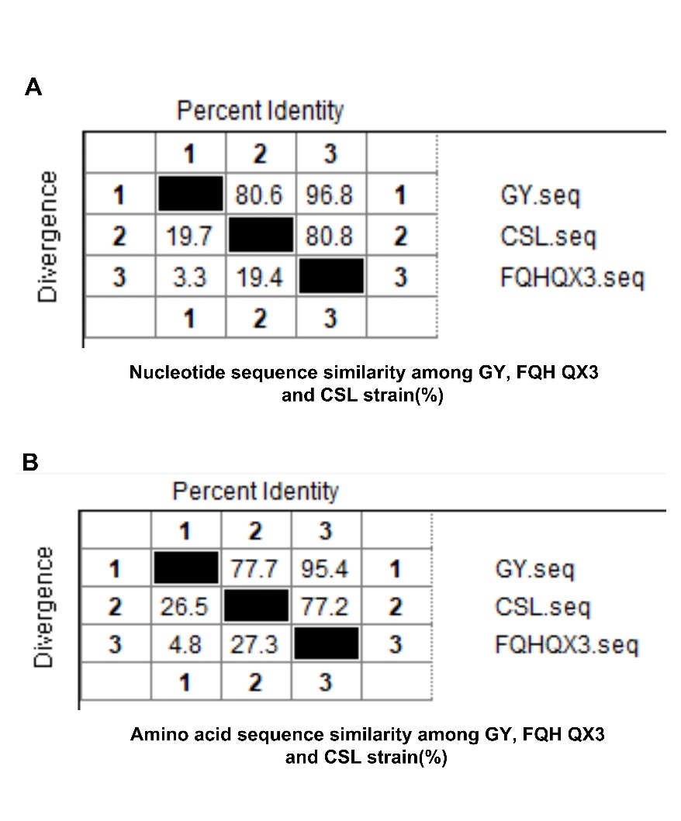
Supplementary Figure S2. The Nucleotide and Amino acid sequence similarities of S1 gene among GY, FQH QX3 and CSL strains. A Nucleotide sequence similarity among GY, FQH QX3 and CSL strains (%). B Amino acid sequence similarity among GY, FQH QX3 and CSL strains (%).

Supplementary Table S1. The background information of seven virus strains.
Strain | Name | Genotype | Isolation frequency | Area of isolation
PYG QX1 | CK/CH/HeB/CZ2201-6 | GⅠ-19(QX-like) | 15 times | Hebei Province
ZQF QX2 | CK/CH/ZJ/SZ2202-3 | GⅠ-19 (QX-like) | 12 times | Zhejiang Province
FQH QX3 | CK/CH/FJ/PT2202-1 | GⅠ-19 (QX-like) | 13 times | Fujian Province
LYZ QX4 | CK/CH/HeB/CZ2201-3 | GⅠ-19 (QX-like) | 12 times | Hebei Province
XXX QX5 | CK/CH/HeN/LB2203-1 | GⅠ-19 (QX-like) | 9 times | Henan Province
CSL | CK/CH/GD/HY2203-2 | GⅠ-30 (CSL-like) | 21 times | Guangdong Province
GY | GY | GⅠ-19 (QX-like) | Unknow | Unknow

Suppelmentary Table S2. The background information of seven genotypic strains.
Strain | NCBI GenBank: | Genotype
D90 | MF508703.1 | GⅠ-19（QX-like）
4/91 | AF093793.1 | GⅠ-13（4/91- like）
LDT3 | KR608272.1 | GⅠ-28（LDT3- like）
XWF | / | GⅠ-22（HN08- like）
GZ14 | KT946798.1 | GⅠ-7（TW- like）
MXF | / | GⅥ-Ⅰ（TC072- like ）
H120 | ON350836.1 | GⅠ-1（Mass- like）
Note:“/” indicates that it has not been uploaded to the NCBI system yet.

Supplementary Table S3. Safety evaluation of recombinant vaccine candidates.
Group | Immune vaccines | Immunizing dose | Age of immunization | Immune pathway | Quantity
1 | H120-FQH QX3 | 10 × dose | 1 d | Nasal drip | 15
2 | H120-CSL | 10 × dose | 1 d | Nasal drip | 15
3 | normal saline | 0.1 mL | 1 d | Nasal drip | 15
Note: 10 × dose of each Vaccine Candidate was 10^{5.5} EID₅₀/0.1 mL. In 5 dpv, five chickens were randomly selected from each group for dissection observation and extracted the trachea to assess cilia viability. At 10 dpv, the remaining chickens in each group were euthanized, and autopsy observation. Additionally, three randomly selected chickens from each group were sampled for histological lesions of their trachea, lungs, kidneys, spleen, and duodenum.

Supplementary Table S4. Serum cross-neutralization titers of GY, FQH QX3 and CSL strains.
Antigen | Antiserum
Antigen | GY | FQH QX3 | CSL
GY | >128 | 128 | 25
FQH QX3 | 125 | >128 | 20
CSL | 75 | 89 | >128
Note: A serum with a neutralization titer > 128 can protect 50% of chicken embryos from disease after being diluted by 2⁸ in a double gradient dilution. A titer < 8 indicates that the serum, when neutralized in equal amounts with the antigen after an 8-fold dilution, fails to protect 50% of chicken embryos. A serum with a neutralization titer ≥ 128 effectively protects 50% of chicken embryos. A titer ≥ 64 provides better protection, while a titer ≤ 64 indicates poor neutralization and protection efficacy.

Supplementary Table S5. Antigen correlation among GY, FQH QX3 and CSL strains (%).
Strain | GY | FQH QX3 | CSL
GY | 100
FQH QX3 | 99 | 100
CSL | 34 | 33 | 100
Note: When the value of antigen correlation is > 80%, it is the same subtype of serum; when the value is between 25% and 80%, it is the different subtype of the same serum; when the value is < 25%, it is the different serotype.

Supplementary Table S6. Grouping information of GY and CSL strains challenge models.
Group | Challenge strain | Challenge dose | Quantity | Challenge pathway | Age of challenge
1 | GY | 10^{6.16} EID₅₀/0.1mL | 10 | Nasal drip | 14d
2 | GY | 10^{5.16} EID₅₀/0.1mL | 10 | Nasal drip | 14d
3 | GY | 10^{4.16} EID₅₀/0.1mL | 10 | Nasal drip | 14d
4 | CSL | 10^{6.0} EID₅₀/0.1mL | 10 | Nasal drip | 14d
5 | CSL | 10^{5.0} EID₅₀/0.1mL | 10 | Nasal drip | 14d
Blank group | normal saline | 0.1mL | 10 | Nasal drip | 14d

Supplementary Table S7. The scoring criteria of the degree of lesion of the air sac, kidney, glandular stomach and muscle stomach (.xlsx file).

Supplementary Table S8. The autopsy results of GY and CSL strains (.xlsx file).

