Virologica Sinica

Supplementary Materials

Compromised efferocytosis during aging is related to COVID-19 severity in mice

Xianliang Ke ^{a, b, 1}, Xian Lin ^{a, b, c, 1}, Jin Wang ^{d}, Minqi Chen ^{e}, Xiaoqin Jian ^{a, b, f}, Chang Ye ^{a, b, f}, Quanjiao Chen ^{a, b, *}

ª CAS Key Laboratory of Special Pathogens and Biosafety, Wuhan Institute of Virology, Chinese Academy of Sciences, Wuhan, 430207, China
^{b} Center for Biosafety Mega-Science, Wuhan Institute of Virology, Chinese Academy of Sciences, Wuhan, 430207, China
^{c} Hubei Jiangxia Laboratory, Wuhan, 430200, China
^{d} Department of Endocrinology & Metabolism, The Third Affiliated Hospital, Sun Yat-sen University, Guangzhou, 510630, China
^{e} Key Laboratory of Stem Cells and Tissue Engineering (Ministry of Education), Zhongshan School of Medicine, Sun Yat-sen University, Guangzhou, 510080, China
^{f} University of Chinese Academy of Sciences, Beijing, 100049, China

¹ Xianliang Ke and Xian Lin contributed equally to this article.

*Corresponding author:
Email address: chenqj@wh.iov.cn (Q. Chen)
ORCID: 0000-0001-8716-6510

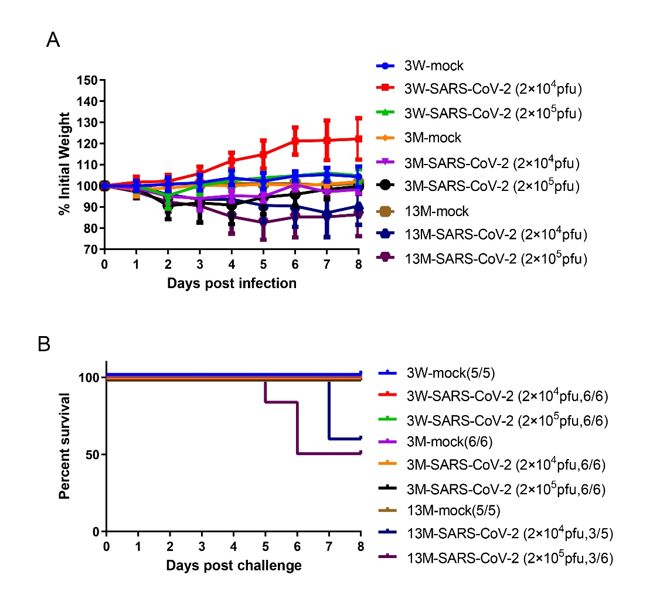

Fig. S1. Weight change and survival curve of mouse of different ages with SARS-CoV-2. A, B 3 W, 3-month- (3M), and 13-month-old (13 M) mice (n=5 or 6 for each group) were mock infected or intranasally infected with 2.0×10⁴ pfu or 2.0×10⁵ pfu SARS-CoV-2 virus, and weight changes (A) and survival rates (B) were recorded until 8 dpi.

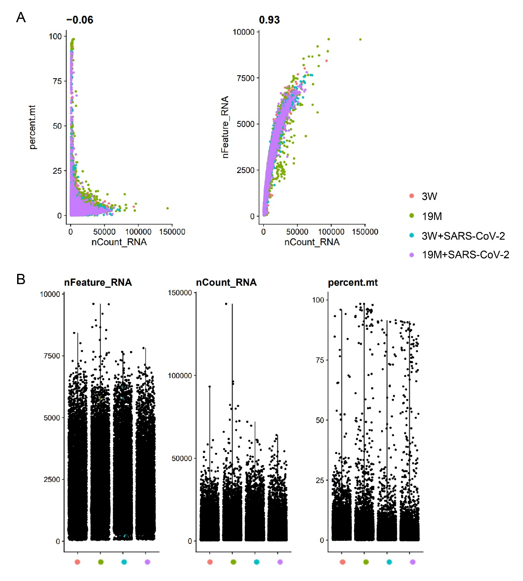
Fig. S2. Quality control of scRNA-seq data. A Scatter plot showing the correlation between UMI counts and gene numbers. Numbers indicate the Pearson correlation coefficient. B Violin plots show the number of unique genes (gene number), number of total unique molecular identifiers (UMI counts), and percentage of mitochondrial transcripts in single cells after removing doublets.

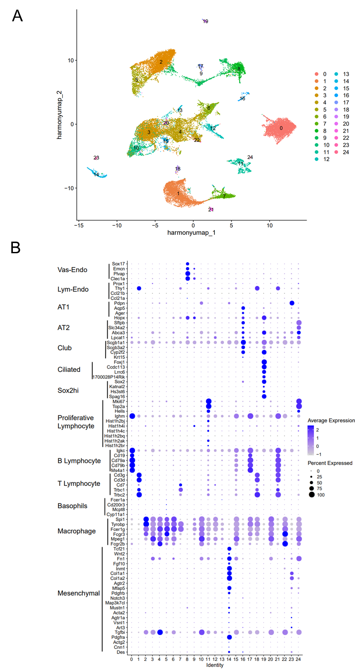
Fig. S3. Clustering of scRNA-seq data. A Clustering of lung cells. B Bubble plot showing signature gene expression in each cell type. The color indicates average expression, and the bubble size indicates the percentage of expression.

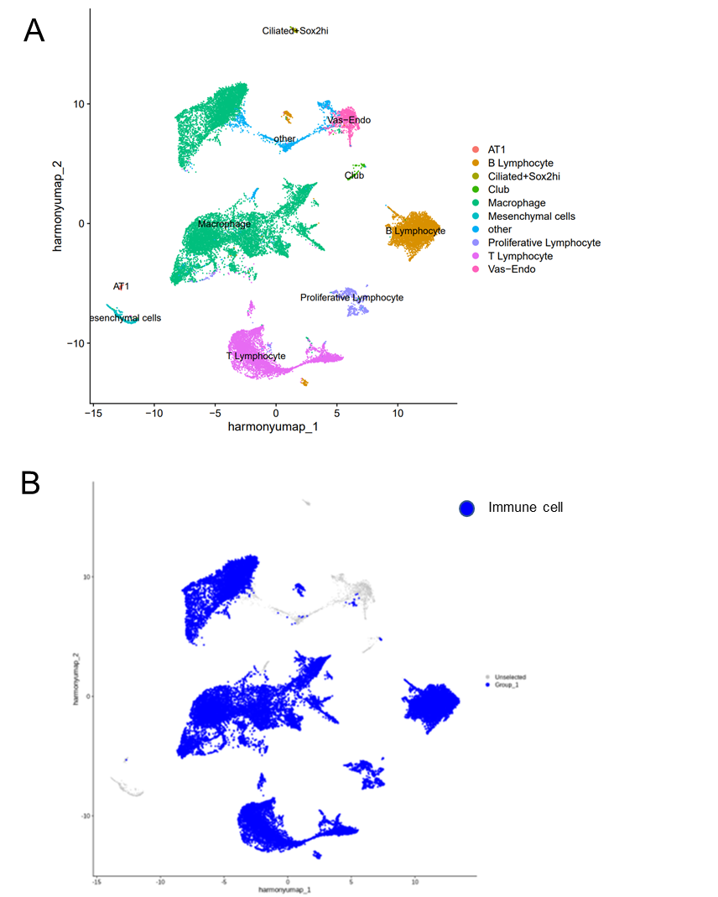

Fig. S4 Annotation of scRNA-seq data. A UMAP of lung cells, colored by cluster identity indicated on the right. B The highlight of immune cells.

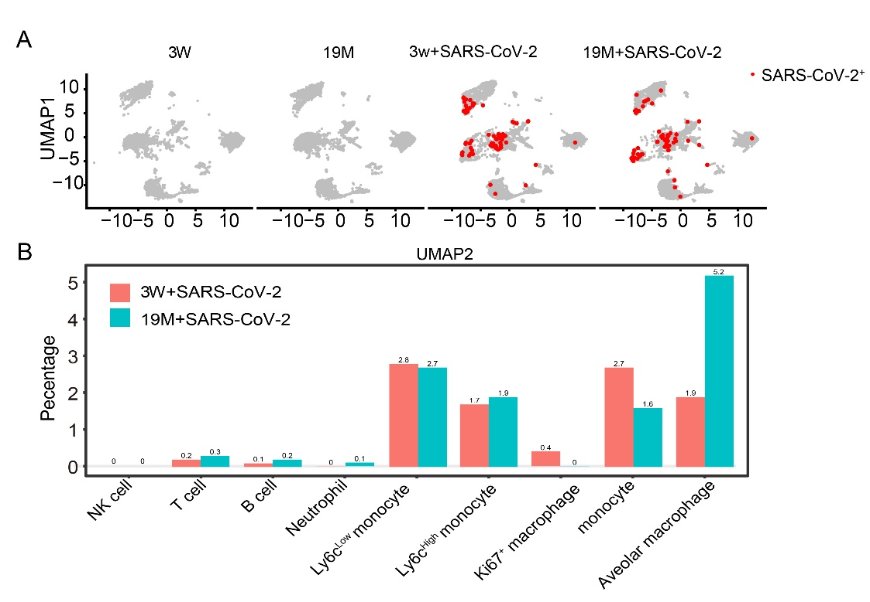
Fig. S5. SARS-CoV2 infection in each immune cell type. A Immune cells with SARS-CoV2 RNA detected (UMI > 0, red dots). B Fraction of SARS-CoV2 positive cells in each immune cell type from young and old mice with SARS-CoV2 infection.

Fig. S6. Analysis of inflammatory responses in each immune cell type of different groups. Inflammatory (A), cytokine (B), and chemokine (C) scores of each immune cell type in 3 W and 19 M mice without or with SARS-CoV-2 infection. Expression of inflammatory, cytokine, or chemokine genes from the GO database in each cell type were analyzed and scores were calculated using the AddModuleScore function of Seurat.

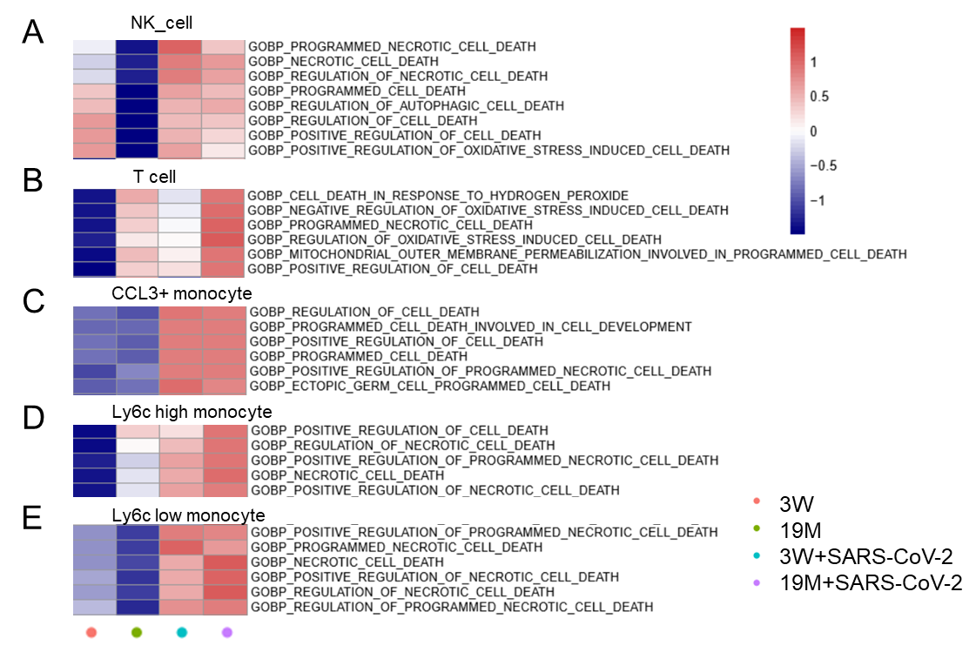
Fig. S7. Cell death pathways in each immune cell type of young and old mouse lungs without or with SARS-CoV-2 infection. GSVA showing cell death gene expression in the NK cell (A), T cell (B), CCL3+ monocyte (C), Ly6c high monocyte (D), and Ly6c low monocyte (E) population of young and old mouse lungs without or with SARS-CoV-2 infection.

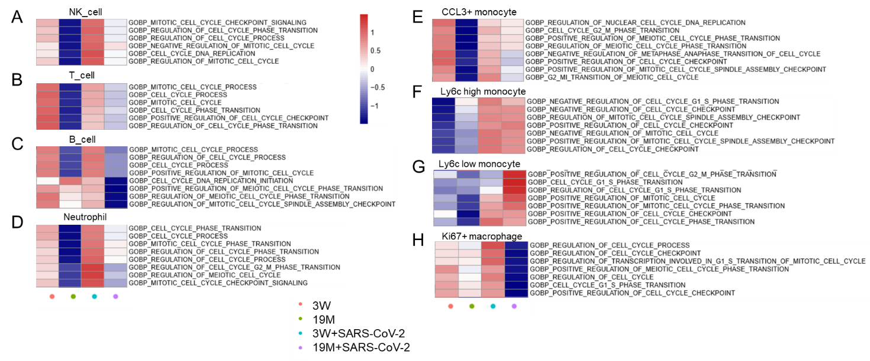
Fig. S8. Cell cycle pathways in each immune cell type of young and old mouse lungs without or with SARS-CoV-2 infection. GSVA showing cell cycle genes in the NK cell (A), T cell (B), B cell (C), neutrophil (D), CCL3+ monocyte (E), Ly6c high monocyte (F), Ly6c low monocyte (G) and Ki67+ macrophage population of young and old mouse lungs without or with SARS-CoV-2 infection.

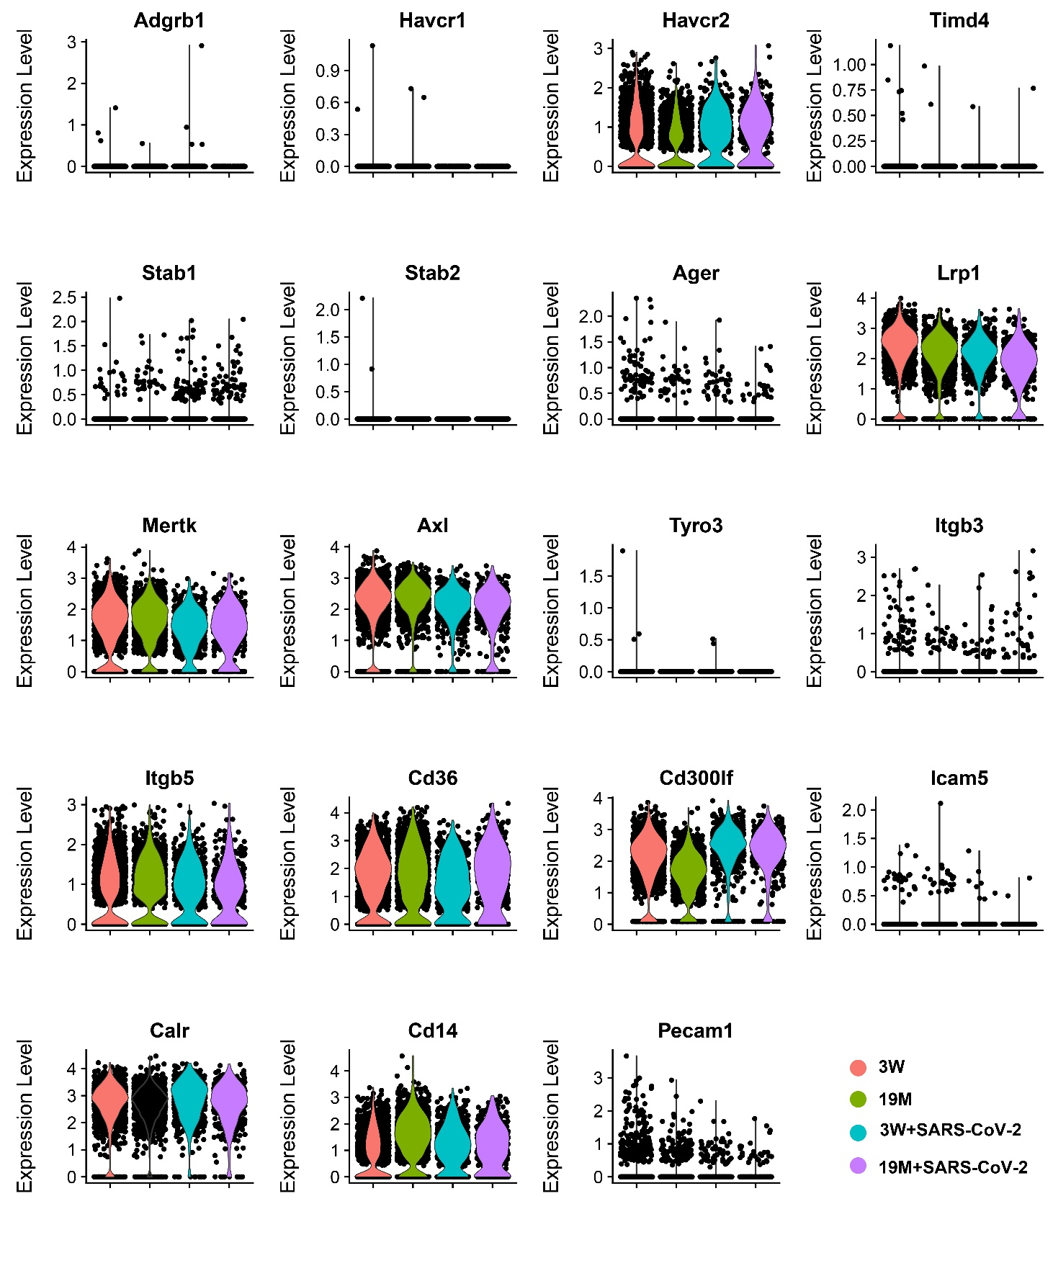

Fig. S9. Expression of efferocytosis receptors in alveolar macrophages. Gene expression levels of Adgrb1, Havcr1, Havcr2, Timd4, Stab1, Stab2, Ager, Lrp1, Mertk, Axl, Tyro3, Itgb3, Itgb5, Cd36, CD300if, Icam5, Calr, Cd14, and Pecam1 in alveolar macrophages of young and old mice with or without SARS-CoV-2 infection.

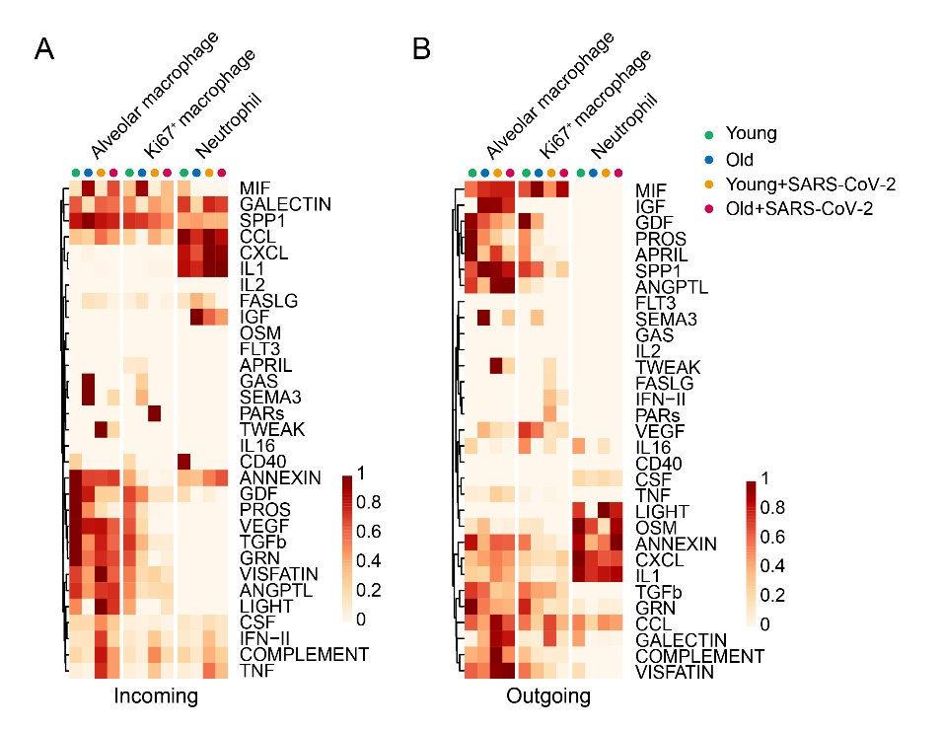
Fig. S10. Immune cell communications. A, B Heatmaps showing incoming (A) and outgoing (B) cell communication patterns of each immune cell type. Higher probability indicates stronger potential communication. Incoming refers to signals received by a cell type (receptor expression), while outgoing refers to signals sent (ligand expression).

