Virologica Sinica
Supplementary Materials

Decoding the virome reveals diverse novel viruses in tree shrews (Tupaia belangeri) in Yunnan Province
Zhong-Hao Lian ^{a 1}, Zhi You ^{a 1}, Pei-Yu Han ^{b}, Ye Qiu ª *, Yun-Zhi Zhang ^{b} * and Xing-Yi Ge ª *

ª Hunan Provincial Key Laboratory of Medical Virology, Institute of Pathogen Biology and Immunology, College of Biology, Hunan University, Changsha, 410012, China
^{b} Institute of Preventive Medicine, School of Public Health, Dali University, Yunnan Key Laboratory of Screening and Research on Anti-pathogenic Plant Resources from Western Yunnan, Yunnan Key Laboratory of Zoonotic Disease Cross-border Prevention and Quarantine, Dali, 671000, China

* Corresponding author.
Email Addresses: xyge@hnu.edu.cn (X. Ge); zhangyunzhi1818@163.com (Y. Zhang); qiuye@hnu.edu.cn (Y. Qiu);

ORCID:
Xing-Yi Ge: 0000-0003-3964-5140
Yun-Zhi Zhang: 0000-0002-4503-4824
Ye Qiu: 0000-0001-9182-1952

¹ Zhong-Hao Lian and Zhi You contributed equally to this work.

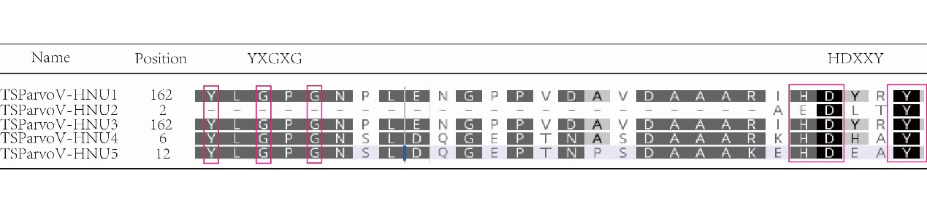Supplementary Fig. S1. Calcium-binding motif (YXGXG) and phospholipase A2 enzymes (PLA2) secretory motif (HDXXY) of novel tree shrew parvoviruses.

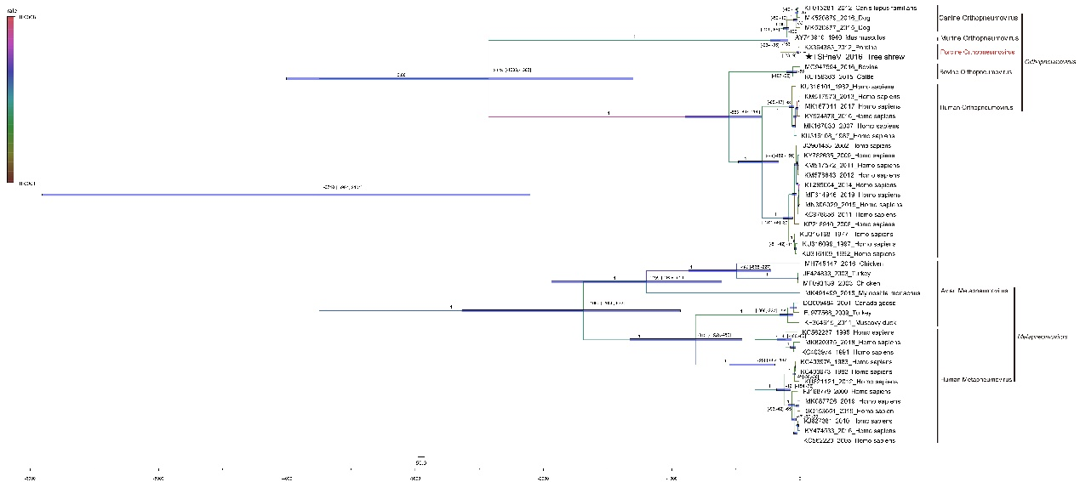
Supplementary Fig. S2. Estimation of divergence times of TsPneV-HNU1. Strict clock models were run for 150 million MCMC samples with a 10% burnin and sampling every 5000. Logs were visualized in Tracer (version 1.7.1) and trees plotted in TreeAnnotator in BEAST.

Supplementary Tables
Supplementary Table S1. Results of overall virome analysis (Excel file)
Supplementary Table S2. The positive rate for novel tree shrew viruses in all samples (Excel file)
Supplementary Table S3. Genomic information of the viruses identified in tree shrews (Excel file)
Supplementary Table S4. The results of pairwise comparisons of nucleotide and amino acid sequence similarities of novel tree shrew viruses (Excel file)
Supplementary Table S5. The PCR primers for detection and amplification of novel tree shrew viruses (Excel file)

