Virologica Sinica

Supplementary Data

Clofazimine targeting the spike protein and RdRp exhibits highly efficient antiviral activity against porcine epidemic diarrhea virus in vitro

Shuting Zhou ^{a, b}, Junrui Zhu ^{c}, Houde Zhao ^{a, b}, Zixin Huang ^{a, b}, Kangqi Zheng ^{a, b}, Fan Xia^{d}, Yufan Xu ^{a, b}, Guocheng Zhao ^{a, b}, Jijie Jiang ^{a, b}, En Zhang ^{b}, Haoyang Nian ^{b}, Li Cui ^{b}, Tao Sun ^{b}, Xiangfeng Wang ^{d},
Yanjun Zhou ^{c}, Zhibiao Yang ^{a, b, *}, Zhe Wang ^{a, b, *}

ª Shanghai Collaborative Innovation Center of Agri-Seeds / School of Agriculture and Biology, Shanghai Jiao Tong University, Shanghai, 200240, China.
^{b} Shanghai Key Laboratory of Veterinary Biotechnology, School of Agriculture and Biology, Shanghai Jiao Tong University, Shanghai, 200240, China.
^{c} Department of Swine Infectious Diseases, Shanghai Veterinary Research Institute, Chinese Academy of Agricultural Sciences, Shanghai, 200241, China.
^{d} College of Agronomy and Biotechnology, China Agricultural University, Beijing, 100094, China.

* Corresponding authors:
E-mail addresses: zbyang@sjtu.edu.cn (Z.-B. Yang), wangz@sjtu.edu.cn (Z. Wang).
ORCID: 0000-0003-0564-1977 (Z.-B. Yang), 0000-0002-7235-3046 (Z. Wang)

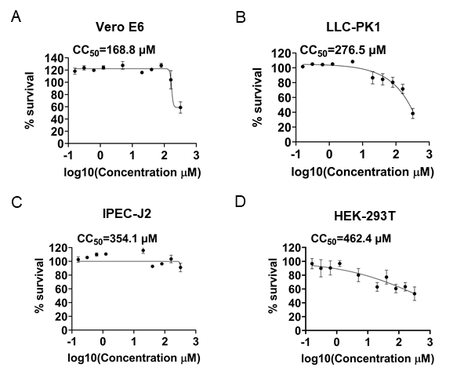
Supplementary Figure S1. Evaluation of CFZ’s cytotoxicity. A Dose-dependent curves showed viability of Vero E6 cells with serial dilution concentrations of CFZ. B Dose-dependent curves showed viability of LLC-PK1 cells with serial dilution concentrations of CFZ. C Dose-dependent curves showed viability of IPEC-J2 cells with serial dilution concentrations of CFZ. D Dose-dependent curves showed viability of HEK-293T cells with serial dilution concentrations of CFZ.

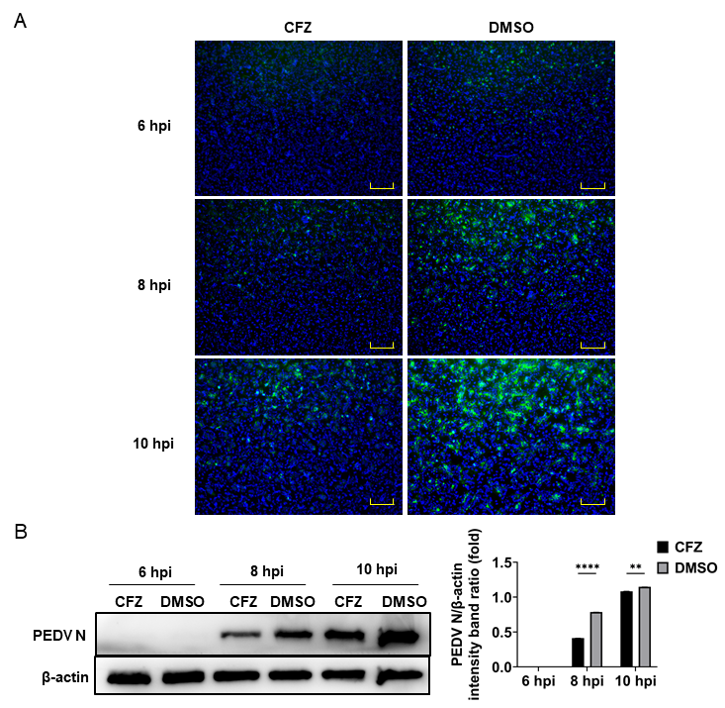
Supplementary Figure S2. The antiviral effect of CFZ on replication steps of PEDV. A VeroE6 cells were infected with PEDV and treated with CFZ during the replication phase were tested with an IFA using a mAb to PEDV N protein. Scale bar = 100 µm. B Expression of the N protein in CFZ or DMSO treated Vero E6 cells was detected by Western blot.

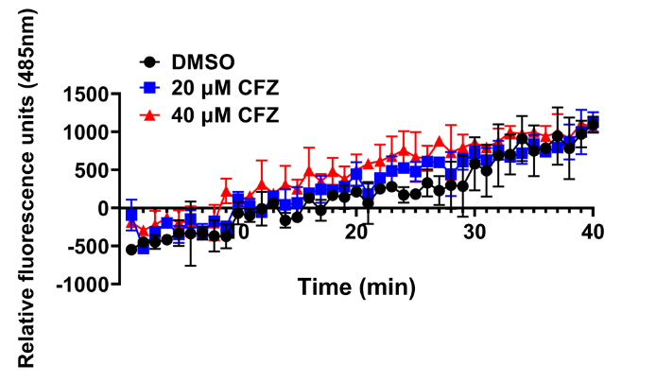
Supplementary Figure S3. FRET-based assays for substrate cleaved by PEDV 3CLpro (Nsp5) with or without CFZ. Substrate Dabcyl-YNSTLQ↓AGLRKM-E-Edans contain the N-terminal auto-cleavage site of PEDV 3CLpro was introduced in the FRET assays.

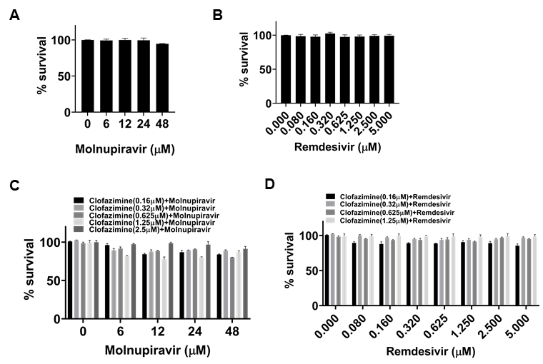
Supplementary Figure S4. The cytotoxicity of compounds on Vero E6 cells. Cell viability of Vero E6 cells following 24 h of treatment with molnupiravir (A), remdesivir (B), molnupiravir combine with clofazimine (C) or remdesivir combine with clofazimine (D) at the indicated concentrations was determined by CCK-8 assay.

Table S1. Chemical structures and molecular weights of compounds used in this study.
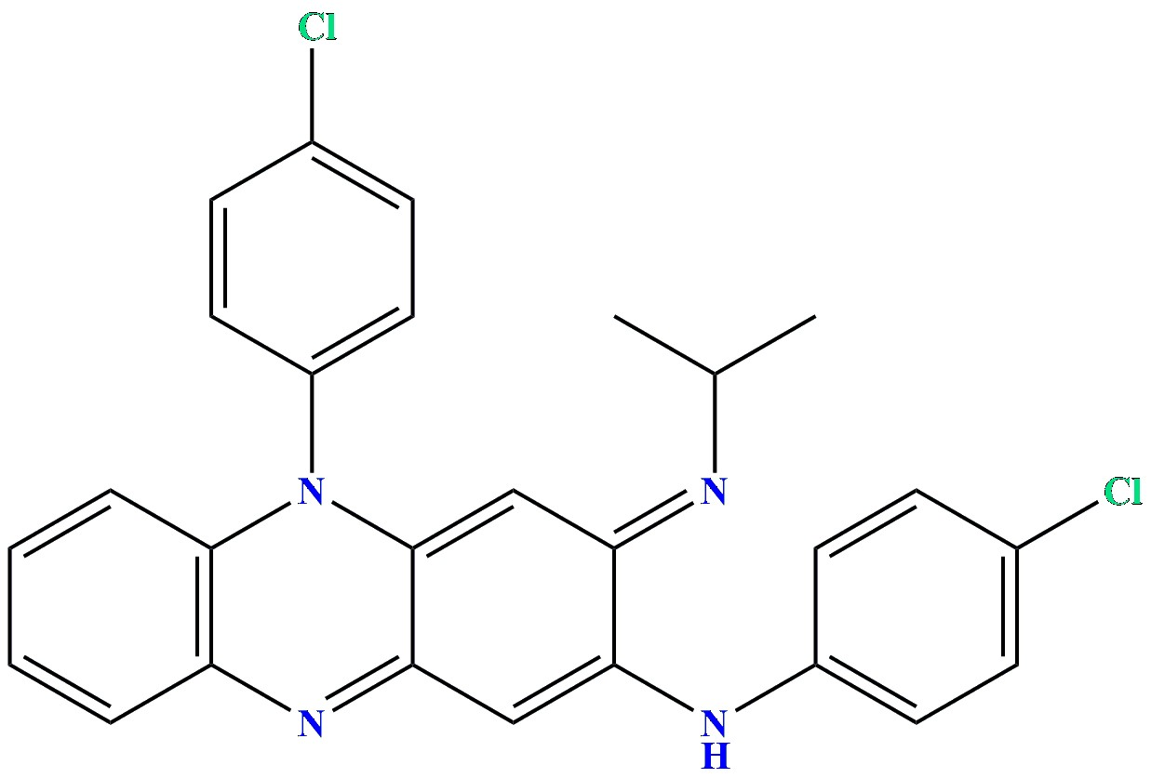
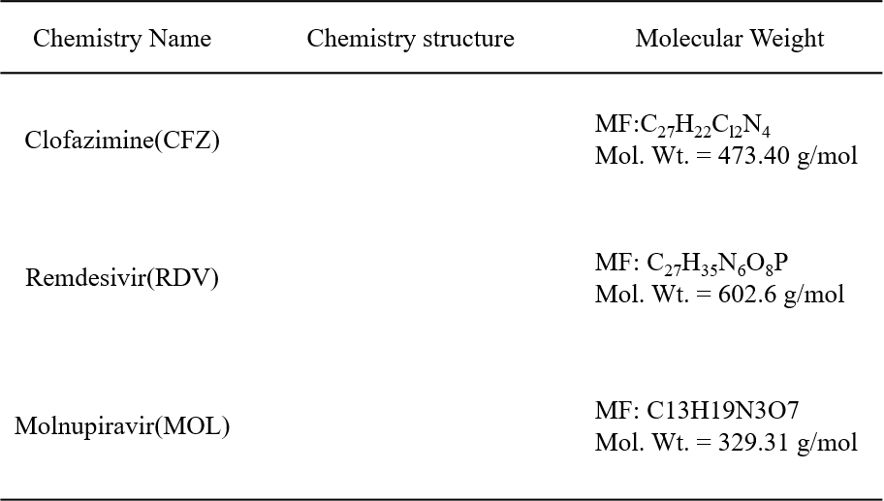

Table S2. List of primers used in this study.
Primer Name | Sequence (5′-3′)
qPCR-PEDV-N-F | CGCAAAGACTGAACCCACTAAC
qPCR-PEDV-N-R | TTGCCTCTGTTGTTACTTGGAGAT
qPCR-GAPDH-monkey-F | ACAACAGCCTCAAGATCGTCAGC
qPCR-GAPDH-monkey-R | GTGGCAGTGATGGCGTGGAC
qPCR-GAPDH-pig-F | GGAAGCTGTGGCGTGATGGC
qPCR-GAPDH-pig-R | TTCTCCAGGCGGCAGGTCAG
pcDNA4.0-S-F | GGTACCGAGCTCGGATCCGCCATGGAGAAGTCTTTAACTTACTTCTGG
pcDNA4.0-S-R | GCTCCACCGCCTCCCTCGAGCTGAACGTGGACCTT

Table S3 Differentially expressed genes (DEGs) between groups.
(Excel file).

