Virologica Sinica
Supplementary Materials

The slow progression of Japanese encephalitis in aged mice is likely associated to B cell recruitment in the brain

Zheng-Ran Song ^{a, c, 1}, Yi-Lin Yang ^{a, c, 1}, Yang Zhou ^{a, c}, Li-Bo Liu ^{b}, Fei-Yang Xue ^{a, c}, Lin-Shen-Yang Liu ^{a, c}, Na Gao ^{a, c}, Dong-Ying Fan ^{a, c}, Yi-Song Wang ^{a, c, *} , Jing An ^{a, c, *}, Pei-Gang Wang ^{a, c, *}

a Department of Microbiology, School of Basic Medical Sciences, Capital Medical University, Beijing, 100069, China.
b Department of Parasitology, School of Basic Medical Sciences, Guizhou Medical University, Guiyang, 561113, China
c Laboratory for Clinical Medicine, Capital Medical University, Beijing, 100069, China.

*Corresponding author.
Email address: pgwang@ccmu.edu.cn (P. Wang); anjing@ccmu.edu.cn (J. An); yswang@ccmu.edu.cn (Y. Wang).
ORCID:
Pei-Gang Wang: 0000-0001-6045-2007
Jing An: 0000-0002-2567-0380
Yi-Song Wang: 0000-0002-1609-2523

1 Zheng-Ran Song and Yi-Lin Yang contributed equally to this article.

Supplementary Figures
Supplementary Fig. S1 Viral loads and pathological changes in JEV-infected mouse brain.
A Early-stage viral load in the brain. At 5 dpi, viral load in the brain tissue of infected mice was assessed using qRT-PCR. B H&E-stained image of the thalamus (Scale bars = 50μm). C H&E-stained image of the cerebellum (Scale bars = 50μm). *P < 0.05, **P < 0.01, ***P < 0.001, ns—not significant.

Supplementary Fig. S2 Neuronal vacuolar degeneration in mouse hippocampus following JEV infection.
A H&E-stained image of the hippocampal CA1 region (Scale bars = 50μm). B H&E-stained image of the hippocampal CA3 region (Scale bars = 50μm). C H&E-stained image of the hippocampal DG region (Scale bars = 50μm).
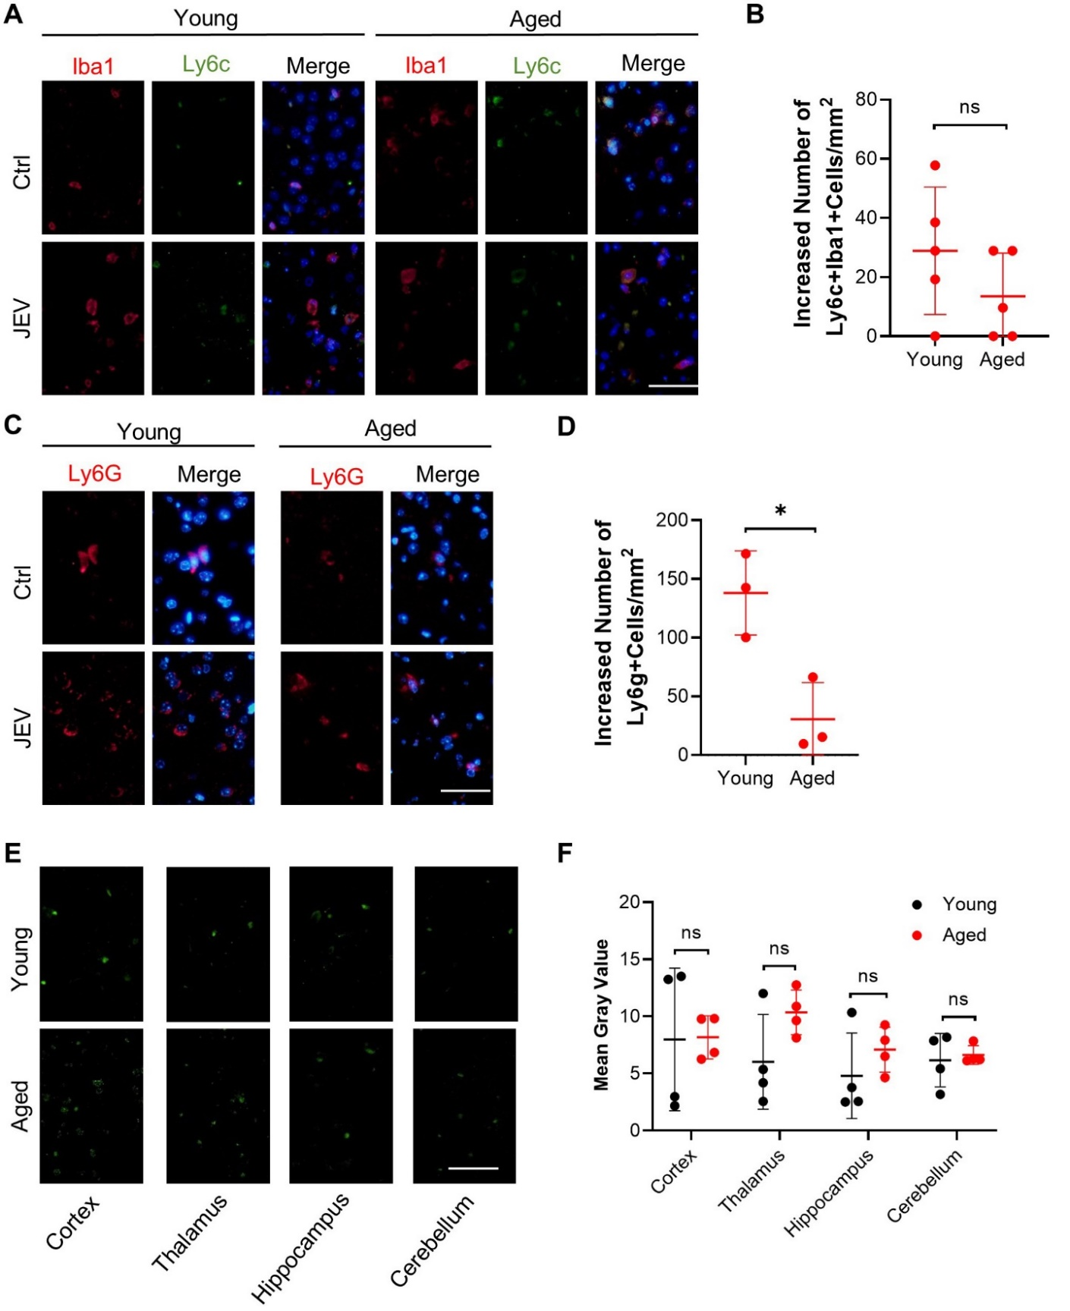
Supplementary Fig. S3 Age-dependent neutrophil infiltration in JEV-infected mouse brains.
A Colocalization of Iba1 (a marker of microglial cells) and Ly6c (a marker of monocytes) in the cerebral cortex of young and aged mice (Scale bars = 50μm). B Quantification of the net increase in Iba1+Ly6c+ monocytes. C Detection of Ly6g expression in the cerebral cortex of young and aged mice (Scale bars = 50μm). D Quantification of the net increase in Ly6g+neutrophils. E Detection of JEV antigen expression in the cerebral cortex, thalamus, hippocampus, and cerebellum of young and aged mice (Scale bars = 50μm). F Quantitative analysis of JEV antigen fluorescence intensity in the cerebral cortex, thalamus, hippocampus, and cerebellum of young and aged mice. * P <0.05, ** P <0.01, *** P <0.001, ns—not significant.
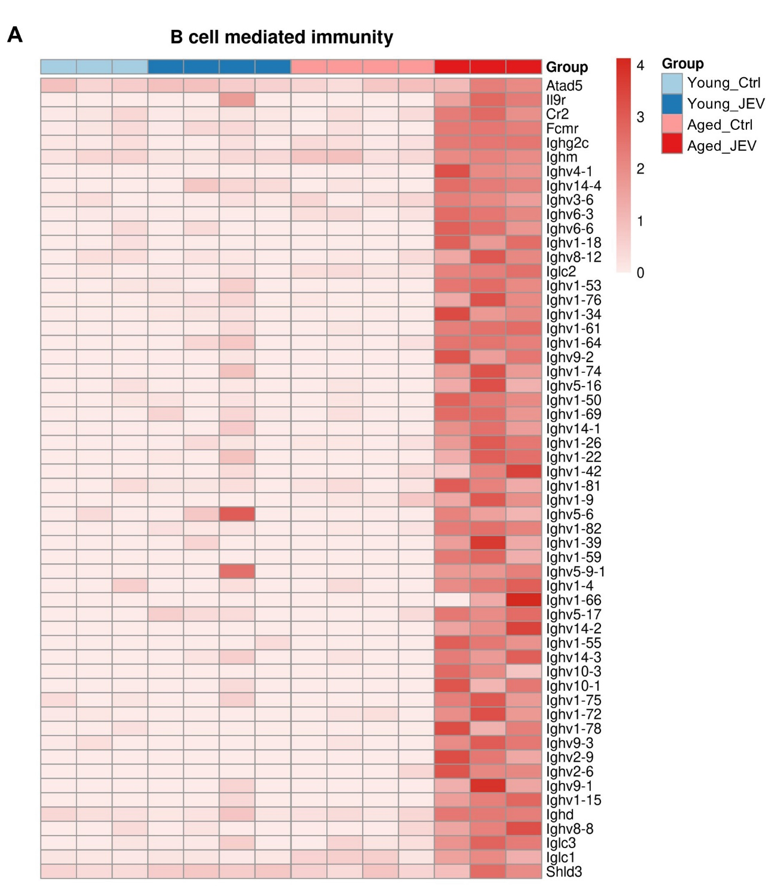
Supplementary Fig. S4 Transcriptomic Analysis of B Cell–Mediated Immune-Related Genes.

Supplementary Table
Supplementary Table S1. Summary of RNA-seq data. (Excel)

