Virologica Sinica
Supplementary Materials

Quercetin Inhibits herpes simplex virus 1 Replication in Corneal Epithelium and Suppresses Keratitis Progression

Yubin Yu^{a, b,1}, Sihao Liu^{a, 1}, Qinghua Liuª, Xiuping Liuª, Kaili Wu^{a,} *

ª State Key Laboratory of Ophthalmology, Zhongshan Ophthalmic Center, Sun Yat-sen University, Guangdong Provincial Key Laboratory of Ophthalmology and Visual Science, Guangzhou 510060, China.
^{b} Department of Ophthalmology, The Second Affiliated Hospital and Yuying Children's Hospital of Wenzhou Medical University, Wenzhou, 325035, China

¹Yubin Yu and Sihao Liu contributed equally to this study.

*Corresponding author: Kaili, Wu;
Email address: wukaili@mail.sysu.edu.cn (K. Wu)
ORCID: 0000-0003-3606-683X (K. Wu)

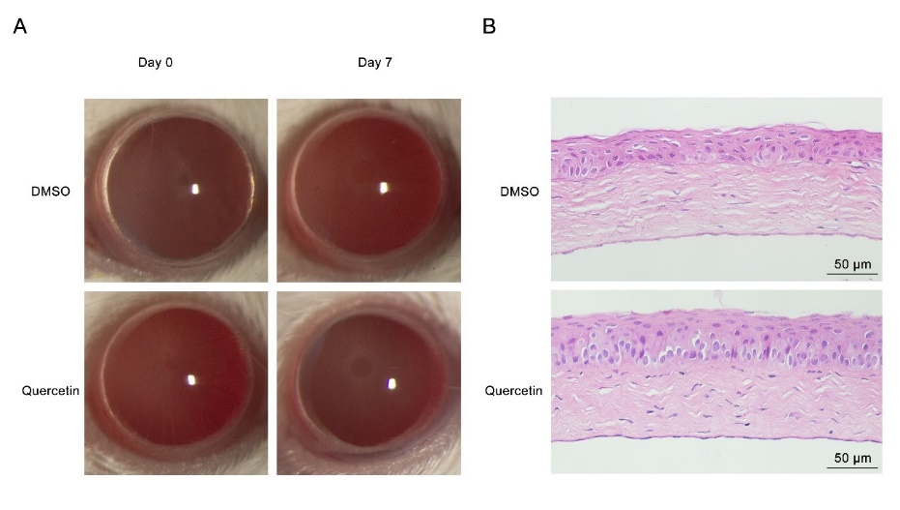
Figure S1 The topical application of quercetin at 100 μmol/L showed no significant toxicity to the mouse cornea. Six to eight-week-old SPF BALB/c female mice received right ocular infection with 1×10⁶ PFU HSV-1f, and were subsequently treated topically with 100 μmol/L quercetin or 0.1% DMSO four times daily, commencing 1 dpi. A Images captured by slit lamp of the right eyes of mice treated with different agents on day 0 and day 7. Each image represents findings from 5 mice in a single experiment. B Corneal histology of eyes on 7 dpi. Each image is representative of 3 mice in a single experiment.

Table S1. Primer sequence used for qRT-PCR
Gene name | Forward primer | Reverse primer
VP16 | 5′-TTTGACCCGCGAGATCCTAT-3′ | 5′-GCTCCGTTGACGAACATGAA-3′
ICP4 | 5′-CGACACGGATCCACGACCC-3′ | 5′-GATCCCCCTCCCGCGCTTCGTCCG-3′
gD | 5′-GCCCCGCTGGAACTACTATG-3′ | 5′-TTATCTTCACGAGCCGCAGG-3′
Nrf2 | 5′-TCAGCGACGGAAAGAGTATGA-3′ | 5′-CCACTGGTTTCTGACTGGATGT-3′
GAPDH | 5′-GAAGGTGAAGGTCGGAGTC-3′ | 5′-GAAGATGGTGATGGGATTTC-3′

Table S2. Differentially expressed genes in HSV-1-infected HCECs treated with 30 μmol/L quercetin versus DMSO.
(Excel file)

