Virologica Sinica
Supplementary materials

Tupaia belangeri better reflects the typical symptoms of Chikungunya virus infection than mice: a comparative study

Yan Guo^{a,b,c,1}, Mengyuan Zheng^{a,1}, Qi Wang^{a,1}, Hui Xiao^{a,1}, Li Liuª, Shuwei Dongª, Yonghan Luoª, Zhouling Panª, Yujie Xiangª, Yanxian Jiangª, Xiao Chenª, Hailin Tang^{d*}, Yuemei Feng^{e*}, Yue Feng^{a*}, Xueshan Xia^{a,e*}

ªFaculty of Life Science and Technology & Yunnan Province Key Laboratory of Public Health and Biosafety, Kunming University of Science and Technology, Kunming, Yunnan, 650500, China.
^{b}Department of Reproductive Gynecology & NHC Key Laboratory of Healthy Birth and Birth Defect Prevention in Western China, First People's Hospital of Yunnan Province, Kunming, Yunnan, 650032, China.
^{c}Department of Reproductive Gynecology, the Affiliated Hospital of Kunming University of Science and Technology, Kunming, Yunnan, 650032, China.
^{d}Department of Microbiology, Navy Medical University, Shanghai 200433, China.
^{e}School of Public Health & Yunnan Province Key Laboratory of Public Health and Biosafety, Kunming Medical University, Kunming, Yunnan, 650500, China.

¹Yan Guo, Mengyuan Zheng, Qi Wang, and Hui Xiao contributed equally to this work.

*Corresponding author:
Email addresses: oliverxia2000@aliyun.com (X. Xia), fyky2005@163.com (Yue Feng), fengyuemei2013@163.com (Yuemei Feng), hailint@163.com (H. Tang)
ORCID: 0000-0003-1120-8870 (X. Xia), 0000-0002-2718-0836 (Yue Feng), 0000-0002-1806-3742 (Yuemei Feng), 0009-0004-8432-747X (H. Tang)

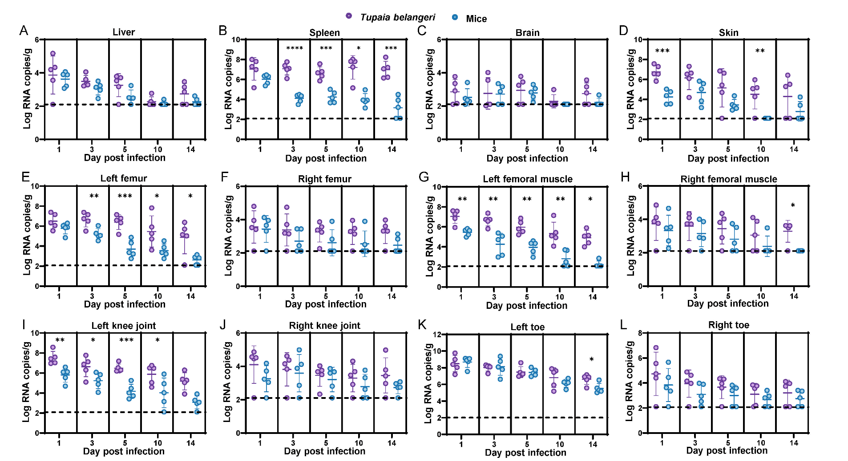

Fig S1. Comparative Viral Load Dynamics in Disseminated Tissues of Tupaia belangeri and Mice Following CHIKV Infection
(A–L) Viral RNA levels in liver (A), spleen (B), brain (C), skin (D), left femur (E), right femur (F), left femoral muscle (G), right femoral muscle (H), left knee joint (I), right knee joint (J), left toe (K), and right toe (L) from mice and Tupaia belangeri at the indicated days post infection. Viral RNA copies were quantified by RT-qPCR. Each dot represents an individual animal. The dashed line indicates the lower limit of detection (LOD). The data are shown as mean ± SD (n=5), comparisons between groups at each time point were performed using unpaired two-tailed t-tests (for normally distributed data) or Mann–Whitney U tests (for non-normal data). *p < 0.05, **p < 0.01, ***p < 0.001, ***p < 0.0001.

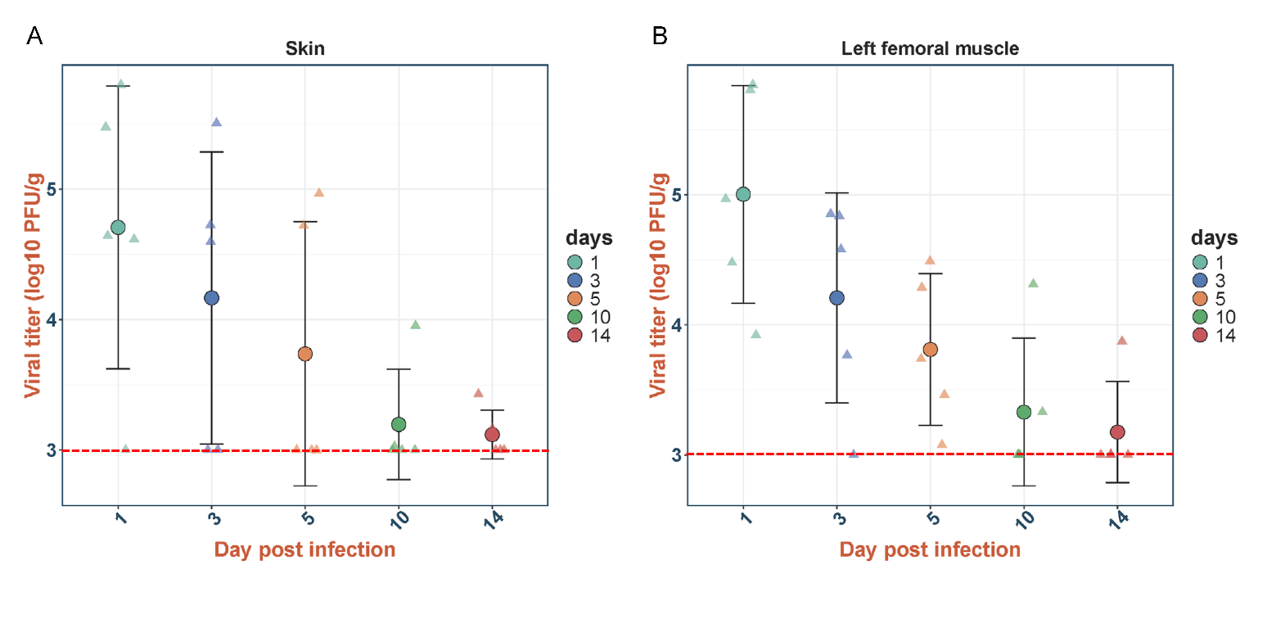

Fig S2. Detection of infectious CHIKV particles in skin and muscle tissues of Tupaia belangeri during the early phase of infection
(A-B) Infectious viral titers, determined by plaque assay, in the dorsal skin (A) and left femoral muscle (B) of CHIKV-infected Tupaia belangeri at the indicated days post-infection (dpi). Data are presented as mean ± SD (n = 5 biologically independent animals). The dashed red line indicates the lower limit of detection (LOD).

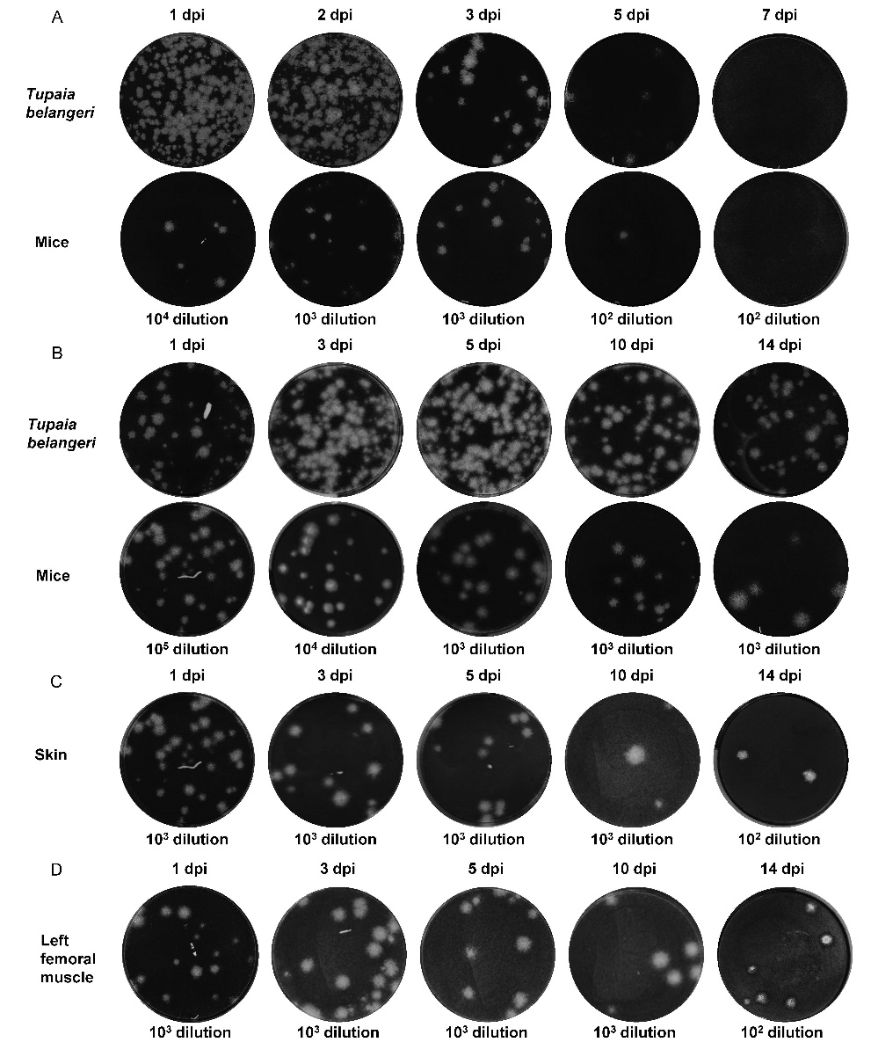
Fig S3. Plaque assay of viral titers in different tissues from mice and Tupaia belangeri at different days post-infection
- Plaque assay of viral titers in blood samples collected from mice and Tupaia belangeri at 1, 2, 3, 5, and 7 dpi. (B) Plaque assay of viral titers in left toe tissues from mice and Tupaia belangeri at 1, 3, 5, 10, and 14 dpi. (C) Plaque assay of viral titers in skin tissues from Tupaia belangeri at 1, 3, 5, 10, and 14 dpi. (D) Plaque assay of viral titers in left femoral muscle tissues from Tupaia belangeri at 1, 3, 5, 10, and 14 dpi. Blood samples or tissue homogenates were serially diluted as indicated and subjected to plaque assays. Representative plaques are shown, and dilution factors are indicated below each image.

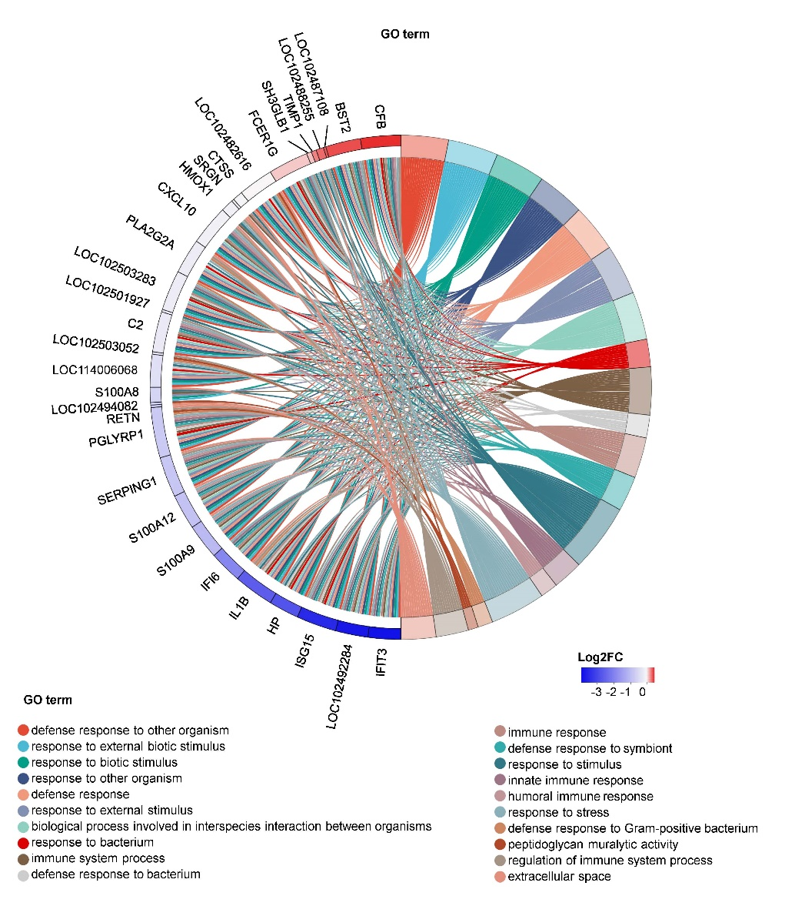

Fig S4. GO enrichment chord diagram
The chord diagram illustrates the associations between DEGs and significantly enriched GO biological processes. Links represent gene–GO term relationships, and colors indicate gene expression changes (log2FC), with red representing upregulation and blue representing downregulation.

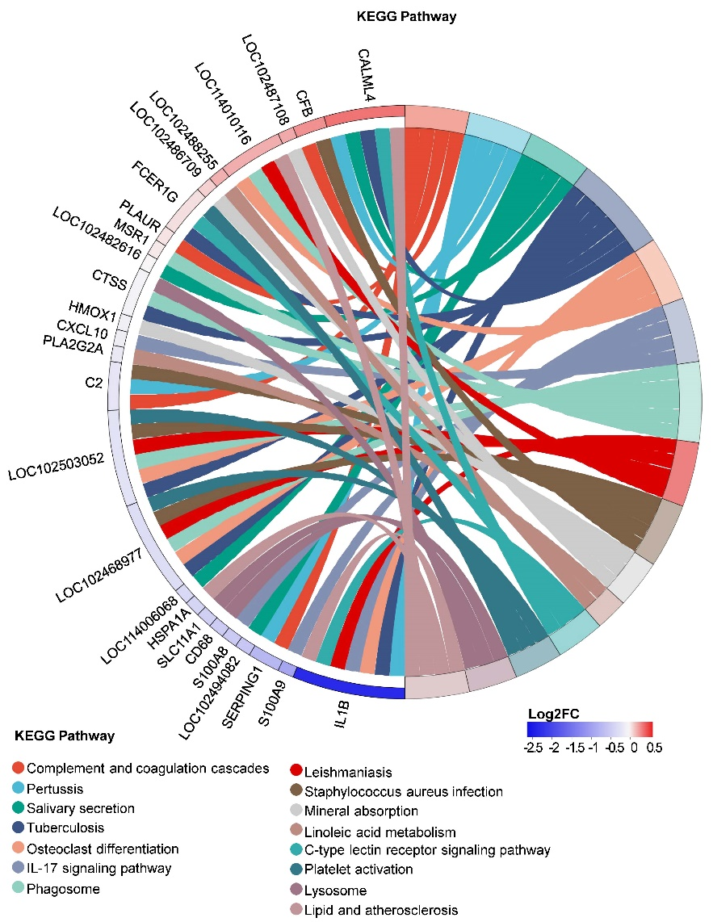

Fig S5. KEGG pathway enrichment chord diagram
The chord diagram illustrates the associations between DEGs and significantly enriched KEGG pathways. Links represent gene–KEGG pathway relationships, and colors indicate gene expression changes (log2FC), with red representing upregulation and blue representing downregulation.

Table S1. Clinical scoring criteria for CHIKV-infected animals (7-point scale).
SCORE | INITIALS | DESCRIPTION | APPEARANCE | MOBILITY | ATTITUDE
1 | H | Healthy | Smooth coat.  Bright eyes.  No observable symptoms. | Active, scurrying,  Burrowing. | Alert
2 | SR | Slightly ruffled | Slightly ruffled coat (usually only around head and neck). <5% weight loss.  Mild foot swelling (an increase in paw thickness of < 30%). | Active, scurrying,  burrowing. | Alert
3 | R | Ruffled | Ruffled coat through out the body ( a “wet” appearance).  5–10% weight loss.  Severe foot swelling (an increase in paw thickness of >30%). | Walking, but no  scurrying. | Decreased alertness
4 | S | Sick | Very ruffled coat.  Slightly closed, inset eyes. Significant hair loss or rash. | Photophobia, curled up,  slow movement. | Mildly lethargic
5 | VS | Very sick | Very ruffled coat.  Closed, inset eyes. | Slow movement or immobility.  Returns to upright position when placed on its side. | Extremely lethargic
6 | E | Euthanize | Very ruffled coat.  Closed, inset eyes.  Near-death state. | No movement or  uncontrollable, spastic movements.  Fails to return to an upright position when placed on its side. | Completely  unaware or in noticeable distress
7 | D | Deceased | - | - | -

