Supplementary Materials

Genomic‑epidemiological analysis of 15 million SARS-CoV-2 genomes reveals accelerated fitness gain of JN.1 lineage
Zhong-yi Lei^{a, b}, Qian-tong Jin^{c, d}, Xiao-min Zhang^{b}, Xiao-chen Bo^{b}, Zi-lin Ren^{c, d, *}, Yi-gang Tong^{a, *}, Ming Ni^{b,*}
ª College of Life Science and Technology, Beijing University of Chemical Technology, Beijing 100029, China.
^{b} Advanced & Interdisciplinary Biotechnology, Academy of Military Medical Sciences, Beijing 100850, China.
^{c} Changchun Veterinary Research Institute, Chinese Academy of Agricultural Sciences, State Key Laboratory of Pathogen and Biosecurity, Key Laboratory of Jilin Province for Zoonosis Prevention and Control, Changchun, 130122, China.
^{d} School of Information Science and Technology, Northeast Normal University, Changchun 130117, China.
*Corresponding authors.
E-mail addresses:niming@bmi.ac.cn (M. Ni), tongyigang@mail.buct.edu.cn (Y. Tong), zilin.ren@outlook.com (Z. Ren).
ORCID: 0000-0001-9465-2787 (M. Ni), 0000-0002-8503-8045 (Y. Tong), 0000-0002-3621-1024 (Z. Ren)

Supplementary Figures S1–S10
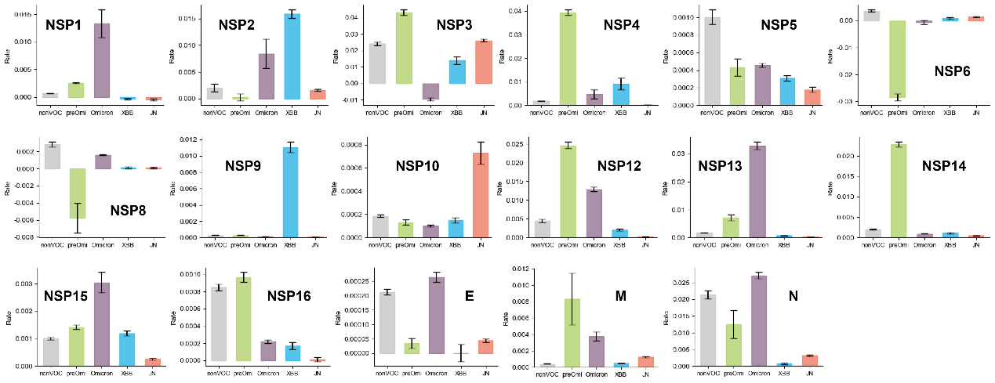
Fig. S1 Rates of mutation accumulation via Huber regression for SARS-CoV-2 genes.
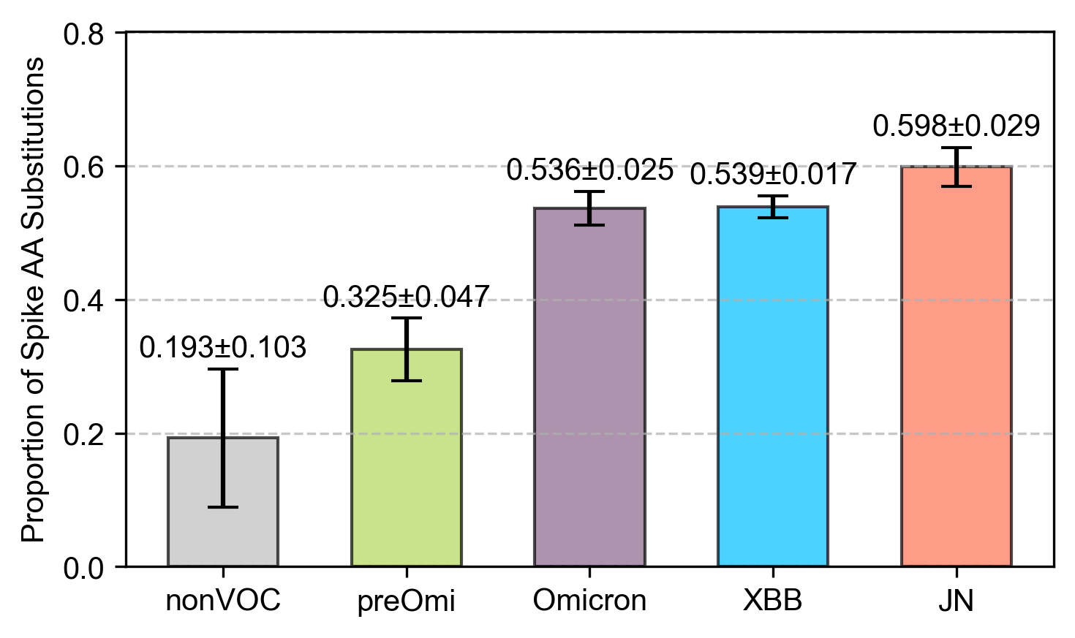
Fig. S2 Spike mutations as a proportion of total genome in different variants.
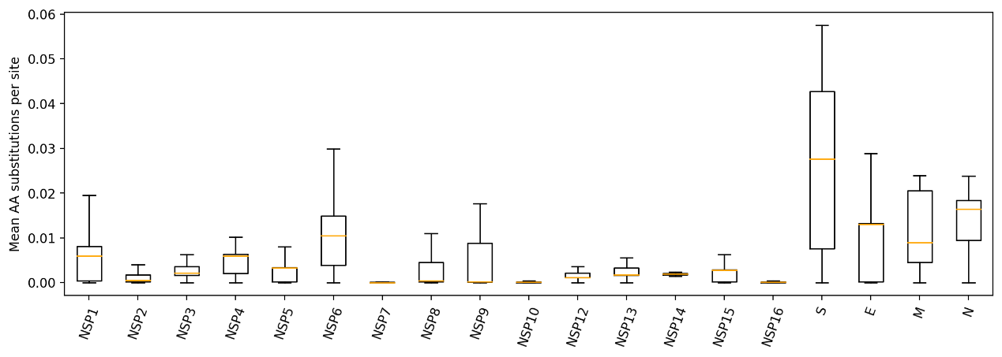
Fig. S3 Distribution of amino acid mutation number normalized by gene loci.
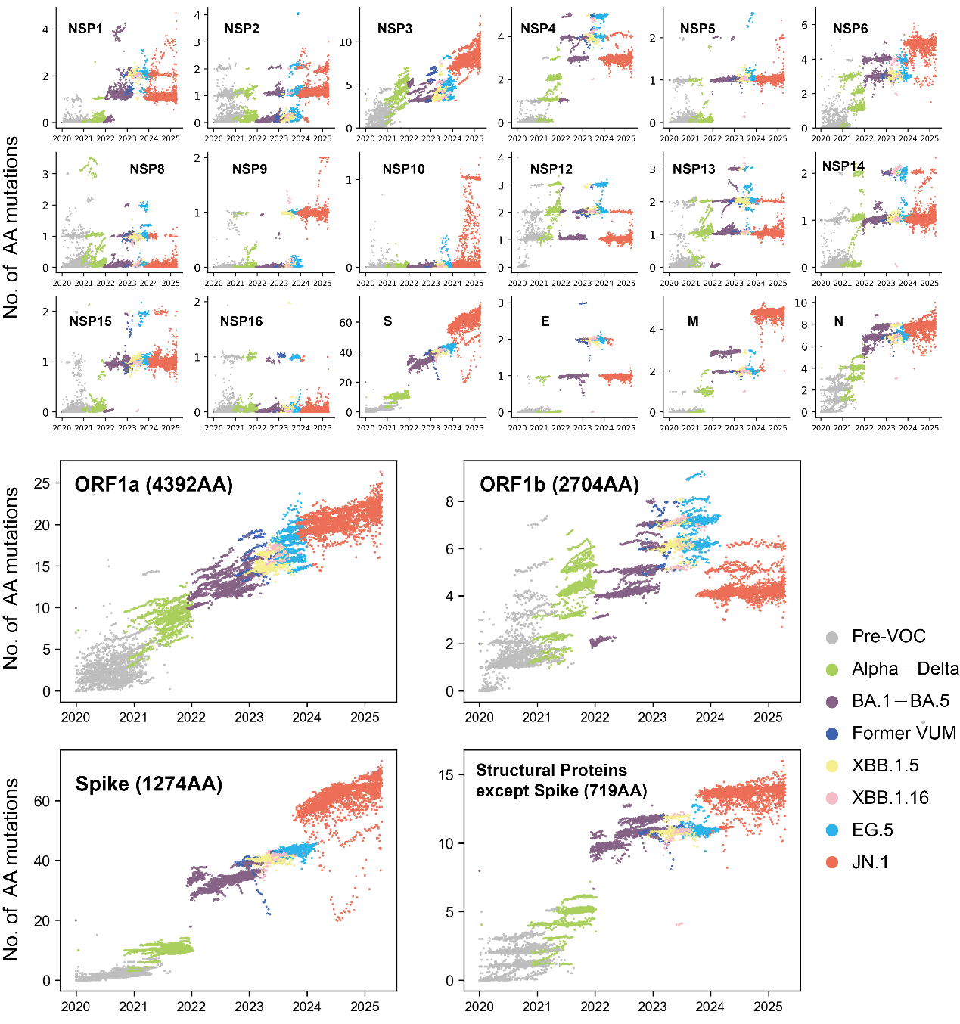
Fig. S4 Distribution of gene mutations number along time in different variants.
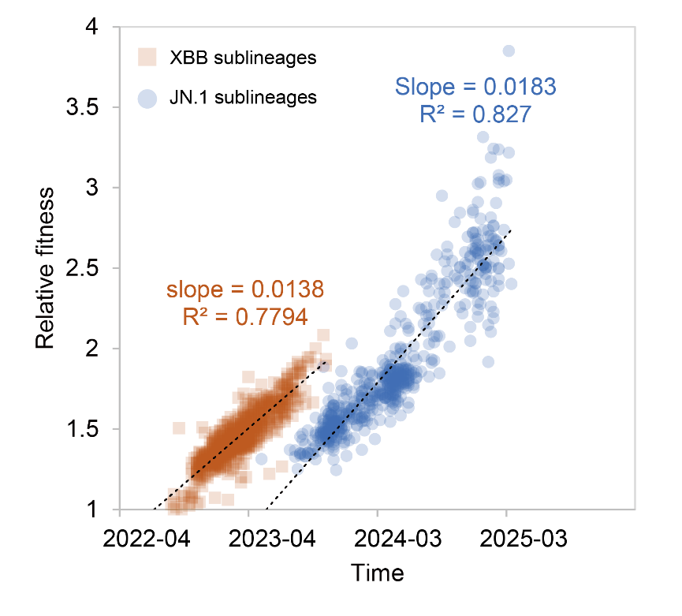
Fig. S5 Comparison of fitness acceleration for XBB and JN.1 lineages using ancestral reference genomes. Relative fitness was computed within each group relative to its reference variant (XBB for the XBB sublineages and BA.2.86 for the JN.1 sublineages).
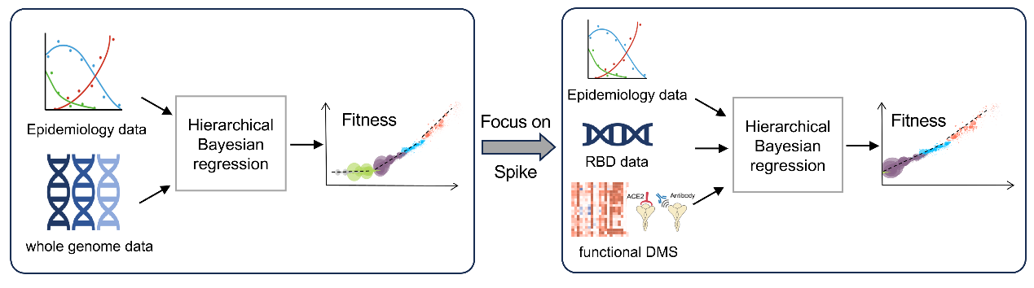
Fig. S6 Schematic comparison of input and analysis workflow for PyR0 versus CoVPF, highlighting differences in data inputs.
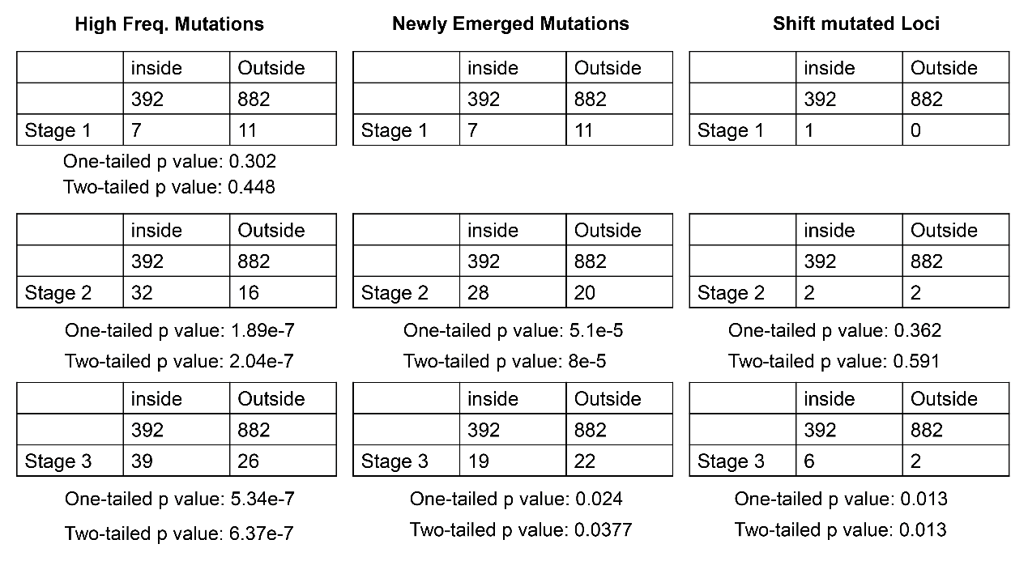
Fig. S7 Fisher's exact test for the distribution of mutations in antigenic epitope regions.
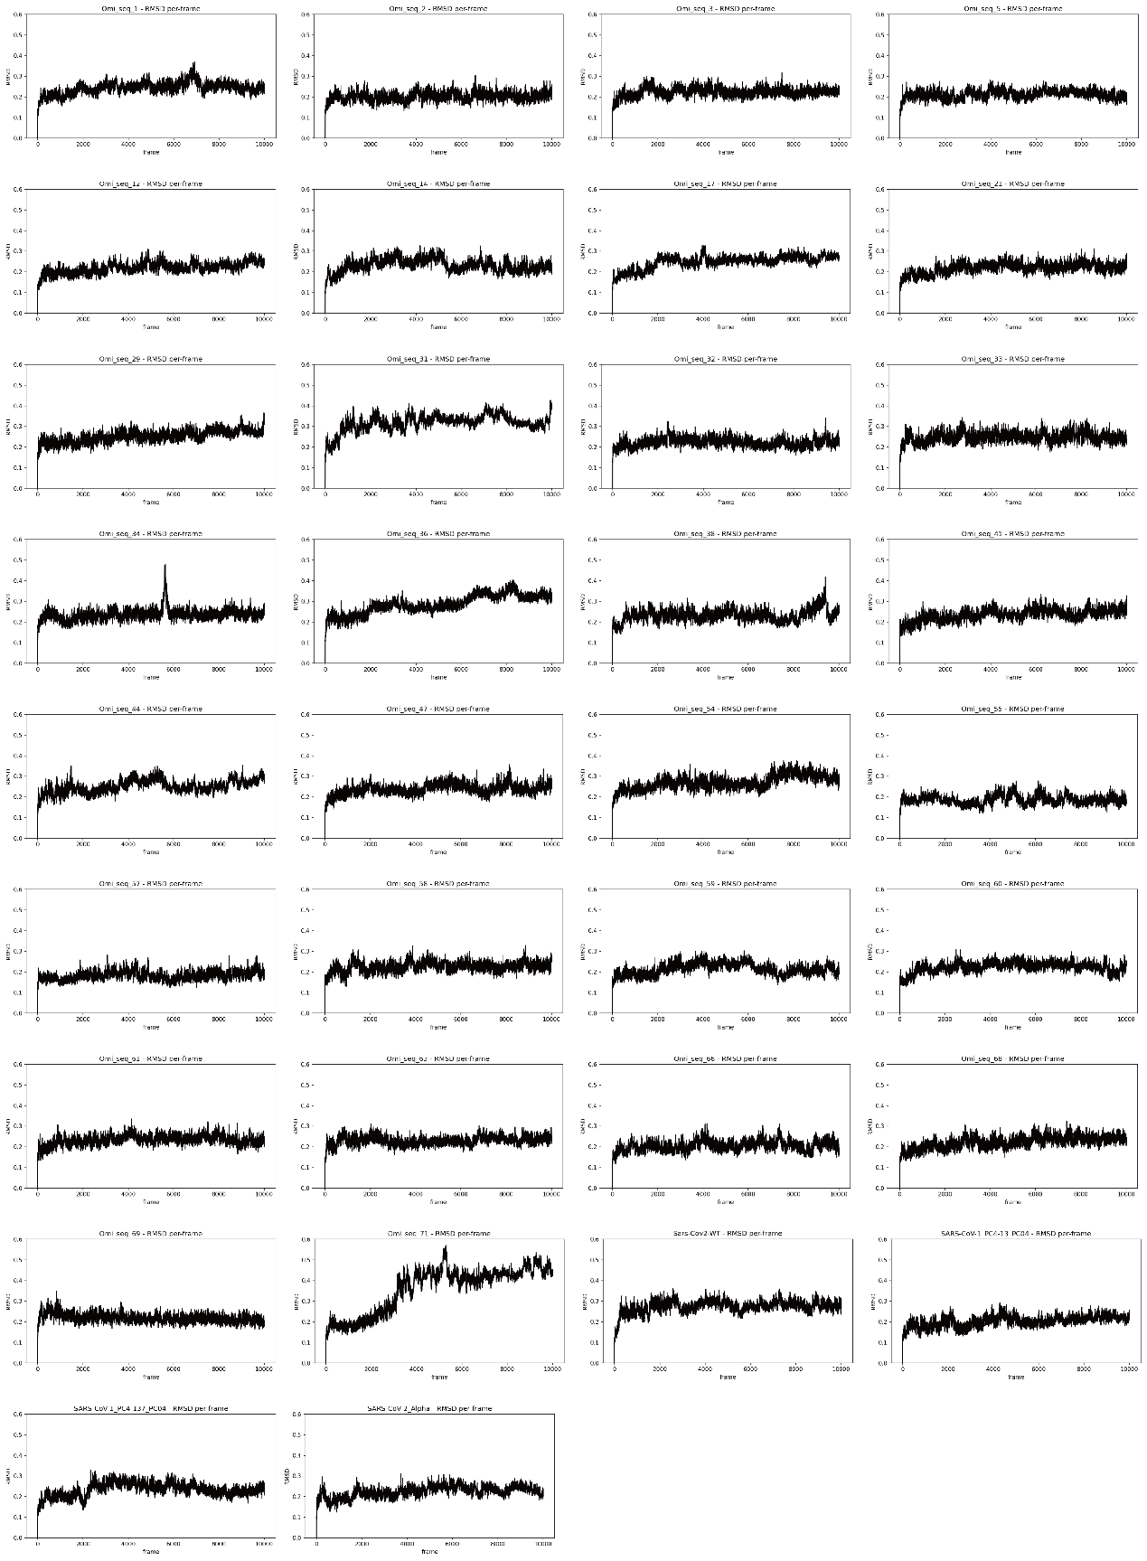
Fig. S8 RMSD of representative RBD in 100 ns molecular dynamics.
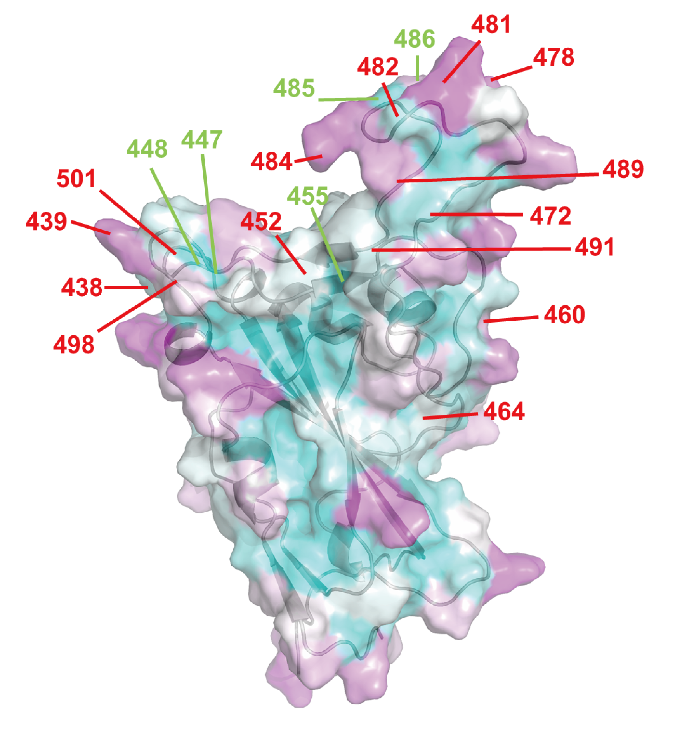
Fig. S9 The RBD structure of the JN.1 representative variant, colored by mean SASA. Red lines indicate loci with SASA increases exceeding 30%, while green lines mark loci with SASA decreases exceeding 30%.
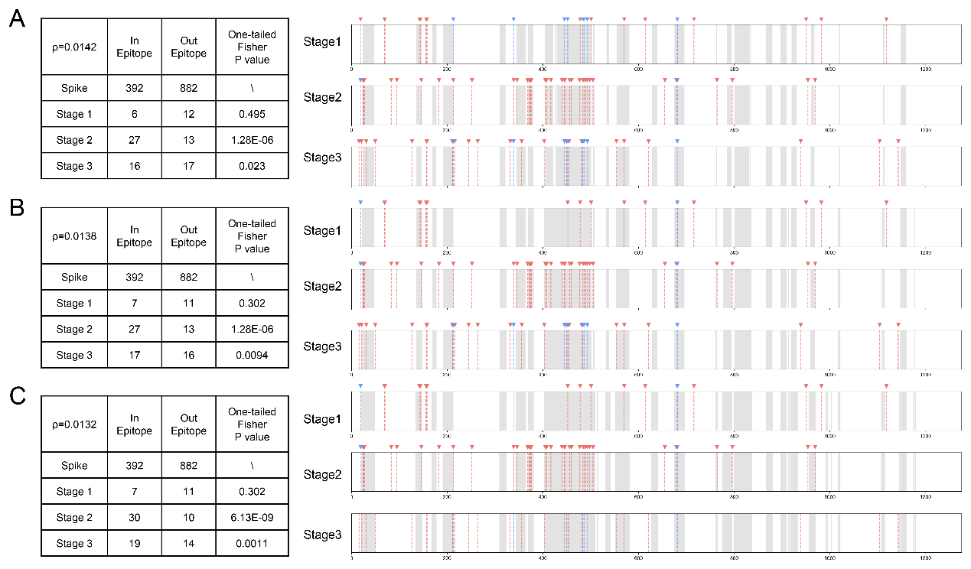
Fig. S10 Fisher’s test for the distribution of mutations using different threshold (ρ, A–C) for defining antigenic epitope regions.

Supplementary Table S1–S6
(Excel files)
Table S1 Functional effects of newly emerged fixed mutations in JN.1 stage.
Mutation | Function | Reference
Ins16MPLF | The NTD mutation ins16MPLF significantly affected neutralization sensitivity, and its reversion resulted in a 4-fold increase in neutralization titers relative to BA.2.86. | (Bdeir et al., 2025)
K356T | The mutation K356T within the RBD plays a contributing role to BA.2.86 escape of neutralization by polyclonal sera, whereby it lead to a six-fold reduction in neutralization efficiency relative to BA.2pp, in comparison to an 18 fold reduction in the case of BA.2.86pp. | (Bdeir et al., 2025)
V483del | The neutralization capacity of serum samples against epitopes in the RBD of BA.2.86pp was significantly affected prior to the XBB.1.5 booster by the mutations K356T and ΔV483, which had a 6 or 7 fold reduction in neutralization titer relative to BA.2. | (Bdeir et al., 2025)
E554K | The impact of BA.2.86 mutations on neutralization escape following vaccination with the adapted XBB.1.5 immunogen revealed that the mutants insMPLF16Δpp, K554Epp, and K460Npp significantly recovered the neutralization efficiency of plasma samples above BA.2.86pp and to levels comparable to that of BA.2 neutralization. | (Bdeir et al., 2025)
P621S | The mutation P621S in the S1/S2 domain of BA.2.86 contributed to significant neutralization escape and this phenotype | (Bdeir et al., 2025)
L455S | mutation L455S has been observed in 856 reported BA.2.86 sequences and has been named JN.1. Neutralization assays show that JN.1 knocks out mAbs BA.4/5–8, −10, −28, and −35, which show neutralizing activity against BA.2.86. | (Liu et al., 2024)
R21T | The antigenic “supersite” of the NTD was reported to consist of the 14-20 N-terminus, the 140–158 β-hairpin and the 245–264 loop. Given this context, the V16MPLF insertion, R21T, Y144del, F157S, R158G, H245N and A264D possibly contributed to the immune escape of the NTD targeted antibodies. | (Ruan et al., 2025)
F157S |  | (Ruan et al., 2025)
R158G |  | (Ruan et al., 2025)
H245N |  | (Ruan et al., 2025)
A264D |  | (Ruan et al., 2025)
N450D | BD55-5840 was highly sensitive (> 10× reduction) to the mutations of D339H/N/Y, R346S/I/T, K444N, V445P, G446D and N450D. For the 85F7, the R346S/T, K444N/R, V445P, G446D/S/V and N450D exhibited strongly evasion (> 10× reduction). | (Chen et al., 2023)

Table S2 Functional effects of shift mutated loci in JN.1 stage.
Spike Mutation | Spike Mutation | Function | Reference
V213G | V213E | V213G: During early Omicron circulation, BA.2 carried the V213G substitution, which has been shown to mediate escape from neutralizing antibodies targeting the N-terminal domain (NTD). | (Cao et al., 2022a)
V213G | V213E | V213E: V213E in XBB, which in combination with other substitutions such as G252V and G339H, conferred enhanced immune escape compared to V213G. | (Roederer et al., 2024)
G339D | G339H | G339D: G339D arose in BA.1/BA.2 and became fixed, with reports of increased antibody escape. With the emergence of XBB, 339H appeared and persisted into the third phase (retained in BA.2.86 and the JN sublineages). In combination with R346T, G339H enhances resistance to neutralizing antibodies, making variants less susceptible to S309, which is raised against the G339D-bearing variant, and thereby facilitating immune escape. | (Cao et al., 2022b)
G339D | G339H | G339H: R346T and G339H mutations could confer the strong neutralization resistance of CH.1.1 and CA.3.1 to S309-like antibodies. | (Qu et al., 2023)
V445P | V445H | V445P: The XBB-characteristic substitution V445P was replaced by 445H in the early third phase, with a recent trend toward 445R. Previous studies have shown that certain mutations at position 445 can enhance viral resistance to specific neutralizing mAbs, but the reasons for the current amino acid changes remain uninvestigated. | (Chen et al., 2023)
L452R | L452W | L452R: L452R is a characteristic mutation of Delta and also appeared as a defining feature of the BA.5 sublineages, but it was absent in the JN ancestors BA.2 and BA.2.86. In the third phase, a fixed L452W substitution emerged at this site. L452R can promote immune escape, whereas L452W confers even stronger escape, showing markedly greater resistance to the antibody pT1616 than L452R. | (Tao et al., 2021)
L452R | L452W | L452W: While the previously reported representatives of this class of SARS-CoV-2 mAbs are highly sensitive to mutations of L452, such as L452R, antibody pT1616 only loses its potency either due to an amino acid exchange into a large bulky residue like L452W (BA.2.86). | (Stein et al., 2024)
E484A | E484K | E484K: E484K has also been identified as an escape mutation that emerges during exposure to mAbs C121 and C144 and convalescent plasma, and was the only mutation described in one study as able to reduce the neutralizing ability of a combination of mAbs (REGN10989 and REGN10934) to an unmeasurable level.” | (Harvey et al., 2021)
E484A | E484K | E484A: Five BA.1 mutations (K417N, G446S, E484A, Q493R, and G496S) have a particularly strong effect in promoting antibody escape. These mutations all individually reduce affinity to ACE2, but strong high-order epistasis with the pair of Q498R and N501Y mitigates this: either N501Y or Q498R alone reduces the cost of the five escape mutations, and the combination of both almost fully compensates for these deleterious effects. | (Moulana et al., 2022)
F486V | F486P | F486V: F486V (BA.5, BQ.1) enhances immune evasion but reduces ACE2-binding affinity. | (Yajima et al., 2024)
F486V | F486P | F486P: This suggested that the XBB.1.5 acquired S:S486P substitution which confers augmented ACE2 binding affinity without losing immune resistance, leading to greater transmissibility compared to XBB.1.” “the RBD Y473–P491 loop regions … were compared between XBB.1 and XBB.1.5. They are slightly shifted outward in closed-2 of XBB.1.5. | (Tamura et al., 2024)
Q493R | Q493E | Q493R: the observations made in the Omicron+Q493 revealed the significance of the Q493R mutation unique to the Omicron variant, including an increased affinity.”; “neutralizing antibodies in groups A–D, the epitopes of which overlap with the ACE2-binding motif, are largely escaped by K417N, G446S, E484A and Q493R.” | (Cao et al., 2022b)
Q493R | Q493E | Q493E: the unique Q493E substitution in KP.3 Spike glycoprotein enhances its receptor ACE2-binding affinity and immune evasion, enabling it to outcompete KP.2.1. | (Liu et al., 2025)

Table S3 Distribution of fixed loci in antigenic epitope region.
Fixed Loci | In Epitope | Out Epitope | One-tailed Fisher P-value
Spike | 392 | 882 | \
Stage 1 | 7 | 11 | 0.302
Stage 2 | 32 | 16 | 1.89E-07
Stage 3 | 39 | 26 | 5.34E-07

Table S4 Distribution of newly emerged mutations in antigenic epitope region.
Newly-emerged Mutations | In Epitope | Out Epitope | One-tailed Fisher P-value
Spike | 392 | 882 | \
Stage 1 | 7 | 11 | 0.302
Stage 2 | 27 | 15 | 5.39E-06
Stage 3 | 15 | 15 | 2.00E-02

Table S5 Information of SARS-CoV-2 RBD sequences that reached a ≥0.5% global viral population frequency.
No. | Lineage | Clade | Mutation
1 | KP.3.1 | JN.1 | I332V,G339H,K356T,S371F,S373P,S375F,T376A,D405N,R408S,K417N,N440K,V445H,G446S,N450D,L452W,L455S,F456L,N460K,S477N,T478K,N481K,E484K,F486P,Q493E,Q498R,N501Y,Y505H
2 | KP.3.1.1 | JN.1 | I332V,G339H,K356T,S371F,S373P,S375F,T376A,D405N,R408S,K417N,N440K,V445H,G446S,N450D,L452W,L455S,F456L,N460K,S477N,T478K,N481K,V483-,E484K,F486P,Q493E,Q498R,N501Y,Y505H
3 | JN.1.16 | JN.1 | I332V,G339H,K356T,S371F,S373P,S375F,T376A,D405N,R408S,K417N,N440K,V445H,G446S,N450D,L452W,L455S,F456L,N460K,S477N,T478K,N481K,V483-,E484K,F486P,Q498R,N501Y,Y505H
4 | JN.1 | JN.1 | I332V,G339H,K356T,S371F,S373P,S375F,T376A,D405N,R408S,K417N,N440K,V445H,G446S,N450D,L452W,L455S,N460K,S477N,T478K,N481K,E484K,F486P,Q498R,N501Y,Y505H
5 | JN.1 | JN.1 | I332V,G339H,K356T,S371F,S373P,S375F,T376A,D405N,R408S,K417N,N440K,V445H,G446S,N450D,L452W,L455S,N460K,S477N,T478K,N481K,F486P,Q498R,N501Y,Y505H
6 | JN.1 | JN.1 | I332V,G339H,K356T,S371F,S373P,S375F,T376A,D405N,R408S,K417N,N440K,V445H,G446S,N450D,L452W,L455S,N460K,S477N,T478K,N481K,V483-,E484K,F486P,Q498R,N501Y,Y505H
7 | BA.2.86.1 | JN.1 | I332V,G339H,K356T,S371F,S373P,S375F,T376A,D405N,R408S,K417N,N440K,V445H,G446S,N450D,L452W,N460K,S477N,T478K,N481K,V483-,E484K,F486P,Q498R,N501Y,Y505H
8 | KP.3.3 | JN.1 | I332V,G339H,K356T,S371F,S373P,S375F,T376A,R403K,D405N,K417N,A435S,N440K,V445H,G446S,N450D,L452W,L455S,F456L,N460K,S477N,T478K,N481K,V483-,E484K,F486P,Q493E,Q498R,N501Y,Y505H
9 | BQ.1.1 | BA.5 | D405N,R408S,K417N,N440K,K444T,L452R,N460K,S477N,T478K,E484A,F486V,Q498R,N501Y,Y505H
10 | BA.5.2.1 | BA.5 | D405N,R408S,K417N,N440K,L452R,S477N,T478K,E484A,F486V,Q498R,N501Y,Y505H
11 | BA.2 | BA.2 | D405N,R408S,K417N,N440K,S477N,T478K,E484A,Q493R,Q498R,N501Y,Y505H
12 | BA.1 | earlyOmi | G339D
13 | BA.1 | earlyOmi | G339D,K417N,N440K,G446S,S477N,T478K,E484A,Q493R,G496S,Q498R,N501Y,Y505H
14 | BA.1 | earlyOmi | G339D,N440K,G446S,S477N,T478K,E484A,Q493R,G496S,Q498R,N501Y,Y505H
15 | BA.5.9 | BA.5 | G339D,R346I,S371F,S373P,S375F,T376A,D405N,R408S,K417N,N440K,L452R,S477N,T478K,E484A,F486V,Q498R,N501Y,Y505H
16 | BA.1.1 | earlyOmi | G339D,R346K
17 | BA.1.1 | earlyOmi | G339D,R346K,N440K,G446S,S477N,T478K,E484A,Q493R,G496S,Q498R,N501Y,Y505H
18 | XBB.1.5 | XBB | D405N,R408S,K417N,N440K,V445P,G446S,N460K,S477N,T478K,E484A,F486P,F490S,Q498R,N501Y,Y505H
19 | BA.1.1 | earlyOmi | G339D,R346K,S371L,S373P,S375F
20 | BA.1.1 | earlyOmi | G339D,R346K,S371L,S373P,S375F,K417N
21 | BA.1.1 | earlyOmi | G339D,R346K,S371L,S373P,S375F,K417N,N440K,G446S,S477N,T478K,E484A,Q493R
22 | BA.1.1 | earlyOmi | G339D,R346K,S371L,S373P,S375F,K417N,N440K,G446S,S477N,T478K,E484A,Q493R,G496S,Q498R,N501Y,Y505H
23 | BA.1.1 | earlyOmi | G339D,R346K,S371L,S373P,S375F,N440K,G446S,S477N,T478K,E484A,Q493R,G496S,Q498R,N501Y,Y505H
24 | BA.1.1 | earlyOmi | G339D,R346K,S371L,S373P,S375F,S477N,T478K,E484A,Q493R,G496S,Q498R,N501Y,Y505H
25 | BF.13 | BA.5 | G339D,R346S,S371F,S373P,S375F,T376A,D405N,R408S,K417N,N440K,L452R,S477N,T478K,E484A,F486V,Q498R,N501Y,Y505H
26 | BQ.1.1 | BA.5 | G339D,R346T,N440K,K444T,L452R,N460K,S477N,T478K,E484A,F486V,Q498R,N501Y,Y505H
27 | BA.4.6 | earlyOmi | G339D,R346T,S371F,S373P,S375F,T376A,D405N,K417N,N440K,L452R,S477N,T478K,E484A,F486V,Q498R,N501Y,Y505H
28 | BQ.1.1 | BA.5 | G339D,R346T,S371F,S373P,S375F,T376A,D405N,R408S,K417N
29 | BA.4.6 | earlyOmi | G339D,R346T,S371F,S373P,S375F,T376A,D405N,R408S,K417N,L452R,S477N,T478K,E484A,F486V,Q498R,N501Y,Y505H
30 | BQ.1.1 | BA.5 | G339D,R346T,S371F,S373P,S375F,T376A,D405N,R408S,K417N,N440K,K444T,L452R,N460K,S477N,T478K,E484A,F486V,Q498R,N501Y,Y505H
31 | BA.4.6 | earlyOmi | G339D,R346T,S371F,S373P,S375F,T376A,D405N,R408S,K417N,N440K,L452R,S477N,T478K,E484A,F486V,Q498R,N501Y,Y505H
32 | BA.2.76 | BA.2 | G339D,R346T,S371F,S373P,S375F,T376A,D405N,R408S,K417N,N440K,S477N,T478K,E484A,Q493R,Q498R,N501Y,Y505H
33 | BQ.1.1 | BA.5 | G339D,R346T,S371F,S373P,S375F,T376A,D405N,R408S,N440K,K444T,L452R,N460K,S477N,T478K,E484A,F486V,Q498R,N501Y,Y505H
34 | BQ.1.1 | BA.5 | G339D,R346T,S371F,S373P,S375F,T376A,D405N,S477N,T478K,E484A,F486V,Q498R,N501Y,Y505H
35 | BA.2 | BA.2 | G339D,S371F,S373P,S375F,K417N,N440K,S477N,T478K,E484A
36 | BA.2 | BA.2 | G339D,S371F,S373P,S375F,T376A,D405N
37 | BA.2.12.1 | BA.2 | G339D,S371F,S373P,S375F,T376A,D405N,K417N,N440K,L452Q,S477N,T478K,E484A,Q493R,Q498R,N501Y,Y505H
38 | BA.5.1 | BA.5 | G339D,S371F,S373P,S375F,T376A,D405N,K417N,N440K,L452R,S477N,T478K,E484A,F486V,Q498R,N501Y,Y505H
39 | BA.2 | BA.2 | G339D,S371F,S373P,S375F,T376A,D405N,K417N,N440K,S477N,T478K,E484A,Q493R,Q498R,N501Y,Y505H
40 | BA.5.2.1 | BA.5 | G339D,S371F,S373P,S375F,T376A,D405N,L452R,S477N,T478K,E484A,F486V,Q498R,N501Y,Y505H
41 | BA.2 | BA.2 | G339D,S371F,S373P,S375F,T376A,D405N,R408S,K417N
42 | BA.2.12.1 | BA.2 | G339D,S371F,S373P,S375F,T376A,D405N,R408S,K417N,L452Q,S477N,T478K,E484A,Q493R,Q498R,N501Y,Y505H
43 | BA.5.1 | BA.5 | G339D,S371F,S373P,S375F,T376A,D405N,R408S,K417N,L452R,S477N,T478K,E484A,F486V,Q498R,N501Y,Y505H
44 | CL.1 | BA.2 | G339D,S371F,S373P,S375F,T376A,D405N,R408S,K417N,N440K,K444N,L452R,N460K,S477N,T478K,E484A,F486V,Q498R,N501Y,Y505H
45 | BA.5.2.18 | BA.5 | G339D,S371F,S373P,S375F,T376A,D405N,R408S,K417N,N440K,K444R,L452R,S477N,T478K,E484A,F486V,Q498R,N501Y,Y505H
46 | BA.2.3.20 | BA.2 | G339D,S371F,S373P,S375F,T376A,D405N,R408S,K417N,N440K,K444R,N450D,L452M,N460K,S477N,T478K,E484R,Q498R,N501Y,Y505H
47 | BQ.1 | BA.5 | G339D,S371F,S373P,S375F,T376A,D405N,R408S,K417N,N440K,K444T,L452R,N460K,S477N,T478K,E484A,F486V,Q498R,N501Y,Y505H
48 | BA.2.56 | BA.2 | G339D,S371F,S373P,S375F,T376A,D405N,R408S,K417N,N440K,L452M,S477N,T478K,E484A,Q493R,Q498R,N501Y,Y505H
49 | BA.2.12.1 | BA.2 | G339D,S371F,S373P,S375F,T376A,D405N,R408S,K417N,N440K,L452Q,S477N,T478K,E484A,Q493R,Q498R,N501Y,Y505H
50 | BA.5.2.1 | BA.5 | G339D,S371F,S373P,S375F,T376A,D405N,R408S,K417N,N440K,L452R,S477N,T478K,E484A,F486V,Q498R,N501Y,Y505H
51 | BF.14 | BA.5 | G339D,S371F,S373P,S375F,T376A,D405N,R408S,K417N,N440K,N450D,L452R,S477N,T478K,E484A,F486V,Q498R,N501Y,Y505H
52 | BA.2 | BA.2 | G339D,S371F,S373P,S375F,T376A,D405N,R408S,K417N,N440K,S477N,T478K,E484A,Q493R
53 | BA.2 | BA.2 | G339D,S371F,S373P,S375F,T376A,D405N,R408S,K417N,N440K,S477N,T478K,E484A,Q493R,Q498R,N501Y,Y505H
54 | BA.5.1.12 | BA.5 | G339D,S371F,S373P,S375F,T376A,D405N,R408S,K417N,N440K,V445A,L452R,S477N,T478K,E484A,F486V,Q498R,N501Y,Y505H
55 | BA.2 | BA.2 | G339D,S371F,S373P,S375F,T376A,D405N,R408S,K417N,S477N,T478K,E484A,Q493R,Q498R,N501Y,Y505H
56 | BA.2.18 | BA.2 | G339D,S371F,S373P,S375F,T376A,D405N,R408S,K417T,N440K,S477N,T478K,E484A,Q493R,Q498R,N501Y,Y505H
57 | BA.5.1 | BA.5 | G339D,S371F,S373P,S375F,T376A,D405N,R408S,L452R,S477N,T478K,E484A,F486V,Q498R,N501Y,Y505H
58 | BQ.1 | BA.5 | G339D,S371F,S373P,S375F,T376A,D405N,R408S,N440K,K444T,L452R,N460K,S477N,T478K,E484A,F486V,Q498R,N501Y,Y505H
59 | BA.5.2.1 | BA.5 | G339D,S371F,S373P,S375F,T376A,D405N,R408S,N440K,L452R,S477N,T478K,E484A,F486V,Q498R,N501Y,Y505H
60 | BA.2 | BA.2 | G339D,S371F,S373P,S375F,T376A,D405N,R408S,S477N,T478K,E484A,Q493R,Q498R,N501Y,Y505H
61 | BA.5.2 | BA.5 | G339D,S371F,S373P,S375F,T376A,D405N,S477N,T478K,E484A,F486V,Q498R,N501Y,Y505H
62 | BA.2 | BA.2 | G339D,S371F,S373P,S375F,T376A,D405N,S477N,T478K,E484A,Q493R,Q498R,N501Y,Y505H
63 | BA.1 | earlyOmi | G339D,S371L,S373P,S375F,K417N
64 | BA.1 | earlyOmi | G339D,S371L,S373P,S375F,K417N,N440K,G446S
65 | BA.1 | earlyOmi | G339D,S371L,S373P,S375F,K417N,N440K,G446S,S477N,T478K,E484A,Q493R
66 | BA.1 | earlyOmi | G339D,S371L,S373P,S375F,K417N,N440K,G446S,S477N,T478K,E484A,Q493R,G496S,Q498R,N501Y,Y505H
67 | BA.1 | earlyOmi | G339D,S371L,S373P,S375F,N440K,G446S,S477N,T478K,E484A,Q493R,G496S,Q498R,N501Y,Y505H
68 | BA.1 | earlyOmi | G339D,S371L,S373P,S375F,S477N,T478K,E484A,Q493R,G496S,Q498R,N501Y,Y505H
69 | BA.5.2 | BA.5 | G339D,S373P,S375F,T376A,D405N,R408S,K417N,N440K,L452R,S477N,T478K,E484A,F486V,Q498R,N501Y,Y505H
70 | BA.2 | BA.2 | G339D,S373P,S375F,T376A,D405N,R408S,K417N,N440K,S477N,T478K,E484A,Q493R,Q498R,N501Y,Y505H
71 | BN.1.3 | BA.2 | G339H,R346T,K356T,S371F,S373P,S375F,T376A,D405N,R408S,K417N,N440K,G446S,N460K,S477N,T478K,E484A,F490S,Q498R,N501Y,Y505H
72 | BR.2.1 | BA.5 | G339H,R346T,S371F,S373P,S375F,T376A,D405N,R408S,K417N,N440K,G446S,L452R,N460K,S477N,T478K,E484A,F486I,Q498R,N501Y,Y505H
73 | B.1.621 | preOmi | R346K,E484K,N501Y
74 | B | nonVOC | N354D,D364Y
75 | B.1.1.176 | nonVOC | R357K
76 | B.1.2 | nonVOC | S359N
77 | A.23.1 | nonVOC | V367F
78 | XBF | BA.5 | G339H,R346T,S371F,S373P,S375F,T376A,D405N,R408S,K417N,N440K,G446S,N460K,S477N,T478K,E484A,F486P,F490S,Q498R,N501Y,Y505H
79 | B | nonVOC | W436-,N437-,S438-,N439-,N440-
80 | B.1.258 | nonVOC | N439K
81 | KP.3.1.1 | JN.1 | I332V,G339H,K356T,S371F,S373P,S375F,T376A,R403K,D405N,K417N,N440K,V445H,G446S,N450D,L452W,L455S,F456L,N460K,S477N,T478K,N481K,V483-,E484K,F486P,Q493E,Q498R,N501Y,Y505H
82 | B.1.1.298 | nonVOC | Y453F
83 | B.1.160 | nonVOC | S477N
84 | B.1.620 | nonVOC | S477N,E484K
85 | B.1.1.519 | nonVOC | T478K
86 | A.1 | nonVOC | V483A
87 | B.1.575 | nonVOC | S494P
88 | B.1.1.7 | preOmi | S494P,N501Y
89 | WT | nonVOC
90 | B.1.2 | nonVOC | A522S
91 | B.1.2 | nonVOC | A520S
92 | B.1.517 | nonVOC | N501T
93 | B.1.1.7 | preOmi | N501Y
94 | B.1.526 | preOmi | E484K
95 | P.1 | preOmi | E484K,N501Y
96 | C.37 | preOmi | L452Q,F490S
97 | AY.4 | preOmi | L452R,T478K
98 | B.1.617.2 | preOmi | L452R,T478K,E484Q
99 | B.1.429 | preOmi | L452R
100 | B.1.617.1 | preOmi | L452R,E484Q
101 | B.1.351 | preOmi | K417N,E484K,N501Y
102 | P.1 | preOmi | K417T
103 | P.1 | preOmi | K417T,E484K,N501Y
104 | XBB.1.16 | XBB | G339H,L368I,S371F,S373P,S375F,T376A,D405N,R408S,K417N,N440K,V445P,G446S,N460K
105 | XBB.1 | XBB | G339H,R346T
106 | XBB.1.5 | XBB | G339H,R346T,L368I,S371F,S373P,S375F,T376A,D405N,K417N,N440K,V445P,G446S,N460K,S477N,T478K,E484A,F486P,F490S,Q498R,N501Y,Y505H
107 | XBB.1.5 | XBB | G339H,R346T,L368I,S371F,S373P,S375F,T376A,D405N,N440K,V445P,G446S,N460K,S477N,T478K,E484A,F486P,F490S,Q498R,N501Y,Y505H
108 | EU.1.1 | XBB | G339H,R346T,L368I,S371F,S373P,S375F,T376A,D405N,R408S,I410V,K417N,N440K,V445P,G446S,N460K,S477N,T478K,E484A,F486P,F490S,Q498R,N501Y,Y505H,P521S
109 | XBB.1.5 | XBB | G339H,R346T,L368I,S371F,S373P,S375F,T376A,D405N,R408S,K417N
110 | HV.1 | XBB | G339H,R346T,L368I,S371F,S373P,S375F,T376A,D405N,R408S,K417N,N440K,K444T,V445P,G446S,L452R,F456L,N460K,S477N,T478K,E484A,F486P,F490S,Q498R,N501Y,Y505H
111 | EG.5.1.1 | XBB | G339H,R346T,L368I,S371F,S373P,S375F,T376A,D405N,R408S,K417N,N440K,V445P,G446S,F456L,N460K,S477N,T478K,E484A,F486P,F490S,Q498R,N501Y,Y505H
112 | FL.1.5.2 | XBB | G339H,R346T,L368I,S371F,S373P,S375F,T376A,D405N,R408S,K417N,N440K,V445P,G446S,F456L,N460K,S477N,T478K,N481K,E484A,F486P,F490P,Q498R,N501Y,Y505H
113 | FL.1.5.1 | XBB | G339H,R346T,L368I,S371F,S373P,S375F,T376A,D405N,R408S,K417N,N440K,V445P,G446S,F456L,N460K,S477N,T478R,E484A,F486P,F490S,Q498R,N501Y,Y505H
114 | HV.1 | XBB | G339H,R346T,L368I,S371F,S373P,S375F,T376A,D405N,R408S,K417N,N440K,V445P,G446S,L452R,F456L,N460K,S477N,T478K,E484A,F486P,F490S,Q498R,N501Y,Y505H
115 | JD.1.1 | XBB | G339H,R346T,L368I,S371F,S373P,S375F,T376A,D405N,R408S,K417N,N440K,V445P,G446S,L455F,F456L,N460K,A475V,S477N,T478K,E484A,F486P,F490S,Q498R,N501Y,Y505H
116 | HK.3 | XBB | G339H,R346T,L368I,S371F,S373P,S375F,T376A,D405N,R408S,K417N,N440K,V445P,G446S,L455F,F456L,N460K,S477N,T478K,E484A,F486P,F490S,Q498R,N501Y,Y505H
117 | GK.2.1 | XBB | G339H,R346T,L368I,S371F,S373P,S375F,T376A,D405N,R408S,K417N,N440K,V445P,G446S,L455F,F456L,N460K,S477N,T478K,E484A,F486P,F490S,Q498R,N501Y,Y505H,V511I
118 | JF.1 | XBB | G339H,R346T,L368I,S371F,S373P,S375F,T376A,D405N,R408S,K417N,N440K,V445P,G446S,L455F,F456L,N460K,S477N,T478R,E484A,F486P,F490S,Q498R,N501Y,Y505H
119 | JG.3 | XBB | G339H,R346T,L368I,S371F,S373P,S375F,T376A,D405N,R408S,K417N,N440K,V445P,G446S,N450D,L455F,F456L,N460K,S477N,T478K,E484A,F486P,F490S,Q498R,N501Y,Y505H
120 | XBB.1.5 | XBB | G339H,R346T,L368I,S371F,S373P,S375F,T376A,D405N,R408S,K417N,N440K,V445P,G446S,N460K,S477N,T478K,E484A,F486P,F490S,Q498R,N501Y,Y505H
121 | XBB.2.3 | XBB | G339H,R346T,L368I,S371F,S373P,S375F,T376A,D405N,R408S,K417N,N440K,V445P,G446S,N460K,S477N,T478K,E484A,F486P,F490S,Q498R,N501Y,Y505H,P521S
122 | XBB.1 | XBB | G339H,R346T,L368I,S371F,S373P,S375F,T376A,D405N,R408S,K417N,N440K,V445P,G446S,N460K,S477N,T478K,E484A,F486S,F490S,Q498R,N501Y,Y505H
123 | XBB.1.16 | XBB | G339H,R346T,L368I,S371F,S373P,S375F,T376A,D405N,R408S,K417N,N440K,V445P,G446S,N460K,S477N,T478R,E484A,F486P,F490S,Q498R,N501Y,Y505H
124 | GE.1 | XBB | G339H,R346T,L368I,S371F,S373P,S375F,T376A,D405N,R408S,K417N,N440K,V445P,G446S,N460K,S477N,T478R,E484A,F486P,F490S,Q498R,N501Y,Y505H,P521S
125 | XBB.1.16.11 | XBB | G339H,R346T,L368I,S371F,S373P,S375F,T376A,D405N,R408S,K417N,N440K,V445P,G446S,N460K,S477N,T478R,E484A,F486P,F490S,Q498R,N501Y,Y505H,P521T
126 | EG.5.1 | XBB | G339H,R346T,L368I,S371F,S373P,S375F,T376A,D405N,R408S,N440K,V445P,G446S,F456L,N460K,S477N,T478K,E484A,F486P,F490S,Q498R,N501Y,Y505H
127 | XBB.1.16.6 | XBB | G339H,R346T,L368I,S371F,S373P,S375F,T376A,D405N,R408S,N440K,V445P,G446S,F456L,N460K,S477N,T478R,E484A,F486P,F490S,Q498R,N501Y,Y505H
128 | HV.1 | XBB | G339H,R346T,L368I,S371F,S373P,S375F,T376A,D405N,R408S,N440K,V445P,G446S,L452R,F456L,N460K,S477N,T478K,E484A,F486P,F490S,Q498R,N501Y,Y505H
129 | HK.3 | XBB | G339H,R346T,L368I,S371F,S373P,S375F,T376A,D405N,R408S,N440K,V445P,G446S,L455F,F456L,N460K,S477N,T478K,E484A,F486P,F490S,Q498R,N501Y,Y505H
130 | XBB.1.5 | XBB | G339H,R346T,L368I,S371F,S373P,S375F,T376A,D405N,R408S,N440K,V445P,G446S,N460K,S477N,T478K,E484A,F486P,F490S,Q498R,N501Y
131 | XBB.1.5 | XBB | G339H,R346T,L368I,S371F,S373P,S375F,T376A,D405N,R408S,N440K,V445P,G446S,N460K,S477N,T478K,E484A,F486P,F490S,Q498R,N501Y,Y505H
132 | XBB.1.16 | XBB | G339H,R346T,L368I,S371F,S373P,S375F,T376A,D405N,R408S,N440K,V445P,G446S,N460K,S477N,T478R,E484A,F486P,F490S,Q498R,N501Y,Y505H
133 | XBB.1.5 | XBB | G339H,R346T,L368I,S371F,S373P,S375F,T376A,D405N,S477N,T478K,E484A,F486P,F490S,Q498R,N501Y,Y505H
134 | EG.5.1 | XBB | G339H,R346T,N440K,V445P,G446S,F456L,N460K,S477N,T478K,E484A,F486P,F490S,Q498R,N501Y,Y505H
135 | BA.2.75.2 | BA.2 | G339H,R346T,S371F,S373P,S375F,T376A,D405N,R408S,K417N,N440K,G446S,N460K,S477N,T478K,E484A,F486S,Q498R,N501Y,Y505H
136 | CH.1.1 | BA.2 | G339H,R346T,S371F,S373P,S375F,T376A,D405N,R408S,K417N,N440K,K444T,G446S,L452R,N460K,S477N,T478K,E484A,F486S,Q498R,N501Y,Y505H
137 | BA.2.24 | BA.2 | G339N,S371F,S373P,S375F,T376A,D405N,R408S,K417N,N440K,S477N,T478K,E484A,Q493R,Q498R,N501Y,Y505H
138 | HK.3 | XBB | G339H,R346T,N440K,V445P,G446S,L455F,F456L,N460K,S477N,T478K,E484A,F486P,F490S,Q498R,N501Y,Y505H
139 | BA.1.1 | earlyOmi | K417N,N440K,G446S,S477N,T478K,E484A,Q493R,G496S,Q498R,N501Y,Y505H
140 | XBB.1.5 | XBB | G339H,R346T,N440K,V445P,G446S,N460K,S477N,T478K,E484A,F486P,F490S,Q498R,N501Y,Y505H
141 | XBB.1.16 | XBB | G339H,R346T,N440K,V445P,G446S,N460K,S477N,T478R,E484A,F486P,F490S,Q498R,N501Y,Y505H
142 | DV.7.1 | XBB | G339H,R346T,S371F,S373P,S375F,T376A,D405N,R408S,K417N,N440K,K444T,G446S,L452R,L455F,F456L,N460K,S477N,T478K,E484A,F486S,Q498R,N501Y,Y505H
143 | XBC.1.6 | XBB | R346S,S371F,S373P,S375F,T376A,D405N,R408S,K417N,N440K,G446S,L452R,S477N,T478K,E484A,F486P,Q498R,N501Y,Y505H
144 | XBB.1.5.12 | XBB | T323I,G339H,R346T,L368I,S371F,S373P,S375F,T376A,D405N,R408S,K417N,N440K,V445P,G446S,N460K,S477N,T478K,E484A,F486P,F490S,Q498R,N501Y,Y505H
145 | BA.5.2.1 | BA.5 | S371F,S373P,S375F,T376A,D405N,R408S,K417N,N440K,L452R,S477N,T478K,E484A,F486V,Q498R,N501Y,Y505H
146 | BA.2 | BA.2 | S477N,T478K,E484A,Q493R,Q498R,N501Y,Y505H
147 | JN.1 | JN.1 | I332V,G339H,K356T,S371F,S373P,S375F,T376A,R403K,D405N,K417N,N440K,V445H,G446S,N450D,L452W,L455S,N460K,S477N,T478K,N481K,V483-,E484K,F486P,Q498R,N501Y,Y505H
148 | JN.1.11 | JN.1 | I332V,G339H,K356T,S371F,S373P,S375F,T376A,R403K,D405N,R408S,K417N
149 | KP.3.3.2 | JN.1 | I332V,G339H,K356T,S371F,S373P,S375F,T376A,R403K,D405N,R408S,K417N,A435S,N440K,V445H,G446N,N450D,L452W,L455S,F456L,N460K,S477N,T478K,N481K,V483-,E484K,F486P,Q493E,Q498R,N501Y,Y505H
150 | KP.3.1.1 | JN.1 | I332V,G339H,K356T,S371F,S373P,S375F,T376A,R403K,D405N,R408S,K417N,A435S,N440K,V445H,G446S,N450D,L452W,L455S,F456L,N460K,A475V,S477N,T478K,N481K,V483-,E484K,F486P,Q493E,Q498R,N501Y,Y505H
151 | XDV.1 | JN.1 | I332V,G339H,K356T,S371F,S373P,S375F,T376A,R403K,D405N,R408S,K417N,A435S,N440K,V445H,G446S,N450D,L452W,L455S,F456L,N460K,S477N,T478I,N481K,V483-,E484K,F486P,Q493E,Q498R,N501Y,Y505H
152 | KP.3.1.1 | JN.1 | I332V,G339H,K356T,S371F,S373P,S375F,T376A,R403K,D405N,R408S,K417N,A435S,N440K,V445H,G446S,N450D,L452W,L455S,F456L,N460K,S477N,T478K,N481K,V483-,E484K,F486P,Q493E,Q498R,N501Y,Y505H
153 | PA.1 | JN.1 | I332V,G339H,K356T,S371F,S373P,S375F,T376A,R403K,D405N,R408S,K417N,A435S,N440K,V445P,G446S,N450D,L452W,L455S,F456L,N460K,S477N,T478K,N481K,V483-,E484K,F486P,Q493E,Q498R,N501Y,Y505H
154 | XDV.1 | JN.1 | I332V,G339H,K356T,S371F,S373P,S375F,T376A,R403K,D405N,R408S,K417N,N440K,V445H,G446S,N450D,L452W,L455S,F456L,N460K,S477N,T478I,N481K,V483-,E484K,F486P,Q493E,Q498R,N501Y,Y505H
155 | XDV.1 | JN.1 | I332V,G339H,K356T,S371F,S373P,S375F,T376A,R403K,D405N,R408S,K417N,N440K,V445H,G446S,N450D,L452W,L455S,F456L,N460K,S477N,T478I,N481K,V483-,E484K,F486P,Q498R,N501Y,Y505H
156 | KP.3.1 | JN.1 | I332V,G339H,K356T,S371F,S373P,S375F,T376A,R403K,D405N,R408S,K417N,N440K,V445H,G446S,N450D,L452W,L455S,F456L,N460K,S477N,T478K,N481K,E484K,F486P,Q493E,Q498R,N501Y,Y505H
157 | XDV.1 | JN.1 | I332V,G339H,K356T,S371F,S373P,S375F,T376A,R403K,D405N,R408S,K417N,N440K,V445H,G446S,N450D,L452W,L455S,F456L,N460K,S477N,T478K,N481K,E484K,F486P,Q498R,N501Y,Y505H
158 | JN.1.16 | JN.1 | I332V,G339H,K356T,S371F,S373P,S375F,T376A,R403K,D405N,R408S,K417N,N440K,V445H,G446S,N450D,L452W,L455S,F456L,N460K,S477N,T478K,N481K,F486P,Q498R,N501Y,Y505H
159 | KP.3.1.1 | JN.1 | I332V,G339H,K356T,S371F,S373P,S375F,T376A,R403K,D405N,R408S,K417N,N440K,V445H,G446S,N450D,L452W,L455S,F456L,N460K,S477N,T478K,N481K,V483-,E484K,F486P,Q493E,Q498R,N501Y,Y505H
160 | JN.1.16 | JN.1 | I332V,G339H,K356T,S371F,S373P,S375F,T376A,R403K,D405N,R408S,K417N,N440K,V445H,G446S,N450D,L452W,L455S,F456L,N460K,S477N,T478K,N481K,V483-,E484K,F486P,Q498R,N501Y,Y505H
161 | KP.3.1.1 | JN.1 | I332V,G339H,K356T,S371F,S373P,S375F,T376A,R403K,D405N,R408S,K417N,N440K,V445H,G446S,N450D,L452W,L455S,F456L,N460K,S477N,T478K,V483-,E484K,F486P,Q493E,Q498R,N501Y,Y505H
162 | JN.1 | JN.1 | I332V,G339H,K356T,S371F,S373P,S375F,T376A,R403K,D405N,R408S,K417N,N440K,V445H,G446S,N450D,L452W,L455S,N460K,S477N,T478K,N481K,E484K,F486P,Q498R,N501Y,Y505H
163 | JN.1.4.5 | JN.1 | I332V,G339H,K356T,S371F,S373P,S375F,T376A,R403K,D405N,R408S,K417N,N440K,V445H,G446S,N450D,L452W,L455S,N460K,S477N,T478K,N481K,F486P,Q498R,N501Y,Y505H
164 | JN.1 | JN.1 | I332V,G339H,K356T,S371F,S373P,S375F,T376A,R403K,D405N,R408S,K417N,N440K,V445H,G446S,N450D,L452W,L455S,N460K,S477N,T478K,N481K,V483-,E484K,F486P,Q498R,N501Y,Y505H
165 | JN.1 | JN.1 | I332V,G339H,K356T,S371F,S373P,S375F,T376A,R403K,D405N,R408S,K417N,N440K,V445H,G446S,N450D,L452W,L455S,N460K,Y505H
166 | JN.1 | JN.1 | I332V,G339H,K356T,S371F,S373P,S375F,T376A,R403K,D405N,R408S,K417N,N440K,V445H,G446S,N450D,L452W,L455S,S477N,T478K,N481K,V483-,E484K,F486P,Q498R,N501Y,Y505H
167 | XDQ.1 | JN.1 | I332V,G339H,K356T,S371F,S373P,S375F,T376A,R403K,D405N,R408S,K417N,N440K,V445H,G446S,N450D,L452W,N460K,A475V,S477N,T478K,N481K,V483-,E484K,F486P,Q498R,N501Y,Y505H
168 | XDQ.1 | JN.1 | I332V,G339H,K356T,S371F,S373P,S375F,T376A,R403K,D405N,R408S,K417N,N440K,V445H,G446S,N450D,L452W,N460K,A475V,S477N,T478K,V483-,E484K,F486P,Q498R,N501Y,Y505H
169 | BA.2.86.1 | JN.1 | I332V,G339H,K356T,S371F,S373P,S375F,T376A,R403K,D405N,R408S,K417N,N440K,V445H,G446S,N450D,L452W,N460K,S477N,T478K,N481K,E484K,F486P,Q498R,N501Y,Y505H
170 | BA.2.86.1 | JN.1 | I332V,G339H,K356T,S371F,S373P,S375F,T376A,R403K,D405N,R408S,K417N,N440K,V445H,G446S,N450D,L452W,N460K,S477N,T478K,N481K,V483-,E484K,F486P,Q498R,N501Y,Y505H
171 | JN.1.50 | JN.1 | I332V,G339H,K356T,S371F,S373P,S375F,T376A,R403K,D405N,R408S,K417N,N440K,V445P,G446S,N450D,L452W,L455S,F456L,N460K,S477N,T478K,N481K,V483-,E484K,F486P,Q498R,N501Y,Y505H
172 | JN.1.11 | JN.1 | I332V,G339H,K356T,S371F,S373P,S375F,T376A,R403K,D405N,R408S,K417N,N460K,S477N,T478K,N481K,V483-,E484K,F486P,Q493E
173 | KP.3.1.1 | JN.1 | I332V,G339H,K356T,S371F,S373P,S375F,T376A,R403K,D405N,R408S,N440K,V445H,G446S,N450D,L452W,L455S,F456L,N460K,S477N,T478K,N481K,V483-,E484K,F486P,Q493E,Q498R,N501Y,Y505H
174 | JN.1 | JN.1 | I332V,G339H,K356T,S371F,S373P,S375F,T376A,R403K,D405N,R408S,N440K,V445H,G446S,N450D,L452W,L455S,N460K,S477N,T478K,N481K
175 | JN.1 | JN.1 | I332V,G339H,K356T,S371F,S373P,S375F,T376A,R403K,D405N,R408S,N440K,V445H,G446S,N450D,L452W,L455S,N460K,S477N,T478K,N481K,V483-,E484K,F486P,Q498R,N501Y,Y505H
176 | JN.1.11 | JN.1 | I332V,G339H,K356T,S371F,S373P,S375F,T376A,R403K,D405N,S477N,T478K,N481K,E484K,F486P,Q493E,Q498R,N501Y,Y505H
177 | JN.1.11 | JN.1 | I332V,G339H,K356T,S371F,S373P,S375F,T376A,R403K,D405N,S477N,T478K,N481K,V483-,E484K,F486P,Q493E,Q498R,N501Y,Y505H
178 | JN.1 | JN.1 | I332V,G339H,K356T,S371F,S373P,S375F,T376A,R403K,D405N,S477N,T478K,N481K,V483-,E484K,F486P,Q498R,N501Y,Y505H
179 | KP.3.1.1 | JN.1 | I332V,G339H,K356T,S371F,S373P,S375F,T376N,R403K,D405N,R408S,K417N,N440K,V445H,G446S,N450D,L452W,L455S,F456L,N460K,S477N,T478K,N481K,V483-,E484K,F486P,Q493E,Q498R,N501Y,Y505H
180 | JN.1.42 | JN.1 | I332V,G339H,K356T,S373P,S375F,T376A,D405N,R408S,K417N,N440K,V445H,G446S,N450D,L452W,L455S,N460K,S477N,T478K,N481K,V483-,E484K,F486P,Q498R,N501Y,Y505H
181 | XEC | JN.1 | I332V,G339H,N440K,V445H,G446S,N450D,L452W,L455S,F456L,N460K,S477N,T478K,N481K,V483-,E484K,F486P,Q493E,Q498R,N501Y,Y505H
182 | KP.2 | JN.1 | I332V,G339H,R346T,K356T,S371F,S373P,S375F,T376A,D405N,R408S,K417N,N440K,V445H,G446S,N450D,L452W,L455S,F456L,N460K,S477N,T478K,N481K,E484K,F486P,Q498R,N501Y,Y505H
183 | KP.2 | JN.1 | I332V,G339H,R346T,K356T,S371F,S373P,S375F,T376A,D405N,R408S,K417N,N440K,V445H,G446S,N450D,L452W,L455S,F456L,N460K,S477N,T478K,N481K,V483-,E484K,F486P,Q498R,N501Y,Y505H
184 | JN.1.18 | JN.1 | I332V,G339H,R346T,K356T,S371F,S373P,S375F,T376A,D405N,R408S,K417N,N440K,V445H,G446S,N450D,L452W,L455S,N460K,S477N,T478K,N481K,E484K,F486P,Q498R,N501Y,Y505H
185 | JN.1.18 | JN.1 | I332V,G339H,R346T,K356T,S371F,S373P,S375F,T376A,D405N,R408S,K417N,N440K,V445H,G446S,N450D,L452W,L455S,N460K,S477N,T478K,N481K,V483-,E484K,F486P,Q498R,N501Y,Y505H
186 | LP.8.1.1 | JN.1 | I332V,G339H,R346T,K356T,S371F,S373P,S375F,T376A,D405N,R408S,K417N,N440K,V445R,G446S,N450D,L452W,L455S,F456L,N460K,S477N,T478K,N481K,E484K,F486P,Q493E,Q498R,N501Y,Y505H
187 | LP.8.1.1 | JN.1 | I332V,G339H,R346T,K356T,S371F,S373P,S375F,T376A,D405N,R408S,K417N,N440K,V445R,G446S,N450D,L452W,L455S,F456L,N460K,S477N,T478K,N481K,V483-,E484K,F486P,Q493E,Q498R,N501Y,Y505H
188 | KP.2.3 | JN.1 | I332V,G339H,R346T,K356T,S371F,S373P,S375F,T376A,R403K,D405N,K417N,N440K,V445H,G446S,N450D,L452W,L455S,F456L,N460K,S477N,T478K,N481K,V483-,E484K,F486P,Q498R,N501Y,Y505H
189 | LP.8.1 | JN.1 | I332V,G339H,R346T,K356T,S371F,S373P,S375F,T376A,R403K,D405N,K417N,N440K,V445R,G446S,N450D,L452W,L455S,F456L,N460K,S477N,T478K,N481K,V483-,E484K,F486P,Q493E,Q498R,N501Y,Y505H
190 | JN.1.11 | JN.1 | I332V,G339H,R346T,K356T,S371F,S373P,S375F,T376A,R403K,D405N,R408S,K417N
191 | KP.3.1.1 | JN.1 | I332V,G339H,R346T,K356T,S371F,S373P,S375F,T376A,R403K,D405N,R408S,K417N,A435S,N440K,V445H,G446S,N450D,L452W,L455S,F456L,N460K,S477N,T478K,N481K,V483-,E484K,F486P,Q493E,Q498R,N501Y,Y505H
192 | LF.7.2.1 | JN.1 | I332V,G339H,R346T,K356T,S371F,S373P,S375F,T376A,R403K,D405N,R408S,K417N,N440K,K444R,V445H,G446S,N450D,L452W,L455S,F456L,N460K,A475V,S477N,T478K,N481K,V483-,E484K,F486P,Q498R,N501Y,Y505H
193 | JN.1.40 | JN.1 | I332V,G339H,R346T,K356T,S371F,S373P,S375F,T376A,R403K,D405N,R408S,K417N,N440K,K444R,V445H,G446S,N450D,L452W,L455S,F456L,N460K,S477N,T478K,N481K,V483-,E484K,F486P,Q498R,N501Y,Y505H
194 | LF.7.7.2 | JN.1 | I332V,G339H,R346T,K356T,S371F,S373P,S375F,T376A,R403K,D405N,R408S,K417N,N440K,K444R,V445P,G446S,N450D,L452W,L455S,F456L,N460K,A475V,S477N,T478K,N481K,V483-,E484K,F486P,Q498R,N501Y,Y505H
195 | LF.7.7.2 | JN.1 | I332V,G339H,R346T,K356T,S371F,S373P,S375F,T376A,R403K,D405N,R408S,K417N,N440K,K444R,V445P,G446S,N450D,L452W,L455S,F456L,N460K,S477N,T478K,N481K,V483-,E484K,F486P,Q498R,N501Y,Y505H
196 | LR.1 | JN.1 | I332V,G339H,R346T,K356T,S371F,S373P,S375F,T376A,R403K,D405N,R408S,K417N,N440K,K444R,V445R,G446S,N450D,L452W,L455S,F456L,N460K,S477N,T478K,N481K,V483-,E484K,F486P,N487D,Q493E,Q498R,N501Y,Y505H
197 | LF.7 | JN.1 | I332V,G339H,R346T,K356T,S371F,S373P,S375F,T376A,R403K,D405N,R408S,K417N,N440K,L441R,K444R,V445P,G446S,N450D,L452W,L455S,F456L,N460K,A475V,S477N,T478K,N481K,V483-,E484K,F486P,Q498R,N501Y,Y505H
198 | KP.2 | JN.1 | I332V,G339H,R346T,K356T,S371F,S373P,S375F,T376A,R403K,D405N,R408S,K417N,N440K,V445H,G446S,N450D,L452W,L455S,F456L,N460K,S477N,N481K,V483-,E484K,F486P,Q498R,N501Y,Y505H
199 | KP.2 | JN.1 | I332V,G339H,R346T,K356T,S371F,S373P,S375F,T376A,R403K,D405N,R408S,K417N,N440K,V445H,G446S,N450D,L452W,L455S,F456L,N460K,S477N,T478K,N481K,E484K,F486P,Q498R,N501Y,Y505H
200 | KP.2.3 | JN.1 | I332V,G339H,R346T,K356T,S371F,S373P,S375F,T376A,R403K,D405N,R408S,K417N,N440K,V445H,G446S,N450D,L452W,L455S,F456L,N460K,S477N,T478K,N481K,F486P,Q498R,N501Y,Y505H
201 | KP.3.1.1 | JN.1 | I332V,G339H,R346T,K356T,S371F,S373P,S375F,T376A,R403K,D405N,R408S,K417N,N440K,V445H,G446S,N450D,L452W,L455S,F456L,N460K,S477N,T478K,N481K,V483-,E484K,F486P,Q493E,Q498R,N501Y,Y505H
202 | KP.2.3 | JN.1 | I332V,G339H,R346T,K356T,S371F,S373P,S375F,T376A,R403K,D405N,R408S,K417N,N440K,V445H,G446S,N450D,L452W,L455S,F456L,N460K,S477N,T478K,N481K,V483-,E484K,F486P,Q498R,N501Y,Y505H
203 | KP.2.3 | JN.1 | I332V,G339H,R346T,K356T,S371F,S373P,S375F,T376A,R403K,D405N,R408S,K417N,N440K,V445H,G446S,N450D,L452W,L455S,F456L,N460K,S477N,T478K,N481K,V483-,F486P,Q498R,N501Y,Y505H
204 | MB.1.1 | JN.1 | I332V,G339H,R346T,K356T,S371F,S373P,S375F,T376A,R403K,D405N,R408S,K417N,N440K,V445H,G446S,N450D,L452W,L455S,F456V,N460K,S477N,N481K,V483-,E484K,F486P,Q498R,N501Y,Y505H
205 | MA.1 | JN.1 | I332V,G339H,R346T,K356T,S371F,S373P,S375F,T376A,R403K,D405N,R408S,K417N,N440K,V445H,G446S,N450D,L452W,L455S,F456V,N460K,S477N,T478K,N481K,V483-,E484K,F486P,Q498R,N501Y,Y505H
206 | JN.1.13.1 | JN.1 | I332V,G339H,R346T,K356T,S371F,S373P,S375F,T376A,R403K,D405N,R408S,K417N,N440K,V445H,G446S,N450D,L452W,L455S,N460K,S477N,T478K,N481K,V483-,E484K,F486P,Q498R,N501Y,Y505H
207 | JN.1.8 | JN.1 | I332V,G339H,R346T,K356T,S371F,S373P,S375F,T376A,R403K,D405N,R408S,K417N,N440K,V445P,G446S,N450D,L452W,L455S,F456L,N460K,S477N,T478K,N481K,E484K,F486P,Q498R,N501Y,Y505H
208 | JN.1.8 | JN.1 | I332V,G339H,R346T,K356T,S371F,S373P,S375F,T376A,R403K,D405N,R408S,K417N,N440K,V445P,G446S,N450D,L452W,L455S,F456L,N460K,S477N,T478K,N481K,V483-,E484K,F486P,Q498R,N501Y,Y505H
209 | KP.1.1.3 | JN.1 | I332V,G339H,R346T,K356T,S371F,S373P,S375F,T376A,R403K,D405N,R408S,K417N,N440K,V445R,G446S,N450D,L452W,L455S,F456L,N460K,A475V,S477N,T478K,N481K,V483-,E484K,F486P,Q493E,Q498R,N501Y,Y505H
210 | LP.8.1.1 | JN.1 | I332V,G339H,R346T,K356T,S371F,S373P,S375F,T376A,R403K,D405N,R408S,K417N,N440K,V445R,G446S,N450D,L452W,L455S,F456L,N460K,S477N,N481K,V483-,E484K,F486P,Q493E,Q498R,N501Y,Y505H
211 | LP.8.1.1 | JN.1 | I332V,G339H,R346T,K356T,S371F,S373P,S375F,T376A,R403K,D405N,R408S,K417N,N440K,V445R,G446S,N450D,L452W,L455S,F456L,N460K,S477N,T478E,N481K,V483-,E484K,F486P,Q493E,Q498R,N501Y,Y505H
212 | LP.8.1 | JN.1 | I332V,G339H,R346T,K356T,S371F,S373P,S375F,T376A,R403K,D405N,R408S,K417N,N440K,V445R,G446S,N450D,L452W,L455S,F456L,N460K,S477N,T478K,N481K,E484K,F486P,Q493E,Q498R,N501Y,Y505H
213 | LP.8.1.2 | JN.1 | I332V,G339H,R346T,K356T,S371F,S373P,S375F,T376A,R403K,D405N,R408S,K417N,N440K,V445R,G446S,N450D,L452W,L455S,F456L,N460K,S477N,T478K,N481K,V483-,E484K,F486P,N487D,Q493E,Q498R,N501Y,Y505H
214 | LP.8.1.1 | JN.1 | I332V,G339H,R346T,K356T,S371F,S373P,S375F,T376A,R403K,D405N,R408S,K417N,N440K,V445R,G446S,N450D,L452W,L455S,F456L,N460K,S477N,T478K,N481K,V483-,E484K,F486P,Q493E,Q498R,N501Y,Y505H
215 | LP.8.1.1 | JN.1 | I332V,G339H,R346T,K356T,S371F,S373P,S375F,T376A,R403K,D405N,R408S,K417N,N440R,V445R,G446S,N450D,L452W,L455S,F456L,N460K,S477N,T478K,N481K,V483-,E484K,F486P,Q493E,Q498R,N501Y,Y505H
216 | JN.1.16.1 | JN.1 | I332V,G339H,R346T,K356T,S371F,S373P,S375F,T376A,R403K,D405N,R408S,N440K,V445H,G446S,N450D,L452W,L455S,F456L,N460K,S477N,T478K,N481K
217 | KP.2 | JN.1 | I332V,G339H,R346T,K356T,S371F,S373P,S375F,T376A,R403K,D405N,R408S,N440K,V445H,G446S,N450D,L452W,L455S,F456L,N460K,S477N,T478K,N481K,V483-,E484K,F486P,Q498R,N501Y,Y505H
218 | JN.1.11 | JN.1 | I332V,G339H,R346T,K356T,S371F,S373P,S375F,T376A,R403K,D405N,S477N,T478K,N481K,V483-,E484K,F486P,Q493E,Q498R,N501Y,Y505H
219 | JN.1.11 | JN.1 | I332V,G339H,R346T,K356T,S371F,S373P,S375F,T376A,R403K,D405N,S477N,T478K,N481K,V483-,E484K,F486P,Q498R,N501Y,Y505H
220 | LF.7.7.1 | JN.1 | I332V,G339H,R346T,K356T,S373P,S375F,T376A,D405N,R408S,K417N,N440K,K444R,V445H,G446S,N450D,L452W,L455S,F456L,N460K,S477N,T478K,N481K,V483-,E484K,F486P,Q498R,N501Y,Y505H
221 | KP.3.1.1 | JN.1 | I332V,G339H,S371F,S373P,S375F,T376A,R403K,D405N,R408S,K417N,N440K,V445H,G446S,N450D,L452W,L455S,F456L,N460K,S477N,T478K,N481K,V483-,E484K,F486P,Q493E,Q498R,N501Y,Y505H
222 | KP.3.1.1 | JN.1 | I332V,G339H,S371F,S373P,S375F,T376A,R403K,D405N,R408S,N440K,V445H,G446S,N450D,L452W,L455S,F456L,N460K,S477N,T478K,N481K,V483-,E484K,F486P,Q493E,Q498R,N501Y,Y505H
223 | XEC | JN.1 | I332V,G339H,T345S,K356T,S371F,S373P,S375F,T376A,R403K,D405N,R408S,K417N,N440K,V445H,G446S,N450D,L452W,L455S,F456L,N460K,S477N,T478K,N481K,V483-,E484K,F486P,Q493E,Q498R,N501Y,Y505H
224 | LB.1.1 | JN.1 | I332V,L335S,G339H,R346T,K356T,S371F,S373P,S375F,T376A,R403K,D405N,R408S,K417N,N440K,V445H,G446S,N450D,L452W,L455S,F456L,N460K,S477N,T478K,N481K,V483-,E484K,F486P,Q493E,Q498R,N501Y,Y505H
225 | KP.3.1.1 | JN.1 | N440K,V445H,G446S,N450D,L452W,L455S,F456L,N460K,S477N,T478K,N481K,V483-,E484K,F486P,Q493E,Q498R,N501Y,Y505H

Table S6. Information of SARS-CoV-2 RBD sequences performed 100 ns molecular dynamics (MD) simulations.
No. | Lineage | Clade | Mutation
1 | BA.5.9 | earlyOmi | G339D,R346I,S371F,S373P,S375F,T376A,D405N,R408S,K417N,N440K,L452R,S477N,T478K,E484A,F486V,Q498R,N501Y,Y505H
2 | BA.1.1.1 | earlyOmi | G339D,R346K,S371L,S373P,S375F,K417N,N440K,G446S,S477N,T478K,E484A,Q493R,G496S,Q498R,N501Y,Y505H
3 | BA.1.1 | earlyOmi | G339D,R346K,S371L,S373P,S375F,N440K,G446S,S477N,T478K,E484A,Q493R,G496S,Q498R,N501Y,Y505H
4 | BQ.1.1,BQ.1.1.1 | earlyOmi | G339D,R346T,S371F,S373P,S375F,T376A,D405N,R408S,K417N,N440K,K444T,L452R,N460K,S477N,T478K,E484A,F486V,Q498R,N501Y,Y505H
5 | BE.10,BE.9,BQ.1 | earlyOmi | G339D,S371F,S373P,S375F,T376A,D405N,R408S,K417N,N440K,K444T,L452R,N460K,S477N,T478K,E484A,F486V,Q498R,N501Y,Y505H
6 | BA.2.12.1 | earlyOmi | G339D,S371F,S373P,S375F,T376A,D405N,R408S,K417N,N440K,L452Q,S477N,T478K,E484A,Q493R,Q498R,N501Y,Y505H
7 | BA.2,BA.2.1 | earlyOmi | G339D,S371F,S373P,S375F,T376A,D405N,R408S,K417N,N440K,S477N,T478K,E484A,Q493R,Q498R,N501Y,Y505H
8 | BA.1.13.1 | earlyOmi | G339D,S371L,S373P,S375F,K417N,N440K,G446S,S477N,T478K,E484A,Q493R,G496S,Q498R,N501Y,Y505H
9 | EG.5.1,EG.5.1.1 | XBB | G339H,R346T,L368I,S371F,S373P,S375F,T376A,D405N,R408S,K417N,N440K,V445P,G446S,F456L,N460K,S477N,T478K,E484A,F486P,F490S,Q498R,N501Y,Y505H
10 | FL.1.5.1,XBB.1.16 | XBB | G339H,R346T,L368I,S371F,S373P,S375F,T376A,D405N,R408S,K417N,N440K,V445P,G446S,F456L,N460K,S477N,T478R,E484A,F486P,F490S,Q498R,N501Y,Y505H
11 | HV.1 | XBB | G339H,R346T,L368I,S371F,S373P,S375F,T376A,D405N,R408S,K417N,N440K,V445P,G446S,L452R,F456L,N460K,S477N,T478K,E484A,F486P,F490S,Q498R,N501Y,Y505H
12 | FL.15.1.1,JD.1.1 | XBB | G339H,R346T,L368I,S371F,S373P,S375F,T376A,D405N,R408S,K417N,N440K,V445P,G446S,L455F,F456L,N460K,A475V,S477N,T478K,E484A,F486P,F490S,Q498R,N501Y,Y505H
13 | EG.5.1.8, HK.3 | XBB | G339H,R346T,L368I,S371F,S373P,S375F,T376A,D405N,R408S,K417N,N440K,V445P,G446S,L455F,F456L,N460K,S477N,T478K,E484A,F486P,F490S,Q498R,N501Y,Y505H
14 | JF.1 | XBB | G339H,R346T,L368I,S371F,S373P,S375F,T376A,D405N,R408S,K417N,N440K,V445P,G446S,L455F,F456L,N460K,S477N,T478R,E484A,F486P,F490S,Q498R,N501Y,Y505H
15 | EG.1,EG.1.2 | XBB | G339H,R346T,L368I,S371F,S373P,S375F,T376A,D405N,R408S,K417N,N440K,V445P,G446S,N460K,S477N,T478K,E484A,F486P,F490S,Q498R,N501Y,Y505H
16 | XBB.1.9 | XBB | G339H,R346T,L368I,S371F,S373P,S375F,T376A,D405N,R408S,K417N,N440K,V445P,G446S,N460K,S477N,T478K,E484A,F490S,Q498R,N501Y,Y505H
17 | XBB.1.16.11 | XBB | G339H,R346T,L368I,S371F,S373P,S375F,T376A,D405N,R408S,K417N,N440K,V445P,G446S,N460K,S477N,T478R,E484A,F486P,F490S,Q498R,N501Y,Y505H,P521T
18 | XBB.1.15 | XBB | G339H,R346T,L368I,S371F,S373P,S375F,T376A,D405N,R408S,N440K,V445P,G446S,N460K,S477N,T478K,E484A,F486S,F490S,Q498R,N501Y,Y505H
19 | CH.1.1,CH.1.1.1 | earlyOmi | G339H,R346T,S371F,S373P,S375F,T376A,D405N,R408S,K417N,N440K,K444T,G446S,L452R,N460K,S477N,T478K,E484A,F486S,Q498R,N501Y,Y505H
20 | BA.2.75 | earlyOmi | G339H,S371F,S373P,S375F,T376A,D405N,R408S,K417N,N440K,G446S,N460K,S477N,T478K,E484A,Q498R,N501Y,Y505H
21 | JN.1.32.1,JN.1.42 | JN.1 | I332V,G339H,K356T,S371F,S373P,S375F,T376A,D405N,R408S,K417N,N440K,V445H,G446S,N450D,L452W,L455S,N460K,S477N,T478K,N481K,V483l,E484K,F486P,Q498R,N501Y,Y505H
22 | KP.3 | JN.1 | I332V,G339H,K356T,S371F,S373P,S375F,T376A,R403K,D405N,R408S,K417N,N440K,V445H,G446S,N450D,L452W,L455S,F456L,N460K,S477N,T478K,N481K,V483l,E484K,F486P,Q493E,Q498R,N501Y,Y505H
23 | JN.1.1.6,JN.1.11.1 | JN.1 | I332V,G339H,K356T,S371F,S373P,S375F,T376A,R403K,D405N,R408S,K417N,N440K,V445H,G446S,N450D,L452W,L455S,F456L,N460K,S477N,T478K,N481K,V483l,E484K,F486P,Q498R,N501Y,Y505H
24 | JN.1.5 | JN.1 | I332V,G339H,K356T,S371F,S373P,S375F,T376A,R403K,D405N,R408S,K417N,N440K,V445H,G446S,N450D,L452W,L455S,N460K,S477N,T478K,N481K,E484K,F486P,Q498R,N501Y,Y505H
25 | JN.1,JN.1.1,JN.1.10 | JN.1 | I332V,G339H,K356T,S371F,S373P,S375F,T376A,R403K,D405N,R408S,K417N,N440K,V445H,G446S,N450D,L452W,L455S,N460K,S477N,T478K,N481K,V483l,E484K,F486P,Q498R,N501Y,Y505H
26 | BA.2.86.1,JN.2 | JN.1 | I332V,G339H,K356T,S371F,S373P,S375F,T376A,R403K,D405N,R408S,K417N,N440K,V445H,G446S,N450D,L452W,N460K,S477N,T478K,N481K,V483l,E484K,F486P,Q498R,N501Y,Y505H
27 | LA.2 | JN.1 | I332V,G339H,R346I,K356T,S371F,S373P,S375F,T376A,R403K,D405N,R408S,K417N,N440K,V445H,G446S,N450D,L452W,L455S,F456L,N460K,S477N,T478K,N481K,E484K,F486P,Q498R,N501Y,Y505H
28 | JN.1.16.1, KP.1.1.1 | JN.1 | I332V,G339H,R346T,K356T,S371F,S373P,S375F,T376A,R403K,D405N,R408S,K417N,N440K,V445H,G446S,N450D,L452W,L455S,F456L,N460K,S477N,T478K,N481K,V483l,E484K,F486P,Q498R,N501Y,Y505H
29 | KP.1.1,KP.2.3 | JN.1 | I332V,G339H,R346T,K356T,S371F,S373P,S375F,T376A,R403K,D405N,R408S,K417N,N440K,V445H,G446S,N450D,L452W,L455S,F456L,N460K,S477N,T478K,N481K,V483l,F486P,Q498R,N501Y,Y505H
30 | JN.1.13.1,JN.1.18 | JN.1 | I332V,G339H,R346T,K356T,S371F,S373P,S375F,T376A,R403K,D405N,R408S,K417N,N440K,V445H,G446S,N450D,L452W,L455S,N460K,S477N,T478K,N481K,V483l,E484K,F486P,Q498R,N501Y,Y505H
31 | WT | preOmi
32 | WT | preOmi
33 | WT | preOmi
34 | Alpha | preOmi | N501Y

References
Bdeir, N., Lüddecke, T., Maaß, H., Schmelz, S., Rand, U., Jacobsen, H., Metzdorf, K., Kulkarni, U., Cossmann, A., Stankov, M.V., Hoffmann, M., Pöhlmann, S., Blankenfeldt, W., Dopfer-Jablonka, A., Behrens, G.M.N., Čičin-Šain, L., 2025. Reverse mutational scanning of SARS-CoV-2 spike BA.2.86 identifies epitopes contributing to immune escape from polyclonal sera. Nat Commun 16, 809.
Cao, Y., Song, W., Wang, L., Liu, P., Yue, C., Jian, F., Yu, Y., Yisimayi, A., Wang, P., Wang, Yao, Zhu, Q., Deng, J., Fu, W., Yu, L., Zhang, N., Wang, J., Xiao, T., An, R., Wang, J., Liu, L., Yang, S., Niu, X., Gu, Q., Shao, F., Hao, X., Meng, B., Gupta, R.K., Jin, R., Wang, Youchun, Xie, X.S., Wang, X., 2022a. Characterization of the enhanced infectivity and antibody evasion of Omicron BA.2.75. Cell Host & Microbe 30, 1527-1539.e5.
Cao, Y., Wang, J., Jian, F., Xiao, T., Song, W., Yisimayi, A., Huang, W., Li, Q., Wang, P., An, R., Wang, J., Wang, Yao, Niu, X., Yang, S., Liang, H., Sun, H., Li, T., Yu, Y., Cui, Q., Liu, S., Yang, X., Du, S., Zhang, Z., Hao, X., Shao, F., Jin, R., Wang, X., Xiao, J., Wang, Youchun, Xie, X.S., 2022b. Omicron escapes the majority of existing SARS-CoV-2 neutralizing antibodies. Nature 602, 657–663.
Chen, S., Huang, Z., Guo, Y., Guo, H., Jian, L., Xiao, J., Yao, X., Yu, H., Cheng, T., Zhang, Y., Guan, M., Mao, R., Zhang, J., Xia, N., Yuan, Q., 2023. Evolving spike mutations in SARS-CoV-2 Omicron variants facilitate evasion from breakthrough infection-acquired antibodies. Cell Discov 9, 86.
Harvey, W.T., Carabelli, A.M., Jackson, B., Gupta, R.K., Thomson, E.C., Harrison, E.M., Ludden, C., Reeve, R., Rambaut, A., Peacock, S.J., Robertson, D.L., 2021. SARS-CoV-2 variants, spike mutations and immune escape. Nat Rev Microbiol 19, 409–424.
Liu, C., Das, R., Dijokaite-Guraliuc, A., Zhou, D., Mentzer, A.J., Supasa, P., Selvaraj, M., Duyvesteyn, H.M.E., Ritter, T.G., Temperton, N., Klenerman, P., Dunachie, S.J., Paterson, N.G., Williams, M.A., Hall, D.R., Fry, E.E., Mongkolsapaya, J., Ren, J., Stuart, D.I., Screaton, G.R., 2024. Emerging variants develop total escape from potent monoclonal antibodies induced by BA.4/5 infection. Nat Commun 15, 3284.
Liu, J., Yu, Y., Jian, F., Yang, S., Song, W., Wang, P., Yu, L., Shao, F., Cao, Y., 2025. Enhanced immune evasion of SARS-CoV-2 variants KP.3.1.1 and XEC through N-terminal domain mutations. The Lancet Infectious Diseases 25, e6–e7.
Moulana, A., Dupic, T., Phillips, A.M., Chang, J., Nieves, S., Roffler, A.A., Greaney, A.J., Starr, T.N., Bloom, J.D., Desai, M.M., 2022. Compensatory epistasis maintains ACE2 affinity in SARS-CoV-2 Omicron BA.1. Nat Commun 13, 7011.
Qu, P., Faraone, J.N., Evans, J.P., Zheng, Y.-M., Carlin, C., Anghelina, M., Stevens, P., Fernandez, S., Jones, D., Panchal, A.R., Saif, L.J., Oltz, E.M., Zhang, B., Zhou, T., Xu, K., Gumina, R.J., Liu, S.-L., 2023. Enhanced evasion of neutralizing antibody response by Omicron XBB.1.5, CH.1.1, and CA.3.1 variants. Cell Reports 42.
Roederer, A.L., Cao, Y., Denis, K.S., Sheehan, M.L., Li, C.J., Lam, E.C., Gregory, D.J., Poznansky, M.C., Iafrate, A.J., Canaday, D.H., Gravenstein, S., Garcia-Beltran, W.F., Balazs, A.B., 2024. Ongoing evolution of SARS-CoV-2 drives escape from mRNA vaccine-induced humoral immunity. CR Med 5.
Ruan, W., Gao, P., Qu, X., Jiang, J., Zhao, Z., Qiao, S., Zhang, H., Yang, T., Li, D., Du, P., Lu, X., Wang, Q., Zhao, X., Gao, G.F., 2025. SARS-CoV-2 serotyping based on spike antigenicity and its implications for host immune evasion. eBioMedicine 114.
Stein, S.C., Hansen, G., Ssebyatika, G., Ströh, L.J., Ochulor, O., Herold, E., Schwarzloh, B., Mutschall, D., Zischke, J., Cordes, A.K., Schneider, T., Hinrichs, I., Blasczyk, R., Kleine-Weber, H., Hoffmann, M., Klein, F., Kaiser, F.K., Gonzalez-Hernandez, M., Armando, F., Ciurkiewicz, M., Beythien, G., Pöhlmann, S., Baumgärtner, W., Osterhaus, A., Schulz, T.F., Krey, T., 2024. A human monoclonal antibody neutralizing SARS-CoV-2 Omicron variants containing the L452R mutation. Journal of Virology.
Tamura, T., Irie, T., Deguchi, S., Yajima, H., Tsuda, M., Nasser, H., Mizuma, K., Plianchaisuk, A., Suzuki, S., Uriu, K., Begum, M.M., Shimizu, R., Jonathan, M., Suzuki, R., Kondo, T., Ito, H., Kamiyama, A., Yoshimatsu, K., Shofa, M., Hashimoto, R., Anraku, Y., Kimura, K.T., Kita, S., Sasaki, J., Sasaki-Tabata, K., Maenaka, K., Nao, N., Wang, L., Oda, Y., Ikeda, T., Saito, A., Matsuno, K., Ito, J., Tanaka, S., Sato, K., Hashiguchi, T., Takayama, K., Fukuhara, T., 2024. Virological characteristics of the SARS-CoV-2 Omicron XBB.1.5 variant. Nat Commun 15, 1176.
Tao, K., Tzou, P.L., Nouhin, J., Gupta, R.K., de Oliveira, T., Kosakovsky Pond, S.L., Fera, D., Shafer, R.W., 2021. The biological and clinical significance of emerging SARS-CoV-2 variants. Nat Rev Genet 22, 757–773.
Yajima, H., Nomai, T., Okumura, K., Maenaka, K., The Genotype to Phenotype Japan (G2P-Japan) Consortium, Ito, J., Hashiguchi, T., Sato, K., 2024. Molecular and structural insights into SARS-CoV-2 evolution: from BA.2 to XBB subvariants. mBio 15, e03220-23.

