Supplementary materials

Cepharanthine hydrochloride alleviates herpesvirus encephalitis by inhibiting Nrf2 degradation

Qiongzhen Zeng ^{a,b,1}, Weixiangmin Zou ^{a,c,1}, Jiaqi Wu ^{a,c,1}, Menghe Li ^{a,c}, Zexu Wang ^{a,c}, Caiwenjie La ^{a,c}, Cuifang Ye ª, Zhe Ren ^{a,c,}*, Yifei Wang ^{a,c,}*, Kai Zheng ^{d,}*

ª Department of Cell Biology, College of Life Science and Technology, Jinan University, Guangzhou 510632, China
^{b} Guangdong Provincial Clinical Research Center for Geriatrics, Shenzhen Clinical Research Center for Geriatrics, Shenzhen People’s Hospital (The Second Clinical Medical College, Jinan University, The First Affiliated Hospital, Southern University of Science and Technology), Shenzhen 518020, China
^{c} Institute of Biomedicine, Guangdong Province Key Laboratory of Bioengineering Medicine, Key Laboratory of innovative technology research on natural products and cosmetics raw materials, Jinan University, Guangzhou 510632, China
^{d} School of Pharmacy, Shenzhen University Medical School, Shenzhen University, Shenzhen 518055, China

¹ Qiongzhen Zeng, Weixiangmin Zou and Jiaqi Wu contributed equally to this work.
*Corresponding authors.
E-mail addresses: zhengk@szu.edu.cn (K. Zheng), twang-yf@163.com (Y. Wang), rz62@163.com (Z. Ren)
ORCID: 0000-0001-9275-1239 (K. Zheng), 0000-0002-9918-2865 (Y. Wang), 0009-0007-5003-5403 (Z. Ren)

Supplementary Figures
Figure S1. Cepharanthine hydrochloride does not affect viral entry. A-C Viral plaque assay was employed to assess viral inactivation (A), viral attachment (B), or viral penetration (C). Data were analyzed using the unpaired t-test and are shown as mean ± SD (n = 3).

Figure S2. Cepharanthine hydrochloride does not affect the antiviral immune response. A The mRNA expression levels of Ifnb1 and Isg15 were determined in BV2 cells infected with HSV-1 (an MOI of 1) for 24 h, either in the presence or absence of cepharanthine hydrochloride treatment. Data were analyzed using the unpaired t test, which are shown as mean ± SD (n = 3). B Immunofluorescence analysis was conducted to assess the ROS intensity in BV2 cells infected with HSV-1 (an MOI of 1) infection and CH treatment for 24 h. Scale bar: 100 μm. C BV2 cells were infected with HSV-1 (an MOI of 1) and treated with CH for 24 h after transfecting HA-STING plasmids for 48 h, and then the DNA copy numbers of viral genes UL54, UL52, and UL27 were determined. D The mRNA expression levels of Cox-2, Mmp-9, Vcam-1 and Icam-1 were determined in BV2 cells infected with HSV-1 (an MOI of 1) for 24 h, either in the presence or absence of cepharanthine hydrochloride treatment.

Figure S3. Cepharanthine hydrochloride influences the stability of Nrf2. A Western blot analysis was performed to detect the indicated proteins in BV2 cells. The histograms on the right display the quantified data. B Western blot analysis of the indicated proteins in BV2 cells was performed with or without CH for 24 h. C BV2 cells were transfected with either negative control (NC) siRNA or HO-1 siRNA for 72 h. Western blotting was employed to evaluate the levels of the indicated proteins in cell lysates. D BV2 cells were transfected with either negative control (NC) siRNA or Nrf2 siRNA for 72 h. Western blotting was employed to evaluate the levels of the indicated proteins in cell lysates.
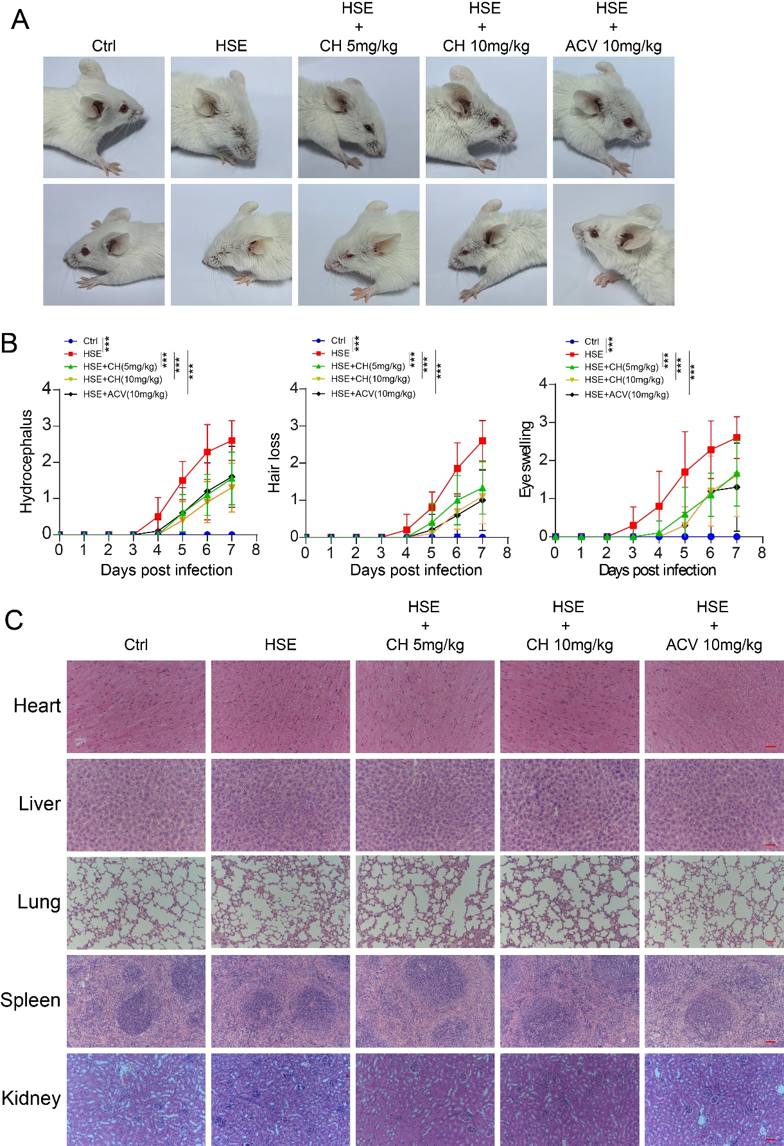
Figure S4. Cepharanthine hydrochloride relieves HSE symptoms. A Photographic documentation of eye and brain symptoms in HSE mice subjected to CH or ACV treatment (n = 4). B Statistical analysis of hydrocephalus, alopecia, and eye swelling in the HSE model, as well as in mice treated with CH or ACV. Data were analyzed using the unpaired t test, which are shown as mean ± SD (n = 10). ***P < 0.001. C Representative images of H&E staining of heart, liver, lung, spleen, and kidney tissues from HSE mice. Scale bar: 200 μm.
Supplemental Tables
Supplementary Table S1 Primers for qPCR analysis in this study
Gene | Forward (5’-3’ Sequence) | Reverse (5’-3’ Sequence)
U_{L}27 | GCCTTCTTCGCCTTTCGC | CGCTCGTGCCCTTCTTCTT
U_{L}52 | GACCGAGGGTGCGTTATT | GAAGGATCGCCATTTAGCC
U_{L}54 | GGCGGACATTAAGGACATTG | TGGCCGTCAACTCGCAGA
Ifnb1 (mouse) | ATGAGTGGTGGTTGCAGGC | TGACCTTTCAAATGCAGTAGATTCA
Isg15 (mouse) | GATTGCCCAGAAGATTGGTG | TCTGCGTCAGAAAGACCTCA
TNF-α (mouse) | AGGGTCTGGGCCATAGAACT | CCACCACGCTCTTCTGTCTAC
IL-6 (mouse) | ATCCAGTTGCCTTCTTGGGACTGA | TAAGCCTCCGACTTGTGAAGTGGT
IL-1β (mouse) | AATGCCACCTTTTGACAGTGATG | AGCTTCTCCACAGCCACAAT
β-actin (mouse) | GGCTTATTCCCCTCCATCG | CCAGTTGGTAACAATGCCATGT
EGFP | AGGAGCGCACCATCTTCTTC | CTCGATGTTGTGGCGGATCT
Cox-2  (mouse) | CTACAAGACGCCACATCCCCTA | GGGCAATTATGATAAGGATTACAGC
Mmp-9  (mouse) | CCATGTCACTTTCCCTTCACCTT | TCTCACTAGGGCAGAAACCAAAT
ICAM-1  (mouse) | AAGGGCTGGCATTGTTCTCTAAT | GCCTCCCAGCTCCAGGTATAT
VCAM-1  (mouse) | CCGGCATATACGAGTGTGAATCT | CACCAGACTGTACGATCCTTTCA

Supplementary Table S2 The sequence of siRNA used in this study
Genes | Sense（5’-3’) | Antisense（5’-3’)
STING #1 | GCUAUGAUUCUACUAUCGU | ACGAUAGUAGAAUCAUAGC
STING #2 | GGUACUUGCGGUUGAUCUU | AAGAUCAACCGCAAGUACC
STING #3 | UGAUUUGGUGGAUCCUUUG | CAAAGGAUCCACCAAAUCA
Nrf2 #1 | GGAUUUGAUUGACAUCCUUTT | AAGGAUGUCAAUCAAAUCCTT
Nrf2 #2 | GGAGGCAGCCAUGACUGAUTT | AUCAGUCAUGGCUGCCUCCTT
Nrf2 #3 | GCUGAAGGCACAAUGGAAUTT | AUUCCAUUGUGCCUUCAGCTT
HO-1 #1 | UGAAGAAGAUUGCACAGAA | UUCUGUGCAAUCUUCUUCA
HO-1 #2 | CCAAGUUCAAACAGCUCUA | UAGAGCUGUUUGAACUUGG
HO-1 #3 | GCUAGCCUGGUGCAAGAUA | UAUCUUGCACCAGGCUAGC

Supplemental materials and method
Viral plaque assay
BV2 and HMC3 cells were exposed to HSV-1 (an MOI of 1) in the presence of CH. Viral lysates were generated by three freeze–thaw cycles at −80 °C and preserved at −80 °C for further analysis. For plaque development, Vero cells were distributed into 24-well plates and inoculated with the harvested virus. Following viral adsorption, the inoculum was discarded and replaced with maintenance medium containing 1% methylcellulose (T10218-500, Sijia Biotech, Guangzhou, China). After 72 h, cells were immobilized using 4% paraformaldehyde (PFA) and visualized by staining with 1% crystal violet (C0121, Beyotime). Plaques were subsequently counted for quantitative analysis.
RNA isolation and real-time quantitative PCR (RT-qPCR)
Total RNA was isolated from cells using TRIzol reagent (DP424, Tiangen Biotech, Beijing, China). cDNA was synthesized by reverse transcription and used for quantitative PCR analysis on a CFX96 real-time PCR system (Bio-Rad, Hercules, CA, USA). β-actin served as the internal reference for normalization, and primer information is provided in Supplementary Table 1.
siRNA Transfection
All Nrf2 siRNAs, STING siRNAs, and HO-1 siRNAs were designed and synthesized by Tsingke Biotechnology (Beijing, China). Transfection of BV2 cells was performed using INTERFERin reagent (PT-409–10, Polyplus Transfection, Illkirch, France). After 48 h, cells were exposed to HSV-1 (an MOI of 1) for 24 h with or without CH. Cell lysates were prepared for Western blot and RT-qPCR analyses, whereas culture supernatants were harvested for ELISA. The corresponding siRNA sequences are shown in Supplementary Table 2.
Western blotting assay
Cell lysates were prepared using RIPA buffer (P0013B, Beyotime) supplemented with 1% phenylmethylsulfonyl fluoride (PMSF; ST506, Beyotime). Protein levels were quantified by bicinchoninic acid (BCA) assay (P0009, Beyotime). Equal amounts of protein were denatured in 5× SDS loading buffer (P0015, Beyotime), followed by separation on 10% SDS–PAGE and transfer to PVDF membranes (ISEQ00010, Millipore, Billerica, MA, USA). PVDF membranes blocked in 5% skim milk were probed with primary antibodies at 4 °C overnight, followed by incubation with secondary antibodies for 1 h at ambient temperature. Detection was performed using enhanced chemiluminescence.
Co-immunoprecipitation
BV2 cells were harvested and lysed to obtain total proteins by using IP lysis buffer (P0013, Beyotime) containing 2% PMSF. Subsequently, the HA-magnetic beads (PHM025, Lablead) were rotated with the protein sample at 4°C overnight. Alternatively, protein A/G magnetic beads (CB0233, Lablead) were mixed with 1 μL of STING antibody and the protein sample, followed by overnight rotation at 4 °C for subsequent experiments.
Drug affinity responsive target stability (DARTS)
Protein extraction from BV2 cells was carried out using NP-40 lysis buffer (P0013F, Beyotime) containing 2% PMSF. Protein levels were quantified using a BCA assay and normalized to a final concentration of 4–5 mg/mL. Lysates were incubated with DMSO or CH at room temperature for 3–4 h. Proteolysis was then initiated by adding Pronase and allowed to proceed for 25 min. Digestion was stopped by adding 5× SDS loading buffer and boiling (10 min), followed by western blotting analysis.
Nuclear and cytoplasmic extract preparation
BV2 cells (3 × 10⁶ cells per 10 cm dish) were exposed to HSV-1 (an MOI of 1) followed by CH treatment for 24 h. Cells were harvested by centrifugation and washed with PBS (1000 rpm, 5 min, 4 °C). Nuclear and cytoplasmic fractions were prepared using a Nuclear and Cytoplasmic Protein Extraction Kit (P0028, Beyotime, China).
Flow cytometry assay
Cells (8 × 10⁵ cells per well) were plated in 6-well plates and exposed to the indicated viruses and/or compounds after attachment, and incubated with DCFH-DA (1:1000 in DMEM) for 30 min at 37 °C in the dark to detect ROS. After washing, cells were harvested and analyzed via flow cytometry.
Immunofluorescence assay
BV2 cells (seeded on glass-bottom dishes) were infected with HSV-1 an MOI of 1, 12 h). Following treatment, fixation was carried out with 4% PFA, and membrane permeabilization was achieved using 0.2% Triton X-100. Blocking was performed with 3% bovine serum albumin. Primary antibodies against STING, Keap1, and Nrf2 (1:300) were applied at 4 °C overnight. Fluorescent secondary antibodies were subsequently applied for 1 h at ambient temperature. Nuclear labeling was achieved with DAPI. Fluorescence imaging was performed using a Zeiss AxioCam MR R3 CCD system with ZEN software (Carl Zeiss MicroImaging GmbH, Göttingen, Germany).
Native-PAGE assay
Total protein was extracted from CH treated and HSV-1-infected BV2 cells using a lysis buffer supplemented with 2% deoxycholic acid ((Beyotime, Cat# P0013). Protein lysates were subsequently mixed with a non-reducing non-denaturing sample buffer (Beyotime, Cat# P0016N) and resolved by native-PAGE. Both the stacking and separating gels in native-PAGE were prepared with a Tris-HCl buffer system at pH 8.8. The electrophoresis buffer in the inner chamber was supplemented with 0.5% sodium deoxycholate (YEASEN, Shang hai, China, Cat# 60334ES10) to maintain solubility of membrane-associated proteins. Prior to sample loading, the gel was pre-run at a constant current of 40 mA for 30 min to stabilize the electrophoresis system. Following sample application, electrophoresis was continued at 25 mA for 1 h to achieve optimal separation of native protein species.

Histopathological assays
Brain, heart, liver, spleen, lung, and kidney tissues were harvested from mice, fixed in 4% PFA, paraffin-embedded, sectioned, and stained with hematoxylin and eosin (H&E).

