Virologica Sinica
Supplementary Materials

Two Orthobunyaviruses: OYAV and EBIV co-opt the AhR-CYP1A1 axis to suppress type I interferon responses

Qianyun Hu^{a,b}, Fei Wangª, Xiaoyu Wang^{a,b}, Xiaokui Li^{a,b}, Zhiming Yuan^{a,b}*, Maohua Zhong^{c}*, Han Xia^{a,c,d}*

ª Key Laboratory of Virology and Biosafety, Wuhan Institute of Virology, Chinese Academy of Sciences, Wuhan 430071, China
^{b} University of Chinese Academy of Sciences, Beijing 100049, China
^{c} Institute of Infection, Immunology and Tumor Microenvironment, Hubei Province Key Laboratory of Occupational Hazard Identification and Control, Medical College, Wuhan University of Science and Technology, Wuhan 430065, China.
^{d} Hubei Jiangxia Laboratory, Wuhan 430200, China

*Corresponding authors:
Email addresses: yzm@wh.iov.cn (Z. Yuan); hanxia@wh.iov.cn (H. Xia); zmh@wust.edu.cn (M. Zhong)
ORCID: 0000-0002-3234-9616 (Z. Yuan); 0000-0001-9932-6040 (H. Xia); 0009-0005-5201-1531 (M. Zhong)

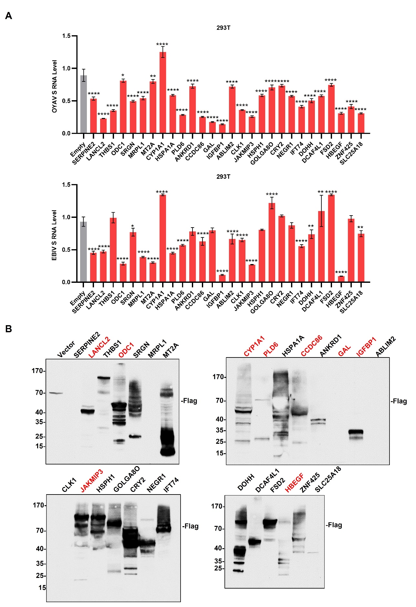
Fig S1. Screening of host genes regulating OYAV and EBIV infection through transcriptome profiling. A Effect of transient overexpression of 28 candidates on viral infection. 293T cells transiently transfected with plasmids encoding each candidate factor were infected with either OYAV (MOI = 0.1) or EBIV (MOI = 0.1). B Examine the expression of 28 exogenous expression plasmids in 293T cells by western blot (anti-Flag, 1:5000; Proteintech, Wuhan, China). The genes marked in red are the nine candidates for subsequent validation. Viral RNA levels in cell lysates were quantified at 24 hpi by RT-qPCR targeting the viral nucleocapsid (NP) gene. The threshold cycle (Ct) values of the target genes were normalized to that of the housekeeping gene GAPDH and presented as relative RNA levels, with the normalized level of the target gene in the Vector group set as 1. Data represent mean ± SD (n = 2 independent experiments; one-way ANOVA test for A). * P < 0.05, ** P < 0.01, *** P < 0.0001, **** P < 0.00001, NS: not significant (P > 0.05).

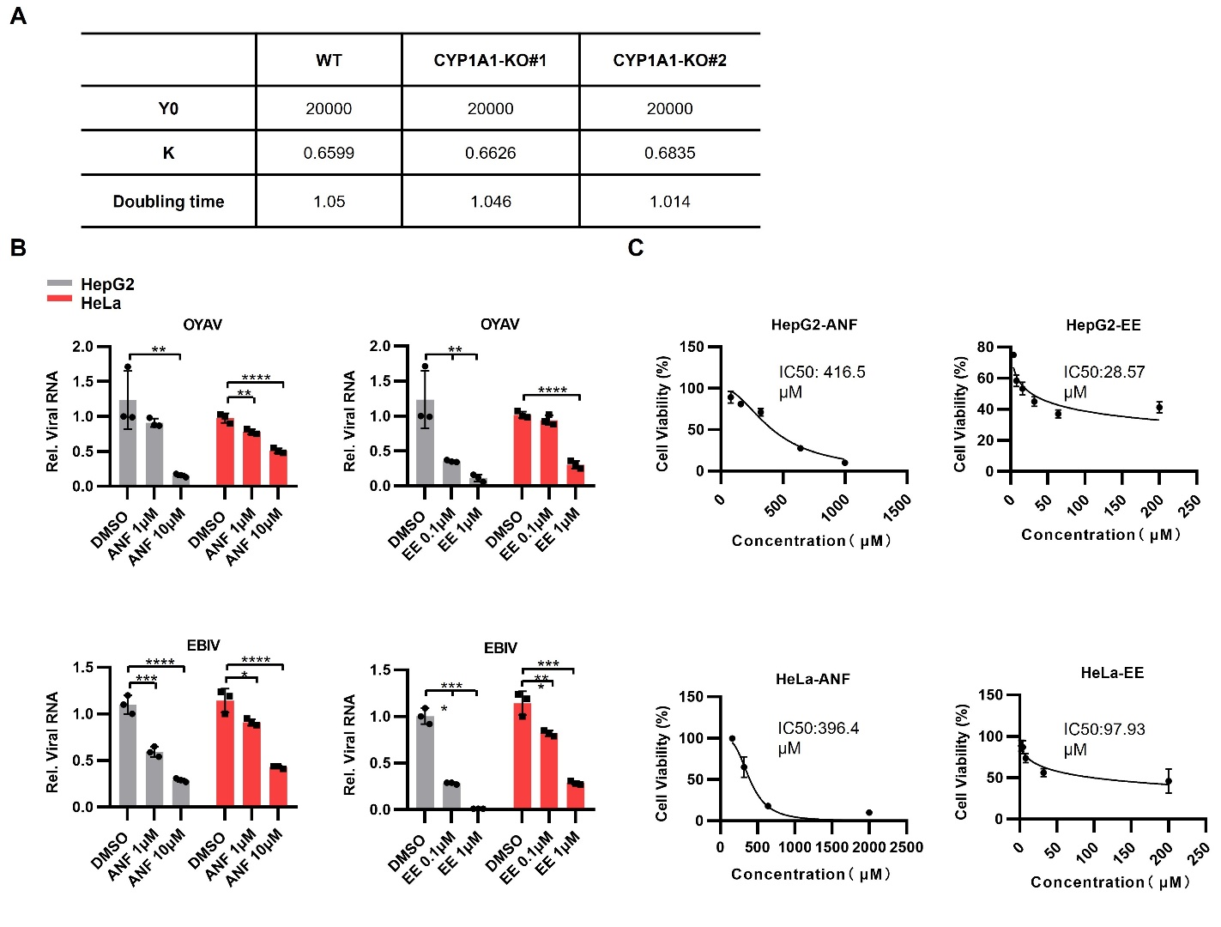
Fig S2. Drugs targeting the CYP1A1 protein can inhibit viral infection. A Growth kinetic parameters of wild-type cells and CYP1A1-knockout HepG2 cell lines. Y0: Initial cell number; K: Growth rate; Doubling time: Cell population doubling time. B Viral RNA levels were measured in HepG2 cells, treated or untreated with 0.1 and 1 μM Ethinylestradiol or 1 and 10 μM Alpha-Naphthoflavone and infected with OYAV and EBIV (MOI = 0.1, 24 hpi). C Dose-response curves for Ethinylestradiol (EE) and Alpha-Naphthoflavone (ANF) in HepG2 and HeLa cells. Infection and treatment procedures were as described in Methods. Data points represent the mean cell viability ± SD from three independent experiments (each in triplicate). IC₅₀ values were calculated using non-linear regression and are listed in the figure. The threshold cycle (Ct) values of the target genes were normalized to that of the housekeeping gene GAPDH and presented as relative RNA levels, with the normalized level of the target gene in the Mock group set as 1. Data represent mean ± SD (n = 3 independent experiments; one-way ANOVA test for B). * P < 0.05, ** P < 0.01, *** P < 0.0001, **** P < 0.00001.
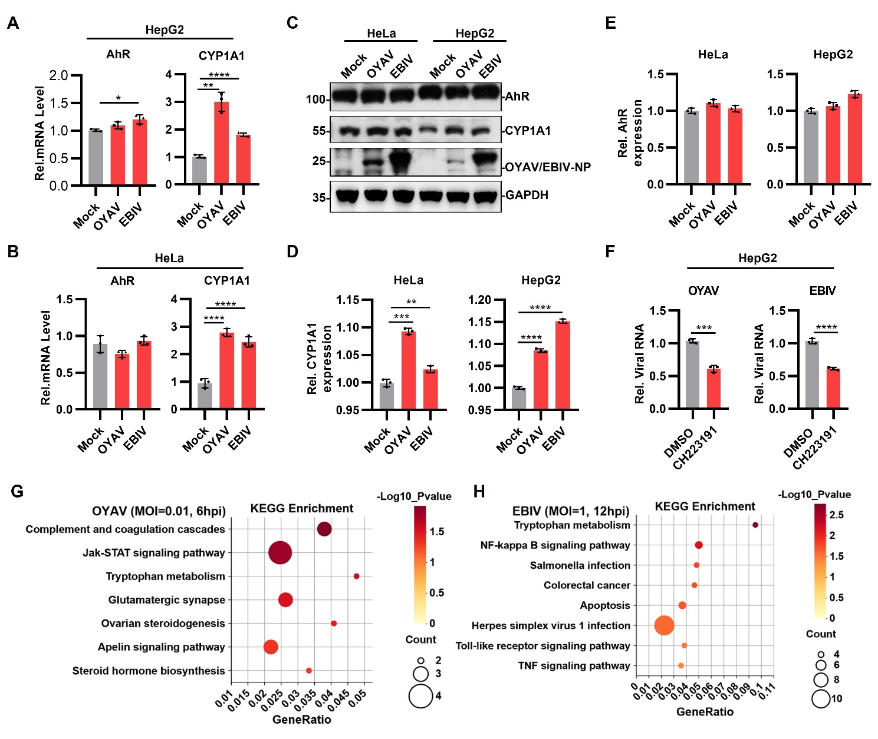
Fig S3. OYAV and EBIV infection leads to upregulation of CYP1A1 mRNA levels. A, B Detected AhR and CYP1A1 mRNA levels of HepG2 and HeLa stimulated by OYAV and EBIV (MOI = 1) infection after 24 hours. C Detected AhR and CYP1A1 expression levels of HepG2 and HeLa stimulated by OYAV and EBIV (MOI = 1) infection after 24 hours. D, E Analyze the grayscale values of (C). F Viral RNA levels in CH223191-treated HepG2 cells were infected with OYAV and EBIV (MOI = 0.01, 24 hpi). G, H The enrichment of differentially expressed genes (DEGs) for OYAV (left panel, MOI = 0.01, 6 hpi) and EBIV (right panel, MOI = 1, 12 hpi) compared to the non-infected control group within KEGG pathways. Each bubble represents a significantly enriched KEGG pathway. The threshold cycle (Ct) values of the target genes were normalized to that of the housekeeping gene GAPDH and presented as relative RNA levels, with the normalized level of the target gene in the Mock and NC group set as 1. Data represent mean ± SD (n = 3 independent experiments; one-way ANOVA test for C, D). * P < 0.05, ** P < 0.01, *** P < 0.0001, **** P < 0.00001.
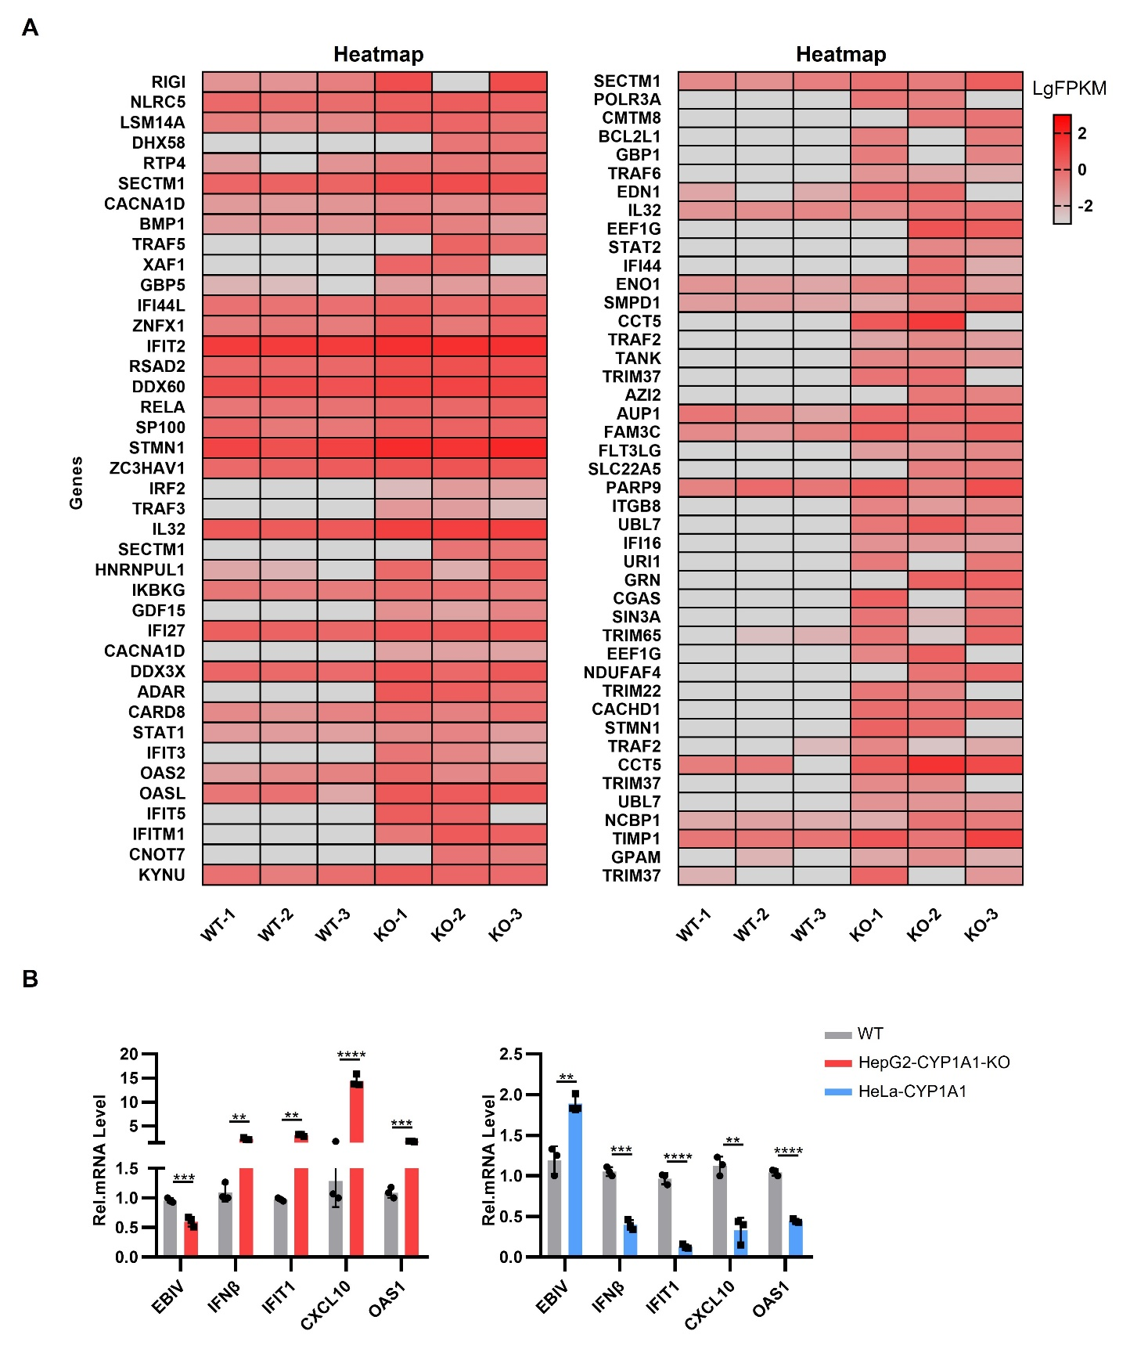
Fig S4. Interferon expression in HepG2 and HeLa cells following infection with EBIV or OYAV. A Heatmap visualization of differentially expressed genes. The heatmap displays the expression patterns of interferon-related genes in wild-type (WT) and CYP1A1 knockout (KO) cells, 24 hours after infection with EBIV (MOI = 1). Colors represent the expression level of each gene (row) processed by log₁₀(FPKM). Shown are genes with |Log₂FC| > 1 and adjusted p-value < 0.05. B Viral replication, IFN-β and ISG (IFIT1, CXCL10, OAS1) RNA levels in HepG2 CYP1A1 KO (left panel) and HeLa-CYP1A1 stable (right panel) cells vs control cells with EBIV (MOI=1) infection after 24 hours. The threshold cycle (Ct) values of the target genes were normalized to that of the housekeeping gene GAPDH and presented as relative RNA levels, with the normalized level of the target gene in the Mock group set as 1. Data represent mean ± SD (n = 3 independent experiments; one-way ANOVA test for the data). * P < 0.05, ** P < 0.01, *** P < 0.0001, **** P < 0.00001.

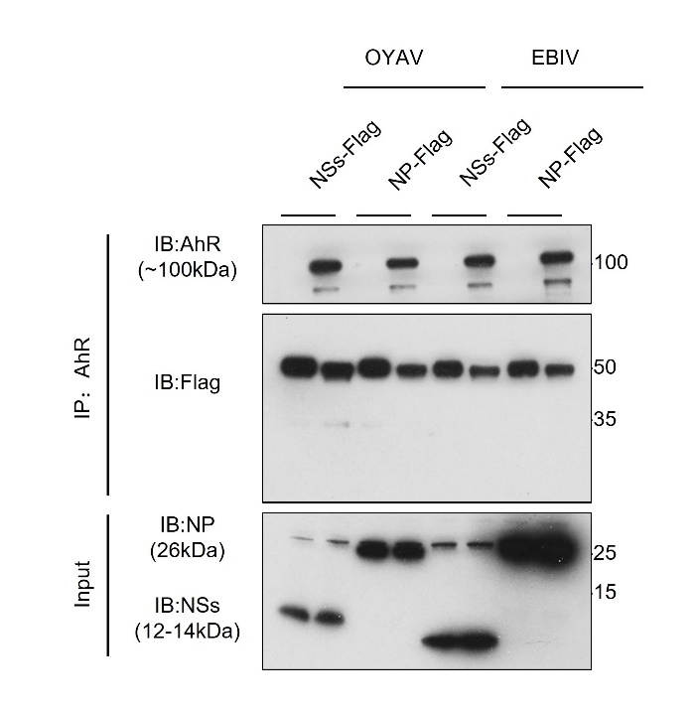
Fig. S5. AhR does not interact with the nonstructural proteins (NP, NSs). Interaction between AhR and NP or NSs was validated by co-immunoprecipitation assays. HeLa cells were transfected with specified plasmids. After cell lysis, immunoprecipitation was performed using anti-AhR antibody (1:200) or IgG, followed by detection with anti-Flag and anti-AhR antibodies via Western blotting.

Table S1. RT-qPCR Primers using in the study.
(Excel file)

