Virologica Sinica
Supplemental Material

Establishment of severe in vitro and in vivo infection models for coxsackievirus B4 and their application in identifying viral virulence determinants

Haoyi Liu ^{a, b, 1}, Xianglin Xuan ^{c, 1}, Bizhen Tang ^{c, 1}, Huan Wang ^{c, d, 1}, Li Zhang ª, Shuyan Qiu ª,
Chuncong Mo ^{a, b}, Xiao Li ^{a, b}, Xingui Tian ^{a, b}, Rong Zhou ^{a, b}, Qian Liu ^{c, *}, Wenkuan Liu ^{a, b, *}

ª State Key Laboratory of Respiratory Disease, National Clinical Research Center for Respiratory Disease, National Center for Respiratory Medicine, Joint International Research Laboratory of Respiratory Health, Guangdong Basic Research Center of Excellence for Respiratory Medicine, Guangzhou Institute of Respiratory Health, the First Affiliated Hospital of Guangzhou Medical University, Guangzhou 510182, China.
^{b} China-Portugal Artificial Intelligence and Public Health Technologies Joint Laboratory, Guangdong-Hong Kong-Macao Joint Laboratory of Respiratory Infectious Diseases, Guangdong Provincial Key Laboratory of Respiratory Disease Research, Guangzhou Medical University, Guangzhou 511436, China.
^{c} Scientific Research Center, The First Affiliated Hospital of Guangdong Pharmaceutical University, Guangdong Pharmaceutical University, Guangzhou 510062, China
^{d} Kunming Medical University Haiyuan College, Kunming 650106, China

¹ Haoyi Liu, Xianglin Xuan, Bizhen Tang, and Huan Wang contributed equally to this work.

*Corresponding authors:
Email addresses: ahlwk2000-2004@163.com (W. Liu); qianliu_ln@163.com (Q. Liu)
ORCID: 0000-0003-3020-9158 (W. Liu); 0000-0002-2130-1879 (Q. Liu).

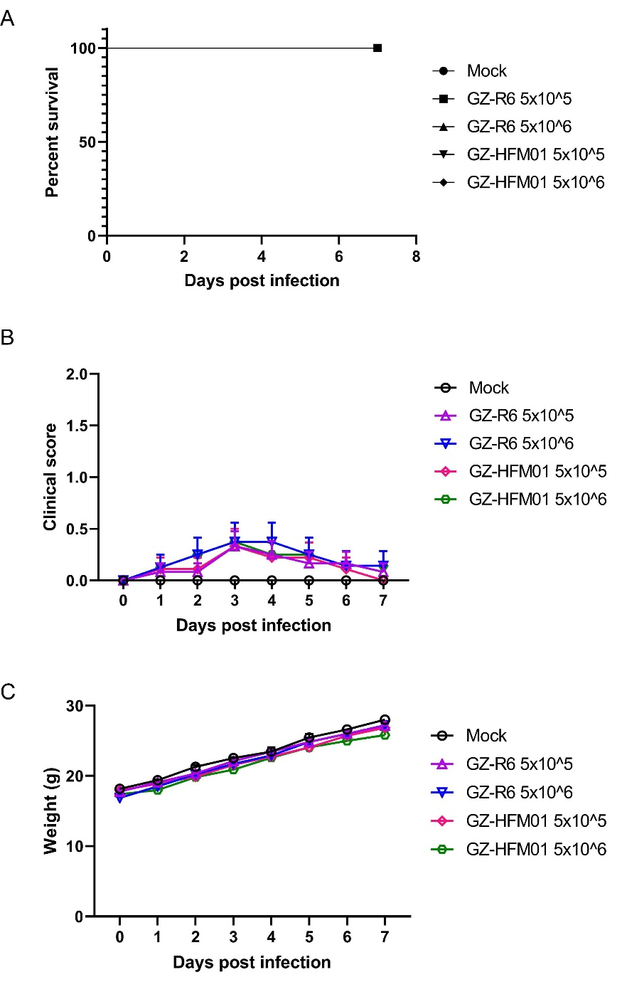
Fig. S1. In vivo pathogenic characteristics of high- and low-neurovirulence coxsackievirus B4 strains GZ-HFM01 and GZ-R6 in 3-week-old ICR mice. Mice were infected with 5×10⁵ to 5×10⁶ plaque-forming units of virus via intranasal inoculation (n = 16 per group). Percent survival (A), clinical scores (B), and body weight of surviving mice (C) were monitored and recorded. Clinical scoring criteria: 0, healthy; 1, lethargy or reduced activity; 2, limb weakness; 3, limb paralysis; 4, moribund or dead. Data are presented as mean values with SEM.
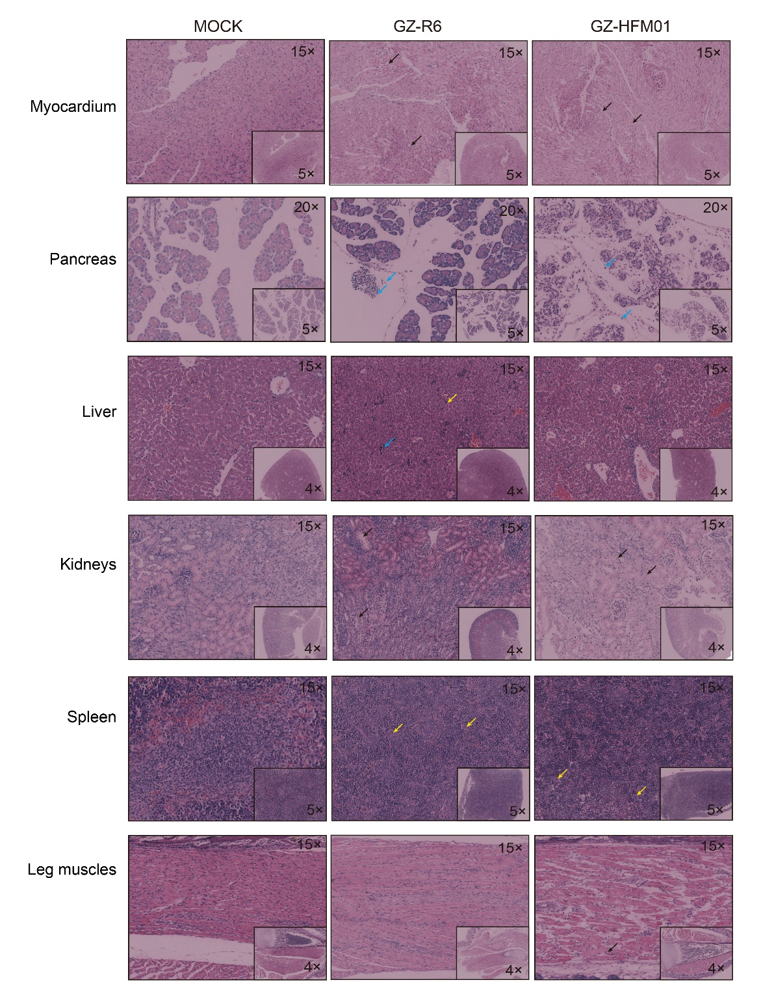
Fig. S2. Pathological characteristics of heart, pancreas, liver, kidney, spleen, and hindlimb muscle tissues in 3-day-old ICR mice 3 days after infection with coxsackievirus B4 strains GZ-HFM01 and GZ-R6. In heart tissue: black arrows indicate mild myocardial cell degeneration. In pancreatic tissue: blue arrows indicate inflammatory cell infiltration in the interstitium. In liver tissue: yellow arrows indicate scattered macrophages; blue arrows indicate inflammatory cell infiltration. In kidney tissue: black arrows indicate edema of renal tubular epithelial cells. In spleen tissue: yellow arrows indicate scattered megakaryocytes. In hindlimb muscle tissue: black arrows indicate occasional lymphocytes in the interstitium.

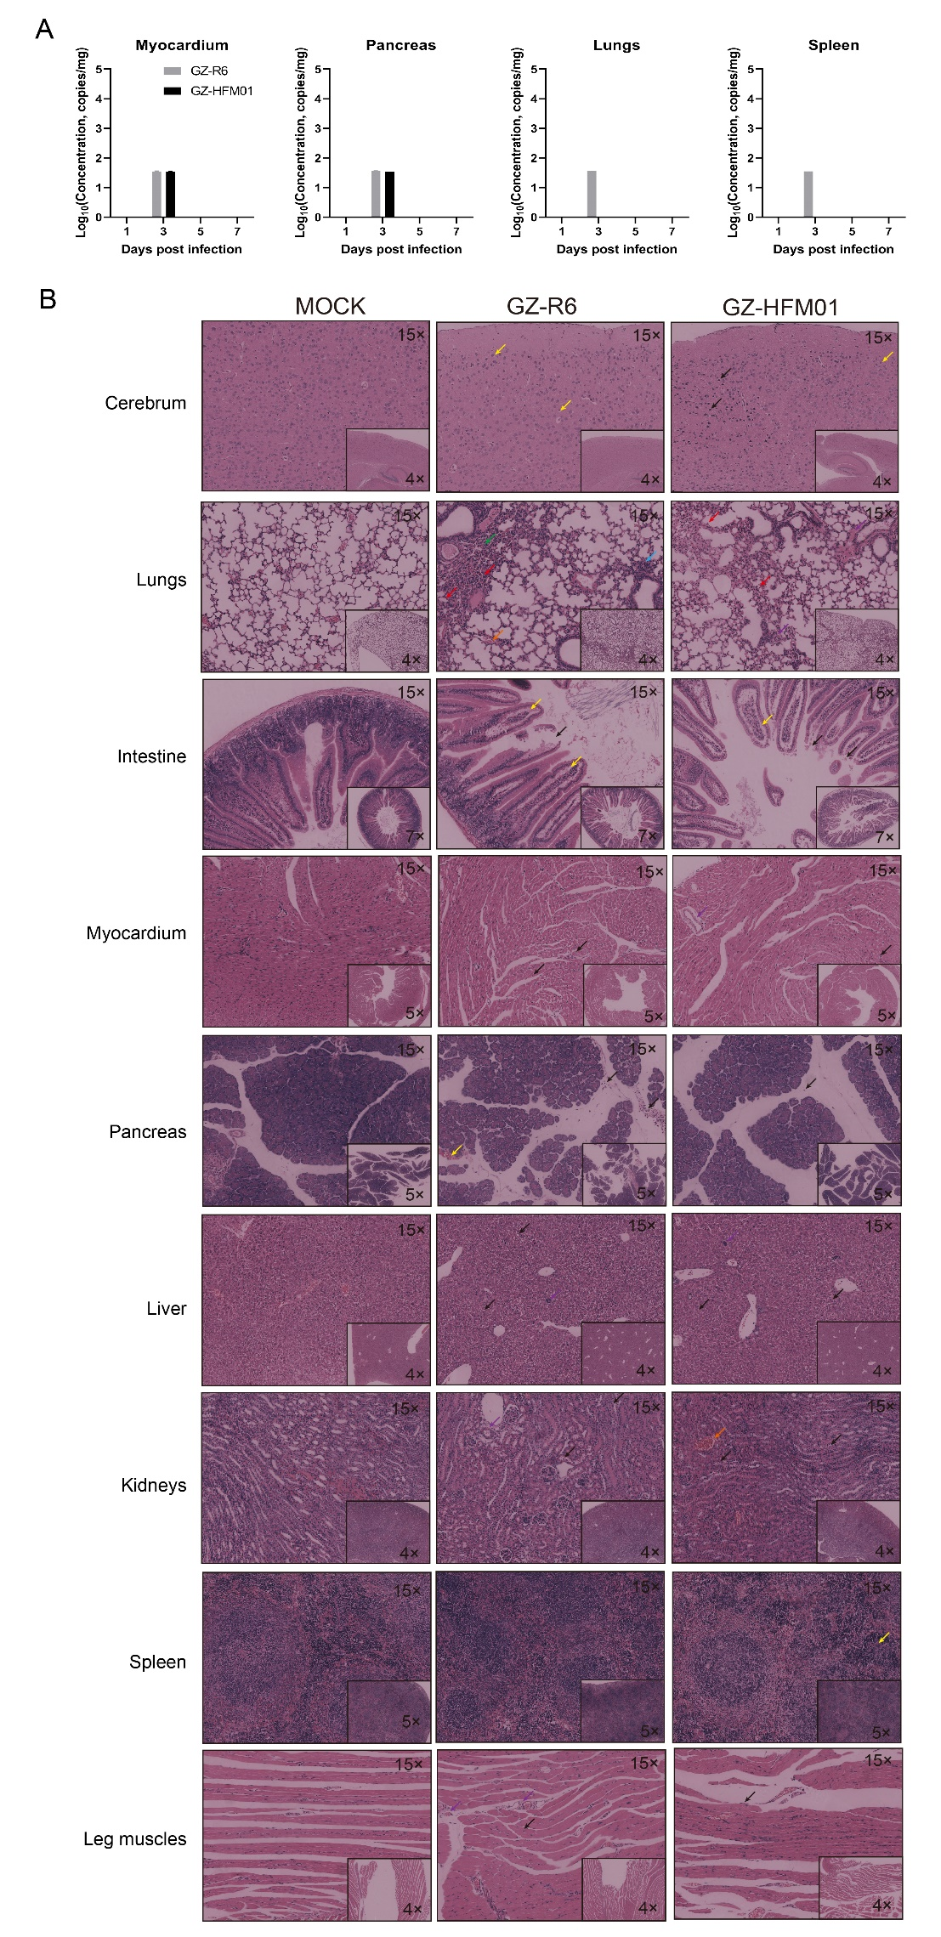
Fig. S3. Viral distribution and histological changes in various tissues of 2-week-old ICR mice infected with coxsackievirus B4 strains GZ-HFM01 and GZ-R6. A Two-week-old ICR mice were inoculated with 5×10⁶ PFU of coxsackievirus B4 strains GZ-HFM01 (high neurovirulence) and GZ-R6 (low neurovirulence) via intranasal injection. Viral distribution in brain, lung, small intestine, heart, pancreas, liver, kidney, spleen, and hindlimb muscle tissues was detected by CVB4-specific qPCR on days 1, 3, 5, and 7 post-infection (n = 3). Data are presented as mean values with SEM. Undetected tissues were not plotted. B Tissues were collected on day 3 post-infection, then subjected to paraffin embedding, sectioning, and hematoxylin–eosin (HE) staining. In brain tissue: yellow arrows indicate neuronal edema; black arrows indicate neuronal pyknosis. In lung tissue: red arrows indicate granulocyte infiltration in alveolar walls; orange arrows indicate vascular congestion; blue arrows indicate inflammatory cell infiltration; green arrows indicate alveolar collapse. In intestinal tissue: yellow arrows indicate intestinal villus edema; black arrows indicate shedding of villus epithelium. In heart tissue: black arrows indicate mild myocardial cell degeneration. In pancreatic tissue: black arrows indicate inflammatory cell infiltration in the interstitium; yellow arrows indicate focal mild hemorrhage. In liver tissue: purple arrows indicate scattered macrophages; black arrows indicate inflammatory cell infiltration. In kidney tissue: black arrows indicate edema of renal tubular epithelial cells; orange arrows indicate vascular congestion. In spleen tissue: yellow arrows indicate scattered megakaryocytes. In hindlimb muscle tissue: black arrows indicate occasional interstitial lymphocytes; purple arrows indicate vascular edema.

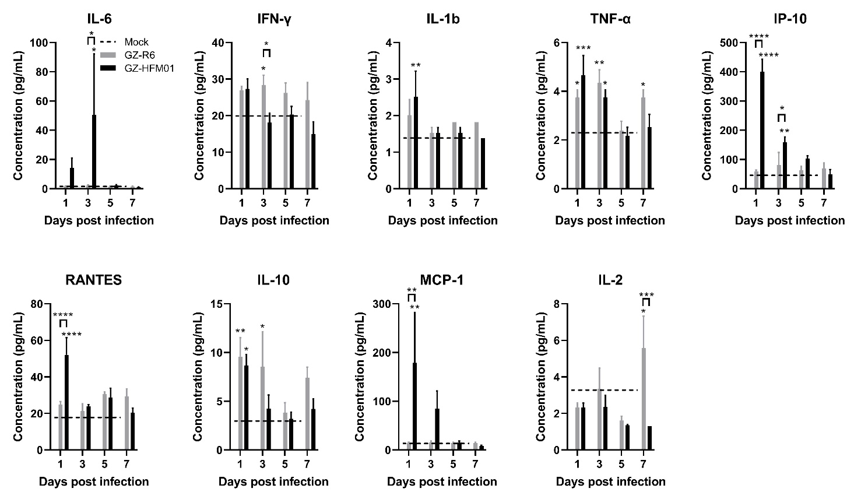
Fig. S4. Cytokine profiles in serum of 2-week-old ICR mice infected with coxsackievirus B4 strains GZ-HFM01 and GZ-R6. Serum samples were collected from 2-week-old ICR mice at 1, 3, 5, and 7 days post-infection with CVB4 strains GZ-HFM01 or GZ-R6, and the levels of nine cytokines were quantified (n = 3 per group). Data are presented as mean values with SEM. Statistical analysis was performed using two-way ANOVA followed by Tukey's multiple comparisons test. Differences between each infected group and the mock-infected group are labeled above the corresponding bars, and differences between the two infected groups are labeled above the connecting lines. *, P <0.05; **, P <0.01; ***, P <0.001; ****, P <0.0001.

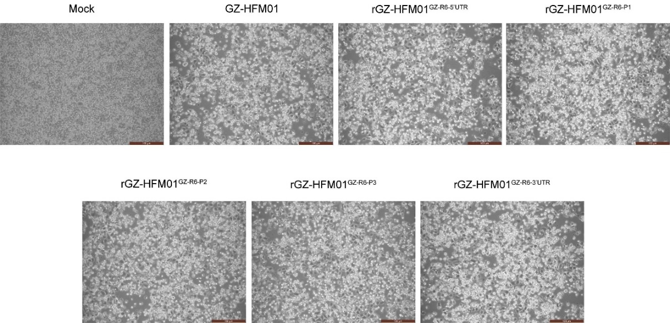
Fig. S5. Successful rescue of genome segment–replacement chimeric coxsackievirus B4 viruses in HeLa cells。

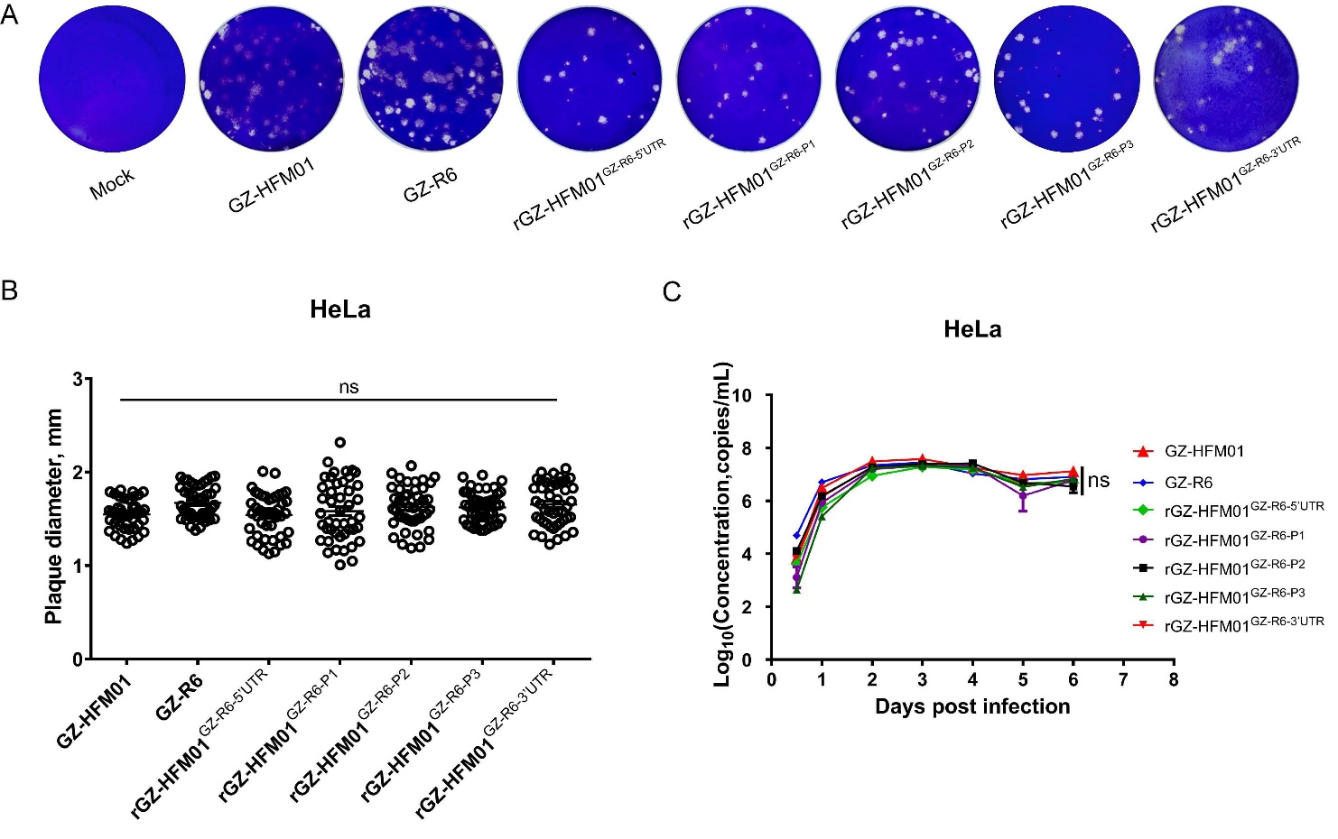
Fig S6. In vitro infection characteristics of the genome segment–replaced chimeric coxsackievirus B4 viruses in HeLa cells. Plaque formation (A), plaque size distribution (B), and proliferation curves (C) of strains GZ-HFM01, GZ-R6, and the genome segment–replaced chimeric coxsackievirus B4 viruses were analyzed in HeLa cells. For plaque assays, cells in six-well plates were infected, incubated, and stained with crystal violet at 2 days post-infection. Plaque sizes are shown as mean values with standard error of the mean (SEM); they were assessed with the Mann–Whitney U test. Viral genome copies were quantified by CVB4 qPCR on various days post-infection (n = 3). Statistical analysis was conducted using one-way ANOVA followed by Tukey's multiple comparisons test. ns, not significant.

Table S1. Primers used to construct genome segment–replacement chimeric coxsackievirus B4 viruses
Primer | Primer sequence (5′–3′) | Target
P1-HFM01-F | ggccttctaggacaacaggca | The pcDNA-CVB4-GZ-HFM01 plasmid was linearized between the 5′UTR and the 2A gene and used to construct pCVB4-GZ-HFM01^{GZ-R6-P1}
P1-HFM01-R | tttccactattaagtagtaatattaggtcaagt
P1-R6-F | ttactacttaatagtggaaaatgggagctcaggtgtcgaca | Amplification of P1gene from pcDNA-CVB4-GZ-R6
P1-R6-R | gcctgttgtcctagaaggcctgtggttattaagcttgctcgc | Amplification of P1gene from pcDNA-CVB4-GZ-R6
P2-HFM01-F | ggtccgccagtgtacaggg | The pcDNA-CVB4-GZ-HFM01 plasmid was linearized between the VP1 and the 3A gene and used to construct pCVB4-GZ-HFM01^{GZ-R6-P2}
P2-HFM01-R | tgtggttattaagcttgctcgc
P2-R6-F | gagcaagcttaataaccacaggccttcaaagacaacaggca | Amplification of P2 gene from pcDNA-CVB4-GZ-R6
P2-R6-R | tccctgtacactggcggaccttggaacagtgcctcgagtgt | Amplification of P2 gene from pcDNA-CVB4-GZ-R6
P3-HFM01-F | aattagagcgcaatttgatttaattc | The pcDNA-CVB4-GZ-HFM01 plasmid was linearized between the 2C and the 3′UTR gene and used to construct pCVB4-GZ-HFM01^{GZ-R6-P3}
P3-HFM01-R | ttggaacagtgcctcaaggg
P3-R6-F | cccttgaggcactgttccaaggtccaccggtatacagagaaatc | Amplification of P3 gene from pcDNA-CVB4-GZ-R6
P3-R6-R | aatcaaattgcgctctaattttaaaaggagtccaaccacttcct | Amplification of P3 gene from pcDNA-CVB4-GZ-R6
5′UTR-HFM01-F | atgggagctcaggtatcaacaca | The pcDNA-CVB4-GZ-HFM01 plasmid was linearized outside the 5′UTR gene and was used to construct pCVB4-GZ-HFM01^{GZ-R6-5’UTR}
5′UTR-HFM01-R | ccctatagtgagtcgtattaatttcga
5′UTR-R6-F | taatacgactcactatagggttaaaacagcctgtgggttgttc | Amplification of 5′UTR gene from pcDNA-CVB4-GZ-R6
5′UTR-R6-R | gttgatacctgagctcccattttacactattgagtggtaatattaagttaagtg | Amplification of 5′UTR gene from pcDNA-CVB4-GZ-R6
3′UTR-HFM01-F | aaaaaaaaaaaaaaaaaaaaaaaaagctcga | The pcDNA-CVB4-GZ-HFM01 plasmid was linearized outside the 3′UTR gene and was used to construct pCVB4-GZ-HFM01^{GZ-R6-3’UTR}
3′UTR-HFM01-R | tcaaaaggaatccaaccacttcc
3′UTR-R6-F | agtggttggattccttttgagattagagcgcaatttgattcaat | Amplification of 3′UTR gene from pcDNA-CVB4-GZ-R6

