Virologica Sinica
Supplementary Materials

A natural five-amino-acid insert at the S2’ cleavage site of MERS-CoV spike enhances viral membrane fusion

Guimin Dai, Wenjie Chen, Wenying Cao, Guigen Zhang*

Institute of Human Virology, Department of Pathogen Biology and Biosecurity, and Key Laboratory of Tropical Disease Control of Ministry of Education, Zhongshan School of Medicine, Sun Yat-sen University, Guangzhou, 510080, China

*Corresponding author:
Email address: zhanggg5@mail.sysu.edu.cn (G. Zhang)
ORCID: 0000-0002-3336-6768

Supplementary Materials
Materials and Methods
Cells and inhibitors
HEK293T cells were purchased from American Type Culture Collection (ATCC). BEAS-2B and A549 cells were obtained from the Cell Bank of Shanghai Institute of Biological Sciences, Chinese Academy of Sciences. A549-ACE2/TMPRSS2 cells were kindly provided by Dr. Shuofeng Yuan (Department of Microbiology, The University of Hong Kong). CHO-K1 cells were ordered from Procell Life Science & Technology, Wuhan. HEK293T, A549, CHO-K1, and BEAS-2B cells were cultured in Dulbecco's Modified Eagle Medium (DMEM; Gibco, USA) supplemented with 10% (v/v) fetal bovine serum (FBS; Excell Bio, China), 1% (v/v) penicillin-streptomycin solution. The inhibitor Camostat mesylate was ordered from Guangzhou Zuoke Biotech (Cat: HY-13512, MCE).

Plasmid construction
The expression vector pcDNA3.1-MERS-CoV/NC270-P9 Spike-His (GenBank: UYV90088.1) was codon-optimized and synthesized (Genewiz, Suzhou, China). The expression vector pcDNA3.1-MERS-CoV/NC283 Spike-His (MERS-CoV/NC270-P9 Spike ΔTSGVF) without TSGVF was also constructed via subcloning. The DPP4 expression plasmid was purchased from Sino Biological (Cat: HG10688-CY, Beijing, China).

Phylogenetic analysis
Phylogenetic analysis was performed using full-length spike glycoprotein sequences obtained from the GenBank database, including human- and camel-derived MERS-CoV strains (Clade A: EMC/2012 [JX869059], Jordan-N3/2012 [KC776174]; Clade B: Riyadh/RY179/2015 [KT368875], Jeddah/JD1(b)/2015 [KT368858], Qatar-2/2014 [KJ650098], Jeddah/D90/2014 [KT368844], KOR/KNIH/002-05/2015 [KT029139], FRA/UAE/2013 [KF745068], Hafr-Al-Batin/2013 [KF600628]; Clade C: AHRI-FAO-1/2018 [MK967708], MERS-CoV/NC270-P9 [OP654179], MERS-CoV/NC283 [OP712623]) as well as related bat coronaviruses (BtCoV/133/2005 [DQ648794], Bat/HKU4/2004 [NC_009019], Bat/HKU5/2004 [NC_009020]). Multiple sequence alignment was conducted using the ClustalW algorithm with default parameters, followed by phylogenetic tree construction via the neighbor-joining method in MEGA11 software (version 11.0.13) with 2000 bootstrap replicates. Branches with bootstrap values ≥ 70% were considered statistically significant.

Production of pseudotyped lentiviral particles
HEK293T cells were co-transfected with 15 μg of Spike expression vector, 10 μg of psPAX2 packaging plasmid, and 10 μg of pHIV-luciferase reporter plasmid. Following 6–8 h of incubation, the medium was replaced with fresh medium. Forty-eight hours later, the supernatant was collected and centrifuged at 6,000 ×g for 10 min at 4 °C to remove cellular debris. The supernatant was then filtered through a 0.45 μm pore-size membrane filter (Millipore, USA), aliquoted, and stored at −80 °C for subsequent pseudovirus entry assays or Western blotting analysis.

Western blotting
Cells were subsequently harvested and lysed in 1× SDS lysis buffer. Protein samples were separated by 10% SDS-PAGE and transferred to PVDF membranes (Millipore, USA). Membranes were blocked with 5% non-fat dry milk in TBS-T buffer for 1 hour at room temperature, then incubated sequentially with a primary antibody, followed by HRP-conjugated secondary antibody. The following antibodies were used in Western blotting: anti-GAPDH, anti-p24, anti-His, and HRP-conjugated goat anti-mouse or rabbit IgG, all of them were purchased from ProteinTech, Wuhan. Protein detection was performed using a chemiluminescence imaging system.

Pseudovirus-based entry assay
HEK293T, A549, or BEAS-2B cells were seeded in 24-well plates at a density of 1×10⁵ cells per well and cultured in a 37 °C, 5% CO₂ incubator for 20–24 h until reaching 70%–80% confluency. After removing the culture medium, 200–300 μL of pseudovirus was added to each well, followed by incubation at 37 °C for 5–6 h. The medium was then replaced with fresh medium supplemented with 10% fetal bovine serum. Forty-eight hours post-transduction, the cells were lysed with 100 μL of Passive Lysis Buffer per well and vortexed for 20 min. The lysates were collected and centrifuged at 12,000 rpm for 10 min at 4 °C. Subsequently, 40–60 μL of supernatant from each sample was transferred to a white 96-well plate and used for measurement of luciferase activity.

Syncytia formation assays
HEK293T cells were co-transfected with 1 μg of GFP and 1 μg of DPP4 expression constructs using polyethyleneimine (PEI, Sigma-Aldrich, USA). When the cells reached 70%–80% confluency, they were transfected with 1 μg of spike protein expression vector. Forty-eight hours post-transfection, the cells were fixed with 4% paraformaldehyde for 15 min at room temperature and stained with DAPI for 10 min. Cell images were acquired using an inverted fluorescence microscope (Leica DMI8, Germany) with a 20× objective.

Statistical analyses
Statistical analysis was performed using Prism (version 5.0; GraphPad, San Diego, CA, USA). Comparisons between two groups were made using unpaired Student's t-tests. All data represent at least three independent replicates. Quantitative data are presented as mean ± standard deviation, and P < 0.05 was considered statistically significant.

Supplementary Table S1
Table S1. Percentage identity between ORFs of MERS-CoV/NC270-P9 and MERS-CoV/NC283/2015 at the nucleotide and amino acid levels.
 | % Identity to Camel/Egypt/NC283/2015
ORF | Nucleotide | Amino acid
ORF1a | 100 | 100
ORF1b | 100 | 100
S | 99.63 | 99.63
ORF3 | 100 | 100
ORF4a | 100 | 100
ORF4b | 100 | 100
ORF5 | 99.85 | 99.55
E | 100 | 100
M | 100 | 100
N | 100 | 100
ORF8b | 100 | 100

Supplementary Figures
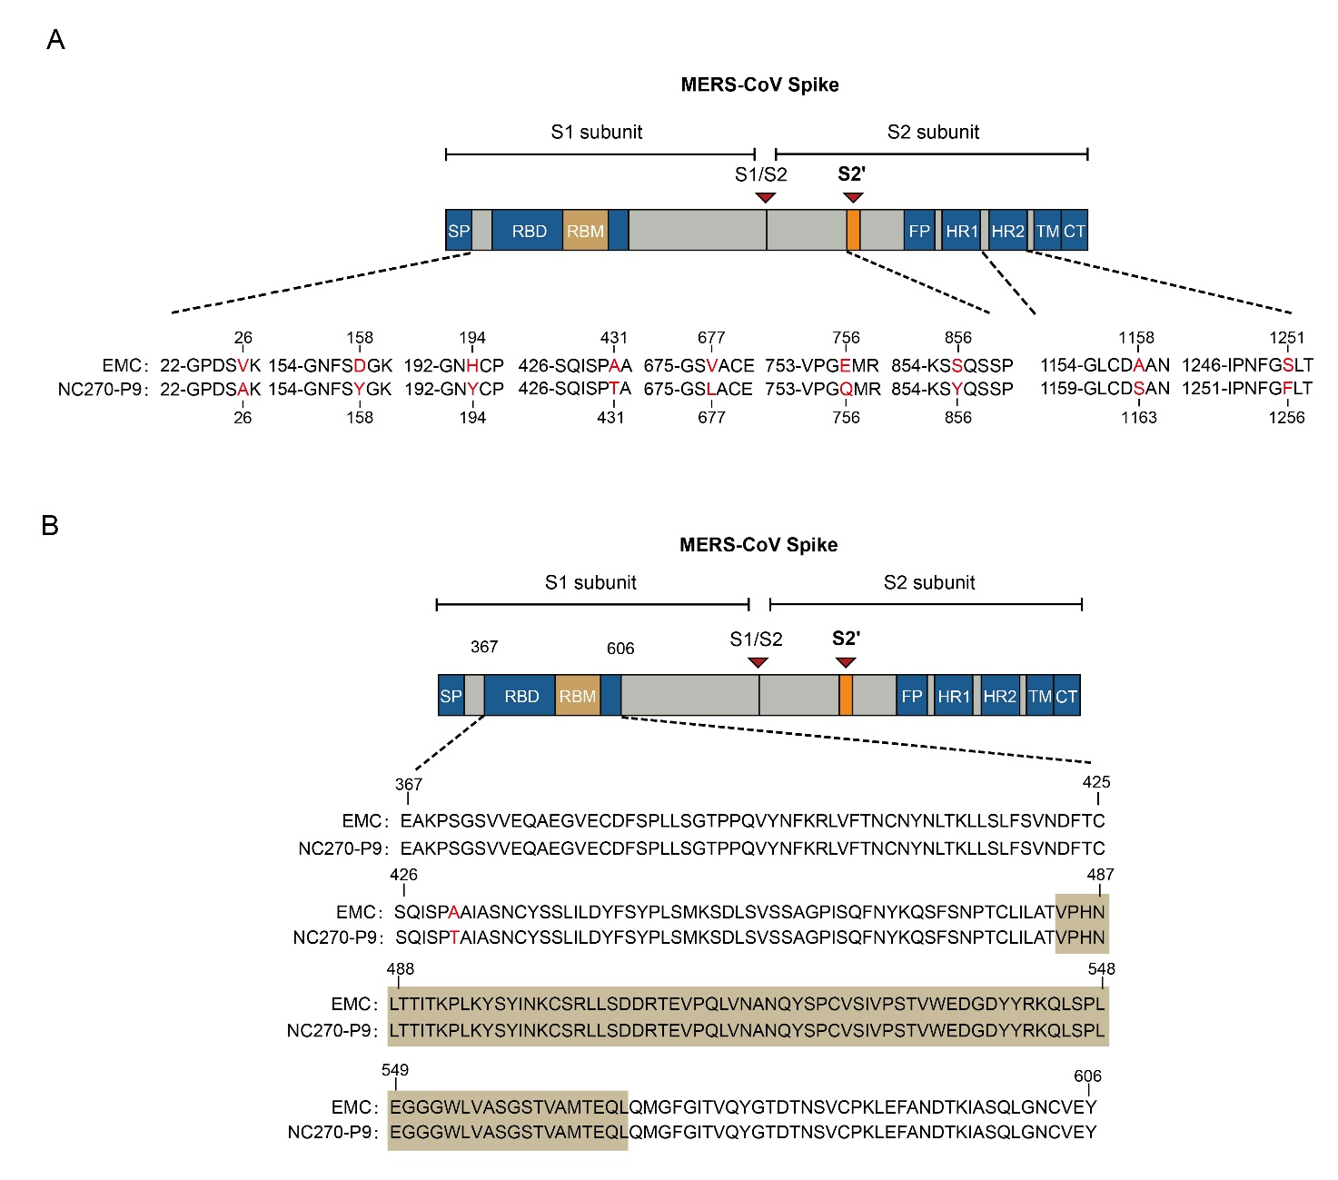
Supplementary Fig. S1. Sequence alignment of the spike proteins between MERS-CoV EMC/2012 and MERS-CoV NC270-P9. A Sequence alignment of the full-length spike between MERS-CoV EMC/2012 and MERS-CoV NC270-P9. Divergent amino acid residues are indicated in red. B Sequence alignment of the receptor-binding domains (RBDs), with the receptor-binding motif (RBM) highlighted. The amino acid substitution at 431 is shown in red.
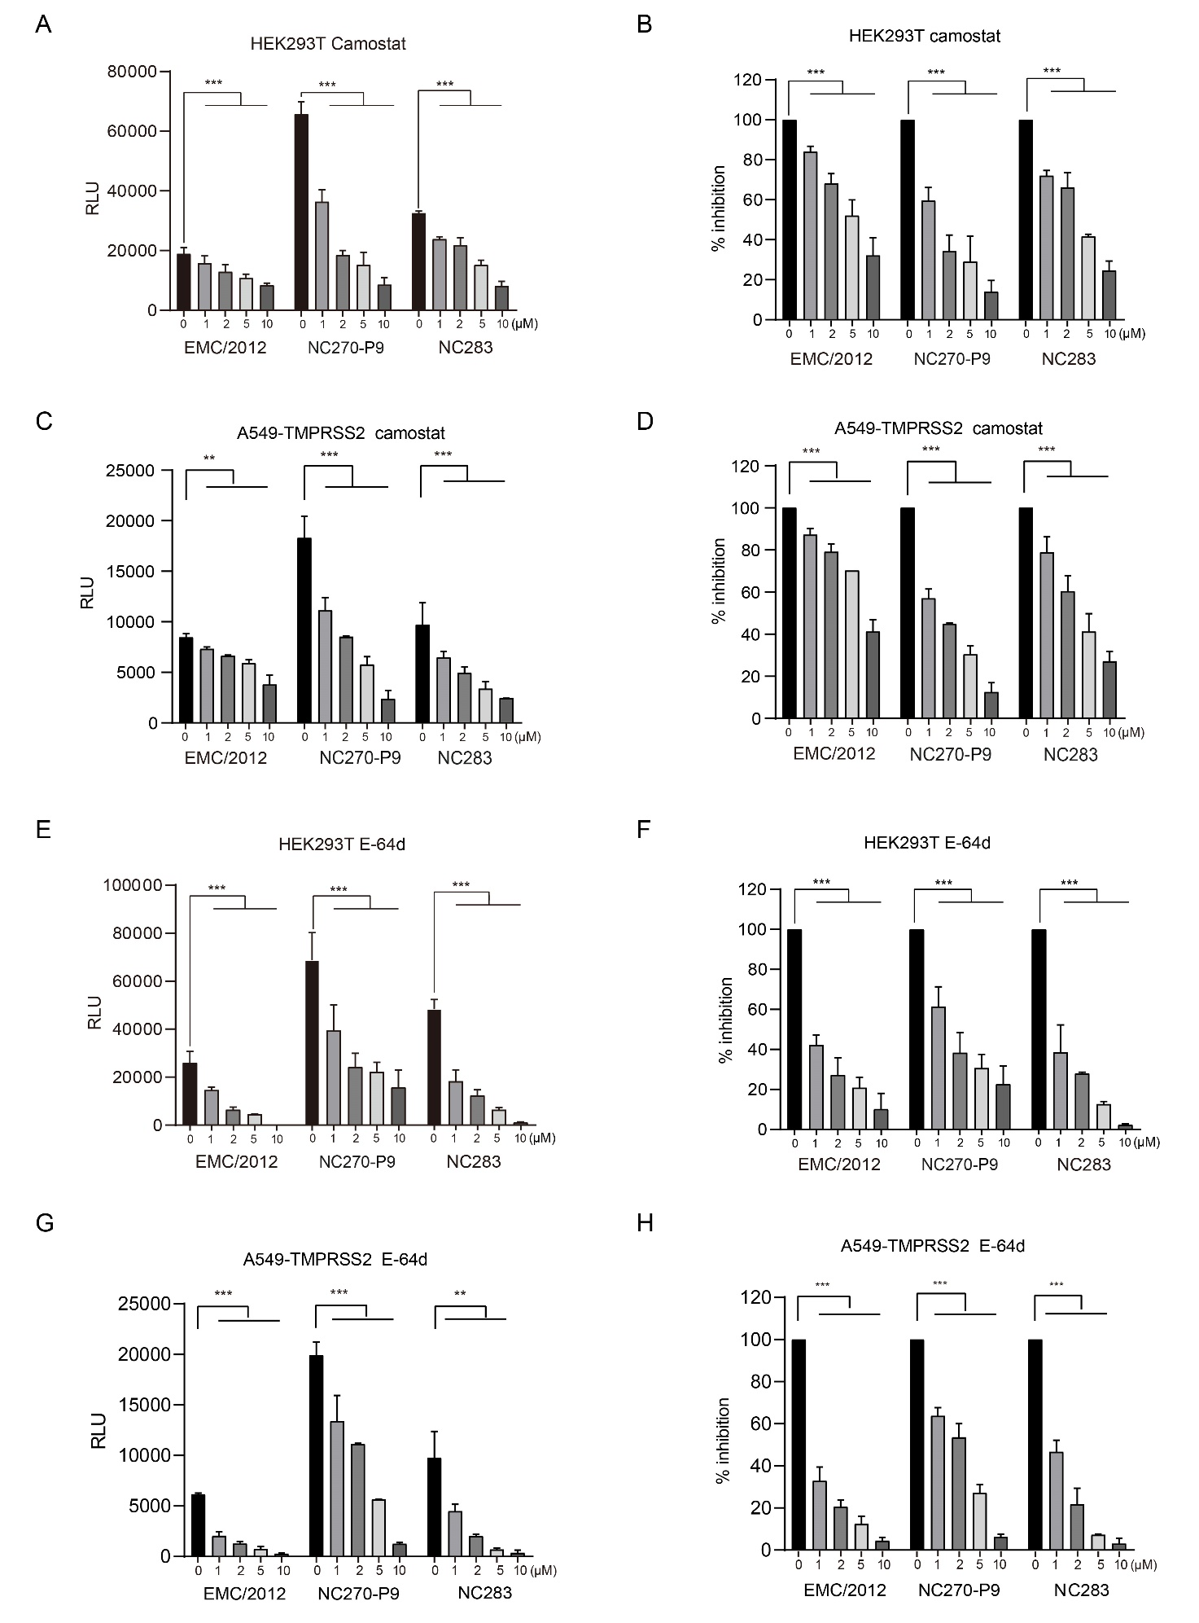
Supplementary Fig. S2. Effects of Camostat and E-64d on the entry of different MERS-CoV pseudoviruses. HEK293T (A, B) and A549-ACE2/TMPRSS2 cells (C, D) were treated with Camostat and transduced with MERS-CoV pseudoviruses at the indicated concentrations. Similarly, HEK293T (E, F) and A549-ACE2/TMPRSS2 cells (G, H) were treated with E-64d and transduced with MERS-CoV pseudoviruses at the indicated concentrations. Luciferase activity was measured and normalized to untreated control (set as 100%). The inhibitor treatment and pseudovirus-based entry assays in HEK293T cells (A, B; E, F) were performed in biological triplicates and repeated twice in A549-ACE2/TMPRSS2 cells (C, D; G, H). The bars show the mean ± SEM. Data were analyzed by Student's t-test (**P < 0.01, ***P < 0.001).

