Virologica Sinica
Supplementary Materials

STING1 negatively regulates translation and replication of Foot-and-Mouth Disease Virus independently of interferon and is antagonized by the viral proteins 3C and 2B
Wenhua Shao^{a,b,1}, Wei Zhang^{b,1,*}, Zhitong Chen^{b,1}, Tingting Zhou^{b}, Xiaoyi Zhao^{b}, Hongyi Liu^{b}, Chuangwei Chen^{b}, Xingyan Dong^{b}, Weijun Cao^{b}, Zongsheng Zhao^{a,*}, Fan Yang^{b,*}, Zixiang Zhu^{b,*}, Haixue Zheng^{b}
ªCollege of Animal Science and Technology, Shihezi University, Shihezi 832001, China
^{b}State Key Laboratory of Animal Disease Control and Prevention, College of Veterinary Medicine, Lanzhou University, Lanzhou Veterinary Research Institute, Chinese Academy of Agricultural Sciences, Lanzhou 730000, China
¹Wenhua Shao, Wei Zhang, and Zhitong Chen contributed equally to this work.
*Corresponding authors.
E-mail addresses: zhaozongsh@sohu.com (Z. Zhao), yangfan02@caas.cn (F. Yang), zhuzixiang@caas.cn (Z. Zhu), zhangwei09@caas.cn (W. Zhang).
ORCID: 0009-0009-4674-763X (Z. Zhao), 0000-0002-8447-9594 (F. Yang), 0000-0002-4093-9683 (Z. Zhu), 0009-0002-1261-5507 (W. Zhang).

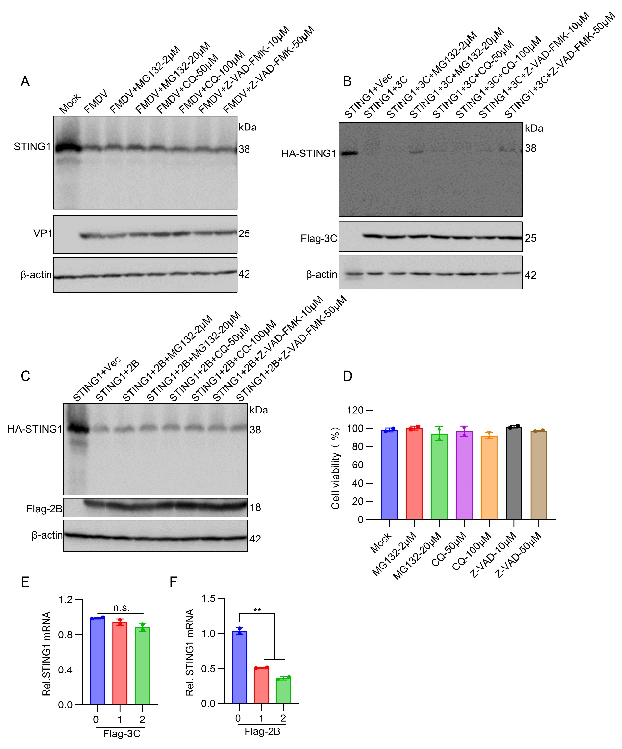
Supplementary Figures
Supplementary Fig. 1. Mechanisms of STING1 downregulation by viral 3C/2B proteins. A Western blotting was used to detect STING1 protein levels in IBRS-2 cells infected with or without FMDV (0.5 MOI) in the absence or presence of MG132 (2 or 20 μM), CQ (50 or 100 μM), or Z-VAD-FMK (10 or 50 μM) for 12 h. B and C Western blotting was used to detect STING1 protein levels in IBRS-2 cells transfected with Flag-3C (B) or 2B (C) plasmids in the absence or presence of MG132 (2 or 20 μM), CQ (50 or 100 μM), or Z-VAD-FMK (10 or 50 μM) for 36 h. D An MTS assay was used to assess the cytotoxicity of MG132 (2 or 20 μM), CQ (50 or 100 μM), or Z-VAD-FMK (10 or 50 μM). E and F The effects of 3C and 2B on STING1 mRNA levels were evaluated. IBRS-2 cells were transfected with 3C (E) or 2B (F) plasmids (0, 1, or 2 μg) for 24 h, and then analyzed by RT-PCR. **P < 0.01; “n.s.” indicates no statistically significant difference.
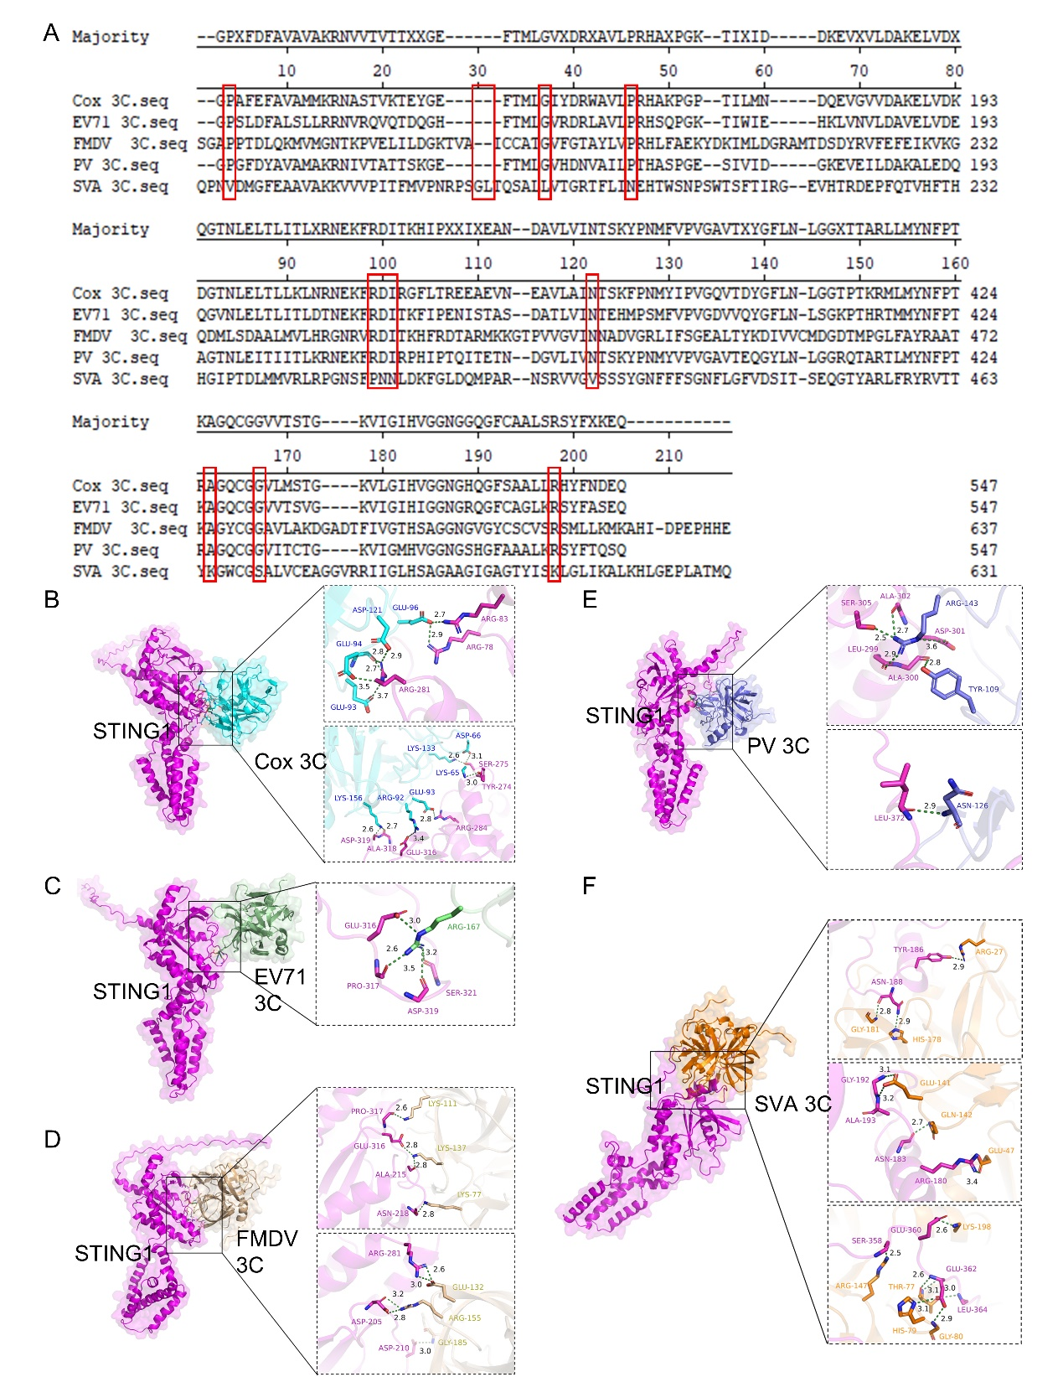
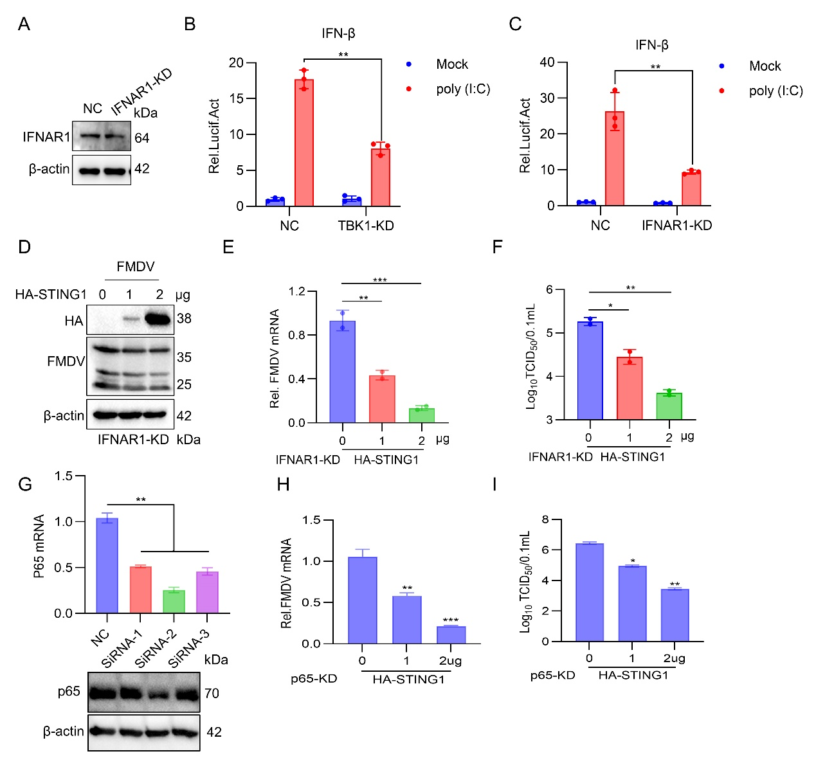
Supplementary Fig. 2. A comprehensive multiple sequence alignment of the 3C amino acid sequences across PV, EV71, Cox, FMDV, and SVA. A The analysis of the conservation of viral 3C nucleic acid sequences. The red box represents that the SVA 3C amino acid sequence is different from other virus 3C sequences. B–F A complex model was constructed using AlphaFold3, followed by energy minimization using Discovery Studio. Protein interactions were then evaluated using PDBePISA (https://www.ebi.ac.uk/msd-srv/prot_int/pistart.html). Panels B–F present molecular docking analyses of STING1 with viral 3C proteins in Cox, EV71, FMDV, PV, and SVA. Docking results for STING1 (modeled by AlphaFold, shown in purple) with Cox 3C (AlphaFold model, cyan) were obtained using the ZDOCK algorithm (B). Similarly, docking results for STING1 (purple) with EV71 3C (green) (C), STING1 (purple) with FMDV 3C (Tan) (D), STING1 (purple) with PV 3C (blue) (E), and STING1 (purple) with SVA 3C (orange) (F) were generated using the ZDOCK algorithm.

Supplementary Fig. 3. STING1 inhibits FMDV replication in an interferon-independent manner. A Knockdown efficiency of IFNAR1 was confirmed by western blotting. B TBK1-KD suppresses poly (I:C)-induced transcriptional activation of the IFN-β promoter. PK-15 cells were transfected with siTBK1 or NC for 16 h, and then transfected with IFN-β luciferase reporters for 20 h. Cells were subsequently treated with or without poly(I:C) (50 ng/mL) for 12 h. Luciferase assays were performed using a dual-luciferase reporter assay kit. C IFNAR1-KD suppresses poly (I:C)-induced transcriptional activation of the IFN-β promoter. PK-15 cells were transfected with siIFNAR1 or NC for 16 h, and then transfected with IFN-β luciferase reporters for 20 h. Cells were treated with or without poly(I:C) (50 ng/mL) for 12 h. Luciferase assays were performed using a dual-luciferase reporter assay kit. D–F STING1 inhibits FMDV replication in IFNAR1 knockdown (IFNAR1-KD) PK-15 cells. IFNAR1-KD cells were transfected with STING1 plasmids in a dose-dependent manner for 24 h and then inoculated with FMDV at an MOI of 0.5 for 12 h. Infected cells were harvested to detect FMDV protein expression using immunoblotting (D), FMDV mRNA levels by RT-PCR (E), and viral titers were assessed by determining TCID₅₀ (F). G–I STING1 inhibits FMDV replication in p65 knockdown (p65-KD) PK-15 cells. p65-KD cells, seeded into 6-well plates, were transfected with STING1 plasmids in a dose-dependent manner for 24 h and then inoculated with FMDV at an MOI of 0.5 for 12 h. The knockdown efficiency was confirmed by RT-PCR and western blotting (G). Infected cells were harvested to detect FMDV mRNA levels by RT-PCR (H), and viral titers were assessed by determining TCID₅₀ (I). *P < 0.05; **P < 0.01; ***P < 0.001.

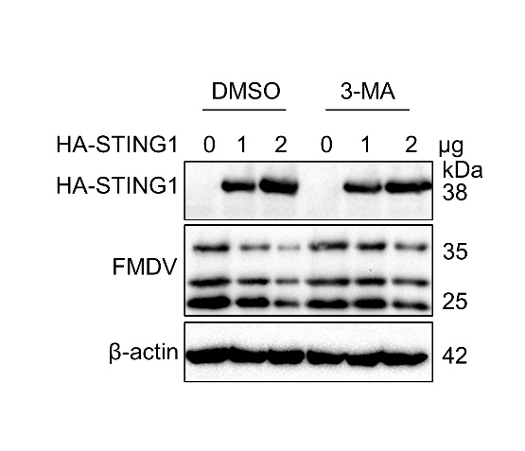
Supplementary Fig. 4. The effect of autophagy inhibitor 3-MA on the anti-FMDV replication of STING1. Western blotting was used to detect viral protein levels in IBRS-2 cells transfected with HA-STING1 plasmids (0, 1, or 2 μg) in the absence or presence of 3-MA (10 mM) for 36 h.
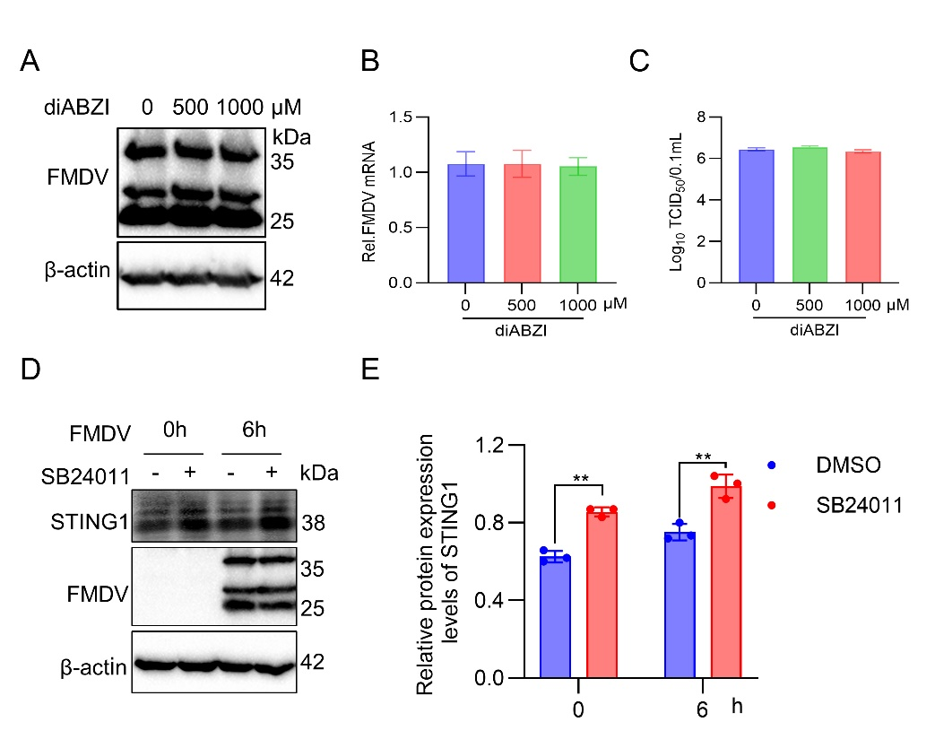
Supplementary Fig. 5. The impact of STING1 agonist diABZI on FMDV replication. A–C BHK-21 cells were treated with varying concentrations of SB24011 (0, 500, and 1000 µM) and subsequently infected with FMDV at 0.5 MOI. At 12 hours post-infection, the levels of viral protein, viral RNA, and viral titers were measured by immunoblotting (A), RT-PCR (B), and TCID₅₀ assay (C), respectively. D The impact of SB24011 on FMDV replication under time-dependent viral infection. IBRS-2 cells were treated with SB24011 (100 μM) or DMSO (control) and then infected with FMDV (MOI = 0.5) for 6 h. Cell lysates were collected and analyzed by Western blotting using antibodies against STING1, FMDV, and β-actin (loading control). E β-actin was used as a loading control to normalize the relative levels of STING1 using Image J. **P < 0.01.

Supplementary Table S1：The RT-PCR primer pairs used in this study.
Primer names | Primer sequences(5'-3')
Sus-GAPDH-F | ACATGGCCTCCAAGGAGTAAGA
Sus-GAPDH-R | GATCGAGTTGGGGCTGTGACT
Hamster-GAPDH-F | GAGAAACCTGCCAAGTATGATGAC
Hamster-GAPDH-R | AGAGTGGGAGTTGCTGTTGAAG
Sus-STING1-F | AATCACGGTTCATTTCCC
Sus-STING1-R | TTTCATTCCAATTTCCAGAAG
Hamster-STING1-F | AATCAGCGACACGACAACCT
Hamster-STING1-R | GCCAGCACGGTTCATGTTTT
FMDV-F | CACTGGTGACAGGCTAAGG
FMDV-R | CCCTTCTCAGATTCCGAGT
Human-GAPDH-F | GAGTCAACGGATTTGGTCGT
Human-GAPDH-R | GACAAGCTTCCCGTTCTCAG
SVA-F | AGAATTTGGAAGCCATGCTCT
SVA-R | GAGCCAACATAGARACAGATTGC
EV71-F | GCTCTATAGGAGATAGTGTGAGTAGGG
EV71-R | ATGACTGCTCACCTGCGTGTT
EMCV-F | CTGTCTTCTTGACGAGCATTC
EMCV-R | CCACTGTTGACTGGGTGTTT
Sus-P65-F | GCATCCACAGCTTCCAGAACCT
Sus-P65-R | AGCAGAGCCGCACAGCATTC
Sus-PERK-F | TCTGGACGGCAGCAATGATGG
Sus-PERK-R | AGTGGTCGGTCTTGGAGGAGAA

