Supplementary material

HVT-based multiepitope vaccine administered subcutaneously or in ovo boosts protection of inactivated H9N2 vaccine against heterologous virus

Zimin Xie^{a, 1}, Yingyi Chen^{a, 1}, Shanyao Du^{a, 1}, Xiumei Huangª, Yuhuan Shaoª, Jiangwu Huangª, Ming Liao^{a, b*}, Manman Dai^{a, b*}

ªGuangdong Laboratory for Lingnan Modern Agriculture, National and Regional Joint Engineering Laboratory for Medicament of Zoonosis Prevention and Control, College of Veterinary Medicine, South China Agricultural University, Guangzhou 510642, China
^{b}UK-China Centre of Excellence for Research on Avian Diseases, Guangzhou 510642, China

¹ Zimin Xie, Yingyi Chen and Shanyao Du contributed equally to this work.

*Corresponding authors.
E-mail addresses: daimanman1229@scau.edu.cn (M. Dai), mliao@scau.edu.cn (M. Liao);
ORCID: 0000-0002-6533-5456 (M. Dai); 0000-0001-8731-4528 (M. Liao)

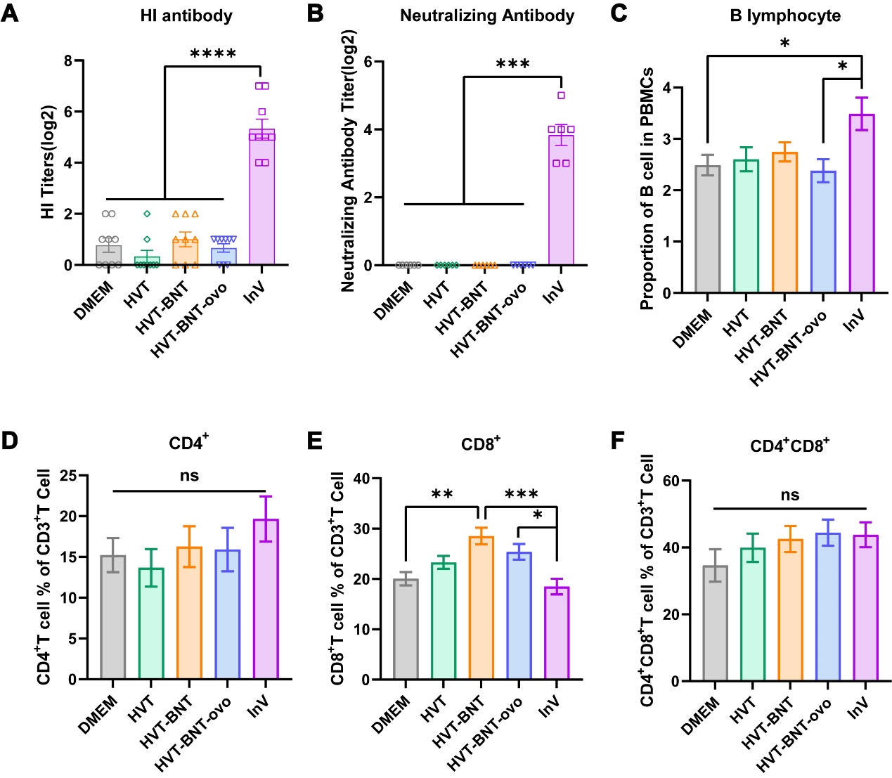
Supplementary Fig. S1. Immunological evaluation of standalone immunization groups at 28 days post-single immunization. Chickens were immunized with DMEM (negative control), HVT, HVT-BNT, HVT-BNT-ovo, or InV. At 28 days post-immunization, serum and PBMCs were collected for analysis. A–B HI antibody and neutralizing antibody titers in serum measured against the H9N2 AIV (A/Chicken/Hunan/HN/2015 strain). C The proportion of B lymphocytes in PBMCs. D–F The proportions of CD4⁺ (D), CD8⁺ (E), and CD4⁺CD8⁺ (F) T lymphocyte subsets within the CD3⁺ T cell population in PBMCs, as determined by flow cytometry. Data are expressed as the mean ± SD (n=9). Statistical significance was analyzed using one-way ANOVA. *P < 0.05, **P < 0.01, ***P < 0.001, ****P < 0.0001; ns, not significant.
Supplementary Fig. S2. The Gate strategy. A Gating strategy for CD8α⁺, CD4⁺, and CD4⁺CD8α⁺ T cells in PBMCs. B Gating strategy for B cells in PBMCs.

Table S1. Summary of Epitope Sequence Conservation
Cell Type | Epitope | Amino Acid Sequence Homology | Reference
B-cell epitopes | HA2₇₆₋₁₃₀ | Highly conserved in structural and antigenic properties; experimentally proven to cross-react with H9 lineages | [1]
B-cell epitopes | M2e₂₋₂₄ | Highly conserved (almost invariant) across human epidemic strains and extremely cross-reactive with avian lineages due to strict genetic constraints | [2-4]
T-cell epitopes | NP₁₈₂₋₁₉₀ | Shares 94.15% identity among diverse H9N2 AIV lineages | [5]
T-cell epitopes | NP₄₅₅₋₄₆₃ | Shares 99.67% identity among diverse H9N2 AIV lineages | [5]
T-cell epitopes | NS1₉₈₋₁₀₆ | Shares 90.07% identity among diverse H9N2 AIV lineages | [5]
T-cell epitopes | PB2₅₅₂₋₅₆₀ | Shares 77.89% identity among diverse lineages, with highly conserved physicochemical properties | [5]
T-cell epitopes | NP₃₈₀₋₃₉₃ | Highly conserved across at least 16 different influenza A subtypes (including H1-H7, H9, H11, and H14 lineages) | [6]
T-cell epitopes | M2e₄₄₋₅₃ | Highly conserved across emerging AIVs, including H9N2 | [7]
T-cell epitopes | NP₁₉₀₋₁₉₇ | Highly conserved AIV-derived CTL epitopes (87.6%–100% homology across divergent strains like H5N1). Highlighting the broad cross-reactivity of such cellular immunity involving the H9N2 AIV | [8]
T-cell epitopes | NP₃₃₉₋₃₄₇ |  | [8]
T-cell epitopes | NP₂₅₁₋₂₅₉ |  | [8]

Reference
1. Wang TT, Tan GS, Hai R, Pica N, Ngai L, Ekiert DC, Wilson IA, Garcia-Sastre A, Moran TM, Palese P. 2010. Vaccination with a synthetic peptide from the influenza virus hemagglutinin provides protection against distinct viral subtypes. Proc Natl Acad Sci U S A 107:18979-84.
2. Fiers W, De Filette M, El Bakkouri K, Schepens B, Roose K, Schotsaert M, Birkett A, Saelens X. 2009. M2e-based universal influenza A vaccine. Vaccine 27:6280-3.
3. Olukitibi TA, Ao Z, Azizi H, Mahmoudi M, Coombs K, Kobasa D, Kobinger G, Yao X. Development and characterization of influenza M2 ectodomain and/or hemagglutinin stalk-based dendritic cell-targeting vaccines. Front Microbiol. 2022 Aug 8;13:937192. doi: 10.3389/fmicb.2022.937192.
4. Wang Q, Zhang Y, Zou P, Wang M, Fu W, She J, Song Z, Xu J, Huang J, Wu F. Self-Assembly M2e-Based Peptide Nanovaccine Confers Broad Protection Against Influenza Viruses. Front Microbiol. 2020 Aug 14;11:1961. doi: 10.3389/fmicb.2020.01961.
5. Jia Y, Wu Q, Li Y, Ma M, Song W, Chen R, Yao Y, Nair V, Zhang N, Liao M, Dai M. 2024. Revealing novel and conservative T-cell epitopes with MHC B2 restriction on H9N2 avian influenza virus (AIV). J Biol Chem 300:107395.
6. Adar Y, Singer Y, Levi R, Tzehoval E, Perk S, Banet-Noach C, Nagar S, Arnon R, Ben-Yedidia T. 2009. A universal epitope-based influenza vaccine and its efficacy against H5N1. Vaccine 27:2099-107.
7. Xiao J, Zhang L, Wang Z, Xiang W, Lu P, Zhao Y, Han M, Ma A, Qi P, Wang M, Gao GF, Liu WJ. 2017. Conserved peptides enhance immune efficiency of inactive vaccines against emerging avian influenza viruses in chicken. Sci China Life Sci 60:1340-1347.
8. Reemers SS, van Haarlem DA, Sijts AJ, Vervelde L, Jansen CA. 2012. Identification of novel avian influenza virus derived CD8+ T-cell epitopes. PLoS One 7:e31953.

