Virologica Sinica

Supplementary Materials

Viral kinetics of the Chikungunya virus ESCA-MAL lineage during the 2025 Guangdong outbreak

Yuwei He ^{a, c, d, 1}, Chuting Zeng ^{b, c, d, 1}, Shuyan Tan ^{e, 1}, Xin Zhang ^{d, 1}, Silin Xiang ^{c, d, f}, Chumin Liang ^{c, d}, Shanshan Gao ^{g}, Baisheng Li ^{d, *}, Jing Lu ^{c, d, *}

ª School of Public Health, Sun Yat-sen University, Guangzhou 510080, China
^{b} School of Biomedical and Pharmaceutical Specialty, Shantou University, Shantou 515063, China
^{c} Guangdong Provincial Institute of Public Health, Guangdong Provincial Center for Disease Control and Prevention, Guangzhou 511430, China
^{d} Guangdong Provincial Key Laboratory of Pathogen Detection for Emerging Infectious Disease Response, Guangdong Workstation for Emerging Infectious Disease Control and Prevention, Guangdong Provincial Center for Disease Control and Prevention, Guangzhou 511430, China
^{e} The Second People's Hospital of Foshan, Foshan 528000, China
^{f} School of Public Health, Southern Medical University, Guangzhou 510515, China
^{g} Jiangmen Central Hospital, Jiangmen 529000, China

¹ Yuwei He, Chuting Zeng, Shuyan Tan, and Xin Zhang contributed equally to this work.

* Corresponding authors:
libsn@126.com (B. Li); Jimlu0331@163.com (J. Lu)
ORCID: 0000-0003-1842-316X (B. Li); 0000-0001-8324-3048 (J. Lu)
Materials and Methods
Study Design and Ethical Considerations
The study was conducted in Guangdong Province, China between July and November 2025. It was a hospital- and public-health–based study. Samples were primarily collected in Shunde District, Foshan City. Participants were enrolled at the Shunde Center for Disease Control and Prevention (CDC) and multiple hospitals in Foshan and neighboring Dongguan; additional longitudinal follow-up was done at hospitals in Foshan and Jiangmen. Details regarding the study locations and participating clinical sites are provided in Supplementary Table S1.
We analyzed a total of 1,183 laboratory-confirmed CHIKV patients divided into two datasets: (1) a longitudinal cohort (n = 37) providing daily capillary blood samples from days 1 to 8 post-symptom onset; and (2) a cross-sectional dataset (n = 1,146) featuring single-point venous serum sampling upon hospital admission.
Viral Quantification
Viral RNA standards were prepared by extracting RNA from CHIKV isolates. The extracted RNA was aliquotted, serially diluted, and quantified using digital PCR (dPCR), following previously described methods (Li., et al., 2022). Viral RNA from serum was extracted and quantified using the following commercial RT-qPCR kits (Supplementary Fig. S1).
Reagent 1 Name and manufacturer: Suzhou Tianlong Biotechnology Co., Ltd.; Chikungunya virus nucleic acid detection kit; Fitted curve: y = -0.26× Ct + 12.927, R² ≥ 0.99
Reagent 2 Name and manufacturer: Berger (Qingdao) Medical Technology Co., Ltd. Chikungunya Virus Nucleic Acid Detection Kit/Mosquito Internal Standard (Fluorescence PCR); Fitted curve: y = -0.255× Ct + 12.568, R² ≥ 0.99.
Reagent 3 Name and manufacturer: Sansure (Shanghai) Biotech Co., Ltd.; Chikungunya Virus Nucleic Acid PCR Detection Kit (Fluorescent Probe Method); Fitted curve: y = -0.249×Ct + 12.519, R² ≥ 0.99.
Reagent 4 Name and manufacturer: Innovative (Tangshan) Biotechnology Co., Ltd. Chikungunya Virus Nucleic Acid PCR Detection Kit (Fluorescent Probe Method); Fitted curve: y = -0.241×Ct + 11.94, R² ≥ 0.99.
Reagent 5 Name and manufacturer: Jiangsu Shuoshi Biotechnology Co., Ltd. Chikungunya Virus Premixed Nucleic Acid Detection Kit (PCR-Fluorescent Probe Method); Fitted curve: y = -0.267×Ct + 13.183, R² ≥ 0.99.
To ensure comparability between the different assays, a universal viral RNA standard was serially diluted to establish standard curves correlating cycle threshold (Ct) values with absolute copy numbers for each kit. This calibration allowed for the conversion of raw Ct values into standardized viral RNA copies, facilitating a unified comparative analysis across all samples. For the 37 capillary blood samples, a consistent RT-qPCR kit was used, and viral loads were determined via these standardized curves to enable direct comparison with the viral concentrations observed in venous blood samples. To facilitate the log-transformation and visualization of viral loads, samples that tested below the limit of detection (LOD) were assigned a value of 50 copies/mL (10^{1.69} copies/mL).

Phylogenetic analysis
We collected 1,858 whole-genome nucleotide sequences of the chikungunya virus (CHIKV) ECSA genotype from NCBI GenBank, performed multiple sequence alignment, and inferred a maximum-likelihood tree in FastTreeMP under the GTR model with 1,000 bootstrap replicates; the tree was visualized in Auspice (v2.67.0, Nextstrain). We further identified sequences recorded during the July–August 2025 outbreak based on NCBI metadata, aligned and placed them on the tree, and found that they form a tight cluster within the ECSA‑MAL clade (ECSA‑MAL_epi).

Statistical Analysis
Due to the non-normal distribution of viral load data, non-parametric tests were used. The Kruskal-Wallis test assessed differences in viral load across time points (Day 1 to Day 8 post-symptom onset), with Dunn’s test for post hoc pairwise comparisons. Bonferroni adjustment was applied, and all analyses were conducted in R (version 4.5.0).

Reference
Li, B., Deng, A., Li, K., Hu, Y., Li, Z., Shi, Y., Xiong, Q., Liu, Z., Guo, Q., Zou, L., Zhang, H., Zhang, M., Ouyang, F., Su, J., Su, W., Xu, J., Lin, H., Sun, J., Peng, J., Jiang, H., Zhou, P., Hu, T., Luo, M., Zhang, Y., Zheng, H., Xiao, J., Liu, T., Tan, M., Che, R., Zeng, H., Zheng, Z., Huang, Y., Yu, J., Yi, L., Wu, J., Chen, J., Zhong, H., Deng, X., Kang, M., Pybus, O.G., Hall, M., Lythgoe, K.A., Li, Y., Yuan, J., He, J., Lu, J., 2022. Viral infection and transmission in a large, well-traced outbreak caused by the SARS-CoV-2 Delta variant. Nat Commun. 13, 460.

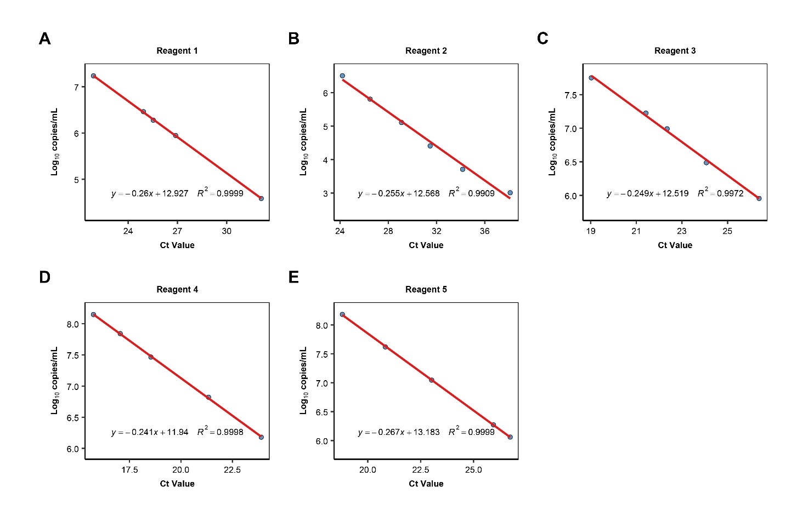
Supplementary Fig. S1 Standard curves for CHIKV viral load quantification. Panels A–E present the standard curves for the five different RT-qPCR reagents used in this study. The solid red lines represent the linear regression fit between Ct values and log₁₀ copies/mL. The corresponding linear regression equations and coefficients of determination (R²) are displayed at the bottom of each panel, indicating the high analytical sensitivity and amplification efficiency of the assays.

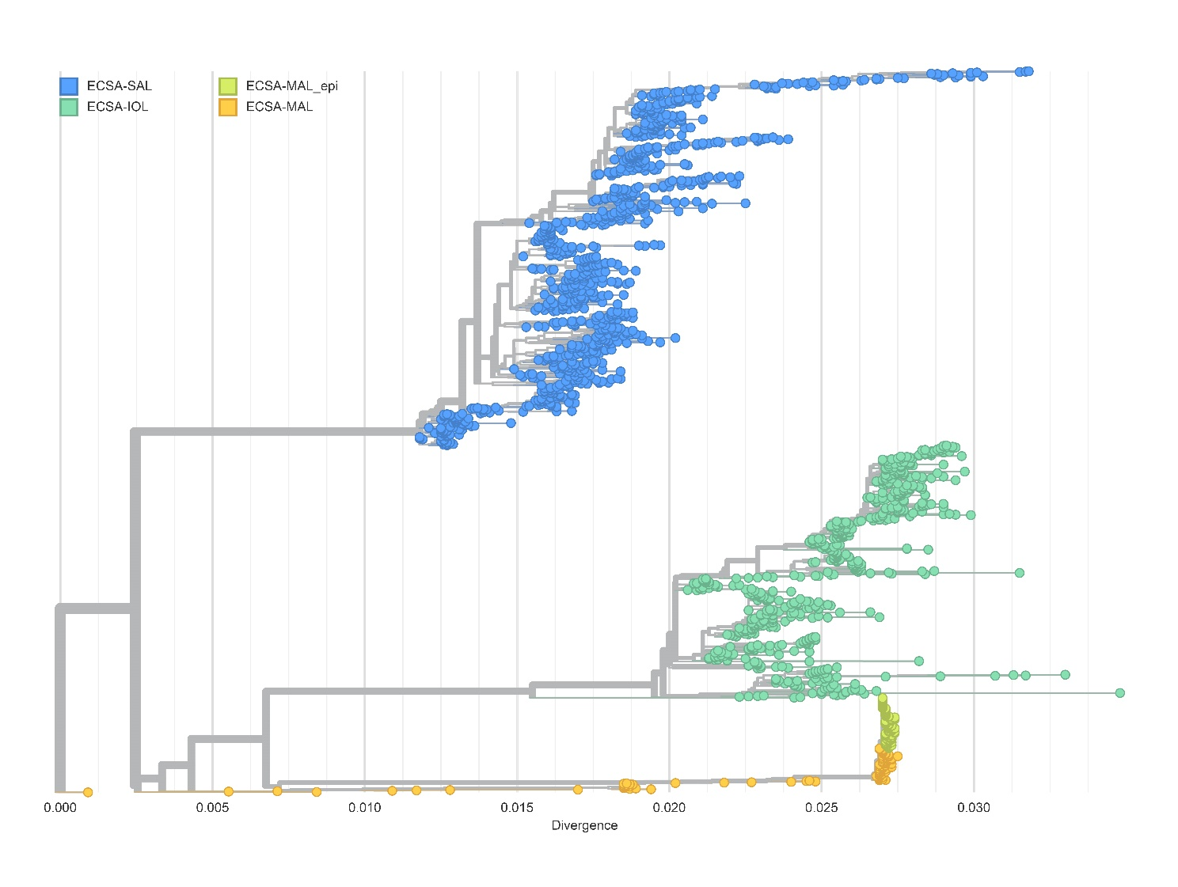
Supplementary Fig. S2 Phylogenetic tree of chikungunya virus and lineage identification of the 2025 outbreak strains. Phylogenetic tree of the chikungunya virus ECSA lineage based on 1,858 sequences from the NCBI database. A Overall phylogenetic topology of the ECSA lineage. All sequences and corresponding metadata used for tree construction were sourced from NCBI GenBank. The x-axis represents genetic divergence. Node colors indicate distinct evolutionary lineages: blue represents the ECSA-SAL lineage, dark green represents ECSA-IOL, and orange represents the established ECSA-MAL reference lineage. B An expanded view of the ECSA-MAL clade (indicated by the dashed box in panel A). Light green nodes (ECSA-MAL_epi) represent viral sequences recorded during the July-August 2025 outbreak. Key nucleotide substitutions (e.g., T4131C, G1855A, C3955T) driving the divergence of these branches are annotated. The phylogenetic analysis demonstrates that the 2025 outbreak sequences share high homology and cluster tightly with the ECSA-MAL lineage, confirming their classification within the ECSA-MAL clade.

Table S1 Hospitals contributing to the cross‑sectional dataset and longitudinal dataset.
Data sources | Case number
Cross‑sectional dataset | n = 1146
Shunde CDC | 486
Beijiao Community Health Service Center, Shunde, Foshan | 71
Beijiao Hospital, Shunde, Foshan | 109
Chencun Hospital, Shunde, Foshan | 78
Foshan Maternal and Child Health Hospital | 31
Shunde Heyou Hospital | 144
Shunde Leliu Hospital | 19
Longjiang Hospital, Shunde, Foshan | 4
Lunjiao Hospital, Shunde, Foshan | 1
Shunde First People’s Hospital | 7
Shunde Maternal and Child Health Hospital | 1
Shunde Hospital of Traditional Chinese Medicine | 1
Foshan First People’s Hospital | 91
Foshan Second People’s Hospital: | 101
Dongguan Donghua Hospital | 1
Dongguan Humen Hospital | 1
Longitudinal dataset | n = 37
Foshan Second People’s Hospital and Jiangmen Central Hospital | 37

Table S2 Raw cycle threshold (Ct) values for the 37-patient longitudinal cohort
Number | Gender | Age, years | Days after onset
Number | Gender | Age, years | 1 | 2 | 3 | 4 | 5 | 6 | 7 | 8
1 | Male | 74 |  |  |  | 28.60 | 34.03 | 39.11
2 | Male | 33 |  |  |  |  | 28.90
3 | Male | 31 |  |  | 30.17 | 38.92
4 | Female | 30 |  |  | 29.63
5 | Male | 48 |  |  | 28.83 | 39.00
6 | Male | 37 |  |  |  | 29.89
7 | Male | 35 |  | 29.11 | 31.61 | 35.15
8 | Female | 31 |  |  | 30.18 | 34.88 | 39.72
9 | Female | 34 |  | 33.84
10 | Female | 41 |  | 32.43 | 39.22
11 | Female | 15 |  | 35.08 | 32.78 | 34.88
12 | Male | 28 |  |  |  | 36.19
13 | Male | 52 |  |  | 35.43 | 40.12
14 | Male | 49 |  |  | 32.83 | 37.81
15 | Female | 52 |  | 25.51 | 28.94 | 34.82 | 38.10
16 | Male | 69 |  |  | 27.10 | 31.87
17 | Male | 27 |  | 31.17
18 | Male | 36 |  |  | 23.46 | 28.43 | 37.27
19 | Male | 34 |  |  | 38.09
20 | Male | 38 |  | 28.12 | 31.32 | 35.72 | 38.56
21 | Male | 65 |  | 23.06 | 28.65 | 33.06 | 38.57
22 | Male | 67 |  |  | 29.64 | 26.34 | 27.10 | 31.72
23 | Female | 48 |  |  | 26.37 | 33.94 | 36.99 | 39.45
24 | Male | 27 |  |  |  | 39.42 | 41.30 | 41.33 | 41.82
25 | Female | 37 |  | 26.45 | 32.39 | 35.79 | 39.54
26 | Male | 41 |  |  | 26.58 | 32.91 | 36.88 | 40.35
27 | Male | 27 |  |  | 29.31 | 34.96 | 32.41 | 40.51
28 | Female | 40 |  |  | 31.08 | 34.19 | 39.95 | 40.90
29 | Male | 34 |  |  |  |  | 39.21 | 41.16 | 41.20 | 41.02
30 | Male | 64 |  | 23.09 | 26.94 | 33.90 | 36.95
31 | Female | 41 |  | 40.68 | 40.89
32 | Male | 79 |  | 26.20 | 29.43 | 33.61 | 39.06
33 | Male | 30 |  | 27.16 | 34.99 | 36.75 | 38.55
34 | Male | 68 |  | 26.87 | 25.36 | 27.49 | 36.12
35 | Male | 24 |  | 27.72 | 35.76 | 37.44 | 39.84
36 | Male | 66 |  | 30.02 | 32.09 | 39.60 | 38.70
37 | Male | 48 | 27.56 | 34.57 | 37.62 | 35.77

