Virologica Sinica
Supplementary materials
VS-7466 Research Article

Effectiveness of lignans against severe fever with thrombocytopenia syndrome virus infection

Jun Huang ^{a,b,c,1}, Jinpeng Lv ^{d,1}, Xiaojie Zheng ^{b}, Junjun Jiang ^{a,c}, Wei Liu ^{b,*}, Shuchen Liu ^{d,*}, Hao Liang ^{a,c,*}, Hao Li ^{b,*}

ª Guangxi Key Laboratory of AIDS Prevention and Treatment & Guangxi Colleges and Universities Key Laboratory of Prevention and Control of Highly Prevalent Diseases, School of Public Health, Guangxi Medical University, Nanning 530021, China
^{b} State Key Laboratory of Pathogen and Biosecurity, Academy of Military Medical Sciences, Beijing 100071, China
^{c} Guangxi Engineering Center for Organoids and Organ-on-chips of Highly Pathogenic Microbial Infections & Biosafety III laboratory, Life Science Institute, Guangxi Medical University, Nanning 530021, China
^{d} Academy of Military Medical Sciences, Beijing 100071, China

*Corresponding author.
E-mail address: lihao_1986@126.com (H. Li); lianghao@gxmu.edu.cn (H. Liang); liusc118@163.com (S. Liu); lwbime@163.com (W. Liu)
¹ Jun Huang and Jinpeng Lv contributed equally to this work.

Corresponding author ORCIDs
Hao Li: 0000-0002-6280-267X
Hao Liang: 0000-0001-7534-5124
Shuchen Liu: 0009-0000-0008-015X
Wei Liu: 0009-0001-6937-2430

Supplementary Figure
Supplementary Figure 1. Preliminary screening of anti-SFTSV lignan compounds.
(A-C) SFTSV-infected Huh7 cells treated with or without indicated concentrations of the type I arylnaphthalene lignan lactones (A), type II arylnaphthalene lignan lactones (B), and other types of lignans(C). At 48hpi, supernatant viral titers were measured by qRT-PCR; n = 3 biologically independent samples. Data presented as mean ± SD. P < 0.05 (*), P < 0.01 (**), P < 0.001 (***), and P < 0.0001 (****).

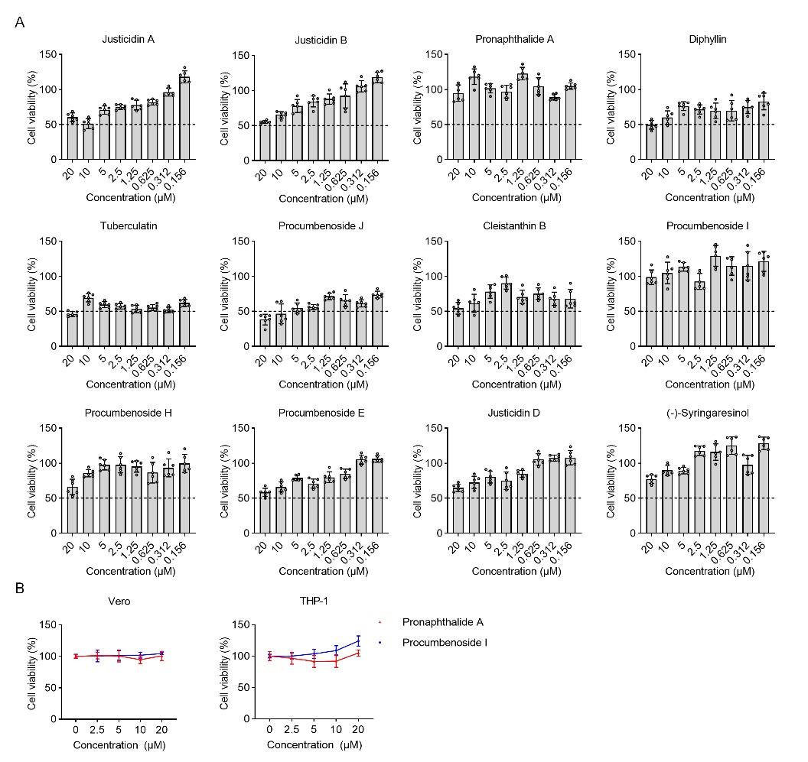
Supplementary Figure 2. Evaluation of the cytotoxicity of lignan compounds.
(A) Viability of diffirent lignans treated Huh7 cells was measured at 48 hours post treatment using CCK-8 assay; n = 6 biologically independent samples. (B) Viability of Pronaphthalide A and Procumbenoside I treated Vero cells or THP-1 cells were measured at 48 hours post treatment using CCK-8 assay; n = 6 biologically independent samples. Data presented as mean ± SD. P < 0.05 (*), P < 0.01 (**), P < 0.001 (***), and P < 0.0001 (****).

Supplementary Table 1. Drug information
Drug type | Code | Name | Formula
Type I arylnaphthalene lignan lactones | A1 | Justicidin A | C22H18O7
Type I arylnaphthalene lignan lactones | A2 | Justicidin B | C21H16O6
Type I arylnaphthalene lignan lactones | A3 | Pronaphthalide A | C22H20O7
Type I arylnaphthalene lignan lactones | A4 | Diphyllin | C21H16O7
Type I arylnaphthalene lignan lactones | A6 | Tuberculatin | C26H24O11
Type I arylnaphthalene lignan lactones | A7 | Procumbenoside J | C29H28O11
Type I arylnaphthalene lignan lactones | A8 | Cleistanthin B | C27H26O12
Type I arylnaphthalene lignan lactones | A9 | Procumbenoside I | C26H24O12
Type I arylnaphthalene lignan lactones | A10 | Procumbenoside K | C26H28O12
Type I arylnaphthalene lignan lactones | A11 | Procumbenoside L | C25H26O11
Type I arylnaphthalene lignan lactones | A12 | Procumbenoside H | C31H32O15
Type I arylnaphthalene lignan lactones | A13 | Procumbenoside A | C31H32O15
Type I arylnaphthalene lignan lactones | A14 | Procumbenoside B | C32H34O16
Type I arylnaphthalene lignan lactones | A15 | Procumbenoside M | C37H38O16
Type I arylnaphthalene lignan lactones | A16 | Justicidinoside B | C28H28O13
Type I arylnaphthalene lignan lactones | A17 | Justicidinoside C | C27H26O12
Type I arylnaphthalene lignan lactones | A18 | Procumbenoside E | C36H4019
Type II arylnaphthalene lignan lactones | B1 | Justicidin C | C22H18O7
Type II arylnaphthalene lignan lactones | B2 | Justicidin D | C21H14O7
Type II arylnaphthalene lignan lactones | B3 | Justicidin E | C20H12O6
Type II arylnaphthalene lignan lactones | B4 | 5`-Methoxy retrochinensin | C22H18O7
Type II arylnaphthalene lignan lactones | B5 | Detetrahydroconidendrin | C20H16O6
Type II arylnaphthalene lignan lactones | B6 | Justicidinoside A | C28H28O13
Other types of lignans | C1 | Juspurpudin | C20H16O7
Other types of lignans | C2 | Rostellulin A | C25H28O9
Other types of lignans | C3 | (+)-Pinoresinol | C20H22O6
Other types of lignans | C4 | Epi-pinoresinol | C20H22O6
Other types of lignans | C5 | (-)-Syringaresinol | C22H26O8
Other types of lignans | C6 | (-)-Medioresionol | C21H24O7

Supplementary Table 2. Oligonucleotides used in this study
Gene | Primer Sequence
SFTSV-L | Forward: 5’- CTCACTCATGCCCTCAACGA -3’
SFTSV-L | Reverse: 5’- GATGAACTCACCAGCCCTGC -3’
GAPDH | Forward: 5’- GGTGGTCCTCTGACTTCAACA -3’
GAPDH | Reverse: 5’- GTTGCTGTAGCCAAATTCGTTGT -3’
SFTSV-S | Forward: 5’- AGCCTAATTGGATATGTCAAATTGC -3’
SFTSV-S | Reverse: 5’- CGGGTGAAGTGGCTGAAGG -3’
SFTSV-S | Probe: 5’- AGCAGCAGCAGCAACCTCAGCAGC -3’
WELV-S | Forward: 5’- AACCGATGGGAAAGTGACTG -3’
WELV-S | Reverse: 5’- GAACTTGAGGGCGTTGACAT -3’
WELV-S | Probe: 5’- ACCCTGTGCTCTGAAAGCAT -3’
LCMV-L | Forward: 5’- GGCCTTGTATGGAGTAGCACCTT -3’
LCMV-L | Reverse: 5’- GGTCTGTGAGATATCAAGTGGTAGAATG -3’
LCMV-L | Probe: 5’- CTGAAGAATACCACCTATTATACCA -3’

Supplementary Table 3. Antibodies used in this study
Antibodies | Dilution | Source | Identifier
Anti-GAPDH Mouse Monoclonal Antibody | 1:2000 | Applygen | Cat# C1312
Mouse monoclonal anti-SFTSV-NP | 1:2000 | This paper | N/A
Rabbit polyclonal anti-SFTSV-Gc | 1:2000 | This paper | N/A
Mouse polyclonal anti-SFTSV-Gn | 1:2000 | This paper | N/A
Peroxidase-conjugated Affnipure Goat Anti-Mouse IgG(H+L) | 1:10000 | Applygen | Cat# C1308
Peroxidase-conjugated Affnipure Goat Anti-Rabbit IgG(H+L) | 1:10000 | Applygen | Cat# C1309
Anti-IFNAR1 IgG | - | Bio X Cell | Cat# BE0241

