Virologica Sinica

Supplementary Materials

Whole-genome evolutionary dynamics of human parainfluenza virus type 3 in Shanghai, China, 2016–2024
Yuqing Zhou ^{a, 1}, Xiao Wang ^{a, b, 1}, Lu Zhang ª, Yang Yuan ª, Tianchun Liu ª, Yuqin Yang ª,
Yingjie Zheng ^{c, d, e} *, Bing Zhao ^{a,} *

ª Shanghai Pudong New Area Center for Disease Control and Prevention (Shanghai Pudong New Area Health Supervision Institute), Shanghai 200136, China.
^{b} Institute of Pathogen Biology, Chinese Academy of Medical Sciences & Peking Union Medical College, Beijing 100730, China.
^{c} Department of Epidemiology, School of Public Health, Fudan University, Shanghai 200032, China.
^{d} Key Laboratory for Health Technology Assessment, National Commission of Health and Family Planning, Fudan University, Shanghai 200032, China.
^{e} Laboratory of Public Health Safety, Ministry of Education, School of Public Health, Fudan University, Shanghai 200032, China.

¹Yuqing Zhou and Xiao Wang contributed to the work equally.

*Corresponding authors
Email addresses: zerg8424@hotmail.com (B. Zhao), yjzheng@fudan.edu.cn (Y. Zheng)
ORCID: 0000-0002-5468-8563 (B. Zhao); 0000-0002-0391-2254 (Y. Zheng).

Materials and Methods

Sample collection and definition

From January 2016 to December 2024, a laboratory-based surveillance system was implemented in Shanghai Pudong New Area. Sentinel sites were selected based on geography, patient demographics, and volume of acute respiratory infection (ARI) cases (Jin-Feng Wang et al., 2009). Patients with ARI were included through Shanghai city-wide ARI guidelines, which required at least one of the following symptoms: cough, sore throat, runny nose, or shortness of breath, with or without fever. Respiratory samples (nasopharyngeal swabs or sputum) and clinical data were collected following ARI protocols. Samples positive for HPIV-3 by the TaqMan Low-Density Array (TLDA) assay (Applied Biosystems, USA) were included for further study.

Primer pools design and optimize
Candidate primers were designed using Primal Scheme (https://primalscheme.com/)(Quick et al., 2017), targeting 400 bp amplicons with 75 bp overlaps. Complete HPIV-3 genomes from GenBank (https://www.ncbi.nlm.nih.gov/) were used as input. The distribution of designed primers was visualized and optimized using SnapGene (https://www.snapgene.com/), Primer Premier software (Singh et al., 1998) and Oligo 7 software (Rychlik, 2007). Primer specificity was confirmed by NCBI Primer-BLAST (https://blast.ncbi.nlm.nih.gov/Blast.cgi/). A total of 116 primers were synthesized by BOJIE Biomedical Technology Co., Ltd. (Shanghai) and reconstituted in RNase-free DEPC-treated water to a final concentration of 10 µM. To ensure consistent overlapping coverage of adjacent genomic regions, primers were divided into two alternating pools (Pool 1 and Pool 2) and alternately arranged. Details are listed in Supplementary Table S1.

RNA extraction, cDNA synthesis, and amplifying

Viral RNA was extracted with the MagNA Pure 96 DNA and Viral NA Small Volume Kit (Roche, Mannheim, Germany) on the MagNA Pure 96 System (Roche, Switzerland). First-strand cDNA was synthesized using reverse transcriptase and random hexamer primers. Double-stranded (ds) cDNA was amplified in two reactions with either primer pool, containing 5 µL cDNA in a 20 µL reaction mix with 0.5 µM primers. The PCR conditions were 98 °C for 3 min, followed by 35 cycles of 98 °C for 15 sec and 60 °C for 5 min. Products from each pool were combined and quantified using Qubit dsDNA HS Assay Kit (ThermoFisher Scientific).

Library preparation and sequencing

PCR products were quantified using the Qubit dsDNA HS Assay Kit (ThermoFisher Scientific). The final libraries were normalized to 4 nM and sequenced in batches of 10–15 samples using a MiSeq flow cell with v2 (300 cycle) reagent chemistry, performing 2 × 150 bp paired-end sequencing on the Illumina MiSeq platform.

Quality control

Candidate primers were verified using Qubit and Qsep400. Each typical run output for the v2 kit is on the order of 12–15 million paired reads per run (about 4.5–5.1 Gb total), ensuring each sample had a quality score (Q-score) above Q30. The Q-score predicts the probability of an error in base calling, where a Q30 score represents an error probability of 0.001 (1 error in 1,000 base calls).

Data preprocessing and quality control

Contigs and consensus sequences were assembled using QIAGEN CLC Genomics Workbench 24.0.1 (https://digitalinsights.qiagen.com/), using the HPIV-3 prototype strain Human respirovirus 3 C243 (ATCC VR-93, GenBank ID: LC817393.1) as the reference due to its high-quality full-length genome and widespread use in comparative genomic analyses. To ensure high-quality data, sequences covering over 98% of the reference genome with a minimum read depth of 10 per position were selected for further analysis (Köndgen et al., 2024).

Reference selection: A total of 691 nucleotide sequences publicly available as of 31 December 2024 were retrieved from GenBank using the search terms "human parainfluenza virus 3" and "Human respirovirus 3"[porgn: txid11216] and "complete genome". Sequences that were incomplete, annotated as partial CDS, or contained ambiguous nucleotides were excluded. To ensure representativeness and reduce redundancy, identical sequences from the same country and year were removed. After quality control and filtering, a total of 101 representative whole-genome sequences were retained for downstream analysis. These sequences were collected globally and spanned the period from 1957 to 2023 (shown in Supplementary Table S2).

Phylogenetic analysis

Maximum likelihood (ML) phylogenetic tree was constructed using MEGA v11 software (Tamura et al., 2021), based on the GTR+G+I model. The reliability of the tree topology was assessed using 1000 bootstrap replicates, and groupings with bootstrap support values > 60% were considered statistically significant (Lemoine, Gascuel, 2024). The final visualization was performed using iTOL (https://itol.embl.de/) (Letunic, Bork, 2024).

Evolutionary Analysis

Evolutionary analysis was conducted using the BEAST software package (http://beast.community/). Dataset was configured in BEAUti v1.10.4 with collection dates incorporated. A relaxed lognormal clock model (Drummond et al., 2006) and the Bayesian Skyline coalescent model was used as the tree prior (Drummond et al., 2005). The Markov Chain Monte Carlo (MCMC) method (Ferreira, Suchard, 2008) was employed, with a chain length of 100 million steps and sampling every 10,000 steps. The first 10% were discarded as burn-in. BEAGLE v3 was used to accelerate computation (Ayres et al., 2019). The final configuration was executed in BEAST v10.5.0 (Suchard et al., 2018). Convergence was checked in Tracer v1.7.2 (Rambaut et al., 2018), with effective sample size (ESS) > 200. The output.trees file was then used to reconstruct Bayesian Skyline Plots (BSP) to visualize changes in the effective population size over time.

Recombination analysis

Whole-genome recombination events were identified using the RDP4 software package (Martin et al., 2015), employing multiple detection methods including RDP, GENECONV, BootScan, MaxChi, Chimaera, SiScan, and 3Seq. Events supported by ≥ 3 methods were considered credible. Subsequent confirmation of putative recombinant sequences was performed with SimPlot++ (Samson et al., 2022). Similarity and bootscanning analyses were conducted using the Kimura 2-parameter model and the neighbor-joining method.

Entropy plots

Aligned HPIV-3 complete genome sequences were translated into amino acid sequences using MEGA v11 software (Tamura et al., 2021). Entropy values (H(x)) were calculated in BioEdit v7.0.9. Sites were classified as highly variable when H ≥ 1.0, moderately variable when 0.6 < H ≤ 1.0, and conserved when H ≤ 0.6.

Selective pressure analysis

Selective pressure at each codon site were evaluated by four algorithms available on the Datamonkey (http://www.datamonkey.org): MEME (Mixed Effects Model of Evolution), FEL (Fixed Effects Likelihood), FUBAR (Fast, Unconstrained Bayesian AppRoximation), and SLAC (Single Likelihood Ancestor Counting). For SLAC and FEL, selective pressure was evaluated based on the difference between nonsynonymous (dN) and synonymous (dS) substitution rates. A site was considered to be under positive selection when dN − dS > 0 and P < 0.05 indicated a statistically significant deviation from neutrality. For MEME, a site is considered to be under positive selection if the likelihood ratio test (LRT) yields a P-value < 0.001. For FUBAR, a posterior probability > 0.95 suggested strong evidence of positive selection, with greater than 95% confidence.

Statistics analysis
Hospital staff recorded demographic and clinical data, including gender, age, symptoms, and diagnosis, which were input into the standard system from the Chinese CDC. Data were analyzed using R 4.4.0. Differences in rates between sub-lineages were tested using the chi-square test or Fisher's exact test, with P-values < 0.05 deemed statistically significant.

References
Ayres, D.L., Cummings, M.P., Baele, G., Darling, A.E., Lewis, P.O., Swofford, D.L., Huelsenbeck, J.P., Lemey, P., Rambaut, A., Suchard, M.A.2019. BEAGLE 3: Improved Performance, Scaling, and Usability for a High-Performance Computing Library for Statistical Phylogenetics. Systematic Biology 68, 1052–1061.
Drummond, A.J., Ho, S.Y.W., Phillips, M.J., Rambaut, A.,2006. Relaxed phylogenetics and dating with confidence. PLoS biology 4, e88.
Drummond, A.J., Rambaut, A., Shapiro, B., Pybus, O.G.,2005. Bayesian coalescent inference of past population dynamics from molecular sequences. Molecular Biology and Evolution 22, 1185–1192.
Ferreira, M.A.R., Suchard, M.A.,2008. Bayesian analysis of elapsed times in continuous-time Markov chains. Canadian Journal of Statistics 36, 355–368.
Jin-Feng Wang, Christakos, G., Mao-Gui Hu,2009. Modeling Spatial Means of Surfaces With Stratified Nonhomogeneity. IEEE Transactions on Geoscience and Remote Sensing 47, 4167–4174.
Köndgen, S., Oh, D.-Y., Thürmer, A., Sedaghatjoo, S., Patrono, L.V., Calvignac-Spencer, S., Biere, B., Wolff, T., Dürrwald, R., Fuchs, S., et al.,2024. A robust, scalable, and cost-efficient approach to whole genome sequencing of RSV directly from clinical samples. Journal of Clinical Microbiology 62, e01111-23.
Lemoine, F., Gascuel, O.,2024. The bayesian phylogenetic bootstrap and its application to short trees and branches. Molecular Biology and Evolution 41, msae238.
Letunic, I., Bork, P.,2024. Interactive Tree of Life (iTOL) v6: recent updates to the phylogenetic tree display and annotation tool. Nucleic Acids Research 52, W78–W82.
Martin, D.P., Murrell, B., Golden, M., Khoosal, A., Muhire, B.,2015. RDP4: Detection and analysis of recombination patterns in virus genomes. Virus Evolution 1, vev003.
Quick, J., Grubaugh, N.D., Pullan, S.T., Claro, I.M., Smith, A.D., Gangavarapu, K., Oliveira, G., Robles-Sikisaka, R., Rogers, T.F., Beutler, N.A., et al.,2017. Multiplex PCR method for MinION and Illumina sequencing of Zika and other virus genomes directly from clinical samples. Nature Protocols 12, 1261–1276.
Rambaut, A., Drummond, A.J., Xie, D., Baele, G., Suchard, M.A.,2018. Posterior Summarization in Bayesian Phylogenetics Using Tracer 1.7. Systematic Biology 67, 901–904.
Rychlik, W.,2007. OLIGO 7 primer analysis software. Methods in Molecular Biology (Clifton, N.J.) 402, 35–60.
Samson, S., Lord, É., Makarenkov, V.,2022. SimPlot++: a Python application for representing sequence similarity and detecting recombination. Bioinformatics 38, 3118–3120.
Singh, V.K., Mangalam, A.K., Dwivedi, S., Naik, S.,1998. Primer premier: program for design of degenerate primers from a protein sequence. BioTechniques 24, 318–319.
Suchard, M.A., Lemey, P., Baele, G., Ayres, D.L., Drummond, A.J., Rambaut, A.,2018. Bayesian phylogenetic and phylodynamic data integration using BEAST 1.10. Virus Evolution 4, vey016.
Tamura, K., Stecher, G., Kumar, S.,2021. Mega11: molecular evolutionary genetics analysis version 11. Molecular Biology and Evolution 38, 3022–3027.

Supplementary Figures
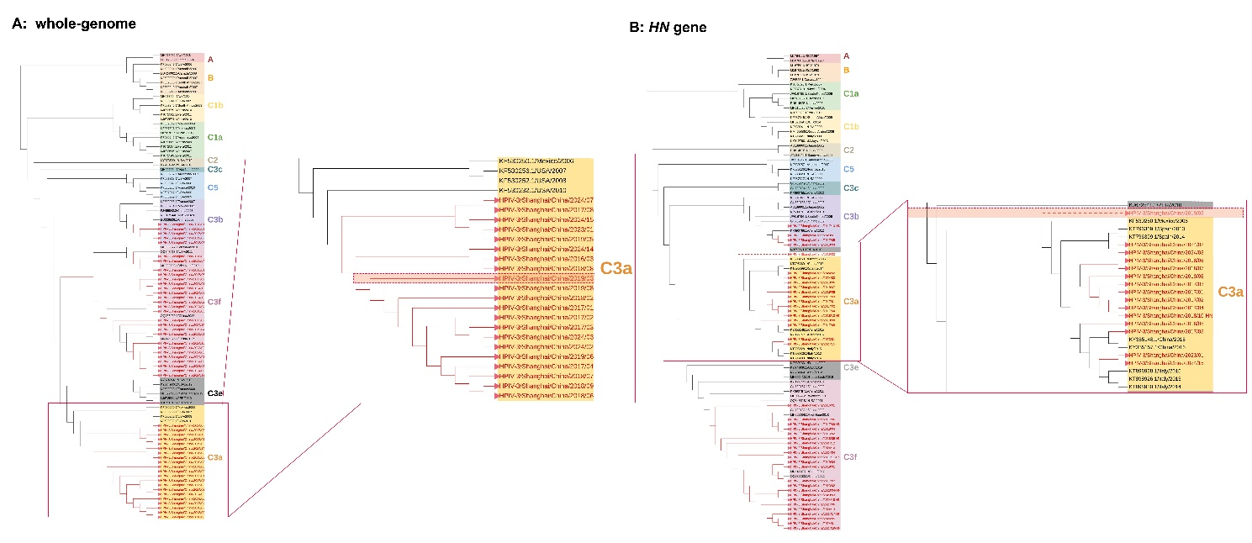
Fig. S1 Phylogenetic trees constructed based on (A) whole-genome sequences and (B) HN gene sequences of HPIV-3 strains. Red squares indicate strains with inconsistent clustering patterns between the two trees.
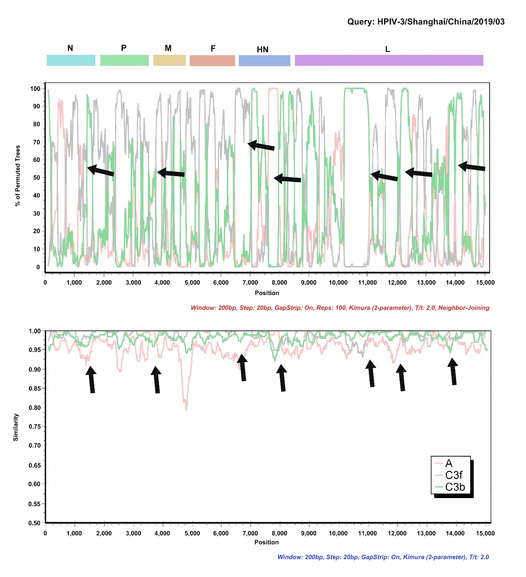
Fig. S2 Similarity and bootscan analyses of the putative recombinant HPIV-3 strain HPIV-3/China/Shanghai/2019/03. Analyses were performed using the whole-genome sequence of strain HPIV-3/China/Shanghai/2019/03, which exhibited discordant lineage assignments between HN-based and whole-genome phylogenies, as the query sequence. A sliding window of 200 bp with a step size of 20 bp was applied. Black arrows indicate putative recombinant regions.
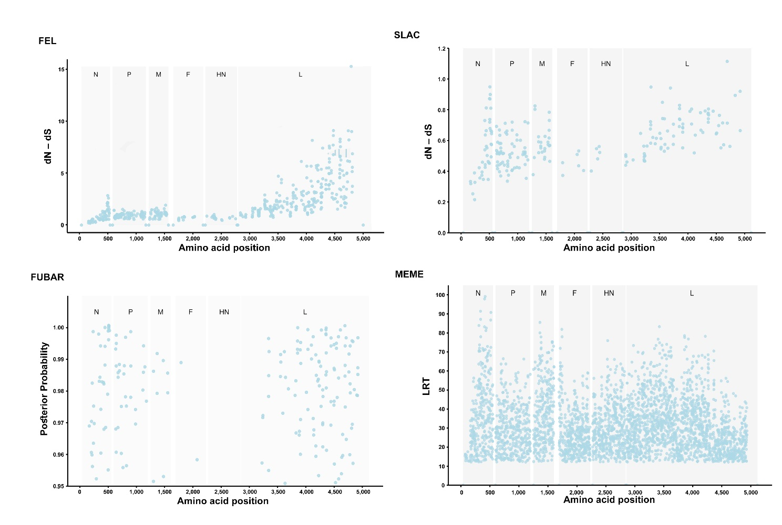
Fig. S3 Amino acid sites under selection pressure in HPIV-3 identified in this study. LRT: Likelihood Ratio Test. Positive selection was defined as dN − dS > 0 with P < 0.05 for SLAC and FEL, P < 0.001 for MEME, and posterior probability > 0.95 for FUBAR.

Supplementary Tables
Table S1. Primer sequences used for HPIV-3 in this study.
(Excel file)
Table S2. Reference sequences retrieved from GenBank used in this study.
(Excel file)
Table S3. Association between clinical phenotypes and HPIV-3 sub-lineages.
(Excel file)

