Supplementary Materials
Virologica Sinica

Host OTUB2 and viral PLpro stabilize NSP8 to promote SARS-CoV-2 replication

Wenying Gao ^{a, 1}, Hongfei Wang ^{b, 1}, Jingguo Xin ª, Chenjia Gu ª, Lu Qiu ^{c}, Xue Zhang ^{b}, Chunlei Wang ª, Qingxiang Zhang ª, Shuai Li ^{c, *}, Guangquan Li ^{b, *}, Wenyan Zhang ^{a, *}

ª Institute of Virology and AIDS Research, Centre of Infectious Diseases and Pathogen Biology, Key Laboratory of Organ Regeneration and Transplantation of the Ministry of Education, the First Hospital of Jilin University, Changchun 130000, China
^{b} Jilin Provincial Key Laboratory on Molecular and Chemical Genetics, The Second Hospital of Jilin University, Changchun 130000, China
^{c} Changchun Institute of Biological Products Co., Ltd, Changchun 130000, China

¹ Wenying Gao and Hongfei Wang contributed equally to this article.

*Corresponding authors.
E-mail addresses: zhangwenyan@jlu.edu.cn (W. Zhang), liguangquan@ jlu.edu.cn (G. Li), lishuai3@sinopharm.com (S. Li).
ORCID: 0000-0003-4507-521X (W. Zhang); 0009-0006-8395-3107 (G. Li); 0009-0007-5150-956X (S. Li)
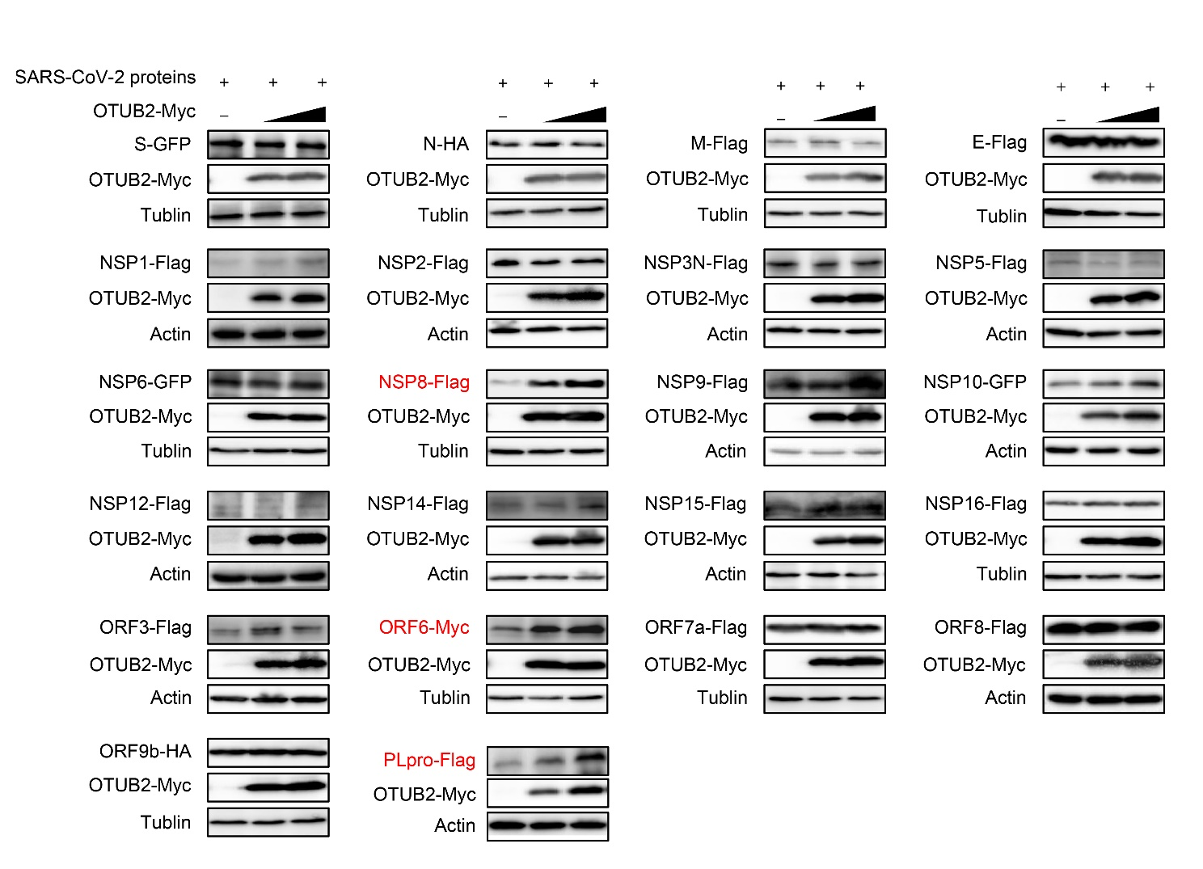
Fig. S1. The effect of OTUB2 on SARS-CoV-2 protein expression. Different SARS-CoV-2 proteins were co-transfected with increasing amounts of OTUB2 (100 ng, 300 ng) into HEK293T cells. Cells were harvested 48 h post-transfection, and the expression levels of SARS-CoV-2 proteins were analyzed by Western blot analysis.
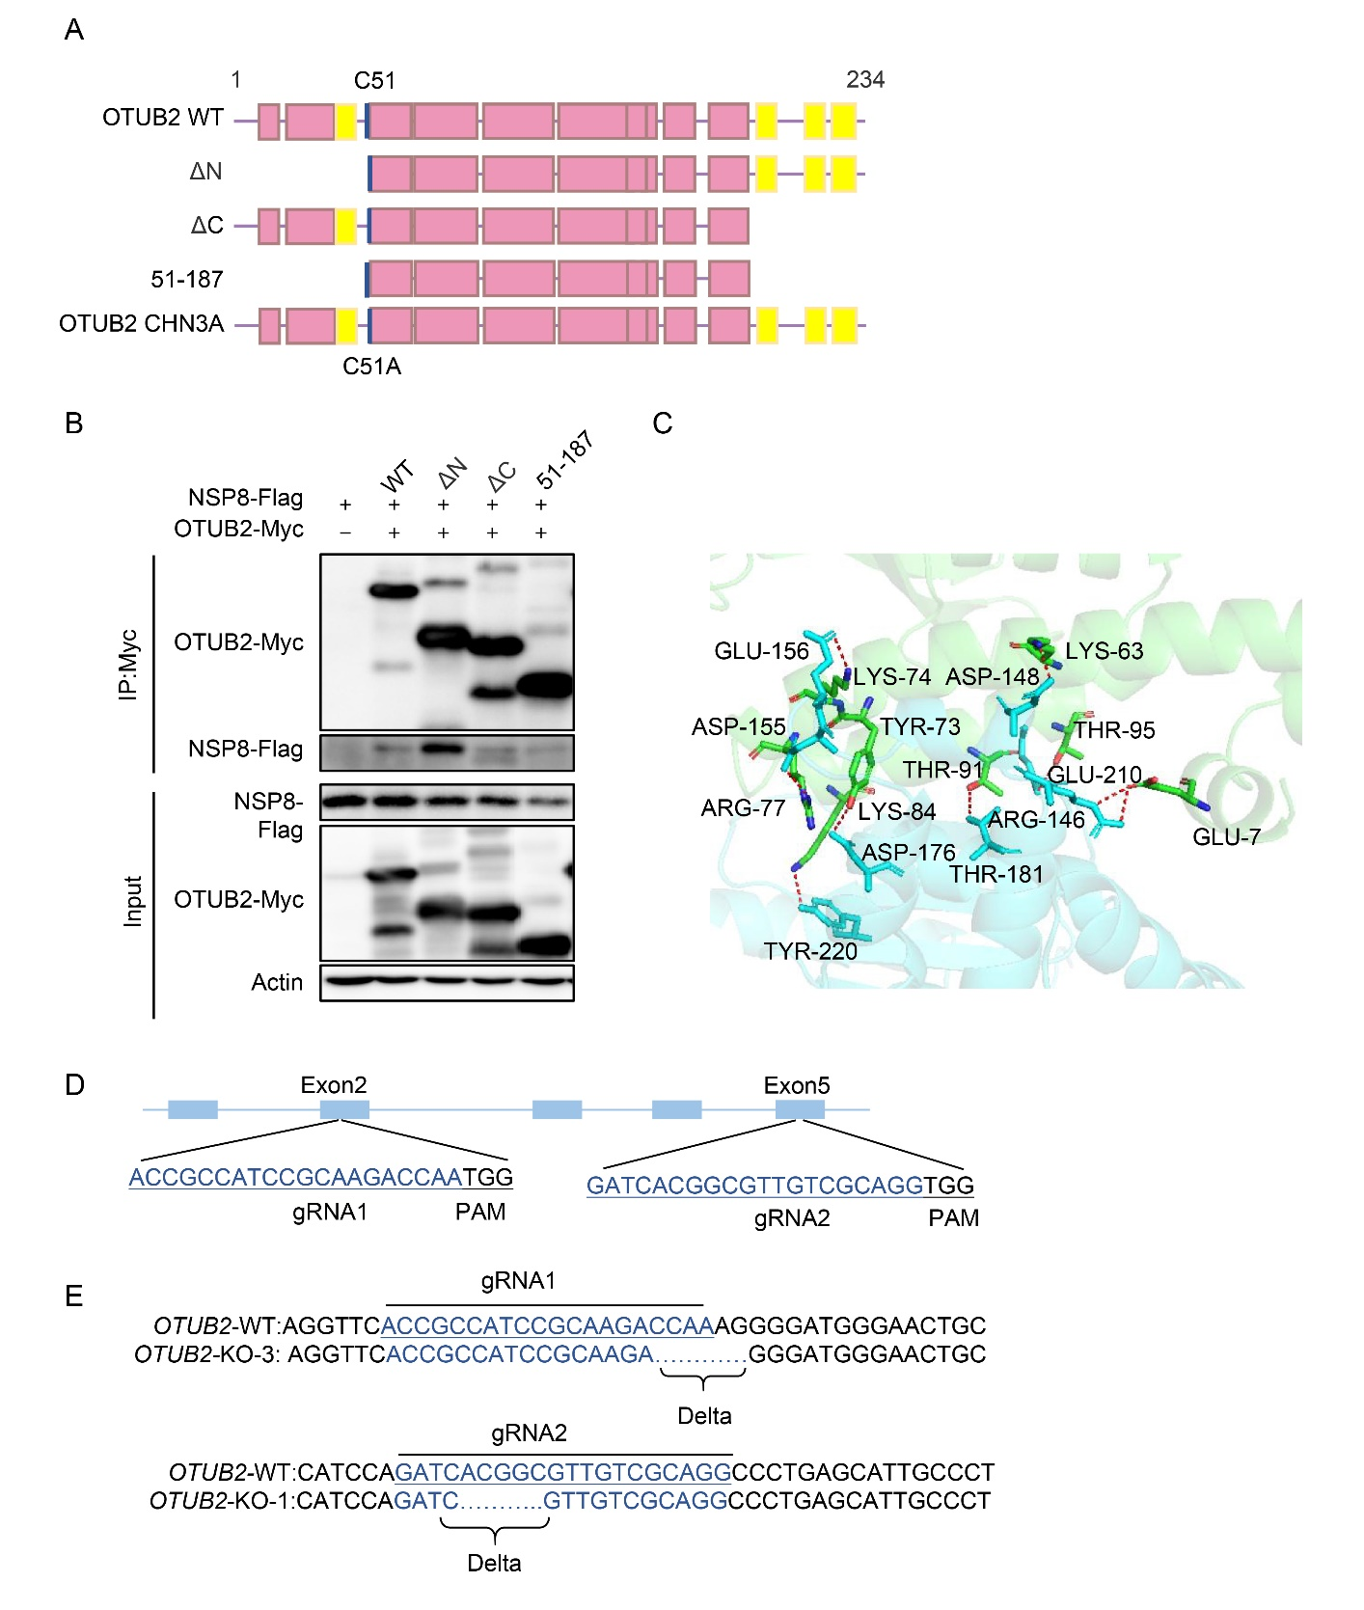
Fig. S2. Effect of OTUB2 on the stability of SARS-CoV-2 proteins. A The pattern diagram of the catalytic active site distribution and truncated mutants of OTUB2. B Co-IP assays were used to analyze the key domains involved in the interaction between OTUB2 and NSP8. C AlphaFold-predicted structural model of the OTUB2-NSP8 interaction (OTUB2, cyan; NSP8, green). D Schematic representation of the OTUB2 knockout strategy. E Confirmation of OTUB2 knockout in HEK293T cells by DNA sequencing.
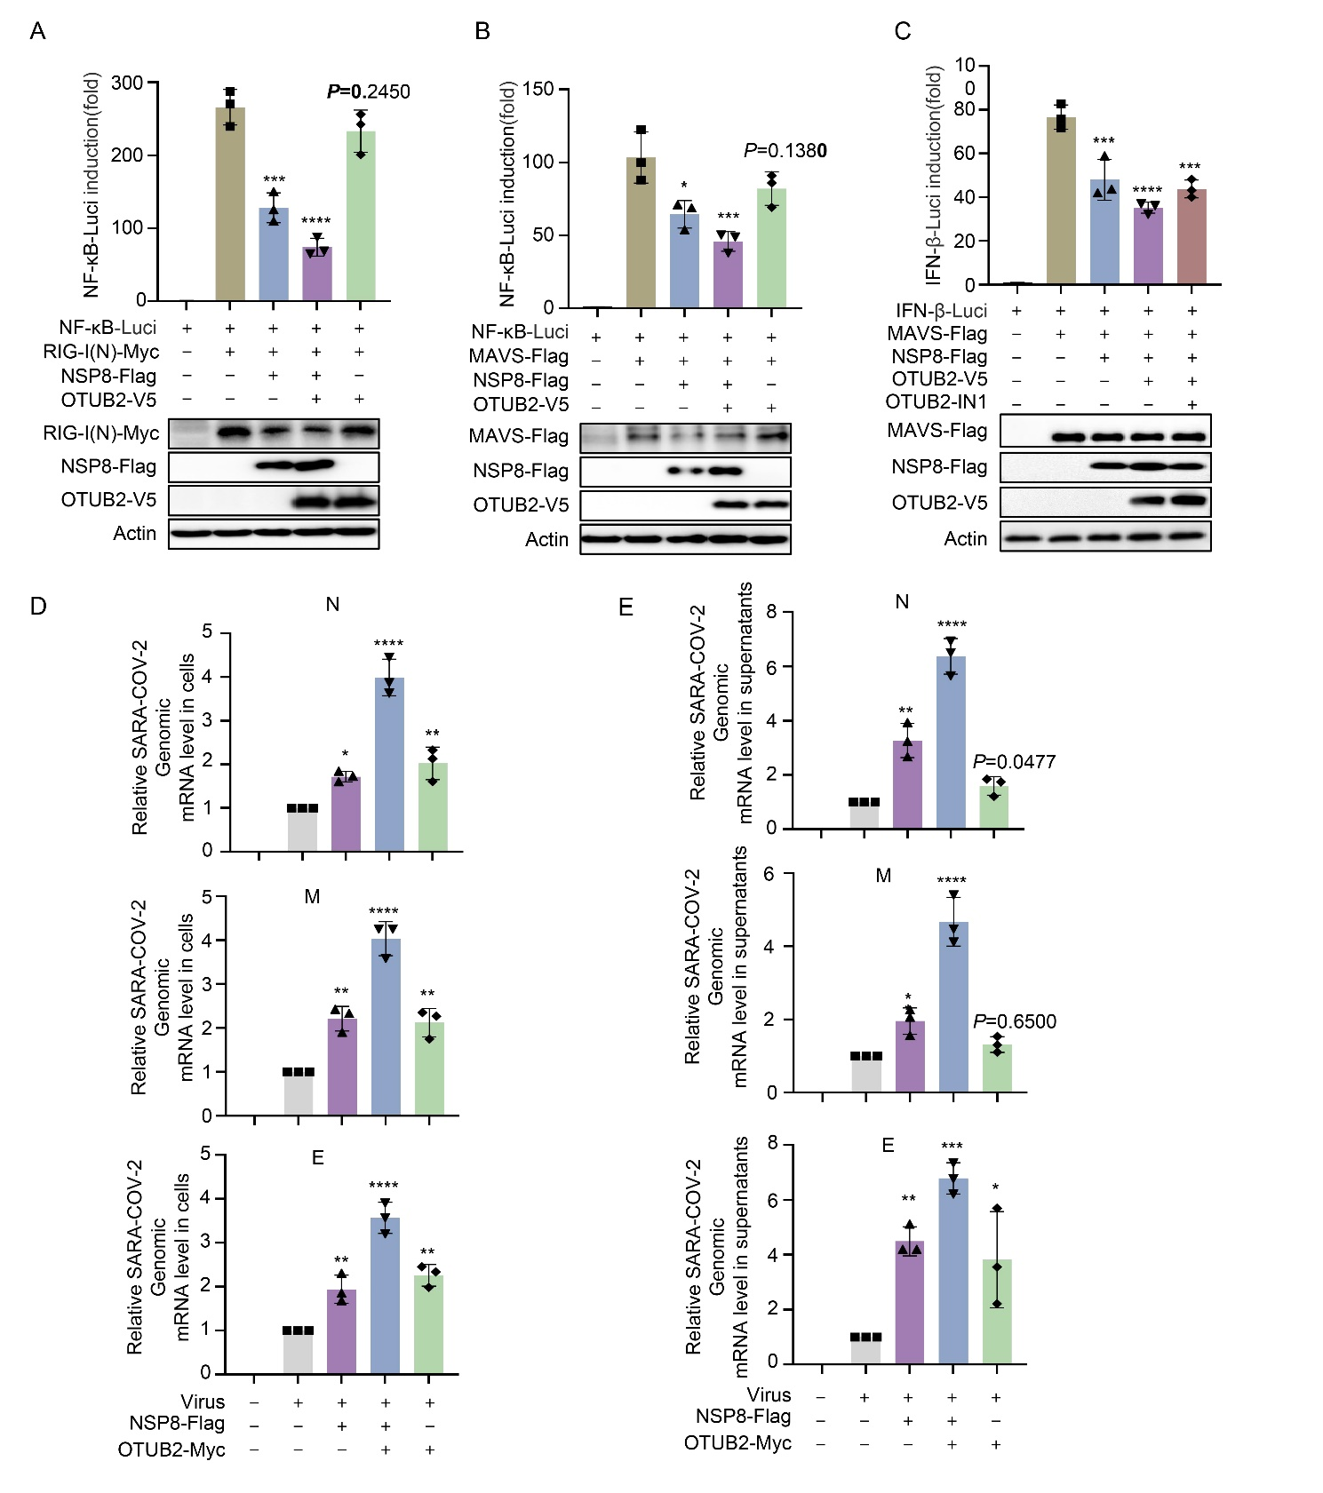
Fig. S3. Effect of OTUB2 on SARS-CoV-2 infectivity. A, B OTUB2 promotes NSP8 inhibition on RIG-N or MAVS to activate NF-κB promoters. HEK293T cells were transfected with an NF-kB promoter Luciferase reporter plasmid, Renilla luciferase reporter plasmid, or NSP8-Flag, along with a control plasmid or OTUB2-Myc for 24 h. Then Luciferase reporter activities were induced by transfection of RIG-I(N)-Myc or MAVS-Flag expressing vectors into HEK293T cells for another 24 h. Cell lysate samples were analyzed using WB. NF-kB-Luc reporter activities were normalized to Renilla luciferase and shown as fold induction. C OTUB2-IN inhibits the ability of OTUB2 to regulate NSP8. D, E OTUB2 promotes viral replication by enhancing NSP8 expression. Vero cells were co-transfected with NSP8-Flag and OTUB2-Myc and then infected with SARS-CoV-2 XBB (MOI = 0.1). At 2 hpi, the medium was replaced with fresh medium. Cells and supernatants were collected at 48 hpi. Viral N/M/E gene mRNA levels in cell pellets and supernatants were quantified by RT-qPCR. Data represent three independent experiments and are shown as mean ± SD (n = 3). Statistical significance was determined by one-way ANOVA: *P < 0.05; **P < 0.01; ***P < 0.001; ****P < 0.0001.

Table S1. The sequence of primers for gene cloning and qPCR
Gene ID / Name | Sequence (5′ to 3′)
NSP8-Myc-F | TCAAATTACAGTCTAGAGAACAAAAACTCATATCAGAAGAAGATCTTTAACCGCGGTTCG
NSP8-Myc-R | TCTCTAGACTGTAATTTGACAGCAGAATTG
OTUB2-Myc-F | AGTCACCGTCGTCGACACGTGTGATCAGATATGAGTGAAACATCTTTCAACC
OTUB2-Myc-R | CCTGGTCTAGAGCGGCCGCGATTCAAAGATCTTCTTCTGATATGAGTTTTTGTTCGTGCTTATCGGCTGCATAAAGGATG
OTUB2-C51A-F | AGGGGATGGGAACGCATTCTACAGGGCCT
OTUB2-C51A-R | CGTTCCCATCCCCTTTGGTCTTG
OTUB2-H224A-F | GCTCTATAAAACATCCGCCTACAACATCCTTTAT
OTUB2-H224A-R | CGGATGTTTTATAGAGCAGGTAAACG
OTUB2-N226A-F | AAAACATCCCACTACGCCATCCTTTATGCAGC
OTUB2-N226A-R | CGTAGTGGGATGTTTTATAGAGCAG
OTUB2-H224AN226A-F | AAAACATCCGCCTACGCCATCCTTTATGCAGC
OTUB2-H224AN226A-R | CGTAGGCGGATGTTTTATAGAGCAG
OTUB2(51-187)-F | AGTCACCGTCGTCGACACGTGTGATCAGATATGTGCTTCTACAGGGCCTT
OTUB2(51-187)-R | CCTGGTCTAGAGCGGCCGCGATTCAAAGATCTTCTTCTGATATGAGTTTTTGTTCCAGGGCCTGCGACAACGC
OTUB2(1-43)-F | AGTCACCGTCGTCGACACGTGTGATCAGATATGAGTGAAACATCTTTCAACC
OTUB2(1-43)-R | CCTGGTCTAGAGCGGCCGCGATTCAAAGATCTTCTTCTGATATGAGTTTTTGTTCTCGGATGGCGGTGAACCTTTT
OTUB2(44-243)-F | AGTCACCGTCGTCGACACGTGTGATCAGATATGAAGACCAAAGGGGATGGGAAC
OTUB2(44-243)-R | CCTGGTCTAGAGCGGCCGCGATTCAAAGATCTTCTTCTGATATGAGTTTTTGTTCGTGCTTATCGGCTGCATAAAGGATG
OTUB2-V5-VR-F | AGTCACCGTCGTCGACACGTGTGATCAGATATGAGTGAAACATCTTTCAACC
OTUB2-V5-VR-R | CCTGGTCTAGAGCGGCCGCGATTCACGTAGAGTCGAGACCGAGGAGAGGGTTAGGGATAGGCTTACCGTGCTTATCAGCTGCATAAAGGATGTTGTAG
Sh-OTUB2-1-F | CCGGGGACCACATCGTGCAGTTCCTCTCGAGAGGAACTGCACGATGTGGTCCTTTTTG
shOTUB2-1-R | AATTCAAAAAGGACCACATCGTGCAGTTCCTCTCGAGAGGAACTGCACGATGTGGTCC
shOTUB2-2-F | CCGGAATGTGACATTCTATCCATTCCTCGAGGAATGGATAGAATGTCACATTTTTTTG
shOTUB2-2-R | AATTCAAAAAAATGTGACATTCTATCCATTCCTCGAGGAATGGATAGAATGTCACATT
OTUB2-RT-F | AGACCCCAAATGACCTTCTG
OTUB2-RT-R | TCTGGTCGTTGAACACCTTC
Mes-TNF-RT-F | CCCACGTTGTAGCAAACCAC
Mes-TNF-RT-R | GTAAACCAGGTACAGCCCGT
Mes-IL1b-RT-F | TCTGTGACTCCTGGGATGGT
Mes-IL1b-RT-R | GCTCATGGAGAACACCACTTG
N-SARS-CoV-2-RT-F | GGGGAACTTCTCCTGCTAGAAT
N-SARS-CoV-2-RT-R | CAGACATTTTGCTCTCAAGCTG
E-SARS-CoV-2-RT-F | CGATCTCTTGTAGATCTGTTCTC
E-SARS-CoV-2-RT-R | ATATTGCATTGCAGCAGTACGCACA
M-SARS-CoV-2-RT-F | GGTTTCCTATTCCTTACATGG
M-SARS-CoV-2-RT-R | ATTCTGTAAACAGCAGCAAGC

