Virologica Sinica
Supplementary Materials
The antiviral role of TRIM25 in mammalian embryonic stem cells

Jie Zou ^{a, 1}, Yuxin Lin ^{b, 1}, Chunyan Wu ^{a, 1}, Yao Ji ª, Xuankai Zhao ª, Zhan Xu ª, Jingfei Gong ª, Zhiyuan Shi ª, Tianyang Luo ª, Xiaoling Xie ª, Yanan Jiang ª, Qi Tian ^{a,} Shuqi Zhang ª, Yanxi Ji ª, Yuan Li ª, Zhenyu He ª, Shuchun Zhang ª, Liu Cao ^{a,} *, Chun-Mei Li ^{a,} *, Junyu Wu ^{a,} *, Deyin Guo ^{a, b, c,} *

ª MOE Key Laboratory of Tropical Disease Control, Zhongshan School of Medicine, Sun Yat-sen University Shenzhen Campus, Shenzhen 518197, China.
^{b} Guangzhou National Laboratory, Guangzhou International Bio-Island, Guangzhou 510320, China.
^{c} State Key Laboratory of Respiratory Disease, National Clinical Research Center for Respiratory Disease, Guangzhou Institute of Respiratory Health, the First Affiliated Hospital of Guangzhou Medical University, Guangzhou 510182, China.

¹ Jie Zou, Yuxin Lin, and Chunyan Wu contributed equally to this work.

* Corresponding authors:
E-mail addresses: guo_deyin@gzlab.ac.cn (D. Guo); wujy68@mail.sysu.edu.cn (J. Wu); lichm8@mail.sysu.edu.cn (C-M. Li); caoliu@mail.sysu.edu.cn (L. Cao)
ORCID: 0000-0002-8297-0814 (D. Guo); 0000-0002-2515-9320 (J. Wu); 0000-0002-4034-978X (C-M. Li); 0000-0001-7960-9414 (L. Cao)

Supplementary Figures
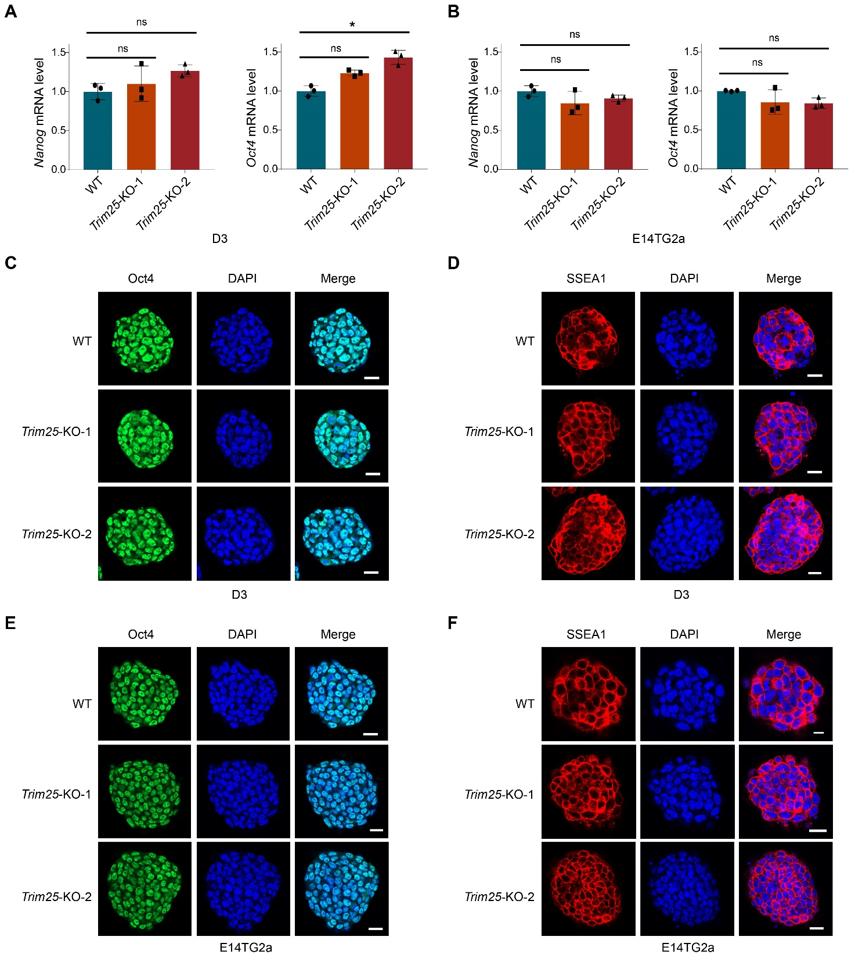
Fig. S1. Knockout of Trim25 does not affect the pluripotency of ESCs. A, B The expression levels of the pluripotent markers (Oct4 and Nanog) in the Trim25-knockout D3 (A) or E14TG2a (B) cells were measured by RT-qPCR. Data are mean ± SEM. Two-tailed unpaired Student’s t test was used for statistical analysis. *P < 0.05, and ns = not significant. C-F The wild-type and Trim25-knockout D3 (C and D) or E14TG2a (E and F) cells were fixed and stained with pluripotent markers: Oct4 (C and E) and SSEA-1 (D and F). Nuclei were stained with DAPI (blue). Scale bar, 10 μm.
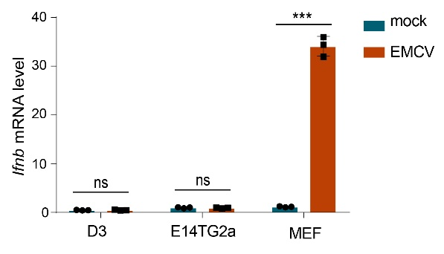
Fig. S2. Virus infection is deficient to induce IFNβ expression in ESCs. D3, E14TG2a and MEF cells were infected with EMCV at 1 moi. The mRNA levels of Ifnb were measured by RT-qPCR at 24 hpi. Data are mean ± SEM. Two-tailed unpaired Student’s t test was used for statistical analysis. ***P < 0.001, and ns = not significant.

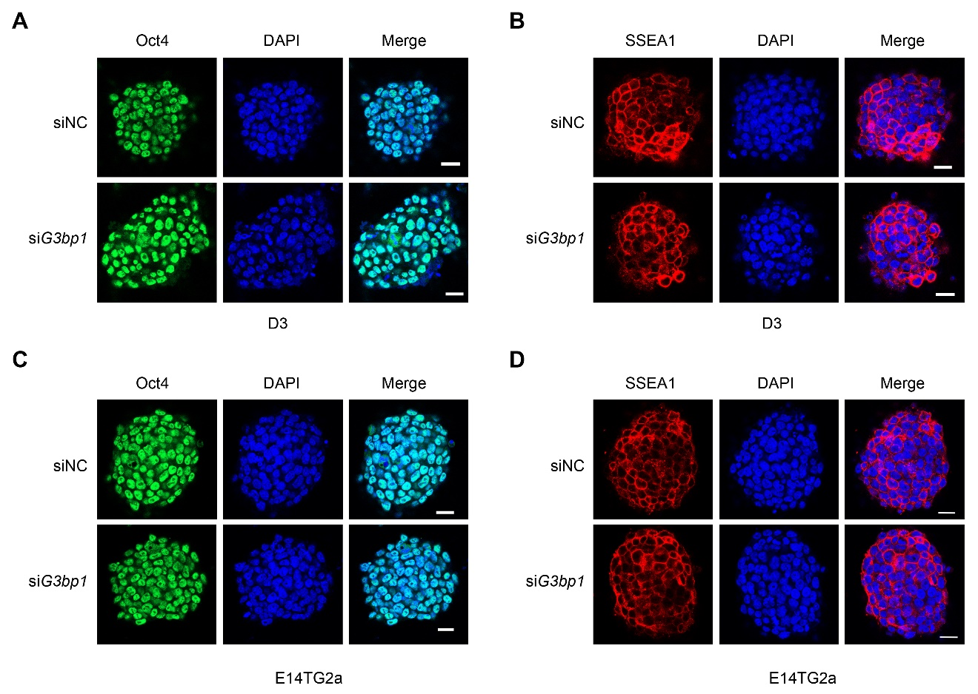
Fig. S3. Depletion of G3bp1 shows minimal effects on the pluripotency of ESCs. The D3 (A and B) or E14TG2a (C and D) cells transfected with siRNAs (siNC or siG3bp1) were fixed and stained with pluripotent markers: Oct4 (A and C) and SSEA-1 (B and D). Nuclei were stained with DAPI (blue). Scale bar, 10 μm.

Table S1. Primers used in this study
Target | Forward primer | Reverse primer
Gapdh | CATGGCCTTCCGTGTTCCTA | CCTGCTTCACCACCTTCTTGAT
Oct4 | CACGAGTGGAAAGCAACTCA | AGATGGTGGTCTGGCTGAAC
EMCV | TGTCATGAACAGAGAGGCGT | TCGAATGATGGCACGACAAC
Trim25 | CGGACCTCAAGAGTGAACTG | CCCTTGTTACCTGAGCCATT
G3bp1 | TTGGAGGAGCATTTAGAGGAGC | TCTTGAATGTCGGACACAGGT
VSV | TGATAGTACCGGAGGATTGACGAC | CCTTGCAGTGACATGACTGCTCTT
Ifitm1 | GACAGCCACCACAATCAACAT | CCCAGGCAGCAGAAGTTCAT
Ifitm2 | TGGGCTTCGTTGCCTATGC | AGAATGGGGTGTTCTTTGTG0
Ifitm3 | CCCCCAAACTACGAAAGAATCA | ACCATCTTCCGATCCCTAGAC
Cd9 | ATGCCGGTCAAAGGAGGTAG | GCCATAGTCCAATAGCAAGCA
Eif3l | TCTTACCCCGCTGATGACTAC | CGCTCATAGGCAAGGTCC
Igfbp2 | TGGAACATCTCTACTCCCTGC | CTTCCCGGTATTGGGGTTCA
Mcl1 | CAAAGATGGCGTAACAAACTGG | CCGTTTCGTCCTTACAAGAACA
Oas1a | GCCTGATCCCAGAATCTATGC | GAGCAACTCTAGGGCGTACTG
Odc1 | GACGAGTTTGACTGCCACATC | CGCAACATAGAACGCATCCTT
Rbm2.5 | ATGGTTGGAAAGCATTTGGGA | AAGCATGTCTGAAGCCTTCTC
Rpl22 | AGCAGGTTTTGAAGTTCACCC | CAGCTTTCCCATTCACCTTGA
Slc16a1 | TGTTAGTCGGAGCCTTCATTTC | CACTGGTCGTTGCACTGAATA
Ifnb | CCGAGCAGAGATCTTCAGGAA | CCTGCAACCACCACTCATTCT
Mx1 | CCTCCCACATCTGTAAATCACTG | CGGTTTCCTGTGCTTGTATCA
Isg15 | CCTCTGAGCATCCTGGTGAG | ACTGGTCTTCGTGGACTTGTT

