Virologica Sinica
Supplementary Materials

Genetic heterogeneity and pathogenic potential of historical Crimean-Congo hemorrhagic fever virus isolates in China

Abulimiti Moming^{a, b, c, 1}, Yuan Bai^{a, 1}, Qiong Zhuª, Jiayin Jinª, Yaohui Fangª, Shouwei Huangª, Qiaoli Wuª, Zhengyuan Suª, Guoyu Zhao^{b, c}, Shuang Tangª, Manli Wangª, Zhihong Huª, Yujiang Zhang^{b, c, *}, Fei Deng^{a, *}，Shu Shen^{a, c, *}

ªState Key Laboratory of Virology and Biosafety, National Virus Resource Centre, Wuhan Institute of Virology, Chinese Academy of Sciences, Wuhan 430071, China
^{b}Center for Disease Control and Prevention of Xinjiang Uyghur Autonomous Region, Urumqi 830002, China
^{c}Xinjiang Key Laboratory of Vector-borne Infectious Diseases, Urumqi 830002, China

¹Abulimiti Moming and Yuan Bai contributed equally to this work.

* Corresponding author:
shenshu@wh.iov.cn (S. Shen); df@wh.iov.cn (F. Deng); xjsyzhang@163.com (Y. Zhang)
ORCID: 0000-0002-0013-5365 (S. Shen); 0000-0002-5385-083X (F. Deng); 0000-0001-9436-2595 (Y. Zhang)

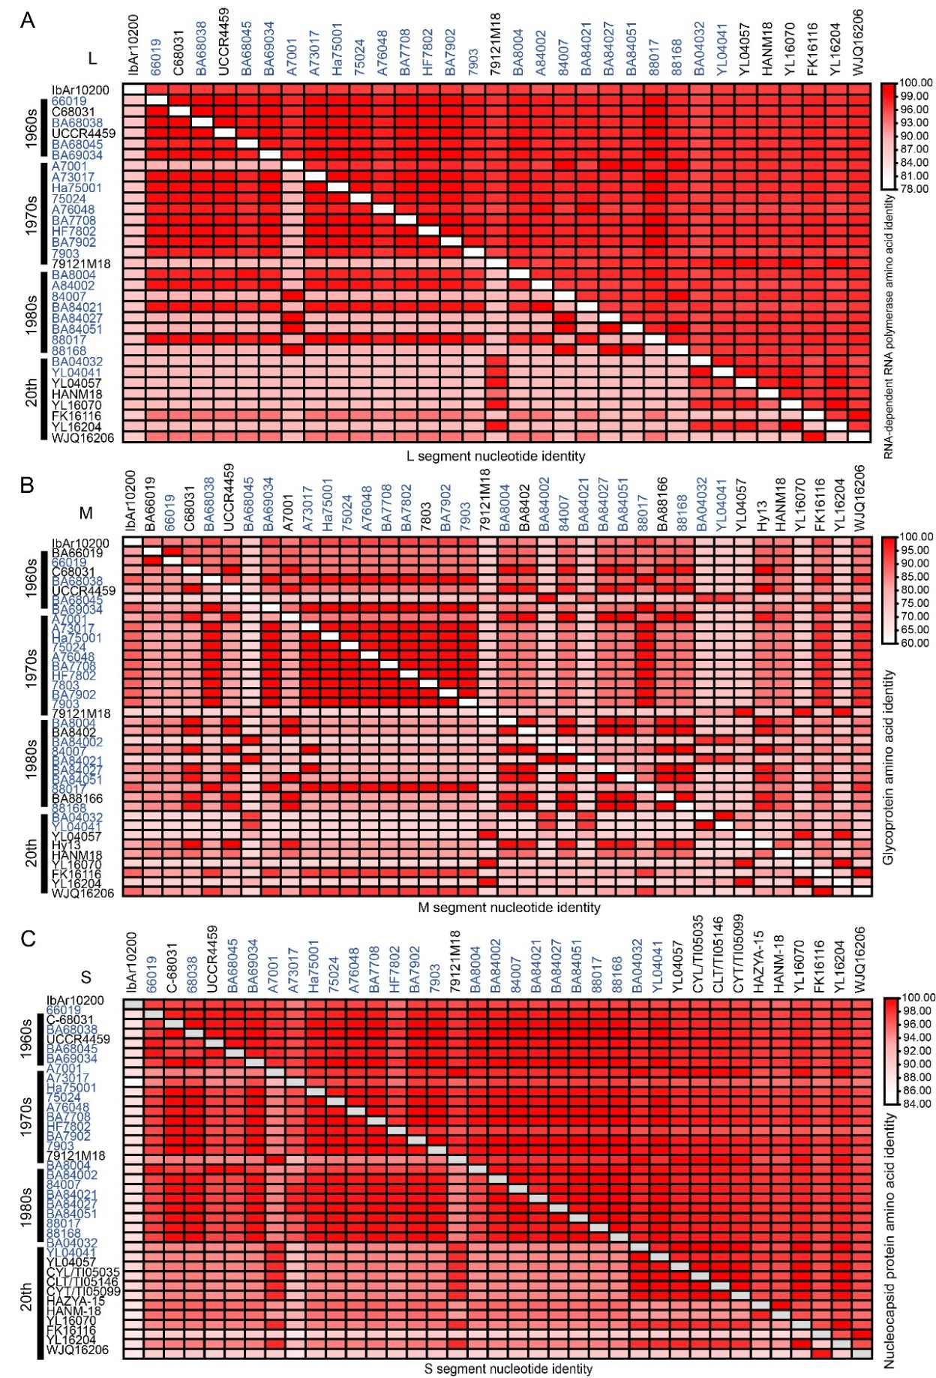
Supplementary Fig. S1. Homology analysis was performed to compare the nucleic acid and aa sequences of the CCHFV strains, specifically the L (A), M (B), and S (C) segments. This analysis included 23 strains from our study, as well as 9 L segments, 15 M segments, and 13 S segments from previously reported Chinese CCHFV strains.

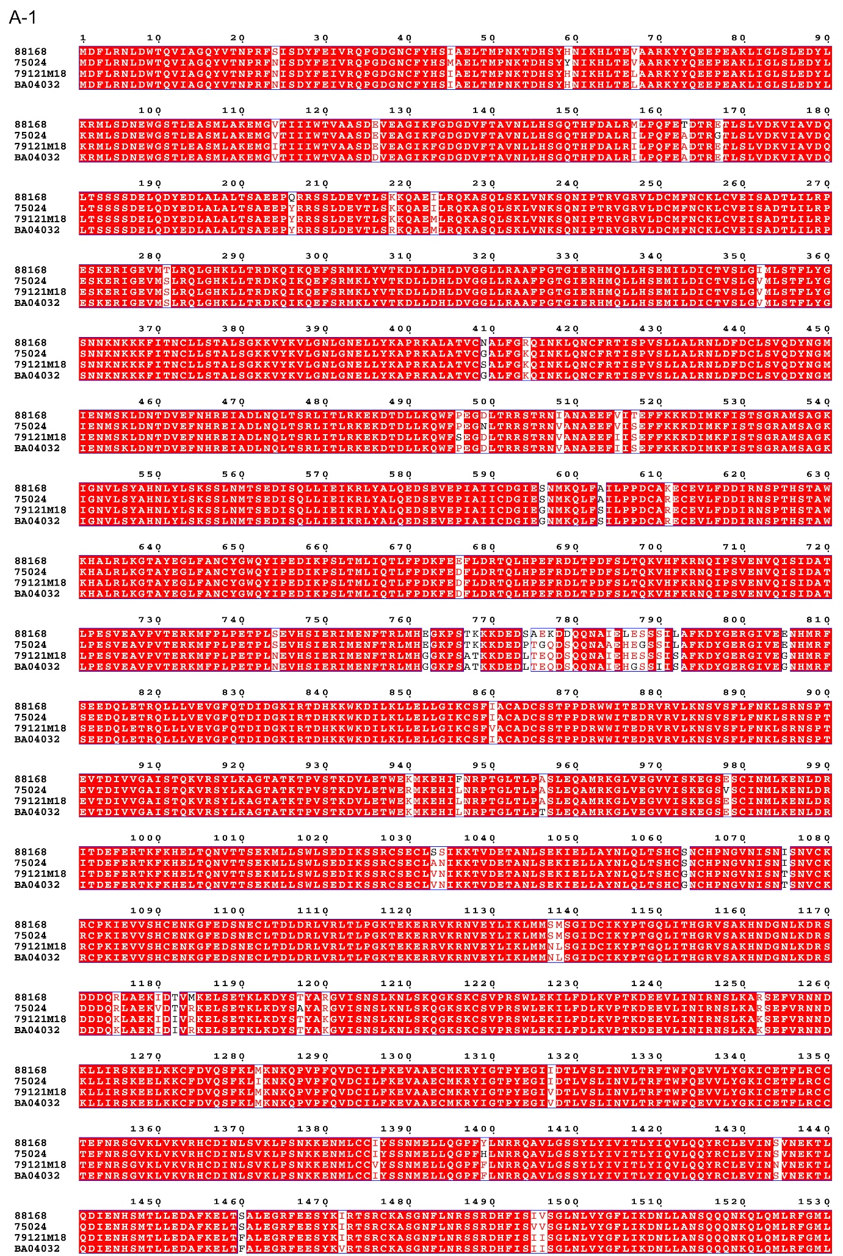
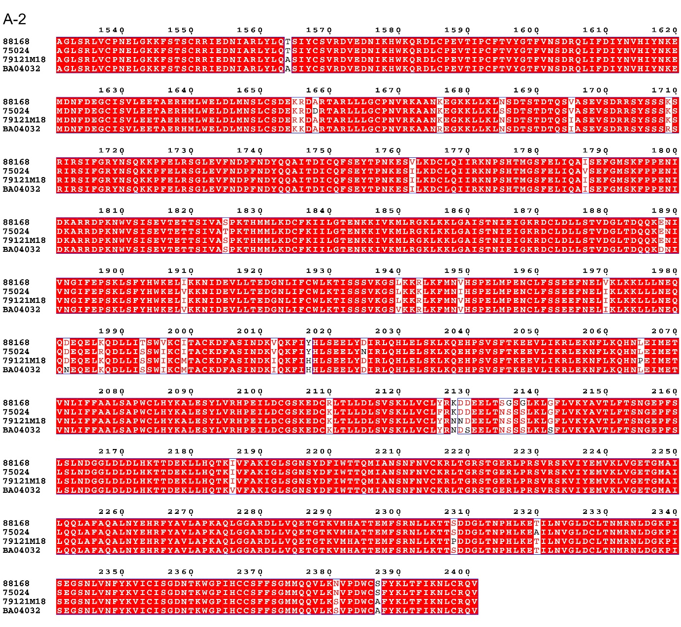

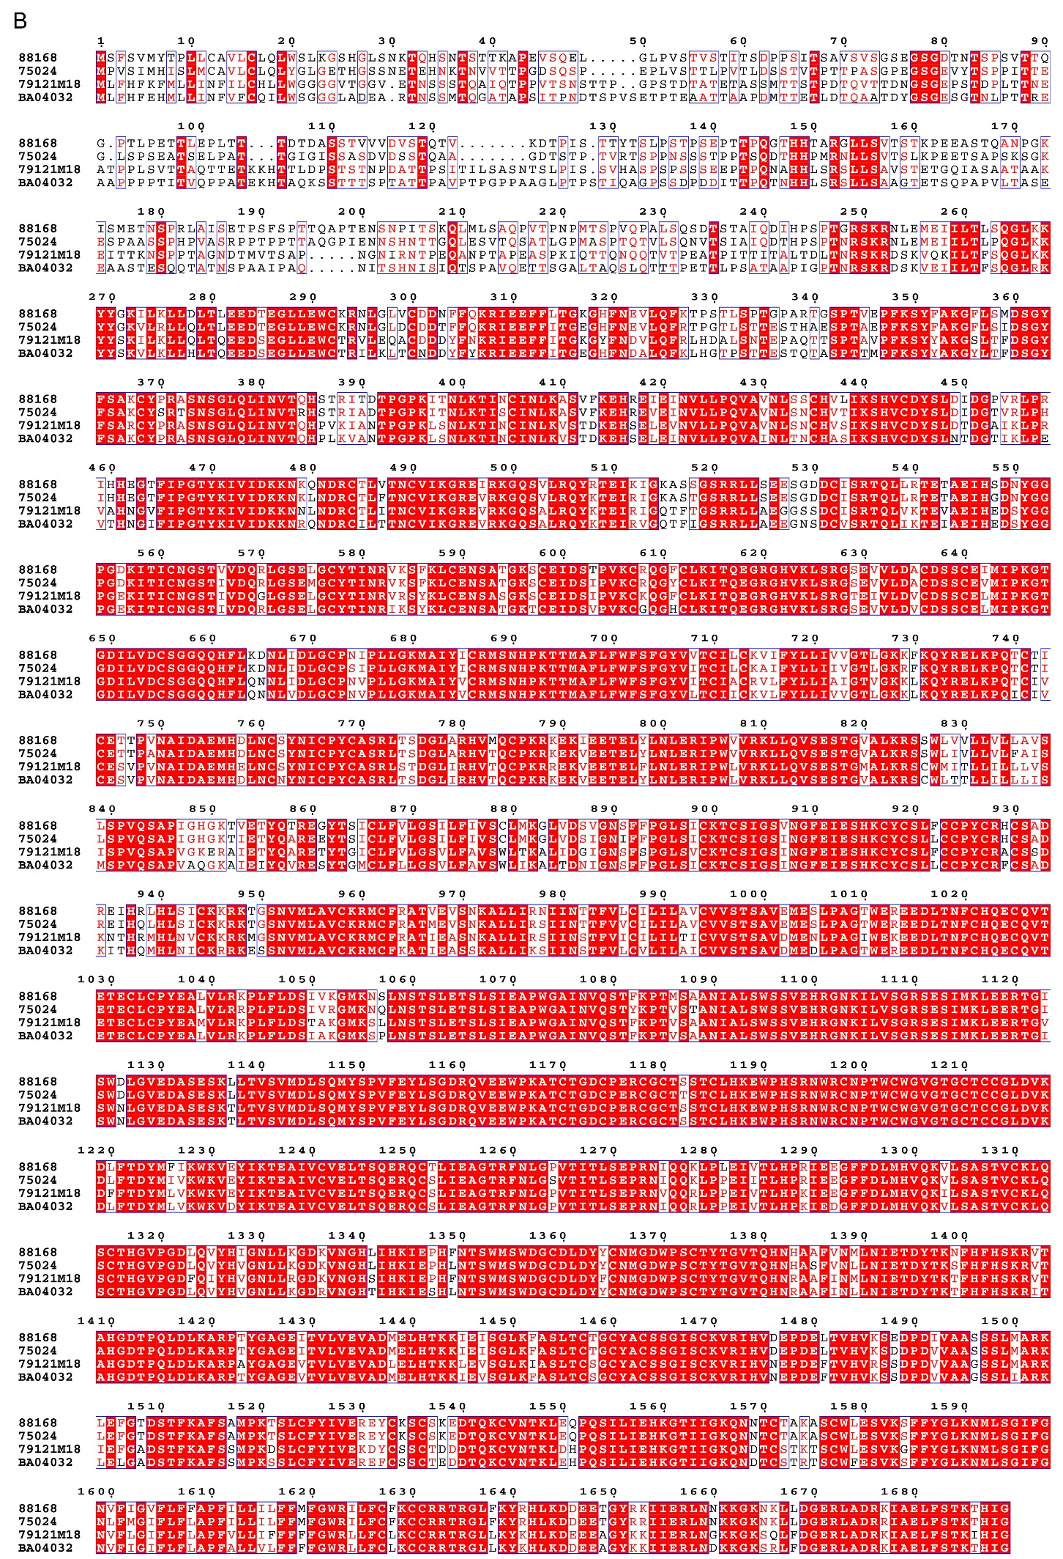
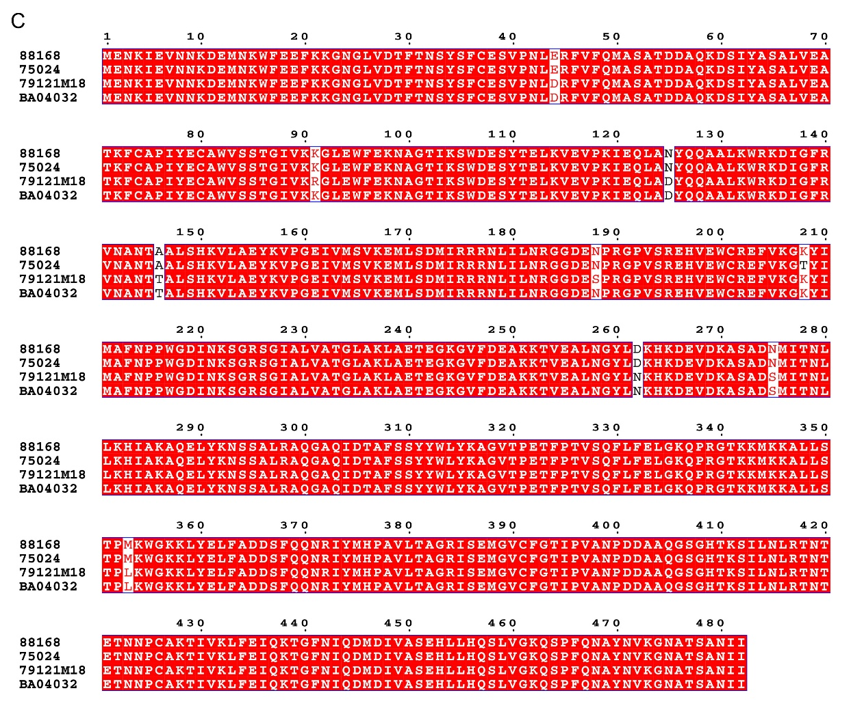
Supplementary Fig. S2. Multiple protein sequence alignments of RdRp (A), GP (B), and NP (C) from CCHFV strains 88168, 75024, 79121M19, and BA04032. The protein lengths of RdRp, GP, and NP were 3945, 1689, and 482 aa, respectively.
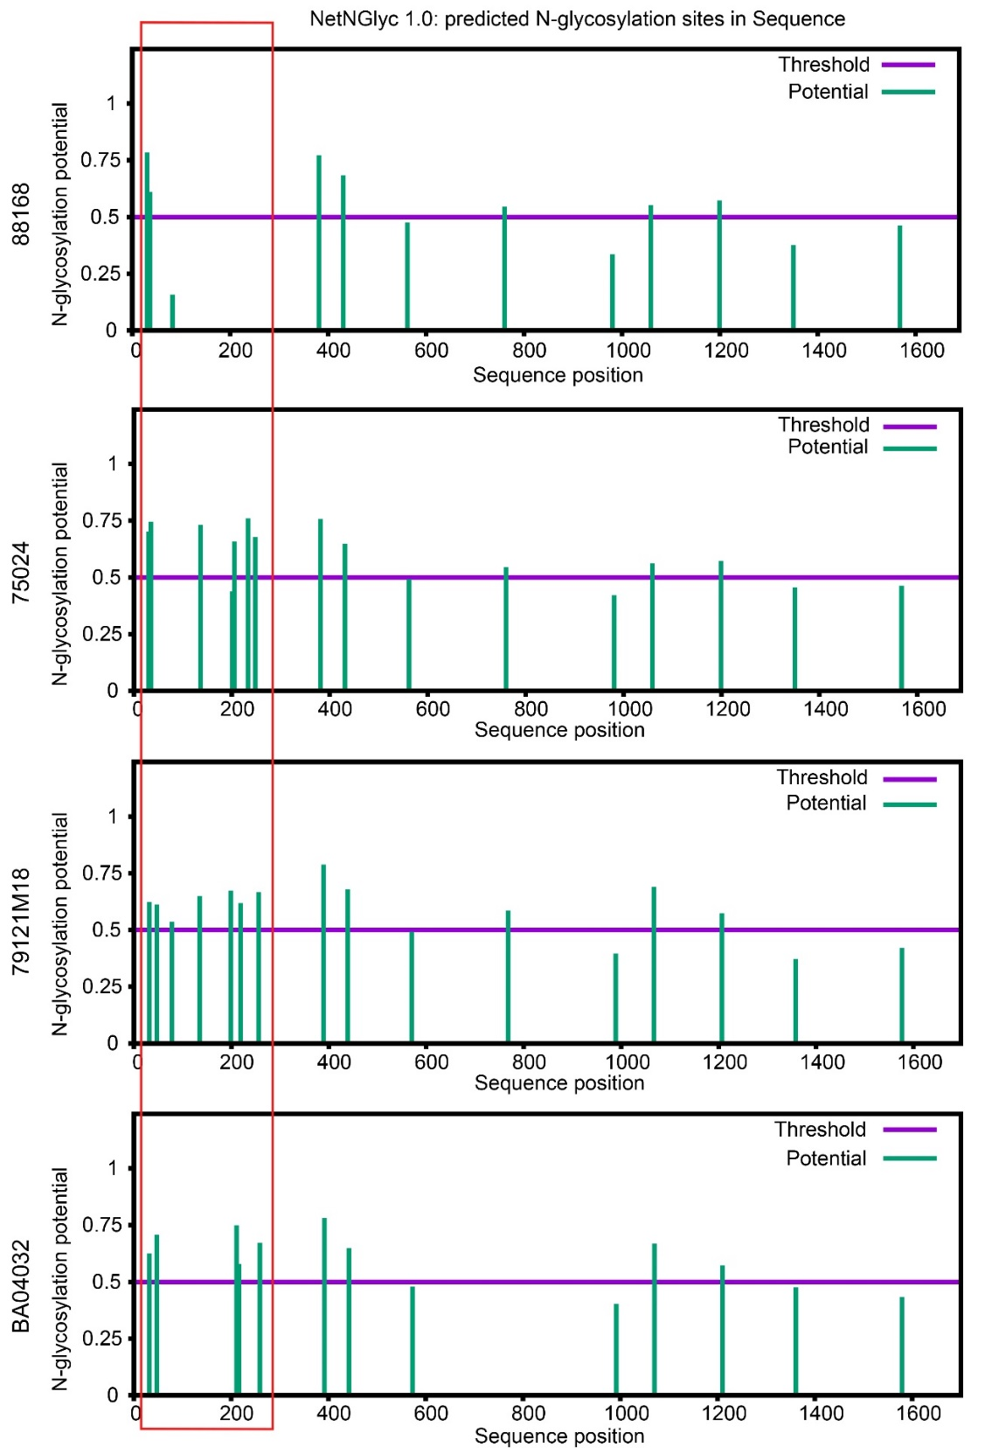
Supplementary Fig. S3. Prediction results of N-glycosylation sites of glycoprotein GP from 88168, 75024, 79121M19, and BA04032. Four genotypes of CCHFV were predicted (https://services.healthtech.dtu.dk/service.php?NetNGlyc-1.0) for N-glycation sites in GP, and it was found that the mucin domain was the region with significant differences in N-glycation in different genotypes in Asia.

