Virologica Sinica
Supplementary Materials

Stabilization of prefusion hMPV F improves manufacturability and protective immunity across hMPV lineages

Changbin Qu ^{a, d, 1}, Jingjing Zou ^{d, e, 1}, Dongyu Niu ^{d}, Qingxin Wu ^{c, d}, Lijie Liu ^{c, d}, Mengting Yu ^{c}, Qiqi Zhang ^{c}, Long Zhang ^{b, c, d, *}, Shuai Wei ^{d,*}, Wei Zhang ^{b, c, d, *}, Wei Peng ^{c, d, e, *}

ª Division of Life Sciences and Medicine, University of Science and Technology of China, Hefei 230027, China.
^{b} State Key Laboratory of Medicinal Chemical Biology, Nankai University, Tianjin 300071 China.
^{c} State Key Laboratory of Respiratory Disease, the First Affiliated Hospital of Guangzhou Medical University, Guangzhou Medical University, Guangzhou 510182, China.
^{d} Guangzhou National Laboratory, Guangzhou International Bio Island, Guangzhou 510005, China.
^{e} Institute of Pathogenic Biology, Hengyang Medical College; Hunan Provincial Key Laboratory for Special Pathogens Prevention and Control, University of South China, Hengyang 421001, China.

¹ Changbin Qu and Jingjing Zou contributed equally to this study.

Corresponding authors.
E-mail addresses: peng_wei@gzlab.ac.cn (Wei Peng); zhang_wei2@gzlab.ac.cn (Wei Zhang); wei_shuai@gzlab.ac.cn (Shuai Wei); zhang_long@gzlab.ac.cn (Long Zhang)
ORCID: 0000-0002-0949-4487 (Wei Peng); 0000-0001-8693-6747 (Wei Zhang); 0009-0004-6338-1418 (Shuai Wei); 0009-0008-2255-1563 (Long Zhang)
Supplementary Materials
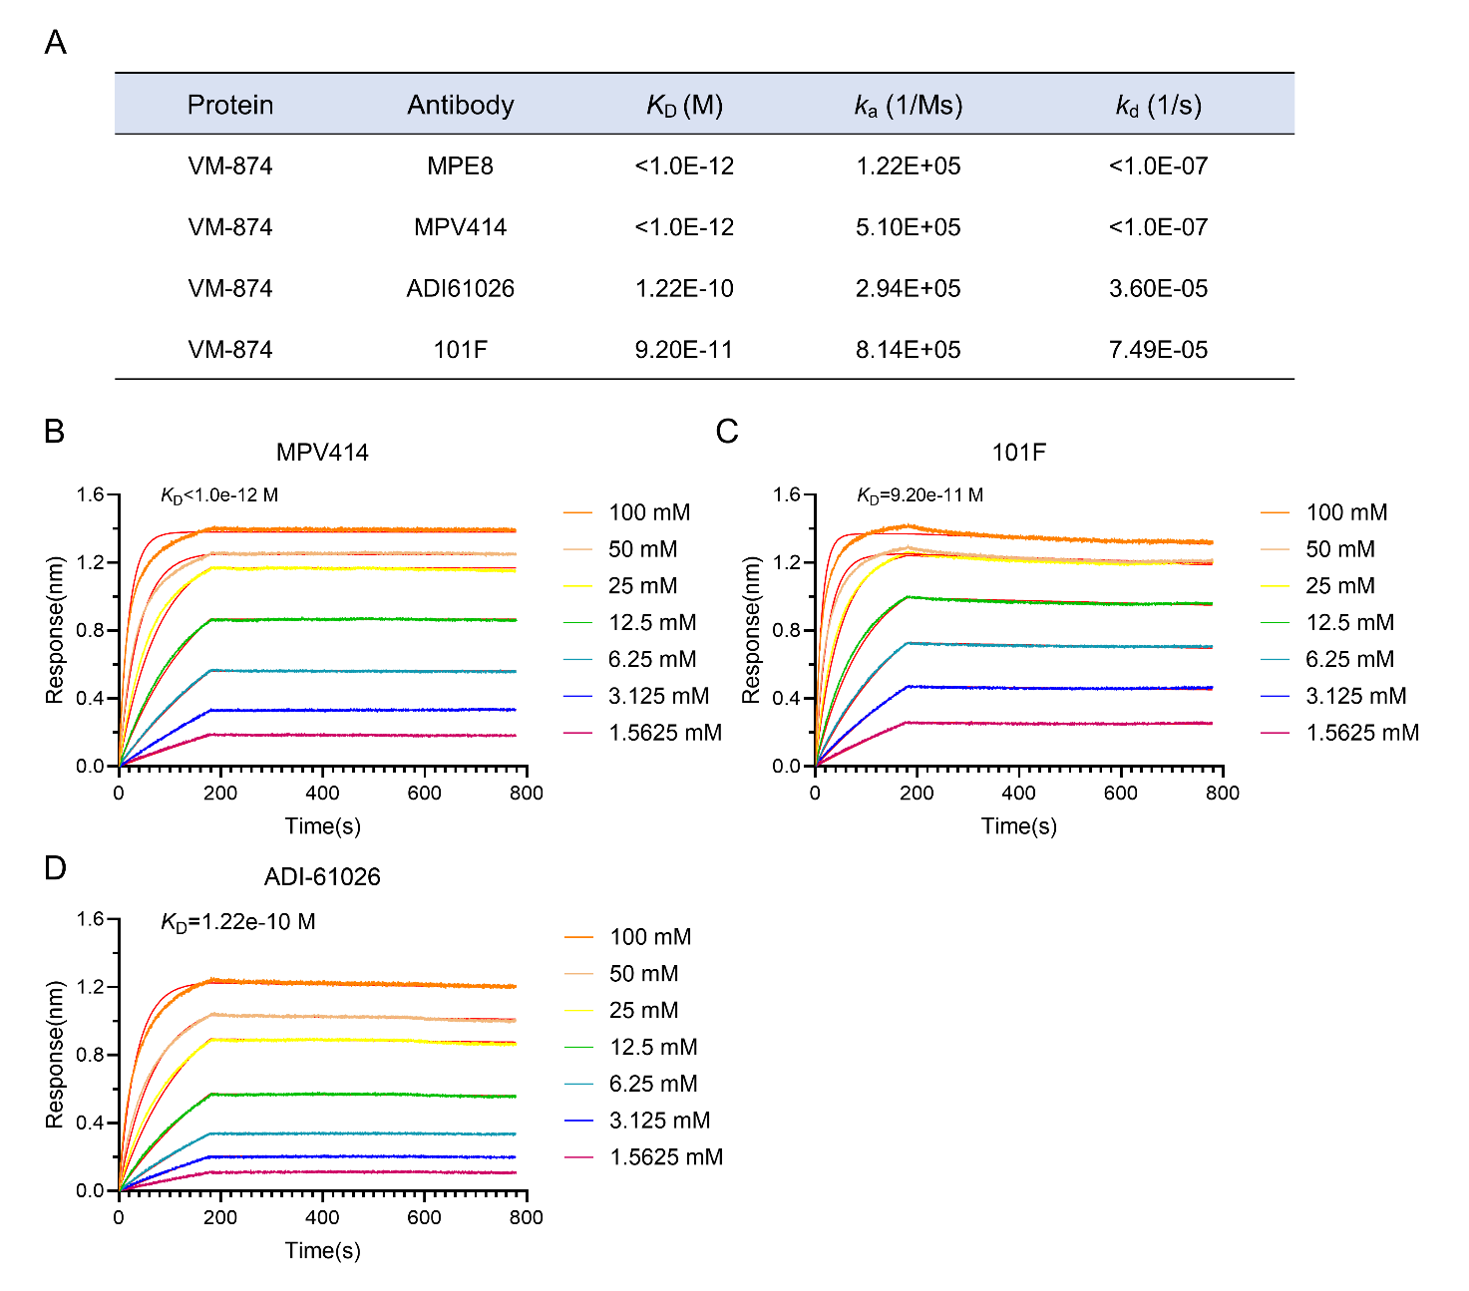
Supplementary Fig. S1. VM-874 showed high-affinity binding to representative neutralizing antibodies as determined by bio-layer interferometry. A Summary of the apparent binding kinetics of VM-874 to the indicated antibodies, including equilibrium dissociation constants (K_{D}), association rate constants (Ka), and dissociation rate constants (Kd). B-D Representative BLI sensorgrams and fitted binding curves showing the interactions of VM-874 with MPV414 (B), 101F (C), and ADI-61026 (D) at serially diluted antibody concentrations. The calculated K_{D} values are indicated in each panel.
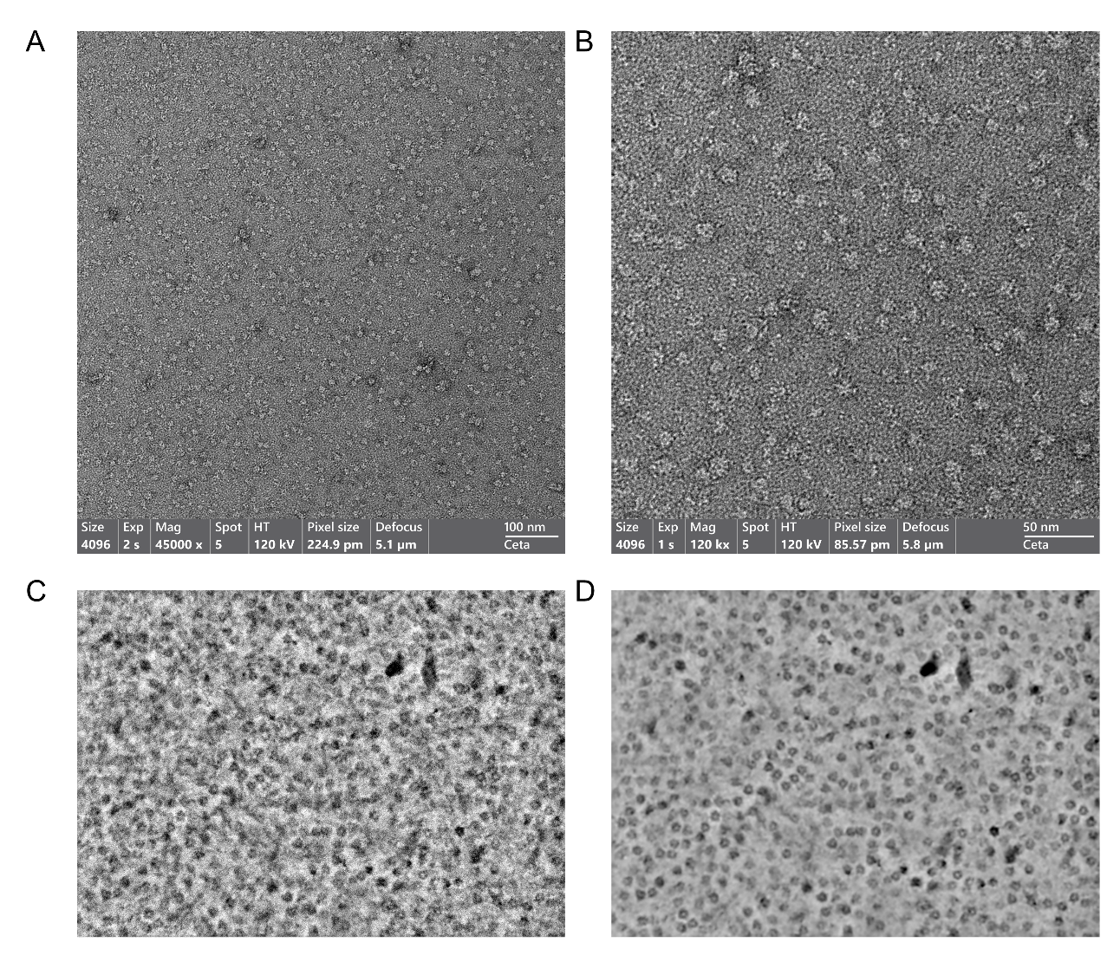
Supplementary Fig. S2. Negative-stain TEM characterization of VM-874 particles. A, B Representative raw TEM micrographs of purified VM-874 particles acquired at low and high magnification, showing the overall particle morphology and sample distribution. C, D Representative raw and denoised micrographs of VM-874 particles processed using the cryoSPARC Micrograph Denoiser. Imaging parameters, including magnification, accelerating voltage, pixel size, defocus, and scale bars, are indicated in each micrograph. Scale bars, 100 nm in panel A and 50 nm in panel B.
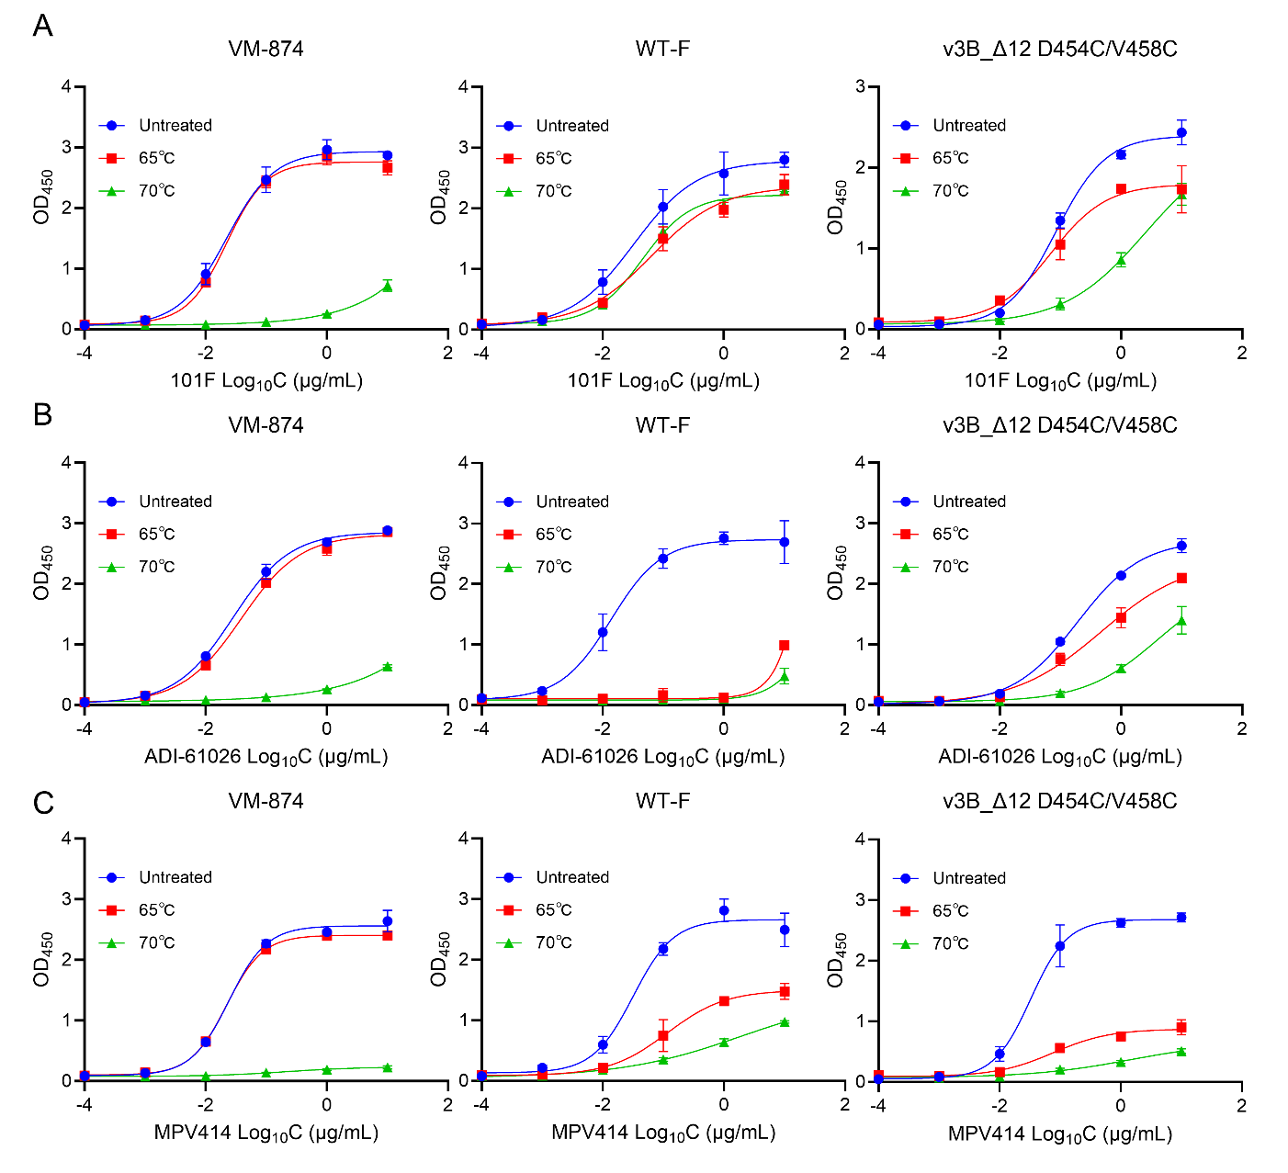
Supplementary Fig. S3. Heat-stress assessment of pre-fusion epitope integrity of hMPV F antigens by ELISA. A–C ELISA binding curves of the indicated hMPV F antigens (VM-874, WT-F, and v3B_Δ12 D454C/V458C) after heat treatment, as measured using the antibodies 101F (A), ADI-61026 (B), and MPV414 (C). Proteins were left untreated or incubated at 65 °C or 70 °C for 30 min prior to analysis. Binding is shown as OD₄₅₀​ plotted against antibody concentration.
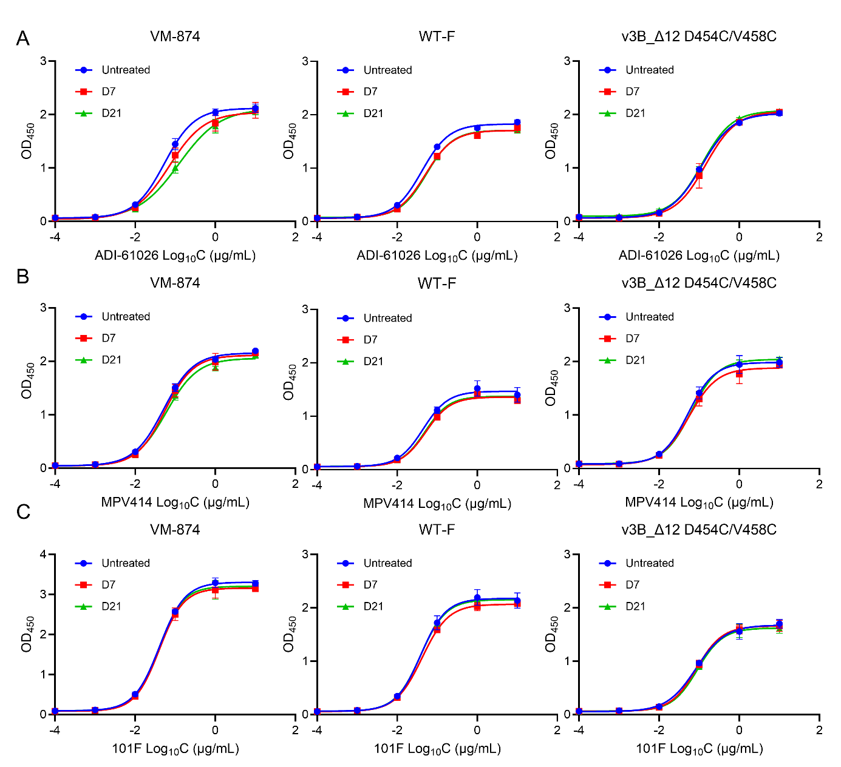
Supplementary Fig. S4. Cold-storage stability of hMPV F antigens assessed by ELISA. A–C ELISA binding curves of the indicated hMPV F antigens (VM-874, WT-F, and v3B_Δ12 D454C/V458C) after storage at 4 °C for 7 days or 21 days, as measured using the antibodies ADI-61026 (A), MPV414 (B), and 101F (C). Untreated proteins were included as controls. Binding is shown as OD₄₅₀ plotted against antibody concentration. The comparable binding profiles after cold storage indicate that the antigenic integrity of the tested pre-F epitopes was largely maintained under these conditions.
Supplementary Fig. S5. VM-874 induces a pre-F–biased serum IgG binding response. Six- to eight-week-old BALB/c mice were intramuscularly immunized with 5 ​μg of VM-874, post-F, or v3B_Δ12 D454C/V458C formulated with 50 ​μg of aluminum hydroxide adjuvant, while control mice received adjuvant alone. A prime immunization was administered at week 0, followed by a booster immunization 3 weeks later. Mouse sera collected 2 weeks after the final immunization were analyzed by ELISA for IgG binding to pre-F hMPV F antigen v3B_Δ12 D454C/V458C and post-F hMPV F antigen. The pre-F/post-F binding IgG ratio was calculated to evaluate the conformational preference of serum antibodies. VM-874 immunization induced a significantly higher pre-F/post-F binding IgG ratio than post-F immunization, indicating a more pre-F–oriented antibody response. The ratio induced by VM-874 was numerically higher than that induced by v3B_Δ12 D454C/V458C, but the difference was not statistically significant. Each symbol represents an individual mouse; bars and error bars indicate the mean and dispersion within each group. Statistical significance was determined by one-way ANOVA with correction for multiple comparisons. ns, not significant; **P < 0.01; n = 5.
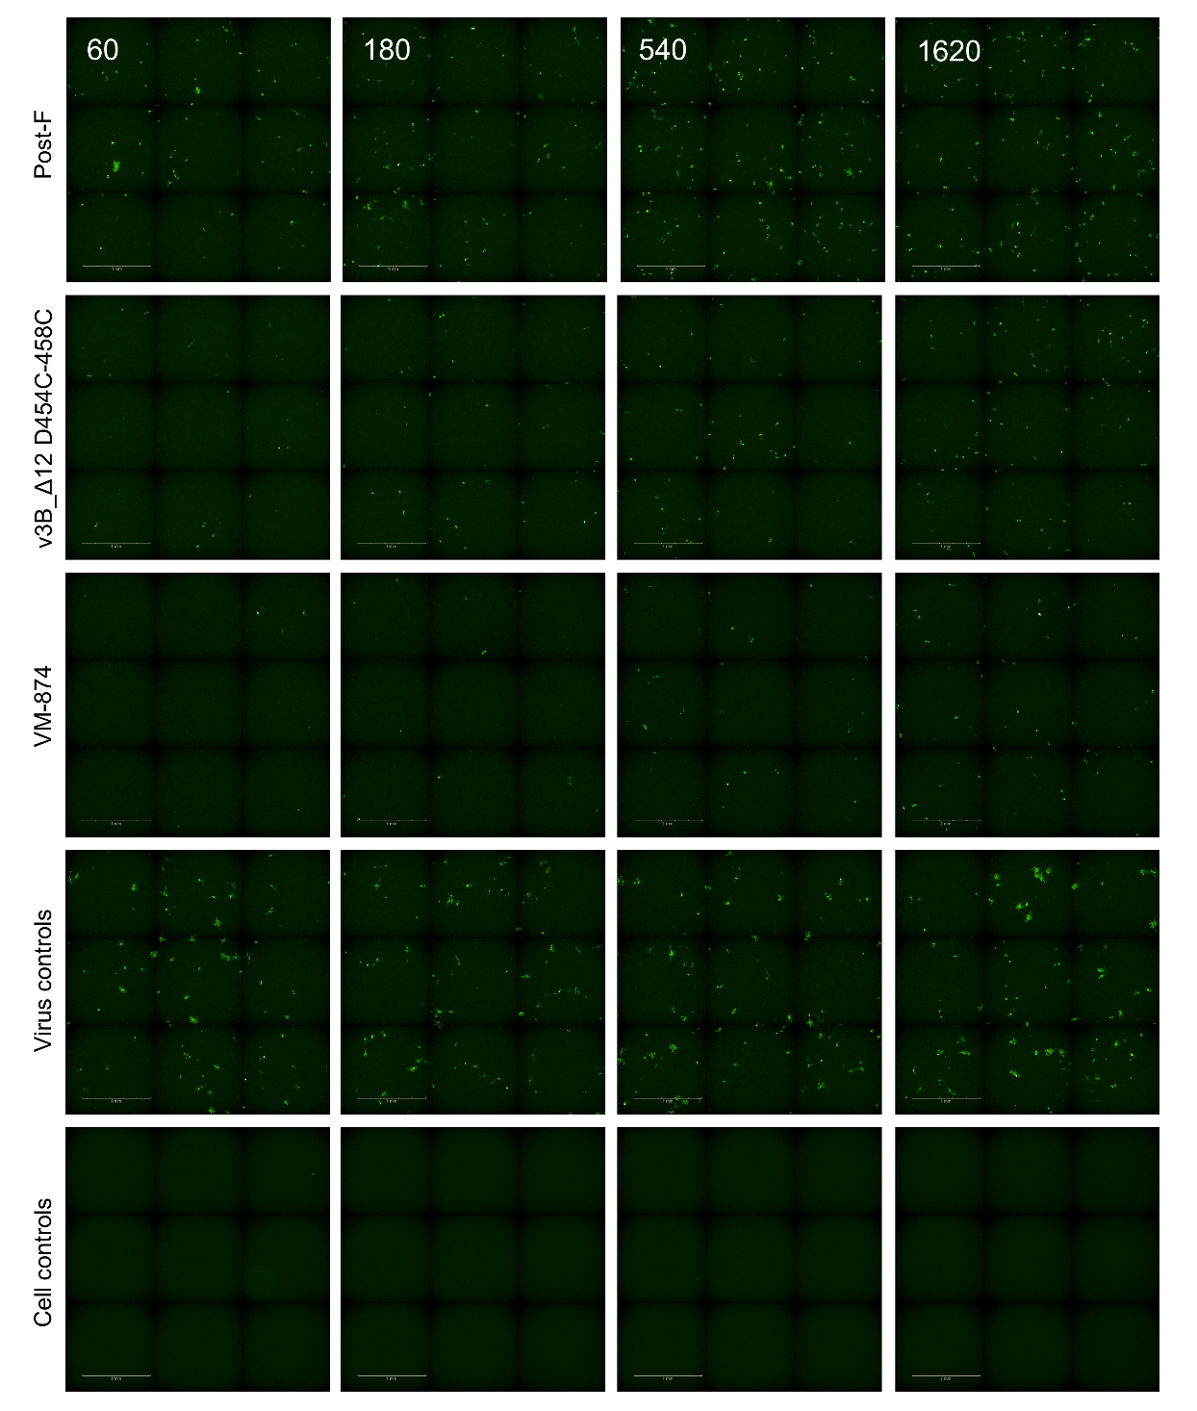
Supplementary Fig. S6. BALB/c mice serum neutralizing antibody titers against hMPV subtype A2 measured by focus reduction neutralization test (FRNT₅₀), indicating induction of functional neutralization. Six- to eight-week-old BALB/c mice were intramuscularly immunized with 5 ​μg of VM-874, post-F, or v3B_Δ12 D454C/V458C formulated with 50 ​μg of aluminum hydroxide adjuvant, while control mice received adjuvant alone. A prime immunization was administered at week 0, followed by a booster immunization 3 weeks later. Serum samples were collected 2 weeks after the final immunization ​and serially diluted in DMEM (starting with an initial 1:20 dilution, followed by 3-fold serial dilutions) and mixed with an equal volume of hMPV A2 (MOI= 0.2). After incubation at 37 ​°C for 1 ​h, the serum-virus mixtures were added to BHK-21 monolayers. FRNT₅₀ was defined as the reciprocal serum dilution that reduced fluorescent focus counts by 50% relative to virus-only controls. Scale bar = 1 mm.

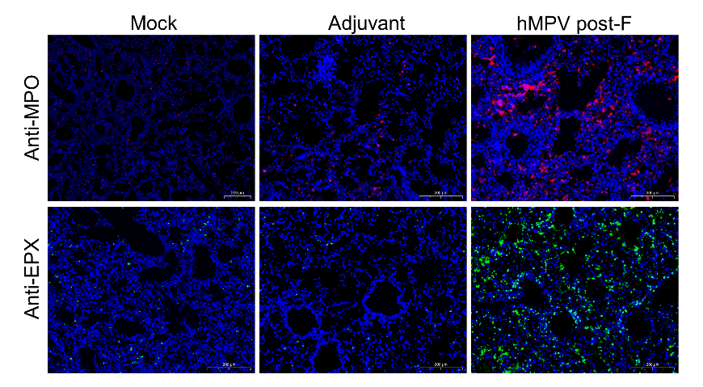
Supplementary Fig. S7. Quantification of lung granulocyte infiltration in BALB/c mice after RSV A2 challenge. Histological staining and quantification of eosinophils and neutrophils demonstrate increased eosinophil and neutrophil infiltration in the hMPV post-F group (n = 5), consistent with enhanced granulocyte recruitment. Scale bar = 200 μm.

Supplementary Table S1 Expression and thermostability summary of hMPV F variants
ID of combinatorial substitutions | Substitutions | Fold change in expression relative to WT | Tm (℃)
 | T365C/V463C | 1.15 | 56
 | A140C/A147C | 6.15 | 54.5
 | v3B_Δ12 D454C-458C | 6.12 | NA
HM-245 | G257C/V271C | 1.48 | 52
HM-246 | A140C/S149C | 9.06 | 47.5/63.5
HM-247 | S65C/D183C | 1.34 | 55
HM-248 | L378C/G432C | 1.7 | 60.5
HM-249 | L66C/V191C | NA | NA
HM-250 | A140C/S149C-G257C/V271C | 4.25 | 57.5
HM-251 | A140C/S149C-S65C/D183C | 6.15 | NA
HM-252 | A140C/S149C-L378C/G432C | 6.96 | 64.5
HM-253 | G257C/V271C-S65C/D183C | 1.56 | NA
HM-254 | G257C/V271C-L378C/G432C | 2.35 | 61.5
HM-255 | S65C/D183C-L378C/G432C | 1.23 | 62.5
VM-855 | A140C/S149C-A225D | 10.89 | 56.5
VM-856 | A140C/S149C-A225D-L378C/G432C | 6.15 | 66
VM-874 | A140C/S149C-A225D-L378C/G432C-rp⁽¹⁰³⁻¹¹³⁾ | 9.6 | 66

