Virologica Sinica
Supplementary materials
VS-7405 Research Article

Enteroviruses Antagonize the Host Restriction Factor ABL2 via Proteasomal Degradation to Facilitate Viral Replication

Mengran Yuan^{a, 1}, Xiaorong Qiao^{a, 1}, Hua Wang^{a, 1}, Nuo Chenª, Yan Wangª, Yuhan Liª, Xiaoxiang Zhouª, Zengjun Ji^{b}, Hongxing Shen^{a,} *

ª Jiangsu Key Laboratory of Medical Science and Laboratory Medicine, Department of Laboratory Medicine, School of Clinical Medicine & Laboratory Medicine, Jiangsu University, Zhenjiang 212013, China
^{b} Department of Laboratory Medicine, Taizhou Second People's Hospital, Taizhou 225599, China.

¹ Mengran Yuan and Xiaorong Qiao contributed equally to this work.
* Correspondence Author.
E-mail addresses: hxshen@ujs.edu.cn (H. Shen).
ORCID: 0000-0001-7311-5464

Supplementary materials
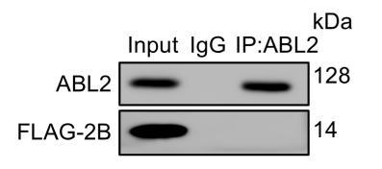
Fig. S1. HeLa cells were cotransfected with FLAG-2B . IP and immunoblot analysis of ABL2 and FLAG-2B were shown.

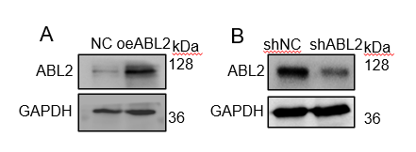
Fig. S2. Stable HeLa cell lines overexpressing (A) or silencing (B) ABL2 were generated using lentiviral transduction. ABL2 expression levels were verified by western blotting.

Fig. S3. HeLa cells were infected with CVB3 (MOI = 5) for the indicated times. Cell lysates were analyzed by western blotting to assess RAC1 protein expression.

Table S1
Primer sequence details.
Name | Forward Primer (5′–3′) | Reverse Primer (5′–3′)
GAPDH | AGGTGAAGGTCGGAGTCAAC | GGGTGGAATCATATTGGAACA
CVB3-VP1 | ATTCAAGGTCCGAGTCAAC | CTGCTTGTCGTGGTGTTA
CVB5-VP1 | CCAGTGCCCACGAAATAAA | TTGCCTATGCTGATGAACGGT
EV71-VP1 | AGGATTTACATGAGAATGAAGCA | GCATAATTTGGGTTGGCTTT

