Virologica Sinica

Supplementary Materials

Ferritin nanoparticle-based vaccine enhances mucosal immunity by promoting antigen uptake and activation of alveolar macrophages

Xiantao Zhang^{a,1}, Yingtong Lin^{a,1}, Jie Liu ª, Dongming Wangª, Jiayi Yuanª, Ran Chenª, Xu Zhangª, Xue Zhang ^{b, *}, Nan Zhou ^{a, c, *}, Hui Zhang ^{a, *}, Xin He ^{a, *}

ª Institute of Human Virology, Department of Pathogen Biology and Biosecurity, and Key Laboratory of Tropical Disease Control of Ministry of Education, Zhongshan School of Medicine, Sun Yat-sen University, Guangzhou, 510080, China
^{b} The Second Clinical Medical School of Guangdong Pharmaceutical University (Guangdong Second Provincial General Hospital), Guangzhou 510317, China.
^{c} Center for Infection and Immunity Study, Zhongshan School of Medicine, Sun Yat-sen University, Shenzhen 518107, China

¹ Xiantao Zhang and Yingtong Lin contributed equally to this work.

* Corresponding authors:
Email addresses: hexin59@mail.sysu.edu.cn (X. He); zhangh92@mail.sysu.edu.cn (H. Zhang); zhangxuea@gdpu.edu.cn (X. Zhang); zhoun55@mail.sysu.edu.cn (N. Zhou);
ORCID: 0000-0002-2131-2092 (X. He); 0000-0003-3620-610X (H. Zhang); 0000-0001-9339-7040 (X. Zhang); 0000-0001-9524-4275 (N. Zhou).
Supplementary Materials and Methods
Ethics statement
All animal experiments were approved by the Ethics Review Board of Sun Yat-sen University and conducted in accordance with institutional and national guidelines. Experimental protocols involving mice were approved by the Ethics Committee of Zhongshan School of Medicine (ZSSOM), Sun Yat-sen University (Assurance Number: 2017-061).

Cells
HEK293T cells were obtained from ATCC and maintained in DMEM supplemented with 10% fetal bovine serum (FBS) and 1% penicillin-streptomycin (Thermo Fisher Scientific). HEK293T cells stably expressing human ACE2 (hACE2-HEK293T) were generated in-house for pseudovirus neutralization assays. FreeStyle HEK293F, obtained from Thermofisher, were cultured in serum-free medium (Union 293F, Union) supplemented with 8 mM glutamine and 1% penicillin-streptomycin, maintained at 37 °C with 8% CO₂ under shaking conditions (120 rpm). All cell lines were routinely tested and confirmed to be free of mycoplasma contamination.

Animals
Female BALB/c mice (5–6 weeks old) and C57BL/6 mice were obtained from Guangdong Medical Laboratory Animal Center and GemPharmatech Co., respectively, and housed under specific pathogen-free (SPF) conditions at Sun Yat-sen University. The number of animals used in each experiment is indicated in the figure legends.

Protein expression and purification
Ferritin nanoparticles derived from Helicobacter pylori (HPF) were engineered using a Gv-tag and expressed in Escherichia coli BL21 (Takara). Protein expression was induced with isopropyl β-D-1-thiogalactopyranoside (IPTG). Bacterial pellets were lysed in Tris buffer (20 mM Tris, 50 mM NaCl, pH 7.5), followed by heat treatment at 70 °C for 15 min to remove host proteins. After centrifugation, the supernatant was purified by size-exclusion chromatography using a Superose 6 Increase column (GE Healthcare). Tandem-RBD antigens fused with SD-tag were expressed in HEK293F cells and purified using Ni-affinity chromatography. Purified proteins were analyzed by SDS-PAGE with Coomassie blue staining and confirmed by Western blotting. For nanoparticle assembly, SD-tagged RBD antigens were conjugated to Gv-tagged HPF via a Gv/SD self-catalyzed isopeptide bond-forming system, enabling stable and multivalent antigen display.
All purified nanoparticle preparations were subjected to Limulus amebocyte lysate (LAL) gel-clot assays (sensitivity: 0.25 EU/mL) according to the instruction (Cat# G010250, Xiamen Bioendo Tech). Briefly, samples were diluted to 10 μg/mL and incubated with LAL reagent at 37°C for 60 min, gel formation was evaluated by 180° inversion. All tested batches yielded negative results to exclude endotoxin contamination, with endotoxin levels below the assay sensitivity of 0.25 EU/mL.

Animal immunization
For intranasal immunization, BALB/c and C57BL/6 mice were immunized with nanoparticle-displayed tandem-RBD antigen (10 μg, corresponding to 150 pmol RBD equivalent) or equimolar monomeric tandem-RBD antigen without exogenous adjuvant. Immunizations were performed under light anesthesia.

Enzyme-linked immunosorbent assay (ELISA)
High-binding 96-well plates (Corning) were coated overnight at 4 °C with recombinant RBD proteins (5 μg/mL). Plates were washed and blocked with 5% non-fat milk in PBS. Serum or bronchoalveolar lavage fluid (BALF) samples were serially diluted and incubated for 1 h at 37 °C. After washing, HRP-conjugated secondary antibodies were added (1:4,000 for IgG; 1:1,000 for IgA detection). Following incubation and washing, TMB substrate was added and reactions were stopped prior to measurement at 450 nm. Endpoint titers were calculated using nonlinear regression in GraphPad Prism.

Pseudovirus neutralization assay
Pseudotyped SARS-CoV-2 viruses expressing variant spike proteins were generated by co-transfecting HEK293T cells with plasmids encoding spike protein variants, psPAX2, and a luciferase reporter vector. Supernatants were collected at 48 h and filtered. Serially diluted serum samples were incubated with pseudovirus for 1 h at 37 °C and added to hACE2-HEK293T cells. After 48 h, luciferase activity was measured to determine neutralization titers (pVNT₅₀).

Flow cytometry
To distinguish circulating and tissue-resident immune cells, mice were intravenously injected with anti-CD45 antibody (2 μg per mouse) 5 min prior to euthanasia. Lung tissues were dissociated into single-cell suspensions and enriched using Percoll gradients. Cells were stained with fluorochrome-conjugated antibodies against surface markers and analyzed using flow cytometry (Supplementary Fig. S8). Dead cells were excluded using viability dyes.
Key cell populations were defined as follows:
Pulmonary antibody-secreting cells: CD45 IV⁻ CD138⁺ IgA⁺ / IgG⁺
GC B cells: CD19⁺ CD95⁺ GL7⁺
Tissue-resident B cells (B_{RM}): CD45 IV⁻ IgD⁻ RBD⁺ CD38⁺
Alveolar macrophages (AMs): CD45⁺ CD11c⁺ Siglec-F⁺

Surface plasmon resonance (SPR)
Binding kinetics between nanoparticle-displayed RBD and human ACE2 were measured using a Biacore T100 system (GE Healthcare). ACE2 was immobilized on a CM5 sensor chip via amine coupling. RBD nanoparticles were injected at multiple concentrations. Analyte concentrations were calculated based on the concentration of the assembled RBD-ferritin nanoparticle preparations following conjugation. Sensorgrams were fitted using a 1:1 Langmuir kinetic binding model. The apparent association rate constant (ka), apparent dissociation rate constant (kd), and apparent equilibrium dissociation constant (K_{D} = kd/ka) were calculated using the Biacore T100 evaluation software.

Transcriptomic analysis
Alveolar macrophages (CD45⁺ CD11c⁺ Siglec-F⁺) were sorted from lung tissue at 72 h post-immunization. Total RNA was extracted and subjected to high-throughput sequencing. Differential gene expression analysis and pathway enrichment were performed to identify transcriptional changes associated with nanoparticle vaccination.
RNA sequencing was performed using three biologically independent mice per group (n = 3). Raw RNA-seq data in FASTQ format were generated and subjected to quality assessment using FastQC (v0.11.9). After quality filtering, clean reads were aligned to the Mus musculus reference genome (mm10) using STAR (v2.7.10a). Gene-level read counts were processed in R (v4.4.1), and differential gene expression analysis was performed using DESeq2 (v1.36.0). Gene counts were normalized using the median-of-ratios method implemented in DESeq2. Differentially expressed genes were defined as those with an adjusted P value (Benjamini–Hochberg false discovery rate, FDR) < 0.05 and an absolute log₂ fold change > 1. Gene Ontology (GO) and Kyoto Encyclopedia of Genes and Genomes (KEGG) pathway enrichment analyses were performed using clusterProfiler (v4.14.6). Raw RNA-seq data have been deposited in the NCBI Sequence Read Archive (BioProject PRJNA1484448) and Science Data Bank (https://doi.org/10.57760/sciencedb.45401).

Statistical analysis
Statistical analyses were performed using GraphPad Prism. Data are presented as mean ± s.e.m. For comparisons between two groups, unpaired Student’s t-tests were used. For multiple-group comparisons, one-way ANOVA with Tukey’s multiple-comparison test was applied. Two-way ANOVA was used where appropriate. Statistical significance was defined as: P <0.05 (*), P < 0.01 (**), P < 0.001 (***), P < 0.0001 (****); ns, not significant.

Supplementary Figure Legends
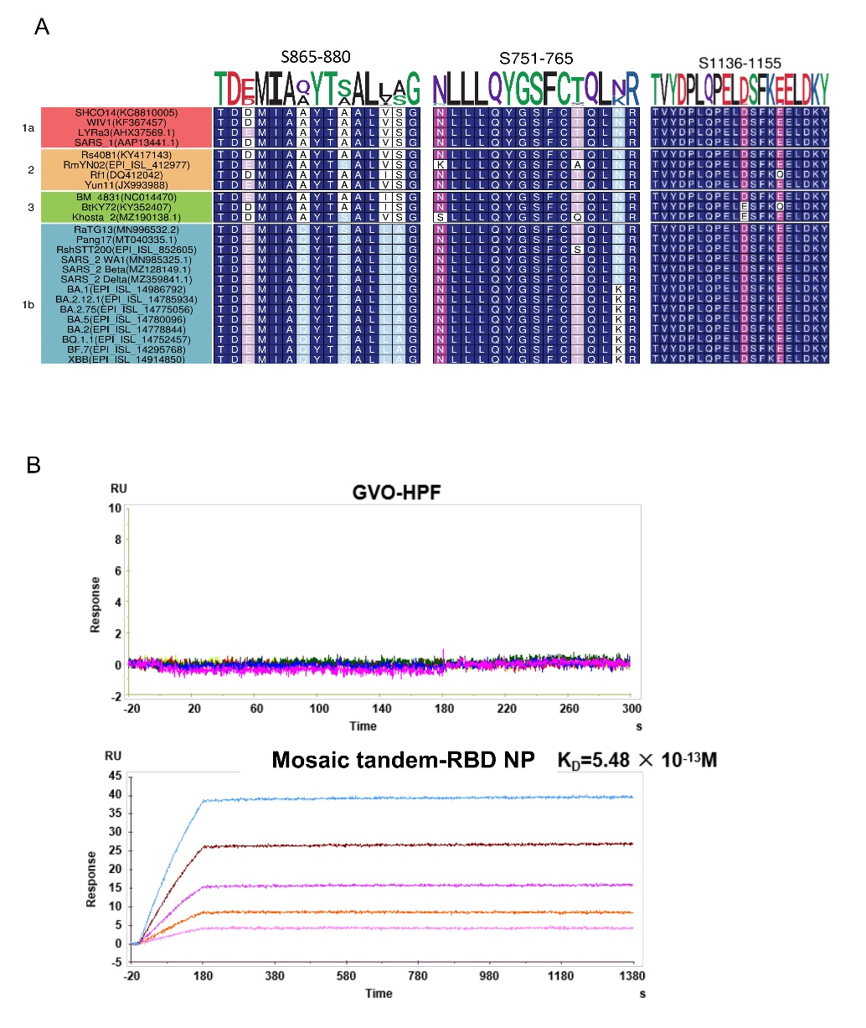
Supplementary Fig. S1. Receptor-binding characterization of mosaic tandem-RBD nanoparticles. A Sequence alignment of the T cell epitope peptides on the S proteins of SARS-CoV-2 among Sarbecovirus which contained four clade 1a of Sarbecovirus (SHCO14, WIVI, LYRa3, SARS-CoV-1 ), four clade 2 of Sarbecovirus (Rs4081, RmYN02, Rf1, Yun11), three clade 3 of Sarbecovirus (BM-4831, BtKY72, Khosta2 ), and fourteen clade 1b of Sarbecovirus coronaviruses (RaTG13, Pang17, RshSTT200, SARS-CoV-2 WA1, Beta, Delta, BA.1, BA.2, BA.5, BA.2.75, BA.2.12.1, BQ.1.1, BF.7, XBB). This analysis was performed using MAFFT v7 with a BLOSUM62 scoring matrix and the L-INS-I algorithm. B Surface plasmon resonance (SPR) analysis of Mosaic tandem-RBD NP binding to human ACE2. Sensorgrams were analyzed using a 1:1 Langmuir kinetic binding model to derive the apparent association rate constant (ka), dissociation rate constant (kd), and apparent equilibrium dissociation constant (K_{D}). The results demonstrate that nanoparticle-displayed RBD retains receptor-binding activity, indicating preserved antigen conformation and functionality.
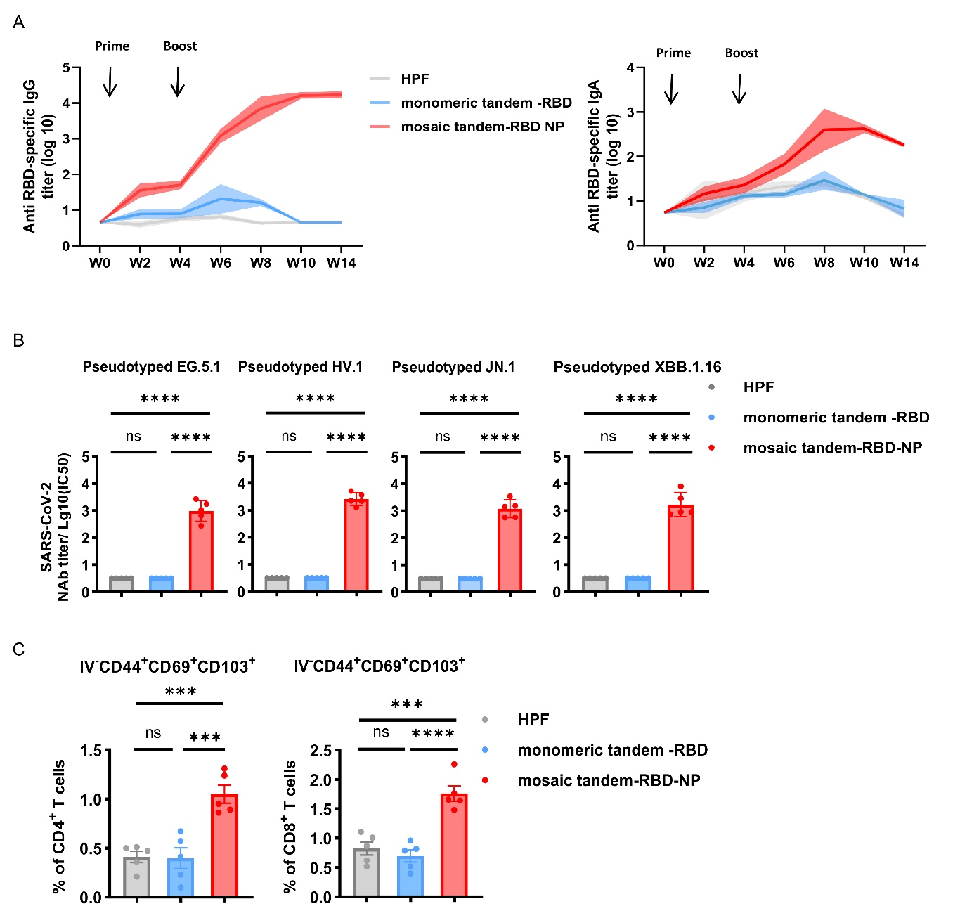
Supplementary Fig. S2. Systemic and mucosal immune responses induced by nanoparticle vaccination. A Kinetics of RBD-specific IgG and IgA responses in serum. BALB/c mice were intranasally immunized on days 0 and 28 with 10 μg Mosaic tandem-RBD NP (150 pmol), with equimolar monomeric tandem-RBD and HPF as controls. Serum samples were collected every two weeks for antibody measurement. B Pseudovirus neutralization assay showing serum neutralizing activity against multiple SARS-CoV-2 variants at week 8 post-immunization. C Flow cytometric analysis of tissue-resident memory T cells (T_{RM}) in the lung at week 8 post-immunization. Tissue-resident cells were distinguished by CD45 intravascular labeling, and CD4⁺ and CD8⁺ T_{RM} populations were quantified. n = 5 per group. Statistical significance was determined by one-way ANOVA with Tukey’s post hoc test. Data are presented as mean ± s.e.m. *P < 0.05; **P < 0.01; ***P < 0.001; **P < 0.0001; ns, not significant.

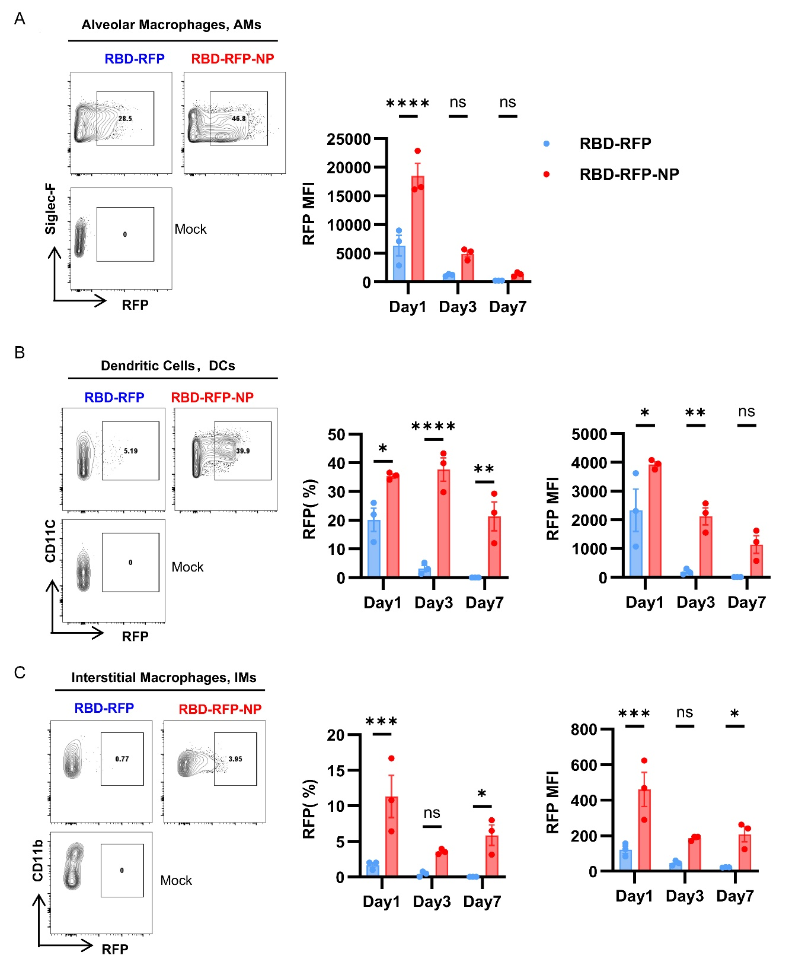
Supplementary Fig. S3. Antigen uptake by pulmonary antigen-presenting cell subsets. A Uptake of RFP-labeled antigen by alveolar macrophages (AMs; CD45⁺ CD11c⁺ Siglec-F⁺) at indicated time points. B Antigen uptake by dendritic cells (DCs; CD45⁺ CD11c⁺ MHCII⁺ Siglec-F⁻). C Antigen uptake by interstitial macrophages (IMs; CD45⁺ CD11b⁺ F4/80⁺ Siglec-F⁻). n = 3 per group. Statistical significance was determined by one-way ANOVA with Tukey’s post hoc test. Data are presented as mean ± s.e.m. *P < 0.05; **P < 0.01; ***P < 0.001; ****P < 0.0001; ns, not significant.
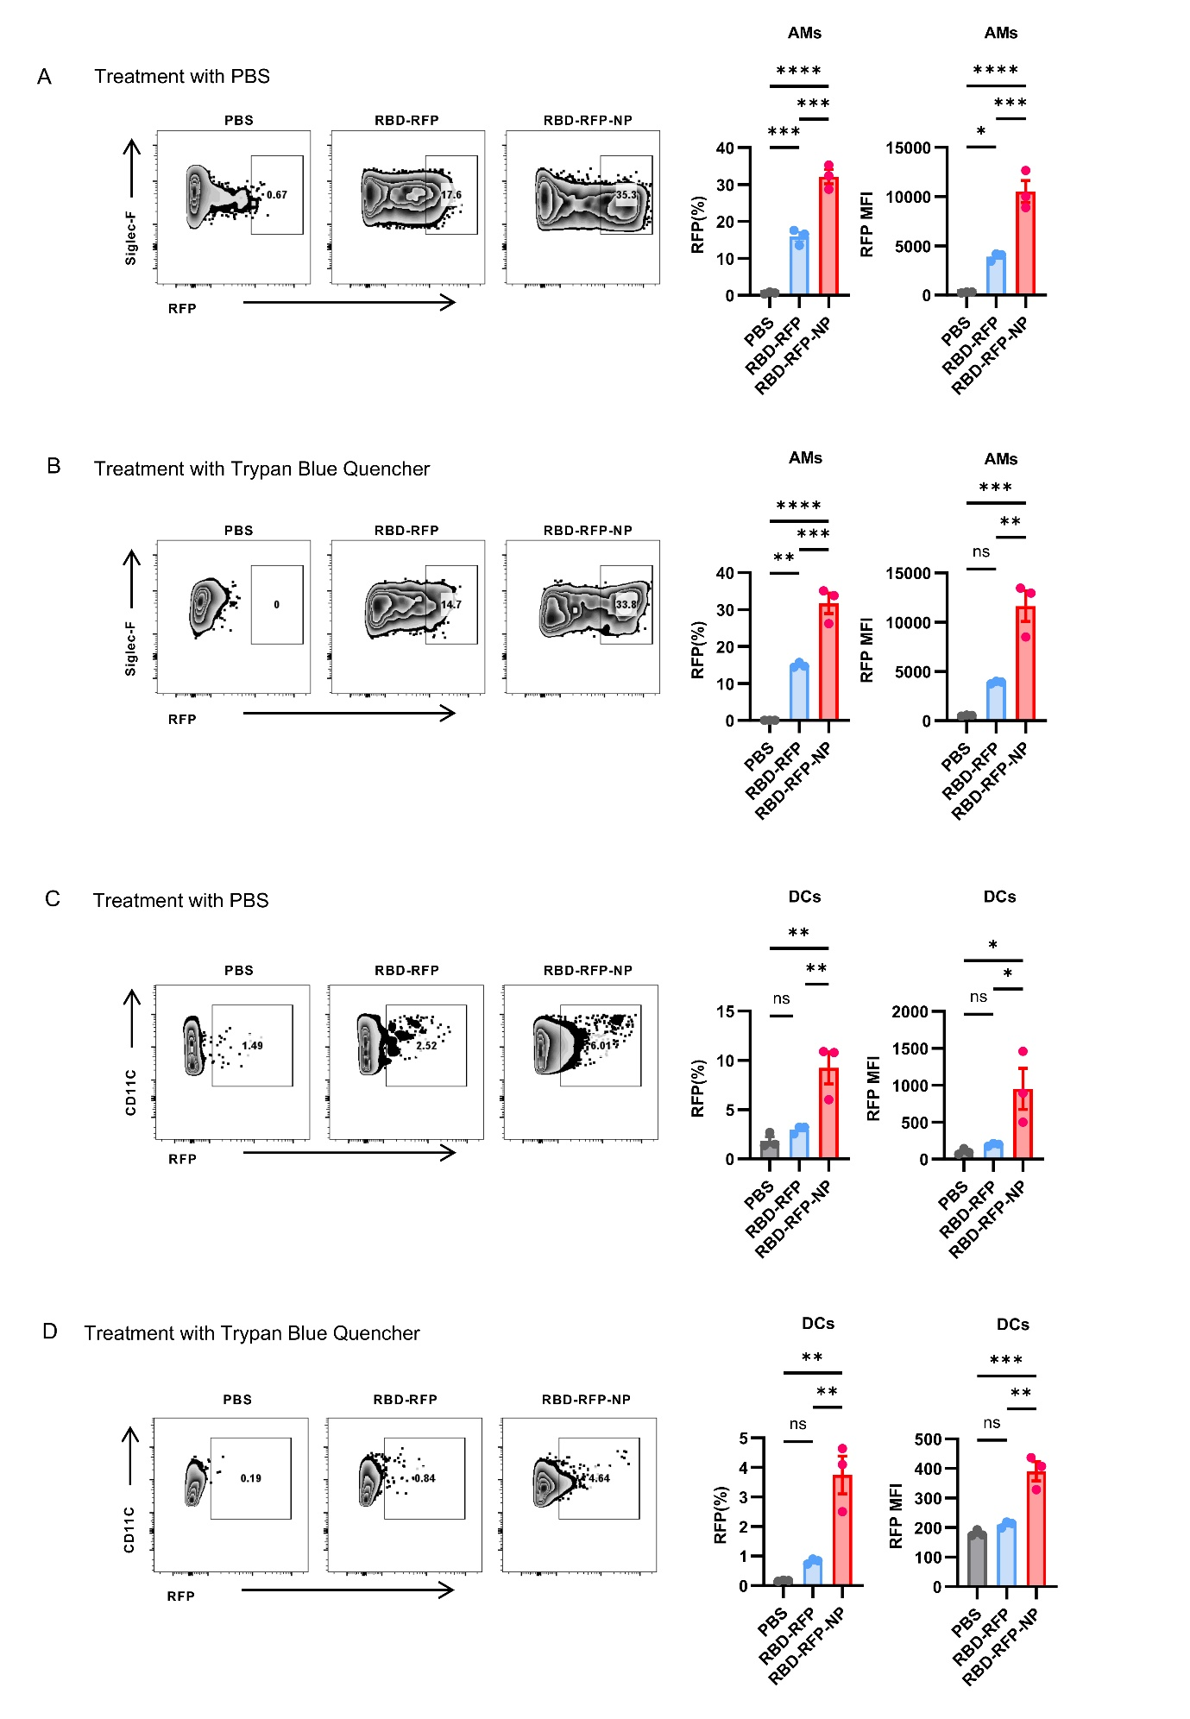
Supplementary Fig. S4. Extracellular fluorescence quenching assay demonstrates enhanced intracellular antigen uptake by alveolar macrophages. C57BL/6 mice were intranasally immunized with soluble RBD-RFP or ferritin nanoparticle-displayed RBD-RFP. Pulmonary AMs were isolated forty-eight hours later and treated with Trypan Blue to quench extracellular fluorescence prior to flow cytometric analysis. A, B Representative flow cytometry plots and frequencies of RFP signals in AMs with (B) or without (A) Trypan Blue quenching. C, D Representative flow cytometry plots and frequencies of RFP signals in DCs with (D) or without (C) Trypan Blue quenching. Data are mean ± s.e.m. from 3 mice per group. Statistical significance was determined by one-way ANOVA with Tukey’s post hoc test. *P < 0.05; **P < 0.01; ***P < 0.001; ****P < 0.0001; ns, not significant.

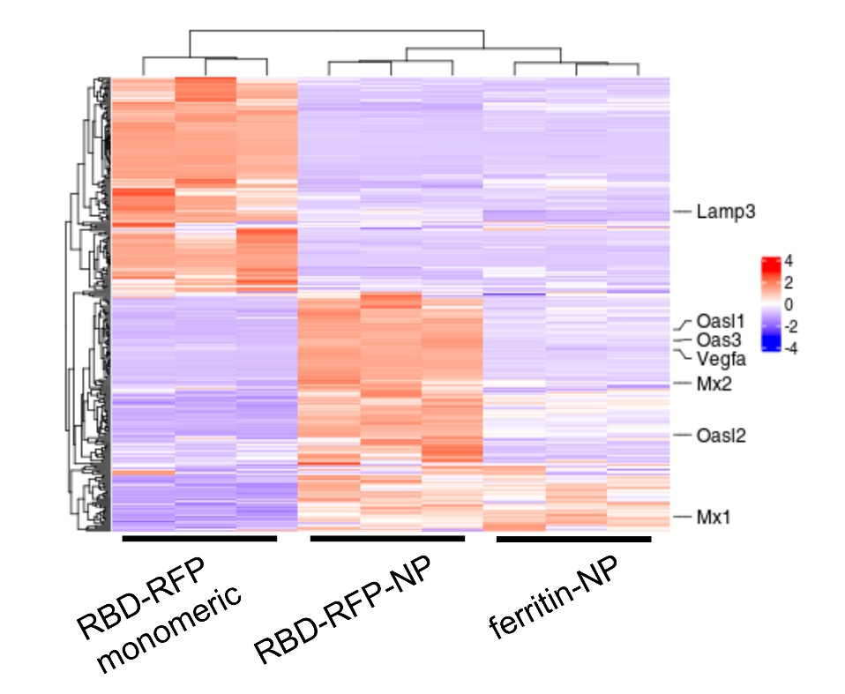
Supplementary Fig. S5. Transcriptomic profiling of AMs. C57BL/6 mice were intranasally immunized with 150 pmol RBD-RFP, or HPF NP, or RBD-RFP NP, and CD45⁺ CD11c⁺ Siglec-F⁺ cells were sorted at day 3 for RNA-seq analysis. Heatmap of differentially expressed genes (|log₂FC| > 1, FDR < 0.05, n= 3 biological replicates per group). Color scale indicates row-wise Z-score normalized expression values (red: high, blue: low). Rows represent genes; columns represent samples grouped by condition.
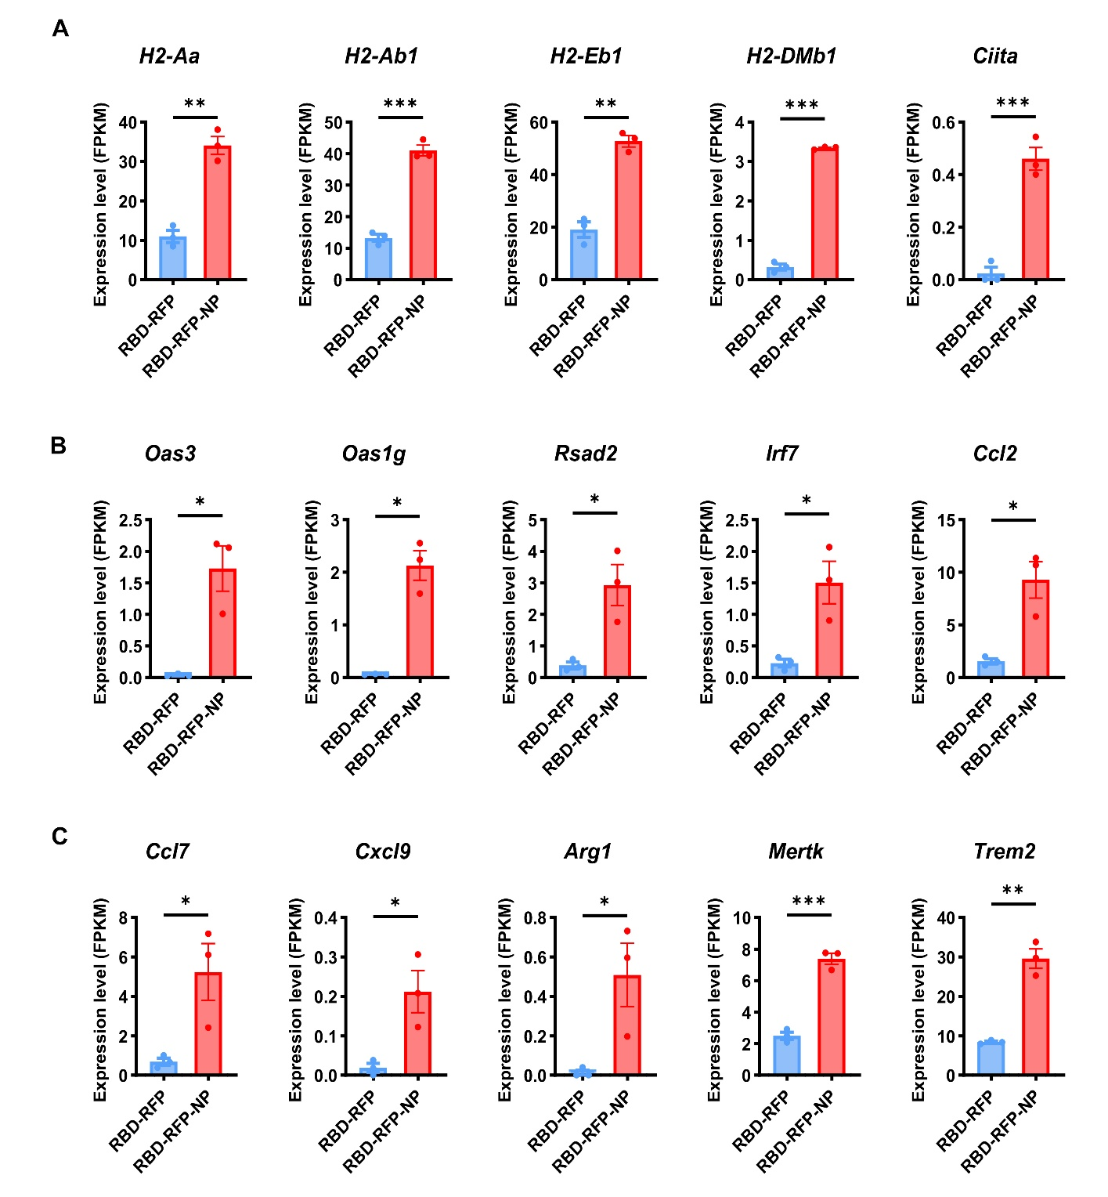
Supplementary Fig. S6. Transcriptional reprogramming of alveolar macrophages following nanoparticle vaccination. A–C Bar plots showing the expression levels of selected genes in alveolar macrophages (AMs) derived from control and nanoparticle-vaccinated groups in C57BL/6 mice, based on RNA-seq analysis. Expression values are presented as normalized expression levels (FPKM). n = 3 per group. Statistical significance was determined by unpaired two-tailed Student’s t-test. Data are presented as mean ± s.e.m. *P < 0.05; **P < 0.01; ***P < 0.001; ****P < 0.0001; ns, not significant.

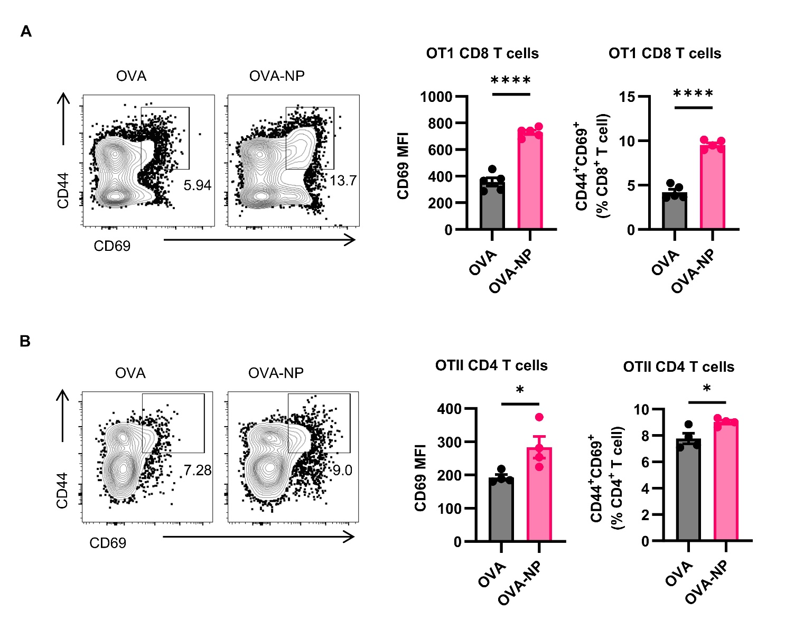
Supplementary Fig. S7. Alveolar macrophages from ferritin nanoparticle-immunized mice exhibit enhanced functional antigen-presenting capacity. C57BL/6 mice were intranasally immunized with soluble OVA or ferritin nanoparticle-displayed OVA. At 48 h post-immunization, pulmonary AMs were isolated and co-cultured with OT-I or OT-II T cells for 6 h ex vivo. A CD69 expression and frequencies of activated CD44⁺CD69⁺ populations among OT-I T cells. B CD69 expression and frequencies of activated CD44⁺CD69⁺ populations among OT-II T cells.
Data are presented as mean ± s.e.m. from 4 mice per group. Statistical significance was determined by two-tailed unpaired t-test, *P < 0.05; ****P < 0.0001.
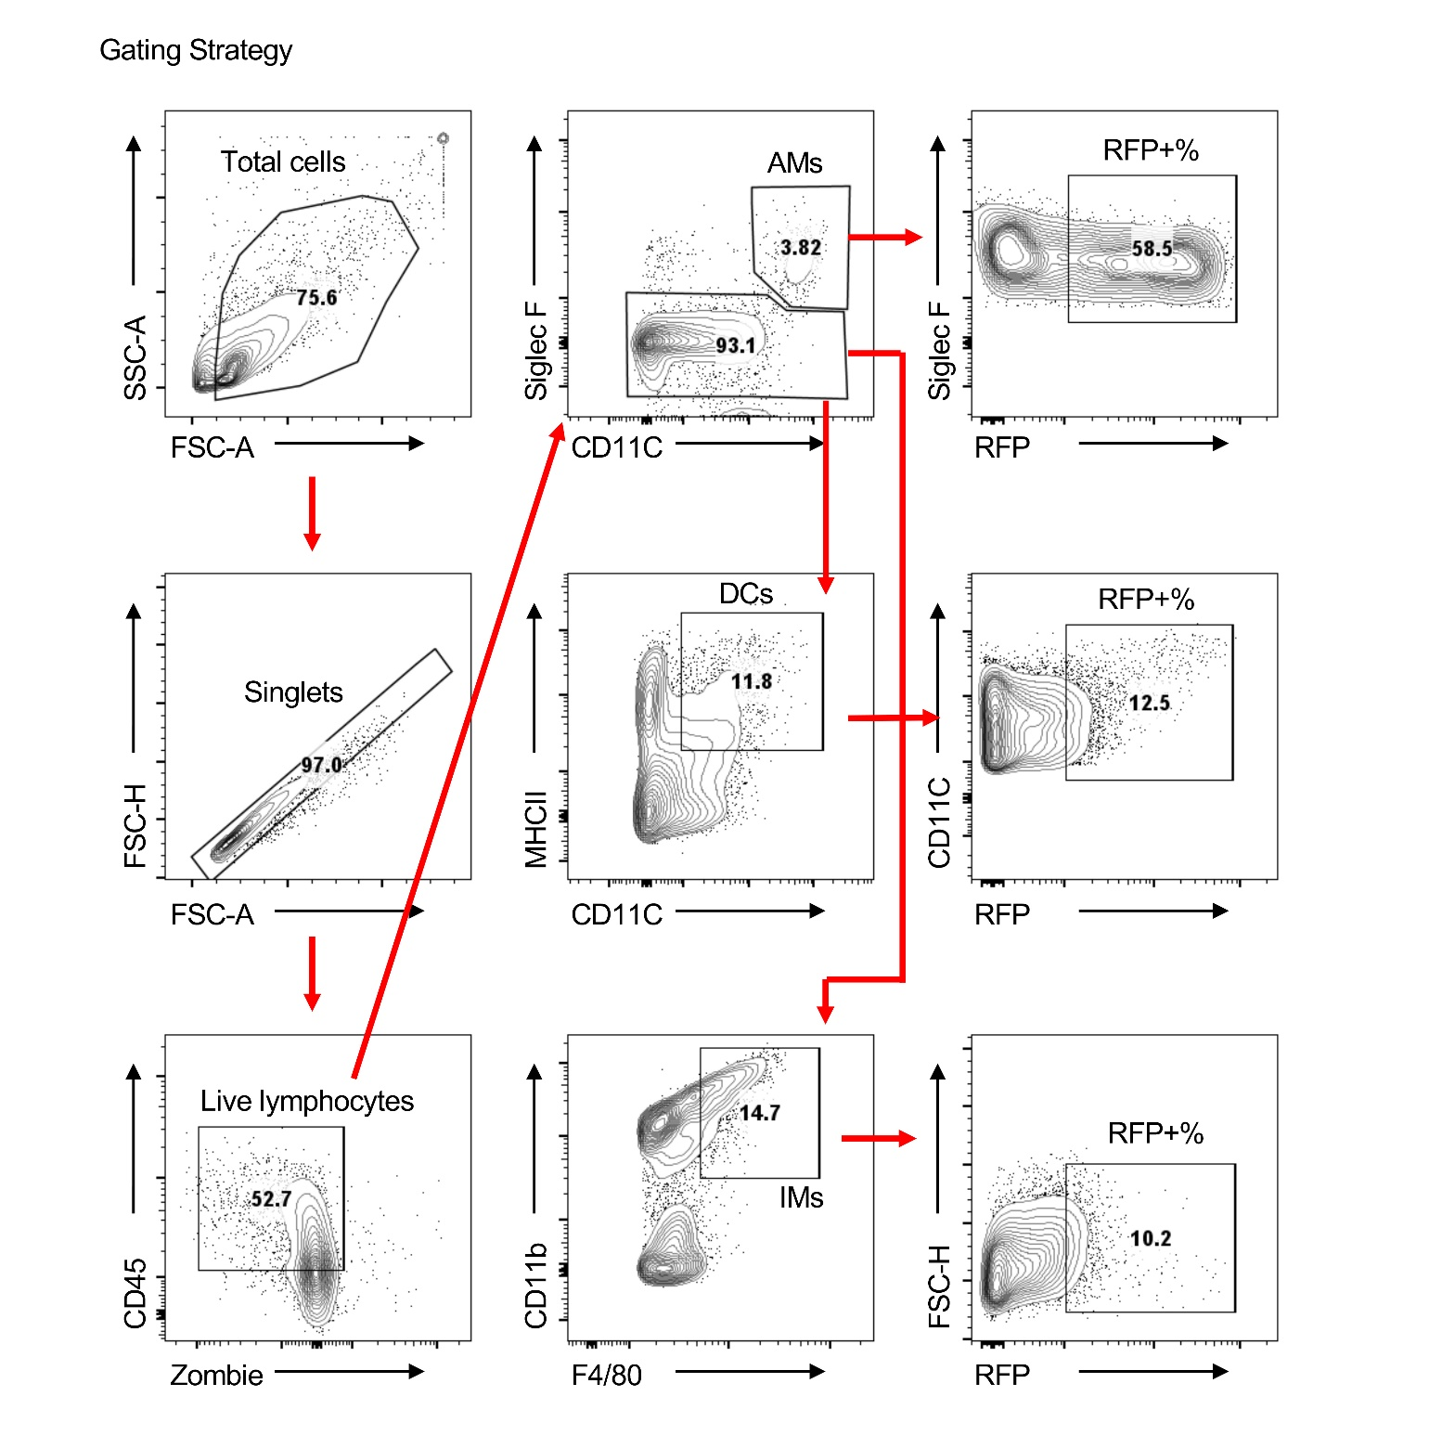
Supplementary Fig. S8. Gating strategy for flow cytometry analysis. Alveolar macrophages (AMs): Live Singlets CD45⁺ CD11c⁺ Siglec-F⁺; Dendritic Cells (DCs): Live Singlets CD45⁺ Siglec-F⁻CD11c⁺ MHC-II⁺; Interstitial macrophages (IMs): Live Singlets CD45⁺ Siglec-F⁻ F4/80⁺ CD11b⁺.

Supplementary Table S1
(Excel file)

