Virologica Sinica
Supplementary Materials

SARS-CoV-2 3CLpro inhibits the replication of influenza viruses through the cleavage of NP and PA

Liubing Du^{a, b, 1}, Xiaoyu Cai^{c, 1}, Ziliang Pengª, Mengxuan Wangª, Huijie Liª, Xue Liu^{d}, Zhihui Zhangª, Manqi Caoª, Shuchun Zhangª, Zhenyu Heª, Zhanjia Zhangª, Yu Yanª, Qitong Linª, Yushan Xueª, Deyin Guo^{b}, Ji-An Pan^{a, d,} *, Yao-Qing Chen^{c,} *, Xiaoxue Peng^{a, d, e,} *

ª The Molecular Cancer Research Center, Zhongshan School of Medicine, Sun Yat-sen University Shenzhen Campus, Shenzhen 518107, China;
^{b} The Division of Basic Research, Guangzhou National Laboratory, Bio-island, Guangzhou 510320, China;
^{c} School of Public Health (Shenzhen), Shenzhen Campus of Sun Yat-sen University, Shenzhen 518107, China;
^{d} The Center for Infection and Immunity Study, Zhongshan School of Medicine, Sun Yat-sen University Shenzhen Campus, Shenzhen 518107, China;
^{e} Shenzhen Key Laboratory for Systems Medicine in Inflammatory Diseases, Shenzhen Campus of Sun Yat-sen University, Shenzhen 518107, China;

¹ Liubing Du and Xiaoyu Cai contributed equally to this work

*Corresponding authors:
E-mail addresses: pengxx9@mail.sysu.edu.cn (X. Peng); chenyaoqing@mail.sysu.edu.cn (Y. Chen); panjan@mail.sysu.edu.cn (J.A. Pan)
ORCID: 0000-0001-8687-9711 (X. Peng); 0000-0002-4659-1550 (Y. Chen); 0000-0002-2842-4126 (J.A. Pan)
SUPPLEMENTARY MATERIALS
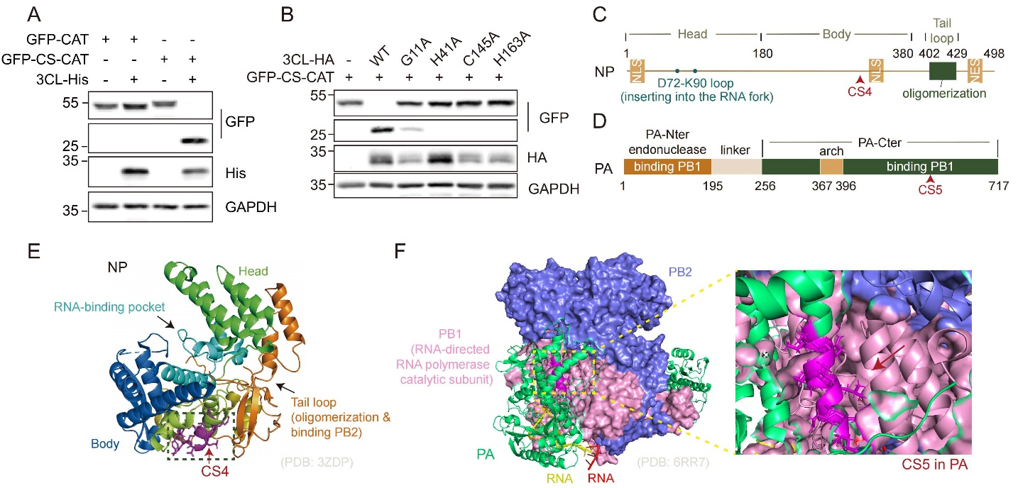
Supplementary Fig. S1 Verification of the GFP-CAT system and identification of candidate 3CLpro cleavage sites within NP and PA. A HEK293T cells were co-transfected with or without 3CL-His together with either GFP-CAT or GFP-CS-CAT; cells were lysed and analysed by Western blot with the indicated antibodies. B HEK293T cells were co-transfected with GFP-CS-CAT together with 3CL-HA or its catalytically inactive mutants; cells were lysed and analysed by Western blot with the indicated antibodies. C Domain mapping of IAV NP showed that CS4 is located between the loop for RNA fork and the key oligomerization domain. D Domain mapping of IAV PA showed that CS5 is located within the C-terminal domain that interacts with PB1. E Structural analysis of IAV nucleoprotein (NP, PDB: 3ZDP) revealed that CS4 resides in a surface-exposed loop between the RNA-binding pocket and the PB2-binding domain. F Structural analysis of the influenza A virus RNA polymerase complex (PDB: 6RR7) shows that CS5 is located at the interface between the PA and PB2 subunits.

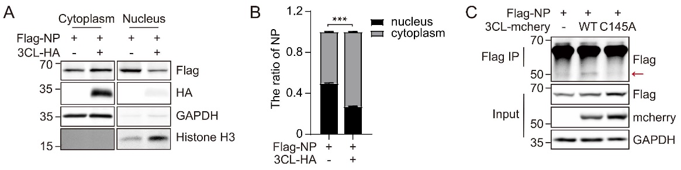
Supplementary Fig. S2 3CLpro alters the cellular localization of NP and cleaves NP. A HEK293T cells expressing Flag-NP alone or together with 3CL-HA were subjected to nuclear-cytoplasmic fractionation, followed by Western blot. B The cytoplasmic versus nuclear ratio of Flag-NP signal in (A) was quantified and plotted. C HEK293T cells were co-transfected with Flag-NP together with 3CL-mcherry or 3CL(C145A)-mcherry. Cell lysates were harvested, subjected to anti-Flag immunoprecipitation (Flag-IP), and subsequently analyzed by Western blot. The bars are represented as mean ± SEM. Statistics: Student’s t-test or two-way ANOVA multiple comparisons tests (*P < 0.05, **P < 0.01, ***P < 0.001).

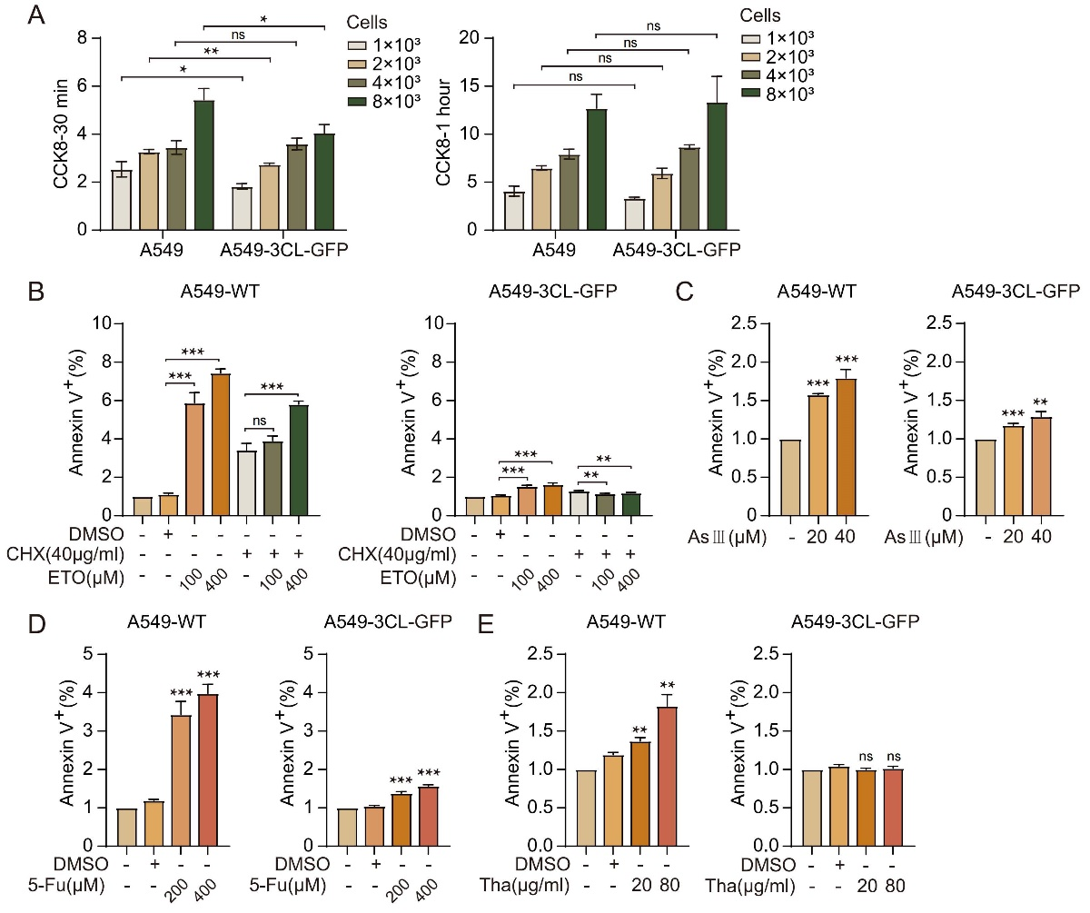
Supplementary Fig. S3 Cell proliferation and cellular sensitivity to various stress inducers were not altered by 3CLpro. A A549-WT and A549-3CL-GFP cells were counted and seeded into 96-well plates at densities of 1 × 10³, 2 × 10³, 4 × 10³, and 8 × 10³ cells per well. After 24 h of culture, CCK-8 reagent was added; absorbance was measured at 30 min and 1 h post-addition to assess cell viability. The calculated values are presented as bar graphs (mean ± SEM, n = 3). B–E A549-WT and A549-3CL-GFP cells were treated for 24 h with cycloheximide (CHX), etoposide (ETO), ETO+CHX, arsenite (As), 5-fluorouracil (5-Fu), or thapsigargin (Tha). Cells were then harvested, stained with Annexin V, and analyzed by flow cytometry; the percentage of Annexin V-positive cells is plotted as bar graphs (mean ± SEM, n = 3). Statistics: Student’s t-test or two-way ANOVA multiple comparisons tests (*P < 0.05, **P < 0.01, ***P < 0.001).
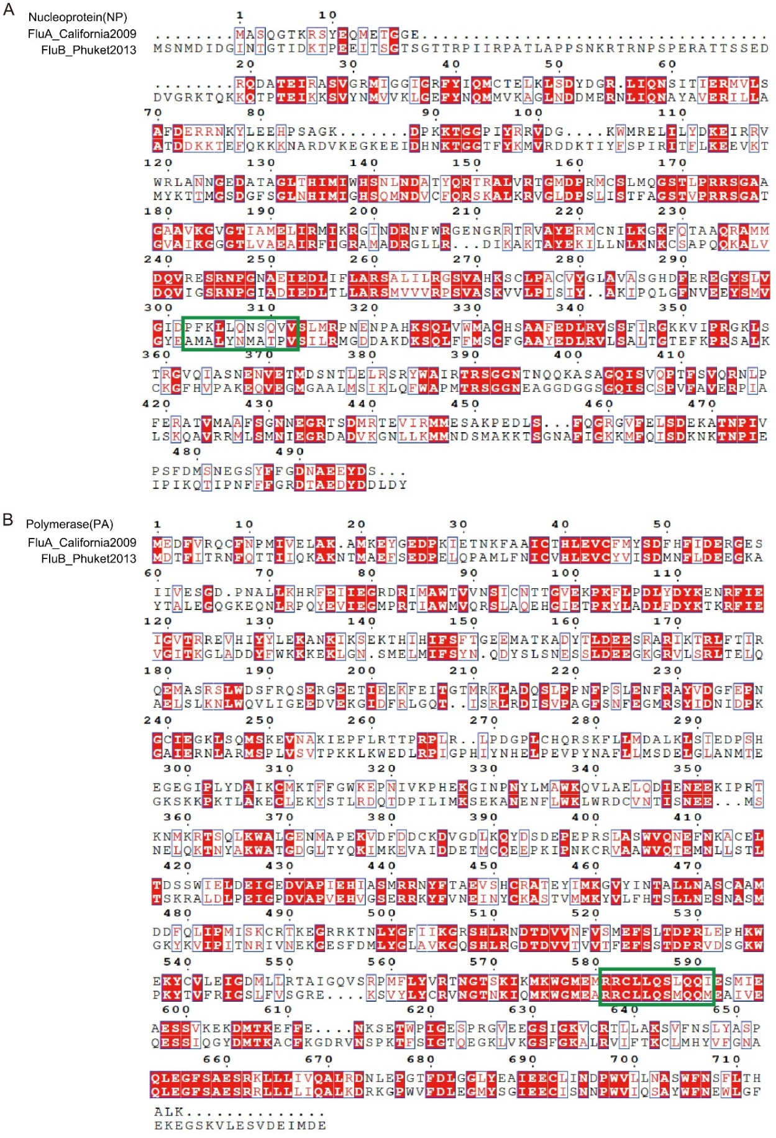
Supplementary Fig. S4 Conserved site analysis of NP and PA in influenza A and B viruses. A, B Amino-acid sequence alignment of NP (A) and PA (B) proteins from influenza A virus A/California/07/2009 (H1N1) and influenza B virus B/Phuket/3073/2013 was performed to evaluate the conservation of putative SARS-CoV-2 3CLpro cleavage sites within these proteins.

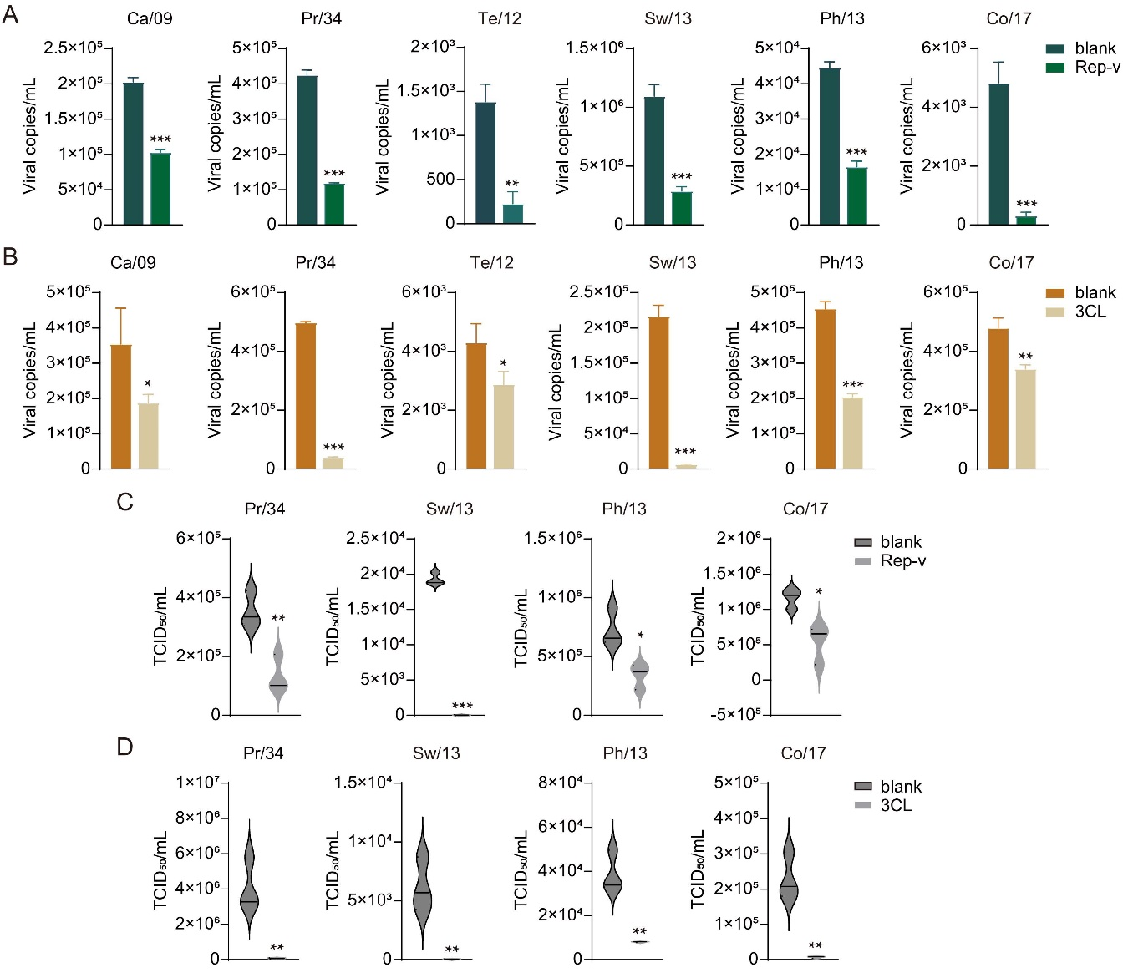
Supplementary Fig. S5 SARS-CoV-2 replication reduces both viral RNA copies and TCID₅₀ of influenza viruses. A A549 cells were pre-infected with VRPs for 24 h, the inoculum was removed, and cells were infected for 1 h with influenza A viruses H1N1 Ca/09 or Pr/34, H3N2 Te/12 or Sw/13, or influenza B viruses Ph/13 or Co/17. After medium exchange and 48 h culture, the cell supernatant was collected for RNA extraction and reverse-transcription, and influenza virus copies were quantified by qPCR and displayed as bar graphs (mean ± SEM, n = 3). B A549-WT and A549-3CL-GFP cells were infected with influenza A viruses H1N1 Ca/09 or Pr/34, H3N2 Te/12 or Sw/13, or influenza B viruses Ph/13 or Co/17 for 1 h, washed, and cultured for 48 h. Total RNA was extracted from the cell supernatant, reverse-transcribed, and influenza virus copies were quantified by qPCR and displayed as bar graphs (mean ± SEM, n = 3). C The cell supernatant of influenza A viruses Pr/34, Sw/13, or influenza B viruses Ph/13 or Co/17 from (A) above were further detected for TCID₅₀ and displayed as violin graphs (mean ± SEM, n = 3). D The cell supernatant of influenza A viruses Pr/34, Sw/13, or influenza B viruses Ph/13 or Co/17 from (B) above were further detected for TCID₅₀ and displayed as violin graphs (mean ± SEM, n = 3). Statistics: Student’s t-test or two-way ANOVA multiple comparisons tests (*P < 0.05, **P < 0.01, ***P < 0.001).

Supplementary Tables
Supplementary Table S1 Identification of cleavage sites in viral coding sequences.
(Excel file)

Supplementary Table S2 Surveillance data of Influenza A, Influenza B, and SARS-CoV-2.
(Excel file)

Supplementary Table S3 The sequences of primers used in this study
Name | Sequence (5′~3′)
Primers for cleavage sites of 3CLpro
Hind3-CS f | AGCTTAATGTGGCAACTTTACAGAGTGCTAATGCTACTA
Hind3-CS r | AGCTTAGTAGCATTAGCACTCTGTAAAGTTGCCACATTA
Hind3-CS1 f | AGCTTACCAGCCTCCCATTTCAGAATATACATCCGATCA
Hind3-CS1 r | AGCTTGATCGGATGTATATTCTGAAATGGGAGGCTGGTA
Hind3-CS2 f | AGCTTCGTAGACGCTTTGTCCAAAATGCCCTAAATGGGA
Hind3-CS2 r | AGCTTCCCATTTAGGGCATTTTGGACAAAGCGTCTACGA
Hind3-CS3 f | AGCTTCTTCTTGAAAATTTGCAGGCCTACCAGAAGCGAA
Hind3-CS3 r | AGCTTCTTCTTGAAAATTTGCAGGCCTACCAGAAGCGAA
Hind3-CS4 f | AGCTTCCATTCAAATTACTCCAAAACAGCCAAGTGGTCA
Hind3-CS4 r | AGCTTGACCACTTGGCTGTTTTGGAGTAATTTGAATGGA
Hind3-CS5 f | AGCTTAGGCGCTGCCTTCTTCAGTCTCTTCAGCAGATTA
Hind3-CS5 r | AGCTTAATCTGCTGAAGAGACTGAAGAAGGCAGCGCCTA
Hind3-CS6 f | AGCTTTTGCTTCTCATTGTTCAGGCACTTAGGGACAACA
Hind3-CS6 r | AGCTTGTTGTCCCTAAGTGCCTGAACAATGAGAAGCAAA
Hind3-CS7 f | AGCTTTGGTGGGATGGGCTCCAATCATCCGACGATTTTA
Hind3-CS7 r | AGCTTAAAATCGTCGGATGATTGGAGCCCATCCCACCAA
Hind3-CS8 f | AGCTTGCAAAAGTGCTTTTCCAGAACTGGGGAATTGAAA
Hind3-CS8 r | AGCTTTTCAATTCCCCAGTTCTGGAAAAGCACTTTTGCA
Hind3-CS9 f | AGCTTGAATTTGAACCATTTCAGTCTCTTGTCCCTAAGA
Hind3-CS9 r | AGCTTCTTAGGGACAAGAGACTGAAATGGTTCAAATTCA
BamH1-CS f | GATCCAATGTGGCAACTTTACAGAGTGCTAATGCTACTG
BamH1-CS r | GATCCAGTAGCATTAGCACTCTGTAAAGTTGCCACATTG
BamH1-CS4 f | GATCCCCATTCAAATTACTCCAAAACAGCCAAGTGGTCG
BamH1-CS4 r | GATCCGACCACTTGGCTGTTTTGGAGTAATTTGAATGGG
BamH1-CS5 f | GATCCAGGCGCTGCCTTCTTCAGTCTCTTCAGCAGATTG
BamH1-CS5 r | GATCCAATCTGCTGAAGAGACTGAAGAAGGCAGCGCCTG
BamH1-CS6 f | GATCCTTGCTTCTCATTGTTCAGGCACTTAGGGACAACG
BamH1-CS6 r | GATCCGTTGTCCCTAAGTGCCTGAACAATGAGAAGCAAG
BamH1-CS8 f | GATCCGCAAAAGTGCTTTTCCAGAACTGGGGAATTGAAG
BamH1-CS8 r | GATCCTTCAATTCCCCAGTTCTGGAAAAGCACTTTTGCG
Primers for cloning 3CL into the LPC or pHAGE-EF1a-dCas9-KRAB vector (P50919)
Homo-LPC-3CL f | CAATAAGGATCCACTAGTAACGGCCG
Homo-LPC-3CL r | AAGCTTGGGTCTCCCTATAGTGAGTC
3CL f | CCGAAGCTTACCATGAGCGGTTTCCGTAAGATGGC
3CL r | CCCTCGAGTTGAAAGGTCACACCGCTGC
Homo-P50919-3CL f | CGACGCGTGCCACCATGAGCGGTTTCCGTAAGATGGC
Homo-P50919-3CL r | CGCGATCGCTTATTGAAAGGTCACACCGCTGCAC
Primers for 3CL mutations
3CL G11A f | AGCGCCAAAGTTGAAGGTTGCATG
3CL G11A r | CTTTGGCGCTCGGAAACGCCATCTTA
3CL H41A f | TGCCCGCGTGCCGTTATCTGCACCAGCG
3CL H41A r | GCAGATAACGGCACGCGGGCAGTAAACCAC
3CL C145A f | CGGTAGCGCCGGCAGCGTGGGTTTCAAC
3CL C145A r | CGCTGCCGGCGCTACCGTTCAGAAAGCTAC
3CL H163A f | GCTATATGGCCCACATGGAGCTGCCGACCG
3CL H163A r | GCTCCATGTGGGCCATATAGCAAAAGCTAACGC
Primers for cloning IAV genes into LPC vector
Homo-LPC-IAV f | GGTAAGCTTGTCATCGTCATCCTTGTAATC
Homo-LPC-IAV r | CATCATCATCATCATCACTGAGAATTCTGCAG
NP f | GATGACAAGCTTACCATGGCGTCTCAAGGCACCAAAC
NP r | GATGATGATGATGATGACTGTCATACTCCTCTGCATTGTCTC
PA f | GATGACAAGCTTACCATGGAAGACTTTGTGCGACAATGC
PA r | GATGATGATGATGCTTCAGTGCATGTGTGAGGAAGGAG
PB1 f | GATGACAAGCTTACCATGGATGTCAATCCGACTCTACTTTTCC
PB1 r | GATGATGATGATGTTTTTGCCGTCTGAGTTCTTCAATGGTG
PB2 f | GATGACAAGCTTACCATGGAGAGAATAAAAGAACTGAGAGATCTAATG
PB2 r | GATGATGATGATGATTGATGGCCATCCGAATTCTTTTGG
Primers for qPCR
Ca/09-M-F1 | GAGACTGGAAAGTGTCTTTGCAG
Ca/09-M-R1 | GGCATTTTGGACAAAGCGTCTAC
Ca/09-NP-F1 | AGAAATCAGAGCATCTGTCGG
Ca/09-NP-R1 | CTCATCAAAAGCAGAAAGCACC
Vic/19-M-F1 | CTATTCAACTGGTGCACTTGCAAG
Vic/19-M-R1 | ATTTGTCTGTGAGACCGATGCTG
Vic/19-NP-F1 | GGGCAATGATGGATCAAGTAAGGG
Vic/19-NP-R1 | CAACTGATCCTCTCAGAATGAGTGC
Pr/34-M-F1 | ACCGTCGCTTTAAATACGGACTG
Pr/34-M-R1 | TGCTGACAAAATGACCATCGTCAGC
Pr/34-NP-F1 | ACATCCAAATGTGCACCGAACTC
Pr/34-NP-R1 | TCTCCTTTCGTCAAAAGCAGAGAGC
Te/12-M-F1 | AGATGCAACGATTCAAGTGACCC
Te/12-M-R1 | CTCTCTTAAGGCCGTGTTTGAAGAG
Te/12-NP-F1 | AGGTGCTGCAGTCAAAGGAATC
Te/12-NP-R1 | CACTTCTTGTTTTCCGCCCATTC
Sw/13-M-F1 | GTGCAGATGCAACGATTCAAGTG
Sw/13-M-R1 | TTAAGGCCGTGTTTGAAGAGTCG
Sw/13-NP-F1 | TCACTGGAAATACGGAGGGAAGAAC
Sw/13-NP-R1 | ATATCAAAAGAGGGCACGATCGG
Ka/17-M-F2 | GGCTCTCATGGAATGGCTAAAGAC
Ka/17-M-R2 | TCCCATTGAGGGCATTTTGGAC
Ka/17-NP-F2 | GCCAACAATGGTGAGGATGCTAC
Ka/17-NP-R2 | GCACATTCTGGGATCCATTCCAG
Ph/13-NP-F2 | CAGTGGAAATGCTTTCATTGGGAAG
Ph/13-NP-R2 | AATCGAGGTCATCATAATCCTCTGC
Ph/13-M-F2 | TGGCAGAAGAACTGCAAAGCAAC
Ph/13-M-R2 | CATAGAGCTCTGCTTTAGCACTTCC
Co/17-NP-F2 | CGACAGAGATAAAGAAGAGCGTC
Co/17-NP-R2 | GGCATGCGCATTTTGGATTAG
Co/17-M-F2 | CACAGAGCCCTTATCAGGAATG
Co/17-M-R2 | ACCATGAGACAGTATAGTAGCGC
GAPDH-F | GGAGCGAGATCCCTCCAAAAT
GAPDH-R | GGCTGTTGTCATACTTCTCATGG
SARS2-Leader-F | CCTTCCCAGGTAACAAACCAACC
SARS2-Leader-R | CTCTCCATCTTACCTTTCGGTCAC
SARS2-N-R | CAGTATTATTGGGTAAACCTTGGGGC

