Virologica Sinica
Supplementary Materials

Pre-existing hemagglutinin-specific antibody levels are associated with B-cell repertoire maturation and antibody breadth after influenza vaccination
Wei Wangª, Yan Sunª, Qing Liuª, Yidan Xia^{d}, Jing Wangª, Minhao Hu^{d}, Mengyao Kong^{c}, Jun He^{c, d,} *, Rongbao Gao^{b,} *, Yong Gao^{a, e,} *
ª The First Affiliated Hospital of USTC, Division of Life Sciences and Medicine, University of Science and Technology of China, Hefei, Anhui, 230001, China;
^{b} NHC Key Laboratory of Biosafety, NHC Key Laboratory of Medical Virology and Viral Diseases, National Institute for Viral Disease Control and Prevention, Chinese Center for Disease Control and Prevention, Beijing 102206, China;
^{c} Microbiological Laboratory, Anhui Provincial Center for Disease Control and Prevention, Hefei 230601, China;
^{d} Department of Health Inspection and Quarantine, School of Public Health, Anhui Medical University, Hefei 230032, China;
^{e} Hefei Infectious Disease Hospital, Hefei 230000, China;

Corresponding author:
E-mail addresses: ygao387@ustc.edu.cn (Y. Gao); rongbaogao@163.com (R. Gao); heliosking@sina.com (J. He)
ORCID: 0000-0001-6352-8652 (Y. Gao); 0009-0009-8915-6119 (R. Gao); 0000-0002-0463-7063 (J. He)

.

SUPPLEMENTARY MATERIALS
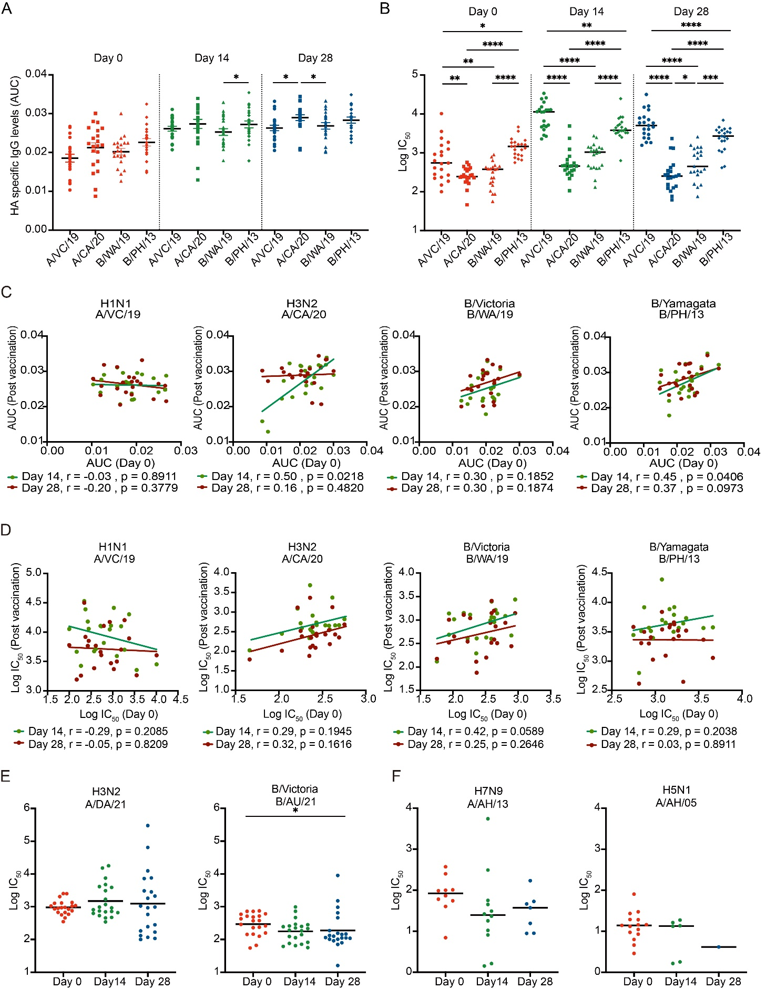
Supplementary Fig. S1. Expanded profiling of HA-specific antibody responses after influenza vaccination. A, B HA-specific IgG antibodies (A) and neutralizing antibody titers (B) against vaccine components across the indicated time points. C, D, Correlations between pre- and post-vaccination levels of HA-specific IgG antibodies (C) and neutralizing antibodies (D). E, Neutralizing antibody responses to the 2022–2023 vaccine components. F, Neutralizing antibody responses to highly pathogenic avian influenza strains H7N9 (A/AH/13) and H5N1 (A/AH/05). Participants without detectable neutralizing antibodies are not shown. Each point represents one participant (n = 21), and the horizontal bars in A, B, E, F represent the mean values. Dunn’s multiple comparisons test in panels A and E and Holm-Šídák's multiple comparisons test in panels B and F for statistical significance between different vaccine components. *P < 0.05, **P < 0.01, ***P < 0.001, ****P < 0.0001; non-significant comparisons (P > 0.05) are not shown. All experiments were performed in duplicate.
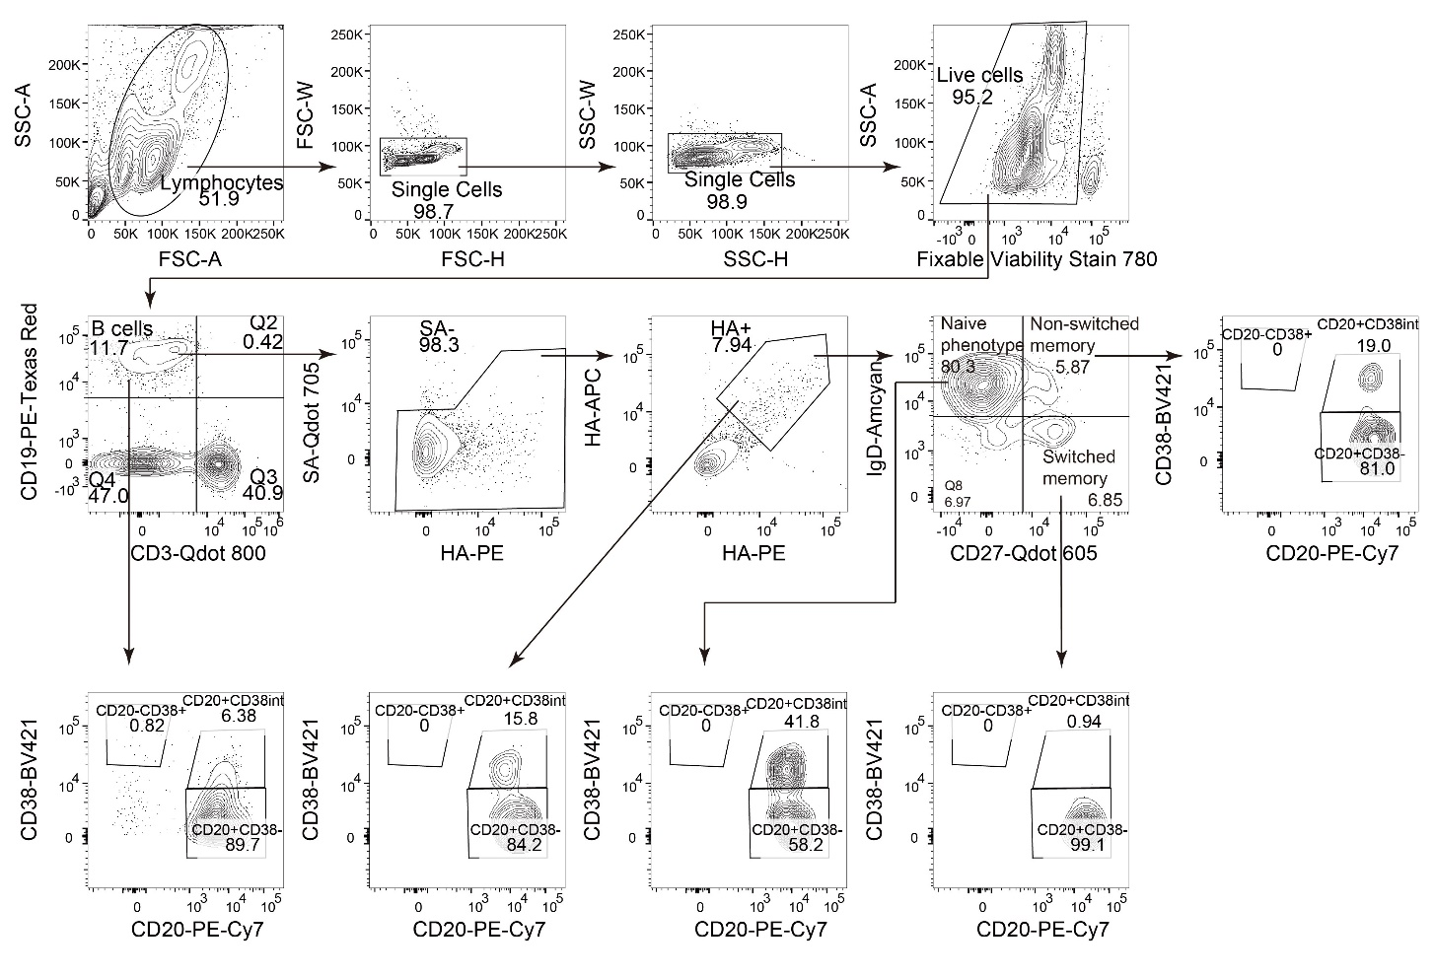
Supplementary Fig. S2. Gating strategy for identifying HA⁺ B cell subsets. Representative gating strategy for identifying HA⁺ B cells and the CD27⁻IgD⁺ naive-phenotype, CD27⁺IgD⁺ non-switched memory, and CD27⁺IgD⁻ switched memory subsets. HA⁺ cells were defined by concordant binding to PE- and APC-labeled HA probes after exclusion of streptavidin-binding events. CD20 and CD38 expression is shown for the indicated populations. Numbers indicate the percentages within parent gates.
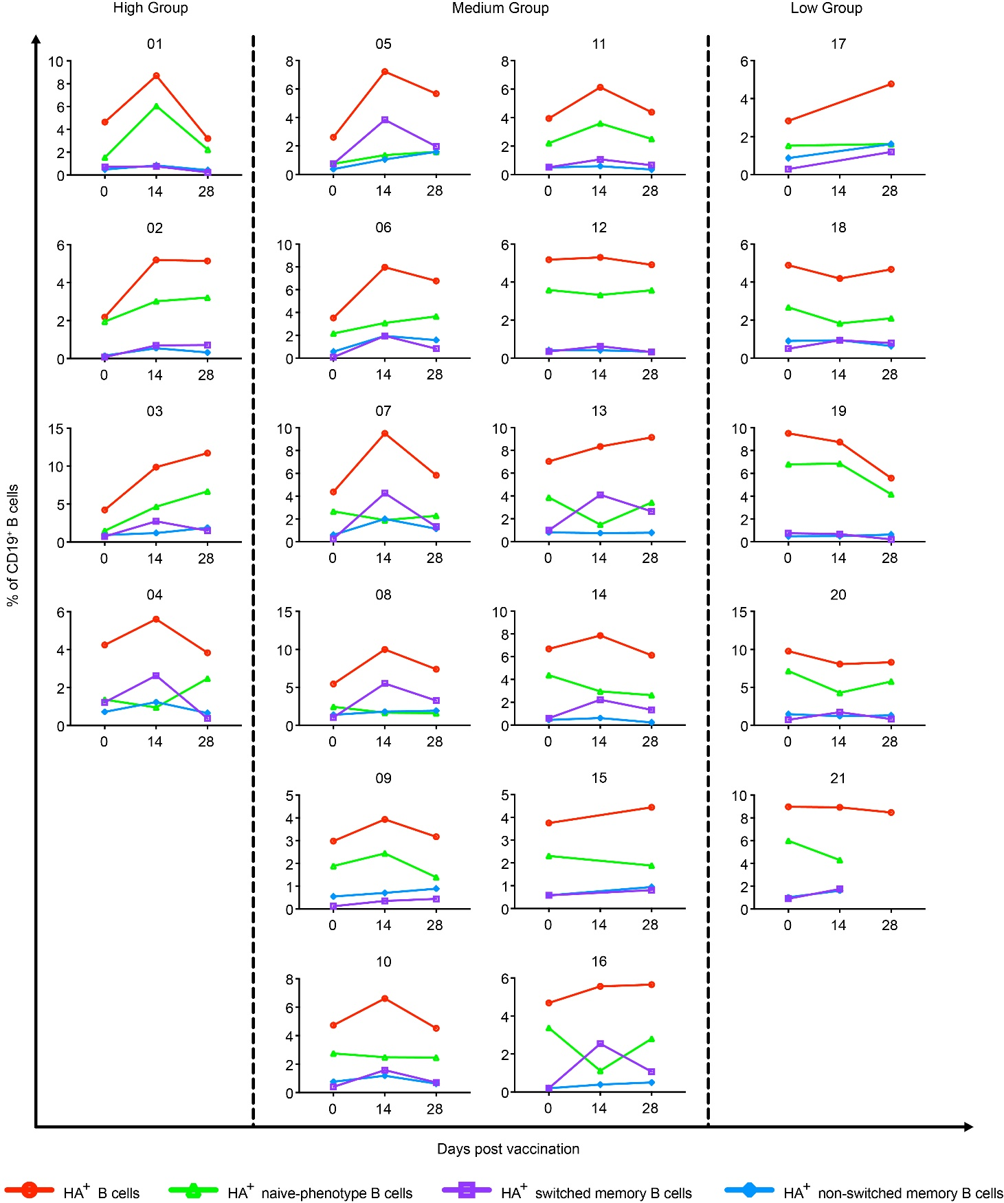
Supplementary Fig. S3. Kinetics of HA⁺ B cell subsets in 21 participants. Each panel represents one participant from the high- (01–04, n = 4), medium- (05–16, n = 12), or low-titer group (17–21, n = 5). Frequencies are expressed as percentages of CD19⁺ B cells. Lines connect available measurements from the same participant. Missing values were not imputed.
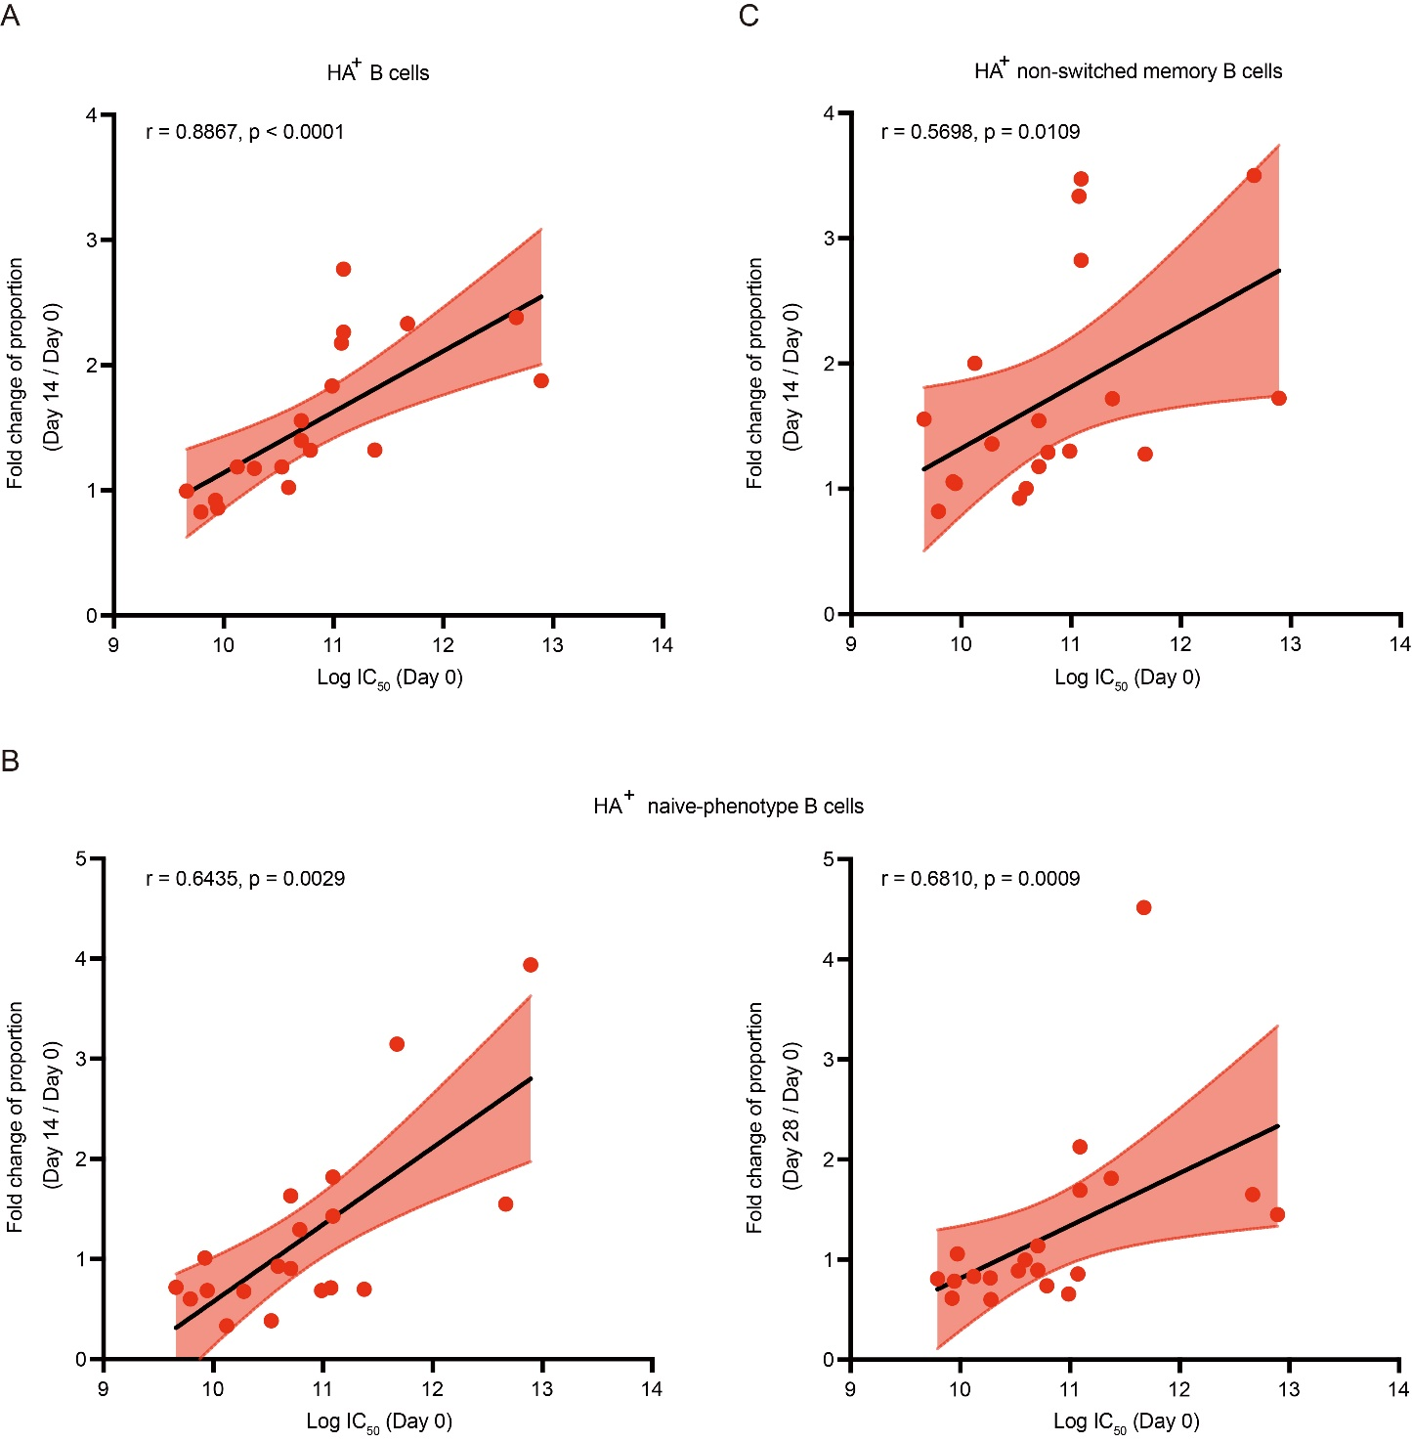
Supplementary Fig. S4. Correlation analysis between pre-existing antibody levels and fold changes of HA⁺ B cell subsets. Correlations between pre-existing antibody levels and fold changes of HA⁺ B cells (A), HA⁺CD27⁻IgD⁺ naive-phenotype B cells (B) and HA⁺ non-switched memory B cells (C).
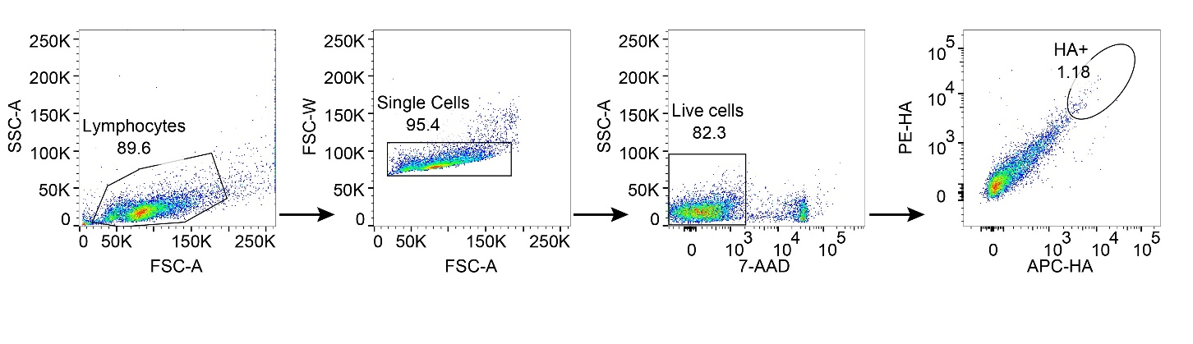

Supplementary Fig. S5. Gating strategy for sorting HA⁺ B cells for single-cell sequencing. Cells were sequentially gated as lymphocytes, singlets, viable cells, and concordant PE-HA⁺/APC-HA⁺ events after magnetic enrichment of CD19⁺ B cells.
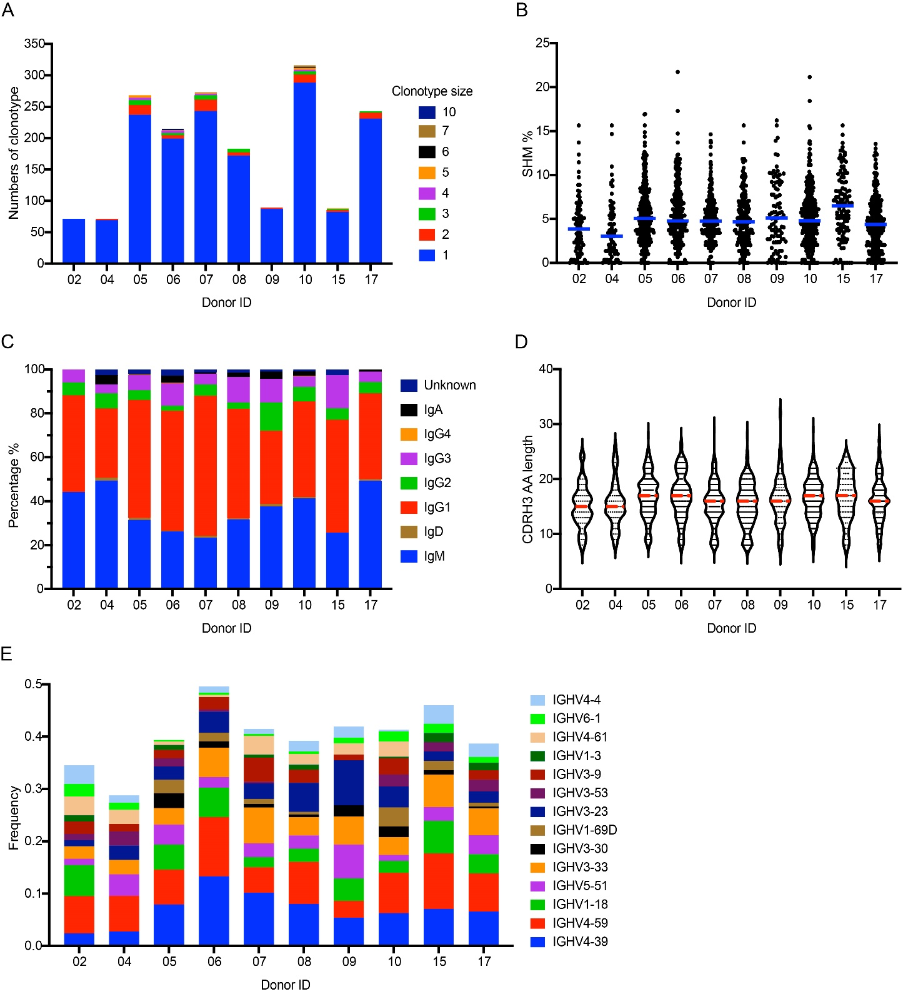
Supplementary Fig. S6. Characteristics of HA-binding BCR heavy chains identified from 10 participants. A Proportions of expanded and non-expanded B-cell clonotypes for each participant. B Somatic hypermutation rates of HA-binding BCR heavy-chain sequences. C Proportions of immunoglobulin subclasses. D CDRH3 amino-acid lengths. E Usage frequencies of selected heavy-chain V genes previously reported in cross-reactive influenza antibodies. The horizontal bars in B and D indicate median values.
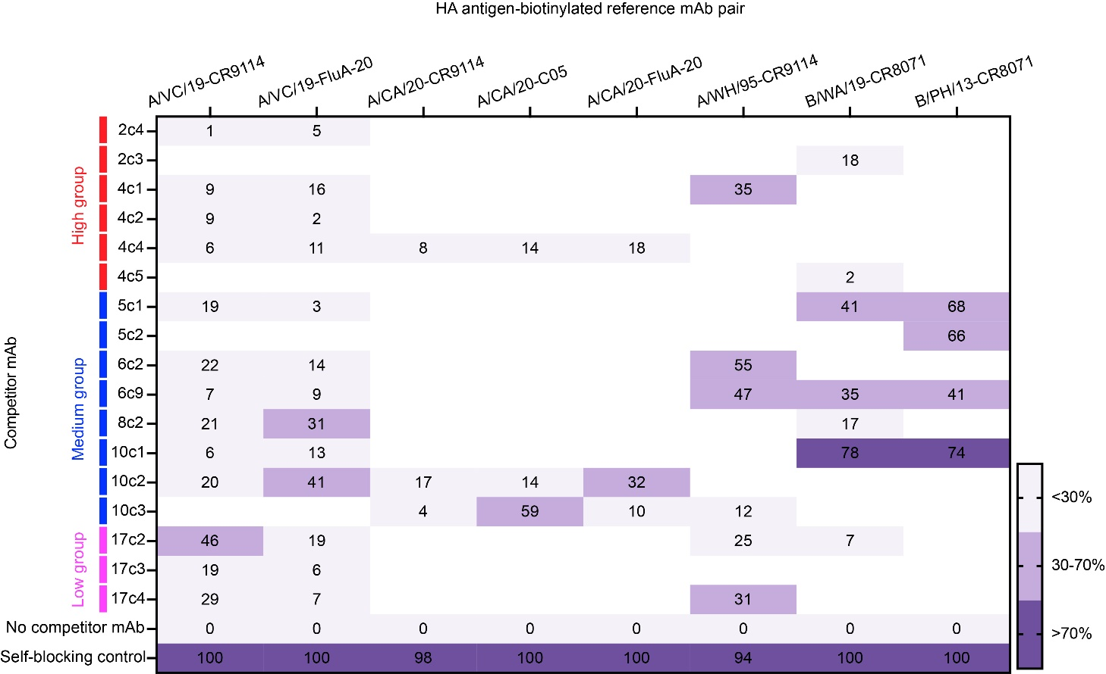
Supplementary Fig. S7. Competition-binding profiles of representative mAbs with reference mAbs. Competition-binding profiles of representative mAbs for the indicated HA antigen–reference mAb pairs. CR9114, FluA-20, C05, and CR8071 were used as reference antibodies for the HA stem, HA head trimer-interface, HA receptor-binding site, and influenza B HA head-base region, respectively. Values indicate the percentage inhibition of reference mAb binding. Blank cells indicate HA–competitor mAb combinations that were not tested because the competitor mAb did not show sufficient (EC₅₀ <10 µg/mL) binding to the corresponding HA antigen. No-competitor and self-blocking controls are shown. Competition was defined as no competition (< 30%), partial competition (30%–70%), or strong competition (> 70%). All experiments were performed in duplicate.
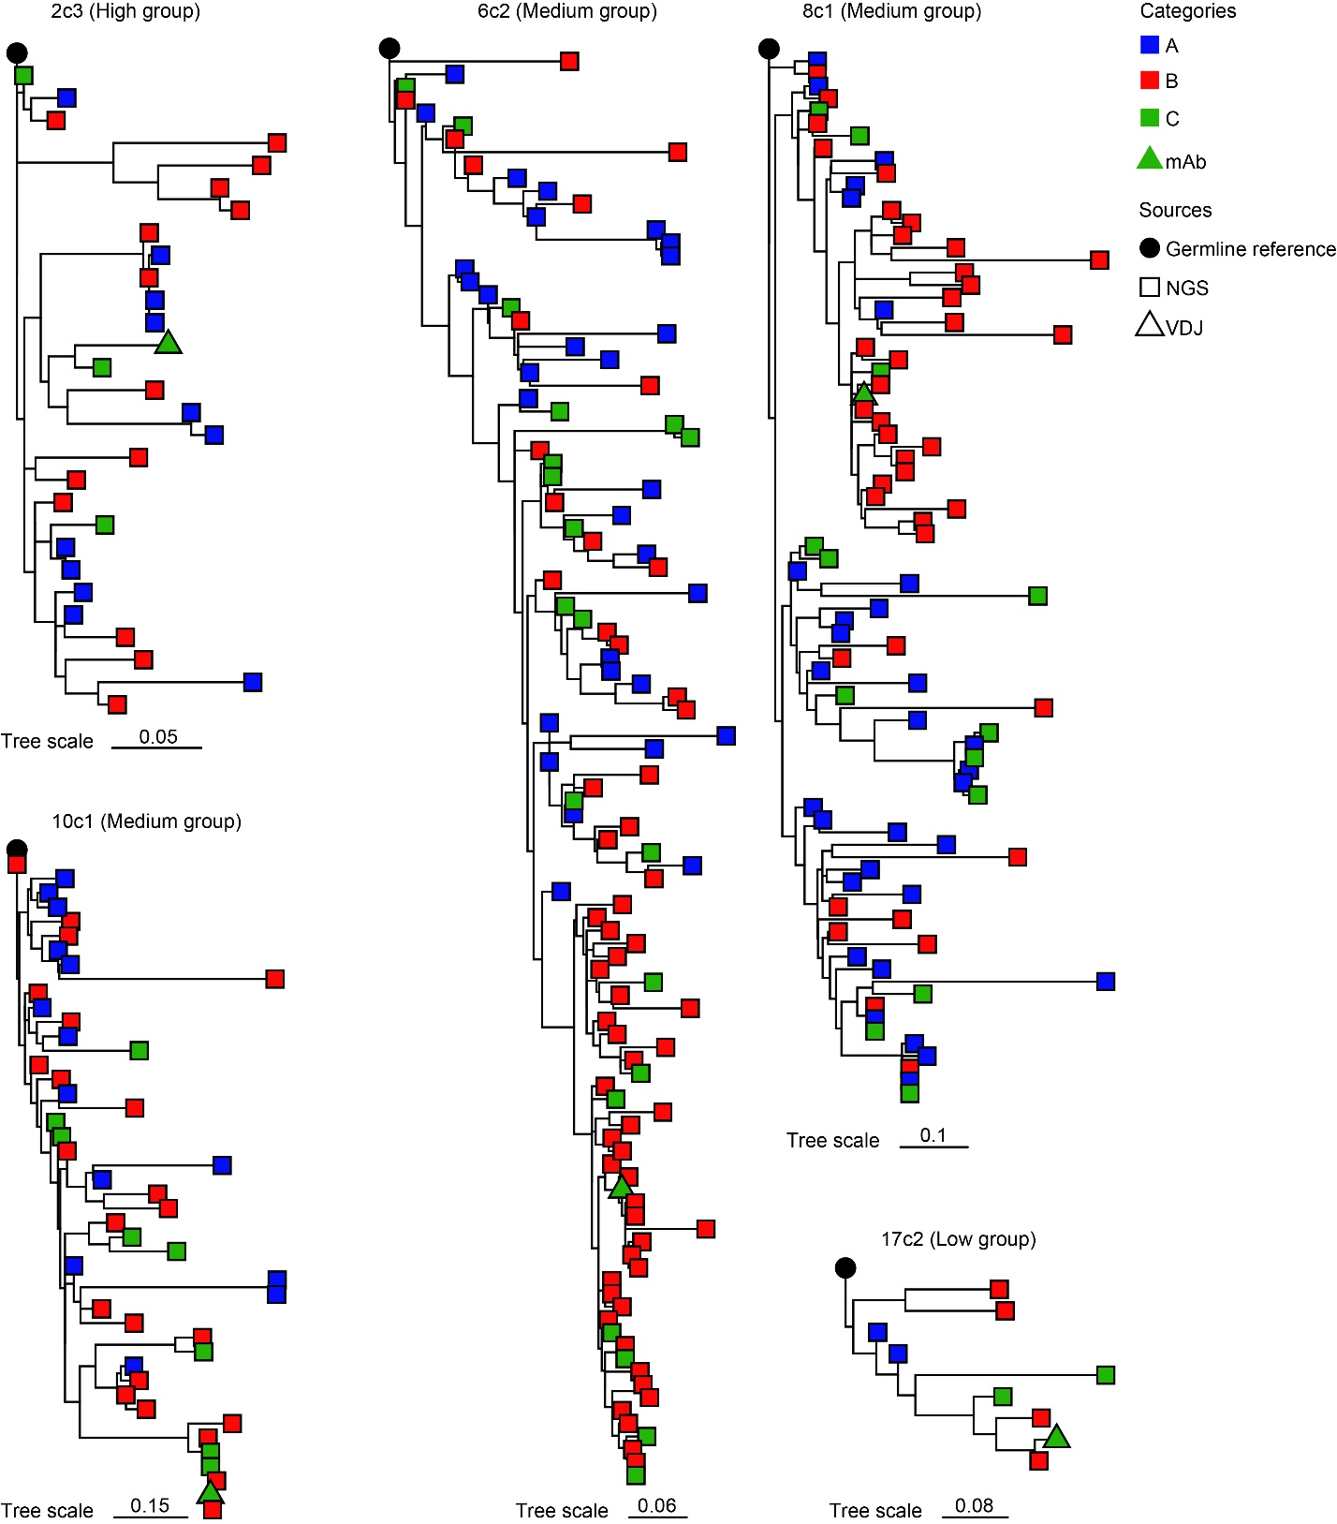
Supplementary Fig. S8. Additional maximum-likelihood phylogenetic trees evaluated during the selection of the representative lineages shown in Fig. 6B. For each mAb, longitudinal heavy-chain sequences meeting the predefined lineage-matching criteria were included. Squares indicate sequences recovered from the longitudinal NGS datasets. Open triangles indicate sequences from the single-cell V(D)J dataset, and green filled triangles indicate the expressed mAbs. Black circles represent the inferred germline reference sequences. Colors indicate sampling time points: Day 0, blue; Day 14, red; and Day 28, green.

Supplementary Table S1 | Demographic and immunological characteristics of enrolled participants.
Participant | Age | Sex | Vaccination history | Pre-vaccination neutralizing antibodies (Log IC₅₀) |  |  |  |  |  | Pre-vaccination HA-binding IgG (AUC)
 |  |  |  | A/VC/19 | A/CA/20 | B/WA/19 | B/PH/13 | Total |  | A/VC/19 | A/CA/20 | B/WA/19 | B/PH/13 | Total
1 | 28 | M | No | 4.008 | 2.434 | 2.896 | 3.555 | 12.893 |  | 0.026 | 0.030 | 0.030 | 0.032 | 0.119
2 | 30 | M | No | 3.55 | 2.647 | 2.804 | 3.664 | 12.665 |  | 0.027 | 0.026 | 0.022 | 0.025 | 0.101
3 | 24 | F | No | 2.611 | 2.754 | 2.954 | 3.356 | 11.675 |  | 0.010 | 0.026 | 0.024 | 0.024 | 0.084
4 | 22 | F | No | 3.026 | 2.35 | 2.678 | 3.322 | 11.376 |  | 0.025 | 0.022 | 0.022 | 0.024 | 0.093
5 | 53 | M | No | 3.271 | 2.388 | 2.593 | 2.839 | 11.091 |  | 0.020 | 0.015 | 0.022 | 0.024 | 0.081
6 | 26 | F | No | 3.193 | 2.264 | 2.363 | 3.271 | 11.091 |  | 0.018 | 0.018 | 0.023 | 0.024 | 0.083
7 | 24 | F | No | 3.376 | 2.586 | 1.938 | 3.171 | 11.071 |  | 0.024 | 0.024 | 0.019 | 0.021 | 0.088
8 | 26 | F | No | 2.795 | 2.692 | 2.574 | 2.927 | 10.988 |  | 0.021 | 0.022 | 0.014 | 0.018 | 0.075
9 | 35 | M | Yes | 2.961 | 2.421 | 2.593 | 2.813 | 10.788 |  | 0.019 | 0.015 | 0.020 | 0.018 | 0.071
10 | 22 | M | No | 2.573 | 2.361 | 2.653 | 3.12 | 10.707 |  | 0.019 | 0.009 | 0.015 | 0.024 | 0.067
11 | 24 | F | No | 3.095 | 2.431 | 2.017 | 3.164 | 10.707 |  | 0.012 | 0.023 | 0.019 | 0.022 | 0.076
12 | 26 | F | No | 2.447 | 2.576 | 2.357 | 3.211 | 10.591 |  | 0.016 | 0.022 | 0.022 | 0.020 | 0.080
13 | 25 | M | No | 2.931 | 2.214 | 2.165 | 3.219 | 10.529 |  | 0.016 | 0.028 | 0.020 | 0.027 | 0.091
14 | 25 | F | No | 2.737 | 2.387 | 1.939 | 3.215 | 10.278 |  | 0.017 | 0.028 | 0.020 | 0.029 | 0.094
15 | 28 | M | No | 2.72 | 1.662 | 2.629 | 3.262 | 10.273 |  | 0.019 | 0.010 | 0.019 | 0.024 | 0.072
16 | 24 | M | No | 2.269 | 2.37 | 2.511 | 2.973 | 10.123 |  | 0.016 | 0.024 | 0.022 | 0.026 | 0.089
17 | 25 | F | No | 2.427 | 2.534 | 2.264 | 2.748 | 9.973 |  | 0.021 | 0.022 | 0.024 | 0.021 | 0.088
18 | 25 | F | No | 2.373 | 2.034 | 2.589 | 2.95 | 9.946 |  | 0.019 | 0.020 | 0.013 | 0.015 | 0.067
19 | 26 | M | No | 2.171 | 2.249 | 2.632 | 2.873 | 9.925 |  | 0.012 | 0.026 | 0.016 | 0.023 | 0.077
20 | 27 | F | No | 2.345 | 2.615 | 1.754 | 3.077 | 9.791 |  | 0.013 | 0.020 | 0.019 | 0.020 | 0.072
21 | 25 | F | No | 1.999 | 2.358 | 2.225 | 3.079 | 9.661 |  | 0.018 | 0.017 | 0.018 | 0.015 | 0.067

Supplementary Table S2 | Characteristics of HA-specific mAbs selected for recombinant expression.
 |  | Maturation and expansion |  |  |  | VDJ combination
mAbs | Group | Clonotype size | SHM (%) | Cell type |  | VH | D | JH
2c1 | High-titer group | 1 | 6.42 |  |  | IGHV3-9 |  | IGHJ2
2c2 | High-titer group | 1 | 5.16 | Exhausted B cells |  | IGHV4-59 | IGHD6-19 | IGHJ5
2c3 | High-titer group | 1 | 6.04 |  |  | IGHV3-9 | IGHD5-5 | IGHJ6
2c4 | High-titer group | 1 | 3.01 |  |  | IGHV2-70 |  | IGHJ4
4c1 | High-titer group | 1 | 6.21 |  |  | IGHV4-59 |  | IGHJ5
4c2 | High-titer group | 1 | 1.37 | Switched memory B cells |  | IGHV4-34 |  | IGHJ6
4c3 | High-titer group | 2 | 4.42 |  |  | IGHV3-48 |  | IGHJ5
4c4 | High-titer group | 2 | 0.34 |  |  | IGHV3-7 |  | IGHJ6
4c5 | High-titer group | 1 | 3.64 | Non-switched memory B cells |  | IGHV3-15 |  | IGHJ4
5c1 | Medium-titer group | 4 | 6.46 |  |  | IGHV5-10-1 |  | IGHJ4
5c2 | Medium-titer group | 1 | 6.46 |  |  | IGHV5-10-1 |  | IGHJ4
5c3 | Medium-titer group | 4 | 5.42 |  |  | IGHV3-7 |  | IGHJ4
6c1 | Medium-titer group | 10 | 3.04 | Switched memory B cells |  | IGHV1-2 | IGHD1-26 | IGHJ6
6c2 | Medium-titer group | 10 | 3.04 | Switched memory B cells |  | IGHV1-2 | IGHD1-26 | IGHJ6
6c3 | Medium-titer group | 4 | 3.03 | Switched memory B cells |  | IGHV3-43 | IGHD3-16 | IGHJ4
6c4 | Medium-titer group | 4 | 3.03 |  |  | IGHV3-43 | IGHD3-16 | IGHJ4
6c5 | Medium-titer group | 4 | 3.03 |  |  | IGHV3-43 | IGHD3-16 | IGHJ4
6c6 | Medium-titer group | 4 | 6.04 | Switched memory B cells |  | IGHV4-39 | IGHD4-17 | IGHJ4
6c7 | Medium-titer group | 4 | 6.04 |  |  | IGHV4-39 | IGHD4-17 | IGHJ4
6c8 | Medium-titer group | 4 | 6.04 | Switched memory B cells |  | IGHV4-39 | IGHD4-17 | IGHJ4
6c9 | Medium-titer group | 3 | 5.75 |  |  | IGHV4-39 |  | IGHJ6
7c1 | Medium-titer group | 2 | 5.02 | Switched memory B cells |  | IGHV4-30-4 |  | IGHJ4
7c2 | Medium-titer group | 2 | 3.39 |  |  | IGHV3-33 |  | IGHJ3
8c1 | Medium-titer group | 3 | 1.35 | Switched memory B cells |  | IGHV3-48 | IGHD5-12 | IGHJ4
8c2 | Medium-titer group | 1 | 4.41 |  |  | IGHV3-23 |  | IGHJ6
9c1 | Medium-titer group | 1 | 16.22 |  |  | IGHV1-2 |  | IGHJ4
9c2 | Medium-titer group | 1 | 5.78 |  |  | IGHV3-7 |  | IGHJ3
9c3 | Medium-titer group | 1 | 2.71 |  |  | IGHV5-51 |  | IGHJ3
9c4 | Medium-titer group | 1 | 0.68 |  |  | IGHV4-34 |  | IGHJ4
9c5 | Medium-titer group | 2 | 3.05 | Non-switched memory B cells |  | IGHV1-58 |  | IGHJ6
10c1 | Medium-titer group | 5 | 9.49 | Switched memory B cells |  | IGHV3-15 |  | IGHJ6
10c2 | Medium-titer group | 2 | 5.37 |  |  | IGHV4-61 | IGHD3-3 | IGHJ4
10c3 | Medium-titer group | 1 | 12.03 |  |  | IGHV3-23 |  | IGHJ5
17c1 | Low-titer group | 2 | 5.07 |  |  | IGHV3-74 |  | IGHJ2
17c2 | Low-titer group | 1 | 4.12 |  |  | IGHV4-59 |  | IGHJ5
17c3 | Low-titer group | 2 | 4.08 |  |  | IGHV5-51 |  | IGHJ6
17c4 | Low-titer group | 2 | 0.68 |  |  | IGHV4-4 |  | IGHJ3

Supplementary Table S3 | Influenza strains for assessing plasma and monoclonal antibody potency.
Subtype | Strain | Abbreviation
H1N1 | A/Beijing/262/1995 | A/BJ/95
H1N1 | A/Brisbane/02/2018 | A/BR/18
H1N1 | A/Victoria/2570/2019 | A/VC/19
H3N2 | A/Fujian/411/2002 | A/FJ/02
H3N2 | A/Wuhan/359/1995 | A/WH/95
H3N2 | A/Guangdong-Luohu/1256/2009 | A/GD/09
H3N2 | A/Kansas/14/2017 | A/KA/17
H3N2 | A/Cambodia/e0826360/2020 | A/CA/20
H3N2 | A/Darwin/9/2021 | A/DA/21
H7N9 | A/Anhui/1/2013 | A/AH/13
H5N1 | A/Anhui/1/2005 | A/AH/05
H5N8 | A/swan/Anhui/FD1203/2020 | A/AH/20
B/Victoria | B/Hong Kong/330/2001 | B/HK/01
B/Victoria | B/Hong Kong/259/2010 | B/HK/10
B/Victoria | B/Colorado/06/2017 | B/CO/17
B/Victoria | B/Washington/02/2019 | B/WA/19
B/Victoria | B/Austria/1359417/2021 | B/AU/21
B/Yamagata | B/Harbin/7/1994 | B/HB/94
B/Yamagata | B/Jilin/20/2003 | B/JL/03
B/Yamagata | B/Phuket/3073/2013 | B/PH/13
*Vaccine component strains are underlined

