Virologica Sinica
Supplementary Materials

First insight into the virome composition of the vulnerable Naemorhedus griseus
Yu Guo ^{a, b, 1}, Meijing Hong ^{c, 1}, Xuefei Sun ^{b, d, 1}, Yuhang Liu ^{b}, Yue Sun ^{b}, Le Yi ^{b}, Biao He ^{b}, Changchun Tu ^{a, b}, Guoqiang Zhu ^{a, *}, Zhongzhong Tu ^{b, *}

ª Jiangsu Co-Innovation Center for the Prevention and Control of Important Animal Infectious Disease and Zoonoses, Yangzhou University, Yangzhou 225009, China;
^{b} Key Laboratory of Jilin Province for Zoonoses Prevention and Control, State Key Laboratory of Pathogen and Biosecurity, Academy of Military Medical Sciences, Changchun 130122, China;
^{c} Chifeng Saihanwula National Nature Reserve Administration, Daban 025150, China;
^{d} College of Veterinary Medicine, Jilin University, Changchun 130062, China;

¹ Yu Guo, Meijing Hong and Xuefei Sun contributed equally to this work

*Corresponding authors:
E-mail addresses: yzgqzhu@yzu.edu.cn (G. Zhu); tudong890901@163.com (Z. Tu)
ORCID: 0000-0002-5491-0670 (G. Zhu); 0000-0003-1079-2710 (Z. Tu)

SUPPLEMENTARY MATERIALS
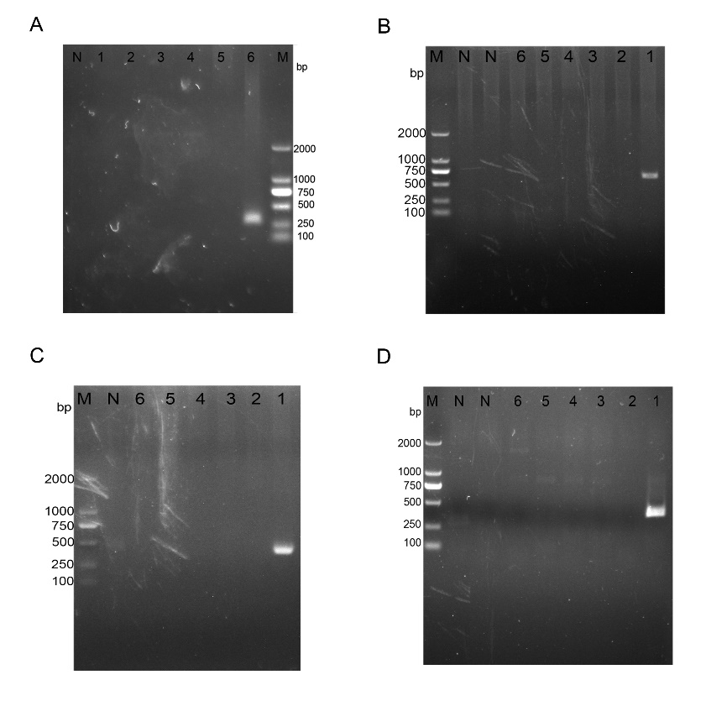
Fig. S1. Conventional PCR was performed to verify the candidate viral sequences identified. A–D represent Tusavirus 1, Sheepavirus Davis_19N, Hubei diptera virus 4, and Bovine picobirnavirus, respectively. Lanes 1–6 correspond to samples of lymph node, kidney, liver, tonsil, lung and spleen, respectively. N indicates the negative control and M represents the DL2000 DNA Marker.

Table S1 The viral species, read counts, and predicted hosts of Naemorhedus griseus borne eukaryotic viruses.
Viral species | Genus | Family | Predicted host | Spleen | Lung | Tonsil | Liver | Kidney | Lymph node
Hubei diptera virus 4 | Hudivirus | Phenuiviridae | Diptera | 0 | 60 | 74 | 0 | 0 | 8,383
Bovine picobirnavirus | Orthopicobirnavirus | Picobirnaviridae | Bovine | 0 | 0 | 90 | 0 | 0 | 791
Picobirnavirus sp. | Picobirnaviridae sp. | Picobirnaviridae | Unconfirmed | 0 | 0 | 528 | 0 | 0 | 2,437
Jaagsiekte sheep retrovirus | Betaretrovirus | Retroviridae | Sheep | 146 | 107 | 47 | 36 | 87 | 76
Enzootic nasal tumour virus of goats | Betaretrovirus | Retroviridae | Goat | 956 | 1,054 | 435 | 361 | 441 | 553
Sheepavirus Davis _19N | Chaphamaparvovirus | Parvoviridae | Sheep | 0 | 0 | 0 | 0 | 0 | 397
Tusavirus 1 | Protoparvovirus | Parvoviridae | Sheep | 20 | 0 | 0 | 0 | 0 | 0
Human associated gemykibivirus 1 | Gemycircularvirus | Genomoviridae | Human | 0 | 0 | 0 | 0 | 78 | 0
Gemycircularvirus HV-GcV1 | Gemycircularvirus | Genomoviridae | Human | 0 | 0 | 0 | 0 | 18 | 0
Finch CRESS-DNA virus | Genomoviridae sp. | Genomoviridae | Zosterops erythropleurus | 0 | 0 | 755 | 0 | 0 | 0
Gemycircularvirus sp. | Gemycircularvirus | Genomoviridae | Unconfirmed | 0 | 0 | 0 | 0 | 0 | 2,315
Tarsiger cyanurus Genomoviridae sp. | Genomoviridae sp. | Genomoviridae | Tarsiger cyanurus | 0 | 0 | 217 | 0 | 0 | 767
Alces alces faeces associated circular virus MP65 | Genomoviridae sp. | Genomoviridae | Alces alces | 0 | 0 | 0 | 17,256 | 0 | 0
Bat associated genomovirus | Genomoviridae sp. | Genomoviridae | Bat | 0 | 0 | 0 | 0 | 0 | 1,685
Genomoviridae sp. | Genomoviridae sp. | Genomoviridae | Unconfirmed | 919 | 0 | 67,176 | 8,575 | 0 | 3,563
Porprismacovirus sp. | Porprismacovirus | Smacoviridae | Unconfirmed | 0 | 321 | 20,399 | 1,356 | 0 | 16,658
Human smacovirus 1 | Smacoviridae sp. | Smacoviridae | Human | 0 | 78 | 4,664 | 308 | 0 | 3,319
Smacoviridae sp. | Smacoviridae sp. | Smacoviridae | Unconfirmed | 0 | 0 | 0 | 0 | 0 | 2,615
Human associated porprismacovirus | Porprismacovirus | Smacoviridae | Human | 0 | 205 | 15,735 | 1,048 | 0 | 11,413

Table S2 Primers used to detect the viruses and amplify the complete genome in this study.
Primer | Sequence (5′–3′) | Location
TusV Q1F | CCTGTCTAAAAAAGGCAAA | 2–20
TusV Q2F | GTGCAAGCGCTGCTATAGGT | 80–99
TusV Q1R: | TGAATKCGAGCAGCTGTGCT | 765–746
TusV Q2R | CTCTTTCTATCTTGAGCAGT | 1062–1043
TusV Q3F | CAATCCAGCTAATGTGAACT | 1501–1520
TusV Q4F | CTAGACCCATACTGGAACTT | 2364–2383
TusV Q3R | TCCAGTGTCCTAGTCTCCCT | 2457–2438
TusV Q4R | TTCCTGCCAGTGTAGGTTCT | 2514–2495
TusV Q5R | TGTGTTGCCAGTCATGTGGT | 2994–2975
TusV Q6F | CAGATACATGCCCAACACAT | 3932–3951
TusV Q7F | CATGGNCAAATATGGGACAA | 3996–4015
TusV Q8R | GGTTGCYTTATAGAAAAGAGT | 4420–4401
ShVD wF | GCACACAGACCAGCATCTCT | 996–1015
ShVD wR | AATCGCYGGGTCTGTTATCC | 2250–2231
ShVD nF | TTGTACAACACCTGCACCGA | 1273–1292
ShVD nR | TACTGTGGTTGCCATGCCTT | 1709–1690
HDV-L wF | AGTCAAGGTTTCCTGCTCCG | 303–322
HDV-L wR | GCTCAGTAGCAACCCACTGT | 1439–1420
HDV-L nF | GGACTTGACCCCAGAAGAGC | 766–785
HDV-L nR | AGGCAGTCAGAGTTGCATCC | 1187–1168
PBV-L wF | CATTAAGTACATGATTCCACT | 943–963
PBV-L wR | CCTTGGCAATGTTGTCAATAT | 1520–1500
PBV-L nF | GTATGGGAAGTGGTTCYGGT | 1002–1021
PBV-L nR | AGAGGATGATACTTCACATT | 1422–1403

