Virologica Sinica
Supplementary Materials

Blood and gut virome remodeling in gastric cancer: Anellovirus expansion and novel virus discovery

Yi Zhou ^{a, 1}, Qing Guo ^{a, 1}, Xingyue Zhao ^{b, c, 1}, Wei Zhang ª, Han Zhang ^{d}, Shiyin Huang ^{d}, Zihan He ^{b}, Youhua Xie ^{b}, Wen Zhang ^{d}, Jinhua Gu ^{a, *}, Shaokun Pan ^{b, *}, Wang Li ^{a, b, d, *}

ª The Affiliated Taizhou People’s Hospital of Nanjing Medical University, Taizhou 225300, China;
^{b} Shanghai Institute of Infectious Diseases and Biosecurity, Key Laboratory of Medical Molecular Virology (MOE/NHC/CAMS), Shanghai Frontiers Science Center of Pathogenic Microbes and Infection, Department of Microbiology and Parasitology, School of Basic Medical Sciences, Shanghai Medical College, Fudan University, Shanghai 20032, China
^{c} Clinical College of Anhui Medical University, Hefei 230031, China;
^{d} Department of Laboratory Medicine, School of Medicine, Jiangsu University, Zhenjiang 212013, China;

¹ Yi Zhou, Qing Guo, and Xingyue Zhao contributed equally to this work.

*Corresponding authors:
Email addresses: liwang20091221@126.com (W. Li); skpan@fudan.edu.cn (S. Pan); tzsrmyy@126.com (J. Gu)
ORCID: 0000-0003-4280-646X (W. Li); 0000-0002-7607-700X (S. Pan); 0009-0006-7817-2373 (J. Gu)

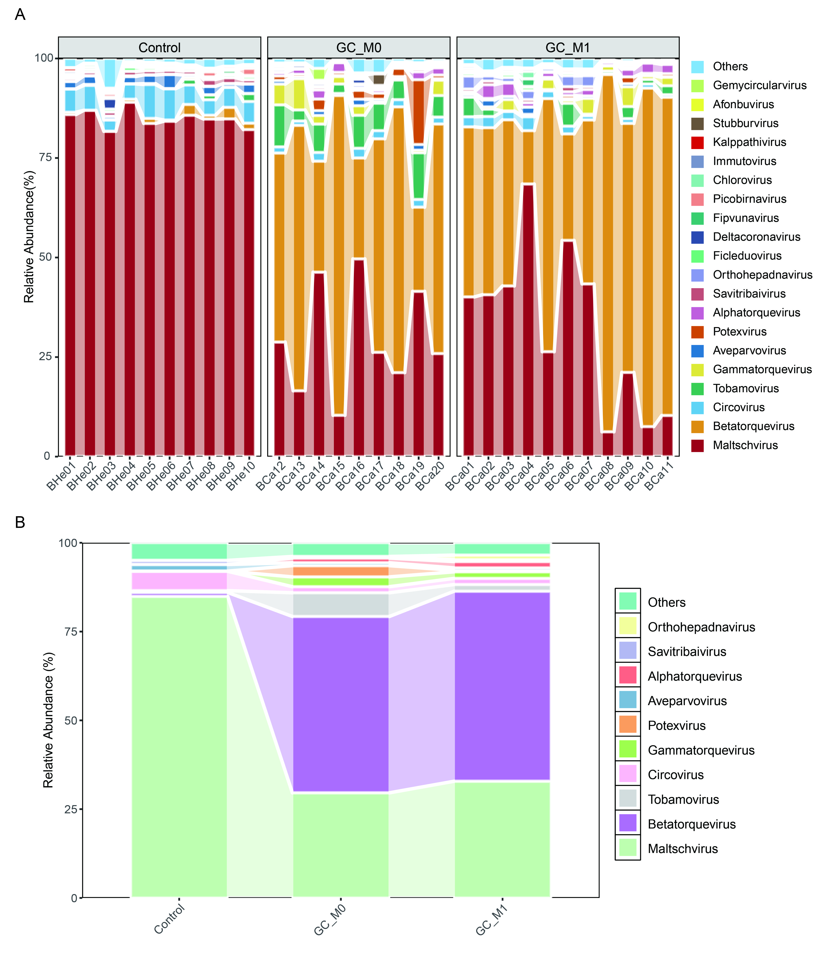
Supplementary Fig. S1. Blood virome composition at the genus level. A Stacked bar chart showing relative abundances of the 20 most prevalent viral genera per pooled library. B Comparison of the same genera among healthy control, M0, and M1 groups.
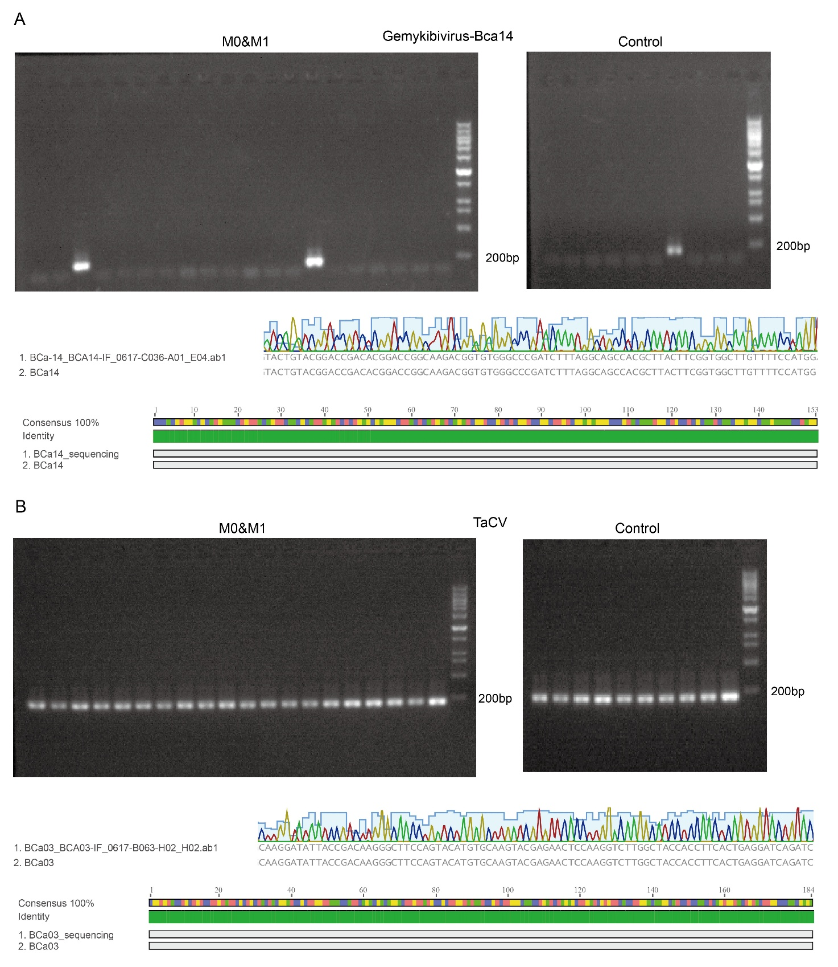
Supplementary Fig. S2. Screening of CRESS-DNA viruses. A Detection and validation of gemykibivirus in tumor and control libraries. Upper panel: PCR product electrophoresis showing the target bands; lower panel: Sanger sequencing chromatograms and the sequence identity comparison with the assembled viral genomes. B Screening and sequence confirmation of TaCV in tumor and control libraries. Upper panel: gel electrophoresis detection of specific PCR amplicons; lower panel: sequencing validation of representative amplicons and their sequence identity analysis with the assembled metagenomic viral genomes.

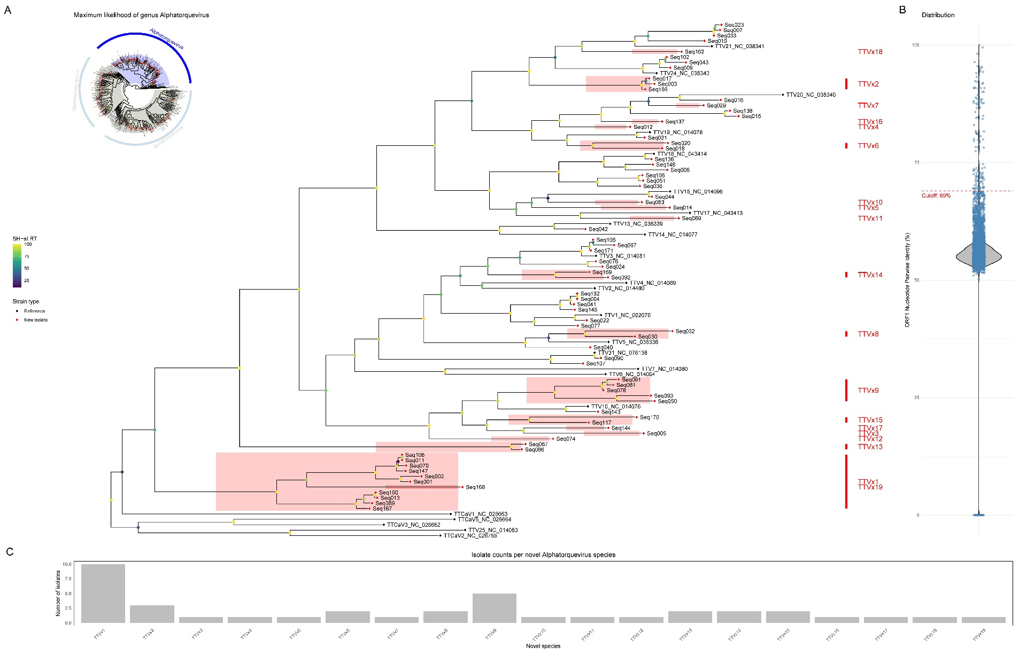
Supplementary Fig. S3. Maximum-likelihood phylogeny and species delimitation within genus Alphatorquevirus (subset of Fig. 8). A Phylogeny inferred with IQ-TREE v2 under the LG+F+G4 model. Node support was assessed with 1,000 SH-aLRT replicates; branch labels show SH-aLRT support (%) on an emerald color scale. The tree includes representative reference sequences and all newly identified alphatorquevirus isolates (n = 73, including Seq001; details in Supplementary Table S7). Tip symbols denote source: black asterisks = reference; red asterisks = new isolate. Colored box labels (TTVx1–TTVx19) indicate provisional novel species defined by ORF1 pairwise nucleotide-identity clustering (within-group ≥69% and <69% to all others). B Violin plots with jittered points showing pairwise ORF1 nucleotide-identity values (computed with SDT v1.2) between each newly identified isolate and representative reference sequences within Alphatorquevirus. (If shown, the dashed line marks the 69% species demarcation threshold.). C Bar charts summarizing, for Alphatorquevirus, each newly defined species (TTVx1–TTVx19) and the corresponding number of isolates assigned to it.

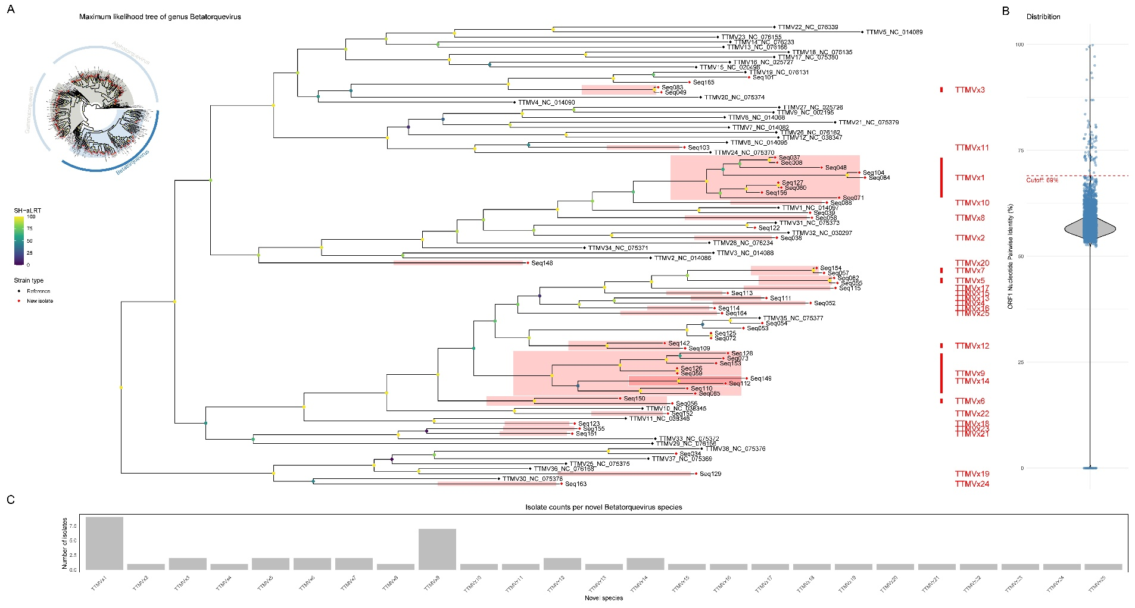
Supplementary Fig. S4. Maximum-likelihood phylogeny and species delimitation within genus Betatorquevirus (subset of Fig. 8). A Phylogeny inferred with IQ-TREE v2 under the LG+F+G4 model. Node support was assessed with 1,000 SH-aLRT replicates; branch labels show SH-aLRT support (%) on an emerald color scale. The tree includes representative reference sequences and all newly identified betatorquevirus isolates (n = 54, including Seq008; details in Supplementary Table S7). Tip symbols denote source: black asterisks = reference; red asterisks = new isolate. Colored box labels (TTMVx1–TTMVx25) indicate provisional novel species defined by ORF1 pairwise nucleotide-identity clustering (within-group ≥69% and <69% to all others). B Violin plots with jittered points showing pairwise ORF1 nucleotide-identity values (computed with SDT v1.2) between each newly identified isolate and representative reference sequences within Betatorquevirus. (If shown, the dashed line marks the 69% species demarcation threshold.). C Bar charts summarizing, for Betatorquevirus, each newly defined species (TTMVx1–TTMVx25) and the corresponding number of isolates assigned to it.
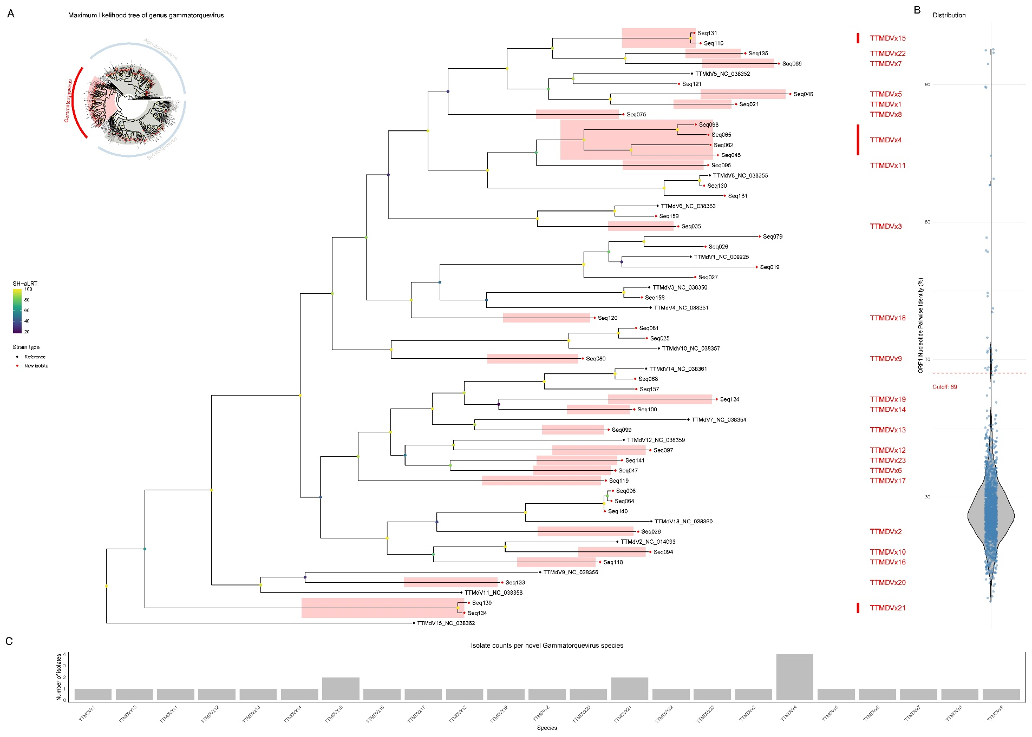
Supplementary Fig. S5. Maximum-likelihood phylogeny and species delimitation within genus Gammatorquevirus (subset of Fig. 8). A Phylogeny inferred with IQ-TREE v2 under the LG+F+G4 model. Node support was assessed with 1,000 SH-aLRT replicates; branch labels show SH-aLRT support (%) on an emerald color scale. The tree includes representative reference sequences and all newly identified gammatorquevirus isolates (n = 44, including Seq021; details in Supplementary Table S7). Tip symbols denote source: black asterisks = reference; red asterisks = new isolate. Colored box labels (TTMDVx1–TTMDVx23) indicate provisional novel species defined by ORF1 pairwise nucleotide-identity clustering (within-group ≥69% and <69% to all others). B Violin plots with jittered points showing pairwise ORF1 nucleotide-identity values (computed with SDT v1.2) between each newly identified isolate and representative reference sequences within Gammatorquevirus. (If shown, the dashed line marks the 69% species demarcation threshold.). C Bar charts summarizing, for Gammatorquevirus, each newly defined species (TTMDVx1–TTMDVx23) and the corresponding number of isolates assigned to it.

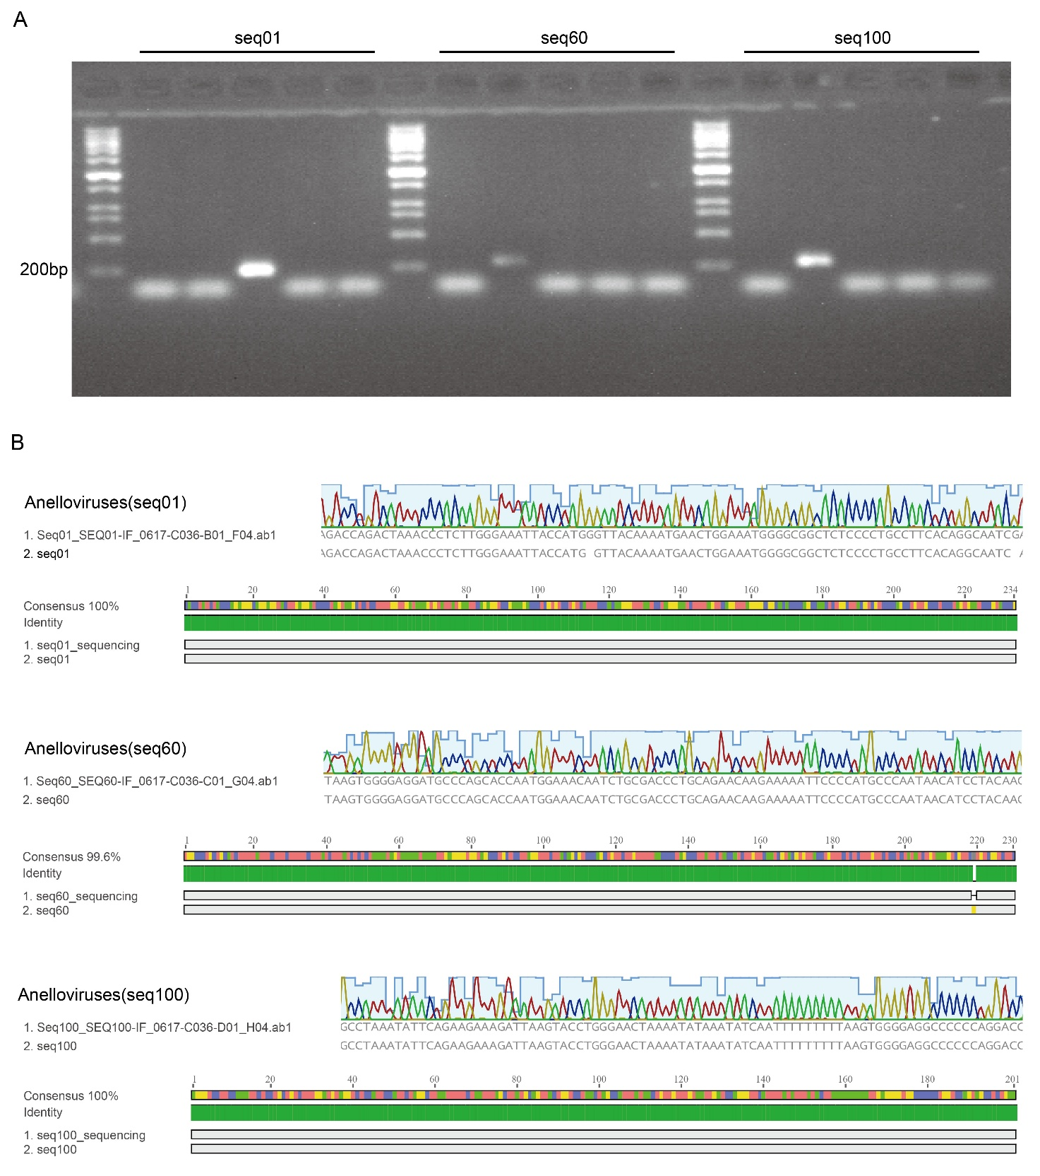
Supplementary Fig. S6. Screening and validation of anelloviruses. A PCR detection of three representative anellovirus strains in individual samples derived from their corresponding pooled libraries, shown as agarose gel electrophoresis images. B Sanger sequencing chromatograms of the three specific amplicons and sequence identity comparison with their respective assembled viral genomes.

Supplementary Tables
Supplementary Table S1. Sequencing raw data statistics
(Excel file)
Supplementary Table S2. Viral read counts at the taxonomic family level in blood and fecal samples
(Excel file)
Supplementary Table S3. Viral read counts at the taxonomic genus level in blood and fecal samples
(Excel file)
Supplementary Table S4. Viral read counts at the taxonomic species level in blood and fecal samples
(Excel file)
Supplementary Table S5. Viral read counts in blood samples, stratified by taxonomic level, for LEfSe (LDA Effect Size) analysis
(Excel file)
Supplementary Table S6. Viral read counts in fecal samples, stratified by taxonomic level, for LEfSe (LDA Effect Size) analysis
(Excel file)
Supplementary Table S7. Human anellovirus sequences—novel species calls and GenBank accessions
(Excel file)
Supplementary Table S8. Primers for candidate novel viruses
(Excel file)
Supplementary Table S9. Accession numbers for raw data
(Excel file)

