Virologica Sinica
Supplementary Materials

RNF152 regulates prototype foamy virus replication by targeting Gag polyubiquitination and VLPs production

Lin Jiang, Xinhong Tian, Keran Ma, Wentao Qiao*, Juan Tan*
Key Laboratory of Molecular Microbiology and Technology, Ministry of Education, College of Life Sciences, Nankai University, Tianjin 300071, China

* Corresponding author.
E-mail address: juantan@nankai.edu.cn (J. Tan), wentaoqiao@nankai.edu.cn(W.Qiao).
OCRID: https://orcid.org/0000-0003-0449-694X, https://orcid.org/0000-0002-0260-3281.

Supplementary Material
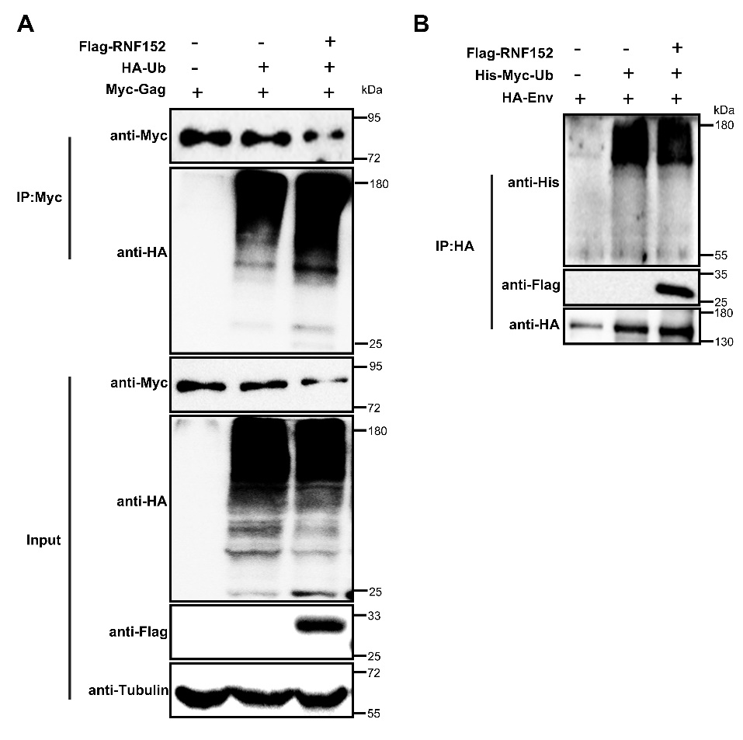
Fig. S1. RNF152 affects the ubiquitination levels of Gag but not Env. A Myc-Gag, HA-Ub and Flag-RNF152 or control vector were co-transfected into HEK293T cells respectively. After 48 h, the IP assays were performed with anti-Myc antibody. B HEK293T cells were transfected with Flag-RNF152, His-Myc-Ub and HA-Env. After 48 h, the IP assays were performed with anti-HA antibody.
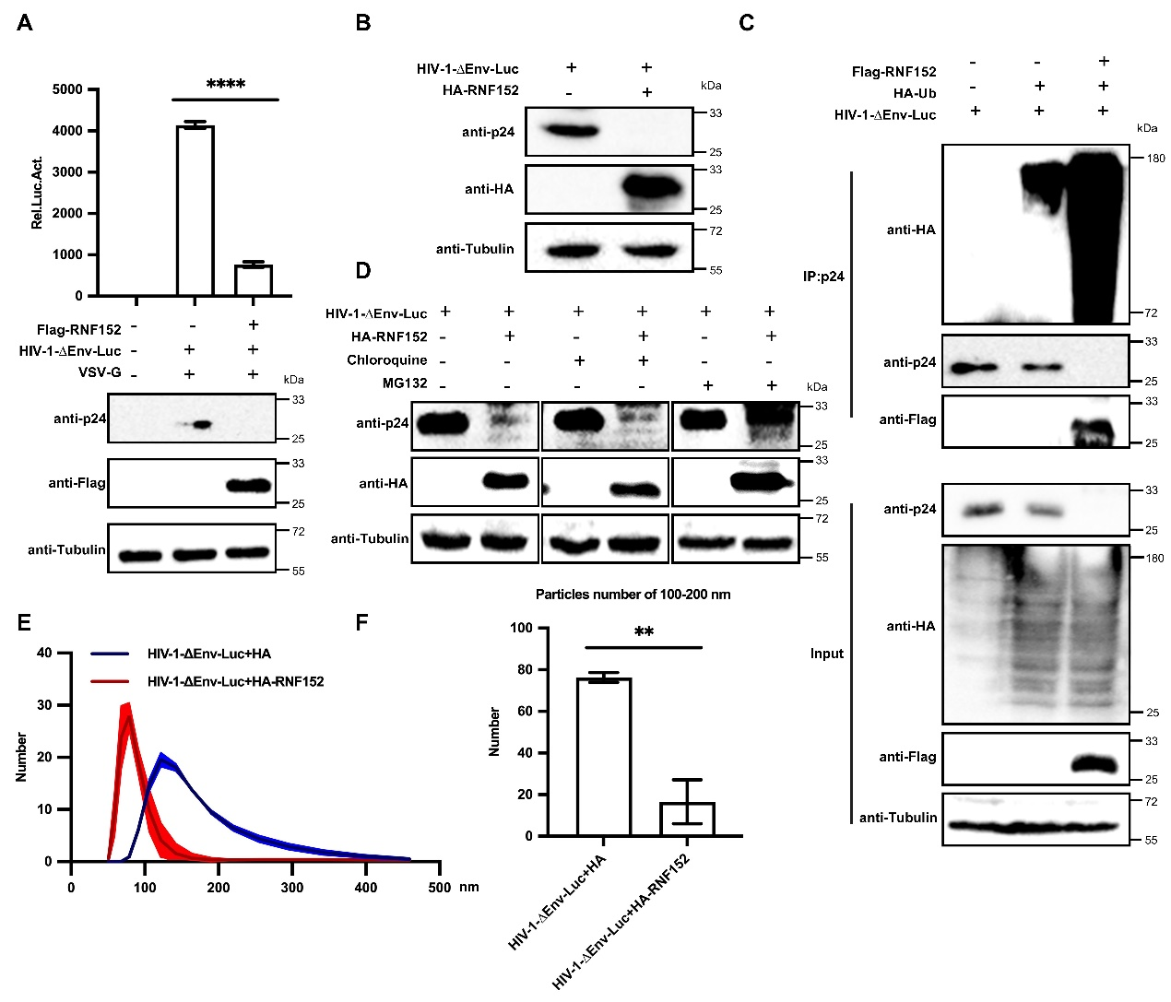
Fig. S2. Inhibition of HIV-1 replication by RNF152. A HEK293T cells were transfected with HIV-1-∆Env-Luc and Flag-RNF152. Following a 48 h incubation, the protein levels in a portion of the cell lysates were assessed using western blotting. The remaining transfected HEK293T cells were then evaluated for luciferase activity. B HEK293T cells were transfected with HIV-1-∆Env-Luc and HA-RNF152 or control vector, respectively. The level of intracellular protein expression was detected at 48 h post-transfection. C HA-Ub and Flag-RNF152 plasmids were co-transfected with HIV-1-∆Env-Luc into HEK293T cells for 48 h. Then, lysates were incubated with indicated anti-p24 antibody and detected using co-IP. D HEK293T cells were co-transfected with HIV-1-∆Env-Luc and HA-RNF152 or control vector. At 24 h post-transfection, the cells were treated with DMSO, MG132 (20 µM), or chloroquine (100 µM). After 48 h post-transfection, the levels of proteins in cells were measured using western blotting. E HEK293T cells were transfected with HIV-1-∆Env-Luc, HA-RNF152 or vector constructs. After 48 h, the cell culture supernatants were filtered through a 0.45 µm filter and purified by ultracentrifugation. Then the numbers of purified VLPs were analyzed with a Zetasizer (Malvern). F Count the number of purified VLPs with sizes ranging from 100-200 nm in the (E). (**P < 0.01 and ****P < 0.0001).

Supplementary Table 1. Primers used in this study
Application | Primer | Sequence (5′–3′)
Expression | RNF152-HA-FW | CCGGAATTCATGGAGACGCTGTCCCAG
 | RNF152-HA-RW | CCGCTCGAGGAGCCACAGGATATCACAGTGAA
 | RNF152-M-HA-FW | CCGGAATTCCGCGGTGTCACCAAGCTG
 | RNF152-M-HA-RW  RNF152-R-HA-RW  RNF152-TM-HA-FW | CCGCTCGAGGAGGAGCTTTTCACCACGCC  CCGCTCGAGGAGCACCAGGGGCACCGCAC  CCGGAATTCACCTGGTCGGGGGTGTGC
 | Gag-Myr-FW | AGCAAGCCTAAGGACTATGAACTTGATGTTGAAGCT
 | Gag-Myr-RW | CTTCGATGAGCCCATGAATTCCTGCAGCCCGGGGGA
 | Gag-Flag-P-FW | CCGGAATTCCACAGGGCAAGGAGGAATA
 | Gag-Flag-GR-RW | CCCAAGCTTTTAGTCCCTTTGATCTCC
 | Gag-K396R-FW | GGAAATGTAATAAGAGGCATAGTTGATCAAGAAGGAG
 | Gag-K396R-RW | CTCCTTCTTGATCAACTATGCCTCTTATTACATTTCC
shRNA | shRNF152-1-F | GATCCGGCCCAAGTTGCTGGACTGCAATTCAAGAGATTGCAGTCCAGCAACTTGGGCCTTTTTTACGCGTG
 | shRNF152-1-R | AATTCACGCGTAAAAAAGGCCCAAGTTGCTGGACTGCAATCTCTTGAATTGCAGTCCAGCAACTTGGGCCG
 | shRNF152-2-F | GATCCGCTTCACAACATGTCTTGCATTTTCAAGAGAAATGCAAGACATGTTGTGAAGCTTTTTTACGCGTG
 | shRNF152-2-R | AATTCACGCGTAAAAAAGCTTCACAACATGTCTTGCATTTCTCTTGAAAATGCAAGACATGTTGTGAAGCG
Real-time PCR | q-GAPDH-F | AACAGCGACACCCACTCCTC
 | q-GAPDH-R | CATACCAGGAAATGAGCTTGACAA
 | q-RNF152-FW | AGATGAGGACCAGCCAGAAGGA
 | q-RNF152-RW | GAAGTGTGTGGAATGGCGATGAC

