Virologica Sinica
Supplementary materials

A HiBiT-Tagged Influenza A Virus Reporter System Reveals Cytokine-Inhibitory Micropeptide 53 as a Modulator of Viral Infection and Immunopathology

Shujie Ma^{a,c,d,1,*}, Sha Liu^{a,c,d,1}, Conghui Zhao^{a,c,d,1}, Wenjun Shi^{b}, Chunping Zhang^{a,c,d}, Jiacheng Huang^{a,c,d}, Yang Wang^{a,c,d}, Xiaoxuan Zhang^{a,c,d}, Haoxi Qiang^{a,c,d}, Huanhuan Wang^{a,c,d}, Peilin Li^{a,c,d}, Xinhui Chen^{a,c,d}, Ziyi Zhang^{a,c,d}

ªJoint Laboratory of Animal Pathogen Prevention and Control of Fujian-Nepal, College of Animal Sciences, Fujian Agriculture and Forestry University, Fuzhou 350002, China;
^{b}Animal Quarantine Laboratory, Technology Center of Qingdao Customs, Qingdao 266000, China;
^{c}Key Laboratory of Animal Pathogen Infection and Immunology of Fujian Province, College of Animal Sciences, Fujian Agriculture and Forestry University, Fuzhou 350002, China
^{d}Key Laboratory of Fujian-Taiwan Animal Pathogen Biology, College of Animal Sciences, Fujian Agriculture and Forestry University, Fuzhou 350002, China
¹Shujie Ma, Sha Liu and Conghui Zhao contributed equally to this work.

*Correspondence Author.
E-mai address: mashujie@fafu.edu.cn (S. Ma).
https://orcid.org/0009-0002-3087-6356

SUPPLEMENTARY FIGURE
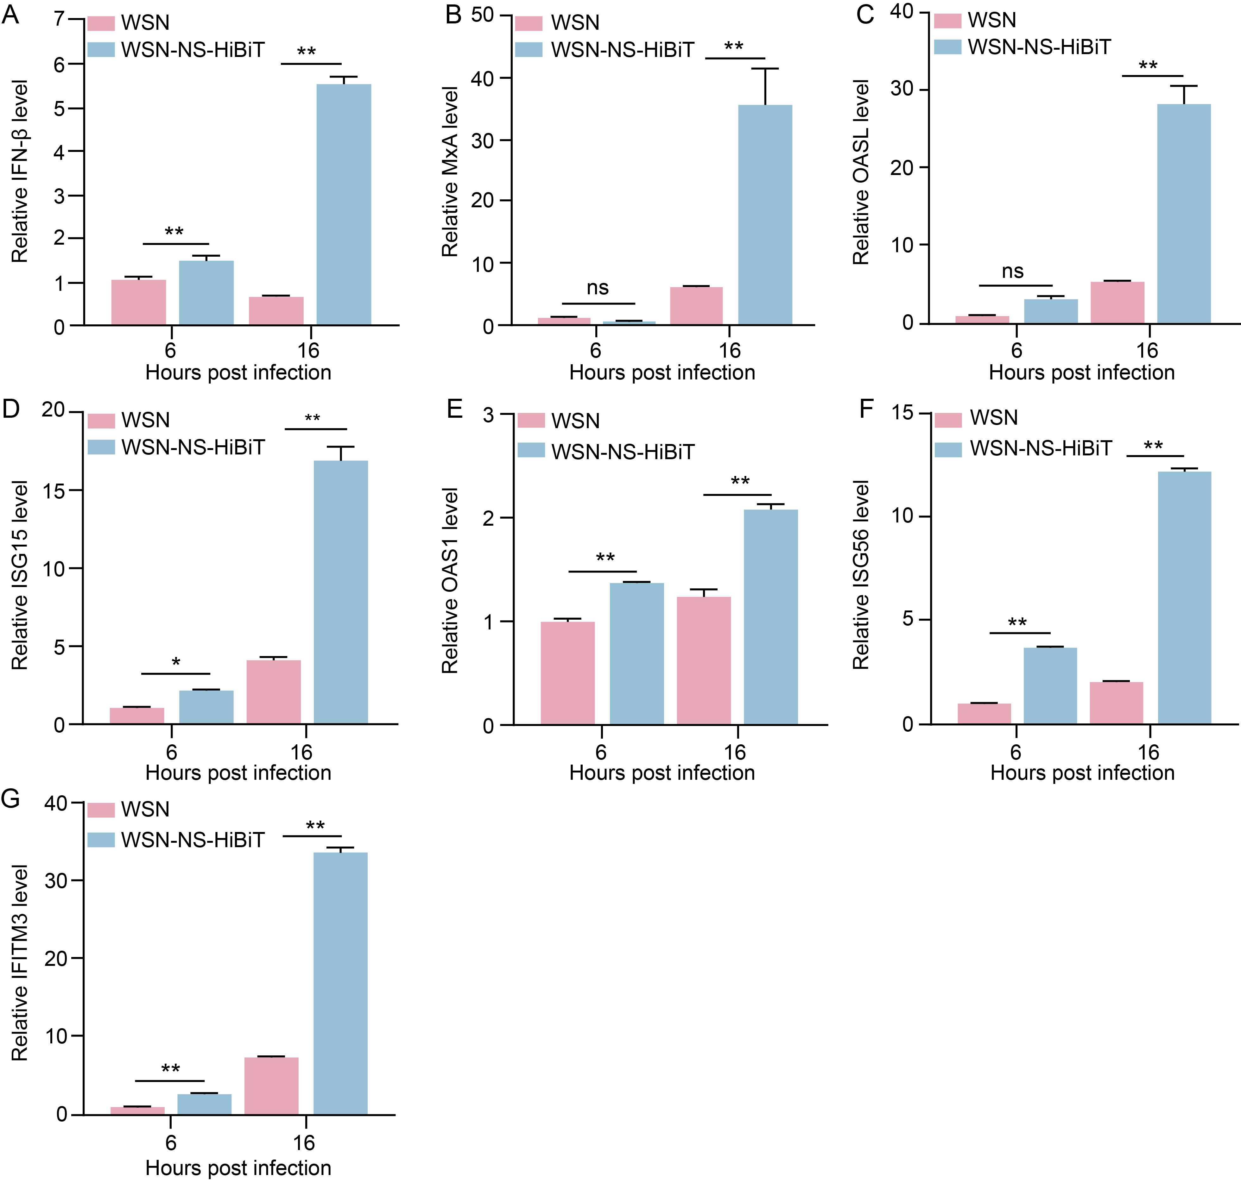
Fig. S1 The modified NS1 impairs virus replication by compromising the interferon response. A549 cells were infected with WSN and WSN-NS-HiBiT viruses (MOI = 0.1). Total RNA was extracted from the cells at 6 hpi and 16 hpi, and the expression levels of (A) IFN-β, (B) MxA, (C) OASL, (D) ISG15, (E) OAS1, (F) ISG56, and (G) IFITM3 were determined by using qPCR. Data are presented as means ± SD in A−G (n = 3). Statistical analysis was performed by using one-way analysis of variance (ANOVA). When one-way ANOVA was warranted, post hoc analysis was performed using Tukey test for multiple comparisons. ** P < 0.01; ns, not significant.
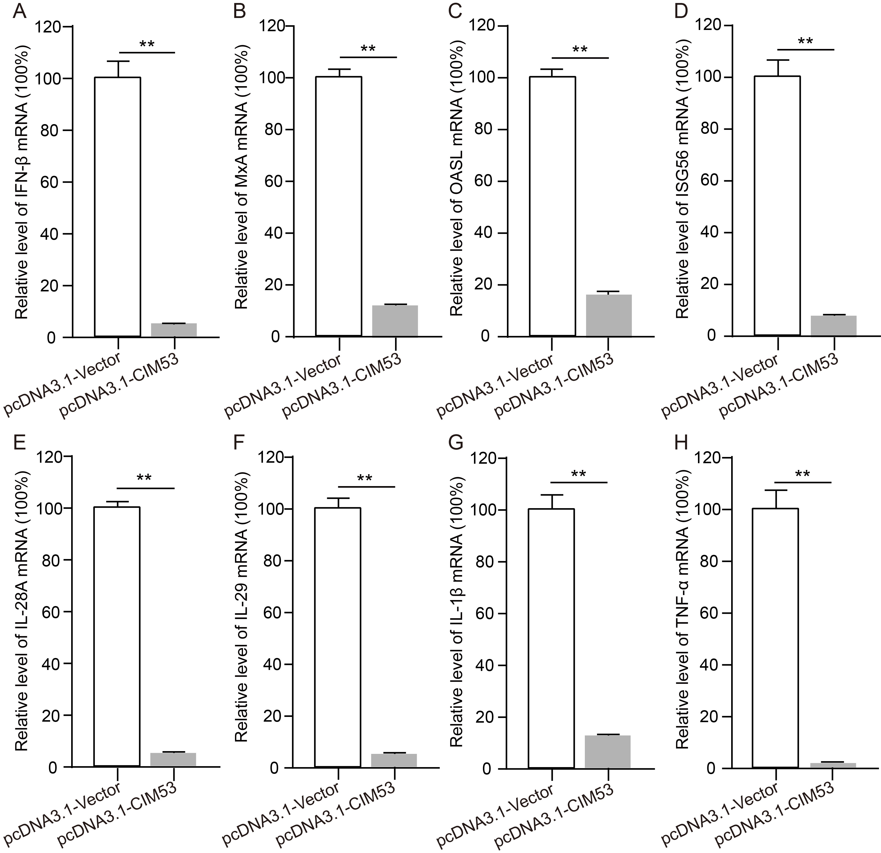
Fig. S2 CIM53 suppresses poly(I:C)-induced cytokine expression in A549 cells. A549 cells were transfected with pcDNA3.1-Vector or pcDNA3.1-CIM53. At 36 h post-transfection, cells were stimulated with poly(I:C), and total RNA was collected at 12 h post-stimulation for qPCR analysis. The mRNA levels of (A) IFN-β, (B) MxA, (C) OASL, (D) ISG56, (E) IL-28A, (F) IL-29, (G) IL-1β, and (H) TNF-α were measured. Data are presented as means ± SD in A-H (n = 3). Statistical analysis was performed by using the one-tailed unpaired t test. ** P < 0.01.
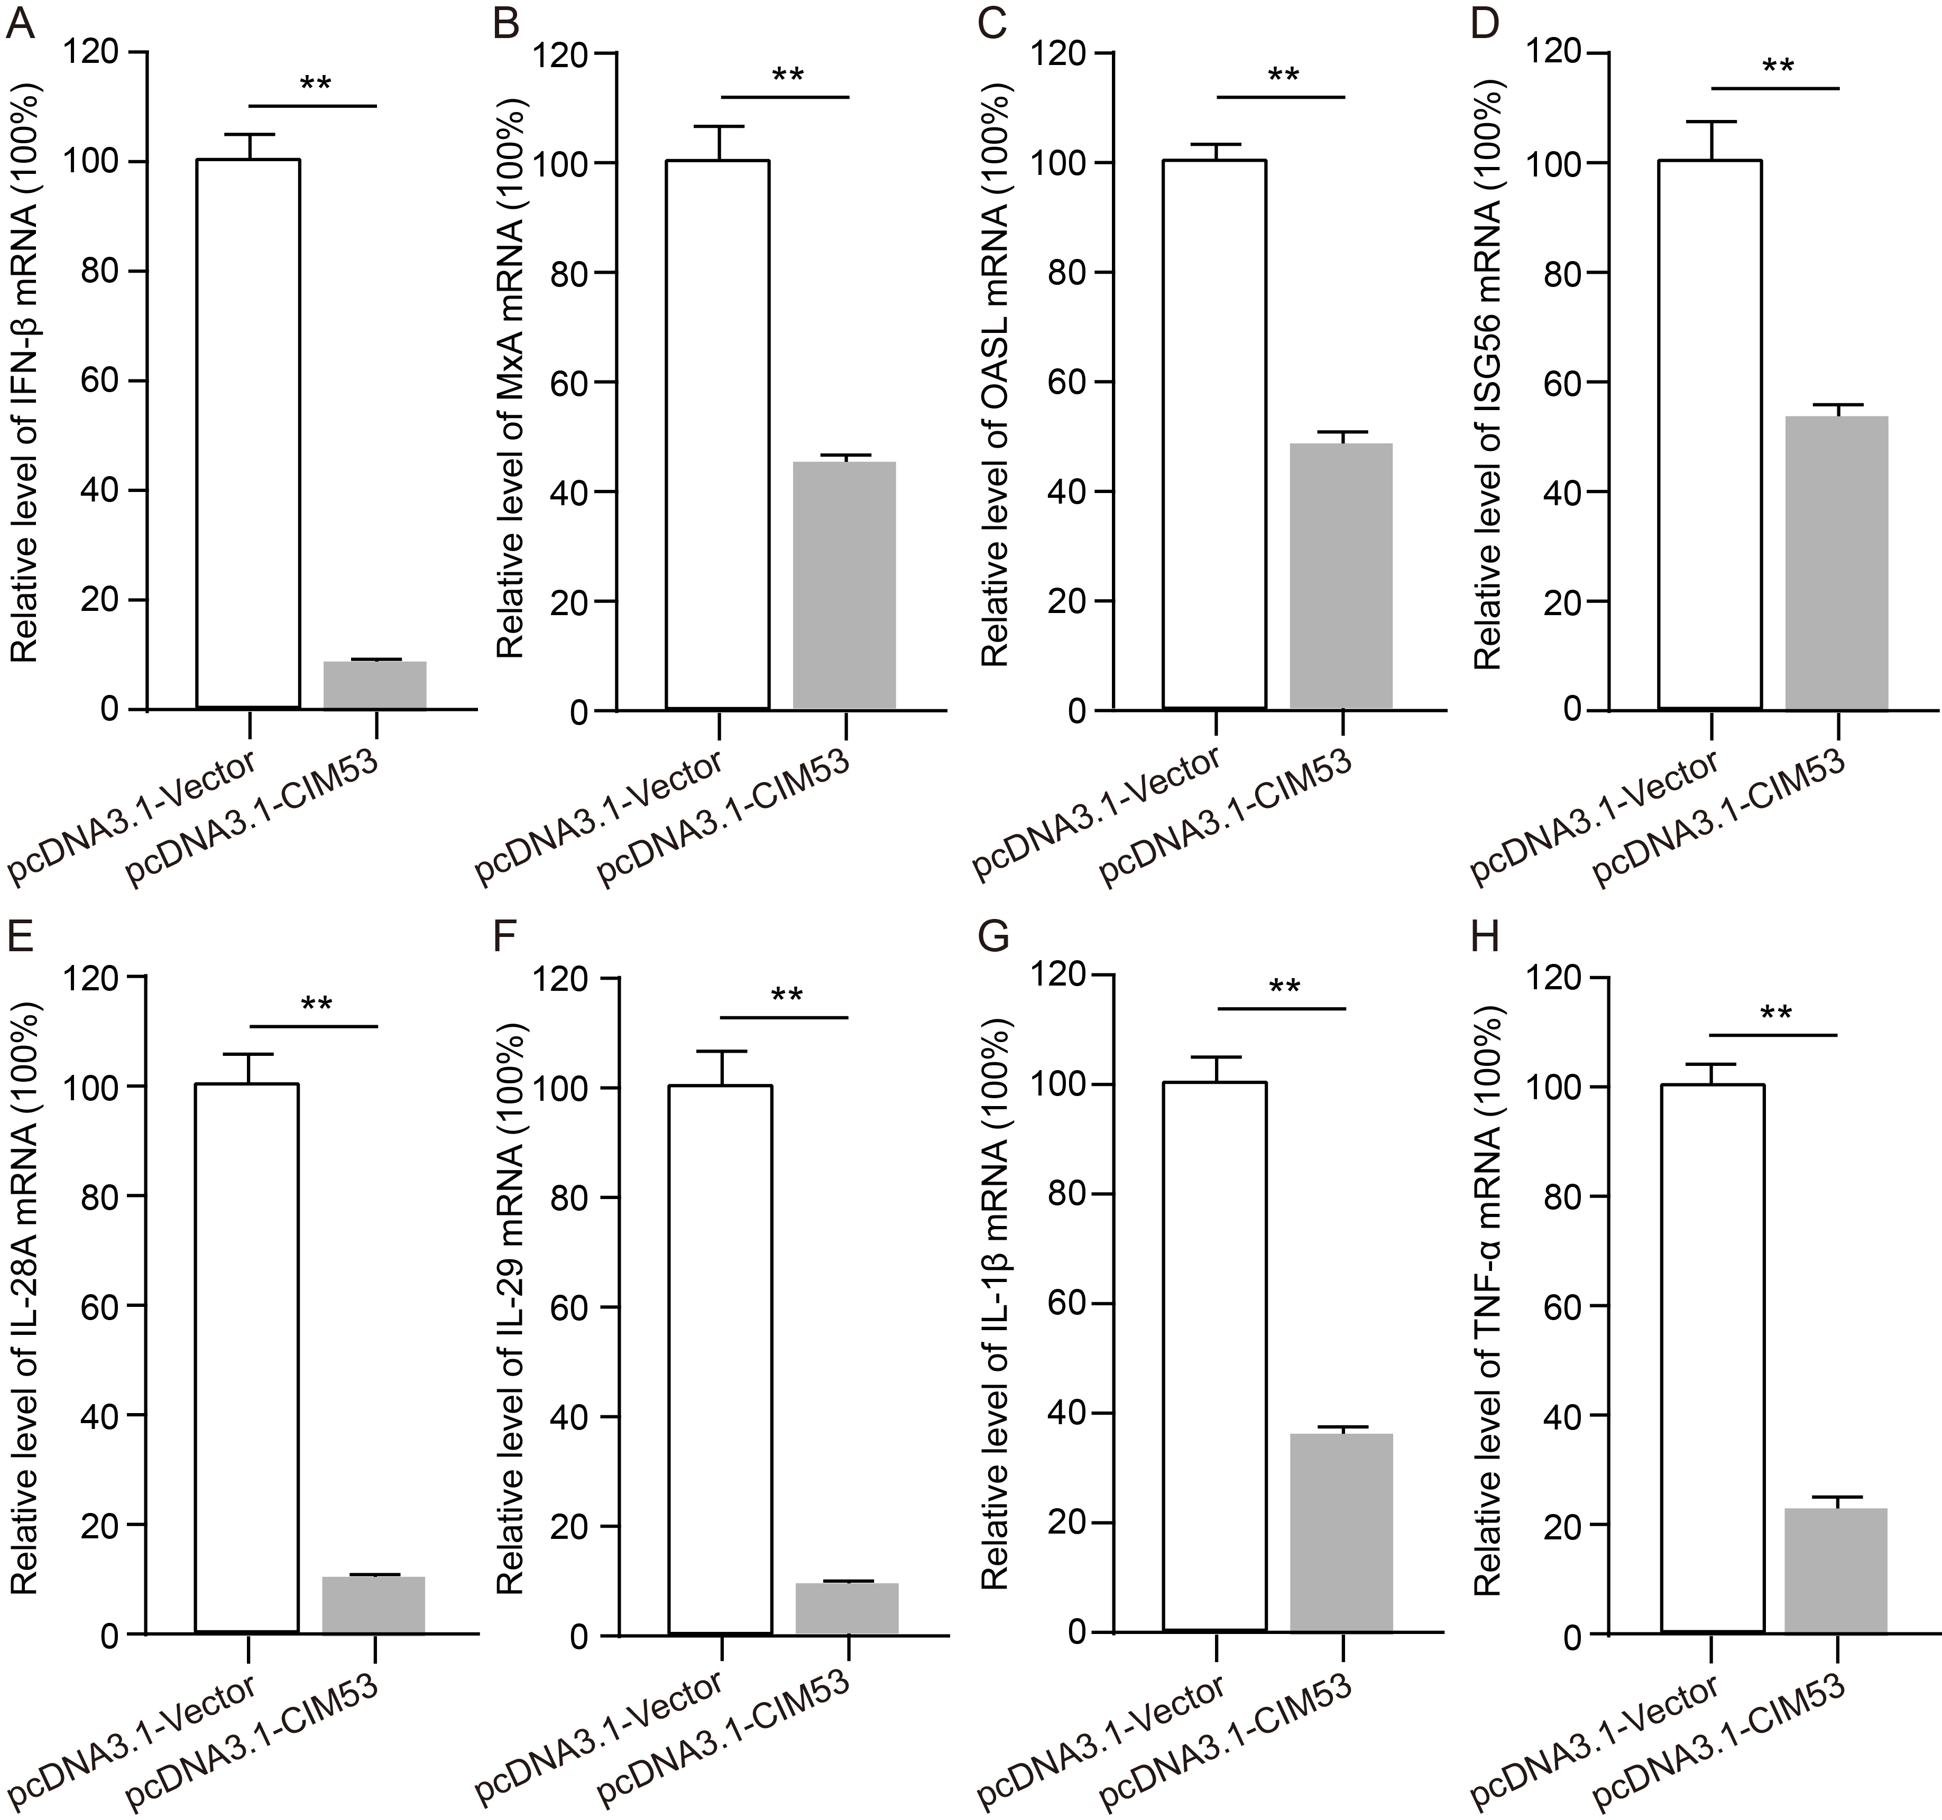
Fig. S3 CIM53 suppresses IFN-β-induced cytokine expression in A549 cells. A549 cells were transfected with pcDNA3.1-Vector or pcDNA3.1-CIM53. At 36 h post-transfection, cells were stimulated with IFN-β, and total RNA was collected 6 post-stimulation for qPCR analysis. The mRNA levels of (A) IFN-β, (B) MxA, (C) OASL, (D) ISG56, (E) IL-28A, (F) IL-29, (G) IL-1β, and (H) TNF-α were measured. Data are presented as means ± SD in A-H (n = 3). Statistical analysis was performed by using the one-tailed unpaired t test. ** P < 0.01.

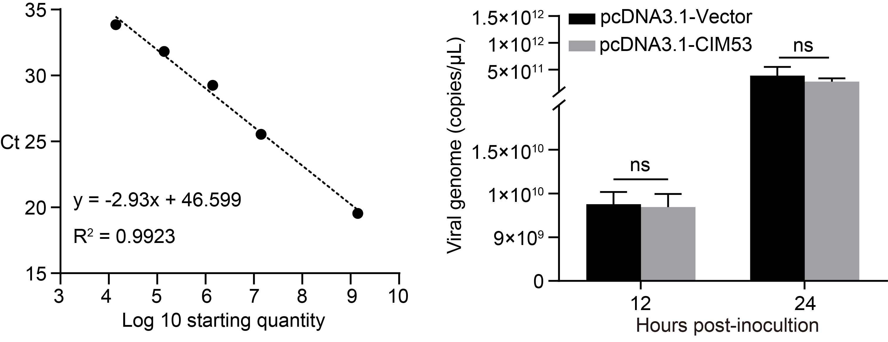
Fig. S4 CIM53 overexpression does not significantly affect PR8 virus replication in Vero cells. Vero cells were transfected with pcDNA3.1-Vector or pcDNA3.1-CIM53. At 36 h post-transfection, cells were infected with PR8 virus (MOI = 1), and culture supernatants were collected at 12 and 24 hpi. Viral RNA levels in the supernatants were quantified by absolute qPCR targeting the viral NP gene. Statistical analysis was performed by using the one-tailed unpaired t test. ns, not significant.

Table S1. Primer sequences used in this study.
Primer | Sequence (5'-3')
WSN-pHH21-PB2-F | cacacaCGTCTCcgggAGCGAAAGCAGGTCAA
WSN-pHH21-PB2-R | cacacaCGTCTCctattAGTAGAAACAAGGTCGTT
WSN-pHH21-PB1-F | cacacaCGTCTCcgggAGCGAAAGCAGGCAA
WSN-pHH21-PB1-R | cacacaCGTCTCctattAGTAGAAACAAGGCATT
WSN-pHH21-PA-F | cacacaCGTCTCcgggAGCGAAAGCAGGTACTG
WSN-pHH21-PA-R | cacacaCGTCTCctattAGTAGAAACAAGGTACTT
WSN-pHH21-HA-F | cacacaCGTCTCcgggAGCAAAAGCAGGGGAAAA
WSN-pHH21-HA-R | cacacaCGTCTCctattAGTAGAAACAAGGGTGTT
WSN-pHH21-NP-F | cacacaCGTCTCcgggAGCAAAAGCAGGGTAGAT
WSN-pHH21-NP-R | cacacaCGTCTCctattAGTAGAAACAAGGGTATTT
WSN-pHH21-NA-F | cacacaCGTCTCcgggAGCGAAAGCAGGAGTTTA
WSN-pHH21-NA-R | cacacaCGTCTCctattAGTAGAAACAAGGAGTTT
WSN-pHH21-M-F | cacacaCGTCTCcgggAGCAAAAGCAGGTTGATA
WSN-pHH21-M-R | cacacaCGTCTCctattAGTAGAAACAAGGTAGTT
WSN-pHH21-NS-F | cacacaCGTCTCcgggAGCAAAAGCAGGGTGACA
WSN-pHH21-NS-R | cacacaCGTCTCctattAGTAGAAACAAGGGTGTT
WSN-pHH21-HiBiT-F | CTGGCGGCTGTTCAAGAAGATTAGCggaagcggagctactaactt
WSN-pHH21-HiBiT-R | TCTTCTTGAACAGCCGCCAGCCGCTCACCATtcctccacttccAACTTCTG
GAPDH-F | GAGTCAACGGATTTGGTCGT
GAPDH-R | GACAAGCTTCCCGTTCTCAG
WSN-NP-F | TCAAACGTGGGATCAATG
WSN-NP-R | GTGCAGACCGTGCTAGAA
Human-IFN-β-F | ATGACCAACAAGTGTCTCCTCC
Human-IFN-β-R | GCTCATGGAAAGAGCTGTAGTG
Human-MxA-F | AACCTGTGCAGCCAGTATGA
Human-MxA-R | TGCCTCCAACACGGAGCTCT
Human-OASL-F | ATTTCGTGAAACATCGGCCA
Human-OASL-R | GGCATAGATGGTTAGAAGTT
Human-ISG56-F | GCCTTGCTGAAGTGTGGAGGAA
Human-ISG56-R | ATCCAGGCGATAGGCAGAGATC
Human-IL28A-F | CAAAGATGCCTTAGAAGAGTCG
Human-IL28A-R | TCCAGAACCTTCAGCGTCAG
Human-IL29-F | GGACGCCTTGGAAGAGTCA
Human-IL29-R | CCAGGACCTTCAGCGTCA
Human-IL1β-F | CAGAAGTACCTGAGCTCGCC
Human- IL1β-R | CATGGCCACAACAACTGACG
Human-TNFα-F | AAAACAACCCTCAGACGCCA
Human-TNFα-R | TCCTTTCCAGGGGAGAGAGG

