Virologica Sinica
Supplementary materials

Subcutaneous immunization with replication-competent live influenza virus confers durable protective immunity without respiratory pathology in mice

Zhoulang Wang ^{a, b, 1}, Chengxing Zhou ^{b, 1}, Lixin Yin ^{a, 1}, Xiaohong Liao ^{b}, Xiao Li ^{c}, Lei Li ^{d, e}, Zhichao Zhou ^{f}, Kangtian Li ^{d}, Meiyun Chen ^{g}, Dingbin Chen ^{h}, Minglei Liu ^{b}, Duo Xu ^{b}, Weibin She ^{d}, Qinhai Ma ^{c, *},
Hui Cai ^{a, *}, Rong Zhou ^{b, c, *}

ª School of Pharmaceutical Sciences (Shenzhen), Shenzhen Campus of Sun Yat-sen University, Shenzhen 518107, China
^{b} Guangzhou National Laboratory, Guangzhou International Bio Island, Guangzhou 510005, China
^{c} State Key Laboratory of Respiratory Disease, National Clinical Research Center for Respiratory Disease, Guangzhou Institute of Respiratory Health, the First Affiliated Hospital of Guangzhou Medical University, Guangzhou 510230, China
^{d} Guangdong Nanshan Institute of Medical Innovation, Foshan 528216, China
^{e} School of Pharmacy, Tongji medical College, Huazhong University of Science and Technology, Wuhan 430030, China
^{f} Guangdong Polytechnic of Environmental Protection Engineering, Foshan 528216, China
^{g} School of Medicine, Southern University of Science and Technology, Shenzhen 518055, China
^{h} Institute of Medical Microbiology, Department of Immunology and Microbiology, College of Life Science and Technology, Jinan University, Guangzhou 510632, China

¹ Zhoulang Wang, Chengxing Zhou, Lixin Yin contributed equally to this work.

*Corresponding authors:
E-mail: zhourong@vip.163.com (R. Zhou); caihui5@mail.sysu.edu.cn (H. Cai); 13268268214@163.com (Q. Ma)
ORCID: 0000-0001-7322-3561 (R. Zhou); 0000-0002-5394-8167 (H. Cai); 0009-0002-7739-9892 (Q. Ma)

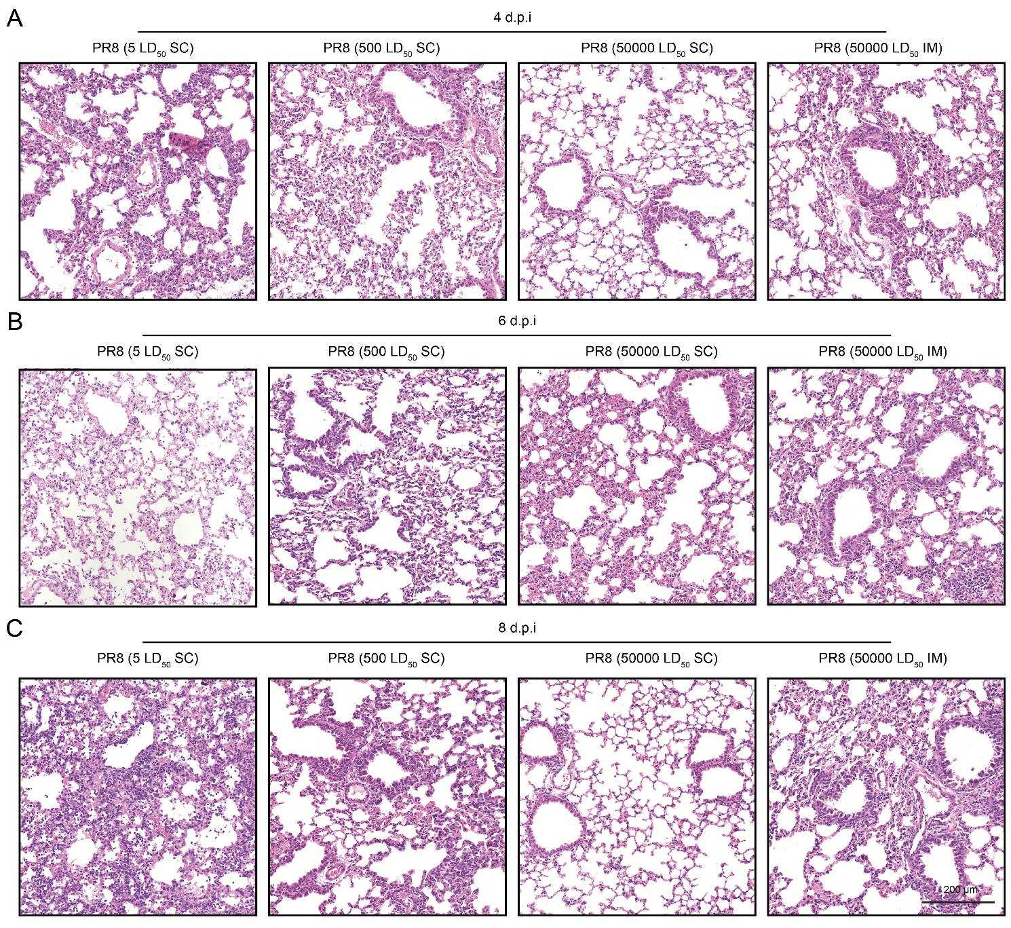
Supplementary Fig. S1. Lung histopathology following PR8 challenge after live influenza A virus (LIV) immunization. Mice immunized subcutaneous (SC) with LIV at low (LLD₅₀), medium (MLD₅₀), or high dose (HLD₅₀), or intramuscular (IM) with HLD₅₀ LIV, were challenged intranasally with PR8 at day 21 post-immunization. Representative hematoxylin and eosin (H&E)-stained lung sections collected at the indicated days post-infection was shown. A Representative image of H&E-stained lung sections at 4 days post infection (d.p.i). B Representative image of H&E-stained lung sections at 6 days post infection (d.p.i). C Representative image of H&E-stained lung sections at 8 days post infection (d.p.i). Scale bar: 200 µm.

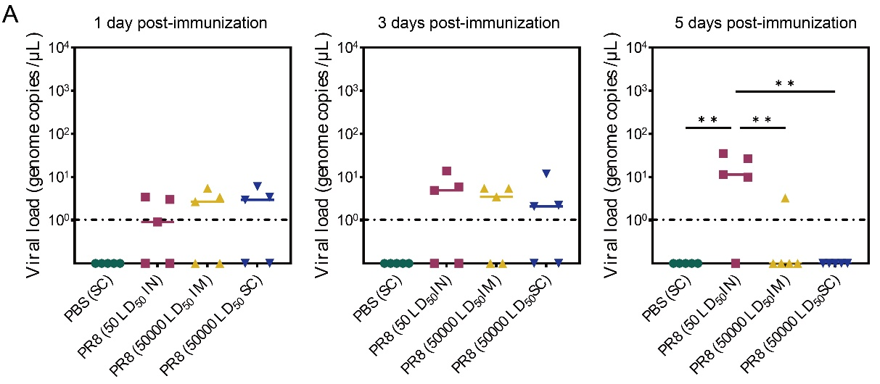
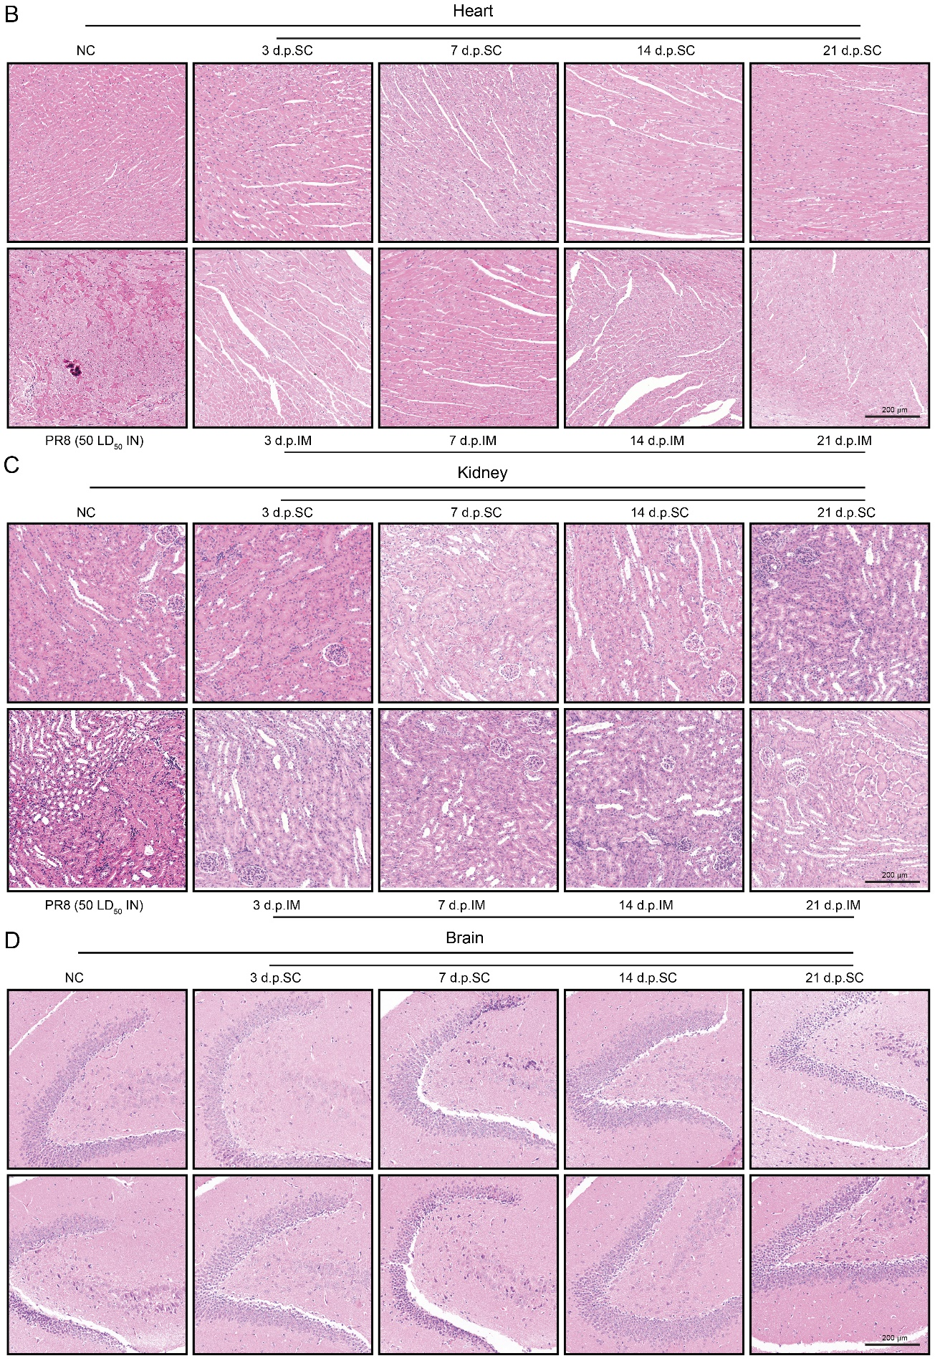
Supplementary Fig. S2. Systemic safety evaluation of LIV immunization in mice. Mice were SC or IM immunized with HLD₅₀ of LIV and euthanized at 3, 7, 14, and 21 days post-immunization for tissue collection. Intranasally (IN) infected mice served as infection controls. A Viral load in blood at 1, 3, and 5 days post-immunization (n = 5 biologically independent mice). B–D Representative H&E-stained sections of heart, kidney and brain were shown. Scale bar: 200 µm. All data were shown as the means ± standard error of the mean (SEM). Statistical significance P-value was calculated by one-way ANOVA with Tukey’s multiple comparison tests. *P < 0.05; **P < 0.01; ***P < 0.001; ****P < 0.0001, when compared to PR8 viral infection control group.

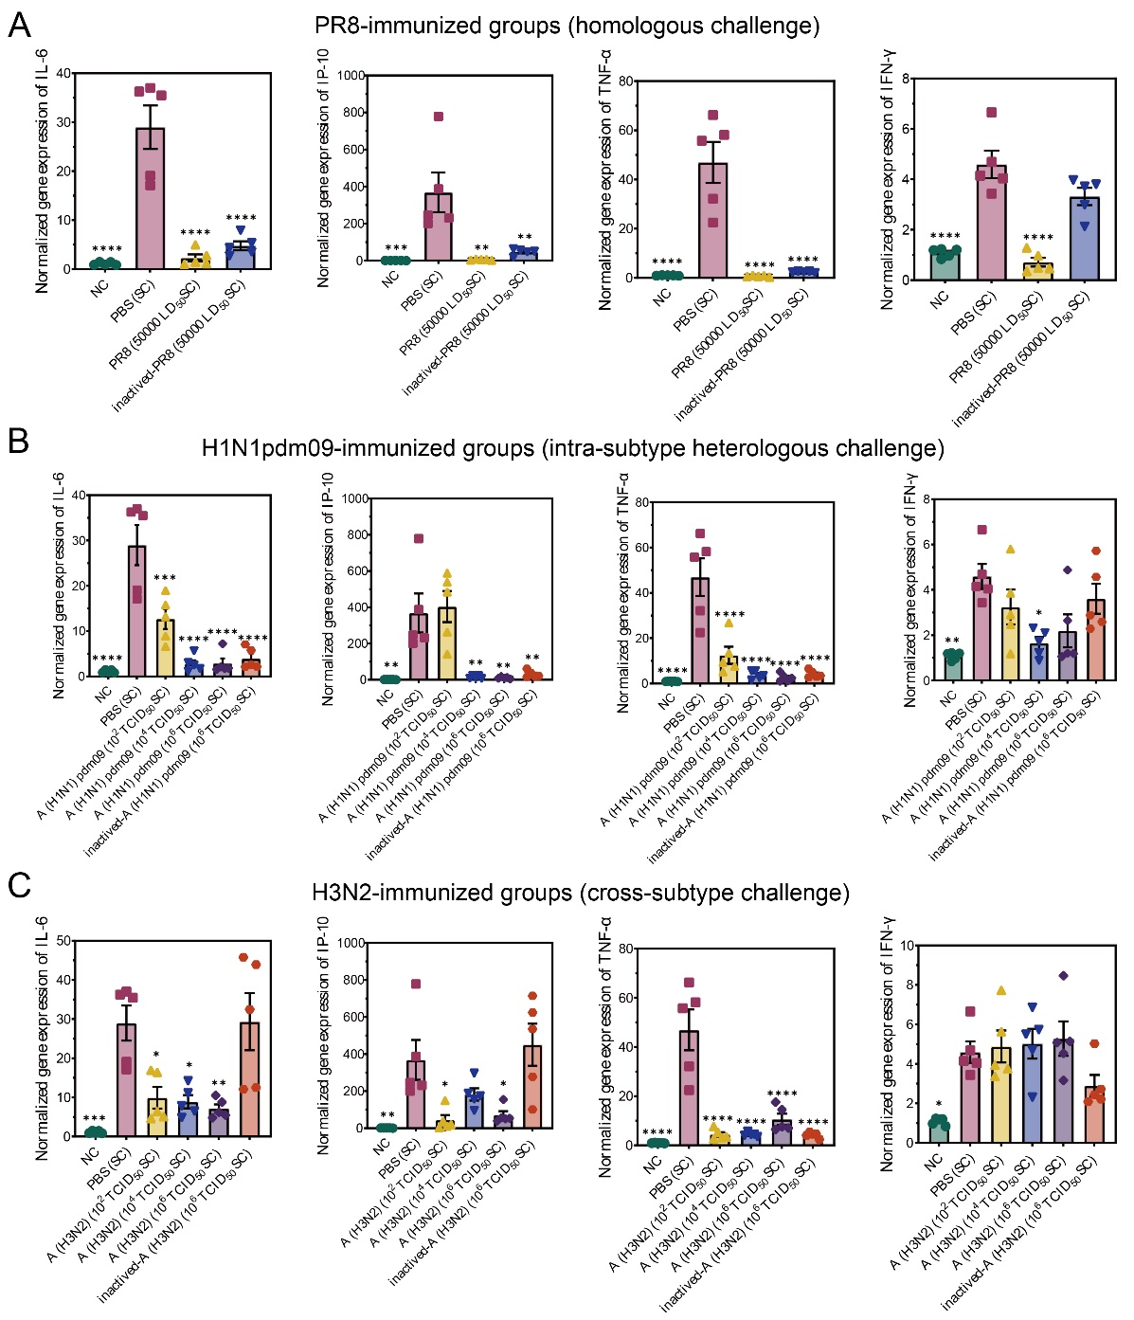
Supplementary Fig. S3. Pulmonary inflammatory cytokine transcription levels following PR8 challenge in mice immunized with live or inactivated influenza virus. A Pulmonary inflammatory cytokines transcription levels of mice 14 days after virus challenge (HLD50 PR8 and inactivated PR8 immunization, n = 5 mice per group). B Pulmonary inflammatory cytokines transcription levels of mice 14 days after virus challenge (H1N1pdm09 immunization, n = 5 mice per group). C Pulmonary inflammatory cytokines transcription levels of mice 14 days after virus challenge (H3N2 immunization, n = 5 mice per group). All data are shown as the means ± standard error of the mean (SEM). Statistical significance P-value was calculated by one-way ANOVA with Tukey’s multiple comparison tests. *P < 0.05; **P < 0.01; ***P < 0.001; ****P < 0.0001, when compared to PBS control group.

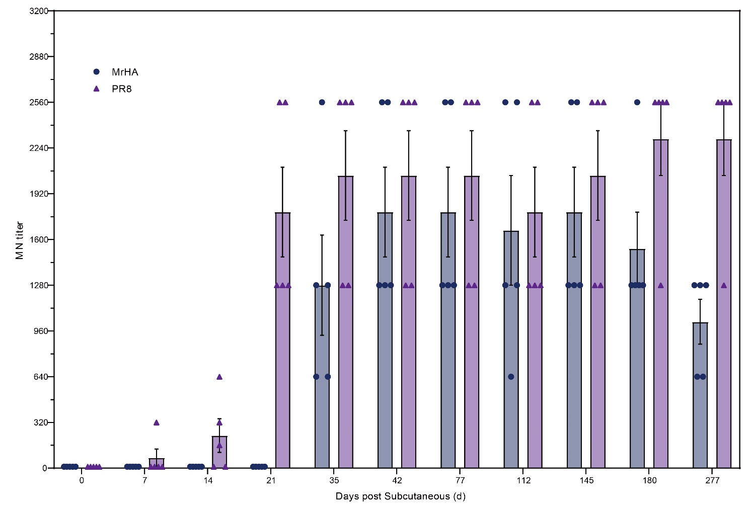
Supplementary Fig. S4. Longitudinal serum virus-neutralizing antibody responses following prime or prime-boost immunization. Serum virus-neutralizing titers were measured from 0 to 277 days post subcutaneous immunization (d.p.SC) in mice immunized with HLD₅₀ LIV or monovalent PR8 recombinant HA trimer (MrHA). All data were shown as the means ± standard error of the mean (SEM).

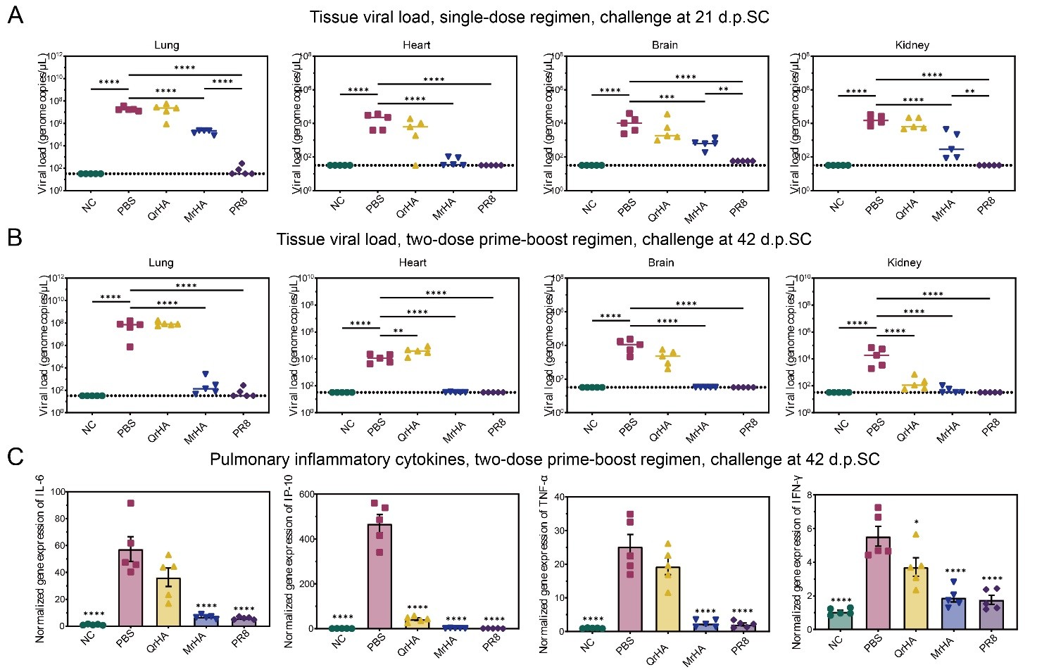
Supplementary Fig. S5. Viral dissemination and pulmonary inflammatory cytokine responses following PR8 challenge in mice immunized with LIV or recombinant HA vaccines. A Viral load in lung, heart, brain, and kidney tissues following single-dose immunization and challenge at 21 d.p.SC (n = 5 mice per group). B Viral load in lung, heart, brain, and kidney tissues following two-dose prime-boost immunization and challenge at 42 d.p.SC (n = 5 mice per group). C Pulmonary inflammatory cytokine transcription levels following two-dose prime-boost immunization and challenge at 42 d.p.SC (n = 5 mice per group). Dotted line indicates LOD. All data are shown as the means ± standard error of the mean (SEM). Statistical significance P-value was calculated by one-way ANOVA with Tukey’s multiple comparison tests. *P < 0.05; **P < 0.01; ***P < 0.001; ****P < 0.0001, when compared to PBS control group.

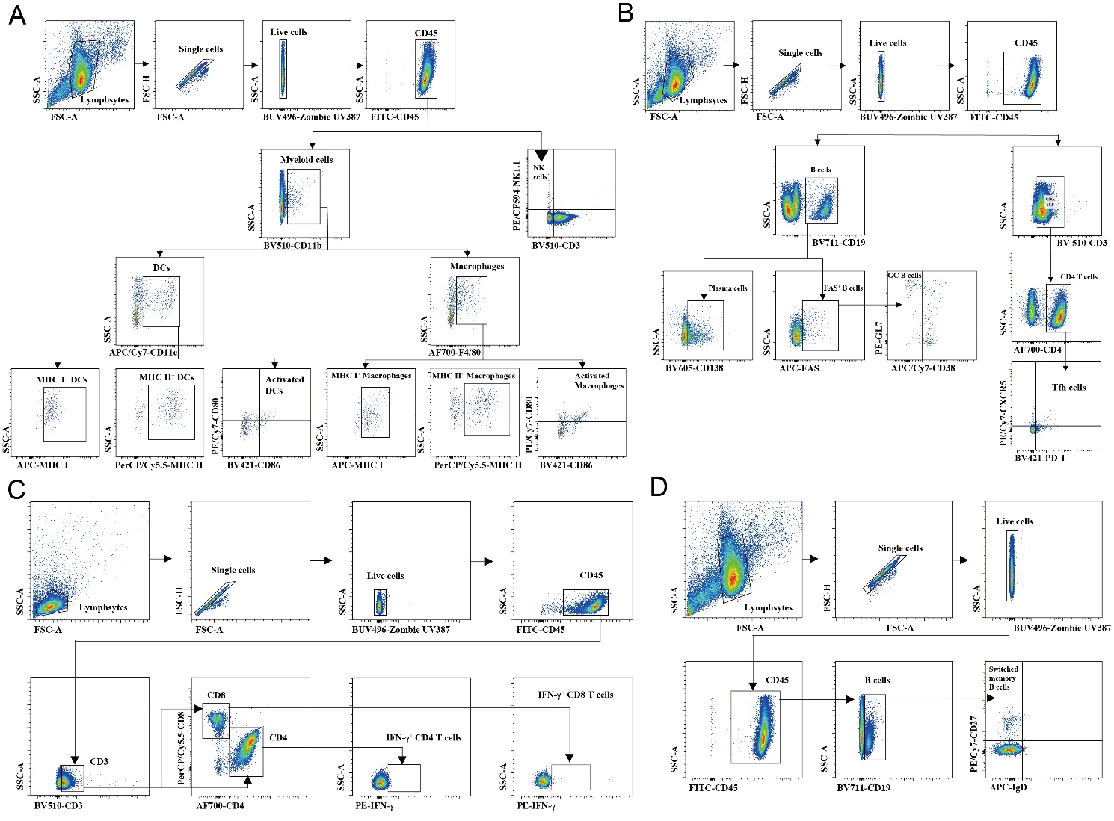
Supplementary Fig. S6. Flow cytometry gating strategy. Gating strategies used to identify major immune cell populations in draining lymph nodes (dLNs), including myeloid cells, dendritic cells (DCs), macrophages, NK cells, B cells, T cell subsets, germinal center (GC) B cells, T follicular helper (Tfh) cells, and plasma cells following SC or IM immunization with HLD₅₀ LIV. Live CD45⁺ cells were gated sequentially excluding debris based on FSC-A versus SSC-A, doublets based on FSC-A versus FSC-H, and dead cells using Zombie UV387. Within live CD45⁺ cells, A Gating strategy for sorting myeloid cells (identified as CD11b⁺), DCs (identified as CD11b⁺CD11c⁺), major histocompatibility complex (MHC) Ⅰ⁺ DCs (identified as CD11b⁺CD11c⁺MHC Ⅰ⁺), MHC Ⅱ⁺ DCs (identified as CD11b+CD11c⁺ MHC Ⅱ⁺), activated DCs (identified as CD11b⁺CD11c⁺CD80⁺CD86⁺), macrophages (identified as CD11b⁺F4/80⁺), MHC) Ⅰ⁺ macrophages (identified as CD11b⁺ F4/80⁺MHC Ⅰ⁺), MHC Ⅱ⁺ macrophages (identified as CD11b⁺ F4/80⁺ MHC Ⅱ⁺), activated macrophages (identified as CD11b⁺ F4/80⁺CD80⁺CD86⁺) and natural kill (NK) cells (identified as NK1.1⁺CD3⁻). B Gating strategy for sorting B cells (identified as CD19⁺), plasma cells (identified as CD19⁺CD138⁺), GC B cells (identified as CD19⁺FAS⁺GL7⁺CD38⁻) and Tfh cells (identified as CD3⁺CD4⁺PD-1⁺CXCR5⁺). C Gating strategy for sorting IFN-γ⁺ CD4 T cells (identified as CD3⁺CD4⁺ IFN-γ⁺) and IFN-γ⁺ CD8 T cells (identified as CD3⁺CD8⁺ IFN-γ⁺). D Gating strategy for sorting switched memory B cells (identified as CD19⁺IgD⁻CD27⁺).

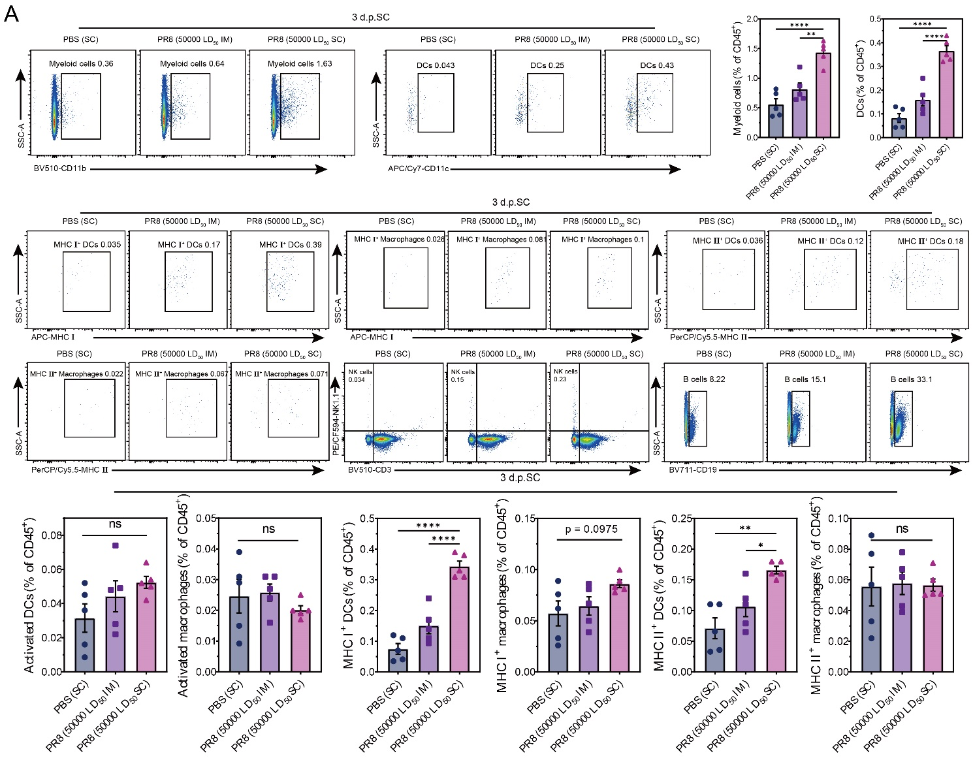
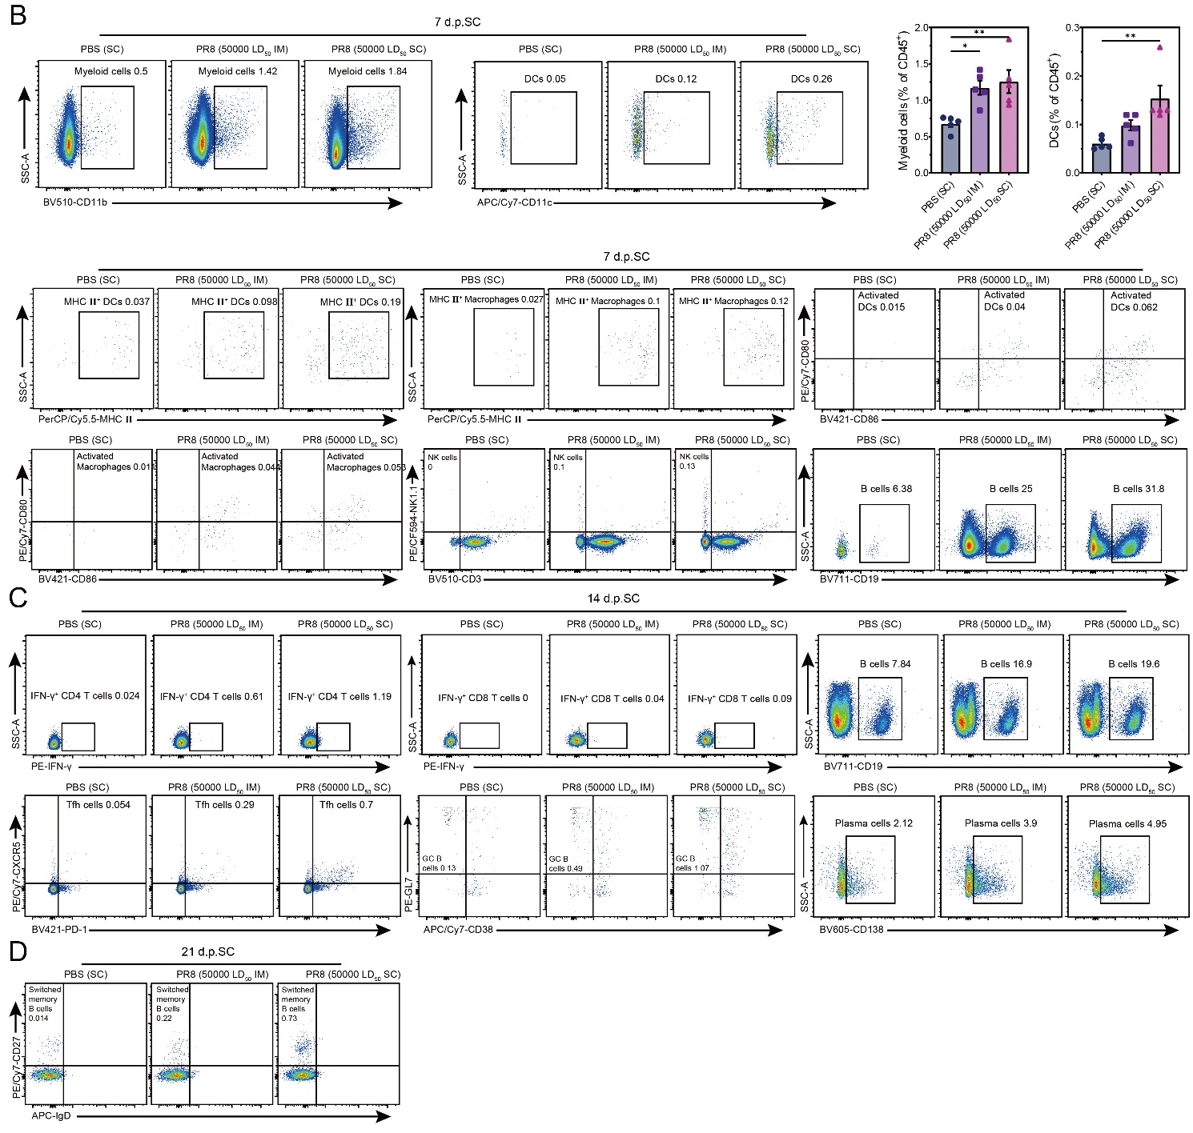
Supplementary Fig. S7. Representative flow cytometry plot. A Representative flow cytometry plot at 3 days post-immunization. B Representative flow cytometry plot at 7 days post-immunization. C Representative flow cytometry plot at 14 days post-immunization. D Representative flow cytometry plot at 21 days post-immunization. All data were shown as the means ± SEM. Statistical significance p-value was calculated by one-way ANOVA with Tukey’s multiple comparison tests. *P < 0.05; **P < 0.01; ***P < 0.001; ****P < 0.0001, when compared to PBS control group.

Supplementary Table S1. Primer sequence for RT-qPCR.
Target Gene | Direction | Sequence (5′–3′)
PR8 HA | Forward | TGAAGGGGGATGGACTGGAA
PR8 HA | Reverse | TTGATCCGCTGCATAGCCTG
IL-6 (mouse) | Forward | GTGGCTAAGGACCAAGACCA
IL-6 (mouse) | Reverse | TAACGCACTAGGTTTGCCGA
IP-10 (mouse) | Forward | ATGACGGGCCAGTGAGAATG
IP-10 (mouse) | Reverse | GAGGCTCTCTGCTGTCCATC
TNF-α (mouse) | Forward | AGGCACTCCCCCAAAAGATG
TNF-α (mouse) | Reverse | CTGCCACAAGCAGGAATGAG
IFN-γ (mouse) | Forward | TCCTGGGGCCTTATTGTCTC
IFN-γ (mouse) | Reverse | ATCCAAAGGCGTTTTGCCAC
GAPDH (mouse) | Forward | CAAAATGGTGAAGGTCGGTGTG
GAPDH (mouse) | Reverse | GTTGAGGTCAATGAAGGGGTCG

