Virologica Sinica
Supplementary Materials

SFTSV exploits PPM1K to inhibit apoptosis through the Bcl-2/BAX/Caspase-3 axis for efficient replication
Qianruo Wang ^{a,b, 1,} Baoyan Wang ^{a, 1}, Penghui Liu ª, Yuanyuan Li ^{a*}

ª State Key Laboratory for Diagnosis and Treatment of Severe Zoonotic Infectious Diseases, Key Laboratory for Zoonosis Research of the Ministry of Education, Institute of Zoonosis, College of Veterinary Medicine, Jilin University, Changchun 130062, China
^{b} State Key Laboratory for Animal Disease Control and Prevention, Harbin Veterinary Research Institute, Chinese Academy of Agricultural Sciences, Harbin 150000, China

¹ Qianruo Wang and Baoyan Wang contributed equally to this work.
* Corresponding author.
E-mail addresses: li_yuanyuan@jlu.edu.cn (Y. Li)
ORCID ID: 0000-0001-8467-9759

Supplementary Materials
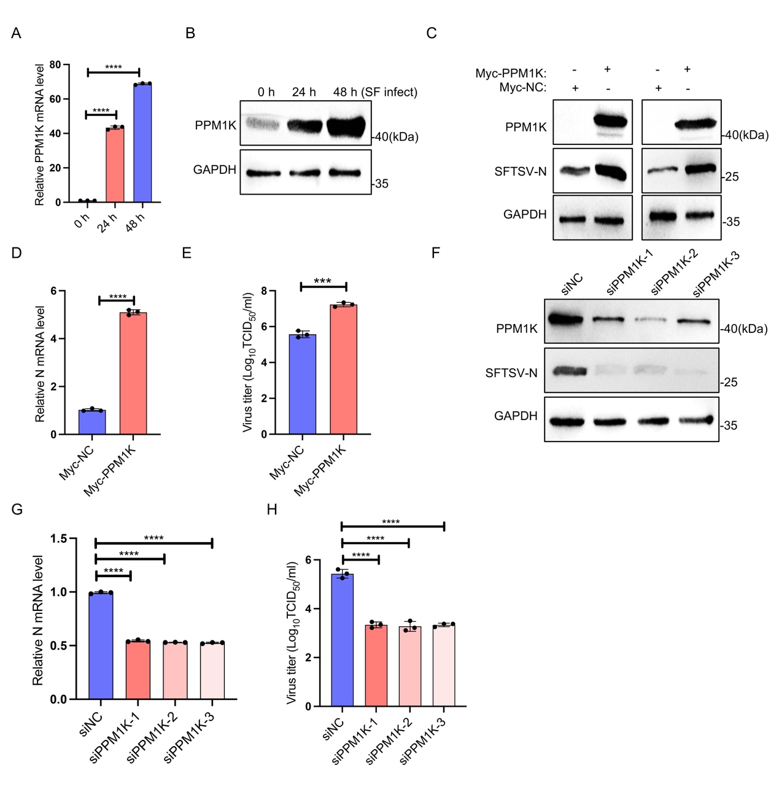
Fig. S1. SFTSV induces PPM1K expression and PPM1K promotes SFTSV replication. A, B 293T cells were infected with SFTSV (MOI = 1) for 0, 24, or 48 h. PPM1K mRNA levels were measured by qPCR (A), and protein levels of PPM1K and GAPDH were analyzed by immunoblotting (B). C THP-1 cells were transfected with Myc-PPM1K and subsequently infected with SFTSV (MOI = 1) for 24 or 48 h. Protein levels of Myc, SFTSV-N, and GAPDH were determined by immunoblotting. D, E 293T cells overexpressing Myc-PPM1K were infected with SFTSV (MOI = 1) for 48 h. SFTSV-N mRNA levels were determined by qPCR (D), and viral titers in the culture supernatants were measured (E). F–H 293T cells were transfected with siNC, siPPM1K-1, siPPM1K-2, or siPPM1K-3, followed by SFTSV infection (MOI = 1) for 48 h. Protein levels of PPM1K, SFTSV-N, and GAPDH were analyzed by immunoblotting (F), SFTSV-N mRNA levels were determined by qPCR (G), and viral titers in the culture supernatants were measured (H). Statistical significance was defined as P < 0.05, with significance levels indicated as follows: ** P < 0.01; *** P < 0.001; **** P < 0.0001.

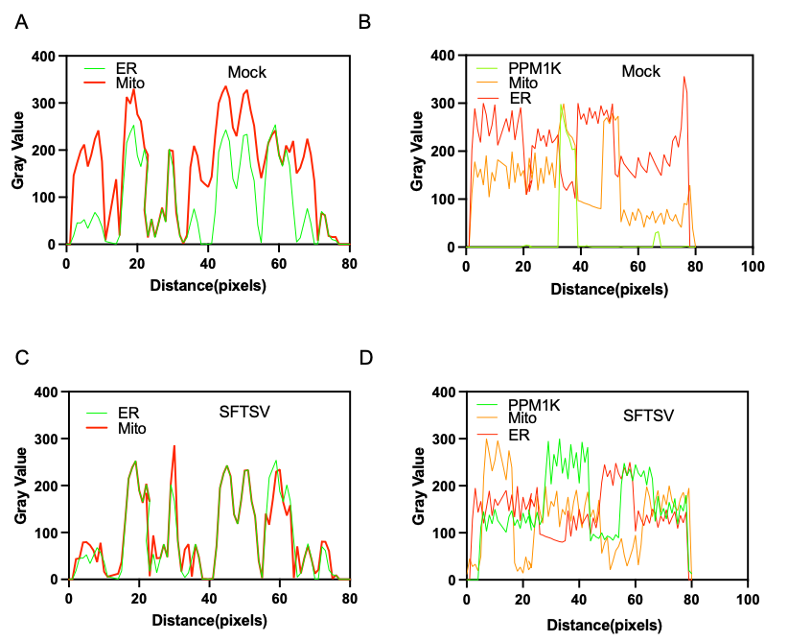
Fig. S2. SFTSV promotes ER–mitochondria contact, leading to the translocation of PPM1K. A, B Curve profiles of ER-mitochondria interaction. C, D Intensity profile curves showing the spatial correlation of PPM1K with mitochondria and the ER.

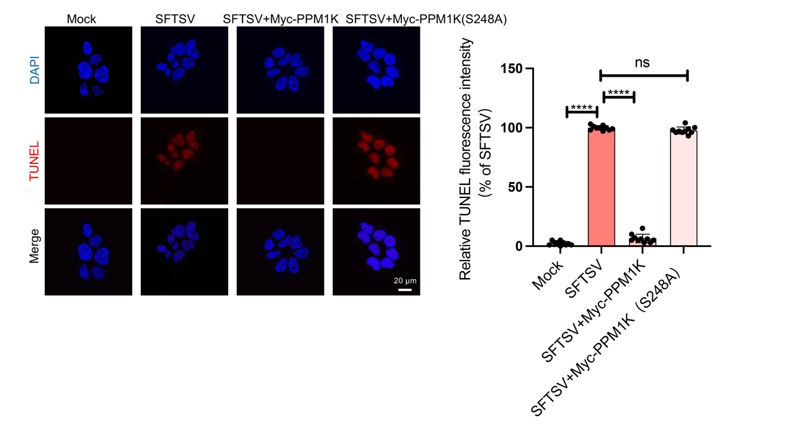
Fig. S3. PPM1K inhibits apoptosis, whereas the S248A mutant fails to suppress apoptosis. Differentiated THP-1 cells were transfected with PPM1K, PPM1K (S248A), or empty vector. At 24 h post-transfection, cells were infected with SFTSV (MOI = 1) for 48 h, whereas an equal volume of DMEM was added to the mock group. Left: TUNEL staining was performed and images were acquired by confocal microscopy. Right: quantitative analysis of fluorescence intensity was performed (n = 10). Statistical significance was defined as P < 0.05, with significance levels indicated as follows: ** P < 0.01; *** P < 0.001; **** P < 0.0001.

Supplementary Table S1 siRNA sequences targeting PPM1K and Bcl-2
Target Gene | siRNA Name | Targeting Sequence (5'→3')
PPM1K | siPPM1K-1 | CCCAAUUAGCUGAAAUACAUUCUG
 | siPPM1K-2 | UUGUUAUUUACUUUGGGAACUCCAG
 | siPPM1K-3 | GAGUGCAGUGGUGUGAUCUUAGCUCA
Bcl-2 | siBcl-2-1 | GGAAUAAAAAUUUCCUGCAUCUCAUG
 | siBcl-2-2 | UGCGGGUGGGCUCCUGGGGCAA
 | siBcl-2-3 | GAAAGGAAUUGGAAUAAA

