Virologica Sinica
Supplementary Materials

SwiVirScan, a high-throughput platform for profiling antibodies to swine-associated viruses, reveals extensive viral exposure histories in pigs

Qian Zhang ^{a, b, c, 1}, Junhua Dong ^{a, b, c, 1}, Pengju Guo ^{a, b, c}, Wenlong Wang ^{a, b, c}, Xueting Zhang ^{a, b, c}, Siyang Pei ^{a, b, c}, Zhaoxu Dong ^{a, b, c}, Ping Qian ^{a, b, c}, Pan Tao ^{a, b, c, *}

ª State Key Laboratory of Agricultural Microbiology, Huazhong Agricultural University, Wuhan 430070, China.
^{b} Hubei Hongshan Lab, Wuhan 430070, China.
^{c} Cooperative Innovation Center for Sustainable Pig Production, College of Veterinary Medicine, Huazhong Agricultural University, Wuhan 430070, China.

¹ Qian Zhang and Junhua Dong contributed equally to this work.

* Corresponding author:
Email address: taopan@mail.hzau.edu.cn (P. Tao)
ORCID: 0000-0002-0082-2229 (P. Tao)

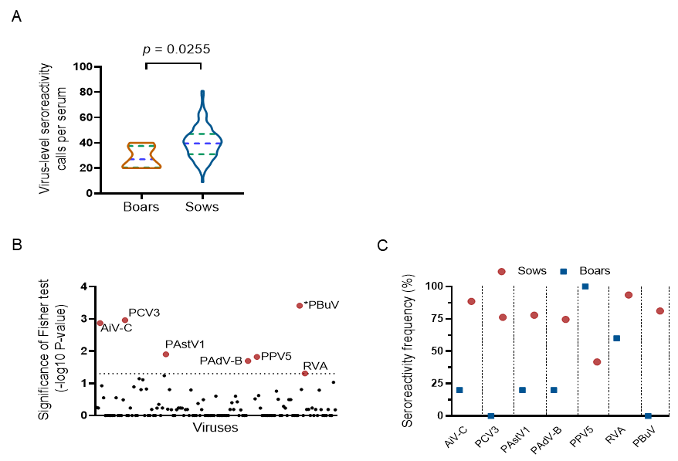
Supplementary Fig. S1. Comparison of virus-level antibody reactivity between boars and sows. A Distribution of virus-level antibody-reactivity calls per serum sample in boars and sows after excluding five vaccine-targeted viruses. The P value was calculated using the Mann-Whitney U test. B Fisher’s exact test results (-log₁₀ P value) comparing virus-level seroreactivity frequencies between boars and sows across the 131 non-vaccine-targeted viruses. The dashed horizontal line indicates an unadjusted P value of 0.05, and red points denote viruses with an unadjusted P < 0.05. C Seroreactivity frequencies of these viruses in boars and sows. A virus-level call denotes reproducible antibody enrichment of displayed peptides assigned to that virus.

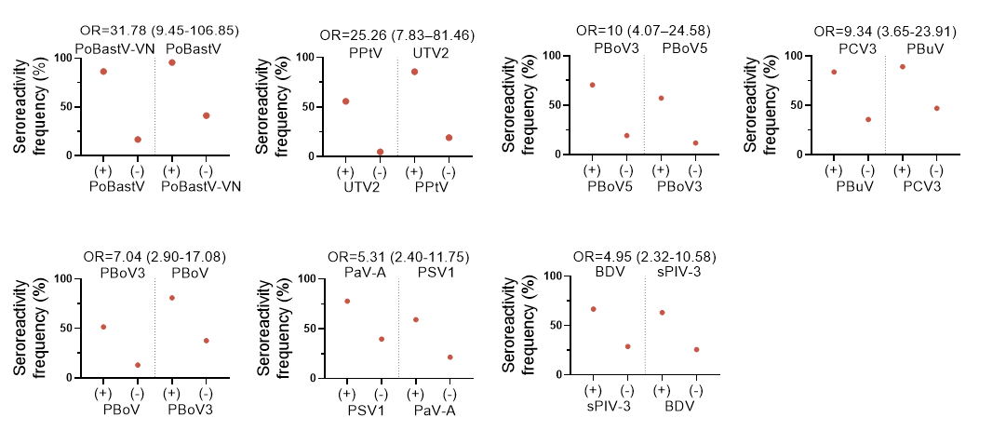
Supplementary Fig. S2. Candidate virus pairs showing enriched co-seropositivity. Each panel shows the prevalence of the second virus among pigs positive (+) and negative (-) for the first virus in each enriched viral pair. Odds ratios (OR) with 95% confidence intervals are shown above each panel.

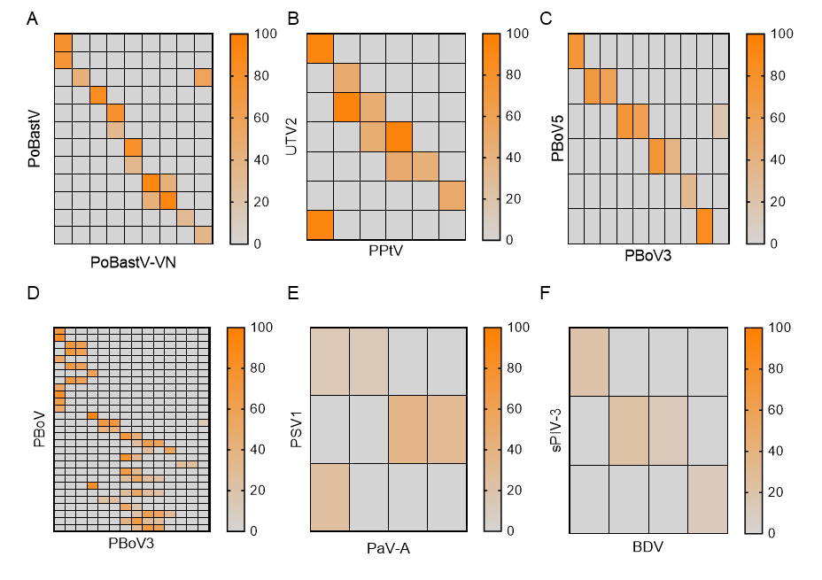
Supplementary Fig. S3. Sequence similarity among enriched peptides from candidate co-seropositivity pairs. Each panel displays a heat map comparing 56-aa peptides from two viruses. Rows are peptides from the PoBastV (A), UTV2 (B), PBoV5 (C), PBoV (D), PSV1 (E), and sPIV-3 (F). Columns are peptides from PoBastV-VN (A), PPtV (B), PBoV3 (C) and (D), PaV-A (E), and BDV (F). Each cell shows the percentage of identical residues between a 56-aa peptide pair. Values are reported only for peptide pairs with a BLASTP-reported alignment (word size = 7); otherwise, the cell is gray.

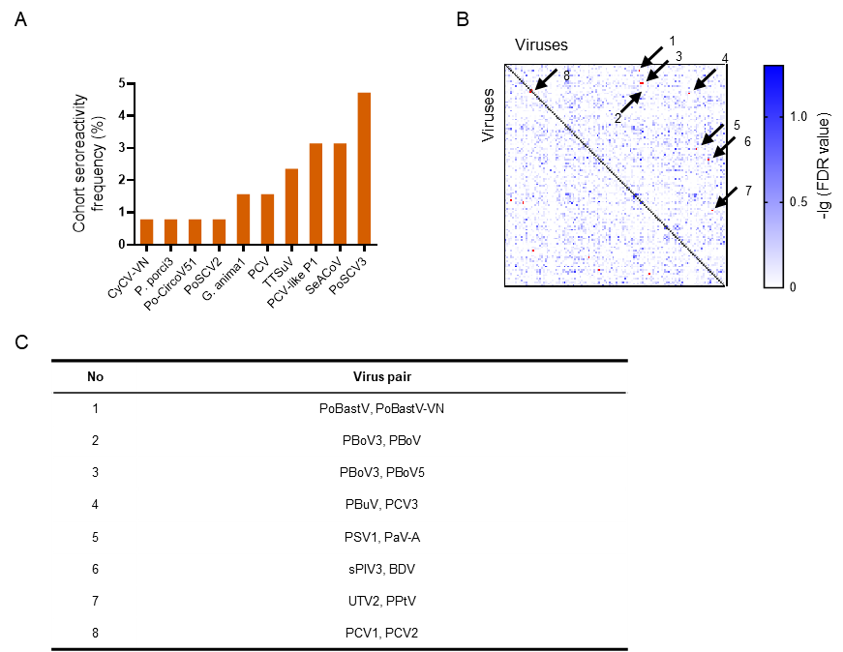
Supplementary Fig. S4. Cohort frequencies of single-peptide-supported virus-level signals and their effects on the co-seropositivity analysis. A Cohort seroreactivity frequencies of ten viruses for which only one assigned peptide was reproducibly enriched across the 127 serum samples. Four of these viruses showed seroreactivity in only one serum sample (0.79%). B Virus-virus association matrix recalculated after excluding the four viruses whose only reproducibly enriched peptide was detected in a single serum sample. Pairwise co-seropositivity associations were evaluated using Fisher’s exact tests. Color intensity represents -log₁₀ (FDR value), and the numbered boxes indicate eight candidate virus pairs with P < 0.05. C Identities of the eight candidate co-seropositivity pairs numbered in panel B.

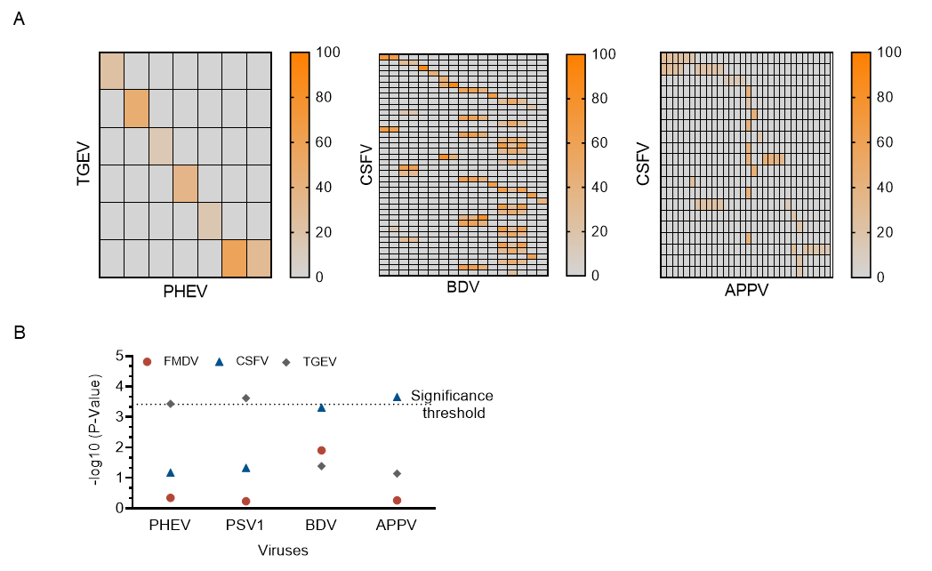
Supplementary Fig. S5. Assessment of sequence-related cross-reactivity in associations between vaccine-targeted and non-vaccine-targeted viral seroreactivity. A Rows and columns represent enriched 56-aa peptides assigned to vaccine-targeted viruses and their associated non-vaccine-targeted viruses, respectively. Each cell shows the percentage sequence identity between a pair of peptides. Values are displayed only for peptide pairs with an alignment identified by BLASTP (word size = 7); cells without a qualifying alignment are shown in gray. B Sensitivity analysis of the associations between seroreactivity to vaccine-targeted viruses (FMDV, CSFV, and TGEV) and the associated non-vaccine-targeted viruses (PHEV, PSV1, BDV, and APPV) after removing potentially cross-reactive peptides from APPV, BDV, and PHEV. Virus-level seroreactivity was recalculated, and the associations were retested using Fisher’s exact tests. Points indicate -log₁₀ (P values), and the dashed horizontal line denotes the Bonferroni-adjusted significance threshold.

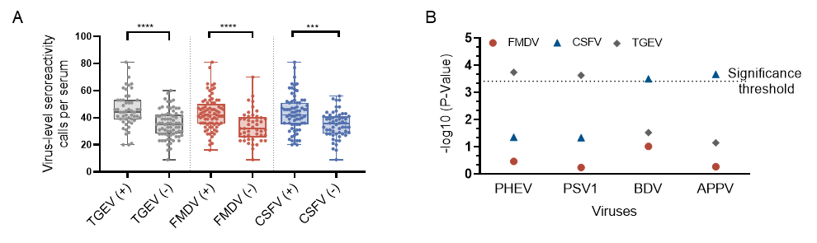
Supplementary Fig. S6. Sensitivity analysis of associations between viral exposure profiles and seroreactivity to vaccine-targeted viruses after exclusion of four low-support viruses. A Numbers of non-vaccine-targeted virus-level seroreactivity calls per serum among pigs with (+) or without (−) seroreactivity to TGEV-, FMDV-, or CSFV-assigned peptides after exclusion of the four viruses supported by a single reproducibly enriched peptide detected in only one serum sample. Individual points represent serum samples, and boxplots summarize the distributions. Groups were compared using two-sided Mann-Whitney U tests. B -log₁₀-transformed P values from two-sided Fisher’s exact tests evaluating the associations of PHEV, PSV1, BDV, and APPV seroreactivity with seroreactivity to TGEV-, FMDV-, or CSFV-assigned peptides after exclusion of the four low-support viruses. Colors and symbols denote the corresponding vaccine-targeted viruses, and the horizontal dotted line indicates the Bonferroni-adjusted significance threshold. ***P < 0.001 and ****P < 0.0001.

Supplementary Table S1. List of well-established zoonotic or potentially zoonotic viruses
Classification | Virus name | References
Well-established  Zoonotic | Alphainfluenzavirus influenzae  (Influenza A virus) | (Long et al., 2019)
Well-established  Zoonotic | Lyssavirus rabies  (Rabies virus) | (Fisher et al., 2018)
Well-established  Zoonotic | Orthoavulavirus javaense | (Goebel et al., 2007)
Well-established  Zoonotic | Orthobunyavirus bataiense | (Mansfield et al., 2022)
Well-established  Zoonotic | Orthoflavivirus japonicum | (Sistrom et al., 2024)
Well-established  Zoonotic | Orthoflavivirus loupingi | (Jeffries et al., 2014)
Well-established  Zoonotic | Orthorubulavirus mammalis | (Chatziandreou et al., 2004)
Well-established  Zoonotic | Paslahepevirus balayani  (Hepatitis E virus) | (Kamar et al., 2017)
Well-established  Zoonotic | Rotavirus A | (Vlasova et al., 2017)
Well-established  Zoonotic | Swine parainfluenza virus 3 | (Asai et al., 2012)
Well-established  Zoonotic | Torque teno virus | (Sarairah et al., 2020)
Well-established  Zoonotic | Vesiculovirus newjersey  (Vesicular stomatitis virus) | (Pelzel-McCluskey et al., 2021)
Well-established  Zoonotic | Foot and mouth disease virus* | (Bauer, 1997)
Well-established  Zoonotic | alphavirus chikungunya  (Chikungunya virus) | (Burt et al., 2017)
Well-established  Zoonotic | Gammainfluenzavirus influenzae  (Influenza C virus) | (Lee et al., 2025)
Well-established  Zoonotic | Pararubulavirus menangleense  (Menangle virus) | (Liu et al., 2024)
Well-established  Zoonotic | Henipavirus nipahense  (Nipah virus) | (Devnath et al., 2022)
Well-established  Zoonotic | Rotavirus tritogastroenteritidis  （Porcine rotavirus） | (Euring et al., 2025)
Potential zoonotic | Aichivirus C  (Porcine kobuvirus) | (Werid et al., 2022)
Potential zoonotic | Betacoronavirus 1 | (Abidha et al., 2020)
Potential zoonotic | Bocaparvovirus ungulate 2 | (Safamanesh et al., 2018)
Potential zoonotic | Coronavirus HKU15  (Porcine deltacoronavirus) | (Tian et al., 2024)
Potential zoonotic | Cyclovirus nhanloai | (Tan le et al., 2013)
Potential zoonotic | Deltainfluenzavirus influenzae | (Yu J. et al., 2024)
Potential zoonotic | Getah virus | (Li et al., 2022)
Potential zoonotic | Mammalian orthoreovirus | (Arnaboldi et al., 2021)
Potential zoonotic | Norwalk virus | (Mattison et al., 2007)
Potential zoonotic | Orthoebolavirus restonense  (Reston virus) | (Haddock et al., 2021)
Potential zoonotic | Porcine picobirnavirus | (Ganesh et al., 2012)
Potential zoonotic | Porcine torovirus | (Hu et al., 2019)
Potential zoonotic | Porcine type-C oncovirus | (Niu et al., 2017)
Potential zoonotic | Sapporo virus | (Oka et al., 2015)
Potential zoonotic | Swine acute diarrhea syndrome coronavirus | (Yu D. et al., 2023)
Potential zoonotic | Cardiovirus A | (Ren et al., 2025)
Potential zoonotic | Roseolovirus suidbeta 2  (Porcine cytomegalovirus) | (Mueller and Denner, 2022)
Potential zoonotic | Alphacoronavirus 1*  (Transmissible gastroenteritis virus) | (Vlasova et al., 2022)
Potential zoonotic | Varicellovirus suidalpha 1*  (Pseudorabies virus) | (Chen et al., 2025)
Boldface indicates viruses detected in the study cohort by SwiVirScan; an asterisk (*) denotes viruses included in the vaccination program-pseudorabies virus (PRV), foot-and-mouth disease virus (FMDV), and transmissible gastroenteritis virus (TGEV). Parentheses indicate the commonly used names of the corresponding viruses.

References
Abidha CA, Nyiro J, Kamau E, Abdullahi O, Nokes DJ, Agoti CN. 2020. Transmission and evolutionary dynamics of human coronavirus OC43 strains in coastal Kenya investigated by partial spike sequence analysis, 2015-16. Virus Evol, 6: veaa031.
Arnaboldi S, Righi F, Filipello V, Trogu T, Lelli D, Bianchi A, Bonardi S, Pavoni E, Bertasi B, Lavazza A. 2021. Mammalian Orthoreovirus (MRV) Is Widespread in Wild Ungulates of Northern Italy. Viruses, 13: 238.
Asai N, Ohkuni Y, Kaneko N, Kawamura Y, Aoshima M. 2012. A successfully treated case of parainfluenza virus 3 pneumonia mimicking influenza pneumonia. J Bras Pneumol, 38: 810-812.
Bauer K. 1997. Foot- and-mouth disease as zoonosis. Arch Virol Suppl, 13: 95-97.
Burt FJ, Chen W, Miner JJ, Lenschow DJ, Merits A, Schnettler E, Kohl A, Rudd PA, Taylor A, Herrero LJ, Zaid A, Ng LFP, Mahalingam S. 2017. Chikungunya virus: an update on the biology and pathogenesis of this emerging pathogen. Lancet Infect Dis, 17: e107-e117.
Chatziandreou N, Stock N, Young D, Andrejeva J, Hagmaier K, McGeoch DJ, Randall RE. 2004. Relationships and host range of human, canine, simian and porcine isolates of simian virus 5 (parainfluenza virus 5). J Gen Virol, 85: 3007-3016.
Chen Y, Gao J, Hua R, Zhang G. 2025. Pseudorabies virus as a zoonosis: scientific and public health implications. Virus Genes, 61: 9-25.
Devnath P, Wajed S, Chandra Das R, Kar S, Islam I, Masud H. 2022. The pathogenesis of Nipah virus: A review. Microb Pathog, 170: 105693.
Euring B, Harzer M, Vahlenkamp TW. 2025. Extended analyses of rotavirus C (RVC) G-types and P-types reveal new cut-off value for the G-types and reclassification of strains. J Virol, 99: e0004925.
Fisher CR, Streicker DG, Schnell MJ. 2018. The spread and evolution of rabies virus: conquering new frontiers. Nat Rev Microbiol, 16: 241-255.
Ganesh B, Bányai K, Martella V, Jakab F, Masachessi G, Kobayashi N. 2012. Picobirnavirus infections: viral persistence and zoonotic potential. Rev Med Virol, 22: 245-256.
Goebel SJ, Taylor J, Barr BC, Kiehn TE, Castro-Malaspina HR, Hedvat CV, Rush-Wilson KA, Kelly CD, Davis SW, Samsonoff WA, Hurst KR, Behr MJ, Masters PS. 2007. Isolation of avian paramyxovirus 1 from a patient with a lethal case of pneumonia. J Virol, 81: 12709-12714.
Haddock E, Saturday G, Feldmann F, Hanley PW, Okumura A, Lovaglio J, Long D, Thomas T, Scott DP, Pulliam M, Richt JA, de Wit E, Feldmann H. 2021. Reston virus causes severe respiratory disease in young domestic pigs. Proc Natl Acad Sci U S A, 118: e2015657118.
Hu ZM, Yang YL, Xu LD, Wang B, Qin P, Huang YW. 2019. Porcine Torovirus (PToV)-A Brief Review of Etiology, Diagnostic Assays and Current Epidemiology. Front Vet Sci, 6: 120.
Jeffries CL, Mansfield KL, Phipps LP, Wakeley PR, Mearns R, Schock A, Bell S, Breed AC, Fooks AR, Johnson N. 2014. Louping ill virus: an endemic tick-borne disease of Great Britain. J Gen Virol, 95: 1005-1014.
Kamar N, Izopet J, Pavio N, Aggarwal R, Labrique A, Wedemeyer H, Dalton HR. 2017. Hepatitis E virus infection. Nat Rev Dis Primers, 3: 17086.
Lee HS, Noh JY, Cheong HJ. 2025. Influenza C virus in humans and animals. Clin Exp Vaccine Res, 14: 203-209.
Li B, Wang H, Liang G. 2022. Getah Virus (Alphavirus): An Emerging, Spreading Zoonotic Virus. Pathogens, 11: 945.
Liu Z, Liu Q, Wang H, Yao X. 2024. Severe zoonotic viruses carried by different species of bats and their regional distribution. Clin Microbiol Infect, 30: 206-210.
Long JS, Mistry B, Haslam SM, Barclay WS. 2019. Host and viral determinants of influenza A virus species specificity. Nat Rev Microbiol, 17: 67-81.
Mansfield KL, Folly AJ, Hernández-Triana LM, Sewgobind S, Johnson N. 2022. Batai Orthobunyavirus: An Emerging Mosquito-Borne Virus in Europe. Viruses, 14: 1868.
Mattison K, Shukla A, Cook A, Pollari F, Friendship R, Kelton D, Bidawid S, Farber JM. 2007. Human noroviruses in swine and cattle. Emerg Infect Dis, 13: 1184-1188.
Mueller NJ, Denner J. 2022. Porcine cytomegalovirus/porcine roseolovirus (PCMV/PRV): A threat for xenotransplantation? Xenotransplantation, 29: e12775.
Niu D, Wei HJ, Lin L, George H, Wang T, Lee IH, Zhao HY, Wang Y, Kan Y, Shrock E, Lesha E, Wang G, Luo Y, Qing Y, Jiao D, Zhao H, Zhou X, Wang S, Wei H, Güell M, Church GM, Yang L. 2017. Inactivation of porcine endogenous retrovirus in pigs using CRISPR-Cas9. Science, 357: 1303-1307.
Oka T, Wang Q, Katayama K, Saif LJ. 2015. Comprehensive review of human sapoviruses. Clin Microbiol Rev, 28: 32-53.
Pelzel-McCluskey A, Christensen B, Humphreys J, Bertram M, Keener R, Ewing R, Cohnstaedt LW, Tell R, Peters DPC, Rodriguez L. 2021. Review of Vesicular Stomatitis in the United States with Focus on 2019 and 2020 Outbreaks. Pathogens, 10: 993.
Ren BR, Qin H, Zhang YF, Du XY, Sun HC, Luo Y, Gan YZ, Wang JL, Hu W, Cao SB, Yang Y. 2025. Optimizing encephalomyocarditis virus VP1 protein assembly on pseudorabies virus envelope via US9 protein anchoring. Virulence, 16: 2445235.
Safamanesh S, Azimian A, Shakeri A, Ghazvini K, Jamehdar SA, Khosrojerdi M, Youssefi M. 2018. Detection of Porcine Bocavirus From a Child With Acute Respiratory Tract Infection. Pediatr Infect Dis J, 37: e338-e339.
Sarairah H, Bdour S, Gharaibeh W. 2020. The Molecular Epidemiology and Phylogeny of Torque Teno Virus (TTV) in Jordan. Viruses, 12: 165.
Sistrom M, Andrews H, Edwards DL. 2024. Comparative genomics of Japanese encephalitis virus shows low rates of recombination and a small subset of codon positions under episodic diversifying selection. PLoS Negl Trop Dis, 18: e0011459.
Tan le V, van Doorn HR, Nghia HD, Chau TT, Tu le TP, de Vries M, Canuti M, Deijs M, Jebbink MF, Baker S, Bryant JE, Tham NT, NT BK, Boni MF, Loi TQ, Phuong le T, Verhoeven JT, Crusat M, Jeeninga RE, Schultsz C, Chau NV, Hien TT, van der Hoek L, Farrar J, de Jong MD. 2013. Identification of a new cyclovirus in cerebrospinal fluid of patients with acute central nervous system infections. mBio, 4: e00231-00213.
Tian Y, Yu T, Wang J, Zhang H, Jian Y, Li X, Wang G, Wang G, Hu Y, Lu C, Zhou J, Ma L, Liao M. 2024. Genetic characterization of the first Deltacoronavirus from wild birds around Qinghai Lake. Front Microbiol, 15: 1423367.
Vlasova AN, Amimo JO, Saif LJ. 2017. Porcine Rotaviruses: Epidemiology, Immune Responses and Control Strategies. Viruses, 9: 48.
Vlasova AN, Toh TH, Lee JS, Poovorawan Y, Davis P, Azevedo MSP, Lednicky JA, Saif LJ, Gray GC. 2022. Animal alphacoronaviruses found in human patients with acute respiratory illness in different countries. Emerg Microbes Infect, 11: 699-702.
Werid GM, Ibrahim YM, Chen H, Fu L, Wang Y. 2022. Molecular Detection and Genetic Characterization of Potential Zoonotic Swine Enteric Viruses in Northern China. Pathogens, 11: 417.
Yu D, Zhao ZY, Yang YL, Qin Y, Pan D, Yuan LX, Huang YW, Wang B. 2023. The origin and evolution of emerged swine acute diarrhea syndrome coronavirus with zoonotic potential. J Med Virol, 95: e28672.
Yu J, Wen Z, Hu W, Chen M, Zhang Y, Liu S, Wang G, Wang Z, Wang D, Zhai SL, Wei WK, Li T, Liao M. 2024. Influenza D virus infection in China, 2022-2023. Emerg Microbes Infect, 13: 2343907.

Supplementary Table S2. Taxonomic classification table of the 140 viruses included in the SwiVirScan library.
Family | Genus | Species
Adenoviridae | Mastadenovirus | Porcine mastadenovirus B
Anelloviridae | Iotatorquevirus | Iotatorquevirus suida 1a
Anelloviridae | Iotatorquevirus | Torque teno sus virus 1b
Anelloviridae | Iotatorquevirus | Torque teno sus virus SH0822/2008
Anelloviridae | Kappatorquevirus | Kappatorquevirus suidak 2a
Anelloviridae | Kappatorquevirus | Kappatorquevirus suidak 2b
Anelloviridae | Iotatorquevirus | Torque teno sus virus
Anelloviridae | NA | Torque teno virus
Arteriviridae | Betaarterivirus | Betaarterivirus suid 1
Arteriviridae | Betaarterivirus | Betaarterivirus suid 2
Astroviridae | NA | Porcine astrovirus 5
Astroviridae | NA | Bastrovirus/VietNam/Porcine/17489_85
Astroviridae | NA | Porcine bastrovirus
Astroviridae | Mamastrovirus | Mamastrovirus 2
Astroviridae | Mamastrovirus | Mamastrovirus 3
Astroviridae | Mamastrovirus | Porcine astrovirus 2
Astroviridae | Mamastrovirus | Porcine astrovirus 3
Astroviridae | Mamastrovirus | Porcine astrovirus 4
Caliciviridae | Sapovirus | Sapporo virus
Caliciviridae | NA | St-Valerien swine virus
Caliciviridae | Norovirus | Norwalk virus
Caliciviridae | Vesivirus | Vesicular exanthema of swine virus
Circoviridae | Circovirus | Circovirus porcine 1
Circoviridae | Circovirus | Circovirus porcine 2
Circoviridae | Circovirus | Circovirus porcine 3
Circoviridae | Circovirus | Circovirus porcine 4
Circoviridae | Circovirus | Mini PCV-like virus
Circoviridae | Circovirus | Porcine circovirus
Circoviridae | Circovirus | Porcine circovirus-like virus P1
Circoviridae | Cyclovirus | Cyclovirus nhanloai
Circoviridae | NA | Fur seal faeces associated circular DNA virus
Circoviridae | NA | Po-Circo-like virus
Circoviridae | NA | Po-Circo-like virus 41
Circoviridae | NA | Po-Circo-like virus 51
Circoviridae | NA | Porcine stool-associated circular virus 4
Circoviridae | NA | Porcine stool-associated circular virus 5
Circoviridae | NA | Porcine stool-associated circular virus/BEL/15V010
Coronaviridae | Alphacoronavirus | Alphacoronavirus 1
Coronaviridae | Alphacoronavirus | Porcine epidemic diarrhea virus
Coronaviridae | Alphacoronavirus | Rhinolophus bat coronavirus HKU2
Coronaviridae | Alphacoronavirus | Swine acute diarrhea syndrome coronavirus
Coronaviridae | Alphacoronavirus | Swine enteric alphacoronavirus
Coronaviridae | Betacoronavirus | Betacoronavirus 1
Coronaviridae | Deltacoronavirus | Coronavirus HKU15
Filoviridae | Orthoebolavirus | Orthoebolavirus restonense
Flaviviridae | Orthoflavivirus | Orthoflavivirus japonicum
Flaviviridae | Orthoflavivirus | Orthoflavivirus loupingi
Flaviviridae | Pegivirus | Pegivirus suis
Flaviviridae | Pestivirus | Pestivirus australiaense
Flaviviridae | Pestivirus | Pestivirus bovis
Flaviviridae | Pestivirus | Pestivirus L
Flaviviridae | Pestivirus | Pestivirus ovis
Flaviviridae | Pestivirus | Pestivirus scrofae
Flaviviridae | Pestivirus | Pestivirus suis
Flaviviridae | Pestivirus | Pestivirus tauri
Genomoviridae | Gemycircularvirus | Gemycircularvirus porci 1
Genomoviridae | Gemycircularvirus | Gemycircularvirus porci 2
Genomoviridae | Gemykibivirus | Gemykibivirus anima 1
Hepeviridae | Paslahepevirus | Paslahepevirus balayani
Orthoherpesviridae | Roseolovirus | Roseolovirus suidbeta2
Orthoherpesviridae | Varicellovirus | Varicellovirus suidalpha1
Orthomyxoviridae | Alphainfluenzavirus | Alphainfluenzavirus influenzae
Orthomyxoviridae | Deltainfluenzavirus | Deltainfluenzavirus influenzae
Papillomaviridae | NA | Sus scrofa papillomavirus 2
Paramyxoviridae | Respirovirus | Swine parainfluenza virus 3
Paramyxoviridae | Orthoavulavirus | Orthoavulavirus javaense
Paramyxoviridae | Orthorubulavirus | Orthorubulavirus suis
Paramyxoviridae | Orthorubulavirus | Orthorubulavirus mammalis
Paramyxoviridae | Respirovirus | Respirovirus suis
Parvoviridae | Bocaparvovirus | Bocaparvovirus ungulate 2
Parvoviridae | Bocaparvovirus | Bocaparvovirus ungulate 3
Parvoviridae | Bocaparvovirus | Bocaparvovirus ungulate 4
Parvoviridae | Bocaparvovirus | Bocaparvovirus ungulate 5
Parvoviridae | Bocaparvovirus | Porcine bocavirus
Parvoviridae | Bocaparvovirus | Porcine bocavirus 5
Parvoviridae | Chaphamaparvovirus | Chaphamaparvovirus ungulate 1
Parvoviridae | Copiparvovirus | Copiparvovirus ungulate 2
Parvoviridae | Copiparvovirus | Copiparvovirus ungulate 4
Parvoviridae | Protoparvovirus | Porcine parvovirus 5
Parvoviridae | Protoparvovirus | Protoparvovirus ungulate 1
Parvoviridae | Protoparvovirus | Protoparvovirus ungulate 2
Parvoviridae | Tetraparvovirus | Tetraparvovirus ungulate 2
Parvoviridae | Tetraparvovirus | Tetraparvovirus ungulate 3
Parvoviridae | NA | Porcine partetravirus
Peribunyaviridae | Orthobunyavirus | Orthobunyavirus bataiense
Picobirnaviridae | Picobirnavirus | Porcine picobirnavirus
Picornaviridae | Aphthovirus | Foot-and-mouth disease virus
Picornaviridae | Cardiovirus | Cardiovirus A
Picornaviridae | Enterovirus | Enterovirus B
Picornaviridae | Enterovirus | Enterovirus G
Picornaviridae | Kobuvirus | Aichivirus C
Picornaviridae | Pasivirus | Pasivirus A
Picornaviridae | Sapelovirus | Sapelovirus A
Picornaviridae | Senecavirus | Senecavirus A
Picornaviridae | Teschovirus | Teschovirus A
Pneumoviridae | Orthopneumovirus | Orthopneumovirus muris
Polyomaviridae | Alphapolyomavirus | Alphapolyomavirus suis
Polyomaviridae | NA | Porcine polyomavirus
Retroviridae | Gammaretrovirus | Porcine type-C oncovirus
Rhabdoviridae | Vesiculovirus | Vesiculovirus newjersey
Rhabdoviridae | Lyssavirus | Lyssavirus rabies
Rhabdoviridae | Ledantevirus | Ledantevirus nishimuro
Sedoreoviridae | Rotavirus | Rotavirus A
Smacoviridae | Drosmacovirus | Pig stool associated circular ssDNA virus
Smacoviridae | Porprismacovirus | Porcine associated porprismacovirus
Smacoviridae | Porprismacovirus | Porcine associated porprismacovirus 1
Smacoviridae | Porprismacovirus | Porcine associated porprismacovirus 10
Smacoviridae | Porprismacovirus | Porcine associated porprismacovirus 3
Smacoviridae | Porprismacovirus | Porcine associated porprismacovirus 4
Smacoviridae | Porprismacovirus | Porcine associated porprismacovirus 5
Smacoviridae | Porprismacovirus | Porcine associated porprismacovirus 6
Smacoviridae | Porprismacovirus | Porcine associated porprismacovirus 7
Smacoviridae | Porprismacovirus | Porcine associated porprismacovirus 8
Smacoviridae | Porprismacovirus | Porcine associated porprismacovirus 9
Smacoviridae | Porprismacovirus | Porprismacovirus porci2
Smacoviridae | Porprismacovirus | Porprismacovirus porci3
Smacoviridae | Porprismacovirus | Porprismacovirus porci7
Smacoviridae | Porprismacovirus | PoSCV Kor J481
Smacoviridae | NA | Pig stool associated circular ssDNA virus GER2011
Smacoviridae | NA | Porcine associated smacovirus
Spinareoviridae | Orthoreovirus | Mammalian orthoreovirus
Tobaniviridae | Torovirus | Porcine torovirus
Togaviridae | Alphavirus | Getah virus
NA | Husavirus | Husa-like virus KS-2016a
NA | Posavirus | Posavirus 1
NA | Posavirus | Posavirus 12
NA | Posavirus | Posavirus 2
NA | Posavirus | Posavirus 3
NA | Posavirus | Posavirus 4
NA | Posavirus | Posavirus sp.
NA | NA | Bovine faeces associated circular DNA molecule 1
NA | NA | Cressdnaviricota sp.
NA | NA | Picornavirales Bu-3
NA | NA | Picornavirales Tottori-HG1
NA | NA | Porcine serum associated circular DNA virus 1
NA | NA | Porcine serum associated circular DNA virus 2
NA | NA | Porcine serum associated circular DNA virus 3
NA | NA | Porcine serum associated circular DNA virus 4
NA | NA | Porcine serum associated circular DNA virus 5
NA | NA | Porcine serum-associated circular virus

Supplementary Table S3. List of viruses highlighted in the manuscript and their abbreviations
Virus | Abbreviation
Aichivirus C | AiV-C
Alphacoronavirus 1 | TGEV
Alphainfluenzavirus influenzae | IAV
Bastrovirus/VietNam/Porcine/17489_85 | PoBastV-VN
Betaarterivirus suid 2 | PRRSV2
Betacoronavirus 1 | PHEV
Bocaparvovirus ungulate 2 | PBoV1
Bocaparvovirus ungulate 5 | PBoV3
Cardiovirus A | EMCV
Circovirus porcine 3 | PCV3
Coronavirus HKU15 | PorCoV HKU15
Cressdnaviricota sp. | Cress. sp.
Cyclovirus nhanloai | CyCV-VN
Deltainfluenzavirus influenzae | IDV
Enterovirus G | EV-G
Getah virus | GETV
Iotatorquevirus suida 1a | TTSuV1a
Lyssavirus rabies | RABV
Mamastrovirus 2 | MAstV2
Mamastrovirus 3 | PAstV1
Mammalian orthoreovirus | MRV
Norwalk virus | NV
Orthoavulavirus javaense | APMV1
Orthobunyavirus bataiense | BATV
Orthoebolavirus restonense | RESTV
Orthoflavivirus japonicum | JEV
Orthoflavivirus loupingi | LIV
Orthorubulavirus mammalis | PIV5
Pasivirus A | PaV-A
Paslahepevirus balayani | HEV
Pestivirus ovis | BDV
Pestivirus scrofae | APPV
Pestivirus tauri | BVDV2
Picornavirales Tottori HG1 | PiCoV-TH1
Porcine associated porprismacovirus | PPSmV
Porcine associated smacovirus | PcSmV
Porcine astrovirus 3 | PAstV3
Porcine astrovirus 4 | PAstV4
Porcine astrovirus 5 | PAstV5
Porcine bastrovirus | PoBastV
Porcine bocavirus | PBoV
Porcine bocavirus 5 | PBoV5
Porcine mastadenovirus B | PAdV-B
Porcine partetravirus | PPtV
Porcine parvovirus 5 | PPV5
Porcine picobirnavirus | PPBV
Porcine torovirus | PToV
Porcine type-C oncovirus | PCOV
Posavirus sp. | Posa-like
Protoparvovirus ungulate 2 | PBuV
Roseolovirus suidbeta 2 | PCMV
Rotavirus A | RVA
Sapelovirus A | PSV1
Sapporo virus | SV
Swine acute diarrhea syndrome coronavirus | SADS-CoV
Swine parainfluenza virus 3 | sPIV-3
Tetraparvovirus ungulate 2 | UTV2
Torque teno sus virus 1b | TTsuV1b
Torque teno virus | TTV
Vesiculovirus newjersey | VSNJV

Supplementary Table S4. Viruses with unadjusted P values < 0.05 under different vaccine backgrounds
Virus | TGEV | FMDV | CSFV
Betacoronavirus 1 | 3.735738416 | ns | 1.346088131
Circovirus porcine 1 | ns | 1.318723764 | ns
Cressdnaviricota sp. | ns | 1.414962704 | 2.536114896
Deltainfluenzavirus influenzae | ns | 2.238701012 | ns
Enterovirus B | ns | 2.273914805 | ns
Enterovirus G | ns | 1.806129611 | 1.714902581
Getah virus | ns | ns | 2.142330376
Husa-like virus KS-2016a | 1.351550549 | ns | ns
Iotatorquevirus suida 1a | 1.521650752 | ns | ns
Ledantevirus nishimuro | 1.351550549 | ns | 1.58007176
Mammalian orthoreovirus | 1.521650752 | ns | ns
Norwalk virus | ns | 1.635836875 | ns
Orthoflavivirus loupingi | ns | ns | 1.378672099
Orthopneumovirus muris | 1.856530787 | ns | ns
Pasivirus A | 1.961968807 | ns | ns
Paslahepevirus balayani | ns | 1.53371781 | ns
Pestivirus australiaense | ns | 2.738224077 | 1.402489122
Pestivirus bovis | ns | 1.89011171 | 3.07202424
Pestivirus L | ns | ns | 1.913613929
Pestivirus ovis | 1.516983104 | ns | 3.492764511
Pestivirus scrofae | ns | ns | 3.660812318
Pestivirus tauri | 1.39147865 | 1.906746521 | 3.312994597
Porcine associated porprismacovirus 7 | 1.351550549 | ns | ns
Porcine astrovirus 5 | 1.32726408 | 1.989905035 | ns
Porcine bocavirus | 1.32726408 | 1.551709022 | ns
Porcine circovirus like virus P1 | ns | ns | 1.449285618
Porcine mastadenovirus B | 2.049052741 | 1.414962704 | ns
Porcine partetravirus | ns | ns | 1.648911943
Porcine parvovirus 5 | ns | 1.592209255 | ns
Porcine polyomavirus | ns | ns | 1.475910223
Porcine serum associated circular DNA virus 4 | 1.947395602 | ns | ns
Porcine stool associated circular virus 5 | 1.329159221 | ns | ns
Porcine torovirus | 1.921786992 | ns | ns
Posavirus 4 | 2.09799335 | ns | ns
PoSCV Kor J481 | 1.656418994 | ns | ns
Protoparvovirus ungulate 1 | ns | ns | 1.402489122
Respirovirus suis | ns | 3.197946883 | ns
Roseolovirus suidbeta 2 | ns | 1.341661257 | ns
Rotavirus A | ns | 1.452120252 | ns
Sapelovirus A | 3.624363669 | ns | 1.329838327
Sapporo virus | 1.947209027 | 1.330868443 | ns
Senecavirus A | ns | ns | 1.364787336
St Valerien swine virus | ns | 1.381935266 | ns
Swine acute diarrhea syndrome coronavirus | ns | 1.430628428 | 1.346088131
Swine parainfluenza virus 3 | 3.016340032 | ns | 2.183868007
Teschovirus A | 1.602710496 | ns | ns
Torque teno sus virus 1b | 2.502158145 | ns | ns
Torque teno virus | 2.763201708 | ns | ns
Vesicular exanthema of swine virus | ns | 1.504819539 | ns
Vesiculovirus newjersey | ns | 1.585330624 | ns
The table summarizes the viruses with Fisher’s exact test P values < 0.05 under different vaccine backgrounds. Numerical entries are -log₁₀(P values); “ns” indicates an unadjusted P value ≥ 0.05. Bolded entries denote results that remain significant after Bonferroni correction.

