Virologica Sinica
Supplementary Materials

A dual-glycoprotein-targeting bispecific nanoantibody confers potent neutralization against Nipah virus

Shengdong Wang ^{a, b, 1}, Xinghai Zhang ^{a, 1}, Haiwei Zhang ^{a, 1}, Guibo Rao ^{a, 1}, Yanfeng Yao ª, Guihong Tian ^{a, b}, Ge Gao ª, Yun Peng ª, Wujian Li ^{c, d, e}, Sheng Cao ^{a, *}, Sandra Chiu ^{c, d, e, *}, Rui Gong ^{a, b, *}, Li Chen ^{a, *}

¹State Key Laboratory of Virology and Biosafety, Wuhan Institute of Virology, Chinese Academy of Sciences, Wuhan 430071, China.
²University of Chinese Academy of Sciences, Beijing 100049, China.
³Department of Infectious Disease, The First Affiliated Hospital of USTC, Division of Life Sciences and Medicine, University of Science and Technology of China, Hefei 230027, China.
⁴Division of Life Sciences and Medicine, University of Science and Technology of China, Hefei 230027, China.
⁵Key Laboratory of Anhui Province for Emerging and Reemerging Infectious Diseases, Hefei 230027, China.

¹ Shengdong Wang, Xinghai Zhang, Haiwei Zhang, and Guibo Rao contributed equally to this work.

*Corresponding authors:
Email addresses: caosheng@wh.iov.cn (S. Cao), qiux@ustc.edu.cn (S. Chiu), gongr@wh.iov.cn (R. Gong), chenli@wh.iov.cn (L. Chen).
ORCID: 0000-0002-6418-8925 (S. Cao), 0000-0001-9034-5755 (S. Chiu), 0000-0001-9222-5642 (R. Gong), 0009-0005-6304-9738 (L. Chen).

Supplementary materials
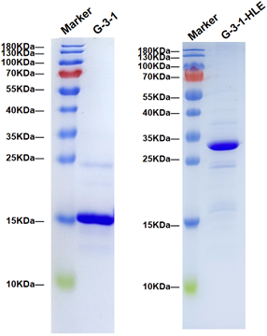
Fig. S1. SDS-PAGE (12.5%) analysis of G-3-1 (left) and G-3-1-HLE (right) under reducing conditions.

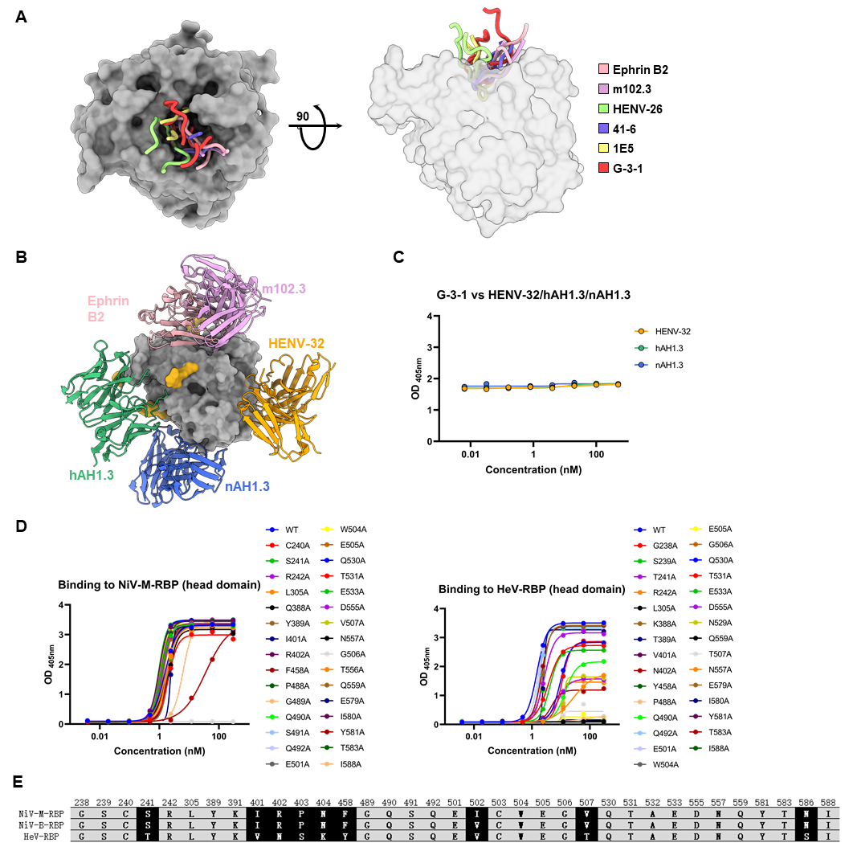
Fig. S2. Epitope characterization of G-3-1. A Superimposition of the CDRH3 regions of representative antibodies and the loop of Ephrin B2 inserted into the cavity of the head domain, shown in top and side views. B Epitope mapping of the RBP head domain. Four representative neutralizing antibodies and the receptor Ephrin B2 occupy four distinct epitopes on the head domain. The head domain is shown as a gray surface, with glycosylation sites highlighted in gold. C Competitive ELISA of G-3-1 with antibodies targeting the three epitopes outside the receptor-binding domain, where G-3-1 was used as the fixed antibody and the positive antibodies served as competitors. The experiment was performed twice and a representative result is shown.
D Binding of G-3-1 to 31 NiV_{M}-RBP head mutants or 30 HeV-RBP head mutants, as determined by ELISA-based alanine scanning. E Epitope information for G-3-1 obtained by analyzing the AlphaFold 3-predicted NiV_{M} RBP head/G-3-1 complex using PDBePISA server. The alignment of the epitope amino acid sequences across NiV_{M}-RBP, NiV_{B}-RBP, and HeV-RBP is shown. Conserved amino acids are shown in black with a gray background, while non-conserved amino acids are shown in white with a black background.

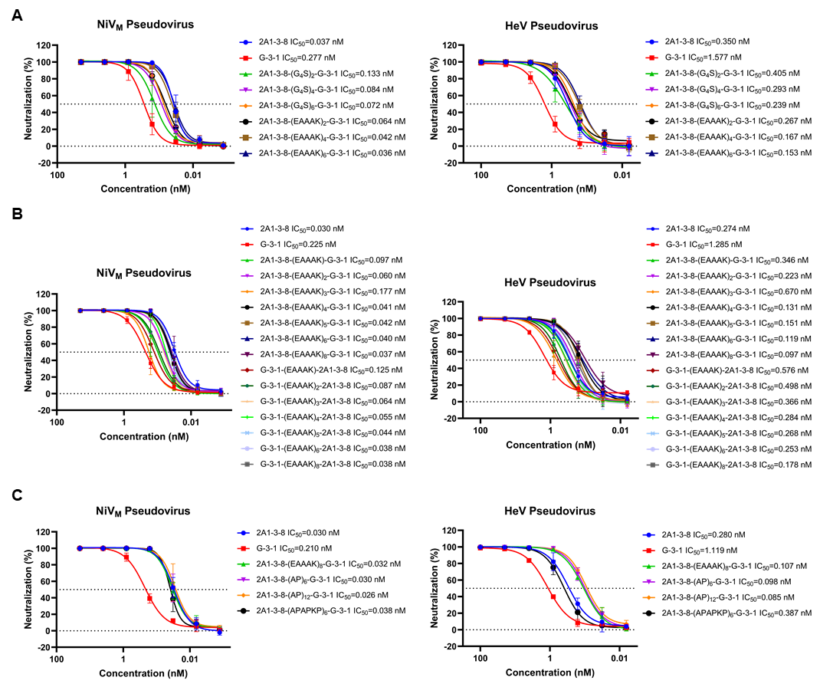
Fig. S3. Neutralizing activity of 2A1-3-8 and G-3-1 fusion proteins. A Neutralizing activity of fusion proteins constructed with flexible linkers (G₄S)_{n} or rigid linkers (EAAAK)ₙ against NiV_{M} and HeV pseudoviruses.
B Effect of the tandem order of 2A1-3-8 and G-3-1, as well as the length of the (EAAAK)_{n} linker, on the pseudoviruses neutralizing activity of the fusion proteins. C Effect of rigid linker types, (EAAAK)n and (AP)n, and their lengths on the neutralizing activity of the fusion proteins against pseudoviruses. Error bars indicate the mean ± SD of three biological replicates in A–C.

