Virologica Sinica
Supplementary Materials

Monocyte-associated C1q upregulation and complement activation contribute to vascular endothelial and multi-organ injury in severe dengue
Wei Yang ^{a, 1}, Qian Chen ^{a, 1}, Nan Yao ^{a, 1}, Zhe Li ª, Yi-Teng Zhang ª, Sheng-Nan Wang ª, Wei Wang ^{a, *}
ª National Center of Technology Innovation for animal model. National Human Diseases Animal Model Resource Center. Key Laboratory of Pathogen Infection Prevention and Control (Peking Union Medical College), Ministry of Education. NHC Key Laboratory of Comparative Medicine. Institute of Laboratory Animal Science, CAMS & PUMC, Beijing 100021, China.

¹ Wei Yang, Qian Chen and Nan Yao contributed equally to this work.

*Corresponding author:
Email: wangw@cnilas.org (W. Wang).
ORCID: 0000-0003-2802-5018 (W. Wang)

SUPPLEMENTARY MATERIALS
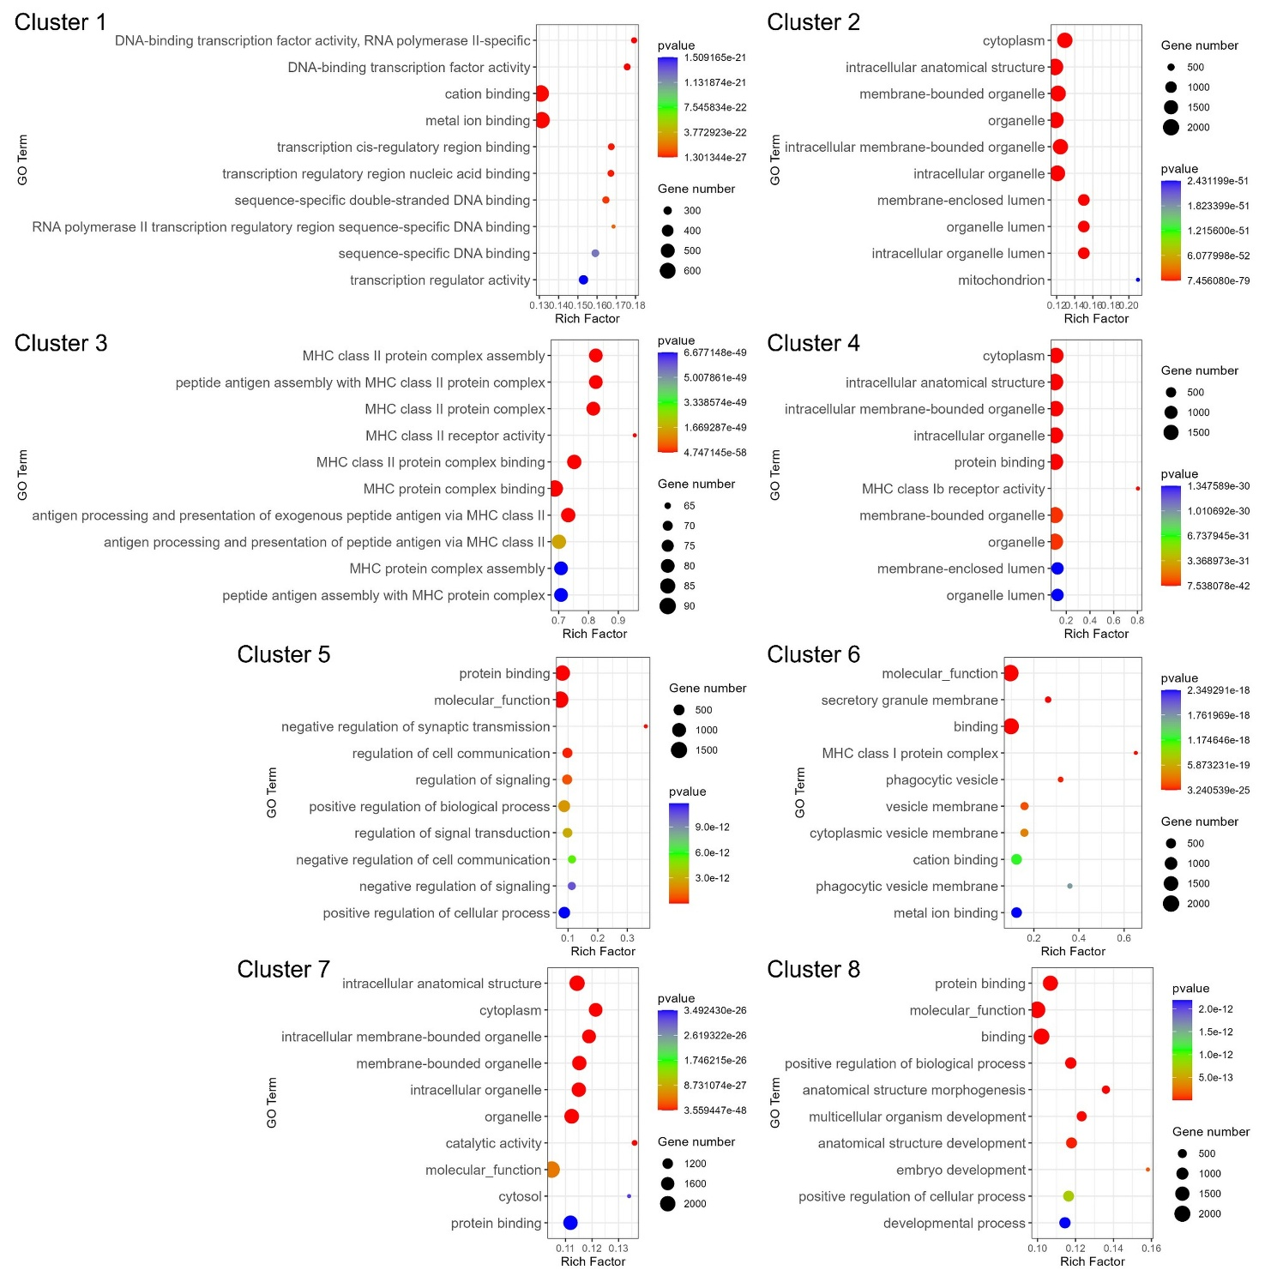
Supplementary Fig. S1. GO enrichment analysis of genes assigned to fuzzy expression clusters. Top 10 enriched Gene Ontology (GO) terms for genes assigned to Cluster 1–Cluster 8 identified by fuzzy c-means clustering of PBMC bulk RNA-seq profiles. The x-axis indicates the rich factor, and the y-axis indicates enriched GO terms. Dot size represents the number of enriched genes, and dot color represents the enrichment P value. Genes in Cluster 2 and Cluster 4 were enriched in biological terms related to intracellular organelles, cellular structures, and cellular functional processes, suggesting dynamic immune-cell transcriptional changes in dengue patients with warning signs and severe dengue.
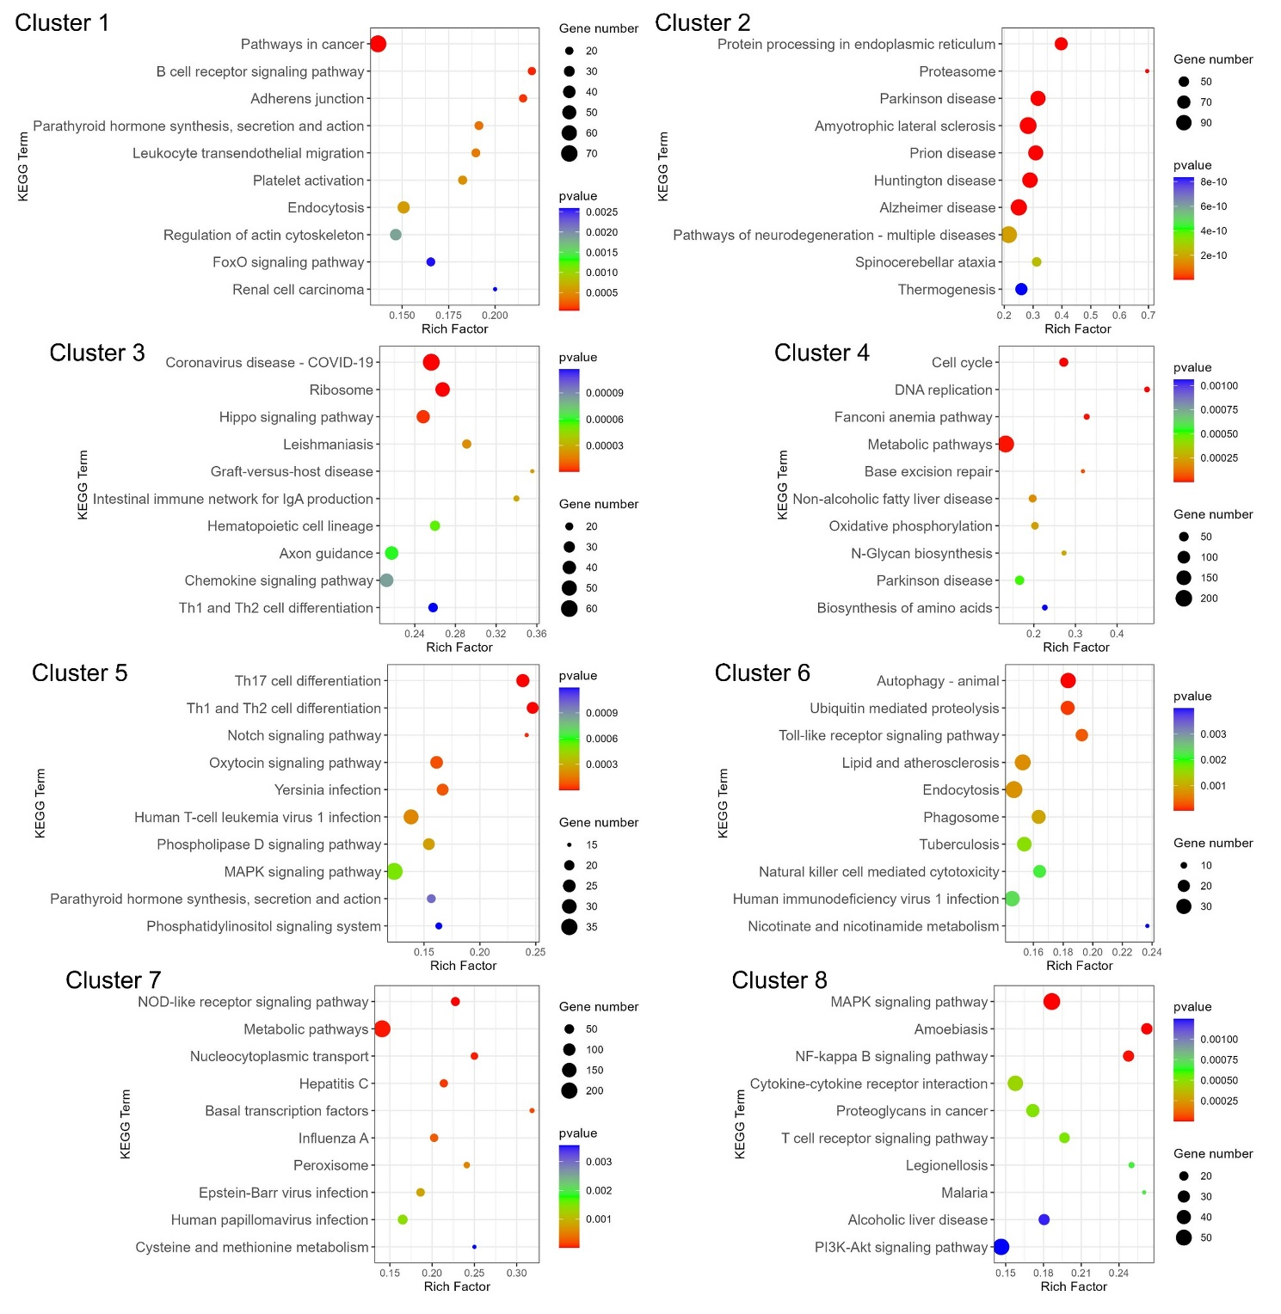
Supplementary Fig. S2. KEGG pathway enrichment analysis of genes assigned to fuzzy expression clusters. Top 10 enriched Kyoto Encyclopedia of Genes and Genomes (KEGG) pathways for genes assigned to Cluster 1–Cluster 8 from PBMC bulk RNA-seq profiles. The x-axis indicates the rich factor, and the y-axis indicates enriched KEGG pathways. Dot size represents the number of genes enriched in each pathway, and dot color represents the corresponding P value. The enrichment profiles reveal cluster-specific involvement of immune-related, metabolic, organelle-associated, and cellular homeostasis pathways during dengue disease progression.
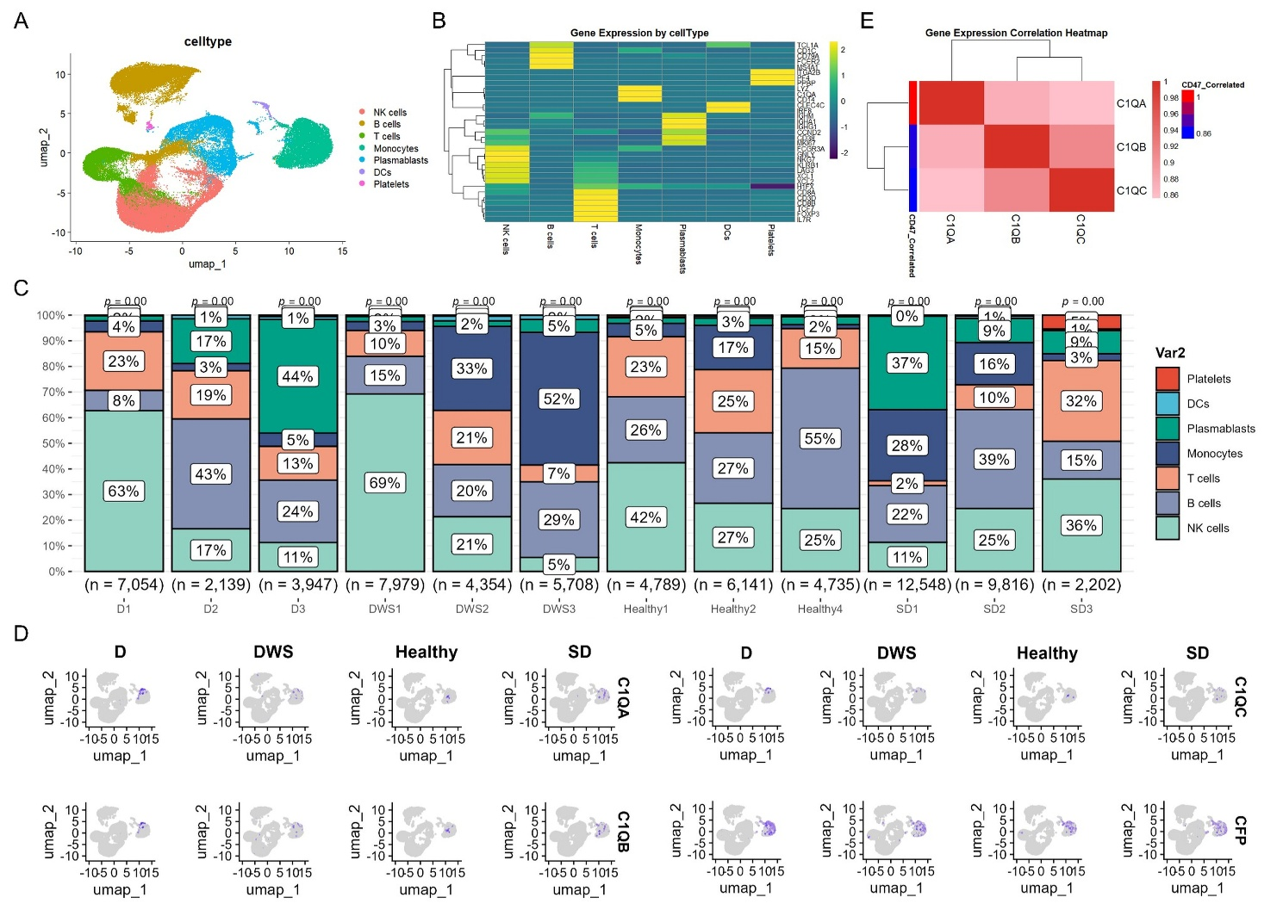
Supplementary Fig. S3. Single-cell annotation and C1Q expression patterns in PBMCs from dengue patients. A UMAP visualization of 71,412 PBMCs from Healthy, dengue fever (D), warning signs (DWS), and severe dengue (SD) groups. Cells were annotated into seven major populations: NK cells, B cells, T cells, monocytes, plasmablasts, DCs, and platelets. B Heatmap showing the expression of representative marker genes used for PBMC cell-type annotation. C Stacked bar plots showing the proportions of annotated PBMC cell types in each individual sample from the D, DWS, Healthy, and SD groups. The number of cells analyzed in each sample is indicated below the corresponding bar. D Feature plots showing the distribution of C1QA, C1QB, C1QC, and CFP expression on UMAP embeddings across clinical groups. E Pearson correlation heatmap showing the co-expression relationships among C1QA, C1QB, and C1QC in monocytes from dengue patients. The color scale indicates the correlation coefficient. These analyses support coordinated expression of C1Q genes in monocytes during dengue progression.
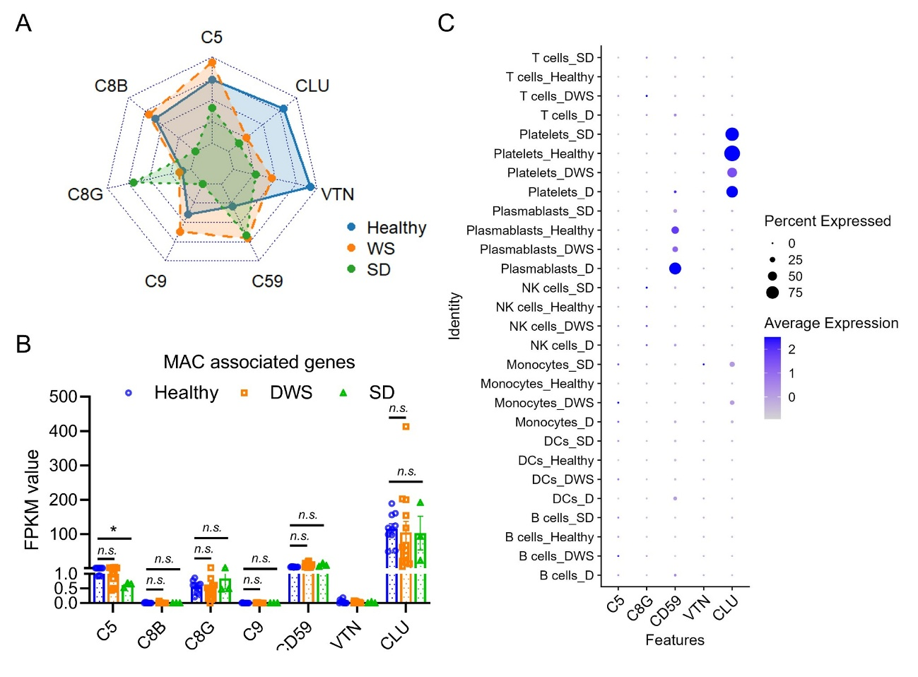
Supplementary Fig. S4. Terminal complement/MAC-related genes are not coordinately upregulated in PBMCs from severe dengue patients. A Radar plot showing the expression patterns of terminal complement and membrane attack complex (MAC)-related genes, including C5, C8B, C8G, C9, CD59, VTN, and CLU, in Healthy, warning signs (DWS), and severe dengue (SD) groups based on bulk RNA-seq analysis. B FPKM values of MAC-associated genes in PBMC bulk RNA-seq samples from Healthy, DWS, and SD groups. No coordinated SD-specific transcriptional upregulation of terminal complement components or terminal complement regulators was observed. C Dot plot showing the expression of MAC-related genes across PBMC cell types and clinical groups in the single-cell RNA-seq dataset. Dot size represents the percentage of cells expressing the indicated gene, and color intensity represents the average expression level. CLU was mainly detected in platelets, whereas CD59 was prominently expressed in plasmablasts. Together, these data suggest that increased MAC deposition in severe dengue is more likely associated with enhanced terminal complement activation and C5b-9 assembly rather than broad transcriptional induction of MAC-component genes in circulating immune cells. n.s., not significant; *P < 0.05.

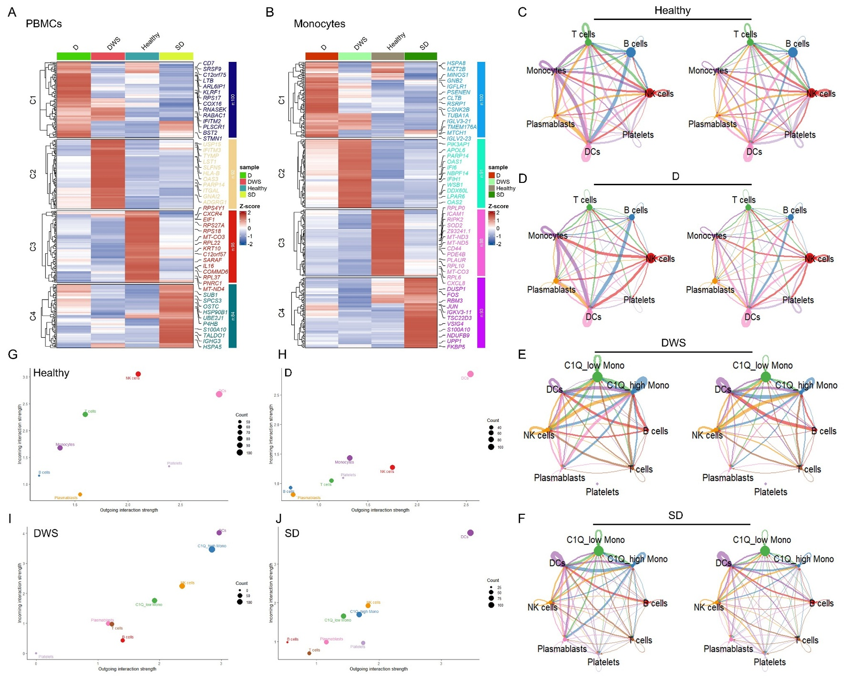
Supplementary Fig. S5. Extended transcriptomic clustering and CellChat analysis of PBMCs and monocytes during dengue progression. A, B Heatmaps showing the top 100 significant DEGs identified by ClusterGVis analysis in PBMCs (A) and monocytes (B) from Healthy, dengue fever (D), warning signs (DWS), and severe dengue (SD) groups. Genes were divided into four clusters according to their stage-associated expression patterns. Representative genes are labeled on the right side of each heatmap, and color represents the scaled expression Z score. C–F Circle plots showing the global CellChat-inferred intercellular communication networks among major PBMC populations in Healthy (C), D (D), DWS (E), and SD (F) groups. In DWS and SD groups, monocytes were separated into C1Q-high and C1Q-low subsets. Edge thickness represents the strength or number of inferred ligand–receptor interactions between cell populations. G–J Scatter plots showing outgoing and incoming interaction strengths of each cell population in Healthy (G), D (H), DWS (I), and SD (J) groups. Dot size represents the number of inferred interactions. C1Q-high monocytes showed prominent incoming and outgoing interaction strengths in DWS and SD groups, supporting their central position in the dengue-associated immune communication network.

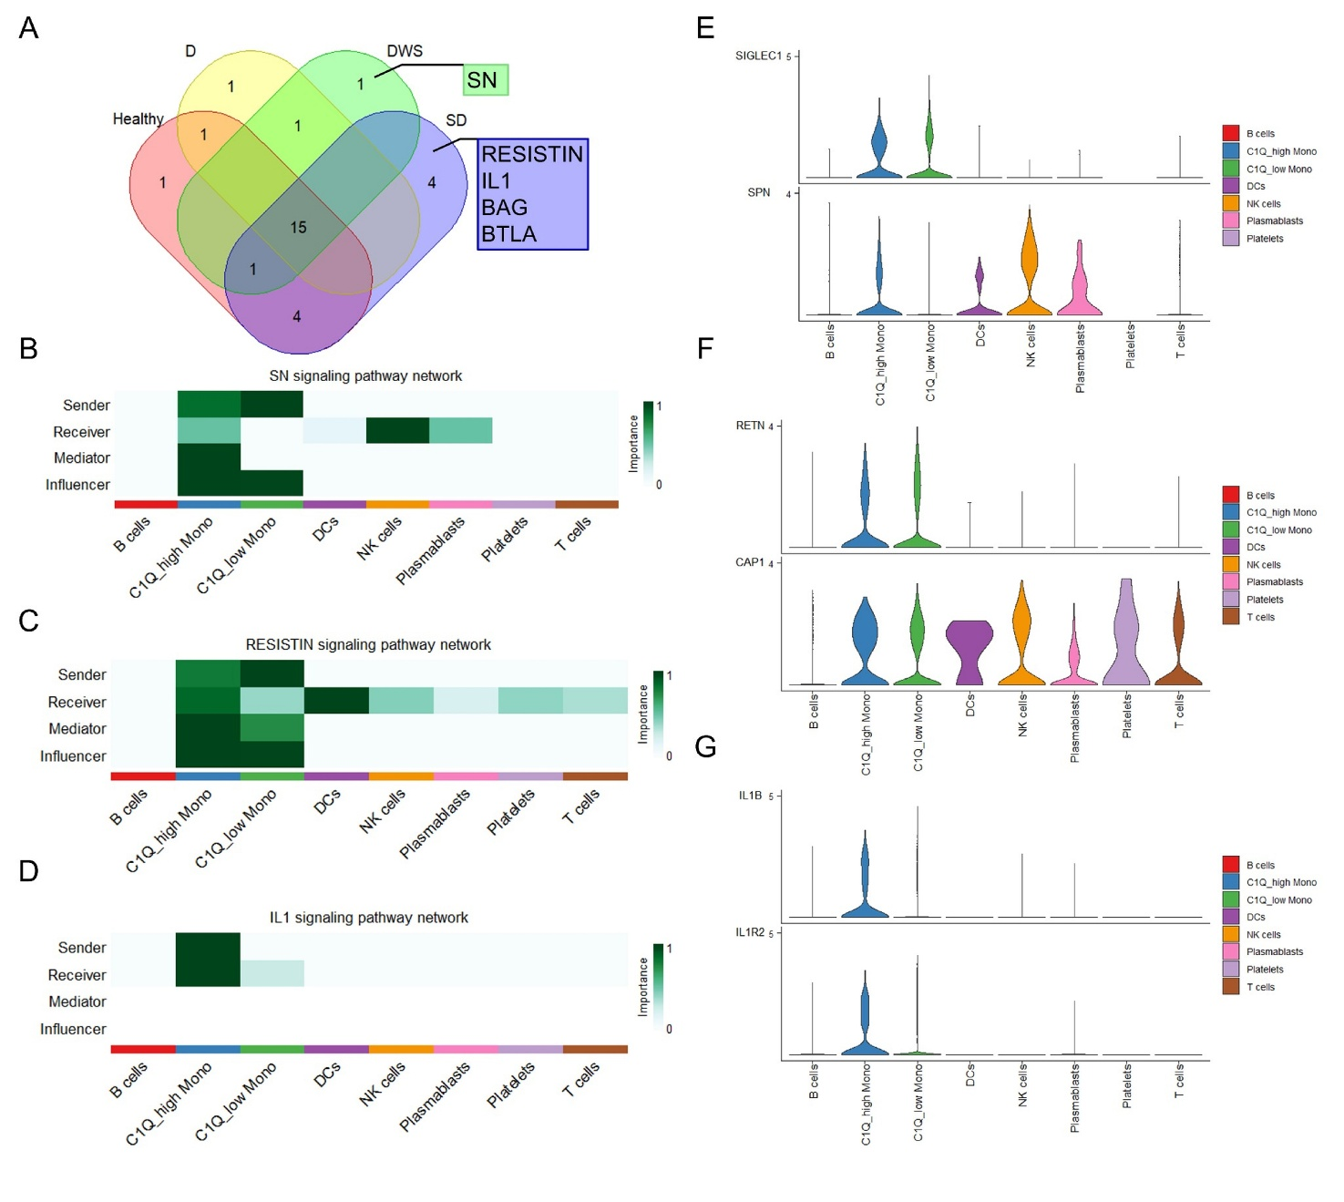
Supplementary Fig. S6. C1Q-high monocytes mediate disease-stage-specific signaling pathways in dengue patients. A Venn diagram showing shared and disease-stage-specific signaling pathways inferred by CellChat in Healthy, dengue fever (D), warning signs (DWS), and severe dengue (SD) groups. The SN signaling pathway was specifically identified in DWS patients, whereas RESISTIN, IL1, BAG, and BTLA signaling pathways were uniquely detected in SD patients. B–D Heatmaps showing the inferred roles of each immune cell population as sender, receiver, mediator, and influencer in the SN signaling pathway in DWS patients (B), the RESISTIN signaling pathway in SD patients (C), and the IL1 signaling pathway in SD patients (D). Color intensity indicates the relative importance score. C1Q-high monocytes showed prominent sender and/or mediator activities in these disease-stage-specific pathways. E–G Violin plots showing the expression of representative ligand–receptor genes involved in the SN pathway, including SIGLEC1 and SPN (E), the RESISTIN pathway, including RETN and CAP1 (F), and the IL1 pathway, including IL1B and IL1R2 (G), across immune cell populations. C1Q-high monocytes were the dominant source of IL1B expression in the IL1 signaling pathway, suggesting that this subset may contribute to the inflammatory immune microenvironment in severe dengue. Abbreviations: PBMCs, peripheral blood mononuclear cells; D, dengue fever; DWS, dengue with warning signs; SD, severe dengue; GO, Gene Ontology; DEGs, differentially expressed genes.
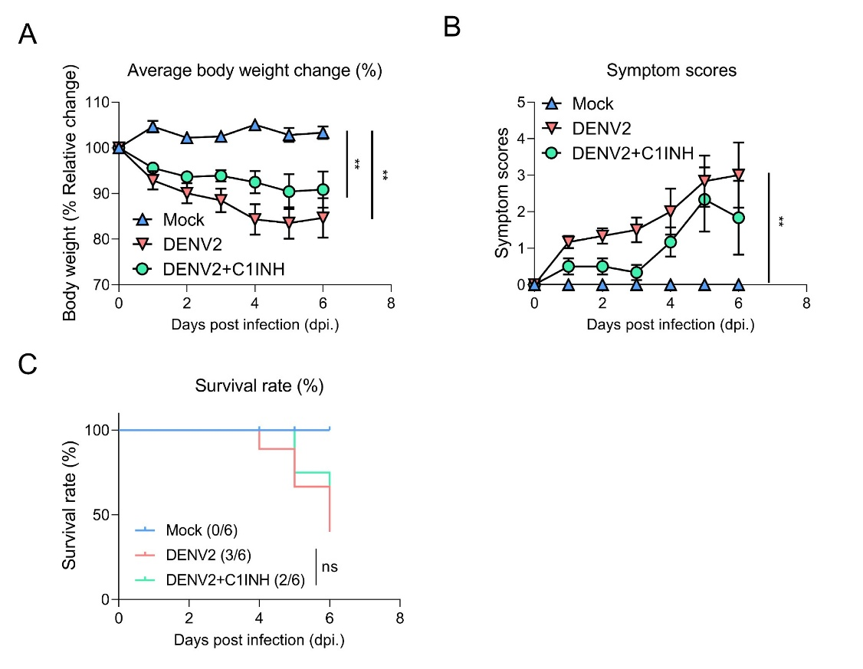
Supplementary Fig. S7. C1INH treatment attenuates disease progression in DENV2-infected IFNAR^{−/−} mice. A Average body weight changes in Mock, DENV2-infected, and C1INH-treated DENV2-infected mice after infection. Body weight is shown as the percentage relative to baseline (n = 6 mice for each group). B Clinical symptom scores of mice in each group during the course of infection (n = 6 mice for each group). C Kaplan-Meier survival curves of Mock, DENV2-infected, and C1INH-treated DENV2-infected mice (n = 6 mice for each group). Data are presented as mean ± SEM. Statistical significance is indicated in the figure. **P < 0.01.
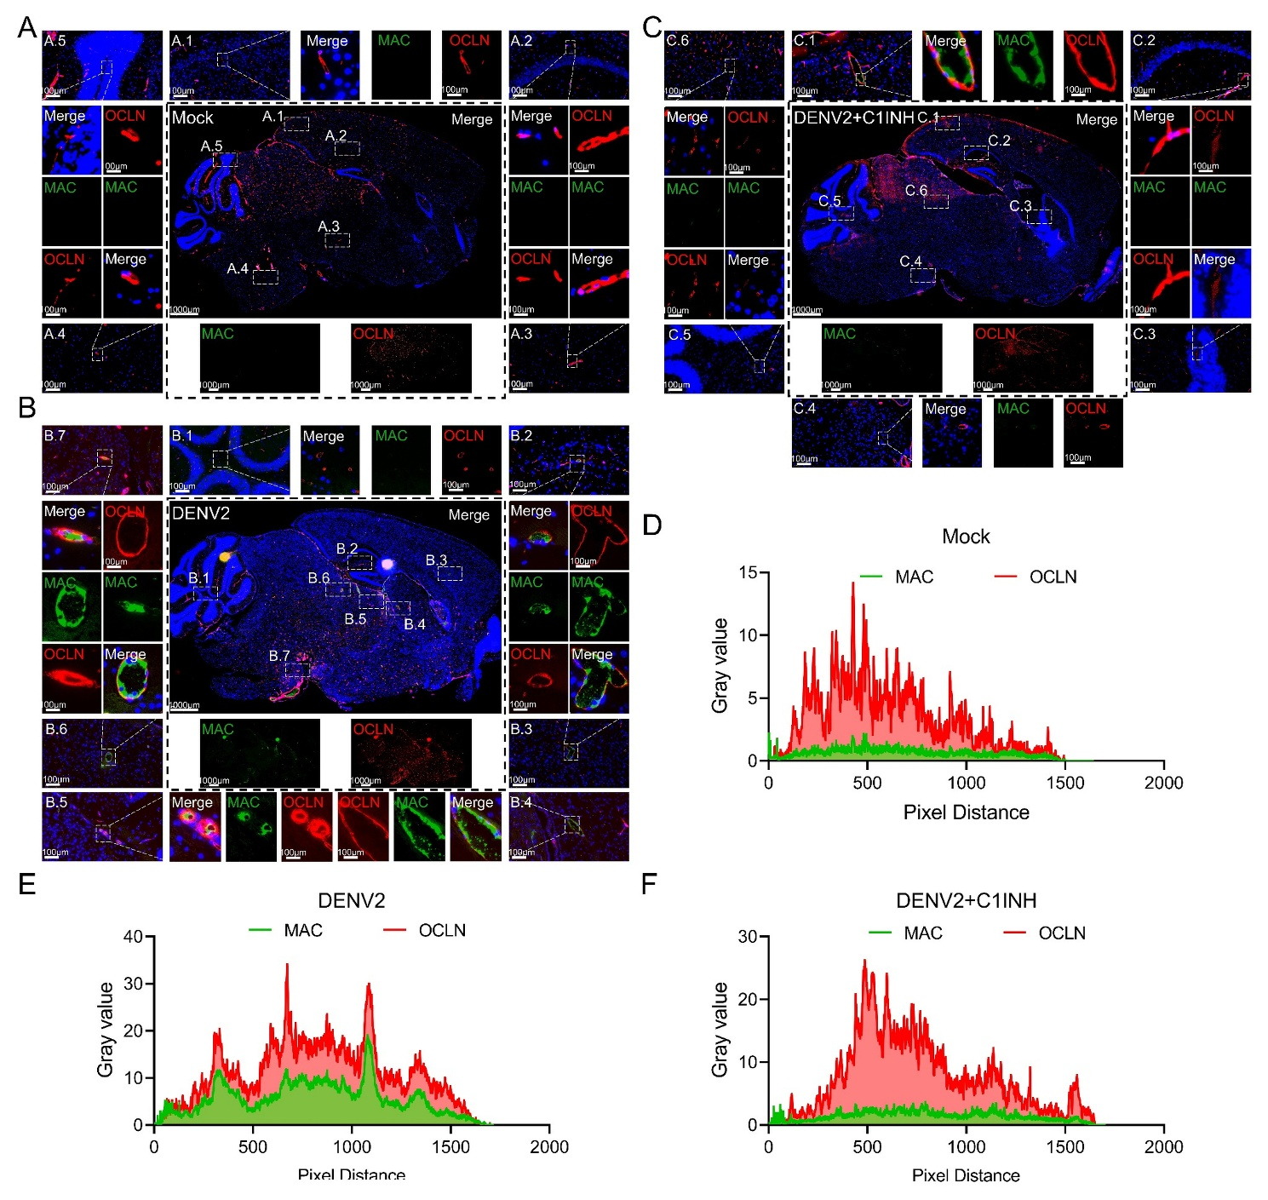
Supplementary Fig. S8. C1INH reduces MAC deposition and preserves OCLN distribution in brain tissues of DENV2-infected mice. A–C Representative immunofluorescence images of brain sections from Mock (A), DENV2-infected (B), and C1INH-treated DENV2-infected mice (C) at 6dpi. Sections were stained for MAC (green), OCLN (red), and nuclei (DAPI, blue). Dashed boxes indicate representative regions shown at higher magnification. DENV2 infection increased MAC deposition and disrupted the continuous vascular OCLN staining pattern, whereas C1INH treatment reduced MAC accumulation and partially restored OCLN distribution. Scale bars are indicated in the images. Scale bar, 1000 μm, 100 μm in enlarged panels. D–F Representative line-scan analysis of MAC and OCLN fluorescence intensity profiles in Mock (D), DENV2-infected (E), and C1INH-treated DENV2-infected mice (F). Gray values were plotted against pixel distance using ImageJ. The overlap between MAC and OCLN signals was increased after DENV2 infection and reduced following C1INH treatment.
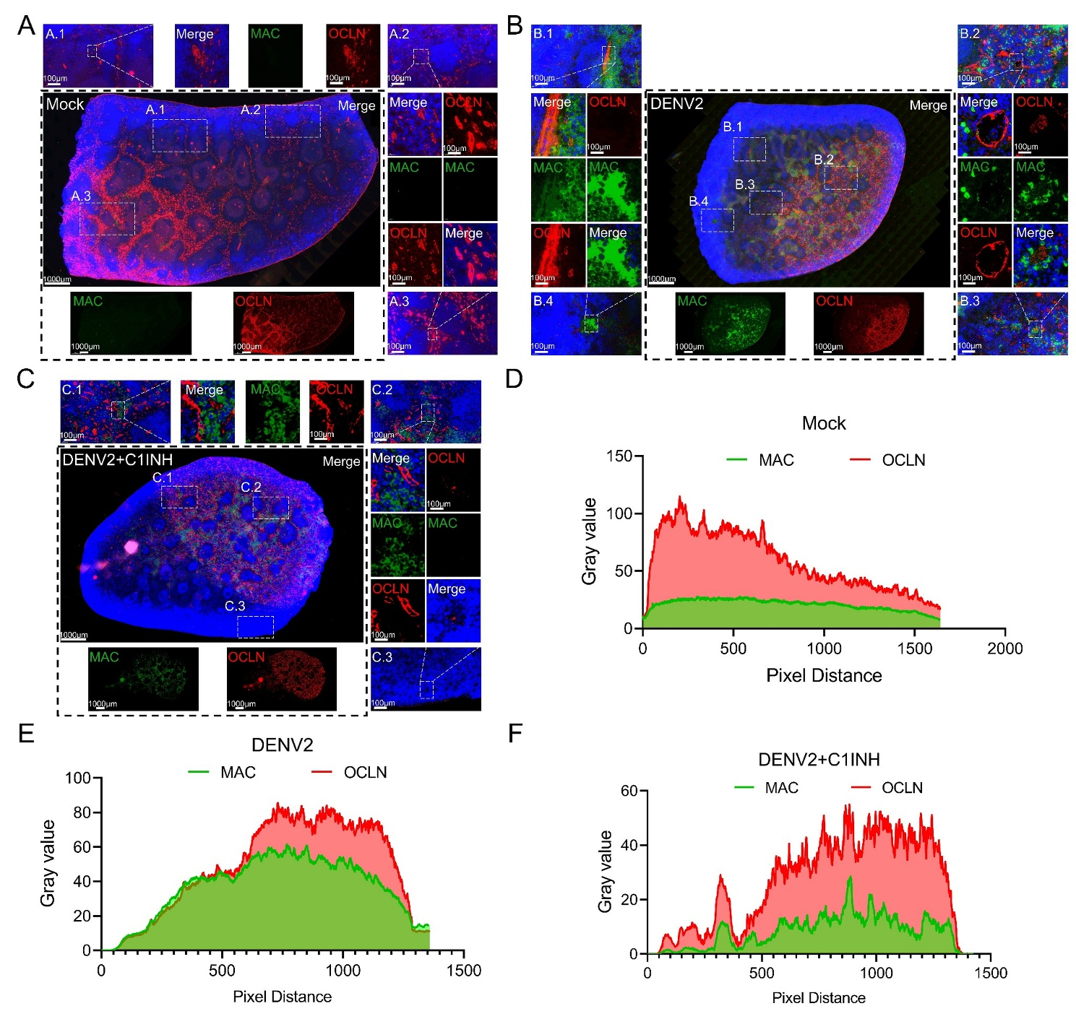
Supplementary Fig. S9. C1INH limits MAC deposition and vascular barrier disruption in spleens of DENV2-infected mice. A–C Representative immunofluorescence images of spleen sections from Mock (A), DENV2-infected (B), and C1INH-treated DENV2-infected mice (C) at 6dpi. Sections were stained for MAC (green), OCLN (red), and nuclei (DAPI, blue). Dashed boxes indicate representative regions shown at higher magnification. DENV2 infection induced marked MAC deposition and altered OCLN distribution in spleen tissues, whereas C1INH treatment decreased MAC signals and improved the continuity of OCLN staining. Scale bars are indicated in the images. Scale bar, 1000 μm, 100 μm in enlarged panels. D–F Representative line-scan analysis of MAC and OCLN fluorescence intensity profiles in Mock (D), DENV2-infected (E), and C1INH-treated DENV2-infected mice (F). DENV2 infection enhanced the spatial overlap between MAC and OCLN signals, while C1INH treatment reduced MAC-OCLN colocalization.
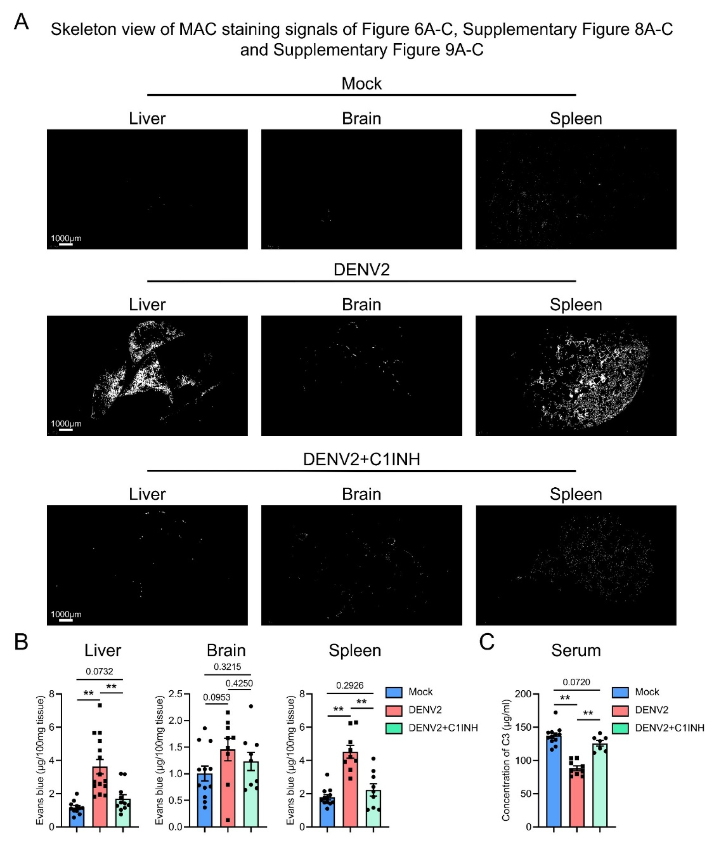
Supplementary Fig. S10. C1INH attenuates organ MAC deposition, vascular leakage, and systemic complement consumption in DENV2-infected mice. A Skeletonized views of MAC staining signals in liver, brain, and spleen sections from Mock, DENV2-infected, and C1INH-treated DENV2-infected mice. Images correspond to representative sections shown in Fig. 6A–C, Supplementary Fig. 8A–C, and Supplementary Fig. 9A–C. DENV2 infection induced extensive MAC deposition in multiple organs, whereas C1INH treatment markedly reduced MAC-positive signals. Scale bars are indicated in the images. B Evans blue permeability assay showing vascular leakage in liver, brain, and spleen tissues. Evans blue content was normalized to tissue weight and expressed as μg per 100 mg tissue. C1INH treatment significantly reduced DENV2-induced vascular leakage in multiple organs (n = 11–15 samples for each group). C Serum C3 concentrations measured by ELISA in Mock, DENV2-infected, and C1INH-treated DENV2-infected mice. DENV2 infection reduced circulating C3 levels, consistent with systemic complement activation and C3 consumption, whereas C1INH treatment partially restored serum C3 levels (n = 7–12 samples for each group). Data are presented as mean ± SEM. Statistical significance is indicated in the figure. *P < 0.05; **P < 0.01.
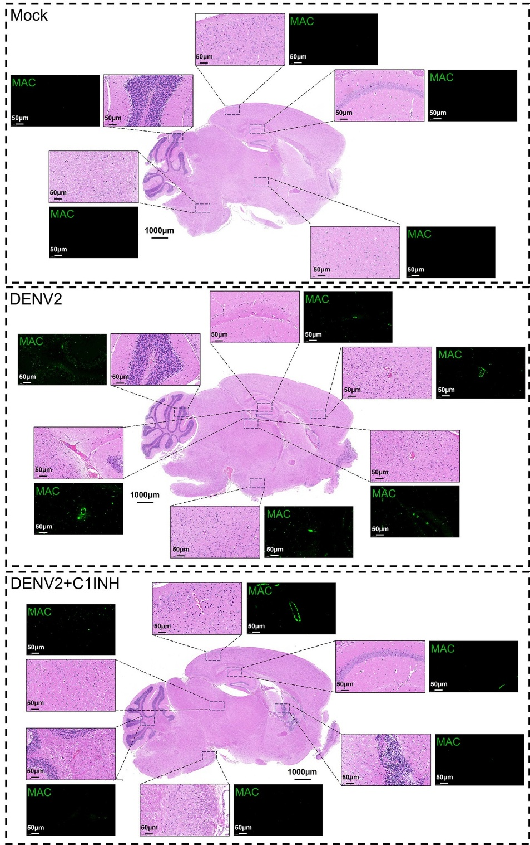
Supplementary Fig. S11. Histopathological changes and MAC deposition in brain tissues of DENV2-infected mice. Representative H&E-stained brain sections and corresponding MAC immunofluorescence images from Mock, DENV2-infected, and C1INH-treated DENV2-infected mice at 6 dpi. Dashed boxes indicate representative regions enlarged in the surrounding insets. DENV2 infection increased MAC-positive signals in brain tissues and was associated with local histopathological alterations. C1INH treatment reduced MAC deposition and alleviated tissue lesion areas. MAC is shown in green. Scale bars are indicated in the images. Scale bar, 1000 μm, 50 μm in enlarged panels.
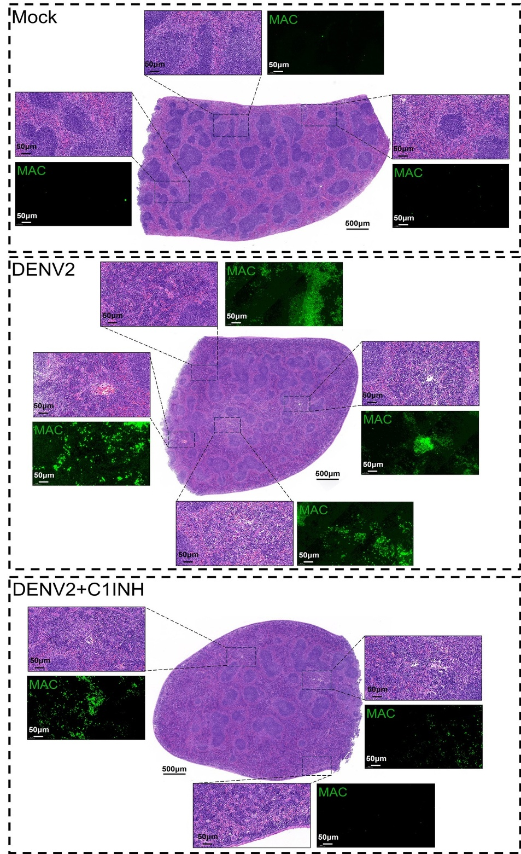
Supplementary Fig. S12. C1INH reduces MAC-associated splenic lesions in DENV2-infected mice. Representative H&E-stained spleen sections and corresponding MAC immunofluorescence images from Mock, DENV2-infected, and C1INH-treated DENV2-infected mice at 6 dpi. Dashed boxes indicate representative regions shown at higher magnification. DENV2 infection induced marked splenic tissue lesions accompanied by extensive MAC deposition, whereas C1INH treatment substantially decreased MAC-positive signals and reduced the extent of pathological injury. MAC is shown in green. Scale bars are indicated in the images. Scale bar, 1000 μm, 50 μm in enlarged panels.
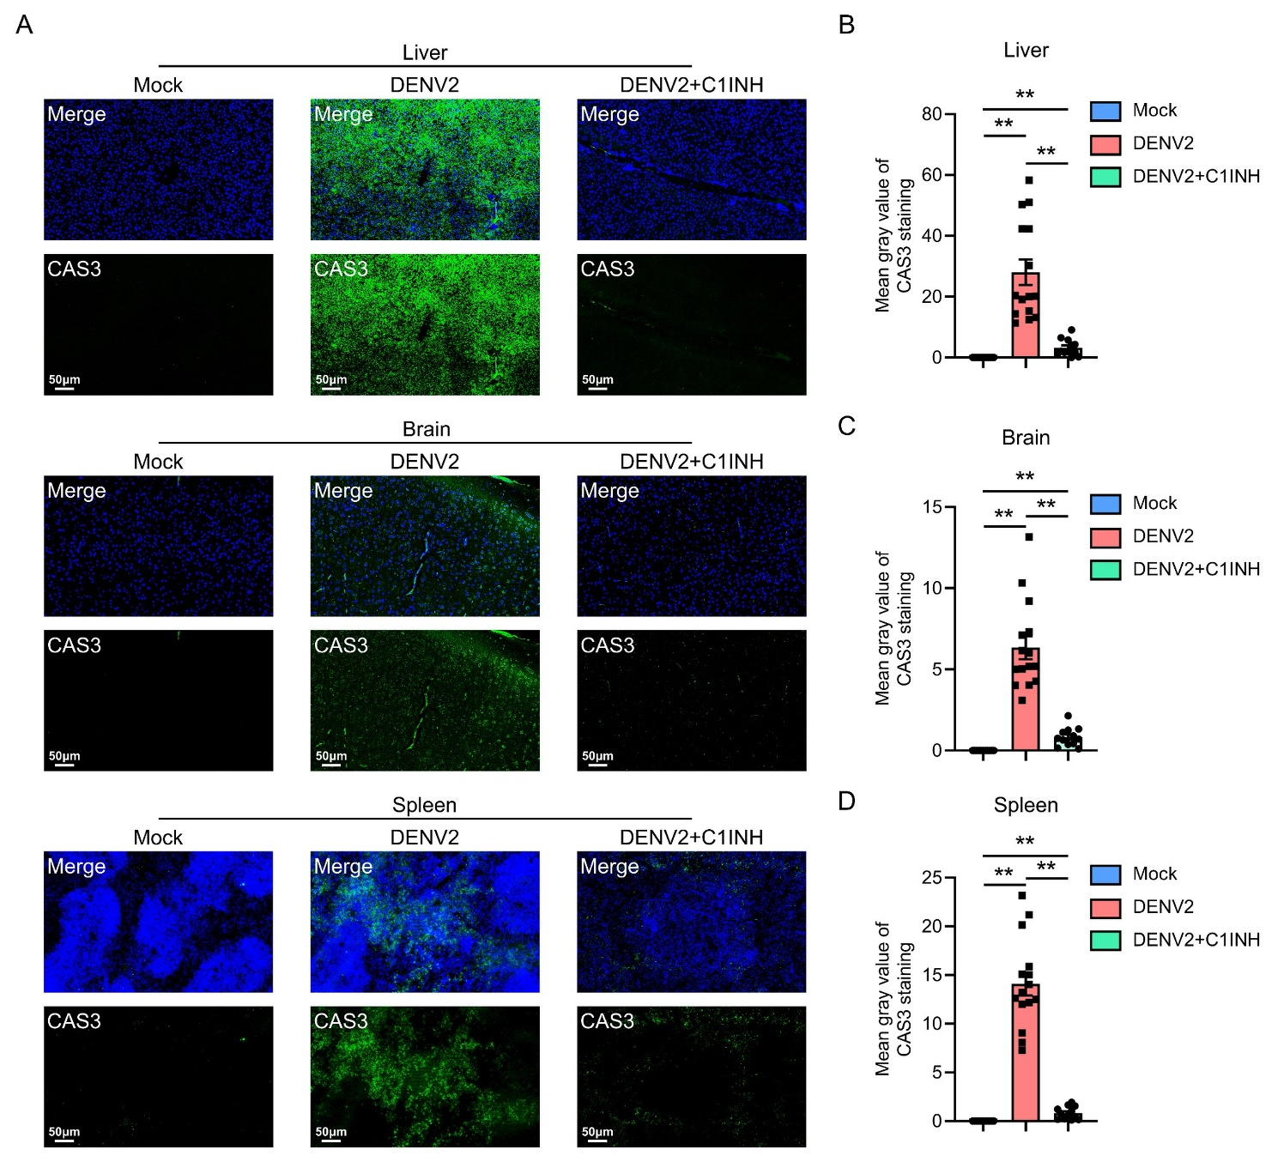
Supplementary Fig. S13. C1INH treatment decreases Caspase-3 expression in multiple organs of DENV2-infected mice. A Representative immunofluorescence images showing Caspase-3 expression in liver, brain, and spleen tissues from Mock, DENV2-infected, and C1INH-treated DENV2-infected mice at 6 dpi. Sections were stained for caspase-3 (CAS3, green) and nuclei (DAPI, blue). DENV2 infection markedly increased Caspase-3 signals in multiple organs, whereas C1INH treatment reduced Caspase-3 expression, consistent with attenuated apoptosis-associated tissue injury. Scale bars, 50 μm. B–D Quantification of CAS3 immunofluorescence intensity, expressed as the mean gray value of CAS3 staining, in the liver (B), brain (C), and spleen (D). DENV2 infection significantly increased CAS3 immunofluorescence signals in all three organs compared with the Mock group, whereas C1INH treatment significantly reduced CAS3 signals compared with the DENV2-infected group. **P < 0.01.

Supplementary Table S1 Primers and probes
Primers and probes | 5′-3′
DENV2 Forward primer | 5′-GARAGACCAGAGATCCTGCTGTCT-3′
DENV2 Reverse primer | 5′-ACCATTCCATTTTCTGGCGTT-3′
Probe | FAM-AGCATCATTCCAGGCAC-MGB
C1q Forward Primer | 5′-CGGGTCTCAAAGGAGAGAGA-3′
C1q Reverse Primer | 5′-TATTGCCTGGATTGCCTTTC-3′
MBL1 Forward Primer | 5′-CTTCTGCTTCCATTACT CCCTG-3′
MBL1 Reverse Primer | 5′-GCCTTTTGGTCCTGGACTTCC-3′
MASP1 Forward Primer | 5′-AC TTTCCGGTCAGA TTTCTCCA-3′
MASP1 Reverse Primer | 5′-TAGCCACCGATGTAGTTGTGA-3′
Complement factor B (CFB) Forward Primer | 5′-GAAAGCCAGTTGTGAGAGAG-3′
CFB Reverse Primer | 5′-AGAGGAACCGTGGAGTGA-3′
Complement factor P (CFP) Forward Primer | 5′-GGTAAAGTAGCCAACGAG TC-3′
CFP Reverse Primer | 5′-GCAGAAGGGTTCAGTAGTAG-3′
CASP3 Forward Primer | 5′-CTCGCTCTGGTACGGATGTG-3′
CASP3 Reverse Primer | 5′-TCCCATAAATGACCCCTTCATCA-3′
GAPDH Forward Primer | 5′-AATGGATTTGGACGCATTGGT-3′
GAPDH Reverse Primer | 5′-TTTGCACTGGTACGTGTTGAT-3′

