Virologica Sinica
Supplementary Materials

Recurrent intrahost G-gene haplotype structures suggest potential co-transmission in RSV-A
Jingqi Yang^{1, #}, Yuhua Liao^{1, #}, Luyao Qin^{1, #}, Haoyang Wang¹, Yun Ma¹, Ye Tong², Fei Deng², Liguo Zhu^{2, *}, Hang-Yu Zhou^{1, *}, Aiping Wu^{1, *}
¹ State Key Laboratory of Common Mechanism Research for Major Diseases, Suzhou Institute of Systems Medicine, Chinese Academy of Medical Sciences & Peking Union Medical College, Suzhou, 215123, China
² Department of Acute Infectious Disease Control and Prevention, Jiangsu Provincial Center for Disease Control and Prevention, Nanjing, 210009, China
# Jingqi Yang, Yuhua Liao, Luyao Qin contributed equally to this work.

* Corresponding authors.
E-mail address: wap@ism.cams.cn (A. Wu), zhy@ism.cams.cn (H.-Y. Zhou), zhuliguo2002@163.com (L. Zhu)
ORCID: 0000-0002-5869-651X (A. Wu), 0000-0002-3762-2319 (H.-Y. Zhou), 0000-0002-0636-4089 (L. Zhu)

Supplementary Figure
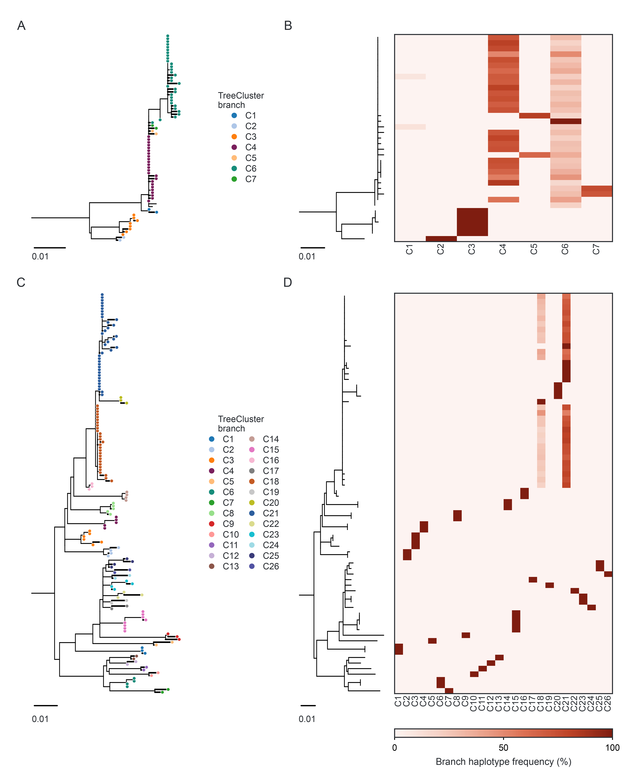
Supplementary Figure S1. Full branch structure and sample-level G-gene haplotype composition. A, C Maximum-likelihood trees of reconstructed G-gene haplotypes from the Australia (A) and United States (C) datasets. B, D Sample consensus G-gene trees with branch-composition heatmaps for Australia (B) and the United States (D). Each row represents one sample ordered by the consensus-tree tip order. Heatmap columns are branches, and color intensity shows the frequency of reconstructed haplotypes assigned to each branch.
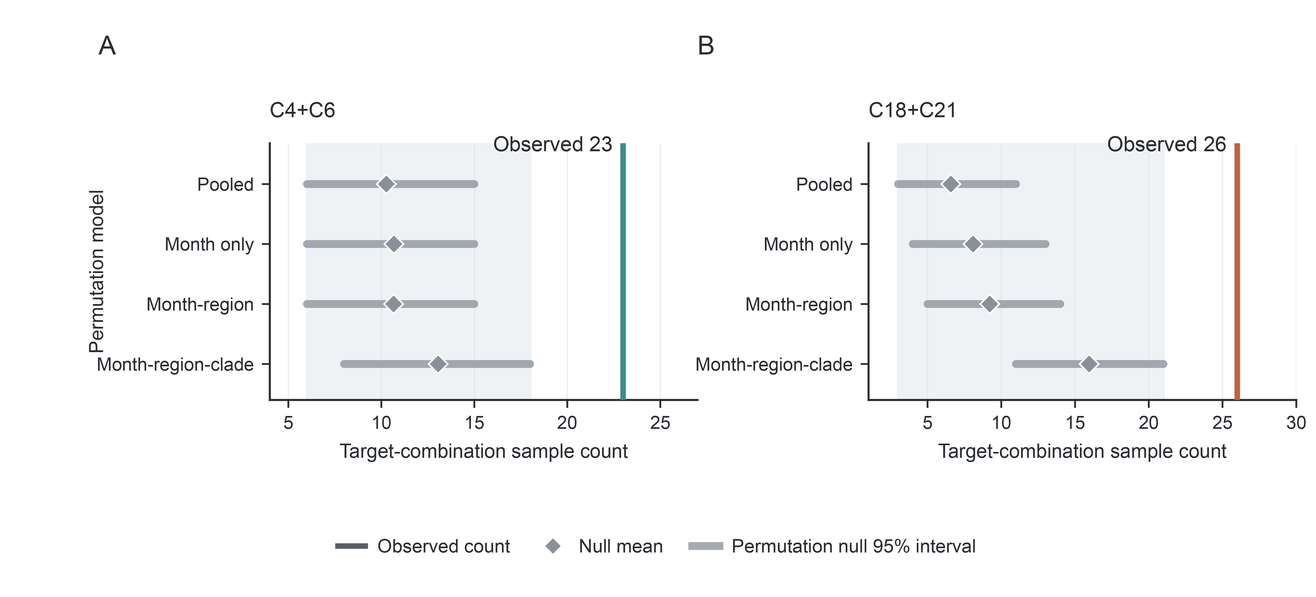
Supplementary Figure S2. Sensitivity of cross-branch pair enrichment to permutation stratification. Null distributions for Australia C4+C6 and United States C18+C21 were compared across four permutation schemes. The x axis shows the number of samples carrying the cross-branch pair. The y axis indicates the stratification scheme. Pooled indicates unstratified permutation. Month, month-region and month-region-clade indicate permutation within sampling month, within month and region, and within month, region and assigned clade, respectively. Colored vertical lines mark observed counts. Gray intervals show 95% intervals of the permutation-based null distributions, and gray diamonds show their means.
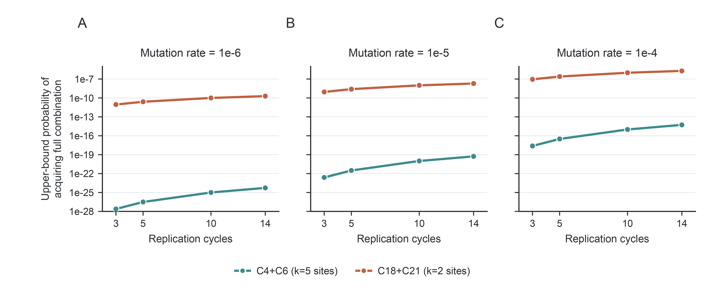
Supplementary Figure S3. De novo mutation plausibility analysis. The figure shows the estimated probability that the observed branch-defining site combinations could arise through within-host de novo mutation during a single infection. A-C Mutation rates of μ = 10⁻⁶, 10⁻⁵, and 10⁻⁴ substitutions per nucleotide per viral replication cycle, respectively. The x axis shows the assumed number of cycles. The y axis shows the estimated probability of acquiring the corresponding site combination in a single viral lineage. The teal line represents the five branch-defining sites in the Australia C4+C6 pair. The orange line represents the two branch-defining sites in the United States C18+C21 pair.
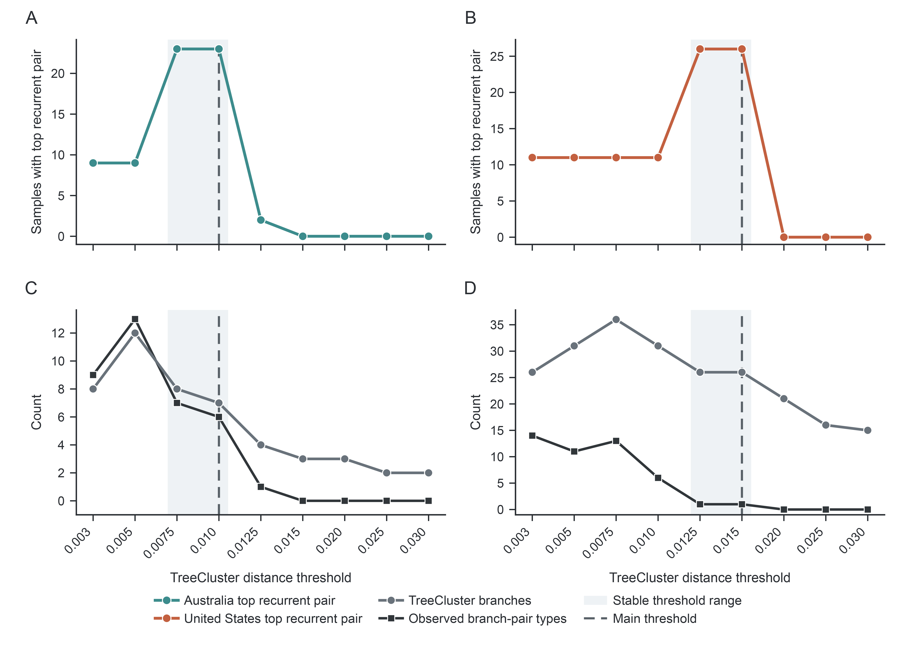
Supplementary Figure S4. Distance-threshold sensitivity of cross-branch pair detection. The x axis shows the clustering distance threshold used to assign local branches on the haplotype tree. Dashed vertical lines mark the main-analysis thresholds (Australia, 0.010; United States, 0.015). A, B At each threshold, the most recurrent cross-branch pair was counted across samples. Colored lines show observed sample counts. C, D Numbers of branches and observed cross-branch pair types across the same thresholds. Low thresholds fragmented the tree, whereas high thresholds merged branches. The selected thresholds preserved the dominant recurrent cross-branch combinations without evidence of over-merging. For the focal combinations, Australia C4+C6 was recovered in the same 23 samples at thresholds 0.0075 and 0.010, whereas thresholds of 0.0125 and above merged the relevant branches. United States C18+C21 was recovered in the same 26 samples at thresholds 0.0125 and 0.015, whereas thresholds of 0.020 and above merged the relevant branches.

