Virologica Sinica
Supplementary Data

Structural insight into EV-A71 3A Protein and Its Interaction with a Peptide Inhibitor

Yahui Liu ^{a, 1}, Panjing Lv ^{a, 1}, Wei Wang ^{b}, Jiahai Zhang ^{c}, Xi Zhou ^{d}, Yang Qiu ^{d}, Kun Cai ^{e, *}, Haoran Zhang ^{a, *},
Yuan Fang ^{d, *}, Yan Li ^{a, f, *}

a Department of Pathogen Biology, School of Basic Medicine, Tongji Medical College and State Key Laboratory for Diagnosis and Treatment of Severe Zoonotic Infectious Diseases, Huazhong University of Science and Technology, Wuhan, 430030, China
b Medical Subcenter of HUST Analytical & Testing Center, Huazhong University of Science and Technology, Wuhan, 430030, China
c MOE Key Laboratory for Membraneless Organelles and Cellular Dynamics, School of Life Sciences, Division of Life Sciences and Medicine, University of Science and Technology of China, Hefei, 230027, China
d State Key Laboratory of Virology, Wuhan Institute of Virology, Chinese Academy of Sciences, Wuhan, 430071, China
e Institute of Health Inspection and Testing, Hubei Provincial Center for Disease Control and Prevention (Hubei CDC), Wuhan, 430079, China
f Department of Pediatrics, Tongji Hospital, Tongji Medical College, Huazhong University of Science and Technology, Wuhan, 430030, China

¹ Yahui Liu and Panjing Lv contributed equally to this work.

*Corresponding authors:
E-mail address: yanli@hust.edu.cn (Y. Li); fangyuan_125@163.com (Y. Fang); hrzhang@outlook.com (H. Zhang); ckreal@163.com (K. Cai)
ORCID: 0000-0003-1963-839X (Y. Li); 0009-0009-6968-3739 (Y. Fang); 0000-0002-4104-7062 (H. Zhang); 0000-0002-4321-133X (K. Cai)

Materials and methods

Plasmid construction
The EV-A71 3A_{1–57} fragment was cleaved by NcoI and XhoI restriction endonucleases and ligated with T4 ligase to the pre-cleaved optimized pET-28a vector, with a poly-histidine (6×His)-tag and a SUMO-tag at its N-terminus. The recombinant construct (named 6×His-SUMO-3A₁₋₅₇ later) was transformed into Top10 chemically competent E. Coli for plasmid amplification and positive clones were selected for sequencing. The correct 6×His-SUMO-3A_{1–57} plasmid was transformed into BL21 STAR (DE3) chemically competent E.Coli and cultured in media containing Kanamycin (50 μg/mL) at 37 °C until an OD₆₀₀ of ∼0.6 was reached. A final concentration of 0.5 mmol/L Isopropyl β-D-thiogalactopyranoside (IPTG) was added to induce the expression of the target protein at 18 °C for 20 hours. Luria-Bertani (LB) media were used to obtain unlabeled protein, and M9 minimal media with ¹³C-glucose, ¹⁵NH₄Cl, and D₂O (Cambridge Isotope Laboratories) were used to obtain isotopically-labeled protein.

Protein expression and purification
The bacteria were harvested and resuspended in buffer A (50 mmol/L Tris, 500 mmol/L NaCl, 5% glycerol, 1 mmol/L TCEP, pH 8.0). The resuspension was mixed with protease inhibitors and lysed by French press at 900 bar for 2 min before being centrifugated at 20,300 ×g for 45 min at 4 °C. The supernatants were loaded into a HisTrap FF chromatography column (GE Healthcare, The Bronx, NY, USA) pre-equilibrated with 10 column volumes (CV) of buffer A. The soluble 6×His-SUMO-3A_{1–57} protein was competitively eluted by imidazole via a gradient procedure with buffer A and buffer B (50 mmol/L Tris, 500 mmol/L NaCl, 5% glycerol, 1 mmol/L TCEP, 350 mmol/L imidazole, pH 8.0). The soluble 6×His-SUMO-3A_{1–57} proteins were mixed with the ULP1 enzyme at a mass ratio of 1:50 overnight at 4 °C to cut off the SUMO-tag. The digested productions were diluted 15-fold with buffer C (30 mmol/L Tris, pH 8.0) to reduce the ionic strength and injected into the MONO Q column (GE Healthcare, The Bronx, NY, USA), which was pre-equilibrated with 10 CV of buffer C. The 6×His-SUMO-tag was removed depending on their different isoelectric point (pI) by a gradient volume procedure of 30 CV up to 25% buffer D (30 mmol/L Tris,1 mol/L NaCl, pH 8.0). Soluble 3A_{1–57} protein was homogenized via a gel filtration chromatography column-Hiload 75 16/600 increase (GE Healthcare, The Bronx, NY, USA) with buffer E (20 mmol/L HEPES, 150 mmol/L NaCl, 1 mmol/L TCEP, pH 7.0), and concentrated by ultra-centrifugal concentrators (MWCO 3 kDa). The purity of the protein was checked by Tricine SDS-PAGE.

Peptide
The peptide ER-DRI (rcyqrveepprrrqrrkkrgy, comprising D-amino acids in a retro-reversed sequence) was synthesized using the previously published method (Fang et al., 2021). The peptide was dissolved in ultrapure water with a concentration of 2 mM stock for in vitro and 10 mg/ml stock for in vivo experiment.

Backbone resonance assignment
The [¹³C,¹⁵N]-labeled 3A_{1–57} protein was prepared in buffer E and used for data acquisition. Backbone assignment of 3A_{1–57} at a concentration of 0.6 mmol/L was achieved from 2D ¹H-¹⁵N HSQC, 3D HNCACB, CBCA(CO)NH, HNCA, HN(CO)CA, HN(CA)CO, HNCO, and ¹⁵N-edited NOESY-HSQC experiments. All the above NMR spectra were recorded at 298 K on a Bruker Avance 600 MHz spectrometer equipped with a triple-resonance cryoprobe. The data were acquired using Topspin (version 4.1.0) from Bruker and processed with NMRPipe (Delaglio et al., 1995), Topspin (4.1.0), and analyzed with POKY (Lee et al., 2021). Secondary structure predictions of 3A_{1–57} were carried out using TALOS-N based on the chemical shifts of the backbone resonances (Shen and Bax, 2013).

Relaxation measurement
The ¹⁵N-labeled 3A_{1–57} protein was prepared in buffer E and was used to conduct NMR ¹⁵N relaxation measurements, including T₁ and T₂ relaxation times and {¹H}-¹⁵N hhNOEs. Two sets of 2D experiments of serial relaxation delays were recorded at 298K, 600 MHz for T₁ and T₂ measurements, and 2D hNOE spectra were recorded at the same condition for hNOE measurements. T₁ values were calculated with relaxation delays of 11.2, 61.6, 142, 243, 364, 525, 757 (×2), and 1150 ms, while T₂ values were determined with relaxation delays of 0, 17.6, 35.2, 52.8, 70.4, 105.6, and 140.8 ms. The hNOEs were obtained in interleaved spectra with and without a 3-s ¹H pre-saturation, the latter being replaced by a 3-s relaxation delay. Peak heights of different relaxation times were used for data analysis. POKY was used to fit exponential decay curves to the experimental serial data for determining R₁ and R₂ rates, where standard errors of rate constants were estimated by the spread in 10,000 repeated Gaussian distribution fits for random noise perturbing peak heights.

Titration assays
The ¹⁵N-labeled 3A_{1–57} protein at a concentration of 0.1 mmol/L was stepwise titrated with ER-DRI of natural abundance in four experiments (with a molar ratio of 1:0, 1:2, 1:4, and 1:8, respectively). ¹H-¹⁵N HSQC spectra were recorded at 298 K on a Bruker Avance 600 MHz spectrometer equipped with a triple-resonance cryoprobe to monitor the changes in chemical shift, the disappearance of the initial signals, or the appearance of additional signals. The data were processed and visualized by Topspin, NMRPipe (Delaglio et al., 1995), and POKY (Lee et al., 2021). Chemical shift mapping was determined using the average chemical shift change of the amide proton and nitrogen Δδ:
$∆δ=\sqrt{0.5×\left[∆δ{\left({}_{}^{1}H\right)}^{2}+{\left(\frac{Υ({}_{}^{15}{N)}}{Υ({}_{}^{1}{H)}}×∆δ\left({}_{}^{15}N\right)\right)}^{2}\right]}$
Where δ(¹H) and δ(¹⁵N) represent the chemical shifts in the ¹H and ¹⁵N dimension, respectively; γ(¹H) and γ(¹⁵N) represent the magnetogyric ratios of the ¹H and ¹⁵N nulcei, respectively.

Molecular docking
The structure model for standalone EV-A71 3A was obtained with AlphaFold2 (Jumper et al., 2021) embedded in ColabFold (Mirdita et al., 2022), with the number of computation recycles set to 24 and the number of generated models set to 5. The model with the highest pLDDT was chosen for follow-up docking. The structure model for the D-peptide ER-DRI was generated with PEPstrMOD (Singh et al., 2015). Molecular docking was carried out via HADDOCK 2.4 webserver (Honorato et al., 2021; van Zundert et al., 2016). Residues on the binding interface identified from the chemical shift mapping described in this work were used as active sites of EV-A71 3A, while the 3A helix-mimicking part of ER-DRI (rcyqrvee) was used as active sites of ER-DRI. Residue D35 of EV-A71 3A, linking the two helices, was designated as fully flexible to allow for more possible conformations. The number of structures generated in rigid-body energy minimization stage, semi-flexible simulated annealing stage, explicit solvent refinement stage, and structures for clustering analysis were set to 10,000, 1000, 500, and 200, respectively. The docking model with the lowest HADDOCK score was used for structural analysis.

Reference
Delaglio, F., Grzesiek, S., Vuister, G.W., Zhu, G., Pfeifer, J., Bax, A., 1995. NMRPipe: A multidimensional spectral processing system based on UNIX pipes. J. Biomol. NMR 6, 277–293.
Fang, Y., Liu, Z., Qiu, Y., Kong, J., Fu, Y., Liu, Y., Wang, C., Quan, J., Wang, Q., Xu, W., Yin, L., Cui, J., Xu, Y., Curry, S., Jiang, S., Lu, L., Zhou, X., 2021. Inhibition of viral suppressor of RNAi proteins by designer peptides protects from enteroviral infection in vivo. Immunity 54, 2231-2244.e6.
Honorato, R.V., Koukos, P.I., Jiménez-García, B., Tsaregorodtsev, A., Verlato, M., Giachetti, A., Rosato, A., Bonvin, A.M.J.J., 2021. Structural Biology in the Clouds: The WeNMR-EOSC Ecosystem. Front. Mol. Biosci. 8, 729513.
Jumper, J., Evans, R., Pritzel, A., Green, T., Figurnov, M., Ronneberger, O., Tunyasuvunakool, K., Bates, R., Žídek, A., Potapenko, A., Bridgland, A., Meyer, C., Kohl, S.A.A., Ballard, A.J., Cowie, A., Romera-Paredes, B., Nikolov, S., Jain, R., Adler, J., Back, T., Petersen, S., Reiman, D., Clancy, E., Zielinski, M., Steinegger, M., Pacholska, M., Berghammer, T., Bodenstein, S., Silver, D., Vinyals, O., Senior, A.W., Kavukcuoglu, K., Kohli, P., Hassabis, D., 2021. Highly accurate protein structure prediction with AlphaFold. Nature 596, 583–589.
Lee, W., Rahimi, M., Lee, Y., Chiu, A., 2021. POKY: a software suite for multidimensional NMR and 3D structure calculation of biomolecules. Bioinformatics 37, 3041–3042.
Mirdita, M., Schütze, K., Moriwaki, Y., Heo, L., Ovchinnikov, S., Steinegger, M., 2022. ColabFold: making protein folding accessible to all. Nat. Methods 19, 679–682.
Shen, Y., Bax, A., 2013. Protein backbone and sidechain torsion angles predicted from NMR chemical shifts using artificial neural networks. J. Biomol. NMR 56, 227–241.
Singh, S., Singh, H., Tuknait, A., Chaudhary, K., Singh, B., Kumaran, S., Raghava, G.P.S., 2015. PEPstrMOD: structure prediction of peptides containing natural, non-natural and modified residues. Biol. Direct 10, 73.
van Zundert, G.C.P., Rodrigues, J.P.G.L.M., Trellet, M., Schmitz, C., Kastritis, P.L., Karaca, E., Melquiond, A.S.J., van Dijk, M., de Vries, S.J., Bonvin, A.M.J.J., 2016. The HADDOCK2.2 Web Server: User-Friendly Integrative Modeling of Biomolecular Complexes. J. Mol. Biol., Computation Resources for Molecular Biology 428, 720–725.

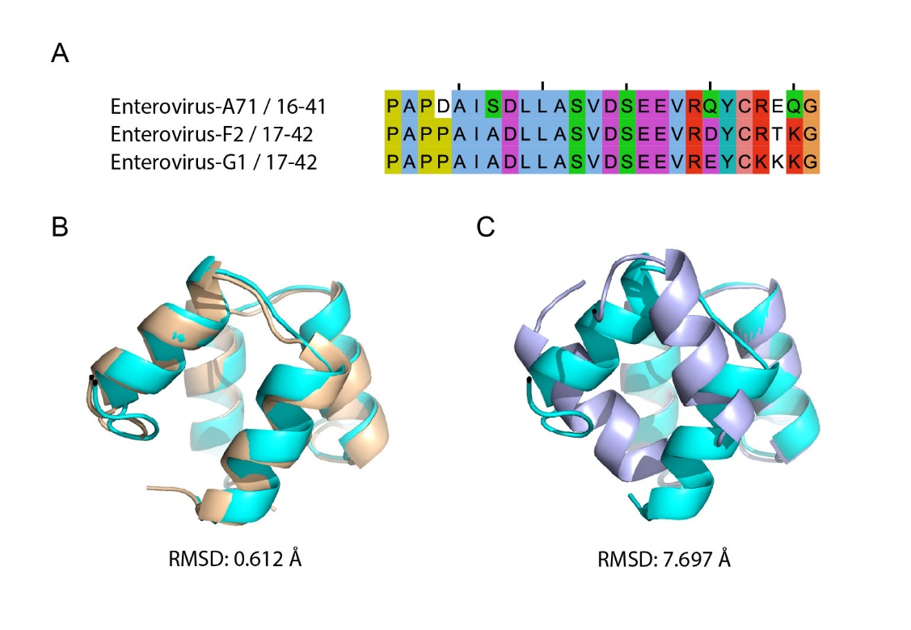
Supplementary Fig. S1. Comparison of the dimerization interface of the 3A proteins in Enterovirus A71, F2, and G1. A The multiple sequence alignment of the two helices that form the dimerization interface of the 3A in EV-A71, F2, and G1. B The superimposed structures of the dimeric 3A helices in EV-A71 (in cyan, PDB: 6HLW) and EV-G1 (in light brown, PDB: 6Q69), structurally aligned with PyMol with an overall RMSD of 0.612 Å. C The superimposed structures of the dimeric 3A helices in EV-A71 (in cyan, PDB: 6HLW) and EV-F2 (in light purple, PDB: 6Q68), with one of the two helical monomer structurally aligned with PyMol. The other helical monomer of EV-F2 is distinctly oriented compared to that of EV-A71 or EV-G1, and therefore resulting in an overall RMSD of 7.697 Å.

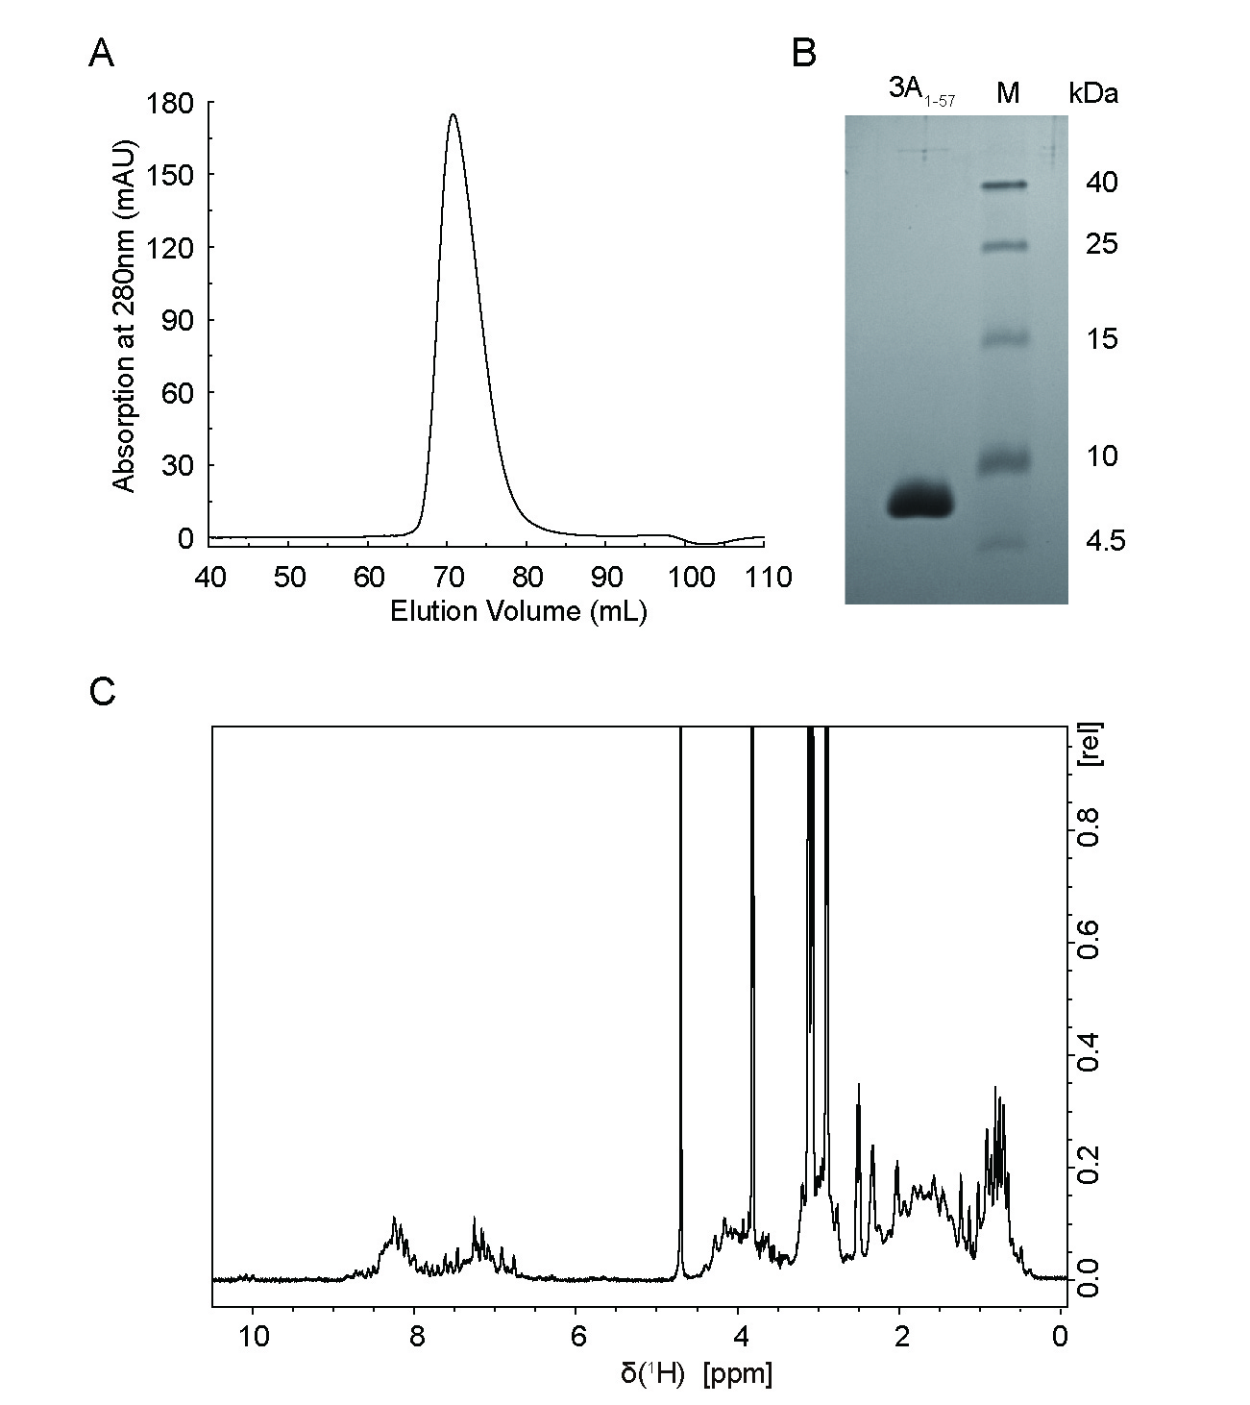
Supplementary Fig. S2. Purification and ¹H NMR characterization of EV-A71 3A_{1–57} protein. A 3A_{1–57} protein was homogenized via HiLoad 16/600 Superdex 75 gel filtration chromatography. B Tricine SDS-PAGE analysis of purified recombinant 3A_{1–57} protein. Lane M: low-range protein ladder; Lane 3A_{1–57}: purified 3A_{1–57} protein. C ¹H NMR spectrum of 3A_{1–57} protein.

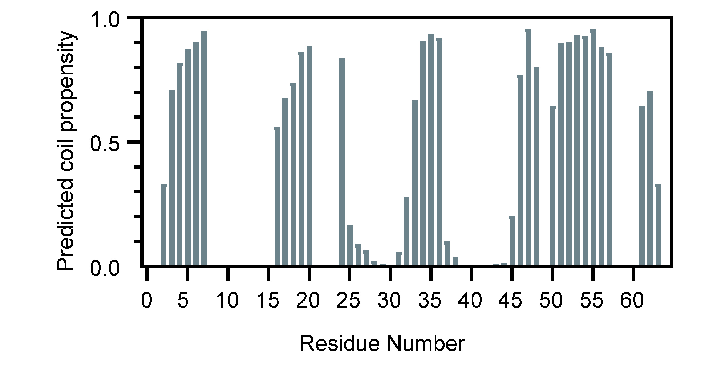
Supplementary Fig. S3. Coil propensity prediction of EV-A71 3A₁₋₅₇ based on TALOS-N. The possibility (0–1) predicted based on chemical shift for each residue to be coiled is plotted.

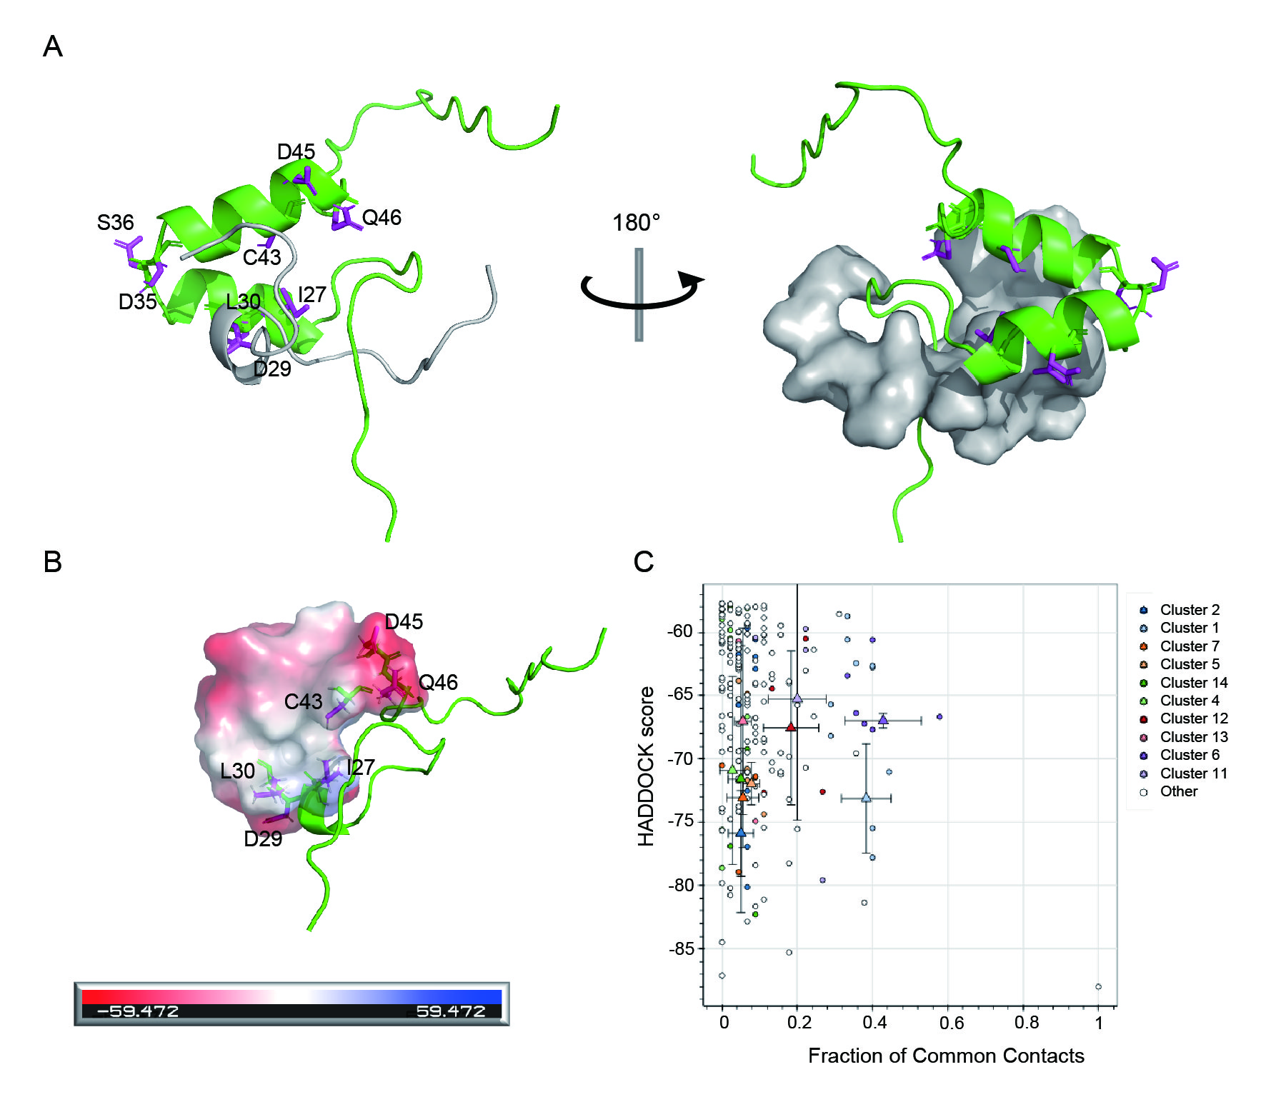
Supplementary Fig. S4. Details of the docking model of the 3A_{1–57} binding with ER-DRI using HADDOCK 2.4. A Display of the docking model. In the left panal, ER-DRI is shown in gray, and 3A_{1–57} is shown in green. The key amino acids experiencing NMR peak broadening were mapped onto 3A_{1–57} and were shown as sticks with the side chain in magenta. In the right panel where the proteins of the left panel were rotated 180°, ER-DRI is shown in gray surface, and 3A_{1–57} is shown in green. B The EV-A71 3A residues involved in the surface that is influenced by the binding to ER-DRI are highlighted as surface, with electrostatic distribution colored in blue for positive potential and red for negative potential, respectively. C The plot of the HADDOCK score distribution v.s. fraction of common contacts of the docking models. The HADDOCK score is a weighted sum of a variety of energy terms including van der Waals, electrostatic, desolvation, and restraint violation energies.

