Virologica Sinica

Supplementary Data

A new luciferase immunoprecipitation system assay provided serological evidence for missed diagnosis of severe fever with thrombocytopenia syndrome

Shengyao Chen ^{1, 3}, Minjun Xu ⁴, Xiaoli Wu ¹, Yuan Bai ¹, Junming Shi ¹, Min Zhou ¹, Qiaoli Wu ¹, Shuang Tang ¹, Fei Deng ^{1*}, Bo Qin ^{2, 4 *}, Shu Shen ^{1*}

1 State Key Laboratory of virology and National Virus Resource Center, Wuhan Institute of Virology, Chinese Academy of Sciences, Wuhan 430071, China;
2 Shaoxing Women and Children’s Hospital, No. 305 East Street Road, Shaoxing 312000, China
3 University of Chinese Academy of Sciences, Beijing 100049, China
4 Shaoxing People's Hospital, Zhejiang University School of Medicine, Shaoxing 312000, China

* Corresponding author.
Email: shenshu@wh.iov.cn (S. Shen), ORCID: 0000-0002-0013-5365
Email:qinbo0809@hotmail.com (B. Qin), ORCID: 0000-0003-2476-7903
Email: df@wh.iov.cn (F. Deng), ORCID: 0000-0002-5385-083X

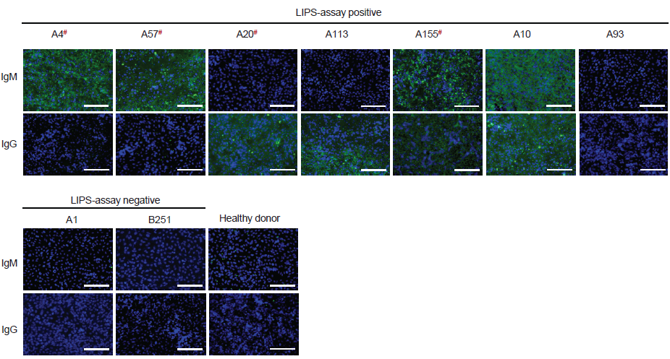

Figrue S1 IgM and IgG response to SFTSV in the serum samples from febrile patients were confirmed by IFAs. Images of representative samples were shown, including seven LIPS-positive samples, two LIPS-negative samples and one healthy donor samples. Samples having neutralization against SFTSV were indicated by a superscript pound sign in red. Scale bar =400 μm.

Table S1 Gender, age, and the time post illness onset of the 82 febrile patients having anti-SFTSV antibody as tested by LIPS
Anti-SFSTV positive patients |  | Positive samples (n, %) | P value
Gender | Male | 47, 10.1% | 0.033
 | Female | 35, 7.5%
Age | 21–40 | 13, 2.8% | <0.001
 | 41–60 | 13, 2.8%
 | ≥ 61 | 56, 12.1%
Day post illness onsetª | 1–7 | 46, 9.9% | <0.001
 | 8–14 | 8, 1.7%
 | 15–21 | 12, 2.6%
 | >3 weeks | 10, 2.2%
ª The days post illness onset was analysed based on 76 patients with detailed records.

