Virologica Sinica

Supplementary Data

PA-E18G substitution in influenza A virus confers resistance to ZX-7101, a cap-dependent endonuclease inhibitor

Dan Luo ^{a, 1}, Qing Ye ^{a, 1}, Rui-Ting Li ^{a, 1}, Hang-Yu Zhou ^{b, 1}, Jing-Jing Guo ª, Suo-Qun Zhao ª, Sen Zhang ª, Tao Jiang ª, Yong-Qiang Deng ^{a, *}, Cheng-Feng Qin ^{a,} *

ª State Key Laboratory of Pathogen and Biosecurity, Beijing Institute of Microbiology and Epidemiology, Academy of Military Medical Sciences, Beijing 100071, China.
^{b} State Key Laboratory of Medical Molecular Biology, Suzhou Institute of Systems Medicine, Chinese Academy of Medical Sciences & Peking Union Medical College, Suzhou 215123, China.

¹ Dan Luo, Qing Ye, Rui-Ting Li, and Hang-Yu Zhou contributed equally to this work.

*Corresponding author:
E-mail address: dengyq1977@126.com (Y.Q. Deng); qincf@bmi.ac.cn (C.F. Qin)
ORCID: 0000-0002-2306-1039 (Y.Q. Deng); 0000-0002-0632-2807 (C.F. Qin)

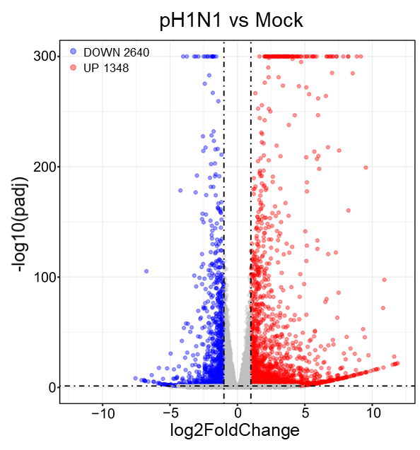
Supplemental Fig. S1. Differentially expressed genes result from pH1N1 infection. Volcano plots indicating differentially regulated genes of pH1N1 infection (pH1N1 vs Mock). The numbers of downregulated and upregulated genes were labeled in blue and red respectively.

Supplemental Table S1 Influenza A viruses with Gly18 of PA subunit
Viruses | Location | Substitution
A/swine/Indiana/A00968325/2010(H3N2) | PA | E18G
A/pheasant/Hong Kong/WF288W/2007(H9N2) | PA | E18G
A/turkey/Nigeria/08RS848-12/2006(H5N1) | PA | E18G
A/swine/Poland/134312/2012(H1N1) | PA | E18G
A/Vietnam/UT31412II/2008(H5N1) | PA | E18G
A/Utah/13/2016(H1N1) | PA | E18G
A/duck/Guangxi/149D24/2013(H4N6) | PA | E18G
A/swine/Indiana/A00968344/2011(H3N2) | PA | E18G
A/chicken/Nigeria/1047-54/2006(H5N1) | PA | E18G
A/California/MA_07/2009(H1N1) | PA | E18G
A/swine/Guangdong/3584/2011(H1N2) | PA | E18G
A/England/451/2009(H1N1) | PA | E18G
A/chicken/Wenzhou/3330/2013(H9N2) | PA | E18G
A/turkey/Poland/14/2013(H9N2) | PA | E18G
A/Gallinula chloropus/Guangdong/GZ174/2014(H5N6) | PA | E18G
A/guinea fowl/Italy/1847/2000(H7N1) | PA | E18G
A/Copsychus saularis/Guangdong/SW8/2014(H5N6) | PA | E18G
A/swine/Saskatchewan/SD0108/2015(H1N1) | PA | E18G
A/chicken/Nigeria/SO300/2006(H5N1) | PA | E18G
A/duck/Bangladesh/26188/2015(H5N1) | PA | E18G
A/chicken/Florida/22780-2/88(H5N2) | PA | E18G
A/duck/Guangxi/1248/2006(H6N2) | PA | E18G

