Virologica Sinica

Supplementary Data

An mRNA vaccine encoding Chikungunya virus E2-E1 protein elicits robust neutralizing antibody responses and CTL immune responses

Ningning Ge^{a,b}, Jin Sunª, Zhihua Liu^{c}, Jiayi Shu^{c}, Huiming Yan^{c,d}, Zhihua Kou^{c*}, Yu Wei^{a,b*}, Xia Jin^{c*}

ª CAS Key Laboratory of Molecular Virology and Immunology, Institut Pasteur of Shanghai, Chinese Academy of Sciences, Shanghai 200031, China.
^{b} University of Chinese Academy of Sciences, Beijing 100049, China.
^{c} Shanghai Public Health Clinical Center, Fudan University, Shanghai 200540, China.
^{d} Wuhan Institute of Virology, Chinese Academy of Sciences, Wuhan 430071, China.

* Corresponding author:
jinxia@serum-china.com.cn (X. Jin)
yuwei@ips.ac.cn (Y. Wei)
kouzhihua@shphc.org.cn (Z. Kou)

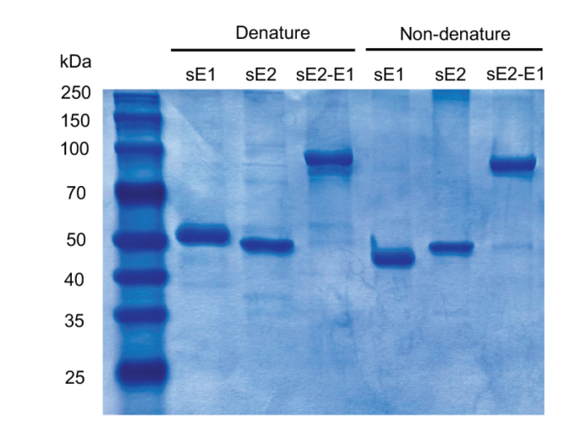
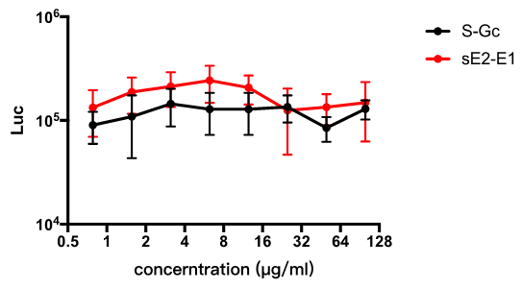
Supplementary Figure S1. The SDS-PAGE in denaturing and non-denaturing conditions of purified sE1, sE2 and sE2-E1. In denaturing condition, proteins with SDS-PAGE sample loading buffer (Beyotime) were incubated at 100°C for 10 min, and in non-denaturing condition, proteins with native gel sample loading buffer (Beyotime) followed by gel electrophoresis.

Supplementary Figure S2. Competitive inhibition assay of sE2-E1 to CHIKV infection. 293A cells were seeded in 96-well-plate and cultured overnight. The sE2-E1 and S-Gc proteins were 2-fold diluted in DMEM medium and added into cells for 1 hour’s incubation. Then the protein was removed followed by adding CHIKV pseudoviruses. After 18 h, the medium was replaced with fresh DMEM with 10% FBS. 72 hours later, the medium was removed and 50 µL 1×Glo lysis buffer was added into each well. Then 30 µL Bright-Glo luciferase substrates (Promega, USA) were added into the cell lysate. The luminescence was measured using a multimode plate-reader.

