Virologica Sinica

Supplementary Data

The genomic characteristics and pathogenicity of a mammalian orthoreovirus within a new lineage from wild pika in plateau

Kexin Zong^{a,b}, Yuanyuan Guo^{b}, Jingdong Song^{b}, Maoshun Liu^{a,b}, Junfeng Hao^{c}, Jie Zhang^{b}, Xin Li^{b}, Shiyan Zhu^{d}, Shuting Huo^{b}, Ziqian Xu^{b}, Peipei Liu^{b}, Yingze Zhao^{b}, Yuhai Bi^{d}, Jiapeng Qu^{e,*}, George F. Gao^{a,b,d,f,*}, Jun Liu^{a,b,f,*}

ª School of Laboratory Medicine and Life Sciences, Wenzhou Medical University, Wenzhou, 325035, China
^{b} NHC Key Laboratory of Biosafety, National Institute for Viral Disease Control and Prevention, Chinese Center for Disease Control and Prevention (China CDC), Beijing, 102206, China
^{c} Laboratory Animal Center, Institute of Biophysics, Chinese Academy of Sciences, Beijing, 100101, China
^{d} CAS Key Laboratory of Pathogen Microbiology and Immunology, Institute of Microbiology, Chinese Academy of Sciences, Beijing, 100101, China
^{e} Northwest Institute of Plateau Biology, Chinese Academy of Sciences, Xining, 810001, China;
^{f} Research Unit of Adaptive Evolution and Control of Emerging Viruses (2018RU009), Chinese Academy of Medical Sciences, Beijing, 100021, China

*Corresponding authors.
E-mail address: liujun@ivdc.chinacdc.cn (J. Liu), gaofu@chinacdc.cn (G.F. Gao), jpqu@nwipb.cas.cn (J. Qu)
ORCID: 0000-0003-3605-4070 (J. Liu); 0000-0002-3869-615X (G. F. Gao); 0000-0002-8584-336X (J. Qu).
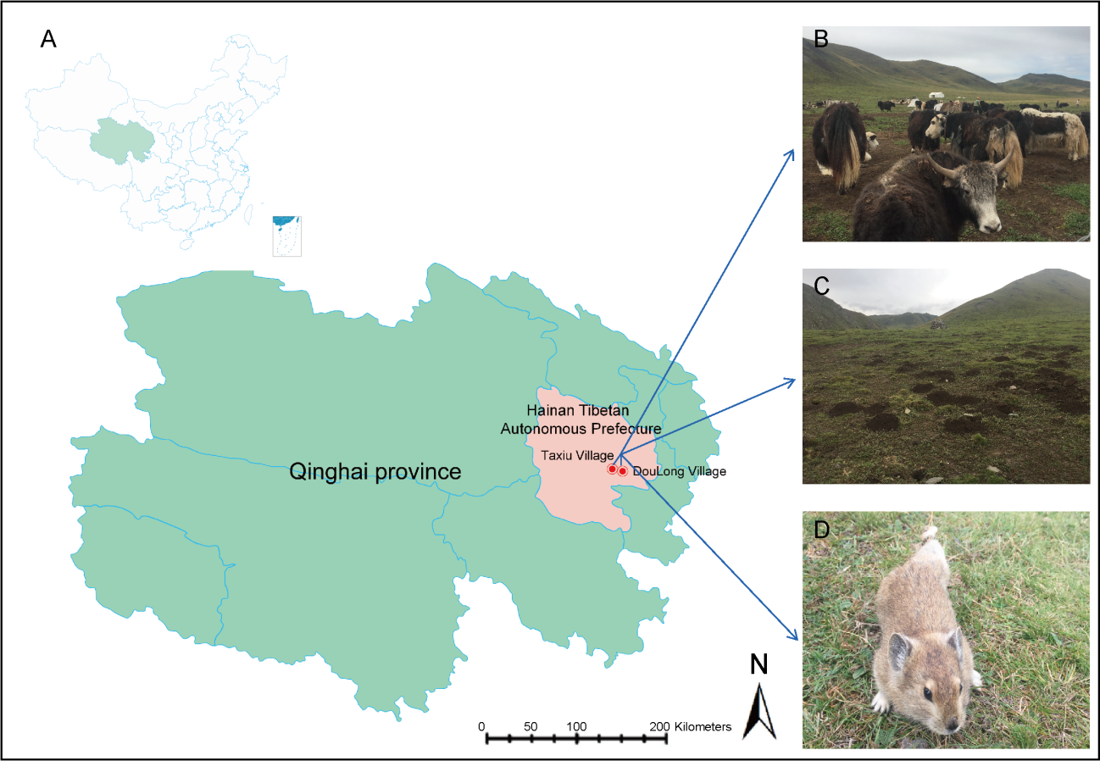
Supplementary Fig. S1. Sampling location and living environment of plateau pika. A Green, Qinghai province; red, Hainan Tibetan Autonomous Prefecture; red circle, Taxiu and Doulong vallage. B When the herders graze, the herders and animals are in close contact with the plateau pika living environment and also possibly the plateau pika. C The habitat of the plateau pika. D Qinghai-Tibet Plateau wild pika.

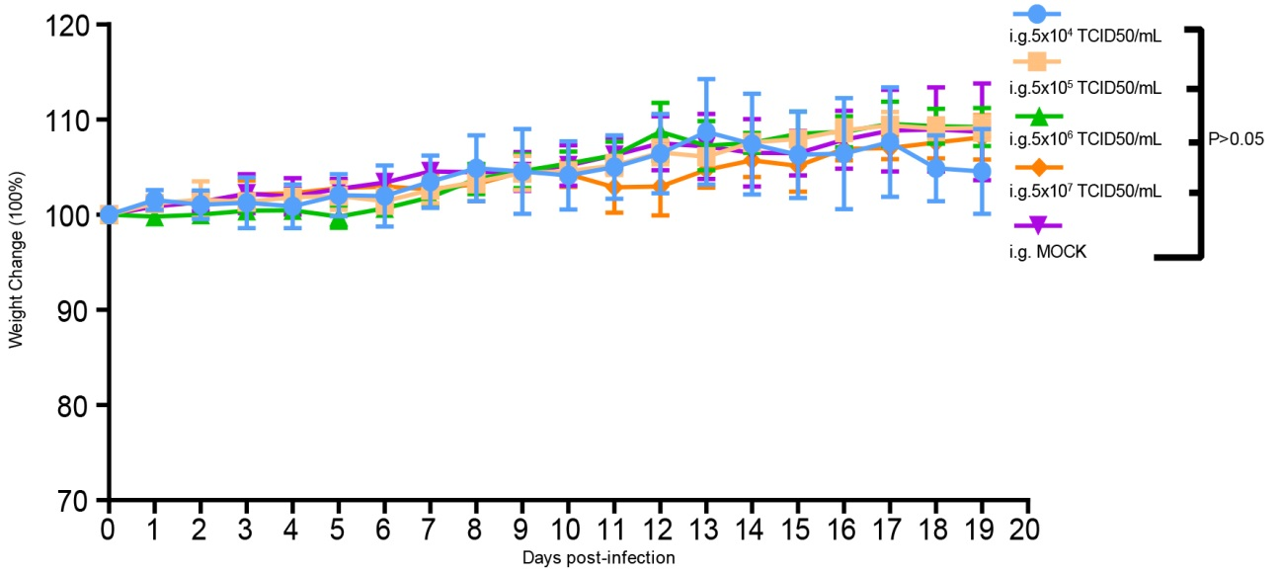
Supplementary Fig. S2. Weight change of BALB/c mice (n = 3/group) infected by intragastric (i.g.) with the different viral titer was monitored daily for a total of 20 days compared with control mice. The weight changes of mice induced by i.g. routes with different doses of PMRV-GCCDC7 were statistically analyzed by unpaired t-tests. Data were shown as the mean and standard deviation of the percentage change of body weight of three mice at each time point. We considered a significant statistical difference when the P value is less than 0.05. Statistical analysis was performed by GraphPad Prism 7.0 (GraphPad, America).

Supplementary Table S1 Human and non-human cell lines used in the study.
 | Abbreviation | Source of cell line
Human lung cancer cell | A549 | Laboratory Cell bank | Human respiratory tract
Human hepatocellular carcinoma cell | Huh7 | Laboratory Cell bank | Human liver
Human colorectal adenocarcinoma cell | HCT | Laboratory Cell bank | Human gastrointestinal tract
Human intestinal cell | LoVo | Laboratory Cell bank | Human gastrointestinal tract
African green monkey kidney cell | Vero-E6 | Laboratory Cell bank | Non-human primate kidney
Rhesus monkey kidney cell | LLC-MK2 | Laboratory Cell bank | Non-human primate kidney
Canine kidney | MDCK | Laboratory Cell bank | Dog
Hamster kidney cell | BHK-21 | Laboratory Cell bank | Hamster
Mouse neuroblastoma cell | N2a | Laboratory Cell bank | Mouse
Bat kidney-derived cell lines | RfKT | Wuhan Institute of Virology | Bat
Aedes albopictus larvae cell | C6/36 | Laboratory Cell bank | Aedes albopictus

Supplementary Table S2 Genebank number of all virus strains used in the study.
Strain | Type | Genebank NO. (S1 Gene) | Genebank NO. (S2 Gene) | Genebank NO. (S3 Gene) | Genebank NO. (S4 Gene) | Genebank NO. (M1 Gene) | Genebank NO. (M2 Gene) | Genebank NO. (M3 Gene) | Genebank NO. (L1 Gene) | Genebank NO. (L2 Gene) | Genebank NO. (L3 Gene)
SI-MRV04 | MRV 1 | MG457104 | MG457105 | MG457106 | MG457107 | MG457101 | MG457102 | MG457103 | MG457098 | MG457099 | MG457100
HB-A | MRV 1 | KC462155 | KC462156 | KC462157 | KC462158 | KC462152 | KC462153 | KC462154 | KC462149 | KC462150 | KC462151
WIV8 | MRV 1 | KT444568 | KT444569 | KT444570 | KT444571 | KT444565 | KT444566 | KT444567 | KT444562 | KT444563 | KT444564
T1_Lang | MRV 1 | M14779 | / | / | / | / | / | / | / | / | /
WIV2 | MRV 1 | KT444528 | KT444529 | KT444530 | KT444531 | KT444525 | KT444526 | KT444527 | KT444522 | KT444523 | KT444524
B/03 | MRV 1 | KX263313 | KX263314 | KX263315 | KX263316 | KX263310 | KX263311 | KX263312 | KX263307 | KX263308 | KX263309
MRV1/TS/China/2011 | MRV 1 | MG451067 | MG451068 | KT900703 | MG451070 | MG451064 | MG451065 | MG451066 | MG451061 | MG451062 | MG451063
SI-MRV03 | MRV 1 | MG457094 | MG457095 | MG457096 | MG457097 | MG457091 | MG457092 | MG457093 | MG457088 | MG457089 | MG457090
Porcine_reovirus_SHR-A | MRV 1 | JX415469 | JX415465 | JX415470 | JX415473 | JX415468 | JX415471 | JX415474 | JX415466 | JX415467 | JX415472
C/bovine/Indiana/MRV00304/2014 | MRV 1 | KJ676385 | KJ676386 | KJ676387 | KJ676388 | KJ676382 | KJ676383 | KJ676384 | KJ676379 | KJ676380 | KJ676381
SI-MRV06 | MRV 1 | MG457124 | MG457125 | MG457126 | MG457127 | MG457121 | MG457122 | MG457123 | MG457118 | MG457119 | MG457120
BatMRV1-IT2011 | MRV 1 | KT900701 | KT900702 | KT900703 | KT900704 | KT900698 | KT900699 | KT900700 | KT900695 | KT900696 | KT900697
SI-MRV07 | MRV 2 | MG999582 | MG999583 | MG999584 | MG999585 | MG999579 | MG999580 | MG999581 | MG999576 | MG999577 | MG999578
D5/Jones | MRV 2 | M10261 | / | / | / | / | M19355 | / | / | / | /
T3/Pipistrellus_kuhlii/Italy/5515-3/2012 | MRV 2 | KU194672 | KU194673 | KU194674 | KU194675 | KU194669 | KU194670 | KU194671 | JX028413 | KU194667 | KU194668
729 | MRV 2 | JN799419 | JN799420 | JN799421 | JN799422 | JN799423 | JN799424 | JN799425 | JN799426 | JN799427 | JN799428
BYD1 | MRV 2 | DQ312301 | DQ664190 | DQ664191 | DQ318037 | DQ664187 | DQ664188 | DQ664189 | DQ664184 | DQ664185 | DQ664186
SI-MRV05 | MRV 2 | MG457114 | MG457115 | MG457116 | MG457117 | MG457111 | MG457112 | MG457113 | MG457108 | MG457109 | MG457110
MORV/47Ma/06 | MRV 2 | KX384852 | KX384853 | KX384854 | KX384855 | KX384849 | KX384850 | KX384851 | KX384846 | KX384847 | KX384848
sR1590 | MRV 2 | LC482244 | LC482245 | LC482246 | LC482247 | LC482241 | LC482242 | LC482243 | LC482238 | LC482239 | LC482240
Osaka2014 | MRV 2 | LC476921 | LC476922 | LC476923 | LC476924 | LC476918 | LC476919 | LC476920 | LC476915 | LC476916 | LC476917
Osaka1994 | MRV 2 | LC476901 | LC476902 | LC476903 | LC476904 | LC476898 | LC476899 | LC476900 | LC476895 | LC476896 | LC476897
Osaka2005 | MRV 2 | LC476911 | LC476912 | LC476913 | LC476914 | LC476908 | LC476909 | LC476910 | LC476905 | LC476906 | LC476907
WIV5 | MRV 2 | KT444548 | KT444549 | KT444550 | KT444551 | KT444545 | KT444546 | KT444547 | KT444542 | KT444543 | KT444544
TRALAU2004 | MRV 2 | JX204737 | JX204744 | JX204745 | JX204746 | JX204741 | JX204742 | JX204743 | JX204738 | JX204739 | JX204740
WIV3 | MRV 2 | KT444578 | KT444579 | KT444580 | KT444581 | KT444575 | KT444576 | KT444577 | KT444572 | KT444573 | KT444574
Tou05 | MRV 2 | GU196315 | GU196311 | GU196312 | GU196313 | GU196309 | GU196310 | GU196314 | GU196306 | GU196307 | GU196308
WIV4 | MRV 2 | KT444538 | KT444539 | KT444540 | KT444541 | KT444535 | KT444536 | KT444537 | KT444532 | KT444533 | KT444534
RpMRV-YN2012 | MRV 2 | KM087111 | KM087112 | KM087113 | KM087114 | KM087108 | KM087109 | KM087110 | KM087105 | KM087106 | KM087107
OV204 | MRV 2 | MK092970 | MK092971 | MK092972 | MK092973 | MK092967 | MK092968 | MK092969 | MK092964 | MK092965 | MK092966
sR1677 | MRV 2 | LC482417 | LC482418 | LC482419 | LC482420 | LC482414 | LC482415 | LC482416 | LC482411 | LC482412 | LC482413
sR1521 | MRV 2 | LC482234 | LC482235 | LC482236 | LC482237 | LC482231 | LC482232 | LC482233 | LC482228 | LC482229 | LC482230
SI-MRV01 | MRV 3 | KF154730 | KF154731 | KF154732 | KF154733 | KF154727 | KF154728 | KF154729 | KF154724 | KF154725 | KF154726
SI-MRV02 | MRV 3 | MG457084 | MG457085 | MG457086 | MG457087 | MG457081 | MG457082 | MG457083 | MG457078 | MG457079 | MG457080
mew716_MRV-3 | MRV 3 | KX932035 | KX932036 | KX932037 | KX932038 | KX932032 | KX932033 | KX932034 | KX932029 | KX932030 | KX932031
MRV3/Swine/Italy/224660-4/2015 | MRV 3 | KX343206 | KX343207 | KX343208 | KX343209 | KX343203 | KX343204 | KX343205 | KX343200 | KX343201 | KX343202
T3/Bat/Germany/342/08 | MRV 3 | JQ412761 | JQ412762 | JQ412763 | JQ412764 | JQ412758 | JQ412759 | JQ412760 | JQ412755 | JQ412756 | JQ412757
MRV-3_chamois_84407_Italy_2009 | MRV 3 | MK408605 | MK408606 | MK408607 | MK408608 | MK408601 | MK408599 | MK408600 | MK408604 | MK408603 | MK408602
BM-100 | MRV 3 | KM820750 | KM820751 | KM820752 | KM820753 | KM820747 | KM820748 | KM820749 | KM820744 | KM820745 | KM820746
FS-03 | MRV 3 | KM820760 | KM820761 | KM820762 | KM820763 | KM820757 | KM820758 | KM820759 | KM820754 | KM820755 | KM820756
ZJ2013 | MRV 3 | KY419126 | KY419127 | KY419128 | KY419129 | KY419123 | KY419124 | KY419125 | KY419120 | KY419121 | KY419122
SC-A | MRV 3 | DQ911244 | DQ396805 | DQ411553 | DQ396806 | DQ396804 | DQ482462 | DQ403254 | DQ997719 | DQ885990 | EF029088
MPC/04 | MRV 3 | GQ468272 | GQ468273 | GQ468274 | GQ468275 | GQ468268 | GQ468269 | GQ468271 | GQ468266 | GQ468267 | GQ468270
SD-14 | MRV 3 | KT224510 | KT224511 | KT224512 | KT224513 | KT224507 | KT224508 | KT224509 | KT224504 | KT224505 | KT224506
GD-1 | MRV 3 | JX486063 | JX486064 | JX486065 | JX486066 | JX486060 | JX486061 | JX486062 | JX486057 | JX486058 | JX486059
WIV7 | MRV 3 | KT444558 | KT444559 | KT444560 | KT444561 | KT444555 | KT444556 | KT444557 | KT444552 | KT444553 | KT444554
MRV3/TS/China/2012 | MRV 3 | MG451077 | MG451078 | MG451079 | MG451080 | MG451074 | MG451075 | MG451076 | MG451071 | MG451072 | MG451073
Abney | MRV 3 | GU589583 | GU589584 | GU589585 | GU589586 | GU589580 | GU589581 | GU589582 | GU589577 | GU589578 | GU589579
P4L-12 | MRV 3 | KP208820 | KP208821 | KP208822 | KP208823 | KP208817 | KP208818 | KP208819 | KP208814 | KP208815 | KP208816
T3D-S | MRV 3 | KP208810 | KP208811 | KP208812 | KP208813 | KP208807 | KP208808 | KP208809 | KP208804 | KP208805 | KP208806
T3_Dearing_VeroAV | MRV 3 | MK246422 | MK246418 | MK246419 | MK246420 | MK246416 | MK246421 | MK246417 | MK238541 | MK238542 | MK246415
jin-1 | MRV 3 | GU991675 | GU991676 | GU991677 | GU991678 | GU991672 | GU991673 | GU991674 | GU991669 | GU991670 | GU991671
R124 | MRV 3 | GU991665 | GU991666 | GU991667 | GU991668 | GU991662 | GU991663 | GU991664 | GU991659 | GU991660 | GU991661
Dearing_strain_T3D | MRV 3 | HM159619 | HM159620 | HM159621 | HM159622 | HM159616 | HM159617 | HM159618 | HM159613 | HM159614 | HM159615
T3D | MRV 3 | EF494441 | EF494442 | EF494443 | EF494444 | EF494438 | EF494439 | EF494440 | EF494435 | EF494436 | EF494437
Ndelle_virus | MRV 4 | AF368035 | AF368036 | / | AF368037 | / | AF368034 | / | AF368033 | / | /
Avian_reovirus_138 | ARV | AF218359 | AF059717 | AF059721 | AF059725 | AY557188 | AY750052 | AY557190 | EU707933 | EU707935 | EU707937
Avian_reovirus_K1600600 | ARV | MK416139 | MK416140 | MK416141 | MK416142 | MK416136 | MK416137 | MK416138 | MK416133 | MK416134 | MK416135
Avian_reovirus_176 | ARV | AF218358 | AF059716 | AF059720 | AF059724 | AY557189 | AY750053 | AY557191 | EU707934 | EU707936 | EU707938
Avian_reovirus_K738/14 | ARV | MF686704 | MF686701 | MF686702 | MF686703 | MF686698 | MF686699 | MF686700 | MF686695 | MF686696 | MF686697
Nelson_Bay_reovirus | PRV | AF218360 | AF059718 | AF059726 | AF059722 | JF342675 | JF342676 | JF342677 | JF342672 | JF342673 | JF342674
Kampar_reovirus | PRV | EU448334 | EU448335 | EU448336 | EU448337 | JF342657 | JF342658 | JF342659 | JF342654 | JF342655 | JF342656
Miyazaki-Bali/2007 | PRV | AB908284 | AB908285 | AB908286 | AB908287 | AB908281 | AB908282 | AB908283 | AB908278 | AB908279 | AB908280
Melaka_reovirus | PRV | NC020448 | NC020444 | NC020445 | NC020446 | NC020441 | NC020442 | NC020443 | NC020439 | NC020447 | NC020440
Cangyuan_reovirus | PRV | NC025806 | NC025809 | NC025807 | NC025810 | NC025804 | NC025808 | NC025805 | NC025801 | NC025802 | NC025803
Pulau_reovirus | PRV | NC038667 | NC038659 | NC038663 | NC038658 | NC038661 | NC038664 | NC038666 | NC038665 | NC038660 | NC038662
Reptilian_reovirus_47/02 | RRV | KC852161 | KC852159 | KC852160 | KC852162 | KC852158 | KC852156 | KC852157 | KC852153 | KC852155 | KC852154
Broome_virus | BRoV | NC014242 | NC014243 | NC014244 | NC014245 | NC014239 | NC014240 | NC014241 | NC014236 | NC014237 | NC014238
Baboon_reovirus | BRV | NC015883 | NC015884 | NC015886 | NC015885 | NC015880 | NC015881 | NC015882 | NC015877 | NC015878 | NC015879

